How to Edit Existing FAQs
- Log into LibApps. A link is available at the bottom right of all FAQ pages.
  - https://illinois.libapps.com/libapps/login.php?site_id=5977&target=
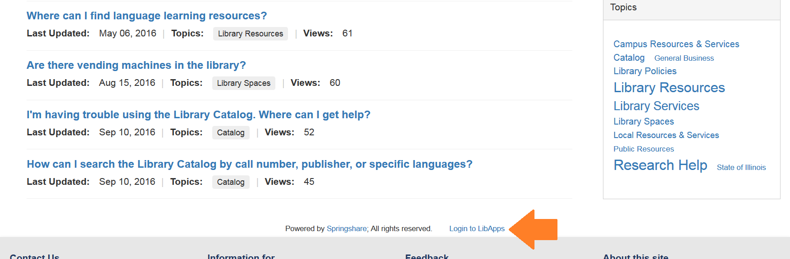
- Select Answers from the top of the menu, then select FAQ Entries.

- On the Knowledge Base Explorer page, you can view questions by group, topic, who owns them, etc. You can also sort them by creation date, status, views, etc.
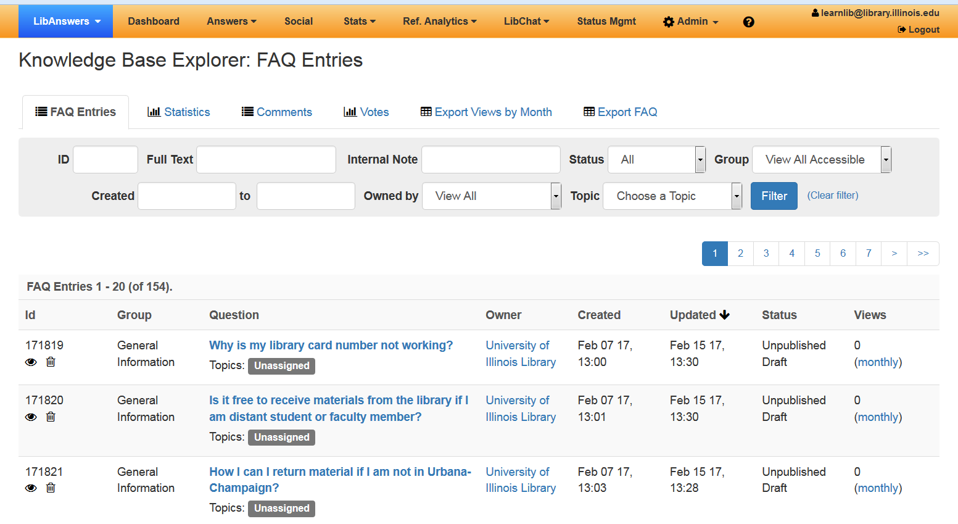

- To edit an FAQ, click on the hyperlinked question text.
- Make your changes, then click Save Answer Text.
- To publish or unpublish an FAQ, click on Change Status at the bottom of the page. Only publish questions you are ready for patrons to see!
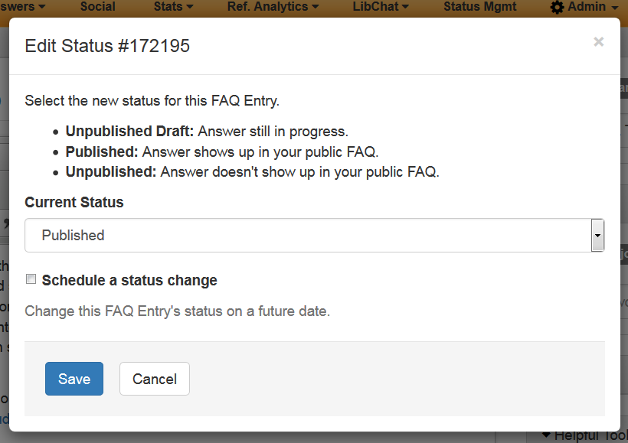
Questions? Contact Jody Ford (jlford3@illinois.edu)

