Innovation Grant Proposal
Creating a Historical Knowledge Graph for the University of Illinois, 1867-2020
Michael Norman – Discovery Services Librarian and ILS Coordinator
December 2, 2019

Project Description

My goal over the past two years has been to build up a historical Knowledge Graph of all the individuals who have worked at the University of Illinois since its inception in 1867 and progressing through to the current year of 2019/2020. There is currently no single source to consult when one wants to know more about the timeline of individuals and events associated with the University. Much of this data about the 100,000+ individuals who have worked for the University of Illinois over the past 152 years is scattered through various sources, including

- Division of Information Management Website (2005 to present)
- University of Illinois Board of Trustees – Academic and Administrative Appointment (Gray Books) (1961-2019)
- Annual Report – University of Illinois Board of Trustees (1868-1962)
- University of Illinois Annual Register (1868-1946)
- University of Illinois Faculty Publications (1908-1979)
- Semi-Centennial Alumni Record of the University of Illinois (1867-1917)

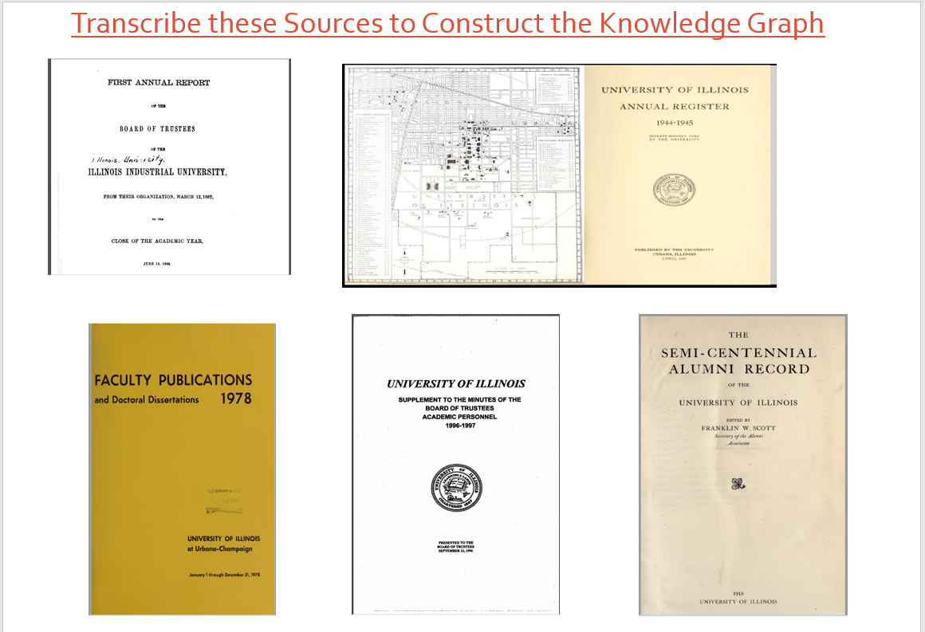

From my previous work over the past couple of years, I have determined that one can build a comprehensive list of the University of Illinois’s faculty, staff, and affiliated personnel. The information is locked up in the six sources listed above. Many of these books and publications have been digitized over the past 10-15 years and the information lays confined in the OCR of those digitized resources. Some of the OCR text is a viable source for search and discovery when doing a search across the full-text documents. Some of it is garbled and unusable for research purposes. These data points are waiting there ready to be pulled into standard metadata schemas to make it easier to collect and structure the data about people, places, events, and other interconnected details associated with the history of the University of Illinois.

When you have this information mapped over to structured metadata it is easier to access and the benefits of unlocking this data could be enormous and could be utilized by many people across the University for search, discovery, bibliometric and scientometric analyses, and producing visualizations showing the output that has occurred over the its history but could also reveal many of the important relationships across the campus over the years and demonstrate the overall impact to the University, the state of Illinois, and the world. Generating these reports could produce longitudinal studies could occur across the history of the University of Illinois to showcase all that the affiliated researchers of the institution have contributed to the universal world of knowledge and information in the sciences, social sciences, arts, and humanities.

It all starts with the transcription of these five identified sources to pull out all the individuals included in these publications (along with their position titles, roles, associated departments/schools, biographical information, research and publication output, and any other pertinent or relevant information).

I’ve already established comprehensive lists of four areas from 1867 to the present at the University including:

- University of Illinois Library (10,046 entries)
- Library School (2,131 entries)
- Department of Philosophy (1,226)
- School of Engineering (50,068 entries)

Now, it is time to build up the list for all the remaining schools, colleges, departments, research laboratories, and units across the entire University to create that all-encompassing historical Knowledge Graph for the University of Illinois. Transcribing and mapping all this available data in these five sources into a structured metadata schema can produce that comprehensive list that doesn’t currently exist. And, while transcribing this data, we continuously push the information into a searchable database that persistently builds over time as new individuals and pertinent information is added.

An additional possibility would be to pull in student interns from the Public History area in the Department of History to aid in this transcription and mapping project. It could continue to build up the history of the University of Illinois. Some of these published works, especially the 1) Semi-Centennial Alumni Record of the University of Illinois and 2) the University of Illinois Annual Register (published annually from 1868 to 1946), provide some very detailed historical information about each individual associated with the University included in the publications, especially biographical information about birth dates, where they were born, residences, degrees and levels of education, where they went to graduate school, achievements after graduation, and even the place of residence of faculty in Urbana and Champaign. The work some of these Public History students could gain with doing some in-depth analyses of these five sources and mapping that data over into searchable repositories for researchers to discover could be invaluable to them. We could possible work with Kathy Oberdeck in the Department of History to identify some students who could be interested in working on this project.

Strategic Framework collaboration -- This project of 1) transcribing these five published and digitized works of such rich institutional history of the University of Illinois and then 2) transforming the data into an overarching historical Knowledge Graph available to internal researchers on campus (and externally around the world too) would also tie in well with several of the Library’s Strategic Framework initiatives for 2019-2023. The collaboration could concentrate in three areas:

- SD2. Transformative learning experiences -- Advance co-curricular programming and practices that connect learning to information-rich resources.

Working with students and interns in the Department of History in the Public History area and the Department of Computer Science + X programs, this project would provide opportunities to work with the associated OCR text from these digitized sources, cleanup the data elements for better use, group and cluster similar data points, and then maneuver and structure the information in ways that allows better access and discovery for researchers across various disciplines. This could be a valuable learning experience these students would experience and enable her or him to extend to similar research projects of digitized texts. Currently, it is still not easy to do this type of data-mining and structuring of information in these digitized texts. Using some of these established methodologies, and possibly introducing Machine Learning into the processes, could allow these students (and others) to more easily create these Knowledge Graphs of institutional histories.

- SD3. Societal and global impact -- Establish collaborative partnerships, both within and outside the campus, to engage the global diversity of the student body and address local and global grand challenges.

The University of Illinois has always been at the forefront of global diversity in the hiring of individuals to work here on campus. As I constructed the Knowledge Graphs for the University Library, Library School, and the School of Engineering, I discovered numerous individuals who were employed from around the world. Pulling this information and data out of these digitized texts will allow the Library and the campus to highlight and showcase many more of these examples of diversity over the rich history of the University.

- SD4. Strategic investments for a sustainable library environment -- Support innovative research and practices in library and information science to establish the Library as a global leader in the research library ecosystem.

If Machine Learning can be successfully integrated into this transcription of these digitized sources, there could be some real innovation here. Several other global initiatives overseen by Amazon, Google, Microsoft, and other international corporate entities can probably already do some of this type of work to structure and utilize OCR digitized text. This transcription project would be an attempt to do this in an open source/open access environment that others could possibly use in other data-mining and digital humanities projects. There could be great value to the library and information science fields if we combine the Public History side of this, especially the history of the University and structuring that in a way that is easily accessible for researchers, with Machine Learning capabilities to analyze each single word and look for concepts and connections of adjacent words and phrases. If we could make it a process and methodology that can be replicated on other published and digitized sources, that could be a strategic collaboration that could benefit many here on campus but also some of the University of Illinois’ peer universities and libraries. We all struggle to work with this institution data that is available in multiple sources. This project would be an attempt to bring some people power, some metadata standards, rules, and policies, and some automated computer algorithms to unlock this valuable and important information stored away in these digitized works.

Project Outline:

- Needs

People (student interns) to transcribe these five sources into the structured metadata to populate the overarching database that produces the historical knowledge graph. Currently, Artificial Intelligence and Machine Learning algorithms are not at the place yet where this can be automated. We need people power at this stage to get this data into a state where it can be transformed into useable form.

To start, we would hire three student interns to do the transcription work of the five sources identified above. These totals would = 3 students for 40 weeks at 10 hours per week at $8.25 per hour = $9,900.

- Challenges in transcribing this data

There are several identified ways to do this transcription of data. We could re-type the data into a structured Access template that groups together the separate metadata elements into its proper grouping (name, rank/title, work year, and affiliated school/department/unit/laboratory)

We could copy out all the OCR text from the digitized volume and then clean-up and structure the text into a template form that can then be pulled into data structures that can map over to metadata fields. To group names (with different spellings, variations, and name changes), we can use Open Refine to cluster like names/entries to get around the anomalies produced when using OCR text.

We could use programs, formulas, and scripts as well to normalize the OCR data and then group each data point into identified buckets of metadata to be housed in a structured database.

Working with the Computer Science + X department program, we could employ Machine Learning to analyze OCR data to identify personal names, profession titles, various departments and units at the University of Illinois and then push that information into an SQL database to work with later to properly structure, cluster, and index for eventual search and discovery by researchers looking for this type of information.

Equally important to this endeavor would be the metadata schema structure to record all this pertinent information about an individual who has worked or been affiliated with the University. Using an already established metadata schema (like Dublin Core, schema.org, Friend of a Friend (FOAF), etc.) would be the best way to go with this but we would need to determine what would be the best practice for gathering of data and mapping to specific agreed-upon metadata elements. It could be possible to work with Dave Dubin over at the iSchool to figure out the best path forward with this. I’ve got some preliminary ideas about best possible scema (schema.org) but working with one of the classes at the School of Information Sciences could provide some additional benefits. This would need to be determined before the transcription work would begin. Also it would need to determined where this transcribed information will be housed (the already established Digital Library, a separate SQL XML database, or we are learning Alma has some capabilities to store this data as well). And, if needed, we could create a schema solely for this project but with the capability of being mapped over to already existing metadata standards and practices. This would be one of the biggest challenges for this project to produce the metadata for this University of Illinois Knowledge Graph that is interoperable with other systems and best practices already established in the Library. Collaboration between the Digital Library Team, the Repositories Team, and Cataloging/Metadata folks would be essential in creating and utilizing current metadata schemas (that is compliant with the Digital Library and Medusa structures) and overall systems like the Digital Library, IDEALS, or Alma/Primo VE as the repository of this data.

- Opportunities

Hire one computer science or CS + X student (50 hours at $15 per hour = $750 dollars) to investigate using Machine Learning algorithms to transform the OCR text into an automated process that can analyze the printed words one-by-one and any adjacency relationships for names (personal names with capital letters, corporate body information for department/unit, bibliographic and citation information, and other biographical information). Then, hopefully the identified data could be pushed into a database repository to match new data to the record for each individual affiliated with the University of Illinois. It starts to sort of become an encyclopedia of Illinois people that becomes the comprehensive listing of all personnel associated with the University.

Producing that comprehensive list is the beginning stage, and, probably most critical part, for this project. Hiring a student programmer, with experience working in Artificial Intelligence and Machine Learning, could provide the opportunity to automate these tedious processes and possibly could be used for other OCR text transcription project and/or datamining work in the Library or the University.

One last opportunity might be to partner this up with our interactions with Amazon Web Services (AWS). They are looking to work with students on campus to aid in bringing large-scale technological and analytical processes into Digital Humanities datamining and data-mapping projects here on campus. I do see how a combination of these innovation funds and the technological services that Amazon Web Services offers could merge together to enable an optimal setting to combine the transcription process and the processing power of Amazon Cloud Services or even Microsoft Azure services that offer similar capabilities. I think this transcription project against possible Public History documents and publications could be one the Amazon representatives might see as viable and that could eventually create processes others could use against similar cleanup of OCR text projects to automate the harvest, grouping of data, and then introduce metadata structure that makes it easier to manipulate the data to researchers at the University looking for that information.

- Approach

Create the methodology to use in the transcription of this OCR text from the five identified sources. There are multiple ways to do this transcription work. I’ve experimented with multiple techniques including:

- re-keying the text into a web-form or Access template that uploads entered data into existing records of UofI individual or creates anew if does not already exist
- re-scanning the digitized pages in AABYY Fine Reader and then dumping the new OCR text directly into a Excel Spreadsheet or Word Document where cleanup can occur
- copy and pasting the OCR Text into various programs like Notepad, Notepad ++, Word, Excel. Once pulled into Excel formulas, scripts, regular expressions, filtering, etc. can be applied and enables easier cleanup of data
- using Open Refine clustering feature to group similar names and titles into similar groupings to allow easier cleanup of text (especially garbled words and misspellings)
- using Python scripting to convert the OCR text into XML where it is easier to manipulate and load into database
- There are positives and negatives to each of these approaches. Part of the learning curve of this project will be to see which of these methods are better suited to the undergraduate students and the tedium one will encounter when doing this transcription and cleanup type of work.

Once the data is transcribed, then the process will be to map that data over to the appropriate metadata fields. The best scenario for this would be to establish an automated process for this that is handled in the background with little intervening by the students. I’ve established a methodology for this that would need to be tested but that would be part of the approach with introducing this to the students and seeing how difficult it is to implement.

- Work Plan

- Create the underlying database/repository (or utilize existing one in the Digital Library, IDEALS, or Alma/Primo VE)
- Create the web form for entering data
- Hire three undergraduate student interns to begin the transcription process of the five publications, starting with the University of Illinois Annual Register and the University of Illinois Annual Report
- Working with the students, determine the methodology that is most effective and efficient in transcribing the data from the initial source or if easier to copy and paste data into appropriate program and clean-up the text to map to appropriate metadata fields
- Have each student work 10 hours per week on the transcription work. The logistics of the physical space and what computers could be used for this work would need to be determined. This work could occur throughout the Library at various times during the day.
- Hire one computer science or CS + X student intern to investigate and create program(s) that uses Machine Learning algorithms to transform the OCR text into an automated process that can analyze the printed words to extract any relevant names and other related information from the identified digitized document or publication. This could possibly be an upper-level student in Computer Science who has an interest in Artificial Intelligence and/or Machine Learning. Or maybe a student associated with the School of Information Sciences who wants to get more experience working with AI or Machine Learning.
- Over the course of one academic year and utilizing 30 hours per week for 40 weeks, work to transcribe and map as much of the data included in the five sources over to the associated University of Illinois Knowledge Graph repository
- By the end of the academic year, create a search interface and website that provides access to the individual graphs of each person identified during the transcription and mapping project. A mockup of possible information to include in the individual graph is below, including a timeline of associated events for each individual.
- By December 31, 2020, demo the University of Illinois Historical Knowledge Graph and search portal to the Library and Campus and open it up for searching by anyone interested to discover more about individuals who have worked here at the University.

- Cost

Hire three undergraduate intern students to do the transcription of the sources, clean-up processes of the OCR data, and mapping of data to database repository

3 undergraduate student for 10 hours per week at $8.25 per hour for 40 weeks = $9,900
1 student with Machine Learning programming skills for total of 50 hours at $15 per hour = $750

Total request: $9,900 + $750 = $10,650 for the next academic year

Appendix

Underlying structure of data from the transcription project:

Transcribed Data from University of Illinois Annual Register 1945-1946

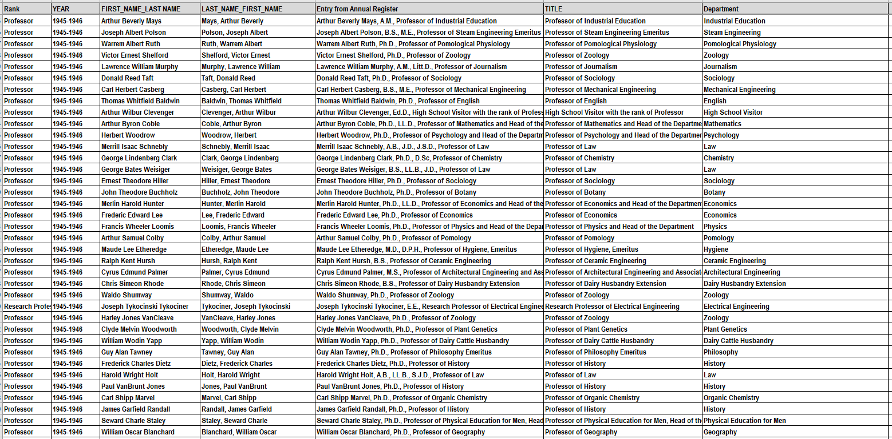

Transcribed Data from the University of Illinois Board of Trustees – Academic and Administrative Appointment (Gray Books)

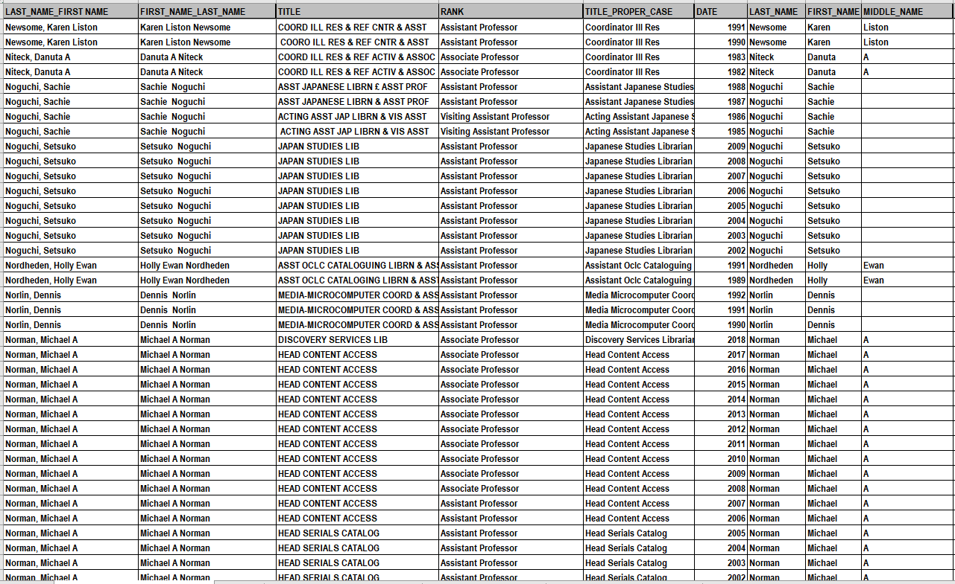

Possible Graph Entry of what could be developed from transcribed data to produce Knowledge Graph:

