CAPT Meeting Minutes
March 28, 2019

Present: Tom Teper, John Laskowski, Bill Mischo, Michael Norman, Cherie’ Weible, Ayla Stein, Jim Dohle, Chris Prom, Heidi Imker, Tracy Tolliver, Wendy Shelburne, MJ Han

Absent: Kyle Rimkus

Agenda and Minutes
Tom Teper opened the meeting requesting approval of the March agenda and February minutes. Agenda and minutes unanimously approved.

ILS System Migration Monthly Update – Michael Norman
Michael has been working with CARLI regarding the ILS migration. Our data will be extracted three different times. The first test will be sometime in the next three weeks. They will extract the data, and then give us access. We will need to see what needs to be improved so we are ready for the second extraction in August. Currently, the third and final extraction is planned for May/June 2020. The group agreed that this is not a good time due to our fiscal year end. CARLI and Ex Libris sent us a form that needs to be completed by April 9th in order to process the dry run. Michael will be attending a workshop hosted by CARLI on April 2nd.
Policy on Local Notes – MJ Han
MJ requested that the group approve changing the policy on local notes to conform to the national standard, not simply to comply with local system’s display needs. The driver for this request is the fact that the current practice will result in the creation of “ghosts” records for nearly 700,000 items as the existing Voyager ILS is migrated to Alma, meaning that we already have a 700,000 clean-up project that must be completed in the next several months. The group approved the request, pending discussions with RBML to make sure that this will not create any problems for their cataloging practices. The change was subsequently announced on April 1, 2019.

Quarterly Working Group Reports
Cataloging and Metadata Group
2019 1st Quarter Report
March 28, 2019
Submitted by Myung-Ja K. Han
- Policy on Local Notes
The Cataloging and Metadata Group has finalized the local notes policy. The basic principle of our policy is to conform to the national standard, not simply to comply with local system’s display needs.
  - Policies on Copy-Specific notes have been approved and available on the webpage now: http://guides.library.illinois.edu/cam/policies/mfhds/mfhdpolicies#copyspecnotes. The policies were decided based on the MARC21 Holdings standard and its usage, utilizing specific MARC21 fields for specific information (for example, gift, binding, purchase note).
  - Policies on Serials local notes have been approved and available on the webpage now: http://guides.library.illinois.edu/cam/policies/mfhds/serialnotes. Serials local notes clean-up work is already underway. This work will focus on removing obsolete local notes, such as:
- Recent issues/Unbound issues + library names (and all the many many variants in wording)
- For later volumes see UIUC online collection
- Indexed by Wilson/Current contents
- For current volumes
And suppress these notes by changing the subfield $z to $x:
- Copy 1 has…
- For earlier/for later issues

- Alma Migration
  - The group started reviewing CALRI’s Pre-Migration Database Maintenance (https://www.carli.illinois.edu/products-services/i-share/alma/datacleanup) and is prioritizing the works our Library will do in order.
  - Bib Reclamation work is under way by Stephanie and Willy.

- Cataloging Policy Change: MFHD Location vs. Item Permanent Location
Our Library keeps the item permanent location as is when the item was withdrawn, i.e., we change MFHD location to ‘wdn-nc’ but do not change the item permanent location. As of October 2018, we have 665,312 records with different locations. However, this discrepancy creates a problem in Alma migration. When locations between MFHD and Item record are different, Alma will create two MFHD for those different locations. Because of this reason, CARLI suggests that resolving conflicts when item records have permanent locations different from the location in the MFHD as one of the critical tasks for pre-migration.

LEITC Quarterly Update
03/28/19
- Monthly meetings
  - Last met: March 21, 2019
  - Next meeting: April 18, 2019

- Recent activity
  - Collaborations
    - UIUC campus VR group
      - Several LEITC team members and other interested Library stakeholders continue participation in a grassroots campus effort to discuss a variety of extended reality topics including Virtual Reality, Augmented Reality, 3D and 360 video, etc.
      - The larger VR group created several working groups to support early organization and collaboration efforts. Additionally, a VR steering group has been convened and is currently working on a VR whitepaper and proposal soliciting campus IT funding for VR-related equipment and projects.
  - Web presence
    - LEITC WordPress website
      - Following several revisions of the draft LEITC website, a small group (EK, MO, DW) is finalizing work on suggested improvements. This work is expected to complete by the April 2019 meeting. The LEITC website will serve as a hub for users seeking more information about the advanced technologies supported in the Library.
      - In lieu of repeating information on decentralized technology resources, the LEITC website will focus on marketing resources, efficiently addressing questions, and routing users to the appropriate technology and services.
    - John Laskowski met with the group to discuss pending plans to revise the ‘Library Technology’ tab on the Gateway. Following this discussion, it was decided to re-design the tab to include links to FAQs on how to access library technology-related resources, as well as a link to the LEITC site for users seeking more information on Library emerging and advanced technologies.
  - 3D and VR content management
    - Rob Wallace (IDEA Lab) is currently working on a system to coordinate system(s) for centralized storage, access and discovery of 3D assets and virtual reality generated content.
    - Rob is attending the April LEITC meeting to demo system progress and discuss next steps.
  - Outreach/engagement
    - Library-driven VR/AR poster session at JCDL conference (accepted) – June 2019
    - VR/AR panel session at Educause annual conference (proposed) – October 2019
- Future plans
  - Spring 2019 (1-2 months)
    - Develop plan to leverage LibDirectory database and associated web applications to connect users to Library advanced technology-related faculty, staff and expertise.
    - Work with John Laskowski to review and improve Library Technology WP site.
    - Documentation and discovery of emerging and advanced technology resources:
      - Work with Bill Mischo to review and assess next steps with Siebel Center for Design (SC4D) prototype resource database
      - Review and publish Library-related Research IT portal resource adds, edits, and removals.
      - Investigate and test feasibility of methods to leverage API’s designed for input and export of Research IT resource data, with a goal of efficient re-use of data entered once in one system with other systems, including the LEITC website.
    - Review Extended reality (XR) @ Educause report & explore XR resources page and community group.
    - Develop inventory of Library advanced technology spaces, equipment, and associated funding sources.
  - Summer 2019 (3-6 months)
    - Work with Communications group (Murphy) on marketing plans for Library emerging and advanced technologies resources (expertise, hardware, software, etc.)
    - Invite new Siebel Center for Design Director to meet with Library stakeholders regarding the Library’s involvement with the Design Learning Network.
    - Following the March Faculty meeting presentation by Discovery Partners Institute Interim Director Bill Sanders, investigate future opportunities to work with DPI efforts on the UIUC campus and in Chicago.
    - Assist with program planning and determine use cases for new spaces associated with the Library building project, collaborating with Top Teper and space planning teams.
    - Investigate use of web-based tools for lightweight VR development.
    - Investigate possible Mozilla sponsorship of open VR technology grant.

ILS Coordination Team Monthly Update Report to CAPT
March 28, 2019
Michael Norman – Discovery Services Librarian and ILS Coordinator
----------------------------------------------------------------------------------------------------------------------------
In this first report, I wanted to update CAPT and the Library on where we are at with the implementation of Alma/Primo. Over the past six weeks, we have learned a lot about the migration of our Library data and the various phases of the implementation of both Alma and Primo VE.

Vanguard Test Phase (April to July 2019)
The pace of the implementation phase will be accelerating over the next 2 months. The University of Illinois Library will be one of five libraries participating in the Vanguard Test Phase of the Alma/Primo Implementation. The five I-Share libraries included in this phase includes: University of Illinois at Urbana-Champaign Library, University of Illinois at Chicago Library, Southern Illinois University at Carbondale, Newberry Library, and North Central College.

Participating in the Vanguard Test Phase (to occur over the next five months (between April to July 2019), will give the Library access to a production-level version of Alma/Primo, allow us to test migrate our Library data to see what comes over successfully and where there are issues mapping the data to functional elements within the new systems, testing the borrowing and fulfillment areas of Alma, and help test and determine the proper configurations of the consortial functions.

There will be an initial Alma/Primo Vanguard Workshop here in Urbana/Champaign from June 4th to June 6th and the Library will be sending a large contingent to these sessions. We will meet with the Ex Libris Project Team. This workshop will be shortly after Ex Libris has loaded our Vanguard Test data. Connie Braun, one of Ex Libris’s leading experts on Voyager and converting to Alma, will be leading much of these presentations and information sessions. It will mostly concentrate on Alma and not incorporate the Discovery side of this implementation. There will be a later workshop in the Summer 2019 to concentrate on Primo.

Over the summer of this Vanguard Test Phase, we will be forming a Systems Administration Team to help configure Alma to its optimum settings for our Library. This will require several of us to gain Ex Libris certification to be able to do configuration work within the cloud-based system. We will have this certification work completed by July 2019 to allow us to be ready for the configuration work that will occur in the Secondary Test Phase of Alma/Primo implementation.

Also, in July and August 2019, there will be three Alma/Primo Information sessions to attend that will showcase Alma/Primo to give a sneak-peek of the new systems in action. These dates are:
Tuesday, July 2nd, 10 to 11 am, Room 106
Tuesday, July 23rd, 1 to 2 pm, Room 106
Tuesday, August 6th, 11 to 12 pm, Room 106

Secondary Test Phase of Alma/Primo (August 2019 to May 2020)
Following the Vanguard Test period there will be a Secondary Test Phase of all 92 I-Share libraries and this should occur from August 2019 to May 2020. There will be a “new” extract of the Library data for this secondary test phase to occur sometime in August or September 2019. From the test loads of data in the Vanguard Test Phase, the Library will have gained invaluable experience about the migration of our data into Alma, particularly Acquisitions, E-Resources, Link Resolver, Cataloging, Library Locations, and Patron Information update and clean-up our Library data to better map over to Alma/Primo.
This Phase will be important as all configurations that are setup by the end of May 2020 will remain in place for the final extraction of updated Library data to occur in June 2020.

We will be doing extensive training for Library personnel during the 9 months of the Secondary Test Phase to get everyone in the Library updated and familiar with Alma and we all will interact with the Acquisitions, E-Resources Management, Cataloging, Borrowing and Fulfillment, and Analytics sections in our daily work.

During the Spring 2020, we will be proactively communicating and engaging with the Library Community to alert them of all the new changes coming up with the roll out of Primo as the Library’s online catalog and its incorporation (replacing VuFind results) into Easy Search Bento.

Go-Live date for Alma/Primo (June 2020)
The estimated timeline for all 92 I-Share libraries to Go-Live with Alma and Primo is June 2020. We are still negotiating with CARLI and Ex Libris about the final Cut Over/Go Live date for UIUC Library as the current proposed timeline would coincide with our busiest period for FY2020 Fiscal Close. We should know soon the exact date in June/July 2020 for final implementation and Go-Live date with Primo becoming our default access to the Library online catalog. Go-Live date would mean:
- Both versions of the VuFind catalogs (0.6 version and 4.1 version) will go away,
- Voyager Classic Catalog will also become inaccessible at this time,
- In Easy Search Bento, Primo results will replace the VuFind feed of records,
- Materials that are checked out in Voyager will automatically convert over from VuFind/Classic Voyager to Primo,
- Saved bibliographies, tags, and lists will not migrate over automatically from VuFind to Primo, and
- The Library will work proactively with all users to best manage the movement of this data of bibliographies, tags, and lists over to Primo or alternative sources (hopefully with an XML feed of data)

There will be lots of communication with the Library User Communities occurring throughout 2020 and we will be pulling the entire Library into helping get this information out to all.

Preliminary Timelines for the Migration of Data and Implementation of Alma/Primo
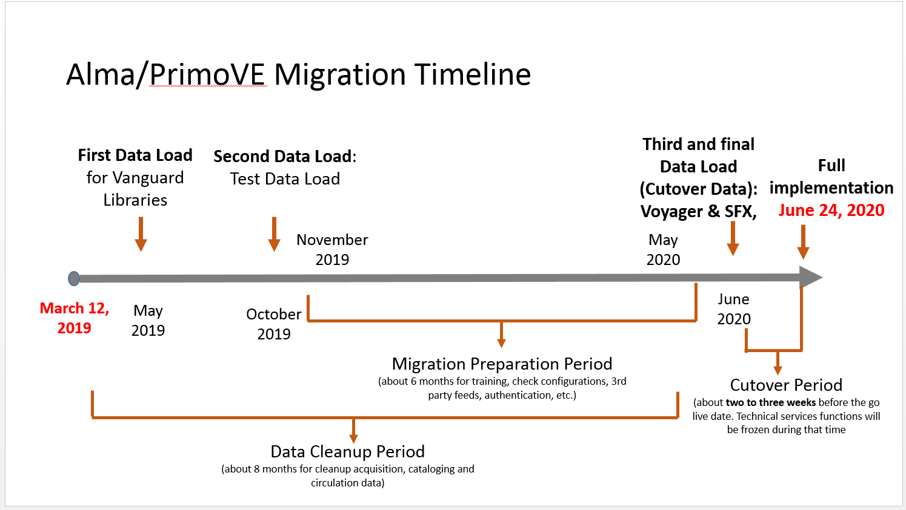
Here is an image of the overall Alma/Primo Migration Timeline:

And, here is a more detailed timeline that the ILS Coordination Team is currently working on with the CARLI Office to meet expected deadlines for the extract of Library data to migrate over to Alma over the next several months.
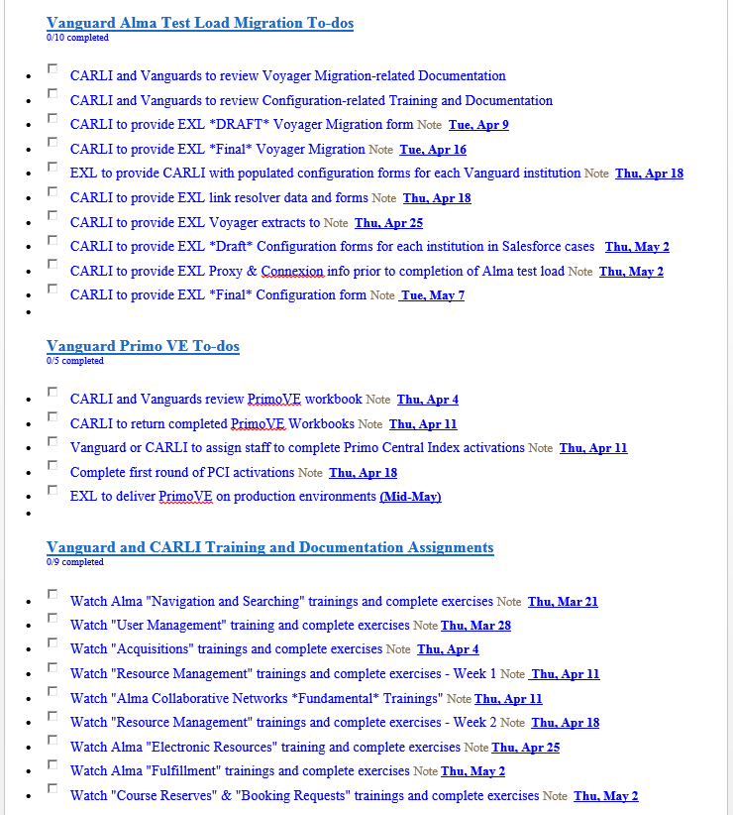
Current Programs and Services Dependent on Voyager or Voyager Data
We are investigating all instances where Voyager or Voyager Data is involved in current Library programs, scripts, or services. Tracy Tolliver in Library IT has set up a running list of instances that involve Voyager. We will be sending out an email to LIBNEWS soon to inquire of all in the Library of any occurrences that are not accounted for in these preliminary lists. That call out to the Library should occur middle of April 2019.

Web page for the progress of the Alma/Primo implementation
We will have a web page that shows the progress of the Alma and Primo implementations through the various test stages of the project and preparing for the Go-Live roll out in Summer 2020. The new web page will be accessible by the end of April 2019.

Meeting adjourned at 3:10 p.m.

