MPAL A/D Station Manual
Fall 2025

Table of Contents
Welcome 3
Policies 3
Equipment Diagrams 4
Set-Up 7
Playback and Digitization 16
Cassette Tape Player 16
Turntable Record Player 23
Post-digitization 34
Frequently Asked Questions 42

Welcome
Welcome to the MPAL Analog-to-Digital station. The equipment in this station enables patrons to create digital copies of records and cassette tapes. This manual guides users through the digitization process. First, users will prepare equipment. Second, users will play and digitize media. Third and finally, users will review and save the digital copy.

Policies
- Please read the manual before handling media and equipment.
- Please only touch the buttons and controls designated in green. Do not adjust equipment or equipment components that are not included in this manual.
- If media or equipment begins to malfunction or show signs of damage, please stop and alert MPAL staff.
- Food and drink are not allowed in the room as they can damage the equipment and the materials being digitized.
- The user must remain with the station during the entirety of the conversion process. Do not leave the room while equipment is running.
- It is the user's responsibility to save their work on an external memory source (cloud storage, flash drive, etc.).
- The individual who booked the appointment is responsible for any damage or misuse of equipment, even if a group is working on a project together. The Library is not responsible for damage to personal property used in the room.
- The Analog-to-Digital Station equipment is to only be used for personal purposes; commercial use is not allowed.

Equipment Diagrams
Digitization Station Diagram
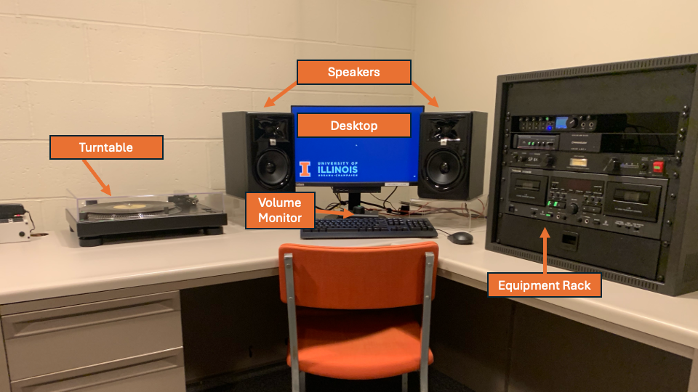
Equipment Rack Diagram (See FAQ for more information)
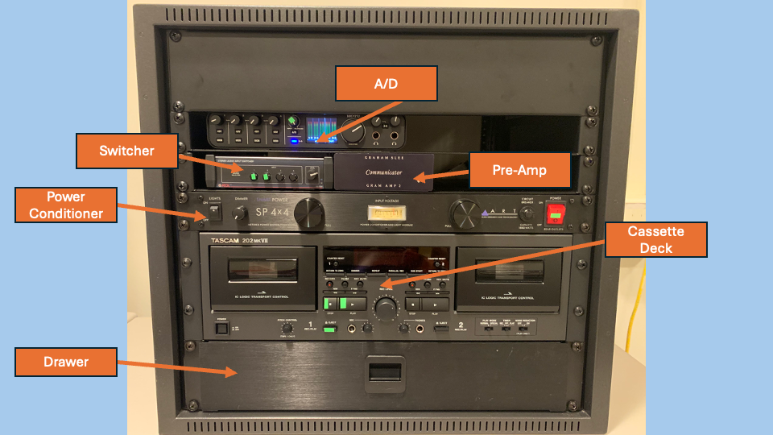
Cassette Player Diagram
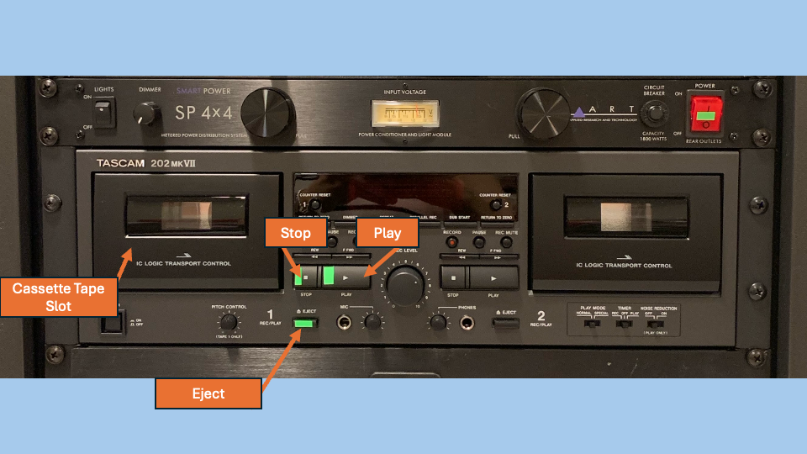
Turntable Diagram
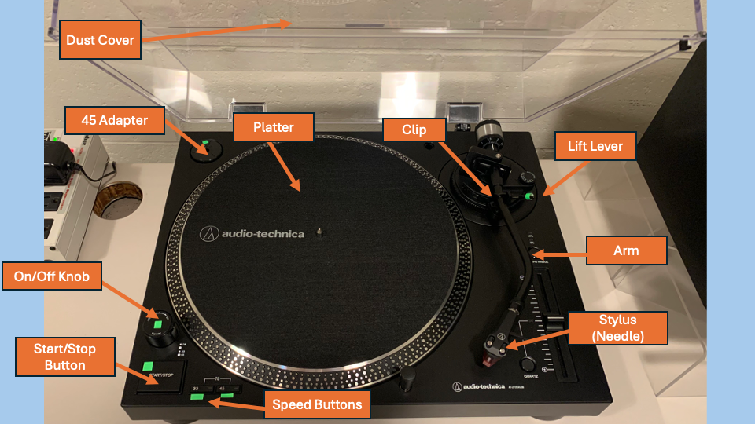

Audacity Diagram
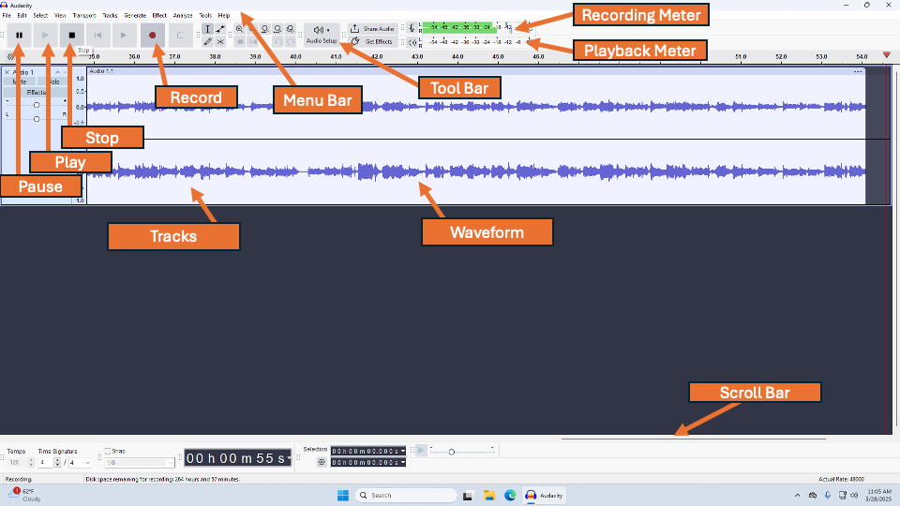
What do the various rack equipment do?
- The Power Conditioner ensures that the electricity powering the equipment remains clean and consistent. It also protects the equipment from surges and damage.
- The Switcher switches audio inputs, allowing the digitization station to alter between the Turntable and the Cassette Deck.
- The Pre-Amp takes the mechanical audio signal from the Turntable and strengthens it, making it louder.
- The A/D (Analog-to-Digital) Converter converts the audio from the Cassette Deck and Turntable from an analog signal to a digital signal. It does the digitization!

Set-Up
- Turn on the rack on the right side of the computer by selecting the on/off switch on the Power Conditioner. This will automatically turn on the various rack equipment including the Cassette Deck.
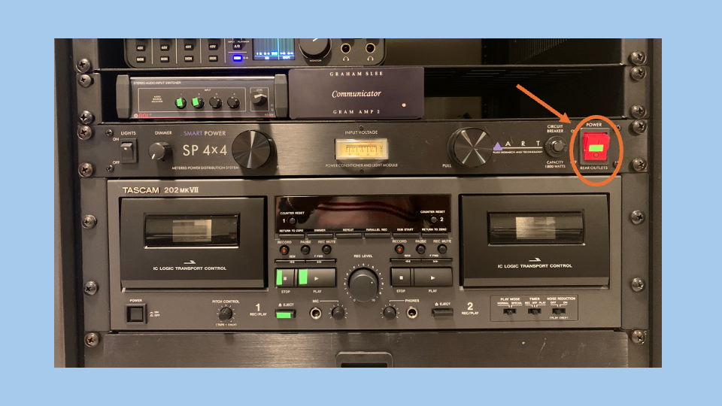

- On the Switcher, push the button labelled “1” if you will be digitizing a cassette tape. Push the button labelled “2” if you will be digitizing a record.
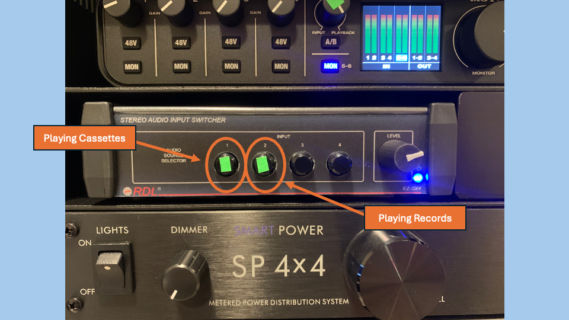

- On the A/D, ensure that the knob in green is turned towards “input.”
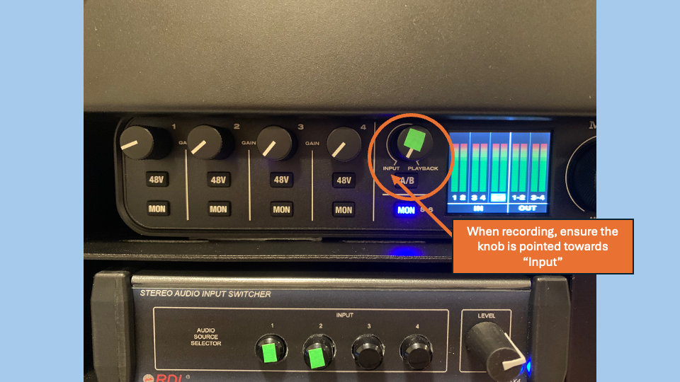

- If you will be digitizing a record, turn on the turntable by twisting the knob in the lower left corner to “on.”
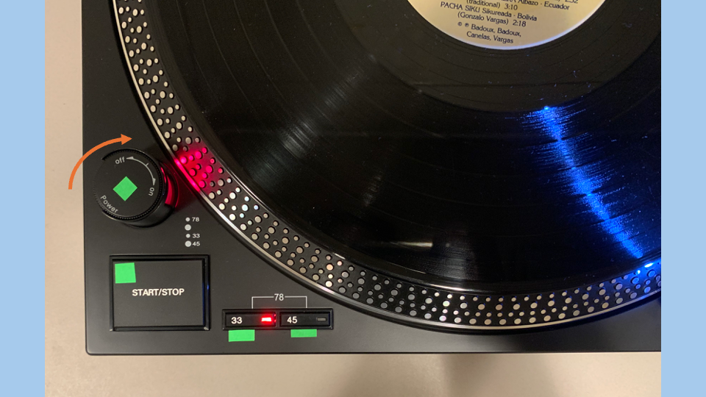

- Log into the computer using your Net ID and password.
- A “Motu M Series” window will appear. Confirm the “Sampling Rate” is set to 48,000 and the “Buffer Size” is set to 256.
- Check the volume monitor in front of the keyboard. Confirm the knob is not set all the way to the left. Confirm “Mute” is not selected.

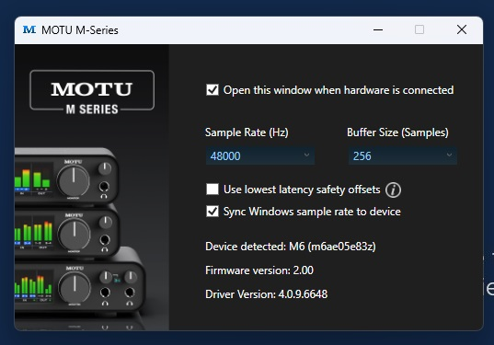

- Open Audacity by typing “Audacity” into the search bar on the bottom of the home screen.
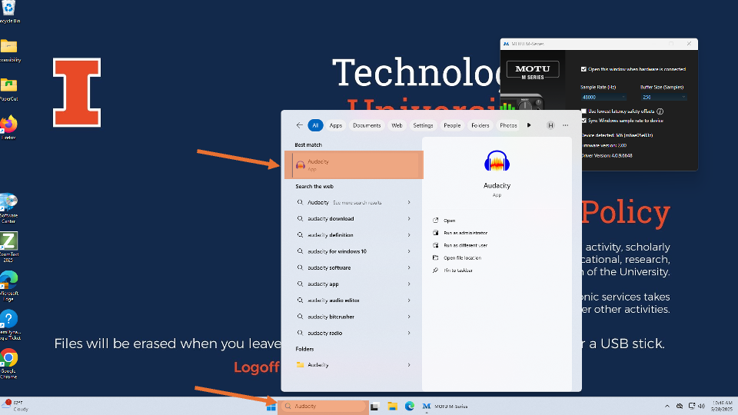

- Add stereo tracks. Select “Tracks” in the top left menu bar. Click “Add New” and then select “Stereo Track.”
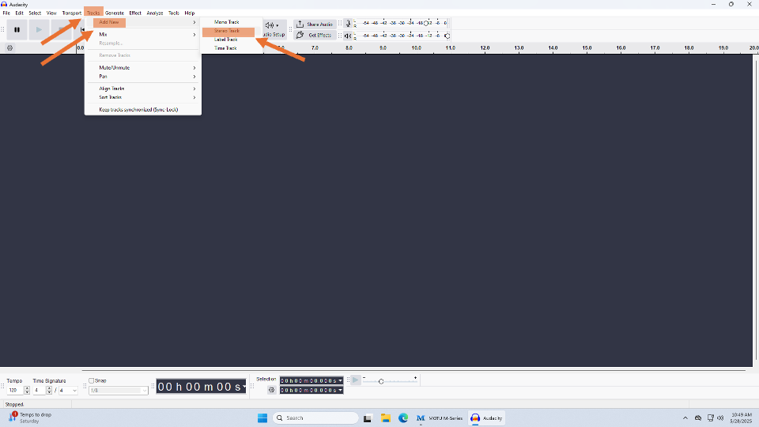

- Confirm the audio settings. Click on “Audio Setup” on the top tool bar. Click “Audio Settings.” A window will open. Confirm the following fields and select “Ok.”
- Playback—Device: Out 1-2 (MOTU M Series)
- Recording—Device: In 5-6 (MOTU M Series)
- Recording—Channels: 2 (Stereo)
- Quality—Project Sample Rate: 48000 Hz
- Quality—Default Sample Rate: 48000 Hz
- Quality—Default Sample Format: 32-bit float
- Latency—Buffer length: 256
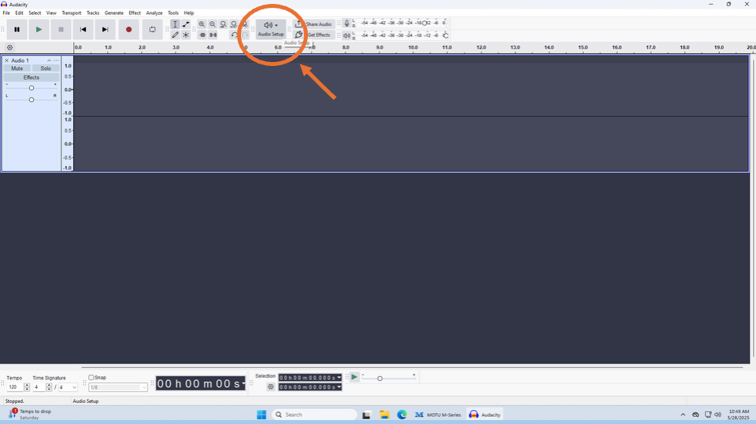
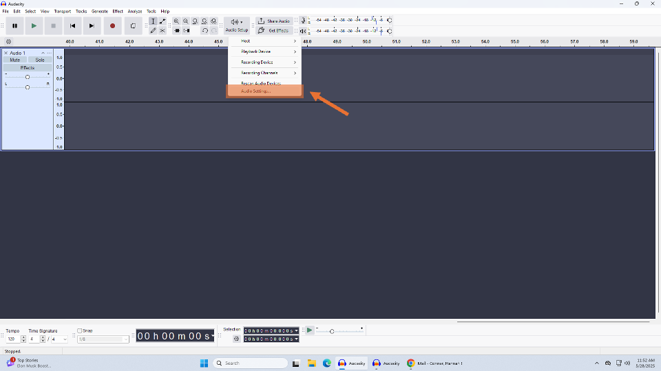
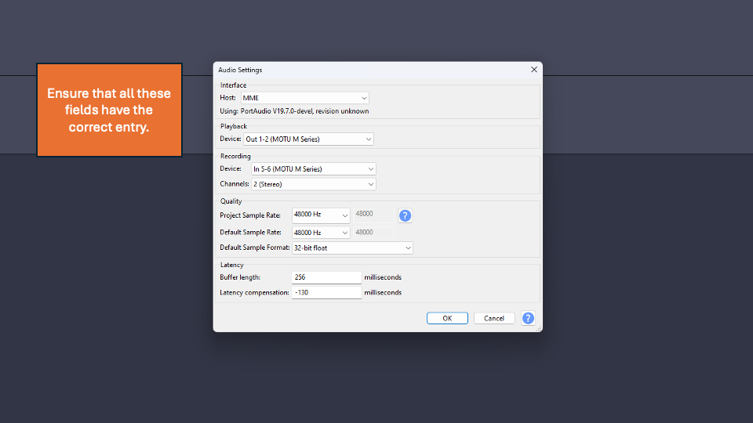

Playback and Digitization

Cassette Tape Player
- Locate the side of the cassette tape you wish to play. Most cassette tapes have two sides, each containing different tracks. The first side may be labelled “A” or “1.” The second side may be labelled “B” or “2.” Face the desired side towards you with the pressure pad facing down.
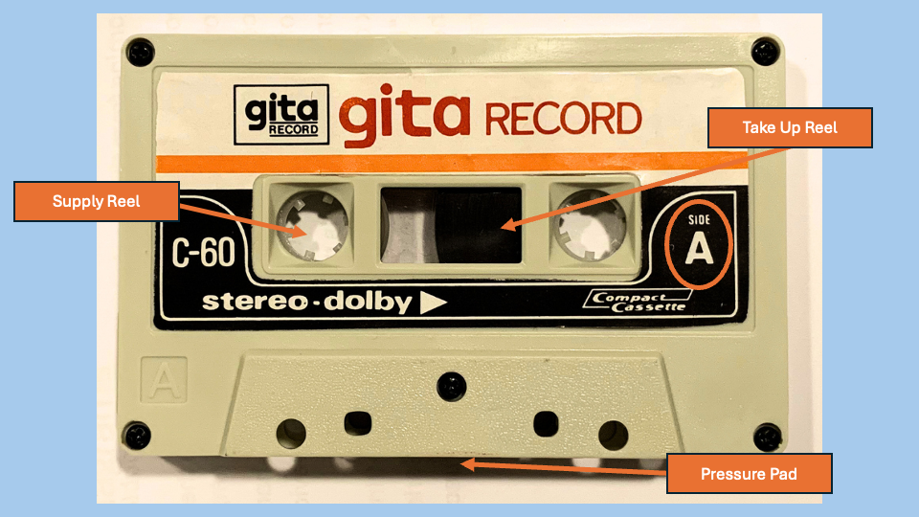
- Ensure the tape is fully wound around the left-side reel.

- Select the eject button on the cassette tape player. Insert the cassette into the opened slot with the desired side facing you and the pressure pad facing down. Close the slot by pushing it in with your hand. The cassette tape is now ready for playback and digitization.
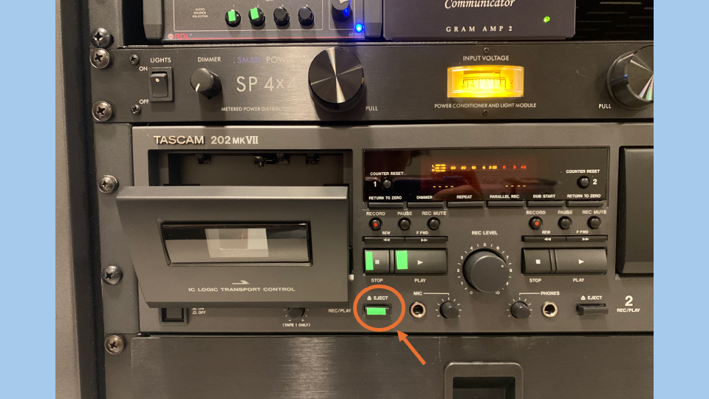
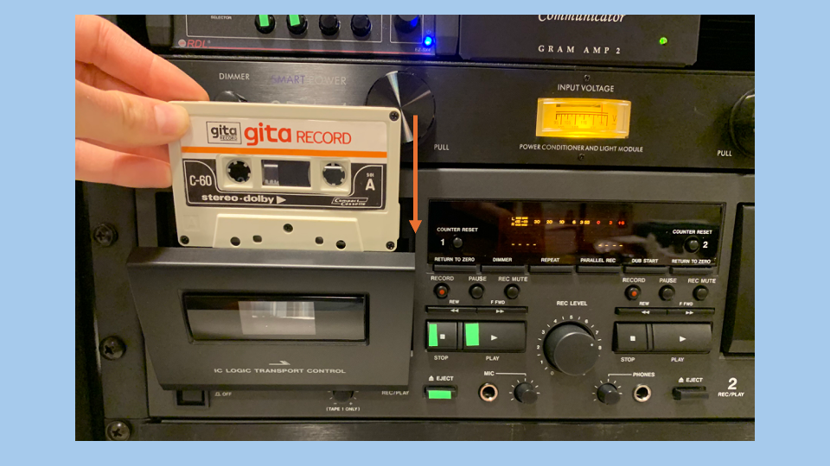

- Select the red record button on Audacity.
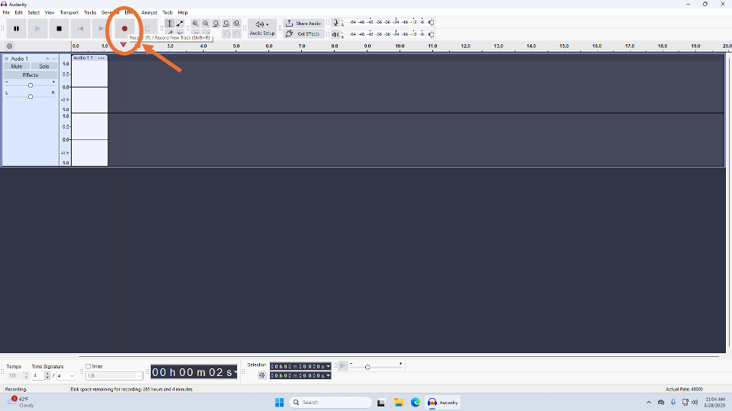

- Push the play button on the cassette tape player. Sound will begin to play from the speakers and waveforms will appear on Audacity. Volume and waveforms may be low; gains can be adjusted post-digitization.
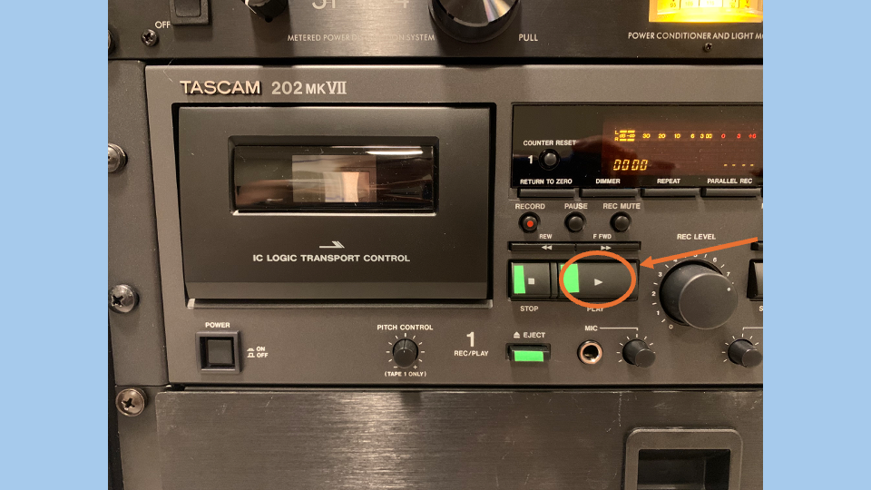
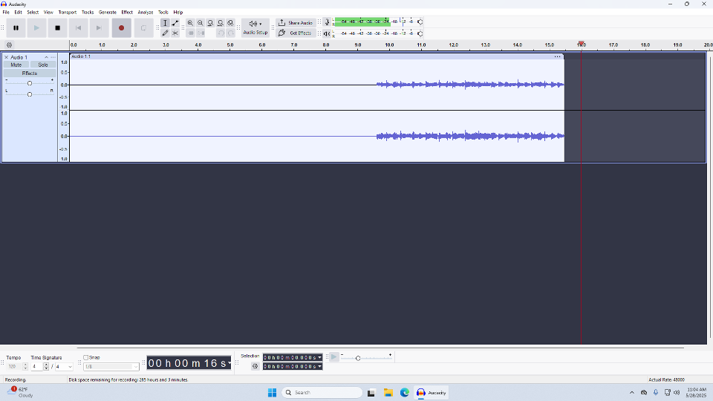

- When you are finished or when the cassette has stopped playing, click the black stop button on Audacity to cease the recording. See the Post-digitization section to learn how to export your file.
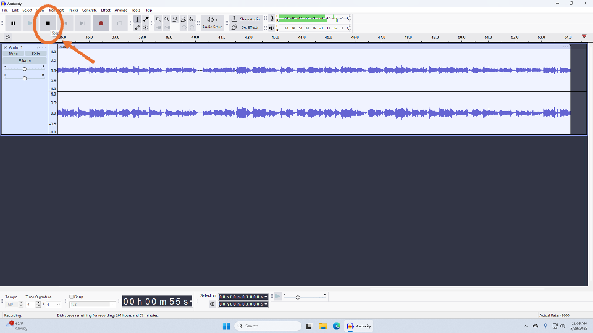

- Hit the stop button. If you do not wish to play the next side, select “Rew” and rewind the tape back to the start. Then hit the eject button on the cassette tape player and remove the cassette tape.
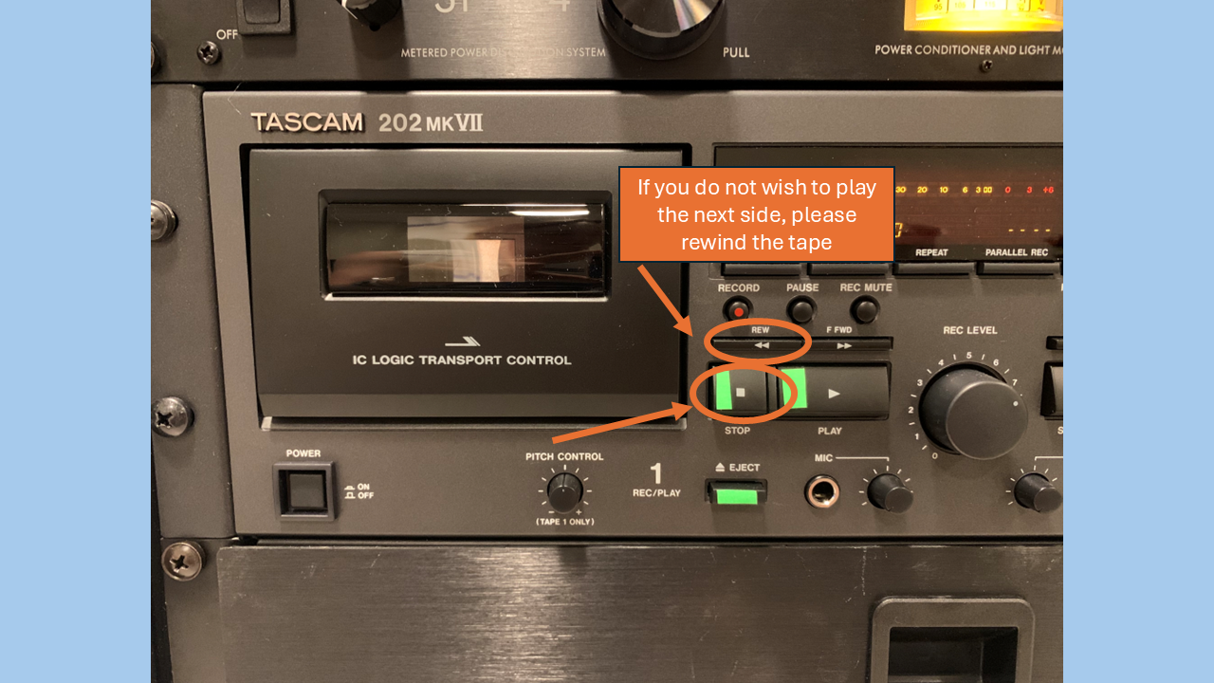

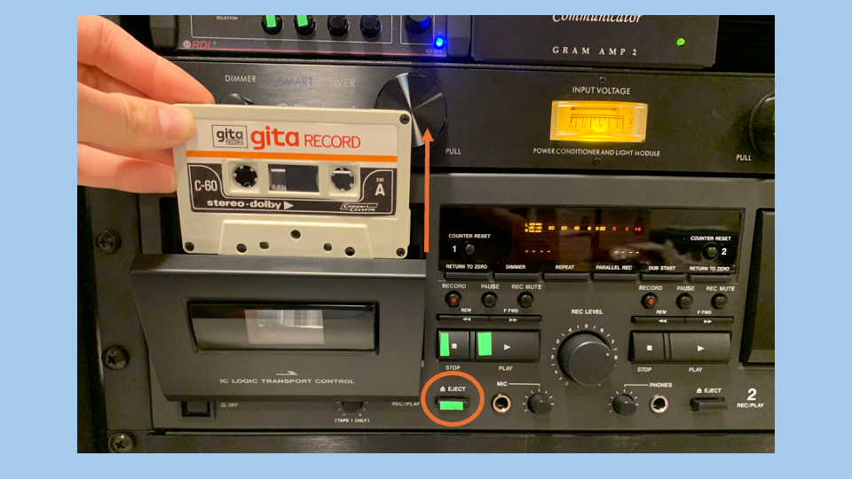

- To play the other side of the cassette tape, hit the eject button on the cassette tape player and remove the cassette tape. Flip the cassette tape and reinsert it into the cassette tape player.
- On Audacity, select “File—New Project” and repeat Set-up steps 8-9 and Cassette Digitization steps 1-7. See the Post-digitization section to learn how to export your file.
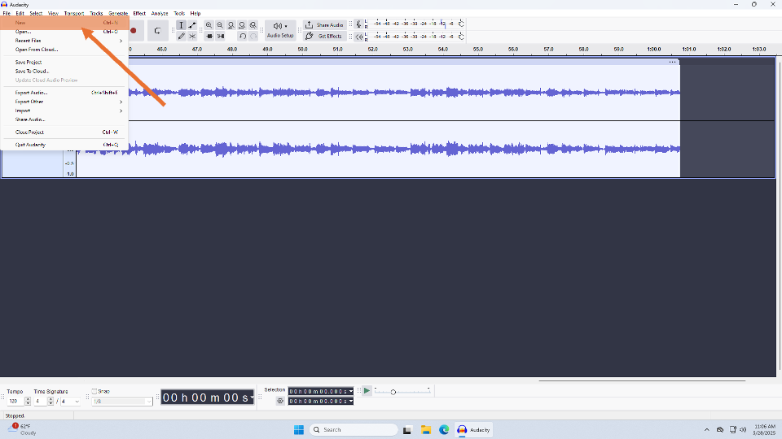

Turntable Record Player
- Identify the type of record you hope to play and its playback speed.
- LP: A 12in vinyl (lighter, plastic) disc that plays at 33 ^{1/3} rpm.
- 45: A 7in vinyl (lighter, plastic) disc that plays at 45 rpm.
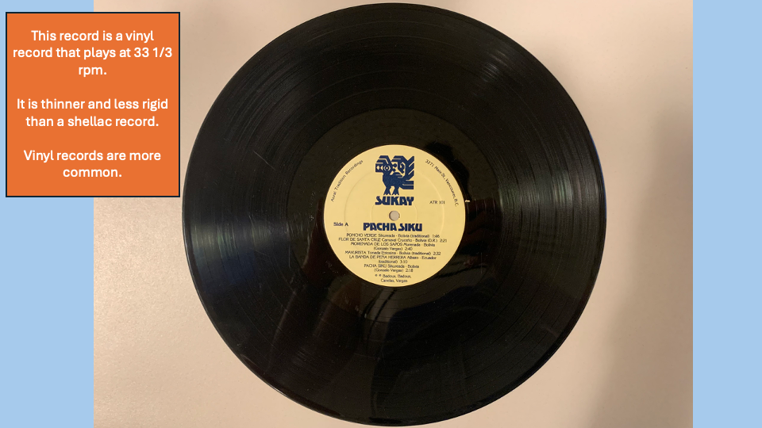
- Remove the record from its sleeve. Place your hands on the outer edge of the record and attempt to avoid touching the grooved surface.
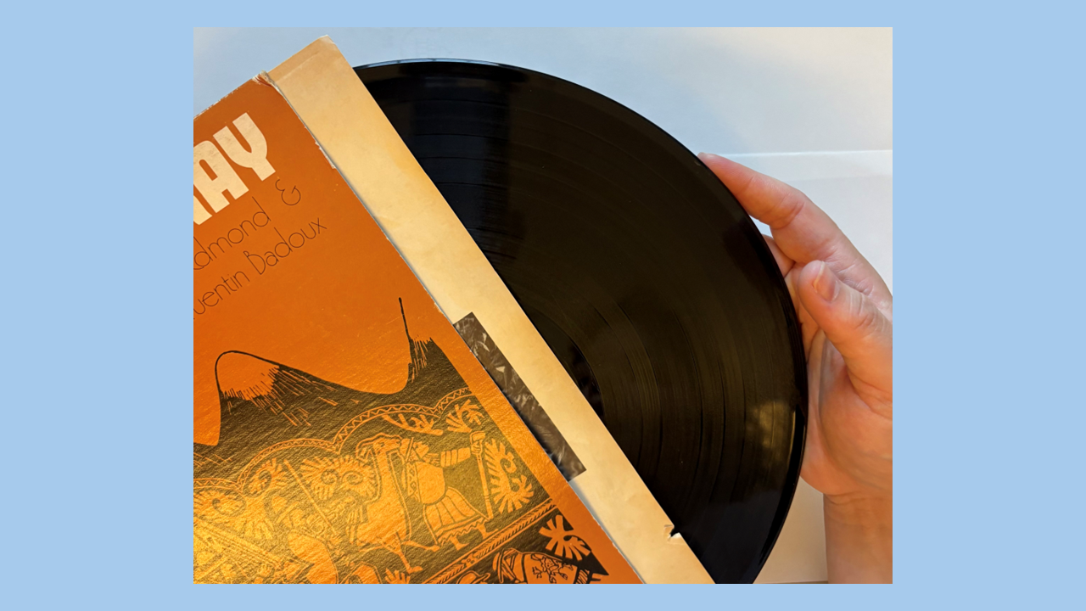
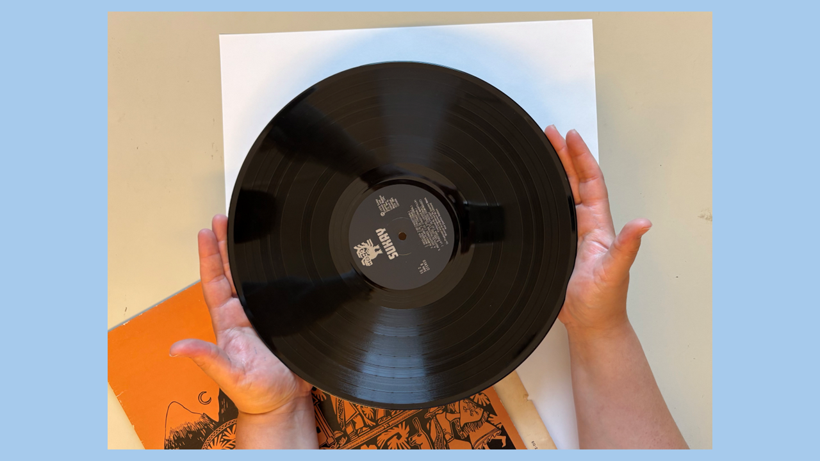

  - Locate the side of the record you wish to play. The first side may be labelled “A.” The second side may be labelled “B.”
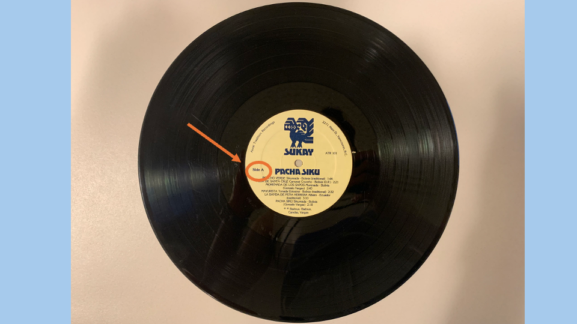

- Place the record on the turntable with the side you wish to play facing up.
If you are playing a 45, place the adapter located on the left side of the turntable around the central spindle. Then place down your 45.
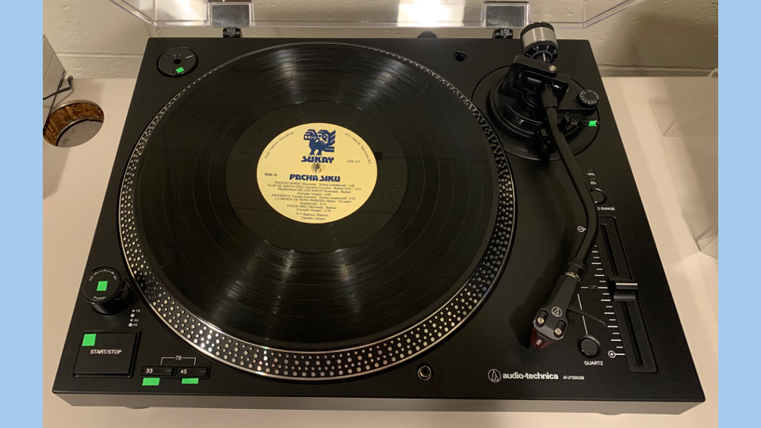
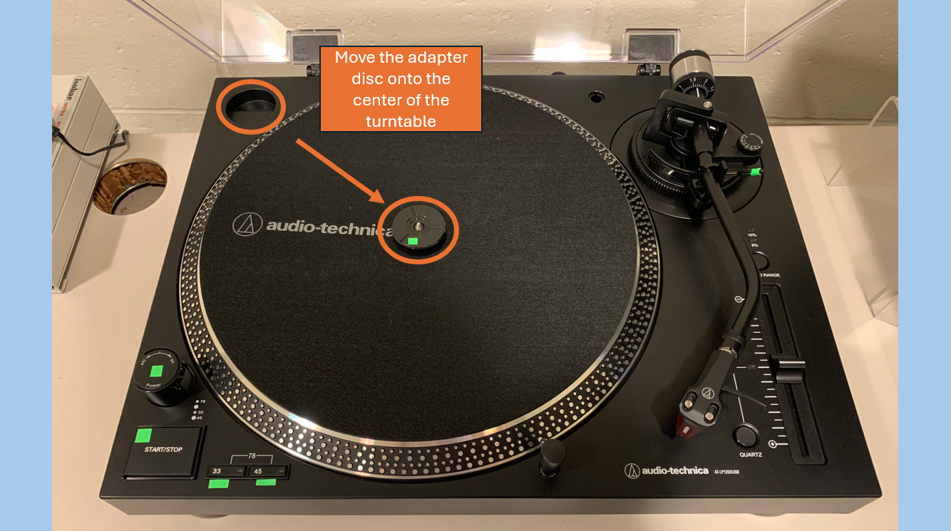

- Select the appropriate speed by hitting the respective button on the lower left side of the turntable. If you are playing a 78, hit both buttons at the same time.
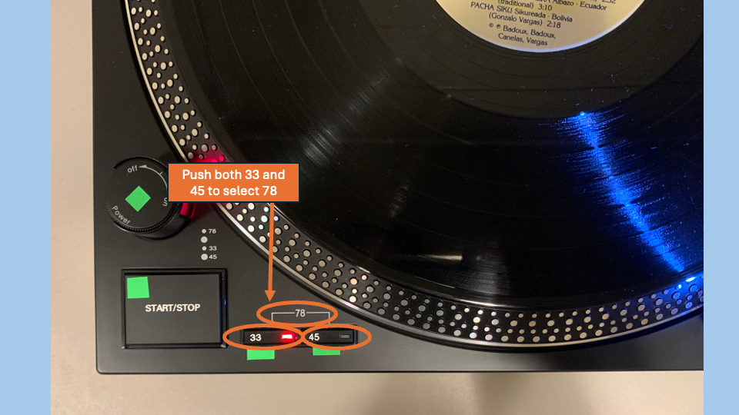

- Select the “start/stop” button on turntable.
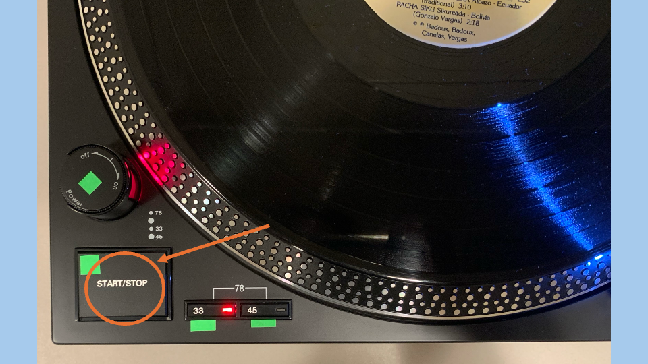
- Select the red record button on Audacity.

- Undo the clip holding the turntable’s arm
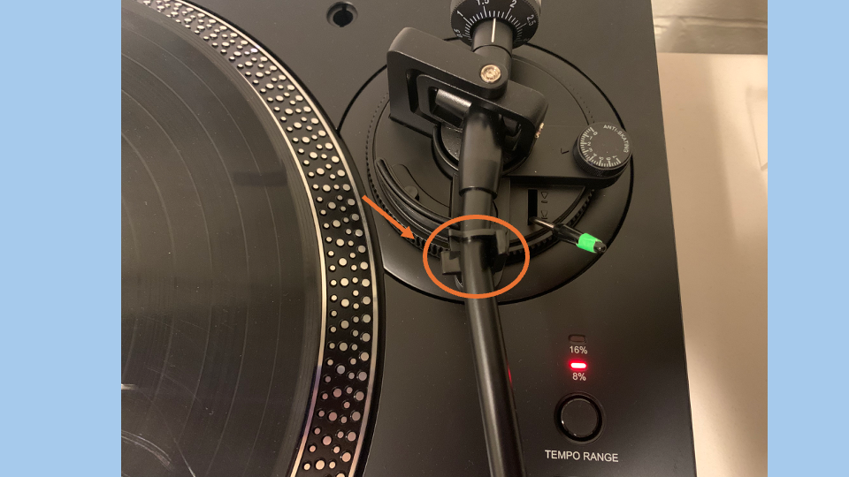
- Raise the lever on the right side of the arm’s base (please do not manually lift the arm). This will raise the arm.
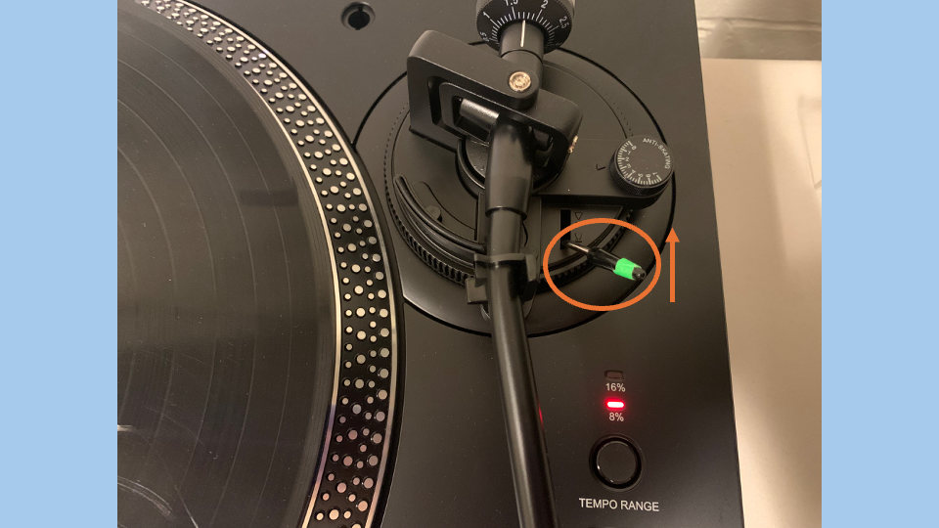

- Using the limb on the right side of the arm, move the arm so that it hovers above the edge of the record.
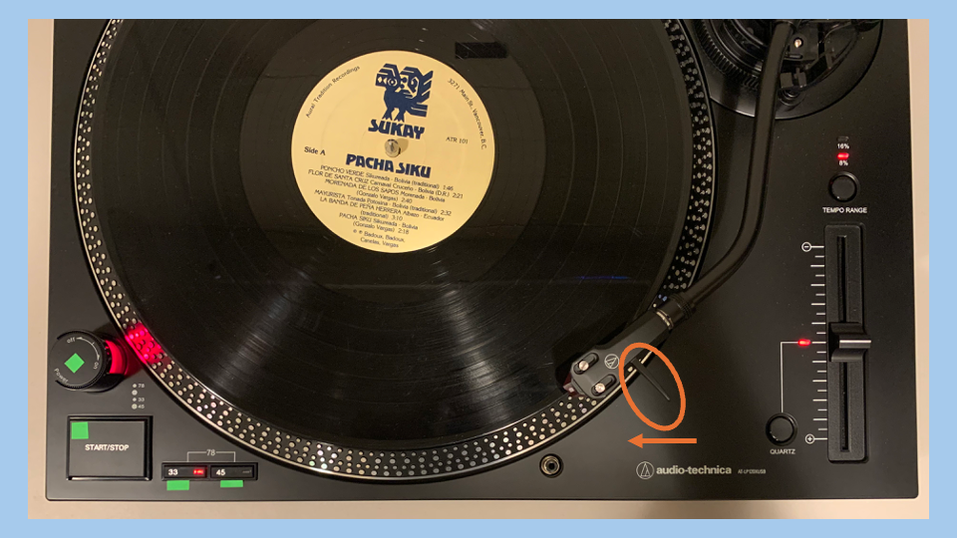

- Lower the lever on the right side of the arm’s base. This will lower the stylus to the record. Sound will begin to play from the speakers and waveforms will appear on Audacity.
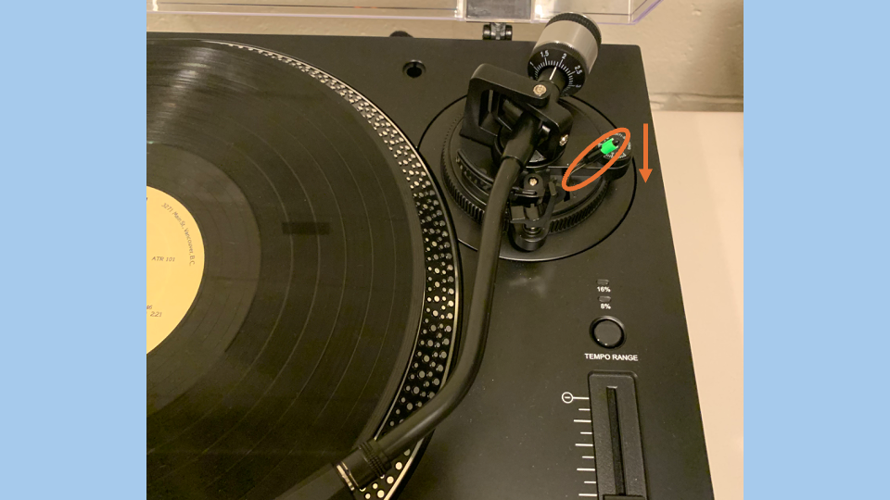

- When you are finished or the record has stopped playing, click the black stop button on Audacity to cease the recording. See the Post-digitization section to learn how to export your file.
- Hit the “start/stop” button on the turntable to stop the turntable.

- If you would like to play the other side of the record, lift the lever on the right side of the arm’s base. The arm will then begin to hover. Move the arm to the side. Flip the record and place it on the turntable so that the side you have just played is now facing the turntable.
  - On Audacity, select “File—New Project” and repeat Set-up steps 7-8 and Turntable Digitization steps 1-9.
- When you are finished, return the arm to its hold: Lift the lever on the right side of the arm’s base. The arm will then begin to hover above the record. Return the arm to its support. Lower the lever to then lower the arm. Close the clip around the arm.
- Remove the record from the turntable and return it to its sleeve. Again, attempt to avoid touching the grooved surface.
  - If applicable, return the adapter to its hold on the left side of the turntable.
- Turn off the turntable by twisting the on/off knob
- Place the dust cover back onto the turntable.

Post-digitization
- On the A/D, turn the green knob all the way from “Input” to “Playback.”
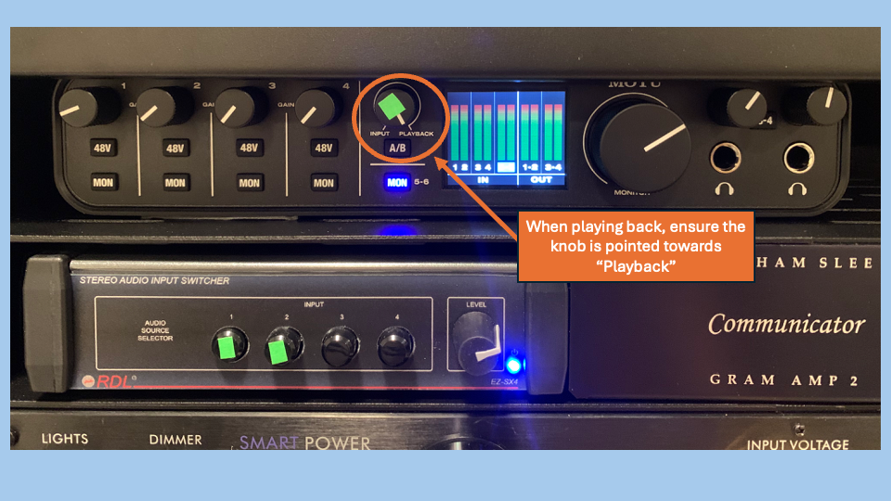

- On Audacity, move the cursor to the beginning of the recording. Select play to listen through the recording. To adjust the speakers’ volume, twist the knob on the Volume Monitor in front of the computer’s keyboard.
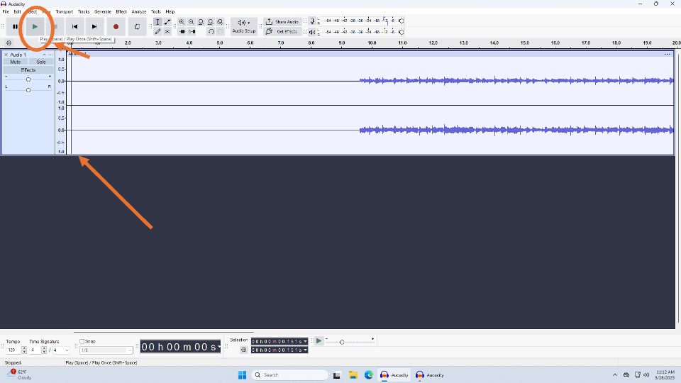

- Confirm that the gain level of the recording hovers between -12 and -6 dB by viewing the meter in the upper right of the screen. Gain measures the loudness of the recording itself regardless of the speaker or computer volume.
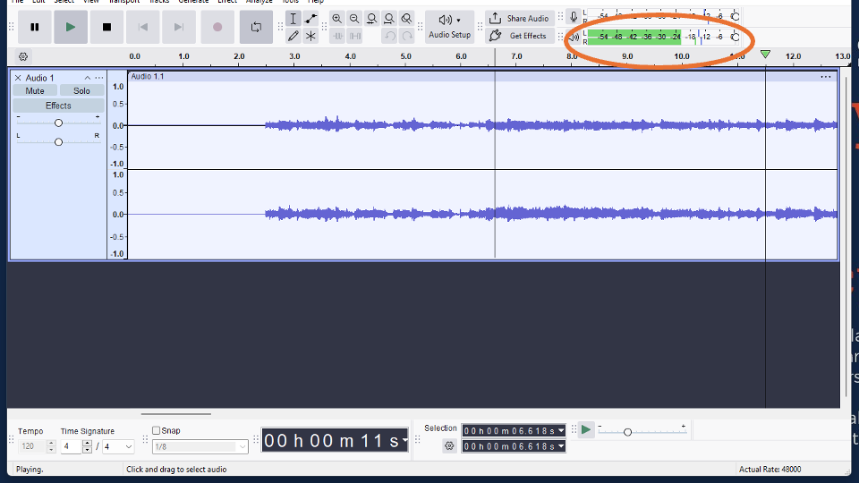
  - To adjust the gain, click on “Select” in the upper left menu bar. Click on “All.” This will select the entire recording.
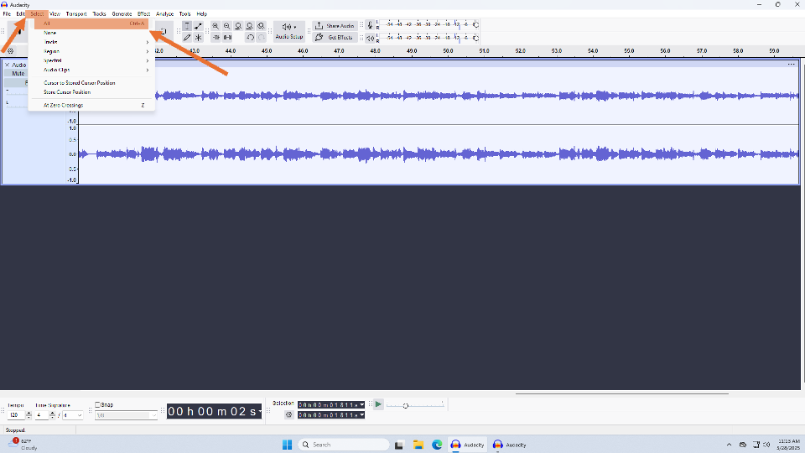
  - Then click on “Effect” in the menu bar. Hover the mouse over “Volume and Compression.” Click “Amplify…” A small window will open.
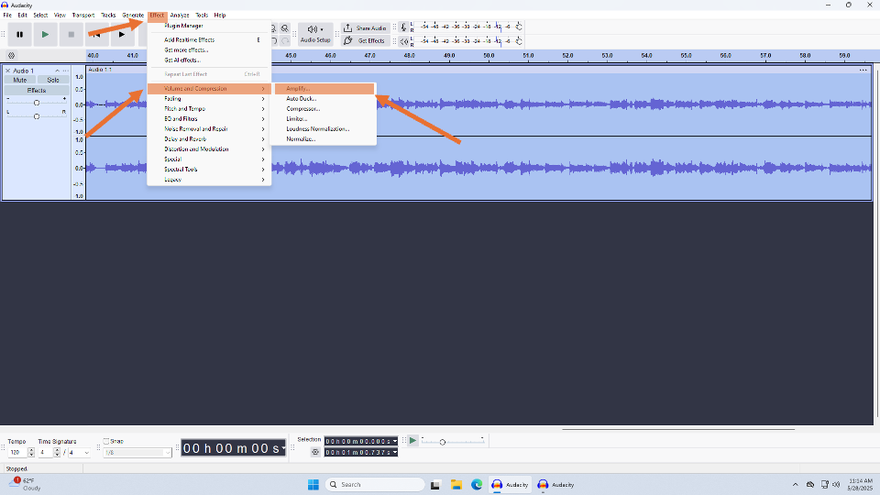
  - Set the “New Peak Amplitude (dB)” to -6 dB.
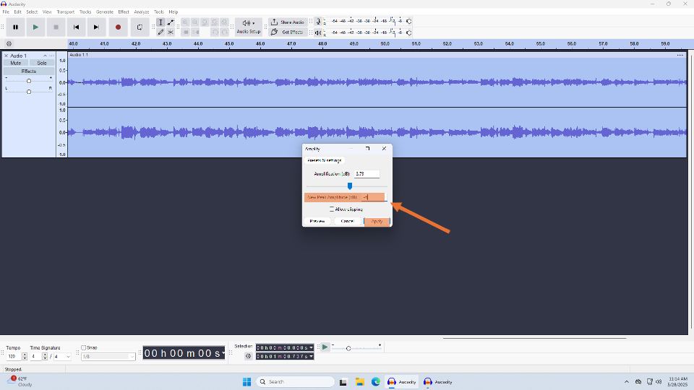

- Once you are content with the audio, you may export your file. Note that clicking “Save” will save your project within Audacity. To save your file outside of Audacity, you will need to export it.
  - Click “File” on the menu bar.
  - Select “Export Audio.”
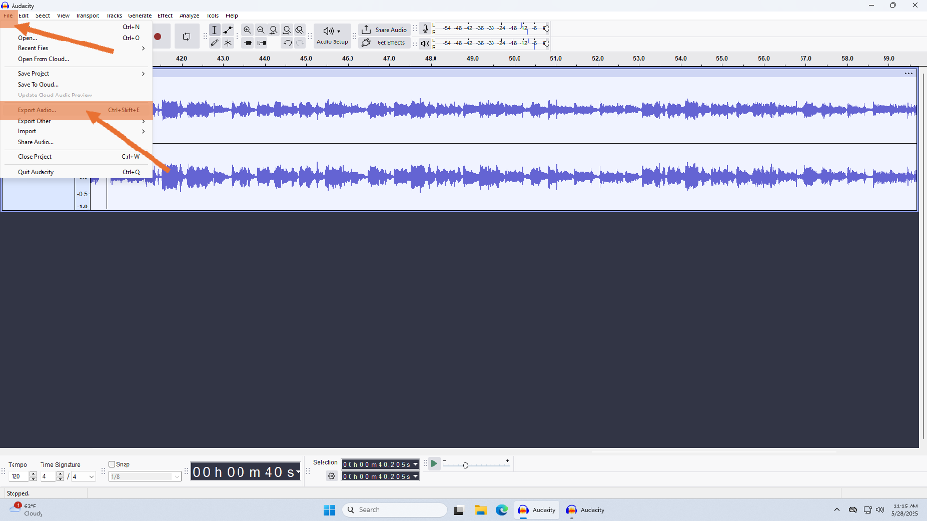
  - Select “Export to Computer.”
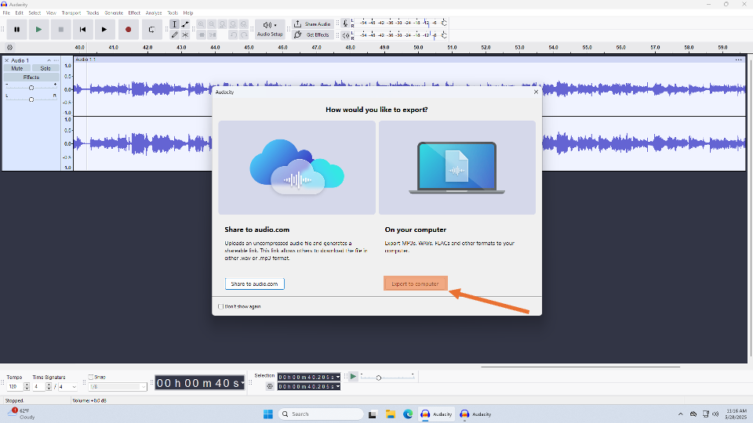
  - Enter your desired file name.
  - Set your destination as Desktop.
  - Select mp3 as the file type.
  - Ensure…
    - The sample rate is 48000 Hz.
    - Bit Mode Rate is Variable.
    - Quality is 170-210 kbps.
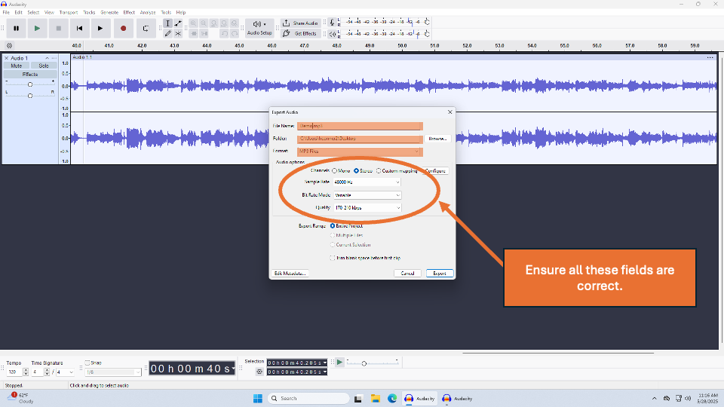

  - Click on “Export.”
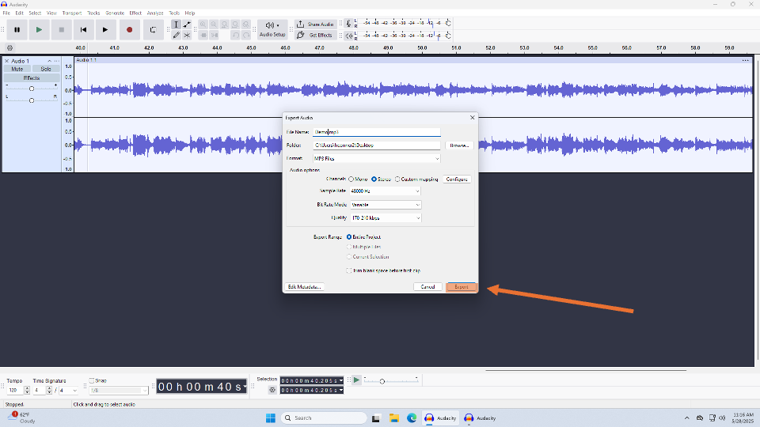
- Upload your file to your desired storage (Google Drive, Box, a thumbdrive).
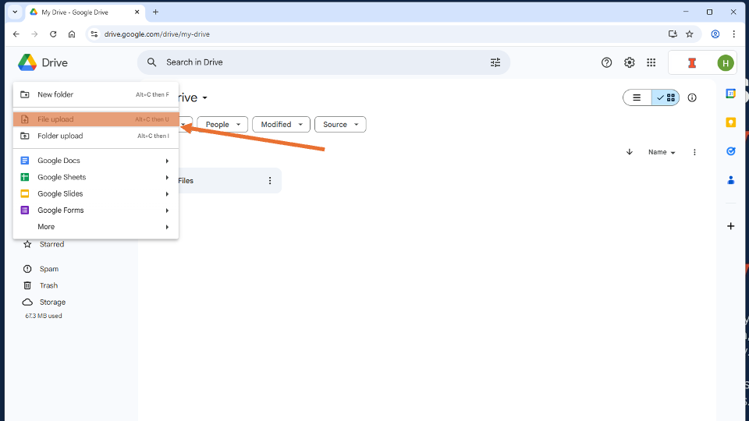

- Confirm your file has been successfully uploaded.
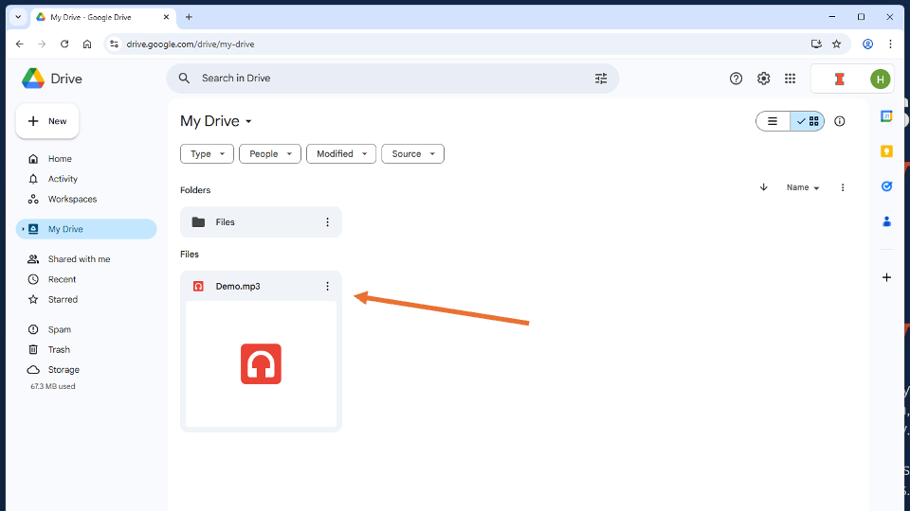
- Delete your file from the desktop.
- Close all applications and log out.
- Turn off the rack by selecting the on/off switch on the Power Conditioner.

Frequently Asked Questions
Audacity is not recording any sound. How can I troubleshoot?
- Confirm…
  - The Switcher is set to correct input. “1” for cassettes and “2” for records.
  - The knob on the A/D is set to “Input.”
  - The input on Audacity is set to “In 5-6 (MOTU M Series).”
  - The audio settings on Audacity are set correctly (see Set-Up section).
I’m having trouble using Audacity. Where can I learn more?
- Audacity offers an in-depth manual online. In your browser, search “Audacity Reference Manual” or visit https://manual.audacityteam.org/index.html. The Audacity’s Frequently Asked Questions page is useful as well.
I want to delete a segment from the recording. How can I do that?
- Using your cursor, click on the beginning of the section you would like to delete. Click, hold, and drag your cursor to select the desired segment. Press “delete” or backspace on your keyboard.
- To learn more basic editing on Audacity, visit https://support.audacityteam.org/basics/audacity-editing.
I’m not hearing any sound coming from the speakers. How can I troubleshoot?
- Check the volume monitor in front of the keyboard. Confirm the knob is not set all the way to the left. Confirm “Mute” is not selected.
- On the computer, access the audio settings in the lower left-hand corner. Click on the audio controls (the speaker icon). Under “Output Device,” select “Out 1-2 (MOTU M Series).” Confirm the volume is not muted.
- On Audacity, click on “Audio Setup” and select “Audio Settings.” Confirm playback is set to “Playback—Device: Out 1-2 (MOTU M Series).”
- On the A/D, confirm the green knob is set all the way to “Playback.”
The record I am playing keeps skipping. How can I troubleshoot?
- If the stylus begins to significantly skip or jump out of the groove, you pause the turntable button as the stylus approaches the scratch by selecting the “Start/Stop” button. Using the lever, lift the turntable’s arm and place it on the other side of the scratch. Lower the arm via the lever and select play by hitting the “Start/Stop” button once more. Once you have finished recording, you may delete the interruption in Audacity.
- The record may be too scratched to play on this turntable. Please inform MPAL staff if it is a library item. Please do not adjust any equipment components that are not designated in green.
My record or cassette doesn’t sound right. How can I troubleshoot?
- Confirm the audio settings on Audacity are set correctly (see Set-Up section).
- The media or equipment may need to be cleaned or otherwise adjusted. Please inform MPAL staff. Please do not adjust any equipment components that are not designated in green.
I’m having trouble figuring out what type of record I have. Where can I learn more?
- In your browser, search “Preservation Self-Assessment Program.” Click “Skip to Collection ID Guide” and then select “Phonographic Record.” Read through the guide to identify your record.

