University Library 5Y Dossier Review Process

Background
During the Spring of a candidate’s 5Y year, the candidate submits a dossier to be reviewed by the Faculty Review Committee following the dates in the Library Master Calendar For Annual Review, Peer Review, Promotion & Tenure: https://www.library.illinois.edu/staff/promotion-tenure-and-annual-review-related-calendar/

The spring review is an initial review, and the outcome of the review provides advice and feedback to the candidate and his or her paper preparers before preparing and submitting the final dossier. The final dossier is typically due in late August/early September (see the Master Calendar for exact dates).

This document discusses the submission process for the initial review by FRC, as well as describing some of the preparatory steps as the candidate and Paper Preparers work on the actual promotion and tenure papers that are submitted in August.

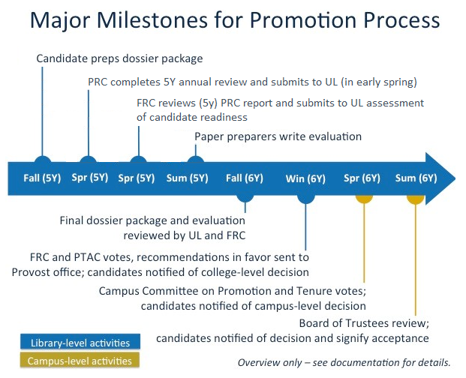

Initial Dossier Review

Timeline
See the Promotion and Tenure Master Calendar for all dates and the order of 5Y review: https://www.library.illinois.edu/staff/promotion-tenure-and-annual-review-related-calendar/

Candidate Responsibilities
- Consult with your PRC, Unit, Division, PTAC, and other mentors during all steps of this process to help make the most informed choices about your case.
- Update your Dossier, following the guidelines and using the template at: https://www.library.illinois.edu/staff/dossier-guidelines-for-library-faculty/ and Provost Communication 9: https://provost.illinois.edu/policies/provosts-communications/communication-9-promotion-and-tenure/
- It is strongly recommended that you ask your PRC or other tenured mentors in the Library to review your Dossier prior to submitting it.
- Review the criteria for qualified reviewers at the link below. Note that all reviewers must be Associate Professor (or equivalent) rank or higher, and preferably at a peer institution: https://www.library.illinois.edu/staff/procedures-for-peer-review-committees-for-nontenured-tenure-track-library-faculty/
- Provide a list of four internal and five external reviewers with biographies to your PRC and Division Chair prior to the date indicated on the Master Calendar (first Monday in November of the 5Y year).
- Work with your PRC to select at least three accepted (or in print) publications for external reviewers to assess, prior to the date indicated on the Master Calendar for the University Librarian’s office to send to the reviewers. See criteria below.
- Your “Statement of Research Goals and Accomplishments” will be sent to external reviewers in March, along with a copy of your CV. Make sure both are updated, polished in format and grammar, and that your Research Statement clearly articulates the impact of your publications and research findings on the field.
- Submit your dossier punctually according to the dates on the Promotion and Tenure Master Calendar.

Suggested Criteria for Publications sent to External Reviewers
- Selected publications should represent your highest quality work
- Selected publications should provide examples of your unique, original, innovative, and/or other substantive contributions to your chosen field of research
- Selected publications should come from sources that carry high prestige in the field
- At least one publication must be written since joining the UIUC faculty, with a strong preference towards all meeting this criterion.
- See additional guidelines for research located in the Statement on Promotion and Tenure to the Library Faculty at UIUC: https://www.library.illinois.edu/staff/wp-content/uploads/sites/24/2017/11/Statement_on_Promotion_and_Tenure_to_the_Library_Faculty_at_UIUC.doc

Division Responsibilities
- Review the candidate’s list of internal and external reviewers
- Prepare the Division’s list of three internal and five external reviewers (with positions and rank for internal reviewers, and full biographies for external reviewers)
- Submit the Division and Candidate lists of reviewers to the University Librarian’s office

PRC Responsibilities
- Write the dossier review for the initial Spring review of the candidate; paper preparers will be provided a copy of this for use in writing the final dossier
- Interview internal reviewers who agree to provide evaluative feedback; these may be the same as the official names the candidate and division are selecting for the final review, or different. Typically 2-3 individuals (maximum) are interviewed
- Write the evaluative sections of the candidate’s Dossier
- Internal reviewer quotes should not include individually identifiable information
- Evaluations should assess the quality and impact of the candidate’s work across the entirety of progress to date; statements should not be just a summary of activities.
- The PRC report at 5Y should include useful information for the paper preparers who will take over the case after this initial review; do not skimp on details
- Submit the Dossier, including the above evaluations and Cover Sheet, directly to the University Librarian’s office
- Meet with the candidate and discuss the completed Dossier
- Sign the signature page (with the candidate) at the meeting
- Submit the Dossier, including the above evaluations, Cover Sheet, and Signature Page, directly to the University Librarian’s office

FRC Responsibilities
- Review all 5Y Dossiers
- Discuss each case and come to a summary evaluative opinion on progress towards tenure
- Write a 5Y Report Letter to the PRC (cc’d to the Candidate) about the quality of the Dossier

University Librarian’s Office Responsibilities
- Receive Candidate and Division lists of internal and external reviewers and contact information
- Consult with the Library Executive Committee to select final names, per the guidelines in Provost Communication No. 9
- Contact the final list of internal and external reviewers to determine their willingness to provide feedback
- Send each external reviewer:
  - official request letter and explanation of process;
  - representative candidate’s publications;
  - Research Statement;
  - CV.
- Send each internal reviewer:
  - official request letter,
  - Candidate’s CV
- Forward letters from evaluators to the Paper Preparers

For the initial dossier review:
- Receive and file completed dossiers from PRCs
- The University Librarian reviews and signs the signature page for each candidate
- From FRC, the University Librarian receives the FRC 5Y Report Letter to the PRC

Final Dossier Review
The following is an outline of some of the key groups and their responsibilities during the final paper preparation and review stages, which commences after the yearly annual review process (see Master Calendar for exact dates). During this stage of the process, the candidate continues to refine their dossier content, format, and statements, with feedback from the Paper Preparers and Faculty Editor.

Candidates should consult Communication 9 for information from campus on the process. The final Library evaluation of promotion and tenure cases is described here:
https://www.library.illinois.edu/staff/wp-content/uploads/sites/24/2017/12/5Y_PRC_Review_Process.docx

Candidate Responsibilities
- Ensuring that the dossier, CV, and personal statements are of a quality that best represents the candidate’s promotion case.
- Continue to update the dossier, including the Librarianship, Research, and Service statements, based on feedback from the Paper Preparers and Faculty Editor(s)
- Meet all deadlines specified in the Master Calendar

Paper Preparer Responsibilities
- Write all evaluative sections of the final dossier; as per Communication Nine, an independent evaluation of research must be completed and in rare instances it may be necessary to secure internal evaluation letters from other University departments. The research evaluation should NOT rely primarily on the external letters.
- Read and incorporate the external and internal evaluator letters, which will be supplied by the University Librarian’s office
- Consult with the final PRC of the candidate at the beginning of the process, when they hand off the candidate’s dossier to you
- Make suggestions to the candidate on his or her dossier, including formatting and quality and content of the candidate statements
- Incorporate feedback from the Faculty Editor(s) into your own drafts
- Meet all deadlines specified in the Master Calendar

Faculty Editor Responsibilities
- Review all dossiers for candidates submitting for final tenure review and/or promotion.
- Submit feedback to candidates and paper preparers on the format of the dossier, grammatical correctness, and quality and content of the personal and evaluative statements
- Proofread dossiers which pass through the Library review process prior to submission to campus
- Meet all deadlines specified in the Master Calendar

Promotion and Tenure Advisory Committee
10/24/2017

