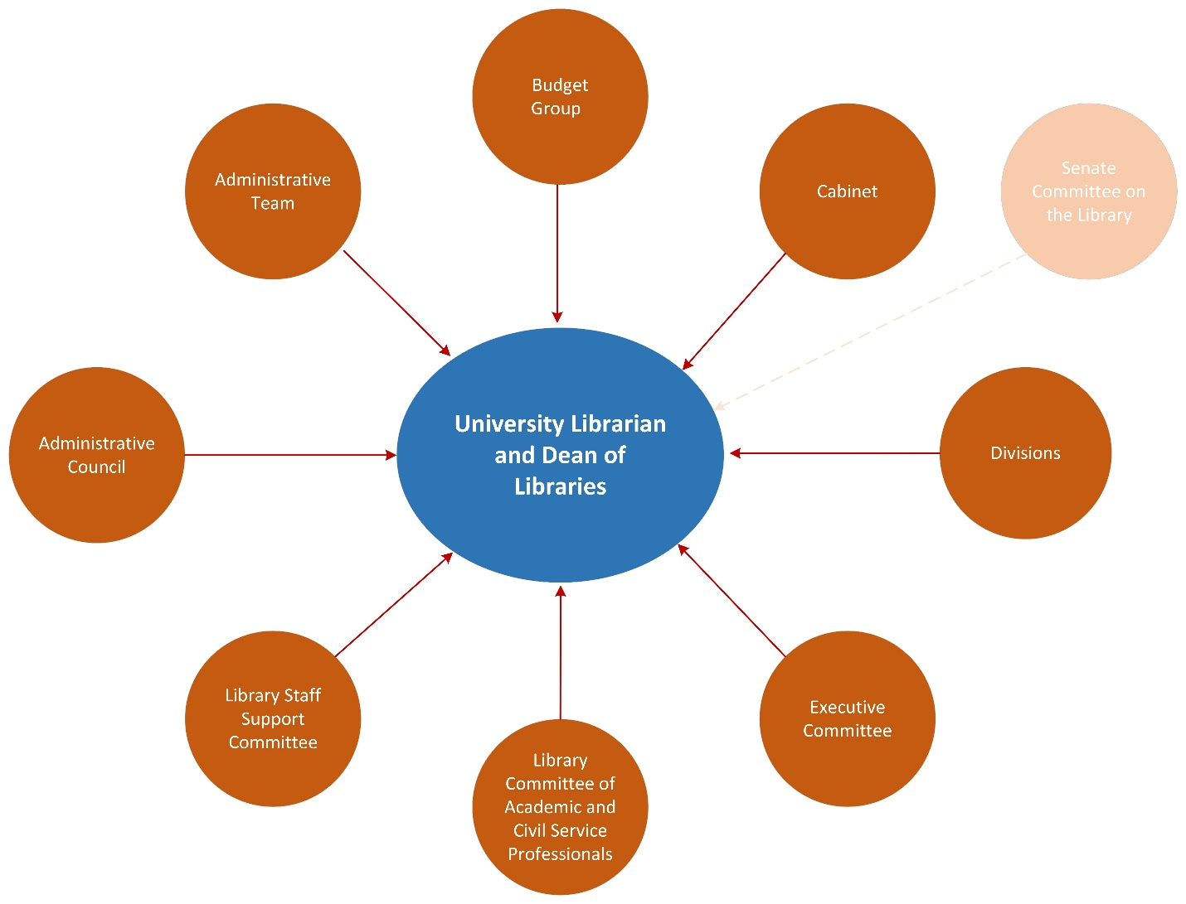
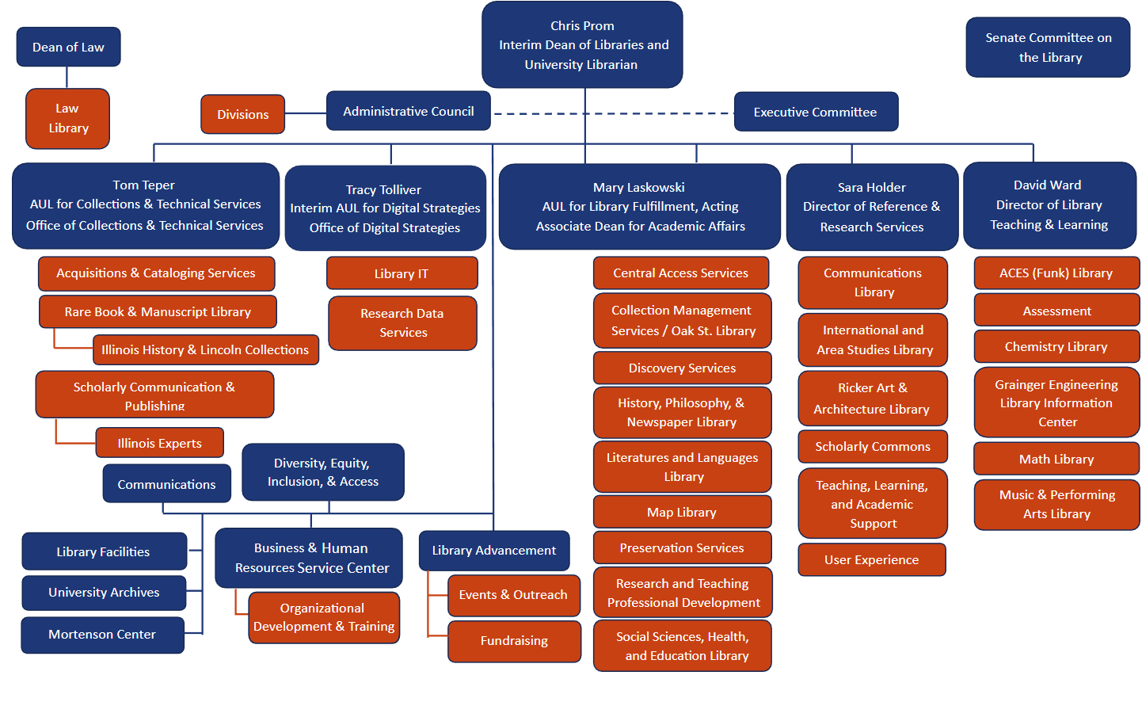
Organizational Chart
The organizational chart shows the direct reporting lines within the University Library, and is up to date as of March, 2023.
Governance Structure
* Directors in the context of this document refers to the two administrative Directors filling roles formerly provided by the AUL for User Services. There are other employees in various classifications in the University Library who have “Director” in their title.
The following, in alphabetical order, represent the major governance structures within the Library.
Administrative Council:
The Administrative Council is comprised of the current division coordinators plus the AUL’s, Directors, and Assistant Deans in ex officio roles.
The Administrative Council serves as an advisory body to the University Librarian with regard to the promulgation and implementation of standards, regulations and procedures that relate to the general operating policies of the Library and such other advisory functions as may be assigned or delegated to it by the University Librarian. The primary responsibility of the Administrative Council is the day-to-day management of the Library.
Administrative Team:
The administrative team, comprised of the AUL’s and directors, typically meet weekly with the dean to discuss current issues and planning. In addition, each of the five AUL’s/Directors meet individually with the dean on a weekly or biweekly basis, plus on an ad hoc basis as needed.
Budget Group:
Group Composition – the Dean, the AULs/Directors*, the Executive Committee’s Vice Chair, a member of the Administrative Council (identified by that body) and the Assistant Dean of Business and Human Resources (serving as chair).
The Budget Group is responsible for reviewing and recommending to the Dean for approval in the following areas:
- hiring requests for Civil Service positions,
- funding requests for civil service audit (pre or post audit),
- funding requests for non–permanent hourly positions wages*
- yearly budget requests for Graduate Assistant (GA) positions,
- yearly budget requests for summer graduate hourly positions, and
- yearly budget requests for non-permanent hourly wages (formerly known as the student budget).
*Units that have available funding such as grant, endowment, or income dollars, do not have to submit requests.
Funds may be approved to individuals/units upon the Dean’s discretion outside of this review process.
Cabinet:
There is no formal structure for the “Cabinet” that was in use during the former dean’s tenure. The term “Cabinet” was used to refer to monthly meetings held by the dean with all the dean’s direct reports (minus the University Archivist), and served as a mechanism for that group to share updates with each other.
Divisions:
The University Library has eight divisions, each with a division coordinator appointed by the dean with the advice of the division:
- Area Studies
- Arts and Humanities
- Central Public Service
- Life Sciences
- Physical Science and Engineering Libraries
- Social Science
- Technical Services
- Special Collections
The information regarding the divisions in the Library Bylaws is outdated, as it still refers to Law as a division in the Library, and Law is no longer administratively part of the University Library structure.
For both academic and administrative purposes, the Library shall be organized into nine divisions. These nine divisions are Area Studies, Arts and Humanities, Central Public Services, Law, Life Sciences, Physical Sciences and Engineering, Social Sciences, Special Collections, and Technical Services.
A. Definition and Purpose. The nine divisions of the Library are educational and administrative sub-units related by common interests and objectives. The internal structure, administration, and governance of a division shall be determined by its faculty under bylaws established by its faculty. Bylaws of the divisions shall be consistent with the Library Bylaws.
B. Membership. The membership of the divisions includes persons of all ranks, who on the recommendation of the University Librarian, are assigned to the units comprising the Divisions as specified in Article VI, Section 1B. Faculty members in units not assigned to a Division who are not an Assistant/Associate University Librarian, or a staff director, shall be assigned to a Division by the University Librarian. Faculty members in the same unit shall always be assigned to the same Division.
Executive Committee:
The Committee is comprised of eight elected members of the Faculty, with no more than two elected from any one division who serve a two-year term. The University Librarian is an ex-officio member of the Executive Committee. The University Librarian serves as its chairperson.
Charge
A. The Executive Committee is the principal advisory body to the University Librarian. It advises the University Librarian on the formulation and execution of Library-wide policy, including but not limited to:
- creation and appointment of library-wide committees, and plans for implementation of Committee recommendations;
- selection of priorities to be reflected in the Library’s budget;
- proposal of library-wide program initiatives and policy changes;
- recruitment and selection of Library Faculty.
B. The Executive Committee advises the University Librarian on the appointment, both temporary and permanent, of the Staff Directors.
C. The Executive Committee, as stipulated in Article VI, part e of the Statutes, advises the Chancellor on an annual basis regarding the reappointment of the University Librarian. On the occasion of the University Librarian’s five-year evaluation, it also works with the Library Committee of the Campus Senate to prepare for the approval of the Library Faculty a plan for conducting this evaluation.
D. One member is elected annually as vice-chair of the Executive Committee and the Library Faculty. Duties include chairing sessions of the Executive Committee and faculty meetings in the absence of the University Librarian, and serving as chair of the Executive Committee when the elected members meet to discuss the reappointment of the University Librarian or to plan or conduct the 5-year evaluation of the University Librarian.
E. One member is elected annually to serve as secretary of the Executive Committee. Duties include providing agendas and minutes for Executive Committee sessions, and aiding the chair and vice-chair as needed.
Library Committee of Academic and Civil Service Professionals (LCP):
The LCP shall consist of seven members elected at-large for two-year terms. Library employees elected to the Campus Council of Academic Professionals (CAP) are ex officio members of LCP during their CAP terms. Elected LCP members who have served two consecutive terms must take a minimum one-term hiatus before being eligible to serve again. Those eligible to vote for and serve on LCP are:
- Academic Professionals
- Visiting Academic Professionals
- Library Civil Service Professionals*
The LCP is charged with:
Liaising with Library administration, faculty, and staff to ensure the representation and inclusion of the AP / CSP* voice in decisions and projects that impact the University Library.
LCP communicates regularly with the University Librarian/Dean of Libraries.
LCP chairs or their designees serve as liaisons to EC to participate in discussions and to voice AP / CSP* concerns, and serve on relevant task-forces and committees as necessary.
LCP works closely with LSSC in their advocacy for all Library staff.
Supporting Library APs and CSPs through representation, regular communication about Library affairs, and advocacy for professional development opportunities; LCP stays current on activities of the Campus Council of Academic Professionals and related groups and ensures Library APs and CSPs* are informed and represented.
Advising Library administration on current and future promotional considerations for APs and CSPs*, including performance metrics and reviews and related matters.
Ensuring that Library APs and CSPs* are nominated and represented in campus-wide activities and governance opportunities.
Library Staff Support Committee (LSSC):
The LSSC consists of 13 members, one ex-officio member elected from Administration Services and one member elected from each of the following divisions: Area Studies (with Mortenson Center), Arts & Humanities, Law Library, Life Sciences, Physical Sciences & Engineering, Residence Hall Libraries, Social Sciences, Special Collections; and two members each elected from Technical Services and Central Access Services. The Committee elects officers at the first meeting of the fiscal year.
Charge
The Library Staff Support Committee serves as a liaison between the Library’s staff and its administrators and librarians.
The LSSC works with administrators, librarians and staff to facilitate communication within the Library. This committee brings staff concerns and ideas before the decision-making bodies that can best address and act upon them. The Committee will endeavor to identify staff members to be added to those library committees where staff input will be beneficial.
Senate Committee on the Library:
The Committee shall advise the director of the campus Library on the apportionment of the Library budget and on the formulation and execution of policies governing the operation of the Library, including its branches. The Committee shall advise the Chancellor on the appointment and evaluation of the director of the campus Library. The Committee shall advise the Senate about issues affecting the ability of the Library to fulfill its mission.
Current membership of the Senate Committee on the Library can be found here: https://uofi.app.box.com/v/Library/file/988859736843.
The latest annual report of the Senate Committee on the Library can be found here: https://uofi.app.box.com/v/Library/file/949837909962.

