Student Focus Spaces Task Force

Final Report
Summer 2024

Contents
- Membership
- Executive Summary
- Detailed Recommendations
- Appendices

Membership
- Victor Jones, Jr. Co-Chair, Director of Diversity, Equity, Inclusion, and Accessibility (DEIA)
- David Ward, Co-Chair, Director of Teaching and Learning
- Elisandro Cabada, Emerging Technologies and Immersive Scholarship Librarian
- Kirsten Feist, Undergraduate Instruction and Engagement Strategist
- Jessica Hagman, Social Sciences Research Librarian
- Kate Lambaria, Music and Performing Arts Librarian
- John Laskowski, User Experience and Web Strategies Librarian
- Jennifer Maddox Abbott, Collection Management Librarian
- Jameatris Rimkus, Archivist Program Officer
- Laila Hussein Moustafa, Middle East and North African Studies Librarian
- Sarah Williams, Head, Funk ACES Library
- Jen-Chien Yu, Director of Library Assessment

Former Members:
- Mara Thacker, South Asian Studies Librarian & Global Popular Culture Librarian

Executive summary

Charge: https://www.library.illinois.edu/committees/committees/student-focused-spaces-task-force/

The Student Focused Spaces Task Force was formed as a result of ongoing, cross-library discussions about designing spaces for students that met their needs and supported student academic and co-curricular success. The task force was appointed in late Fall 2021 and held its first meeting in in February 2022. While investigating the impacts of the closure of the Undergraduate Library and future space design for the building project were key drivers of the group, there was also significant interest in creating a shared understanding of current student perceptions of and needs for library spaces. In early discussions and through a literature review, the team chose to have a research-based focus using methodologies which surfaced diverse student voices, and focused on identifying what factors helped create a sense of welcoming and inclusiveness within library spaces. From the literature review (see Appendix), focus groups and photovoice methodologies were selected as preferred research methods for framing student collaborations. A combined IRB submission covered both studies, and incentives were obtained for student participation. After the studies were completed, two additional working groups were formed in Fall 2023 to address remaining priorities from the task force charge – making recommendations for ongoing quantitative data collection, and identifying strategies for more inclusive student involvement in ongoing space planning.

Focus Groups
The focus group team designed a series of prompts organized around the theme of identifying what elements contributed towards a space feeling welcoming to students. Focus groups were held in Fall 2022 and Spring 2023, with a total of 5 session (3 in person, 2 on Zoom) and 33 total participants. Undergraduate and Graduate students participated, from a variety of majors and programs. Some participants regularly used Library spaces, while others used them infrequently.

Photovoice
Photovoice is a participatory research method where participants are seen as co-researchers involved in developing the research prompts and involved in subsequent analysis to some extent. Participants take photos during their day-to-day lives to capture their experiences as they relate to the research prompts, then come together as a group to discuss them. The Photovoice research team broke down the process into three steps for participants:
- An initial informational meeting where student participants were introduced to the research goals, photovoice method, and expectations for their participation.
- A photo taking period where participants took photographs, submitting them along with comments via Canvas.
- A final discussion meeting where the student participants and research team came together to discuss the photos and identify themes and similarities/differences amongst student experiences in various study spaces.
The Photovoice study occurred in two separate rounds. Five students originally signed up to participate in the Fall 2022 round, and three students fully participated in the study. A total of 26 pictures were submitted by the participants. Eight students signed up to participate in the Spring 2023 round, and five students fully participated in the study. A total of 53 pictures were submitted.

Based on the Fall 2022 round, in Spring 2023, the research team instead asked participants to take three different photos of a space where they were working, and to take photos of at least three different spaces in total. By not focusing on specific criteria or features, this allowed participants to document their individual experience and emphasize the features that stood out to them. During the initial informational meeting, the research team also showed participants in the Spring 2023 round a picture and demonstrated the discussion process that would occur later. The research team believe this approach resulted in higher participation and more robust discussion with participants.

Assessment Subgroup
This team addressed the following item from the charge: “Collect, analyze, and recommend standards for quantitative data about space usage, such as gate counts, head counts, and related analytics on the types of space use.” The analysis considered both local needs, as well as requirements for mandatory space-related reporting at campus and professional levels (e.g. ACRL, ARL).

The group gathered data on current practices for gathering data on space use from multiple internal and external sources. Sources consulted include:
- Analysis of space-related data points in LibInsight and Unit Annual Reports;
- A review of best practices in library literature;
- Consultation with peers in the BTAA Library Assessment group and the DLF Assessment Interest Group on User Experience (DLF AIG UX);
- A survey of current practices in UIUC Library units;

Inclusive Spaces Subgroup
This team investigated methodologies for ongoing collaborative spaces planning incorporating student input and partnerships with cultural houses, RSOs, and other units from the Office of Student Success, Inclusion, and Belonging (SSIB). The group organized conversations with library colleagues who had pre-existing relationships with one or more of these campus partners, and identified what worked well and what didn’t in terms of cooperative planning. A significant piece of feedback was that organizations supporting underrepresented students, as well as the students themselves, are over-surveyed and over-studied, without tangible benefits regularly returning to them. As a result of this feedback, the group investigated approaches to build ongoing partnerships about the design of spaces, rather than creating a one-off study about spaces.

Detailed Recommendations

The Follow-up groups listed below are recommended as the appropriate actors to investigate implementation of the Focus Group and Photovoice study recommendations:
- Library Internal Marketing Group – This group has already begun work on signage creation, and should continue developing standards for language, UX, best practice, and distribution of signage. The group may also want to work with Library Administration to secure a budget for a signage revamp, and inventory the types of signage and space need requests they receive to build a larger picture of library space allocation.
- Web Team – For recommendations about how spaces are presented on the website.
- Library Facilities - For recommendations which involve the placement of furniture, allocation of resources such as power, and related needs.
- Unit Heads (and others who manage patron spaces) - For recommendations which involve updating unit signage, designating study space types within a unit, and communicating expectations about spaces to patrons within a unit space.

Focus group & Photovoice Recommendations
Recommendation 1 - Clearly communicate space expectations visually
University Library signage should be evaluated for consistency, with messaging aligned with patron priorities for using spaces, rather than lists of what not to do in a space. A focus group participant expressed the feeling of “Maybe doing something that is not right, or doing in the wrong way.” A photovoice participant also stated “Some buildings communicate that you cannot go into the building if not the correct major.” The tone should emphasize inclusivity and empowerment, and avoid restrictive policing language prevalent in historic signage practices where possible. Overall signage in spaces should be prioritized and streamlined to reduce visual clutter and emphasize wayfinding, services, features (e.g. study rooms), and relevant characteristics of space, such as noise level.

Recommendation 2 - Highlight variety of spaces
Students want different types of spaces depending on their particular needs. Findings indicate that unit libraries should lean into their distinct characteristics, while at the same time adopting common and consistent language, branding, signage, and marketing to help students understand what to expect when they visit a new library. Characteristics of interest to participants included seating, volume levels, privacy, access to food, and lighting. 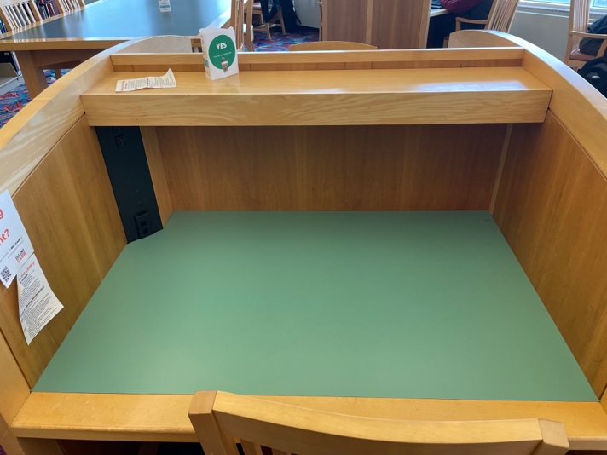
Figure 1. The student that took this photo commented that “[this] picture shows what makes [Funk ACES Library] my favorite library, individual booths with chargers in every single booth. This was something that was sorely missing from every other place that I have studied at other than the quiet level of the UGL.” This student valued individual, long-term study spaces.

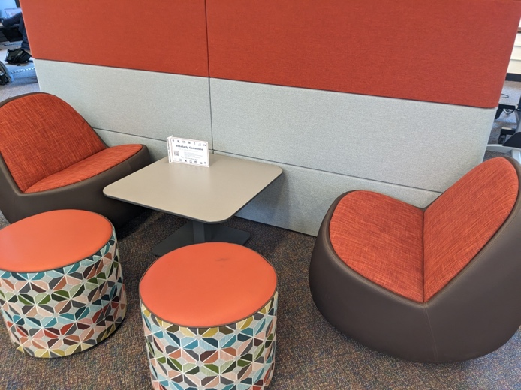
Figure 2. The student that took this photo commented that “Compared to other options, these seats are usually available, maybe because they can be a bit uncomfortable to work on at times because they are so low. I find these chairs comfortable to do a light study session with a friend more so than if I were studying on my own or really needed to concentrate.” This student valued spaces they could use in passing for brief periods.

Student feedback indicated a lack of clarity about whether subject libraries are restricted to majors in a discipline. Smaller unit libraries, particularly those not regularly reaching maximum capacity, are encouraged to participate in shared marketing efforts, and identify collaborative methods to communicate that their spaces are open to students outside of the primary disciplines served by their collections.

Recommendation 3 - Clarify organization and presentation of collections in the Main Library
Participants reported difficulties locating collections in the Main Library, identifying materials within those collections, as well as understanding the organization of materials across multiple physical spaces (e.g. collocation of like materials). One focus group participant said “‘Stacks’ doesn’t mean anything to me. Just have a sign that says, ‘Books this way.’” Another student commented on the layout of materials in the Main Library, rhetorically asking “does anyone here want to read?” Increasing the findability and browsability of materials in the Main Library would address the needs students expressed in the study. Participants called out the challenges of finding popular fiction or “fun” reading within the current arrangement of materials.

Recommendation 4 – Learn more about appropriate space adjacencies.
Further investigation into how to situate student study spaces in relation to other library spaces and services would help maximize student belonging. While some feedback was received about incongruous adjacencies (e.g. group study next to collection browsing areas), more detailed data would help develop a plan to align different types of study spaces within individual units. Privacy, safety, and security were emphasized as values for space design. Students noted, for example, that Grainger lighting was a “nice dark,” with good visibility even at night, while the Main Library’s lack of consistent lighting made it seem scarier, with one student noting that going to the bathroom at night felt unsecure. At Funk ACES, student felt the open interior design created a feeling of visibility and therefore safety, but at night the location could feel unsafe to visit, in part due to a lack of nearby bus routes. As planning for the “exhale” phase begins, the strategic body in charge of Main Library space planning should follow up on this recommendation.

Recommendation 5 – Identify how to integrate food-friendly spaces
The ability to eat while studying, and as part of taking breaks from studying, was frequently mentioned. Some selections of study space were made based on both the ability to eat within the space, and the location of nearby sources of food, with one participant noting about the Orange Room “I LOVE that you can eat there,” and multiple users commenting on the coffee shop in Grainger. The Funk ACES Library, for example, is situated in a food desert, which could influence willingness to study there for some students. Additionally, the Illinois Student Senate hosted a meeting with members of library administration in Spring 2024 to request more study spaces which are food-friendly to help commuter students traveling to campus. Further study about where and when to include food, and how to make food options available for students within or near Library units, is needed. We suggest that the Administrative Council and Unit Heads should work with the Library Internal Marketing Group to identify how to increase the amount of food friendly spaces, how to consistently identify and make them findable to students, and how to evaluate their impact in meeting student need.

Analytics Subgroup Recommendations
Recommendation 6 - Establish shared reporting practices
The variance in frequency of data collection and documentation of space data makes it challenging to understand trends in space use across an academic year as well as in response to significant events such as the building project. We recommend the Library Senior Administrative Team and the Administrative Council work with Library Assessment and develop a process for establishing shared reporting timeframes and data collection tools (such as LibInsight) to facilitate building a holistic understanding of space use. This process should identify standard expectations and define roles for individual space data collection.

Recommendation 7 - Create and document shared tiers of space assessment methods
We can address the interest from colleagues in expanding options for space assessment by articulating a range of tiers aligned with the different needs of individual Library physical space. We recommend that the Library Senior Administrative Team and the Administrative Council implement the following tiers of data collection:
- Core Tier - This tier encompasses data that is roughly comparable across units, and can help build a picture of library usage as a whole to share internally and with student and campus stakeholders. Current data points which align with the Core tier include gate count and visitor count, and could be expanded as needs are identified. Core data should be collected through LibInsight at a minimum of daily. We recommend that the Library Assessment coordinates the compilation of data received from individual space managers and supports the collection of the Core data tier.
- Augmented Tier - The Augmented tier incorporates both ongoing data collection of unit-specific needs (such as data on technology use, use of specialty services, use of unique collections, etc.) as well as one-off or occasional studies which take a deeper dive into space needs. Characteristics of data collection at the Augmented tier include studies investigating who visitors are and how they want to use space, and might include data points such as Wi-Fi usage, noise levels; temperature; and types of groups (solo vs group).
Recommendation 8 - Sharing results
Colleagues expressed a keen interest in learning from each other’s practice, which can be supported through the use of common reporting tools, such as LibInsight, and devising solutions to share methods and data collection instruments. We recommend that Library Assessment create dashboards to share space assessment data collected through LibInsight.

Recommendation 9 - Updating data points
We recommend that the Core level of space data reporting be reviewed periodically by the Library Assessment Unit, the Senior Administrative Team, and the Administrative Council, to be sure that they are current with standardized reporting needs (e.g. ARL, ACRL, and Campus reporting), and resulting in sufficient data to inform ongoing strategic space planning needs.

Inclusive Spaces Subgroup Recommendations
Recommendation 10 - Ongoing Relationship Building
We recommend the Library Senior Administrative Team, in conjunction with the Executive Committee, and/or the Administrative Council, develop a group dedicated to building ongoing partnerships centered around belonging in the Library. These partnerships would yield feedback and input that could be incorporated into our space designs as well as other functional areas of the Library.

Appendix

Literature Review

Beatty, S., Hayden, K. A., & Jeffs, C. (2020). Indigenizing Library Spaces Using Photovoice Methodology. In S. Baughman, J. Belanger, E. Durnan, E. Edwards, M. Kyrillidou, K. Maidenberg, A. Pappalardo, & M. Strub (Eds.), Proceedings of the 2020–2021 Library Assessment Conference: Building Effective, Sustainable, Practical Assessment. Association of Research Libraries. https://www.libraryassessment.org/wp-content/uploads/2021/08/186-Beatty-Indigenizing-Library-Spaces.pdf

Bedwell, Linda, and Caitlin Banks. (2013). Seeing Through the Eyes of Students: Participant Observation in an Academic Library. Partnership: The Canadian Journal of Library & Information Practice & Research 8(1): 1-17. http://hdl.handle.net/10222/45254

Brook, Freeda, et al. (2015) In Pursuit of Antiracist Social Justice: Denaturalizing Whiteness in the Academic Library. Library Trends, 64(2),246-284. https://doi.org/10.1353/lib.2015.0048

Chapman, J., Daly, E., Forte, A., King, I., Yang, B. W., & Zabala, P. (2020). Understanding the experiences and needs of Black students at Duke (p. 39). Duke University Libraries. https://hdl.handle.net/10161/20753

Chodock, T. (2020). Mapping Sense of Belonging in Library Spaces. In S. Baughman, J. Belanger, E. Durnan, E. Edwards, M. Kyrillidou, K. Maidenberg, A. Pappalardo, & M. Strub (Eds.), Proceedings of the 2020–2021 Library Assessment Conference: Building Effective, Sustainable, Practical Assessment. Association of Research Libraries. https://www.libraryassessment.org/wp-content/uploads/2021/09/197-Chodock-Mapping-Sense-of-Belonging.pdf

Elteto, S., Jackson, R. M., & Lim, A. (2008). Is the Library a “Welcoming Space”?: An Urban Academic Library and Diverse Student Experiences. Portal: Libraries and the Academy, 8(3), 325–337. https://doi.org/10.1353/pla.0.0008

Habre, C., & Kammourié, H. (2018). Redesigning Spaces for Effective Learning: Challenges Facing Riyad Nassar Library in Meeting Users’ Perceptions and Expectations. Journal of Library Administration, 58(5), 519–544. https://doi.org/10.1080/01930826.2018.1468674

Louca, E., Narayan, B. (2016). Signage by Design: A Design-Thinking Approach to Library User Experience. Weave, Journal of Library User Experience. 1(5). https://doi.org/10.3998/weave.12535642.0001.501

Medaille, A., Beisler, M. (2016). Using Images to Understand Students Approaches to the Research Process. Library Assessment Conference 2016. http://old.libraryassessment.org/bm~doc/55-medaille-2016.pdf

Rayford, T. (2023) A Phenomenological Approach to Understanding Black Graduate Students’ Sense of Belonging to their Program. Masters Theses. https://www.ideals.illinois.edu/items/127429

Samson, S, Granath, K, and Alger, A, (2017). Journey Mapping the User Experience. College & Research Libraries, 78(4). 459-471. https://doi.org/10.5860/crl.78.4.459

Scoulas, J.M. (2021) College students' Perceptions on Sense of Belonging and Inclusion at the Academic Library During COVID-19. The Journal of Academic Librarianship, 47(6). https://doi.org/10.1016/j.acalib.2021.102460

Tewell, E. (2019). Reframing Reference for Marginalized Students: A Participatory Visual Study. Reference & User Services Quarterly, 58(3), 162–176. https://doi.org/10.5860/rusq.58.3.7044

Torres, A., & Paul, G. (2019). Reaching maximum occupancy: What the numbers tell us about space and ways to improve services. Journal of Access Services, 16(2–3), 78–93. https://doi.org/10.1080/15367967.2019.1614931

Wilkinson, J., & Breneman, K. (2020). Bridging the Digital and the Physical User Experience: Analysis of Academic Library Floor Plans. Journal of Web Librarianship, 14(1–2), 28–51. https://doi.org/10.1080/19322909.2020.1788497

