CAPT Minutes
September 25, 2025

Present: Tom Teper, Kyle Rimkus, John Laskowski, Tracy Tolliver, Will Schlaack, Kate Lambaria, Eric Mosher, Jennifer Teper, Michael Norman, Mary Laskowski, Chloe Ottenhoff, Hannah Williams (notes)

- Approve agenda and minutes – Approved

- Digital Strategies Discussion Document
  - https://uofi.box.com/s/ewqzukie2ucqs40o79ht4wgwxbfcez45
  - Feedback received has indicated broad support and affirmed the value of the document and the direction it’s going. Stakeholders would like to see more clarity about the implementation and impact. There is a need for strategic clarity in who sets the goals, how priorities are chosen, and what criteria goes into decisions. There is also a desire for transparent and inclusive leadership.
  - Concerns about resources with initiatives proposing new or reallocated resources. There is a need to scale services sustainably.
  - Strong support for looking at digital areas of proven value, such as data curation, open data, and metadata improvement.
  - Traditional methods and approaches might no longer be working as effectively. There is a desire for more innovation in engagement and use of flexible and creative approaches.
  - Recommendations to frame this document within other larger guiding principles and define key terms and audiences.
  - Jennifer, Will, Kyle, and Tracy will meet to refine the document based on provided feedback. It will then go to the dean and potentially LLG for their feedback.

- AI Task Force Report: Recommendation #1
  - “The Task Force recommends the Library adopt the Generative AI Tool or Service Assessment and process. The Task Force also supports sharing it broadly.”
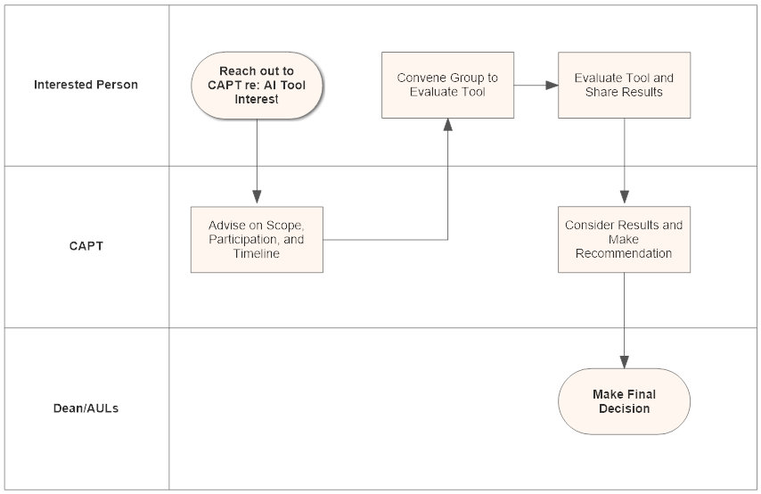
Suggested process:
- If a tool or service is offered by an existing Library vendor, the primary Library contact for that vendor should be directly involved in conversations. The regular library contact for the vendor should be maintained.
- Person interested in a particular tool or service reaches out to CAPT to advise on scope, participation, and possibly timeline.
- Based on input from CAPT, person interested in tool or service convenes a group to complete the evaluation.
- Review is completed by the group and results shared with CAPT, Collection Development Committee, AUL’s and relevant library units or stakeholders.
- Results and feedback are considered and CAPT makes recommendation to AULs and Dean whether to pursue or not.
- AULs and Dean make the final decision whether to pursue or not.
  - How do we implement this tool so it can be used Broadly across the Library?
  - CAPT will advise on scope, participation, timelines, and other groups to consult with/get feedback from.
  - Tracy will refine the document to add scope and context before it is communicated to the Library.

- Accessibility Roadmap – Six Month Update (John L)
  - Deque’s AxeMonitor platform doesn’t scale up to our needs, but there are not really other tools available that meet the needs. We contracted for this as the entire university system. Chicago and Springfield are already looking at supplemental or replacement solutions.
  - Proposal to create two new task forces. They would be focused on two fairly specific areas.
    - One would be putting together instructional information and potential systems to assist instructors and students in finding the most accessible materials available in the library.
    - The other group would be looking at digitization of materials. This might affect how we do ILL scans in the future.
    - John will be working with Tracy, Tom, and the steering committee to develop the charges and memberships for these groups to bring to the CAPT October meeting for discussion.
  - Work is in progress on what is being branded as Boldly Accessible, which will encourage instructors to get their online course materials compliant.

- Quarterly working group reports

Cataloging and Metadata- Chloe Ottenhoff

CMWG Q3 report
Cataloging and Metadata Working Group
September 25, 2025

Meetings: Met 3 times since last report, on July 24, August 21, & September 18
1. Accessibility fields 341 (modes of access or accessibility features), 552 (entity and attribute information note) have been introduced
· CARLI will work on for consortium
2. BIBCO membership
· Has long been a goal of the library/ACS to be part of the BIBCO program
· Now that NACO participation is rejuvenated, it is good time to pursue
· CMWG gave go-ahead and encouragement

· Cataloging supervisors (physical materials) have begun the process to apply for BIBCO membership
· Anna Schlaack will be BIBCO liaison
· Next steps: training, logistics
3. Alma, Primo, & BIBFRAME Updates
· Michael gives the group regular updates on Alma and Primo to ensure we are all aware of changes that have happened or that are coming for staff behind the scenes or for users.
· MJ has begun exploratory work with CARLI on BIBFRAME and gives regular updates from various meetings and presentations
· Attended BIBFRAME workshop in Naples(!) last week and will be updating CMWG further on developments
4. ADA Title II Update
· We are the least impacted working group. Is there more we could be doing?
· Would like to move the DEIA pages that are on ACS Libguides (https://guides.library.illinois.edu/acs/deia) to a more public-facing place such as the main library’s Collections Overview pages: https://www.library.illinois.edu/collections/
5. Working Group future goals and priorities
· Wait until new head arrives and revaluate membership, but also evaluate ideas for future priorities
· Primo’s interaction with other services (DL, Archives space, etc.) and impact
· Reparative cataloging discussion to be ongoing
· BIBCO membership
· Official RDA implementation
· BIBFRAME implementation
· Become more actively involved with CARLI working groups (Primo VE and Technical Services align most closely)

- Archon Update (Kyle R)

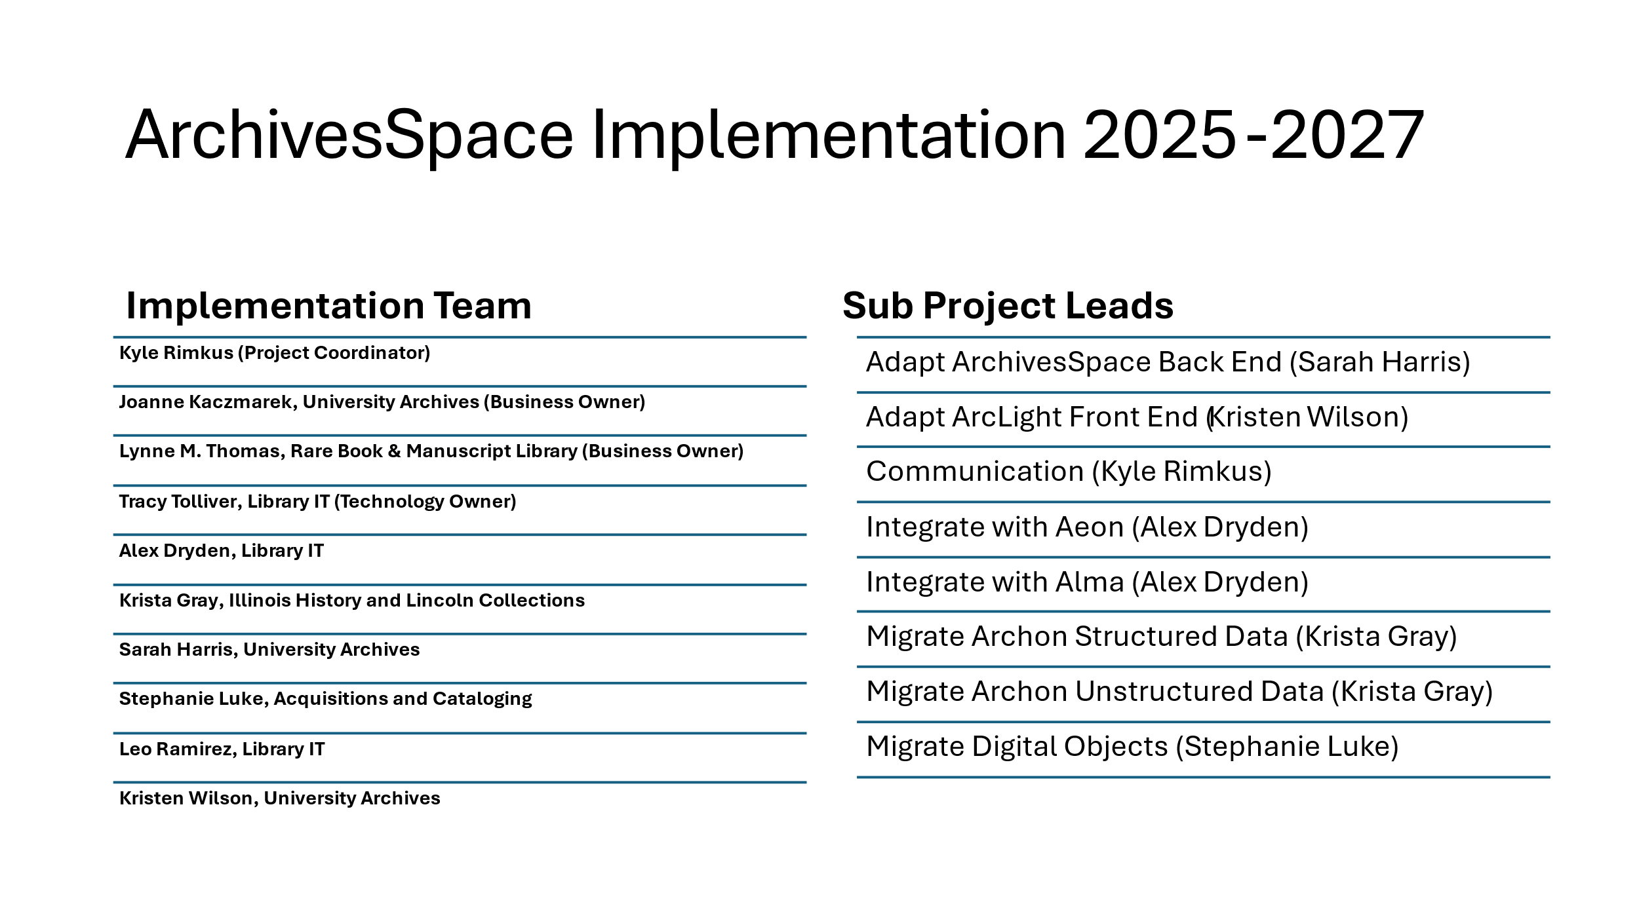
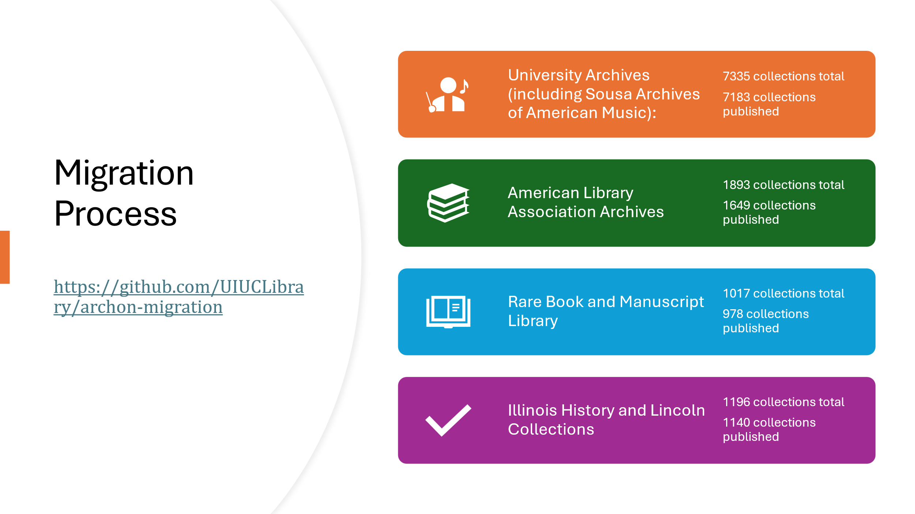
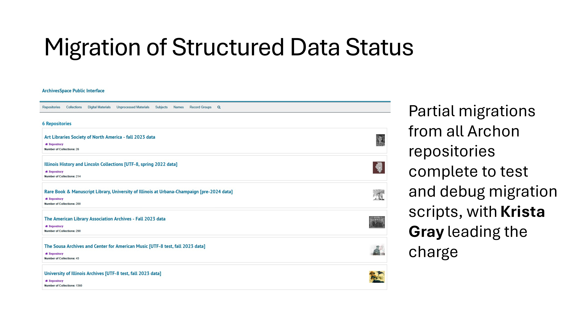
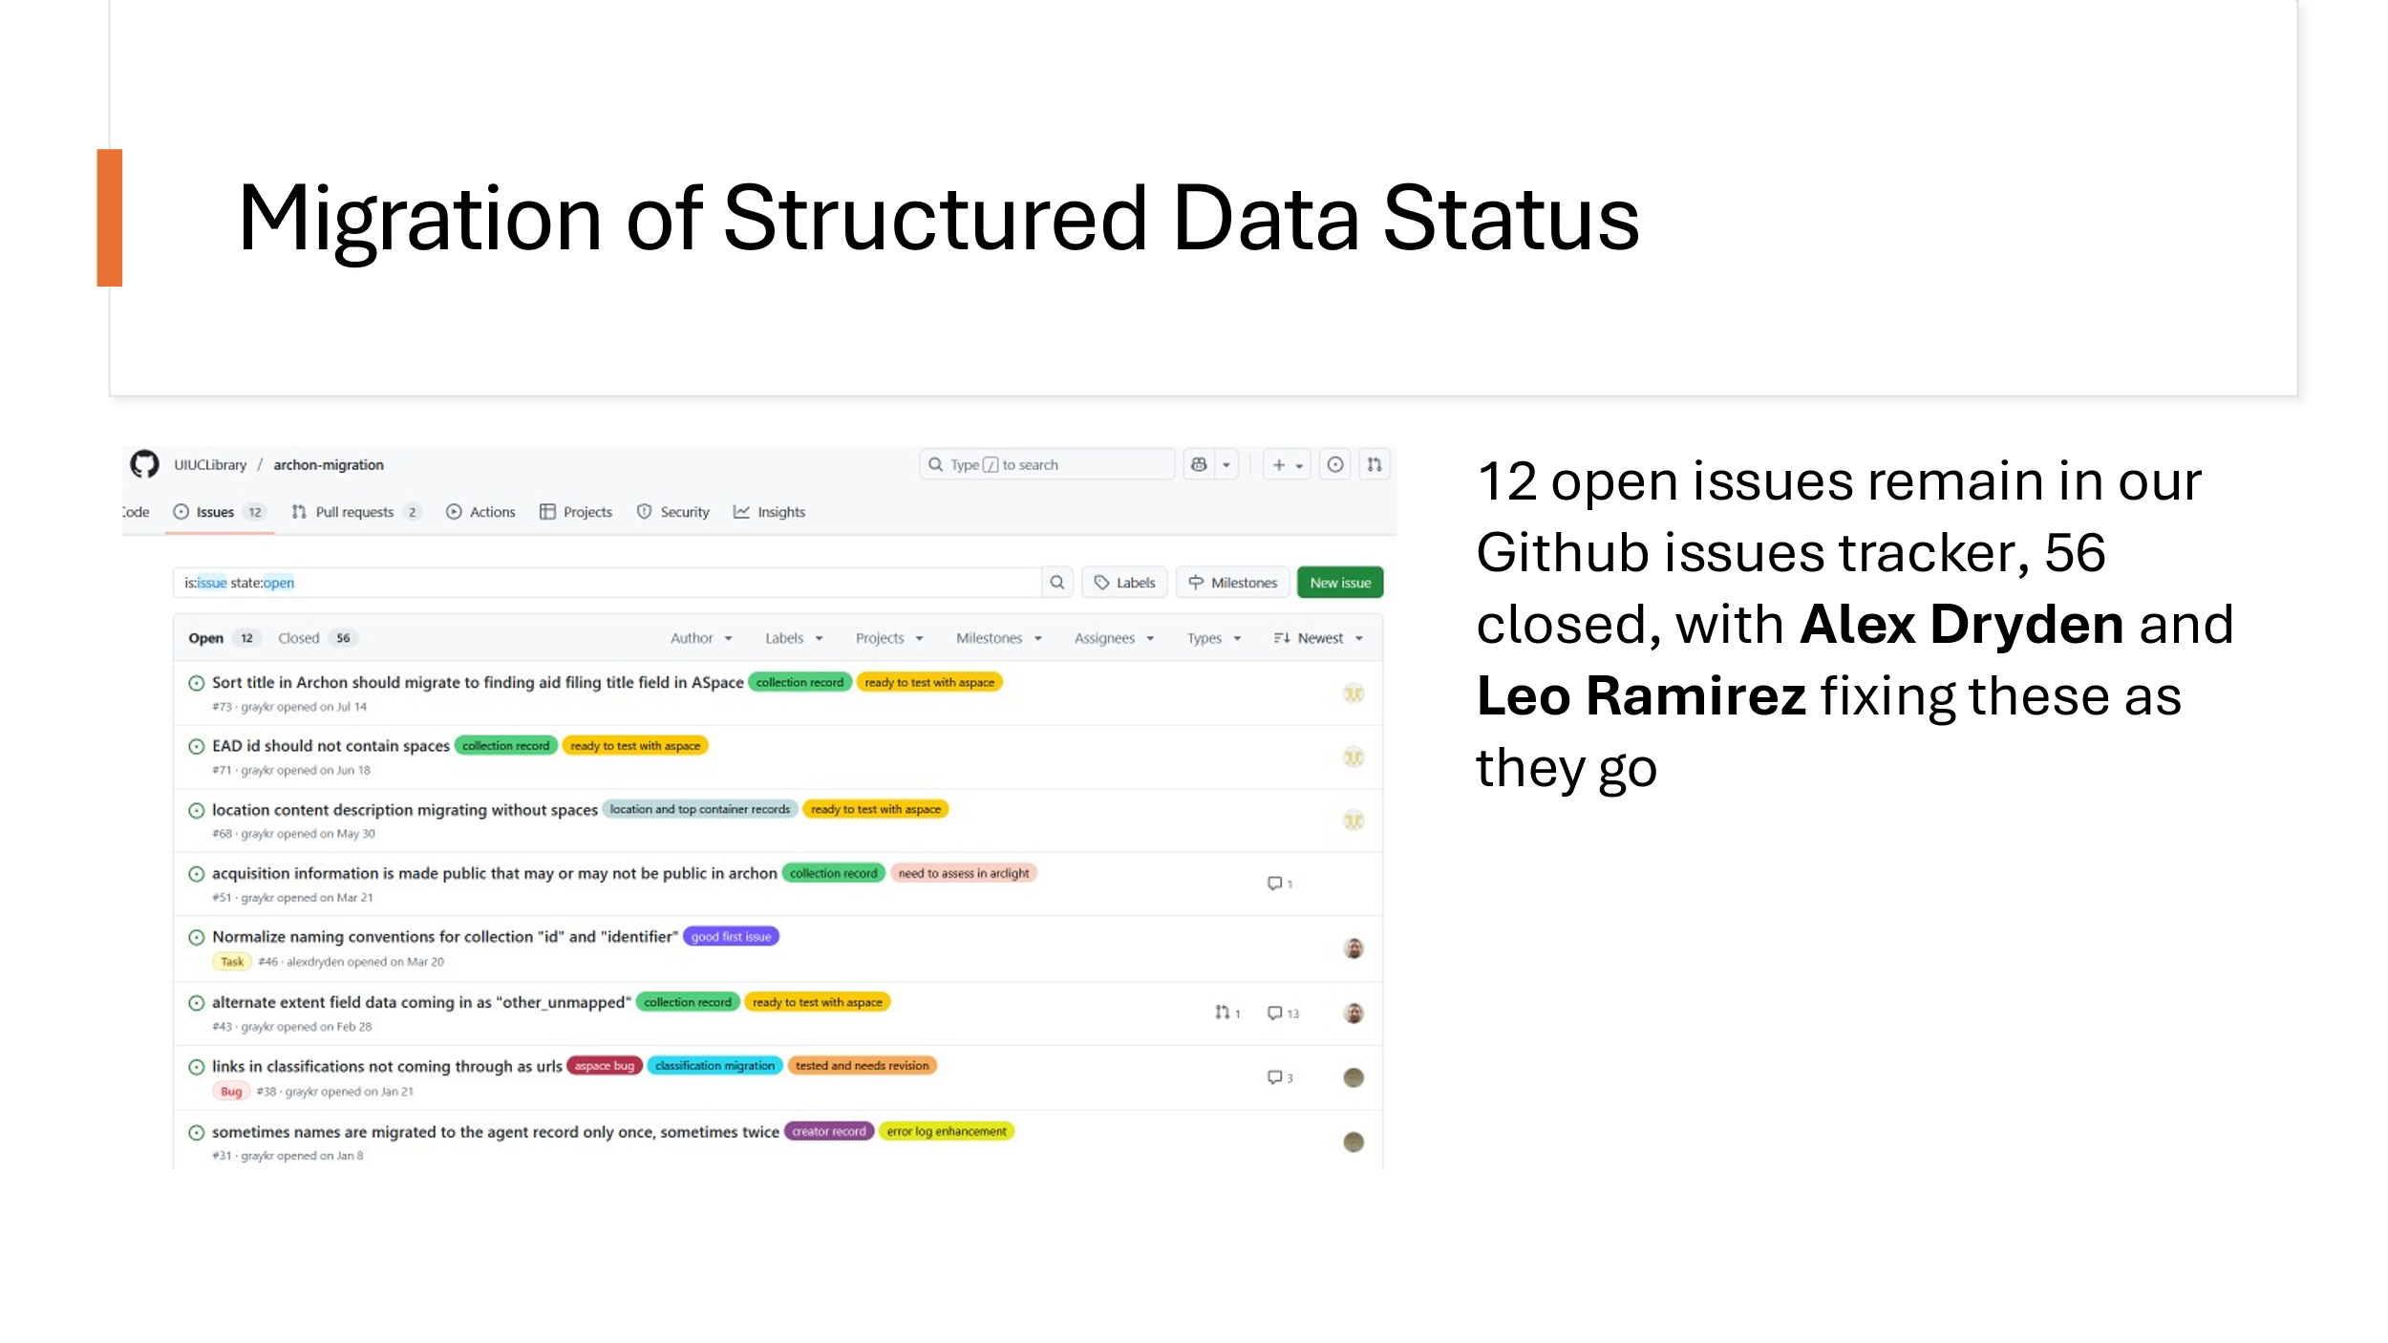
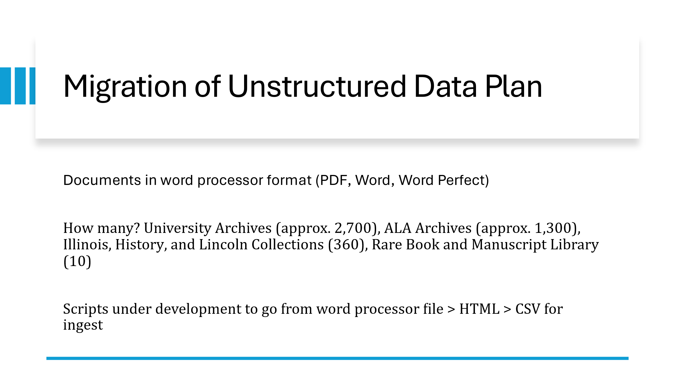
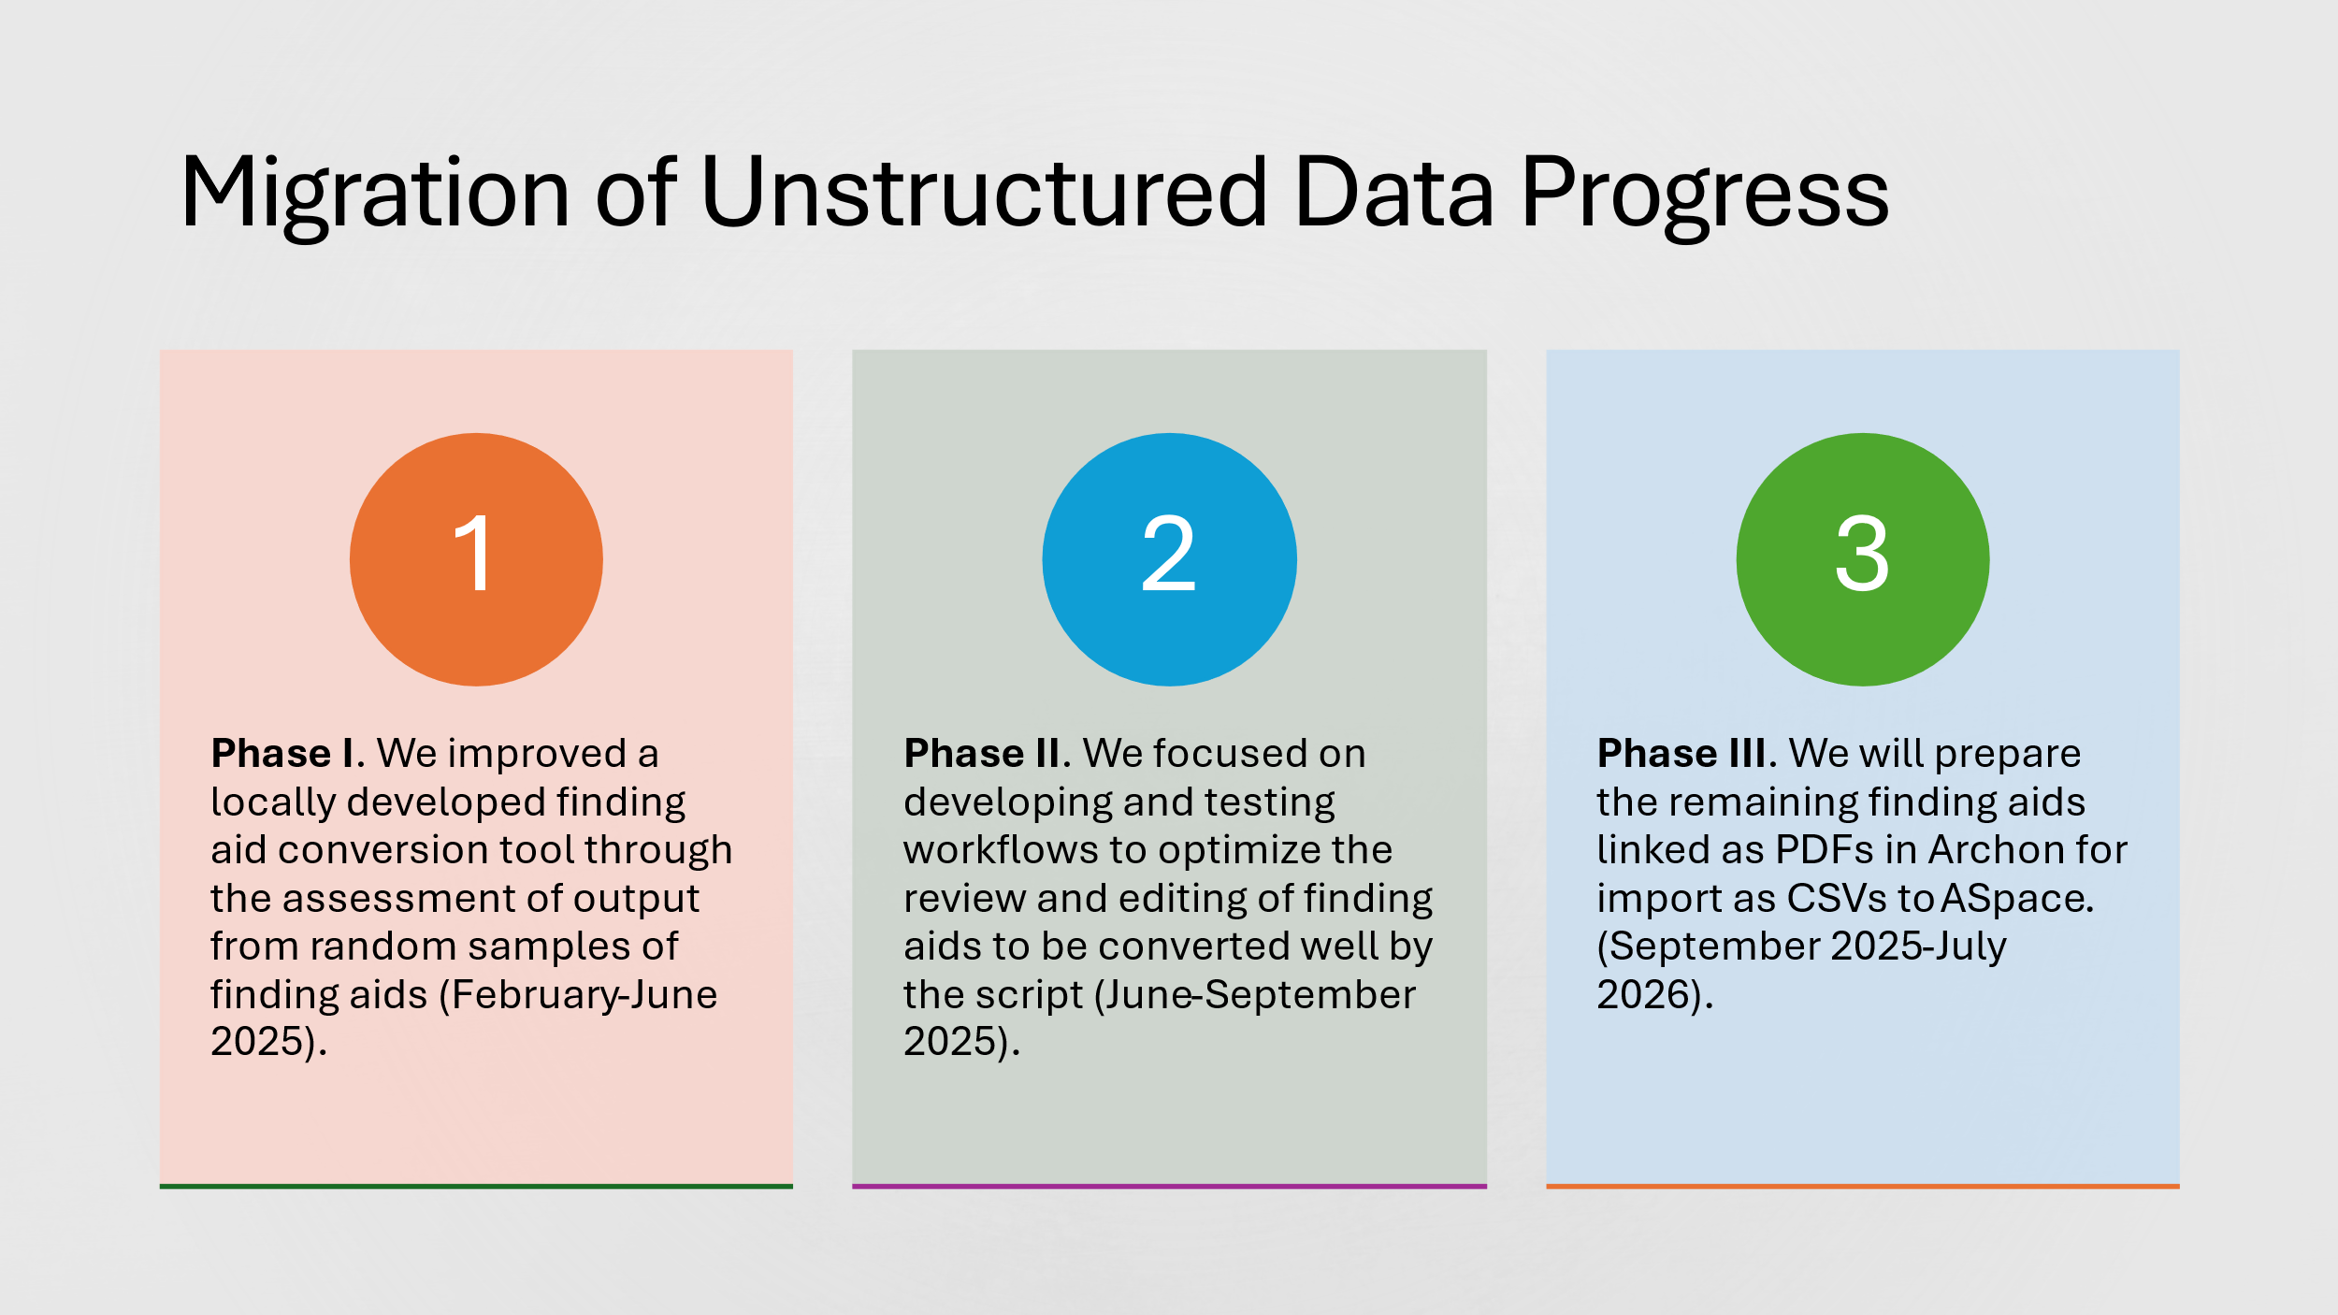
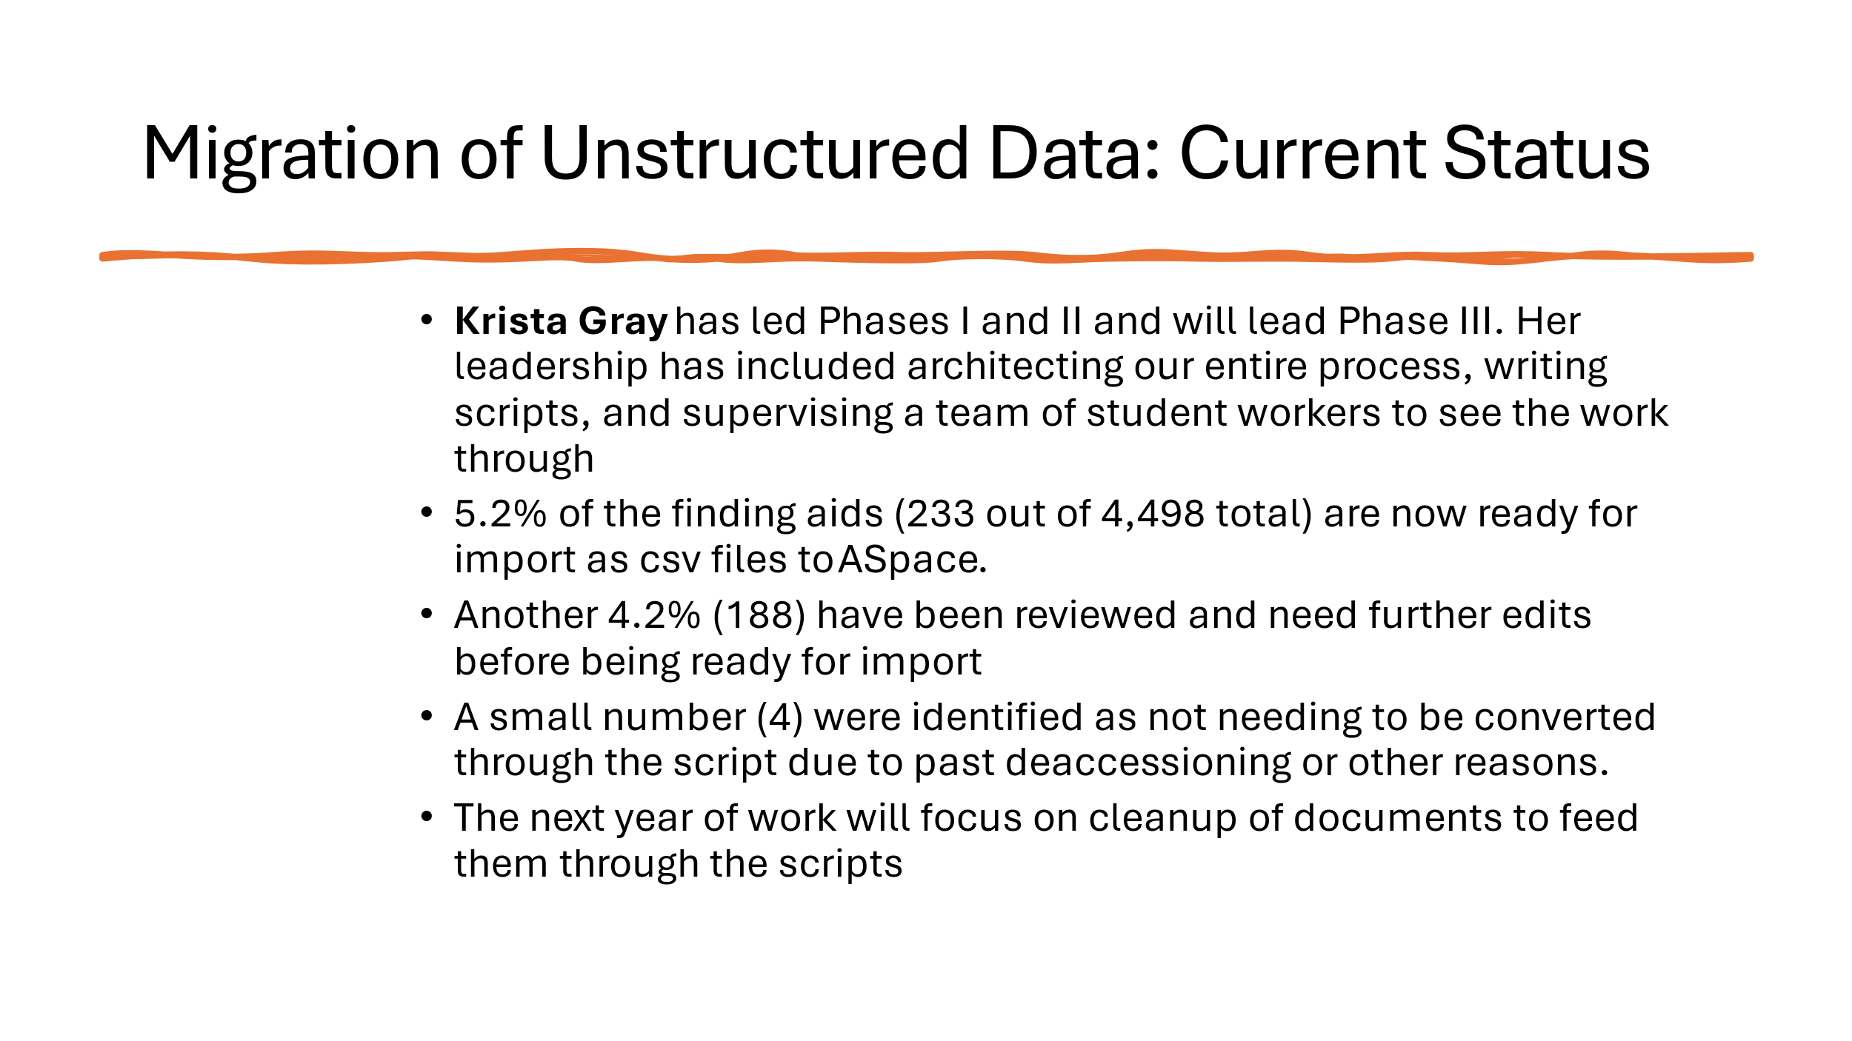
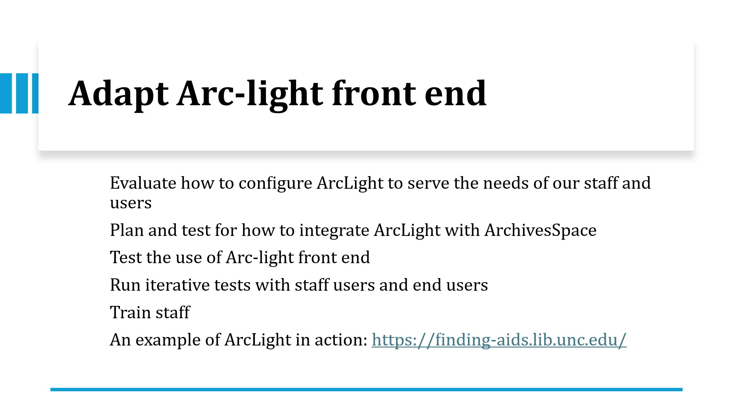
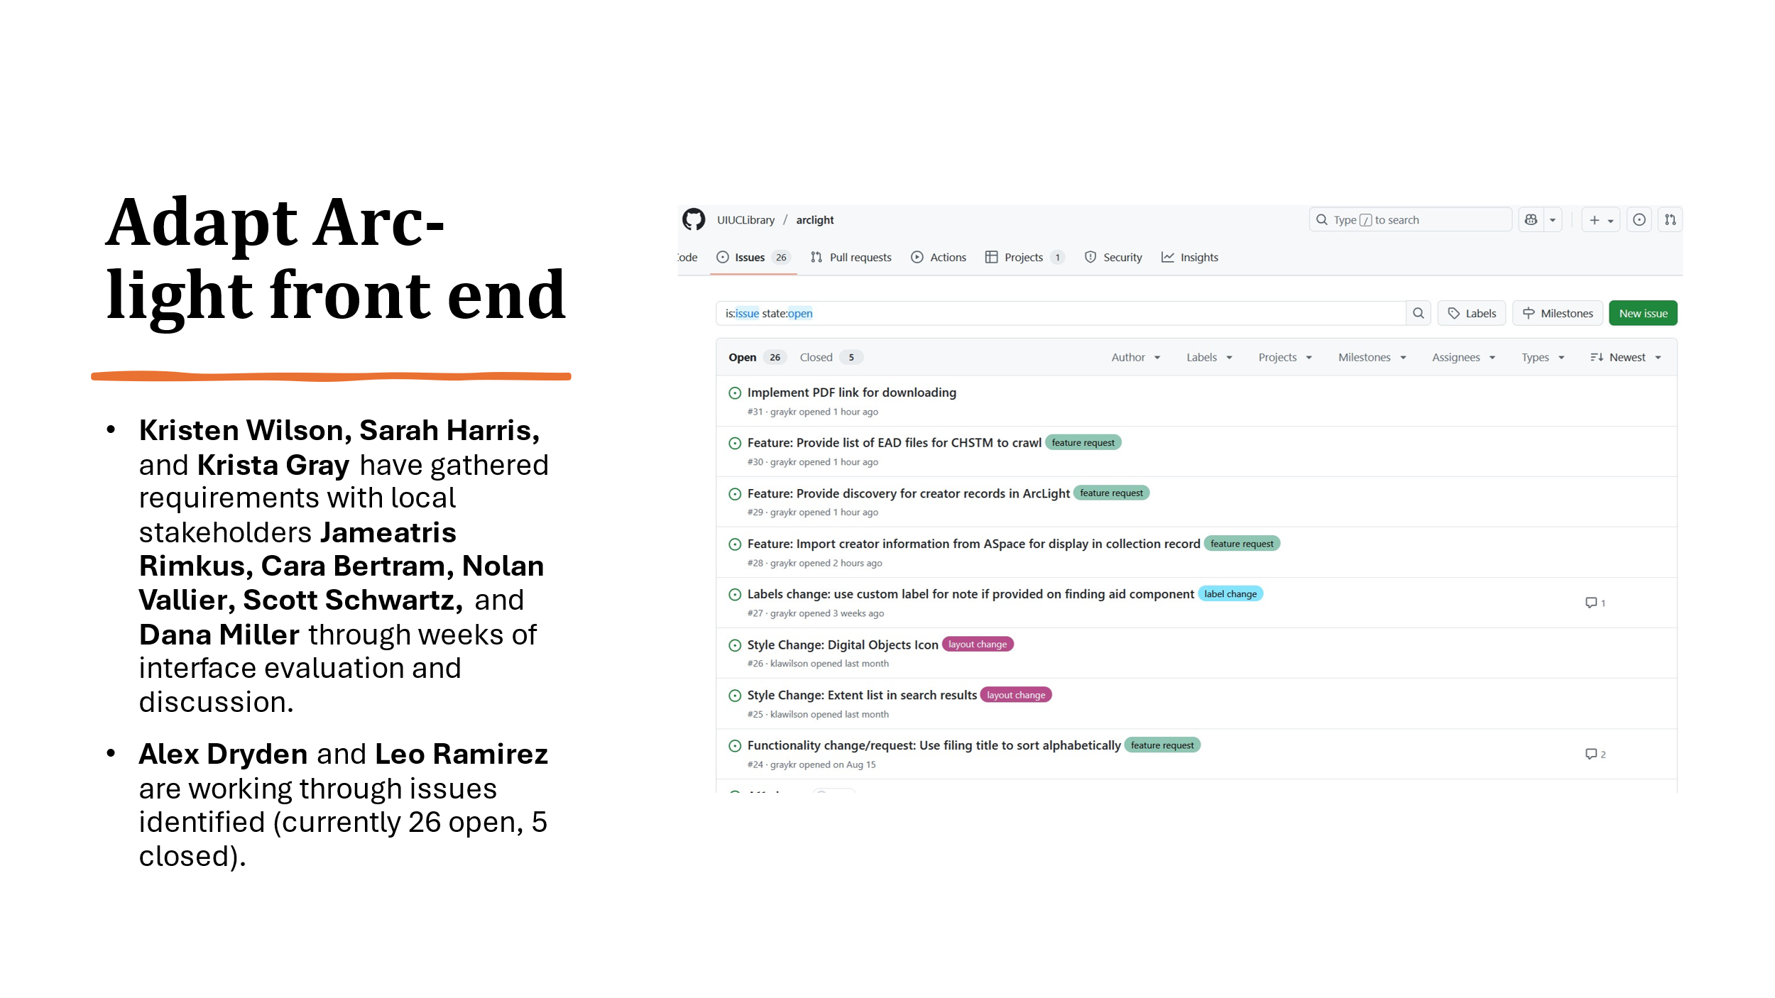
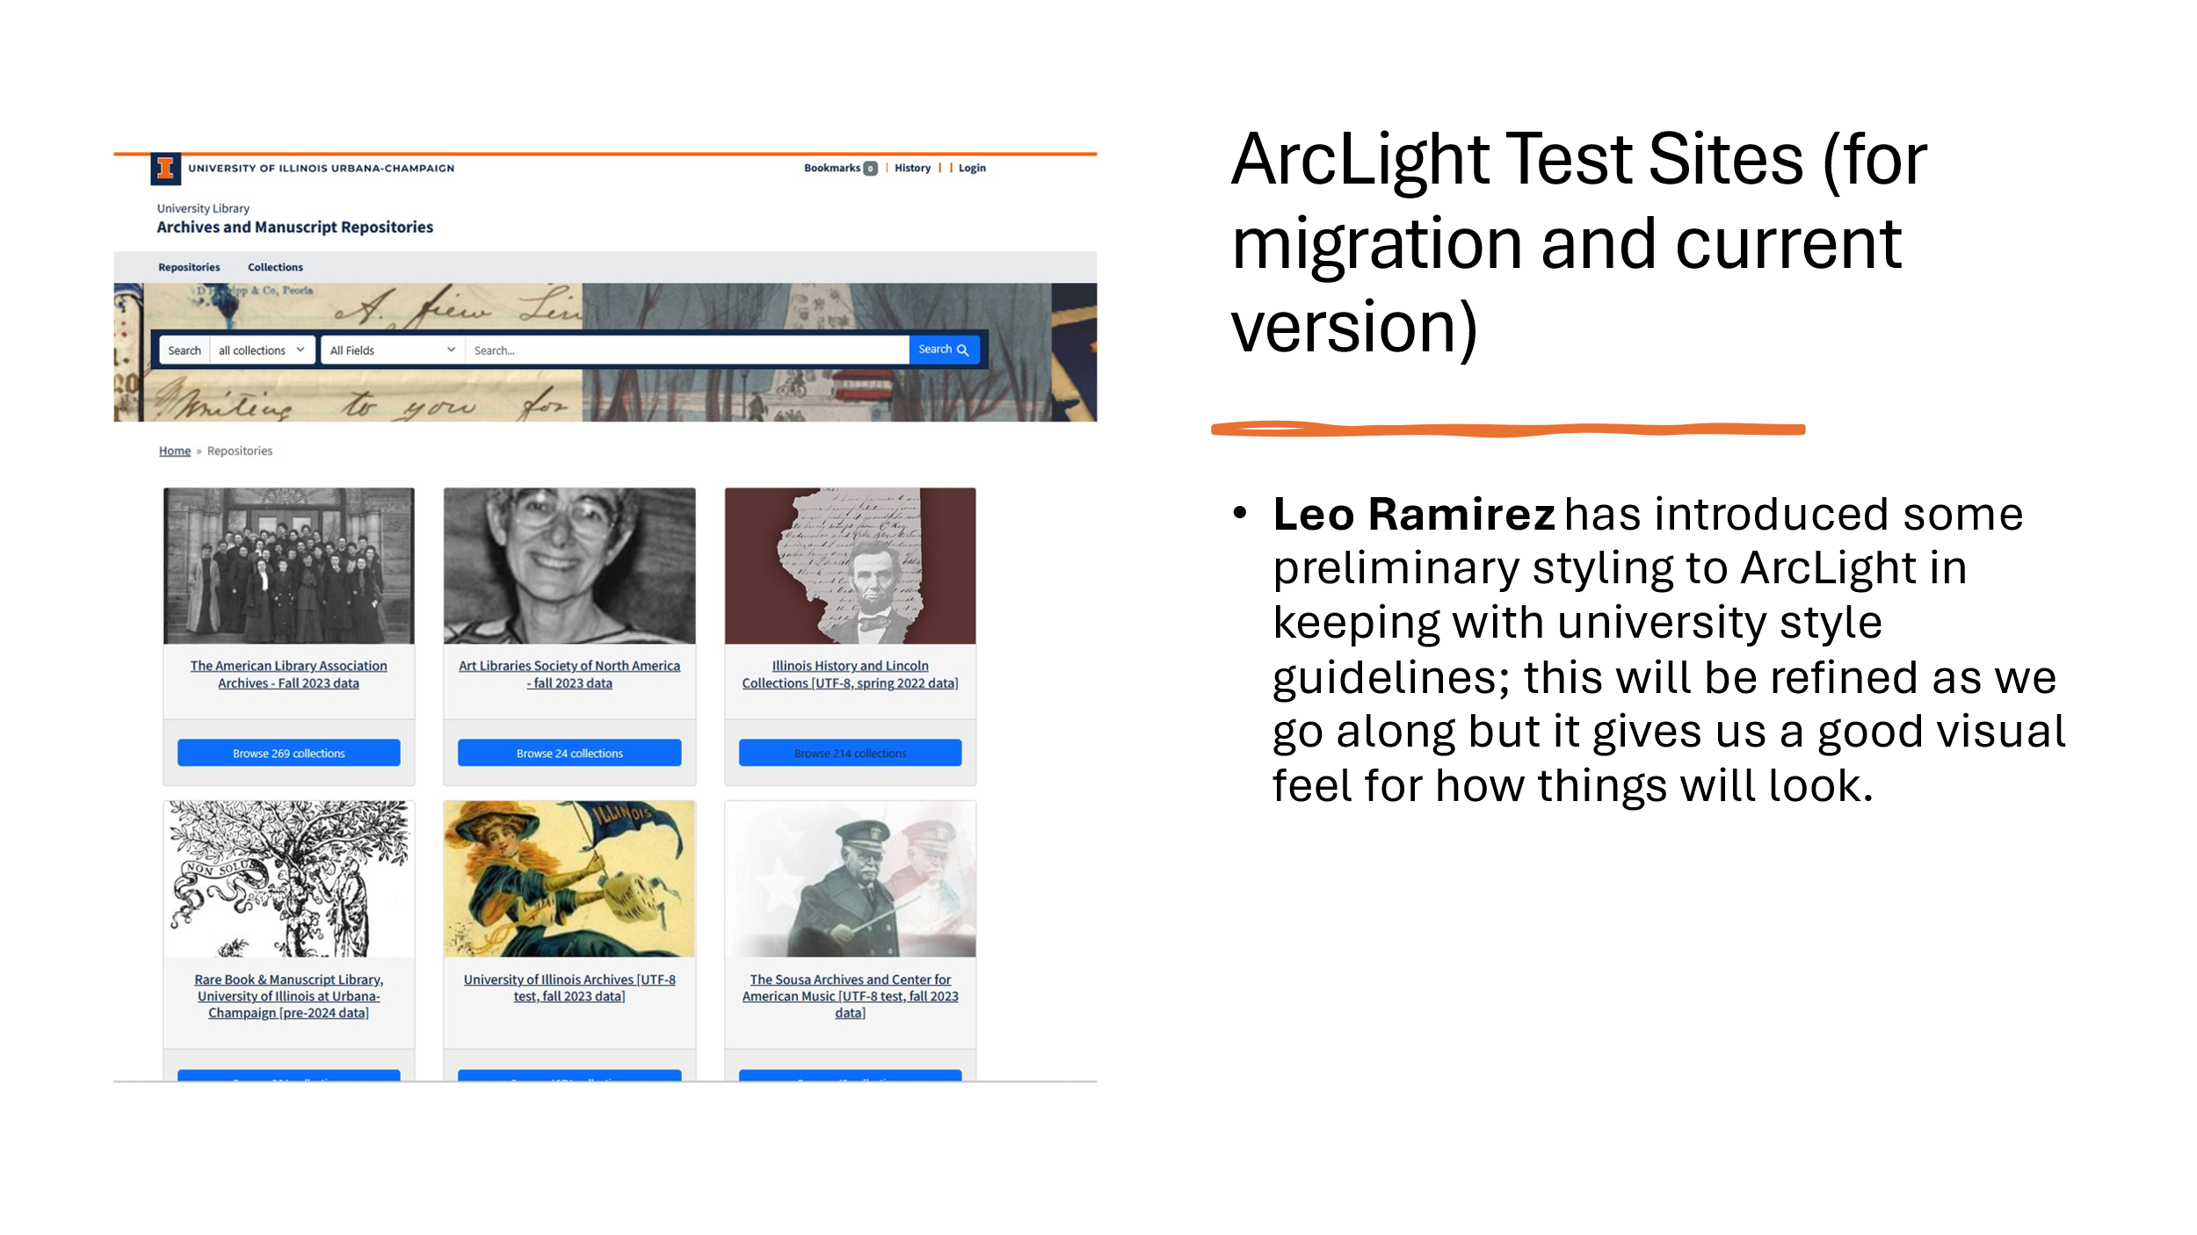
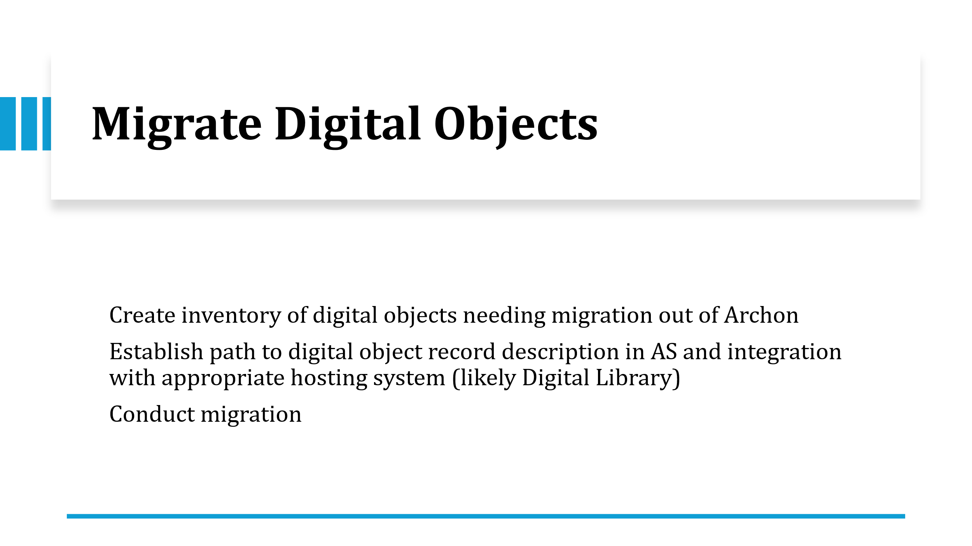
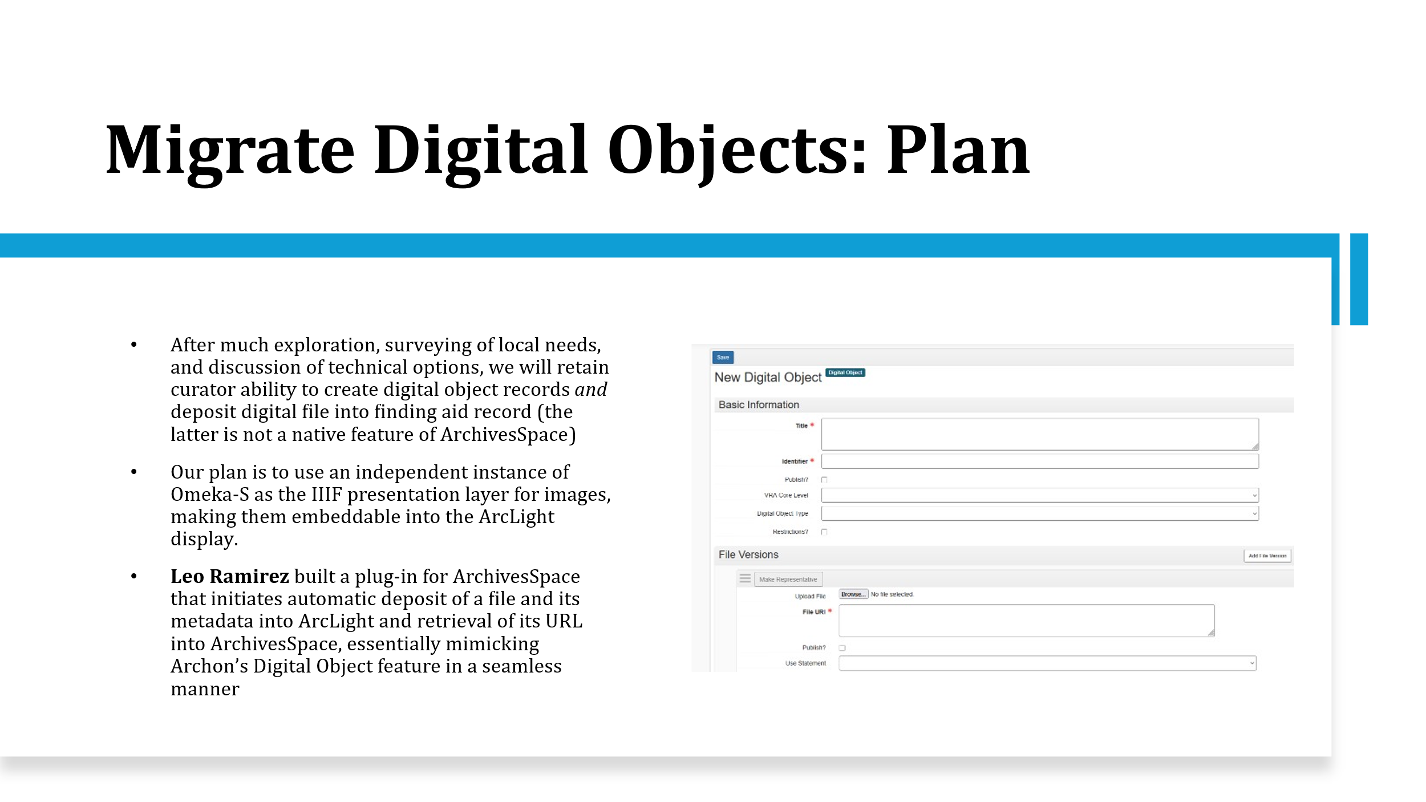
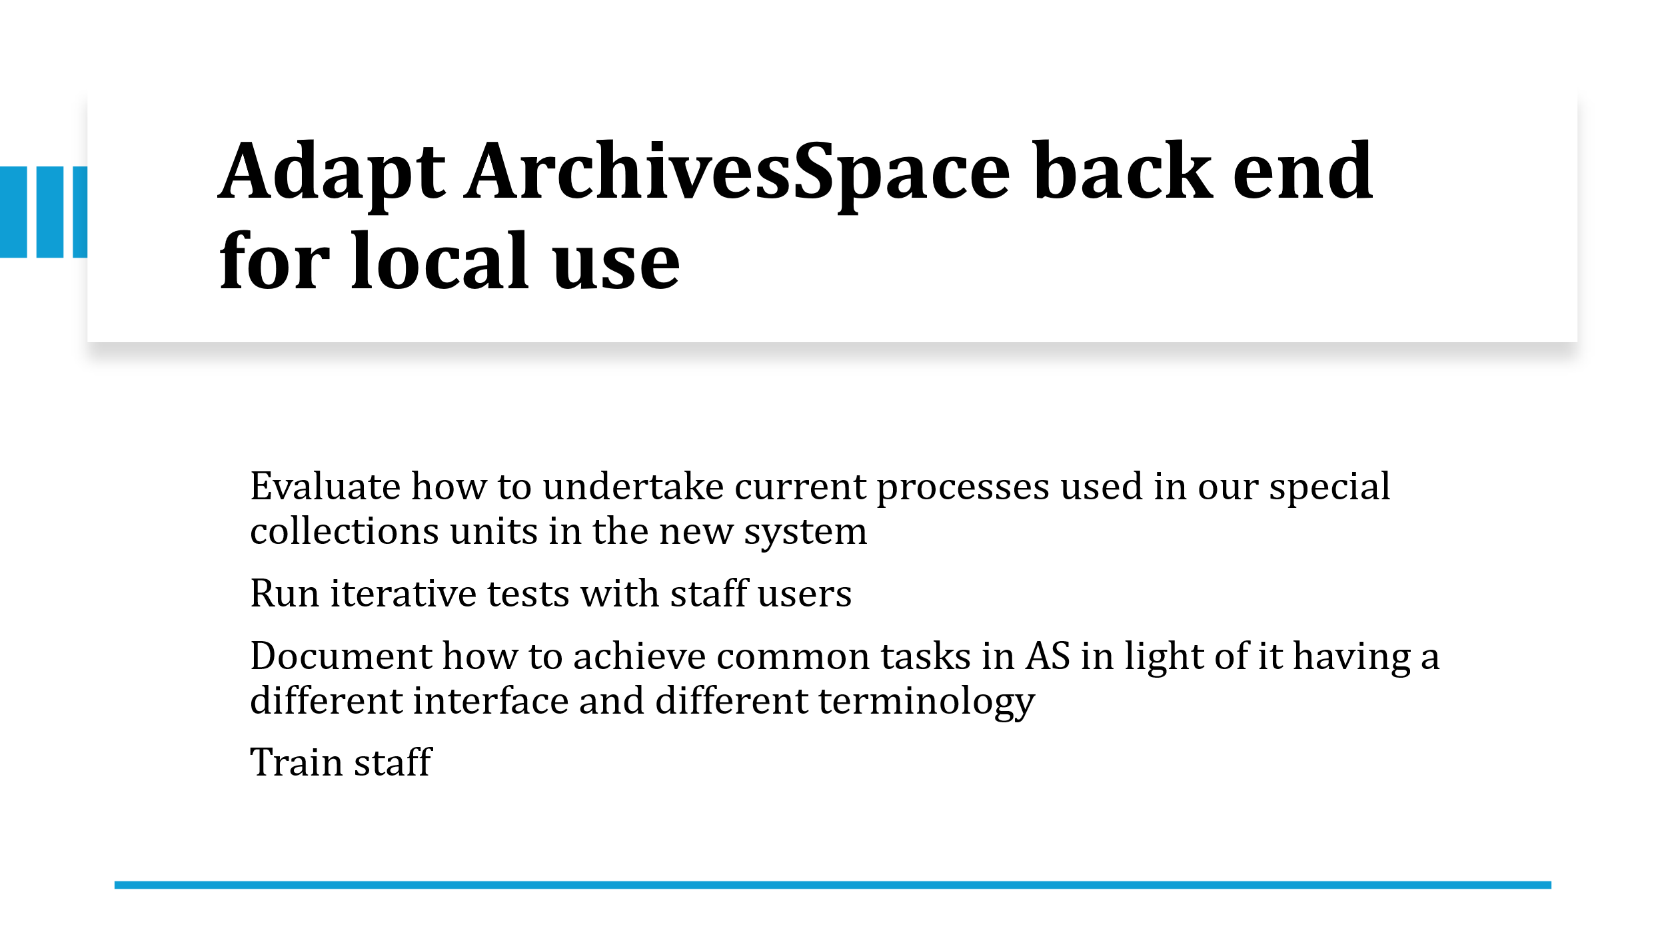
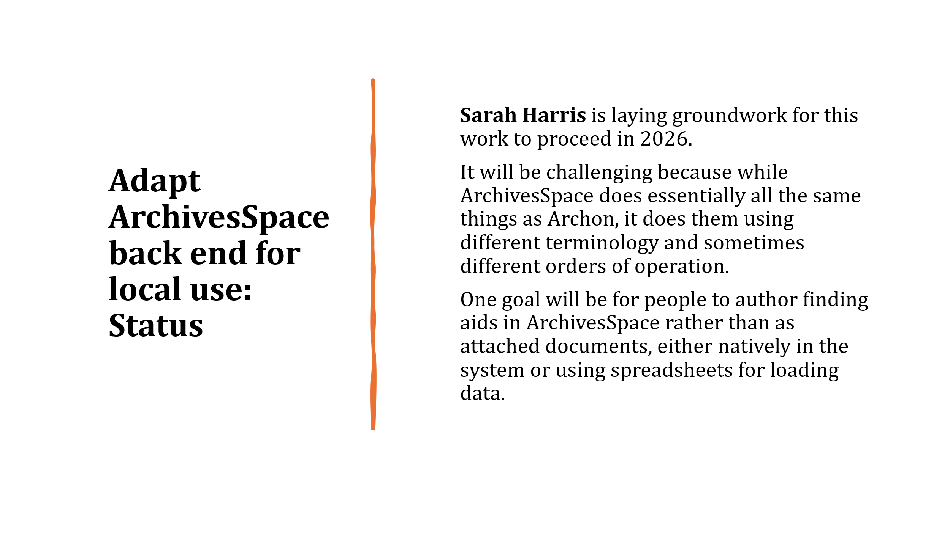
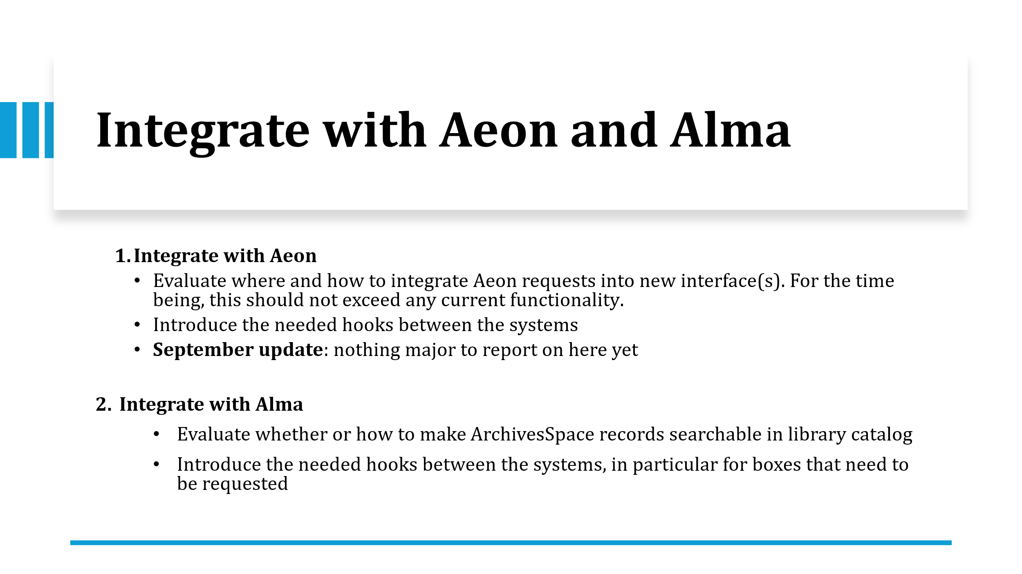
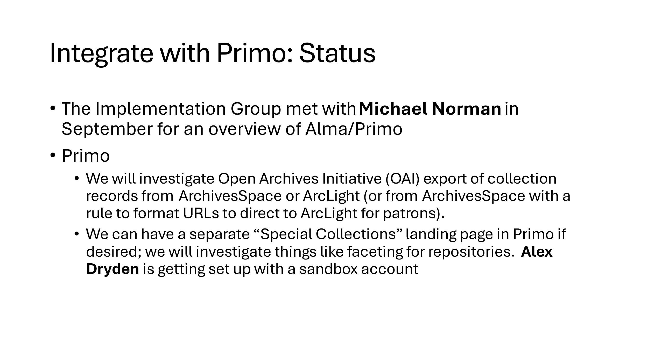
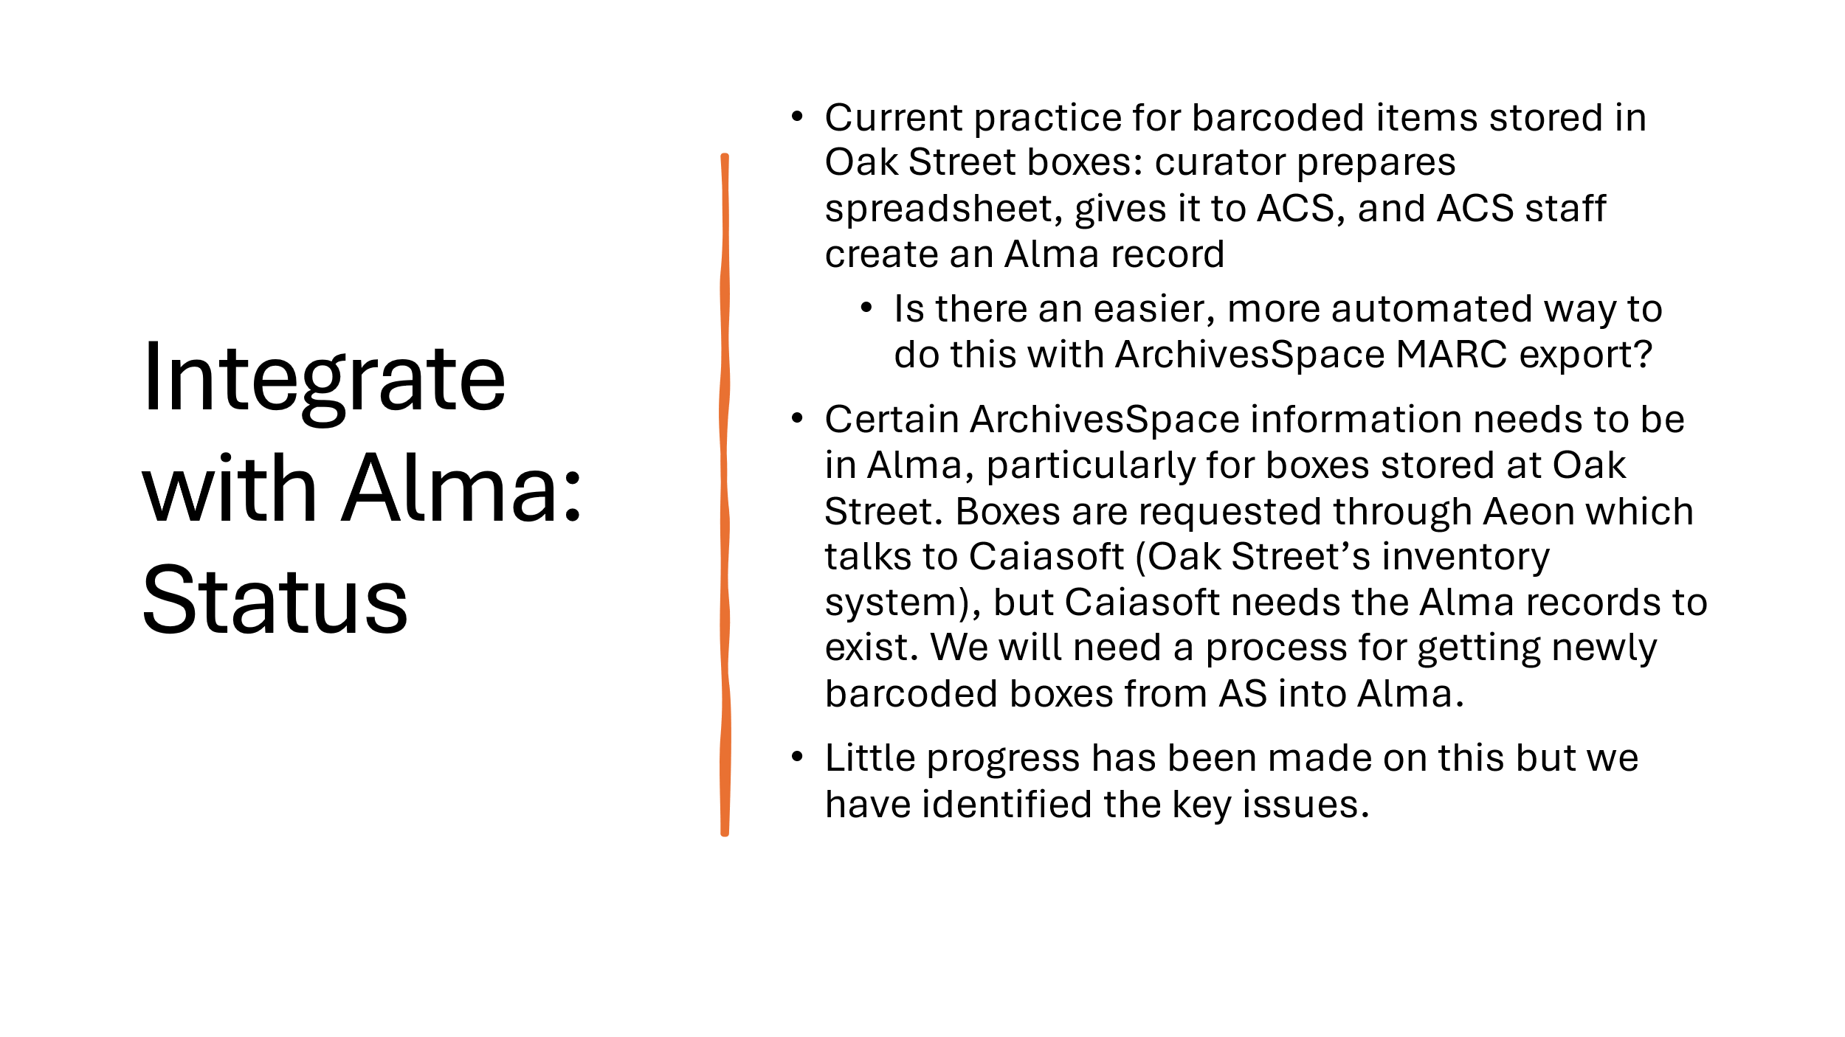
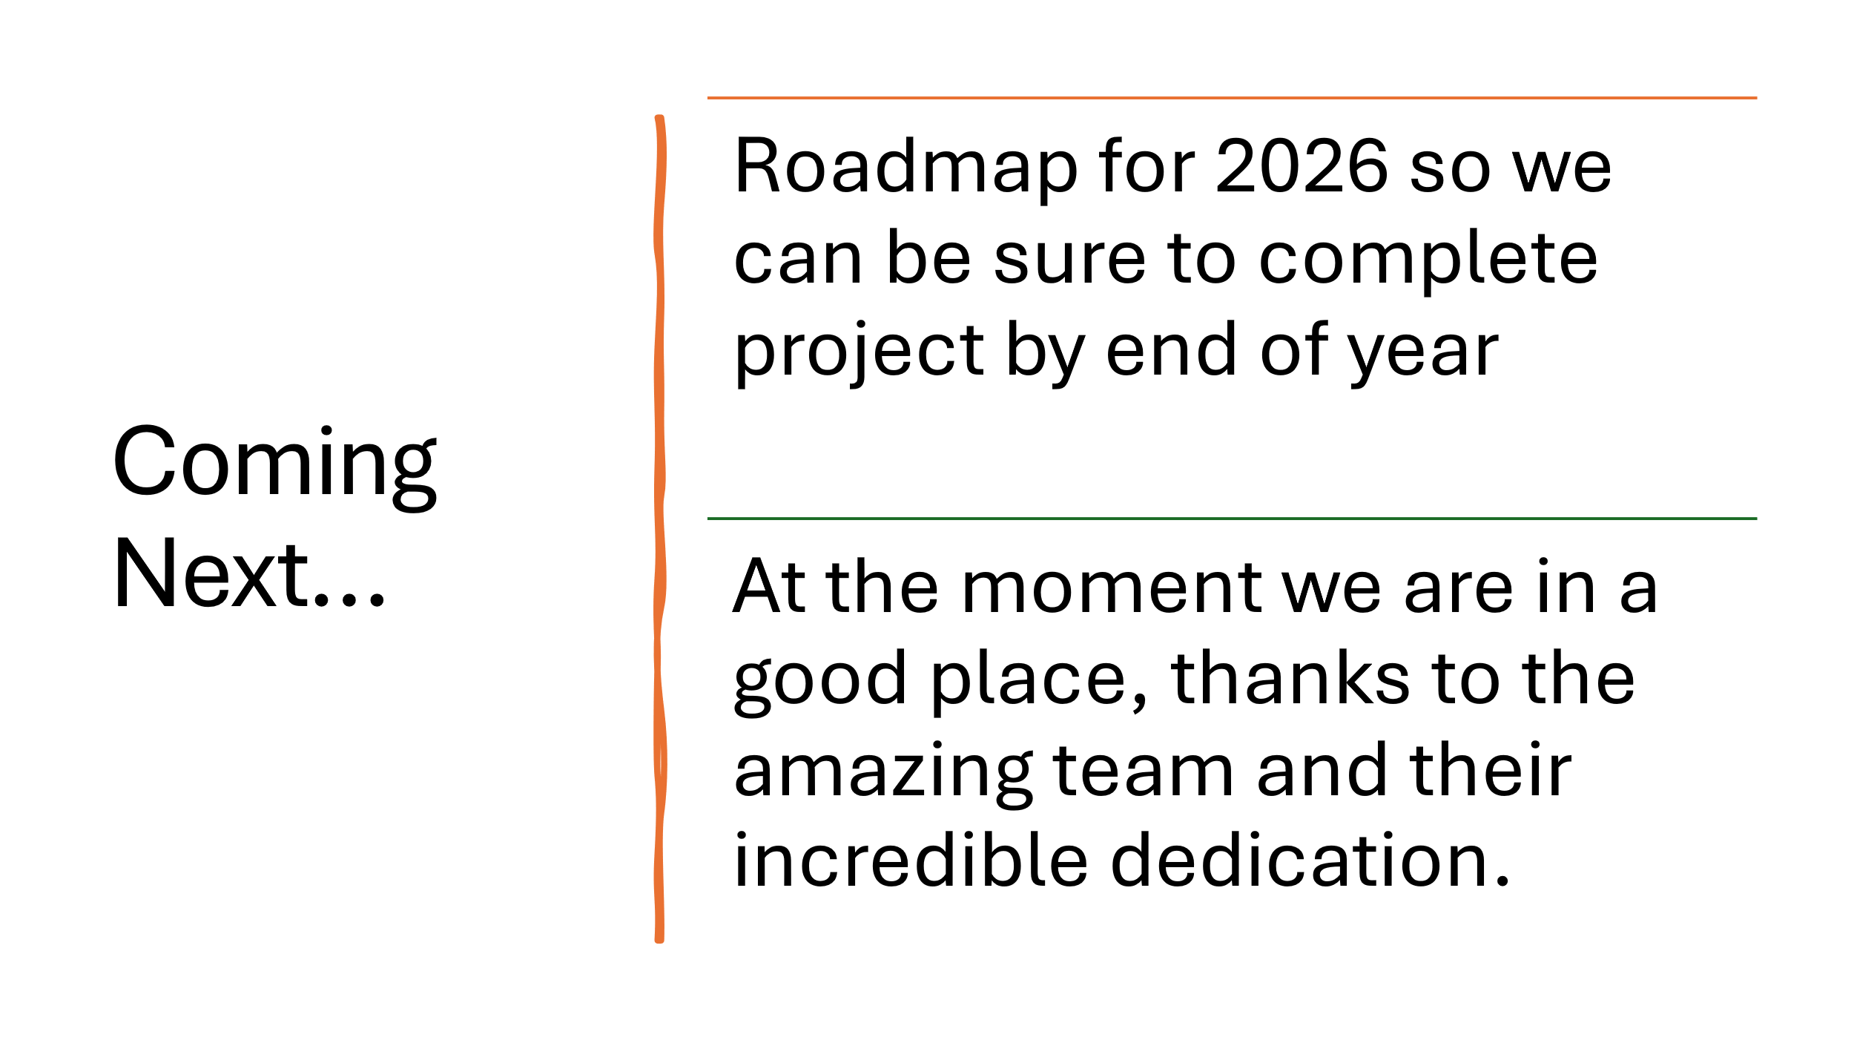

Reports by Month
January-Search, Discovery, and Delivery, Web
February-Digital Production, Repositories, Preservation, and Access, LEITC
March-Cataloging and Metadata, Electronic Resources
April-Search, Discovery, and Delivery, Web
May- Digital Production, Repositories, Preservation, and Access, LEITC
June- Cataloging and Metadata, Electronic Resources
July- Search, Discovery, and Delivery, Web
August- Digital Production, Repositories, Preservation, and Access, LEITC
September- Cataloging and Metadata, Electronic Resources
October- Search, Discovery, and Delivery, Web
November- Digital Production, Repositories, Preservation, and Access, LEITC
December- Cataloging and Metadata, Electronic Resources

