Collection Development Committee Minutes
September 22, 2026

Present: Tom Teper, Wendy Shelburne, Jennifer Teper, Jen Yu, Caroline Syzlowicz, Anna Liss Jacobsen, Esra Coskun, Rachel Scott, Emily Benton, Steve Witt, Cindy Ingold, Hannah Williams (minutes)

- Agenda and minutes
- Bylaws discussion
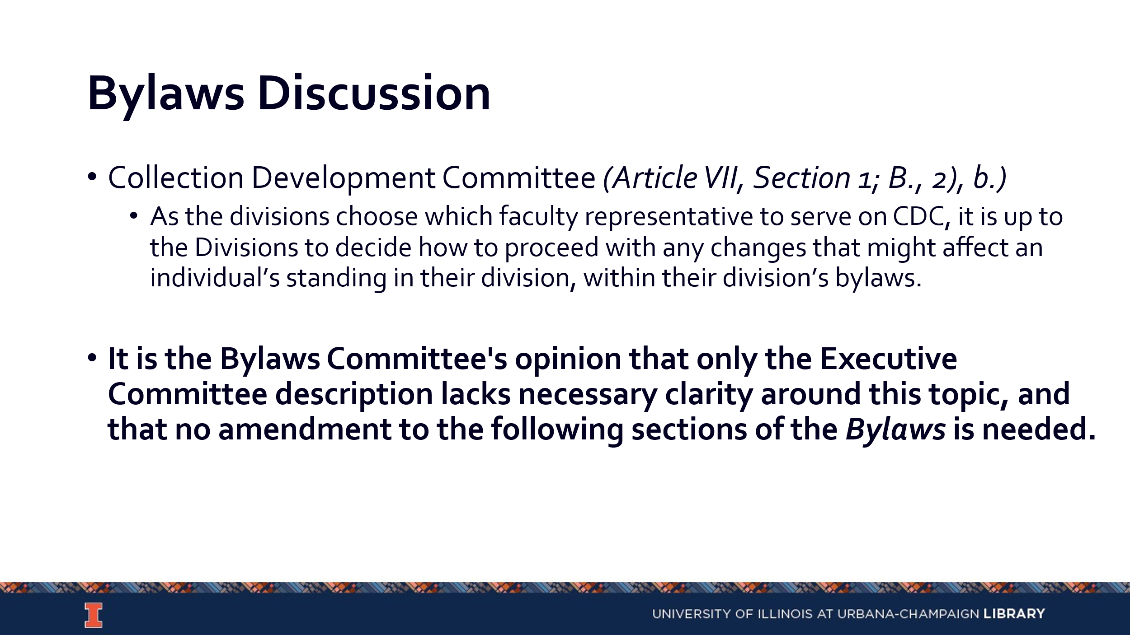
  - We should have no real change to CDC membership until we get through the governance refresh. If the governance refresh has impact on how divisions are structured this will impact the membership of CDC.
- Offers under consideration
  - Inside Higher Education
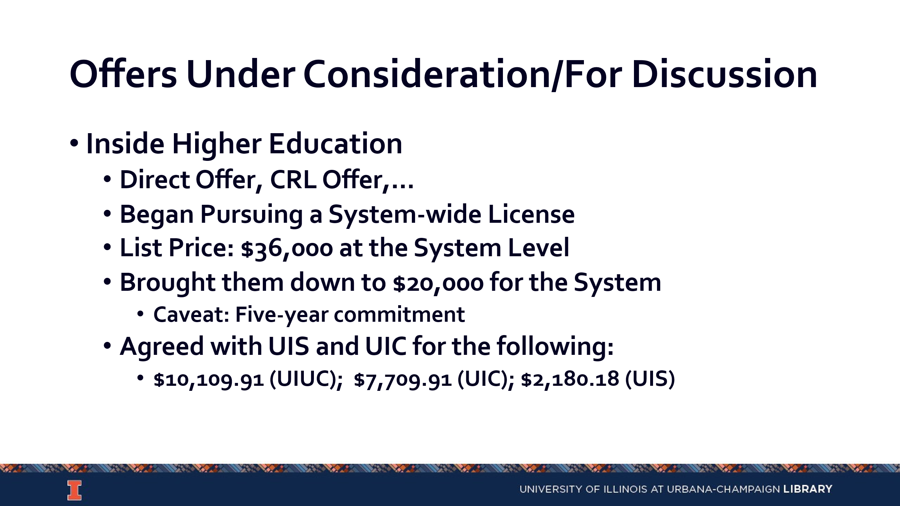
    - This is moving from advertising supported model to fee-based subscription.
  - T&F Serials
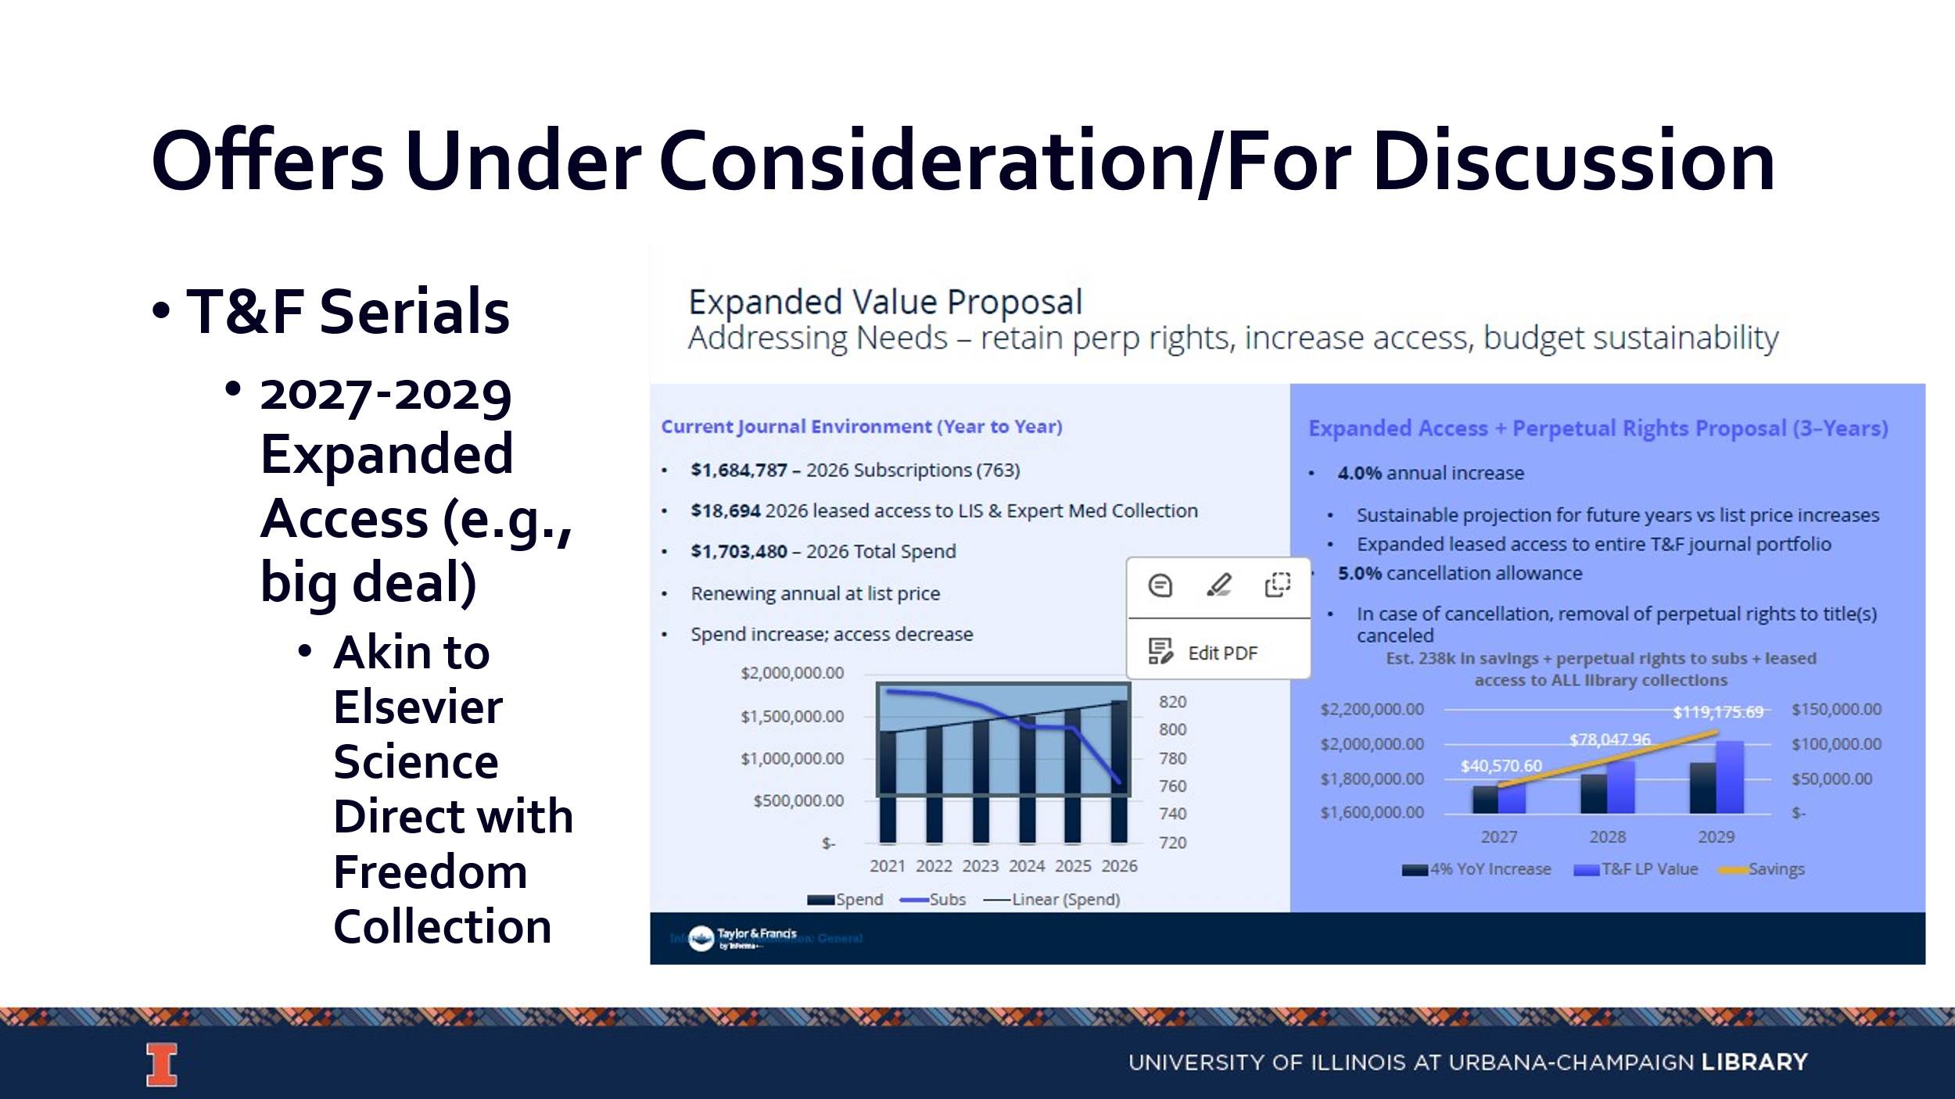
    - We do title by title purchasing with them and do not have a large deal. This has been a safety valve for years when things are tight in the budget.
    - They have given us an offer to shift from title by title purchasing to big deal purchasing. The suggested deal is akin to Elsevier.
    - We would be paying for access to titles, which would not be owned and would not have perpetual access.
    - They are proposing a 4% fixed annual increase. This would increase the number of titles that faculty have access to and would allow for a more predictive pricing model.
    - This would likely not be in place for calendar year 2027 and likely wouldn’t include anything for read & publish off the bat.
    - CDC believes this is worth exploring.
  - OUP Serials
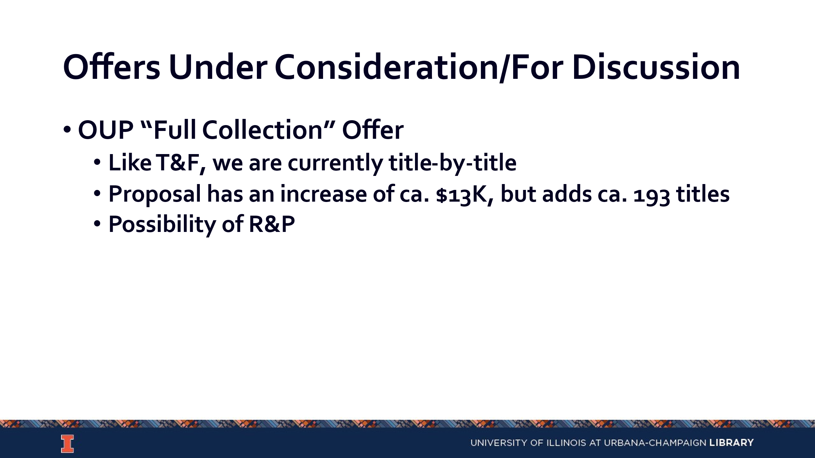
    - This would be perpetual access.
    - Engagement from OUP Academic
    - CDC believes this is worth exploring.
  - Coherent Digital
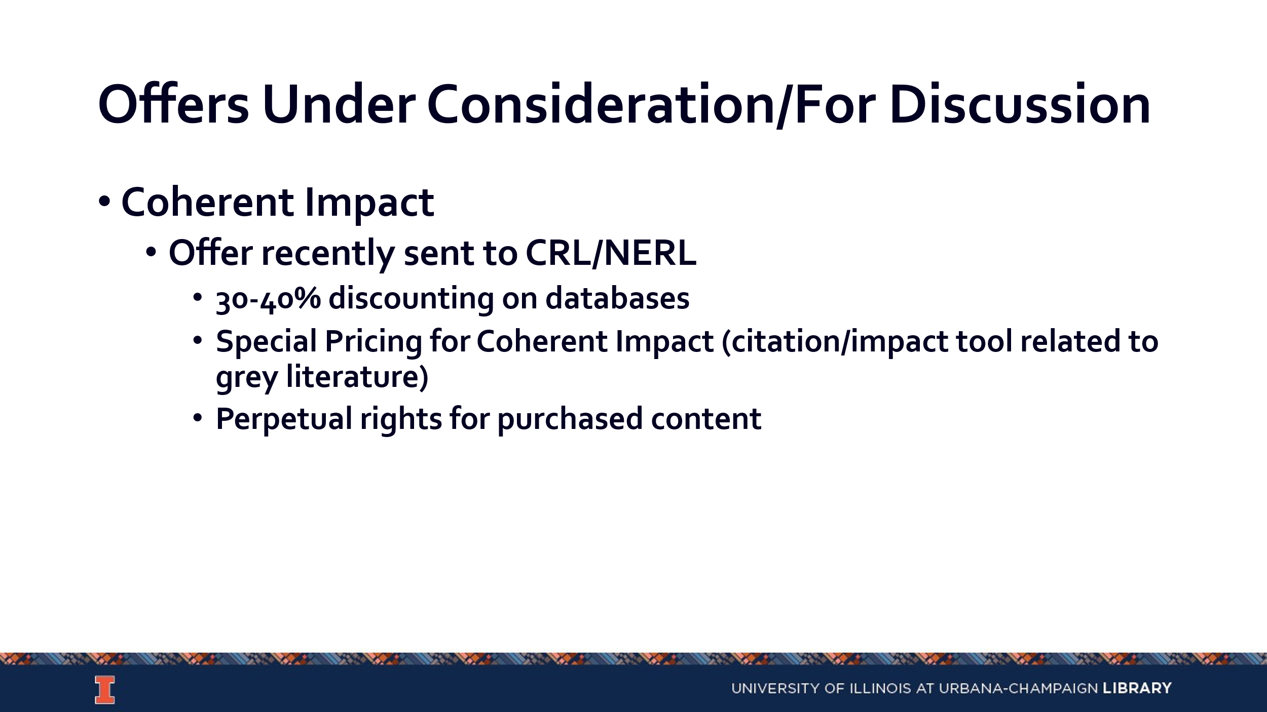
    - As databases are added, access would be given with no additional cost.
    - There might be potential options for integrating this into other services, like IL experts.
- Update on existing projects/programs
  - T&F ebooks
    - Amy is pulling data from across the system to identify materials we should purchase and deduping ones we already have from other platforms. She will come to a future CDC meeting to go over this in more detail.
    - There is a need to incentivize continuing EBAs beyond years three and four, and they are working on this.

- FY28 budget prep
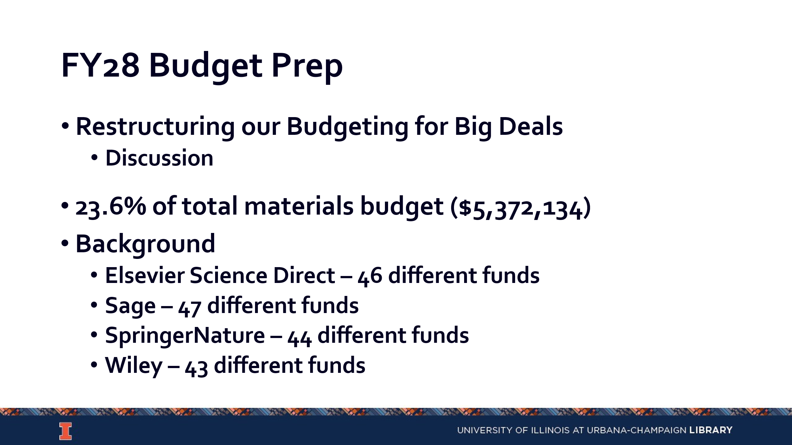
  - We have not centralized funding for various big deals for the most part and need to consider if we should restructure the budget for materials allocation.
  - Many disciplinary funds are already spoken for by the larger bills. This limits the ability of fund managers to make decisions, when they don’t have an accurate status of their funds before final bills have been processed. This also puts pressure on ACS to move the bills through quickly.
  - Elsevier and Springer are more complicated than Sage and Wiley and would require more thought and discussion. This also needs to be a larger discussion with subject specialists and fund managers.
  - CDC believes there is a need for communication and consensus building but overall its not a bad idea.
- AI in Platforms
  - No one is effectively in charge of a process to determine if we activate an AI module in a platform. We need to consider what the process or decision making should be for this.
  - Many platforms have run AI in the background unbeknownst to us, and we have little agency and incomplete information for AI use in many of our platforms.
  - We should consider adding a disclaimer on our pages to acknowledge that we don’t have control over the systems and potential use of AI in them.
  - The problem is larger than the Library and needs to be done more collectively with the people paying for data bases to gain some agency in how they operate.
  - We don’t have a common understanding of what AI tools we have control over or a common way to communicate that to faculty or students.
  - This is worth exploring at a future CDC meeting with specific examples.
- Updates
  - Acquisitions – There is a new rep for GOBI.
  - E-Resources- No new updates
  - Preservation Services – No new updates.
  - BTAA Updates- Credits for Gold OA Publishing ran through August 31st. The ongoing discount for Gold OA publishing is 15%. Hybrid OA is covered 100%. This information has been updated on the Scholarly Communications website.

--

Meeting adjourned at 4:30 pm.

