CAPT Minutes
October 30, 2025

1. Approval of Agenda and Minutes (5 minutes)
- The agenda and prior meeting minutes were reviewed and approved without amendments.

2. ADA Title II: Recommended Sub-Groups (Presented by John Laskowski)
John Laskowski discussed the establishment of two proposed task forces arising from the mid-year roadmap review:
A. Library Support / Best Practices for Accessible Course Readings
- Focus: Support for teaching faculty in providing accessible course materials.
- Noted the lack of a centralized service for course accessibility.
- Campus is testing a PDF remediation workflow expected to automate ~80% of accessibility corrections.
- Key concerns include faculty misconceptions about accessibility (e.g., that all PDFs are automatically accessible).
- The task force will develop proactive guidance for faculty and library staff on accessible course readings, discovery, and use of tools such as the Internet Archive and ILL.
- Coordination with interlibrary loan (ILL) processes remains under legal review to determine compliance boundaries.
B. Accessibility of Digitized Archival Collections
- Focus: Ensuring accessibility compliance in the digitization and management of archival collections.
- Clarified that materials created before June 2024 are generally exempt under current Title II interpretations; new materials will require WCAG-compliant digitization.
- The group will examine digitization workflows, prioritization, and potential automation for remediation.
- Discussion included:
  - Coordination between Preservation Services, Special Collections, and Archives.
  - Balancing workflow adjustments with turnaround times.
  - Avoiding overloading key personnel (e.g., Krista’s heavy workload noted).
  - Defining timelines—first group targeted for completion by Spring 2026; the second is a longer-term effort.
  - Clarifying inclusion of born-digital materials created after June 2024.
  - Addressing requests for remediation of already-digitized items assigned in courses.
- John will revise the draft charges and membership lists to reflect these discussions and distribute updates to the committee.

3. Free and Open Use of Online Public Domain Reproductions, Metadata, and Digitization Requests
Presented by Eric Mosher (with comments from Kyle Rimkus, Tracy Tolliver, and Michael Norman)
- CAPT reviewed an amendment to the statement on “Free and Open Use of Online Public Domain Reproductions, Metadata, and Digitization Requests.”
- The proposed addition (Section 6) allows for harvesting of public domain metadata via OAI-PMH, enabling inclusion in the Illinois Digital Heritage Hub (IDHH) and Digital Public Library of America (DPLA).
- Discussion points:
  - Once metadata is exposed for harvesting, it can be accessed by external entities, including AI systems.
  - Members acknowledged potential exposure risks but agreed that open access outweighs limitations.
  - Consensus: Metadata should remain free and publicly harvestable; monetization is not being considered.
- Action: Eric Mosher will finalize and correct the text for publication after consultation with Dean Stewart for confirmation.

4. Quarterly Working Group Reports
Search, Discovery, and Delivery (Michael Norman & Kate Lambaria)

Search, Discovery, and Delivery Working Group Report – October 30, 2025

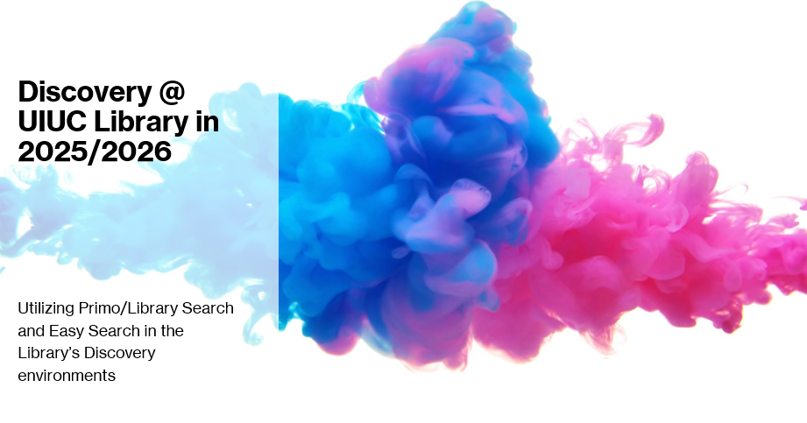
- Since our last CAPT report, the Working Group has been very busy updating the various Library’s Discovery Environment
- July 21, 2025: CAPT SDD WG Co-Chairs shared 2025-2026 Library Discovery proposal via email to LibNews (Subject: Upcoming changes to single search box on Library gateway)
- August 1, 2025: Launched toggle option between Easy Search and a new Library Search option (Primo Library Catalog+) on Library Gateway. This Toggle Search Box will be available 2025-2026 academic year. The default option is Easy Search, although the toggle is “sticky” so a user’s browser will remember which option they previously selected.
- October–December 2025: CAPT SDD WG Co-Chairs visiting Library Divisions to discuss unit and division discovery needs
- In late December 2025: the CAPT SDD WG will host open, library-wide sessions on the future of Library Discovery
- Spring 2026: there will be continued maintenance and user testing and working on the continued configuration of the new Primo UI to be released in the Summer 2026.

Hopefully you have experienced and worked with the Library Search option now available on the Gateway and the toggle that allows you to move back and forth between it and Easy Search. We’ve talked previously about the ongoing desire to increase the visibility of the Primo search experience, particularly as we see the Primo Central Index and Easy Search results becoming similar in scope and sources.

The Toggle options in the Single Search Box available:

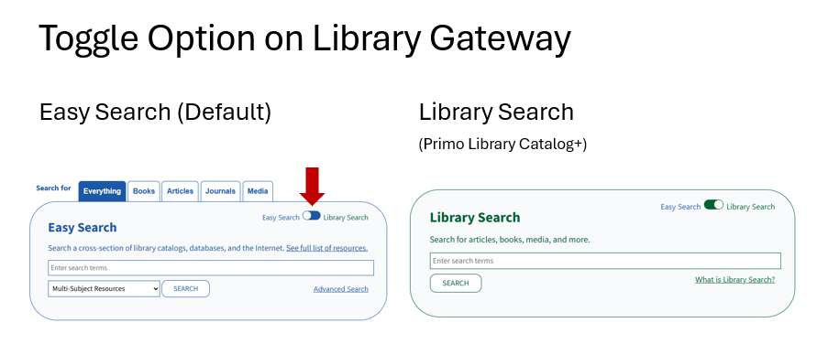

We are seeing increase in the direct use of the Primo/Library Search service but Easy Search is still seeing high level of usage per day.

Reminder that the Primo/Library Search (Library Catalog+) is:

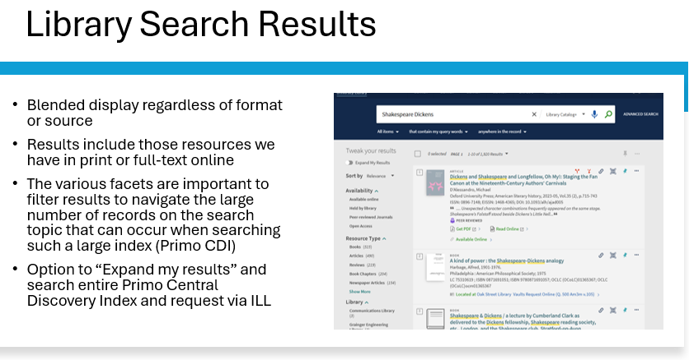

Optimizing Primo for Search and Discovery of Newspapers:
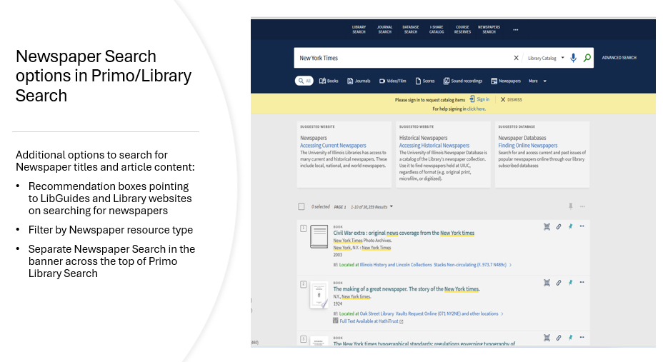

Activating the Browzine service in Primo:

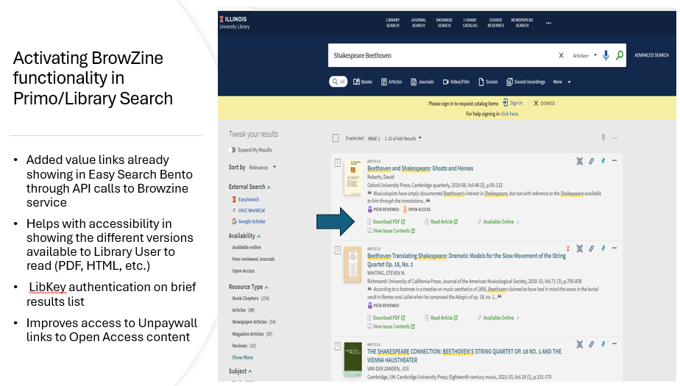

AI Insights

Available in August 2025, Ex Libris is offering a Primo AI Insights feature that links into the ProQuest systems to provide AI-generated summaries and show related references based on the Ex Libris Central Discovery Index (CDI) and the natural language search query. The Working Group is continuing to discuss and investigate the option to active this search within the Primo CDI for access to the service in Articles+ and Library Catalog+. The screenshot below shows the Primo AI Insights activated in our Primo DevTest version.
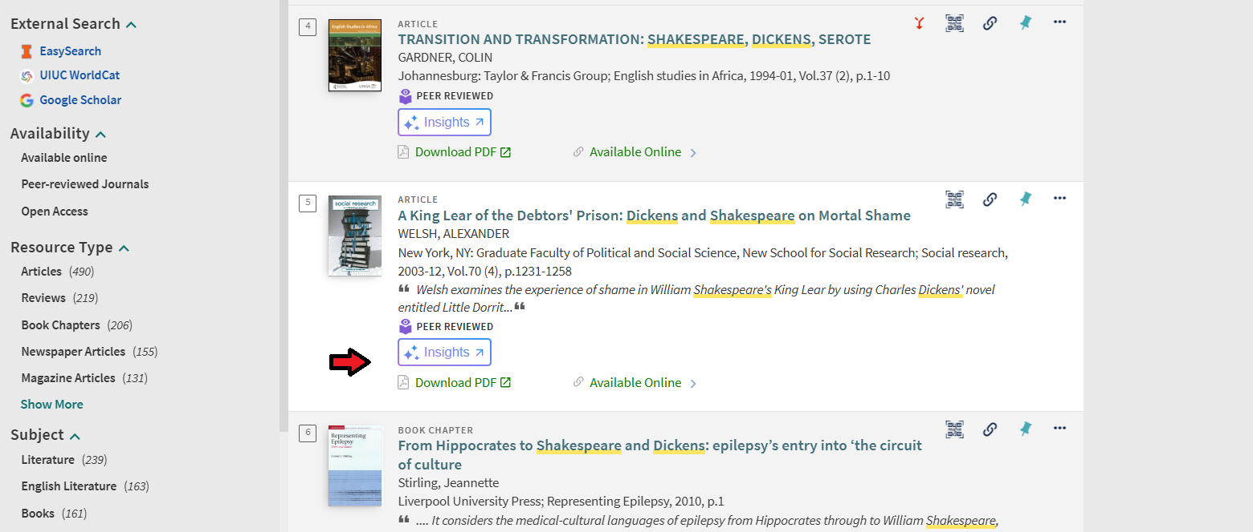
These features (recommended resource boxes and separate newspaper search, BrowZine, and AI Insights) are still being discussed within the Working Group to guarantee we implement options that function best for our users. For example, the BrowZine API offers 5 different configuration options which the WG is reviewing.

Creation of Team Dynamix for Primo Maintenance

The Working Group discussed the creation of a Team Dynamix for Primo Maintenance as there is difficulty internally about how best to report issues in Primo. The full group will monitor tickets submitted to the queue with the co-chairs monitoring and delegating to make sure tickets are resolved. The Primo Maintenance Team Dynamix will be ready in November 2025 and the WG will communicate to the Library by email to LIBNEWS when it becomes active for service.

User Experience

The sub-group focused on user experience testing was able to incorporate discovery-related questions into the Library Assessment’s standing library satisfaction survey (with support from Tom Teper, thank you!). Questions were designed to gather information about the types of information sources students seek when using the search features on the library website, when in a student’s research process, they consult the library website, and what criteria are most important when selecting sources. The sub-group will be reviewing preliminary results in their November meeting and using the information to help establish a baseline to build from moving forward.

Web Working Group (John Laskowski)
- Reported on updates to the library’s web navigation structure.
- The current global menu (developed ~7 years ago) is being reviewed for accessibility, user focus, and consistency.
- Planned actions:
  - Develop a prototype site using the university’s central WordPress theme and tools.
  - Reorganize top-level pages for clarity and accessibility.
  - New and revised sections will include:
    - About: Mission, governance, and statements on DEIA and intellectual freedom.
    - Services & Spaces: Updated navigation for study, reflection, and lactation rooms.
    - Policies: Integration of the policies site and public access via shortcode templates.
    - Faculty, Staff & Accomplishments: Centralized recognition and information repository.
- Feedback and UX engagement sessions will follow after prototype completion.

Meeting adjourned at 2:43 p.m.

