CAPT Minutes
March 26, 2026

Present: Tom Teper Kyle Rimkus, John Laskowski, Sarah Park, Michael Norman, Mary Ton, Tracy Tolliver, Chloe Ottenhoff, Wendy Shelburne, Will Schlaack, Jennifer Teper, Hannah Williams (notes)

- Approve agenda and minutes

- Quarterly working group reports

- Cataloging & Metadata- Chloe Ottenhoff

Cataloging and Metadata Working Group
2026 Q1 Report
March 26, 2026
Submitted by Chloe Ottenhoff
Meetings: Met 2 times since last report, January 15 and February 19; no March meeting
- Membership update:
  - Rachel Scott, Head of ACS, joined the group as ex officio
  - Jenny Johnson will be retiring at the end of May
- BIBCO membership
  - Have been approved as a BIBCO participant in PCC (Program for Cooperative Cataloging) to contribute monographic bibliographic records
  - Waiting to be assigned a reviewer and begin training
    - Delay may mean that active participation will be put off to coincide with Official RDA training and implementation
- Official RDA
  - Libraries will need to implement Official RDA by April 30, 2027
  - Still in a holding pattern, waiting for PCC to produce guidelines, documentation, and training programs
  - ALA workshop this summer, with free webinars becoming available in fall/winter
  - ACS folks starting to compile resources and go through training that is available
- BIBFRAME/Linked data editors
  - MJ continues to attend meetings and informational sessions on the various BIBFRAME editors that will be made available and are in development
  - Ex Libris has developed their own editor, which finally became available for testing in the Alma Sandbox in mid-February
    - Most viable editor as it does not require additional subscriptions or memberships (unlike OCLC’s editor and ShareVDE)
    - Ex Libris will provide both MARC and BIBFRAME editors and support management of records in both formats
- Alma/Primo Updates
  - Michael gives the group regular updates
    - Continue to work together to improve and enable the display of MARC fields in Primo – most recently with CARLI to get all 264 fields (producer, publisher, printer) to display
- LC Announcement re: $$v form subdivisions (effective February 2, 2026)
  - In anticipation of linked data (or entirely post-coordinated data), LC will no longer add form subdivisions (e.g. Fiction, Poetry, etc.) in subject strings, in favor of genre terms
    - There will be no retroactive removal/cleanup
    - Problematic because certain user groups – music, children’s, special collections – rely on these strings to collocate resources and there are form subdivisions that have no equivalent in LCGFT
  - We will follow PCC practice, and continue to use both subject strings and LCGFT (or other vocabularies) as appropriate
    - Will work to ensure that genre terms are applied consistently and accurately to better align with LC practice

- Electronic Resources- Wendy Shelburne
ERWG CAPT Report 03/26/2026

ERWG has met once this semester (March 4th). We had a bit of informal discussion around AI and also some upcoming changes to the ebscohost ebook reader which is moving away from Adobe editions. Our main topic of discussion was the continuing work around remote access work with shibboleth. We did update SSO authentication (with the continuing assistance of Technology Services) on the following platforms in January -- Elsevier, Springer, Wiley, Proquest, Taylor and Francis, Oxford, and IEEE. We really didn’t receive much in the way of complaints regarding this change. The next platforms slated for change include AIP, ACS, ASCE, Annual Reviews, American Physical Society, BioOne, BMJ, Cambridge, DeGruyter Briil, Emerald, IOP, JSTOR, Project Muse, Royal Society of Chemisty, and Sage. We are also discussing next steps of aligning VPN access to match what we have alreday done with EzProxy and what is currently happening with SSO.

- LEITC- Mary Ton

LEITC Updates 03/2026

- Membership Changes: Eric Kurt and Stu Turner have decided to roll off of the committee. Many thanks for their years of service!
- AI Literacy: The ad-hoc working group continues to organize events and create resources. A working outline for the “AI in the Research Process” Canvas module is open for comments until April 3rd with two design sprints planned for mid-April to develop content. X+AI curriculum plans are moving forward, including campus-wide summer upskilling program for faculty and staff.
- Emerging Media: In January, Mary proposed an environmental scan of emerging media services to compliment our reports on digital scholarship and purchased text mining collections. Megan indicated that Grainger was doing a scan as part of a mission/vision/scope statement work and would inform LEITC of the results. That project has since evolved into a scoping document to guide patron expectations, which will be shared with LEITC when ready.

LEITC Charge Discussions

Because Grainger is now responsible for emerging media operations, the committee plans to review our charge and monitor how the reorganization might impact emerging and integrated tech services more broadly. We considered the following questions:
- What things could LEITC be doing to contribute to the Library?
- What is LEITC’s role?
- Does our charge need to change to reflect this evolving role? If so, how?

In January and March, we discussed the following areas as potential focal points for future committee work:
- Advocate for campus-wide research software,
  - Gather data on use cases and develop reports on potential impact of purchase
  - Work with Tracy and Tom to communicate those needs to broader campus IT networks and potentially negotiate funding buy in from other units
- Communicating software changes and service updates
  - Use TLAS’ emails as model to convey the contributions of emerging and integrated tech to library’s mission
  - Update the library on licensing changes
- Anticipating emerging tech curriculum needs (i.e. X+DS and X+AI majors)
  - Communicating technical infrastructure needs as new major

Are there other areas of emerging and integrated tech that the committee could focus on?
General Updates
Below is a brief summary of activities led by LEITC committee members. For an expanded list of activities, please see our meeting minutes posted on the LEITC committee page.

- Service Updates
  - SCIM Studio (Media Commons) is now open! Consultation form is available on the Media Commons website. The space has limited availability due to schedules. Mondays is the main day for access and use, but other days can be discussed in the form.
  - The 3D printer for library departments is still in the process of being added to Grainger Library’s in-house collection as it is part of the Grainger Library’s Technology Enhanced Classroom Room 335. It will be available once that room is completed and all documentation is finalized (policies, how to use, supplemental materials, services, etc.).
  - Media Commons is in process of adding the text-to-speech pen to the loanable technology as there were some issues with its cases.

- Events
  - Lauren Goodlad’s lecture on Critical AI in February was well attended—standing room only in the Media Commons with another 50 joining online!
  - Domestic Science Edit-a-Thon was a success! Debuted a new AI-enhanced archival research tool, Archive Lab. Learned that OpenAI tends to misspell named entities and will not transcribe documents that mention Bunsen burners.
  - AI for Qualitative Data Analysis session had an engaging panel discussion with Jess Hagman, Chris Lehmann, Jen Hardesty, and Mary Ton about research, privacy, and ethics.
  - Detecting AI Generated Content Savvy had a lively Q&A session about student writing and AI use, including questions about how to manage suspected cases of AI use that violate the class policy.
  - Console Game Showcase at GELIC on Thursday, April 9 – Patrons will engage with the console loanable tech pool (consoles, games, accessories).
  - Campus is hosting an AI Expo on April 15th. Tracy Tolliver and Yali Feng will be staffing a table, co-located with CITL and Tech Services.
- Grants
  - There was an IMLS grant for AI in databases involving Sara Benson and Melissa Ospeck.
  - Letter of Interest for the Mellon Open Call for Concepts submitted by Ryan Cordell, Travis Wagner, and Mary Ton to support critical making as a vehicle for AI Literacy.
  - Chris Prom was coordinating a proposal for the Schmidt Sciences Humanities AI Virtual Institute that brought together various projects from the Library. That proposal ended up splitting into multiple. MJ Han submitted a proposal with folks in CS to study AI approaches to gesture in Oral History interviews. There were at least 5 proposals coming from the iSchool.
  - Parthenon at Illinois (Mary Ton, Elias Petrou, and Victoria Austen) received $30K from the Campus Research Board for scanning and replicating friezes at the Spurlock.

- Accessibility Roadmap – John Laskowski
- Focal points for this year’s roadmap: Libguides, web policy, staff site, Accessible Reader Support Taskforce, Title II archival process management, document management, continuing to improve accessibility of homegrown platforms and web development
- John and Eva are working on two companion documents: 1) policy to set governance & expectations 2) style guide and guidelines for Wordpress accessibility .
- Any issues with the staff website since its relocation behind Shibboleth should continue to be sent to John through a Team Dynamix ticket.
- A Reader Support Task Force has been launched and is co-chaired by John and Cherie Weible. This will be a partnership to assist teaching faculty with finding and identifying accessible content within the catalog. It will also provide reference-based support for our service points.
- Processes across the Library need to be finalized for accessibility of archival materials. Language will need to be finalized for use on different archival platforms to indicate what purpose they serve and how they may not be accessible for various reasons.
- We are still waiting for campus to develop and finalize the automated remediation processes, particularly for PDFs.
- April 24th was the originally provided date by which we would need to be compliant. Campus reiterates that this is a university responsibility and the obligations are not just on us at a Library level.

- 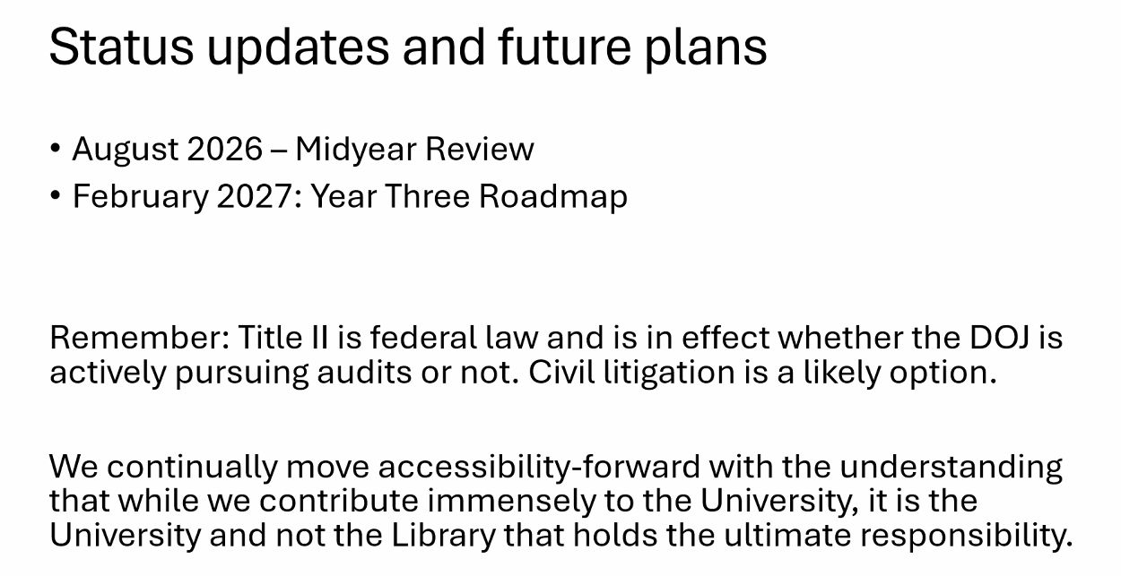

- Parking lot items-review

- Any other new business

Meeting adjourned at 2:39 PM.

