What are we doing?  Engaging in ongoing discussions with decision-making bodies within the Library involving governance matters.  Collaborating with other committees.  Connecting Civil Service Employees with available funding resources for professional development opportunities.  Scheduling drop-in sessions and providing feedback to raised issues and concerns.  Utilizing the LSSC Comment/Feedback form as a tool for gathering information on employee concerns.
  Current LSSC Membership by Division:
  - Area Studies …………….…Laura Poulosky l-poulo@illinois.edu
  (July 2026-June 2028)
  - Arts & Humanities…....Nicolette Coleman coleman7@illinois.edu (July 2026-June 2028)
  - Central Public Services……Maddy Hardy mhardy7@illinois.edu (Aug 2025-June 2027)
  - Central Public Services……….Ben Riegler briegler@illinois.edu
  (May 2026-May 2028)
  - Law & Social Sciences...Jessica Sommers sommers3@illinois.edu (Aug 2025-June 2027)
  - Life Sciences…………………John Bennett benntt@illinois.edu (June 2026-June 2028)
  - Physical Sci & Engineering…...... Stefanie Postula (Secretary) postula@illinois.edu (July 2026-June 2028)
  - Special Collections...Carrie Lingscheit carriel@illinois.edu (Sep 2025-June 2027)
  - Staff-at-Large……….………..….Alex Klec ajklec@illinois.edu (Aug 2025-June 2027)
  - Technical Services…..…..Kyle McCafferty kmccaff4@illinois.edu
  (Oct 2025-June 2027)
  - Technical Services…..….Rosemary Trippe (Chair) trippe1@illinois.edu (Aug 2025-June 2027)
  
  Library Staff Support Committee (LSSC)
  Communicating across the Library one step at a time!
  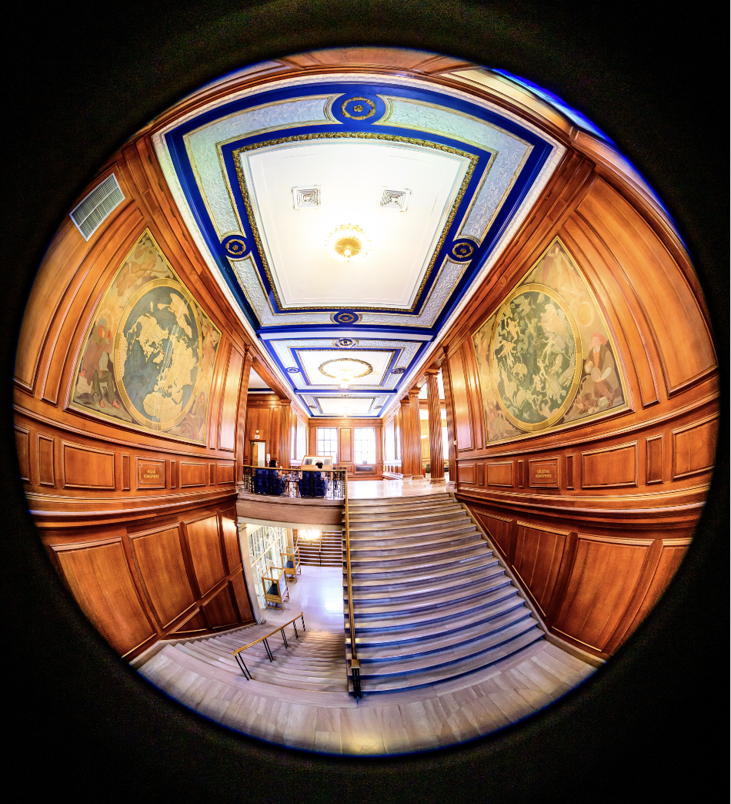
  Contact us today!
  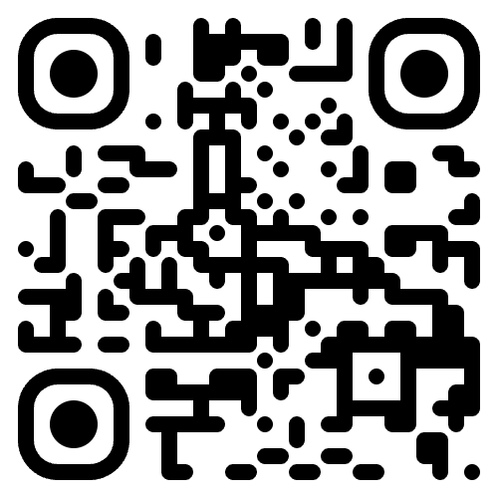
  We are listening!
LSSC serves as a liaison between the Library’s staff, its administrators, and librarians.  LSSC brings staff concerns and ideas before the decision-making bodies that can best address and act upon them.  Have a question or idea? Connect with us!    Want to know what’s going on? Chat with your liaison & check out our minutes! | CONTACT US  LSSC Comment Form:  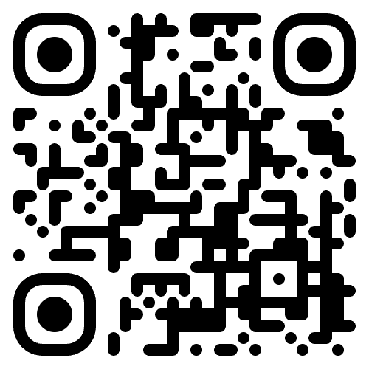  forms.illinois.edu/sec/120002  LSSC website:  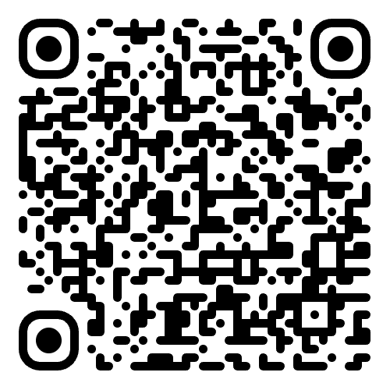  go.illinois.edu/LSSC  LSSC drop-in sessions: announced in libnews emails.  LSSC email: lssc@library.illinois.edu  Express any questions, concerns, or feedback you might have about work at the Library. | LIBRARY STAFF SUPPORT COMMITTEE (LSSC)  How can we help? Let’s band together!    WE ARE LISTENING!

