Collection Development Committee Minutes
June 24, 2025

Present: Tom Teper, Paula Carns, Jennifer Teper, Esra Coskun, Kit Condill, Jenny Johnson, Cherie Weible, Kelli Trei, Sanga Sung, Wendy Shelburne, Hannah Williams (notes)

Agenda/Minutes

Agenda and last month’s meeting minutes approved.

- FY25 Budget Updates

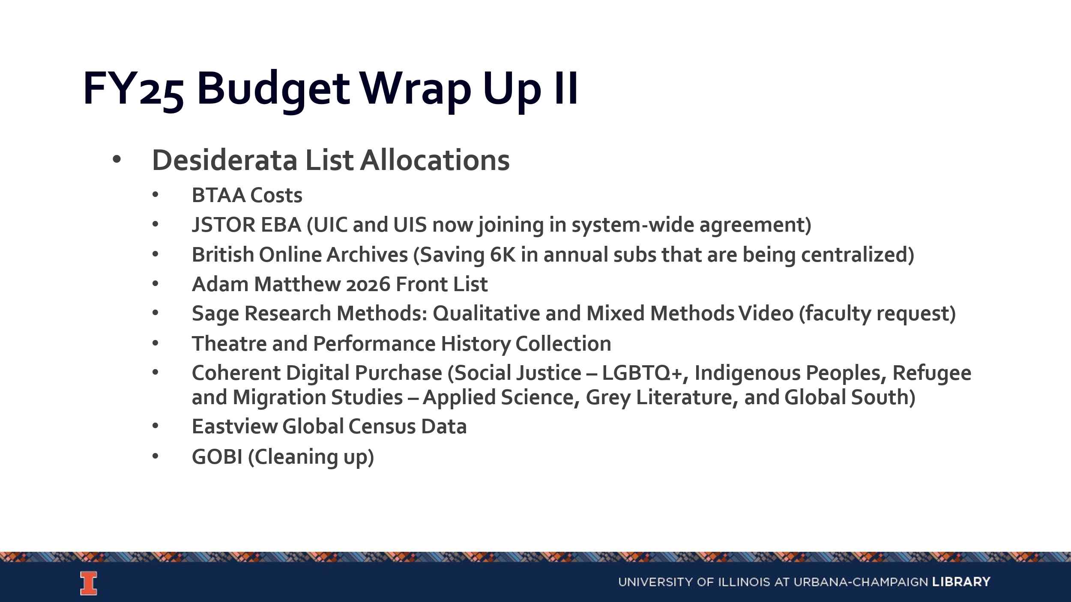

- FY26 Budget Update & Preparation
  - Allocation for FY26
    - We have not received budget information from campus yet. We are unsure about the potential impact of the salary program and how it will be apportioned out to colleges or if it will be self-funded until this is announced.
    - We also do not know the outcome with F&A rates will be. Grants have not been processed as quickly, which has decreased the total number of grants on campus and subsequently the F&A dollars.
  - FY26 Scenarios
    - No Funding from Campus
    - Partial Funding from Campus
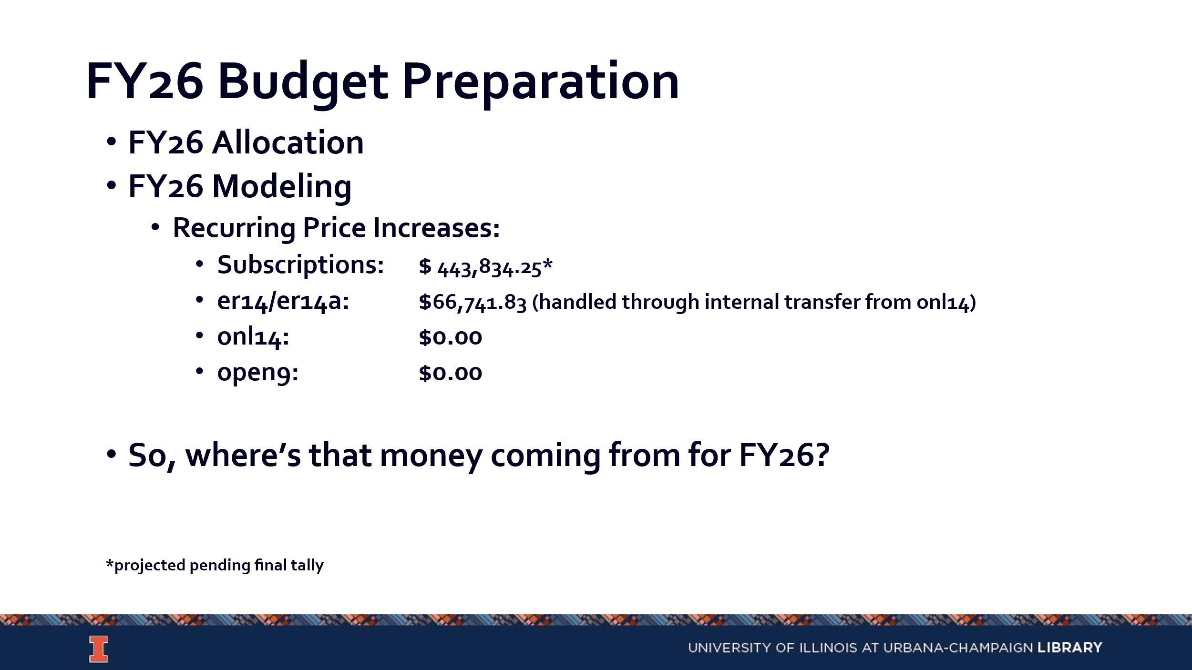
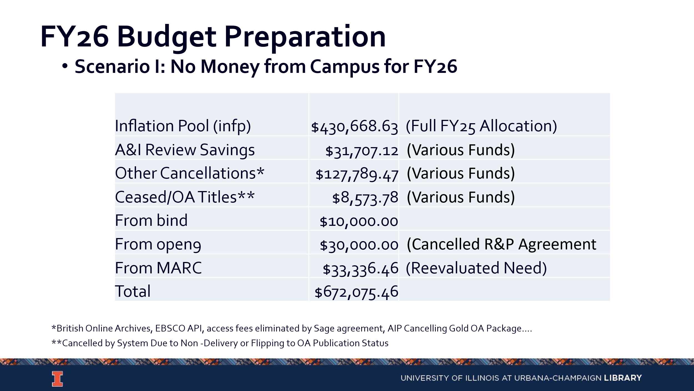
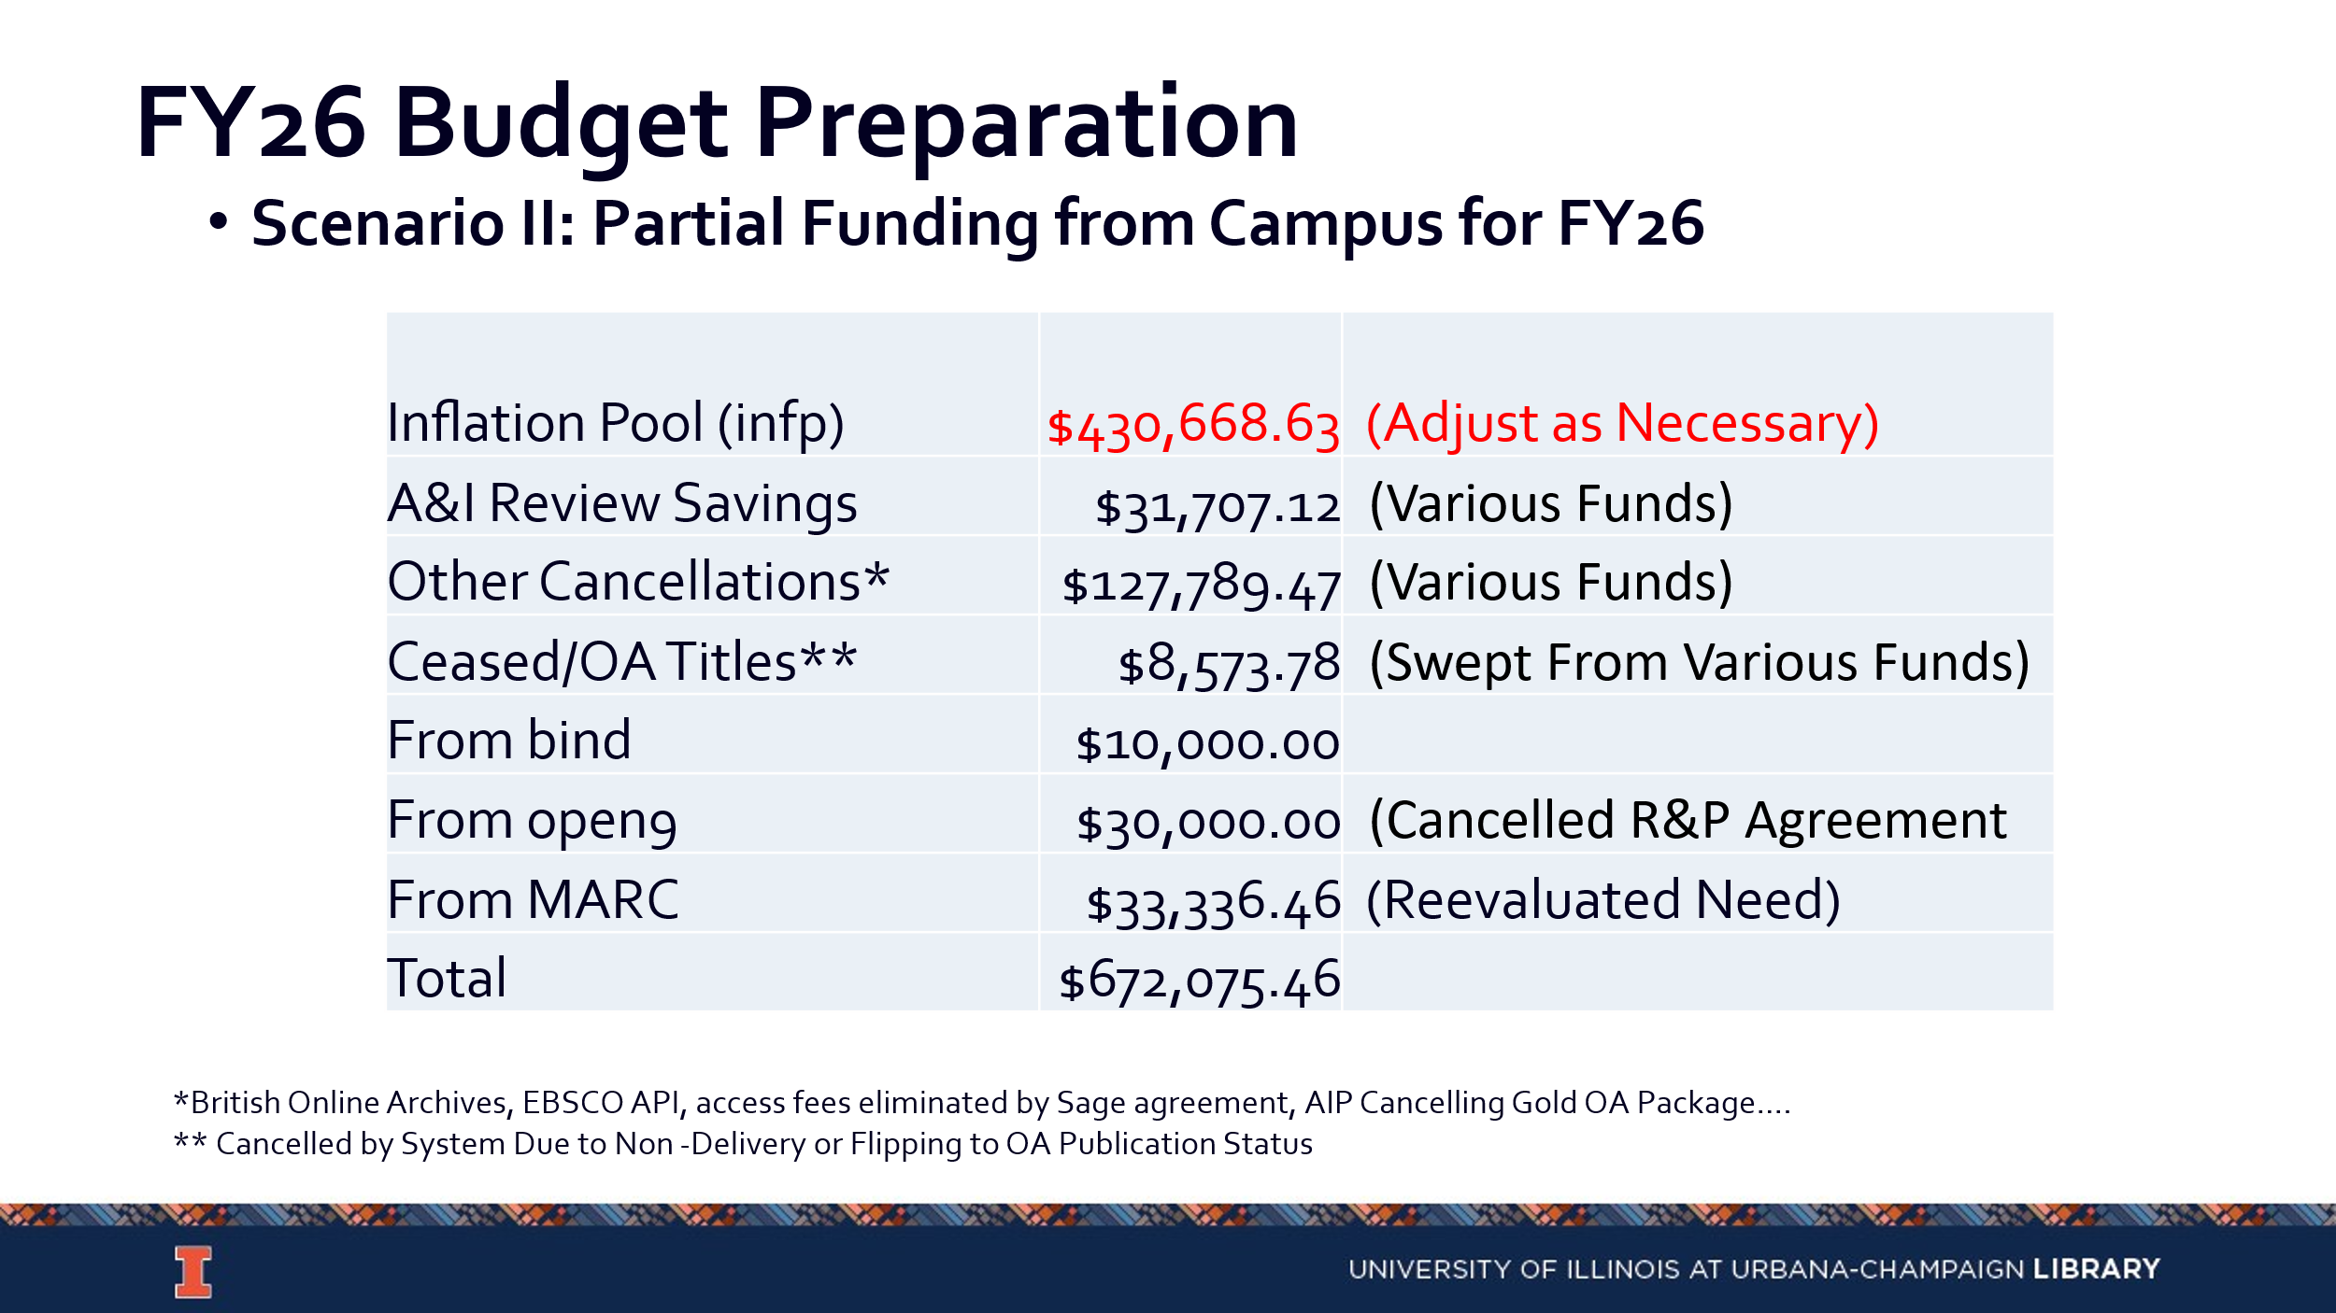
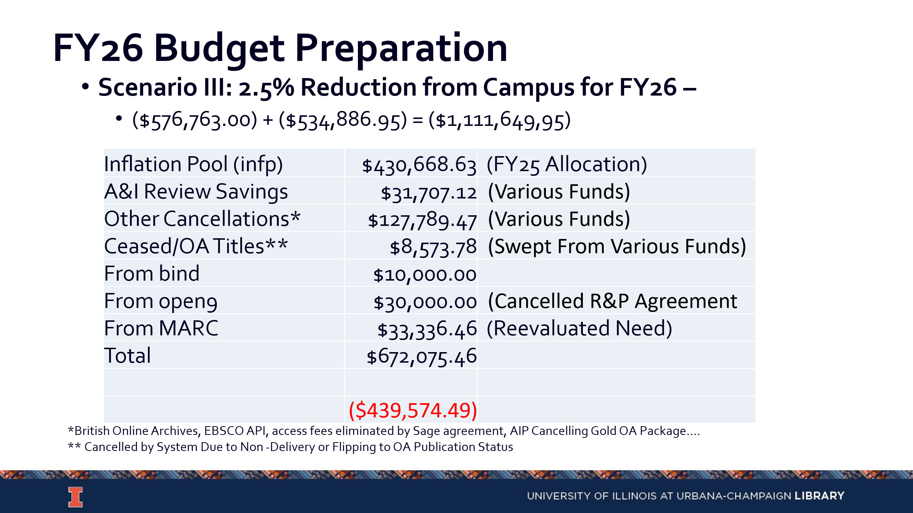
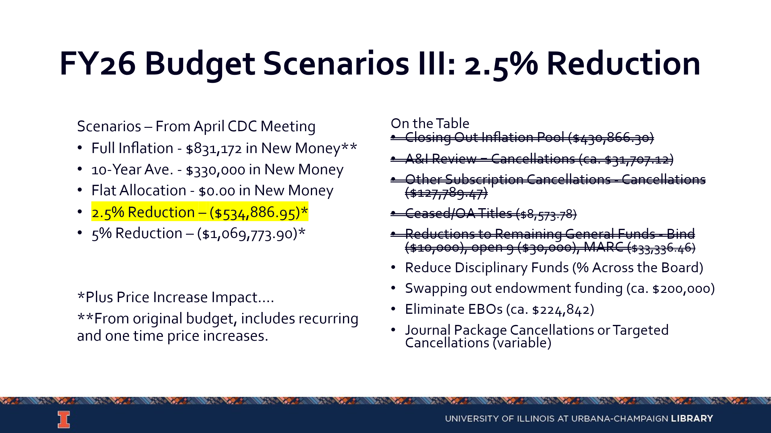
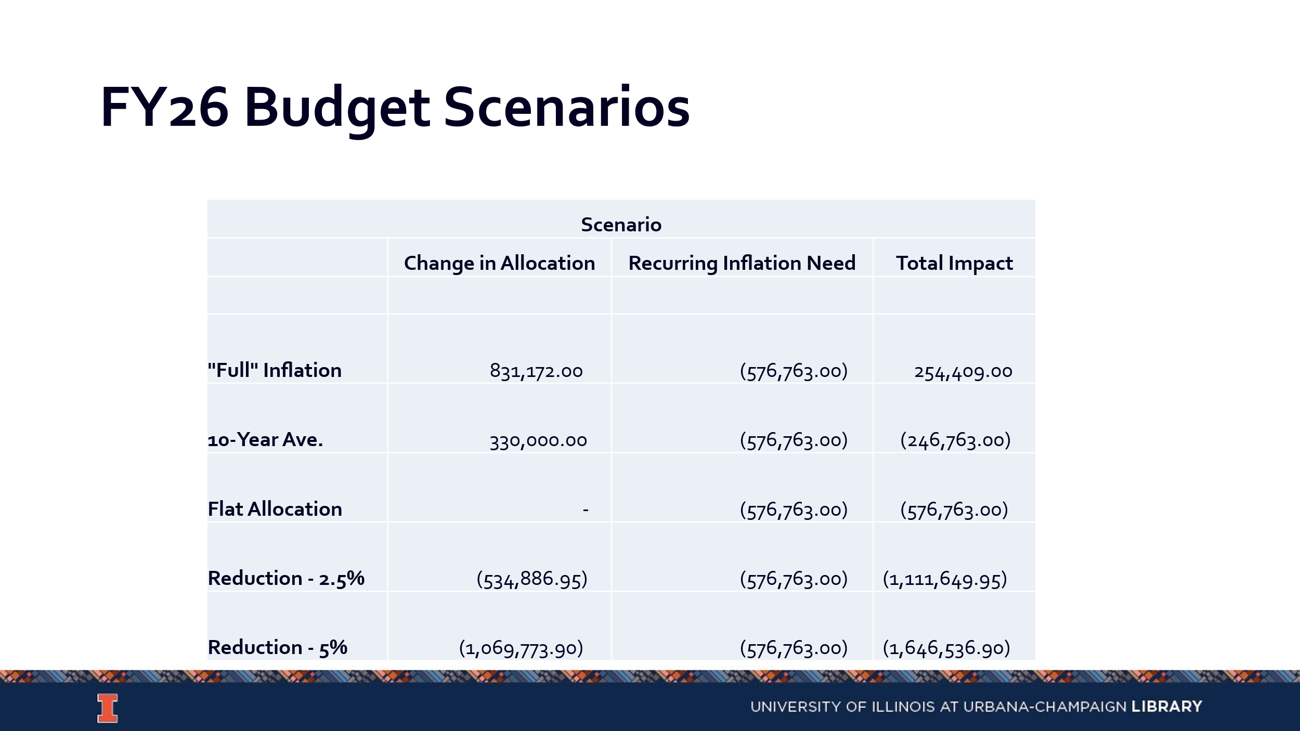
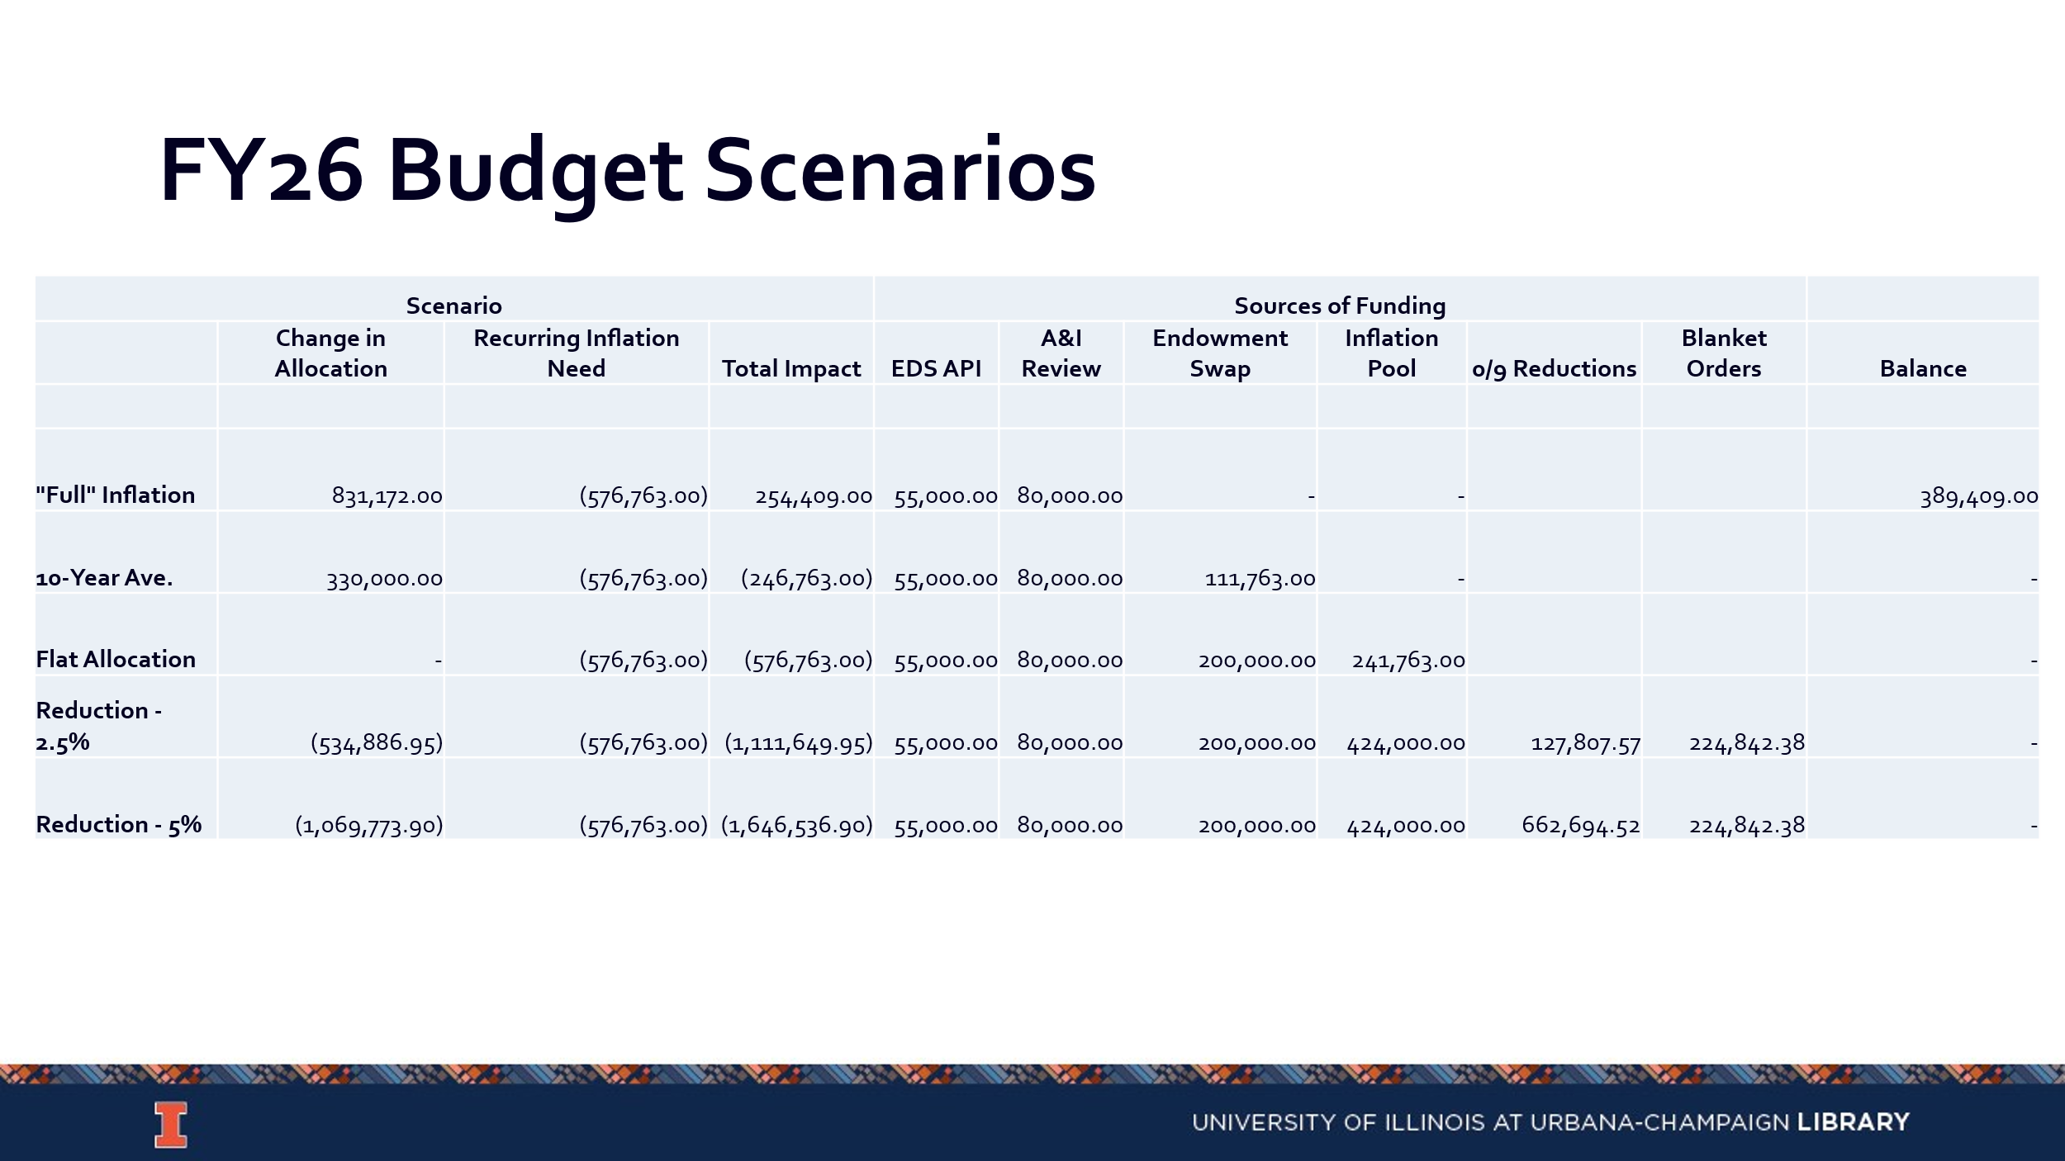

- Copyright Costs (Cherie’ Weible)
  - We paid copyright on 38 titles, with a cost of around $10,500. It is less expensive to pay on these individual titles than subscribing to those journals.
  - Copyright is done by the calendar year, not the fiscal year. Copyright payments are paid for journal articles that were published in the last 5 years and for which we have more than 5 requests. Articles older than that do not require a copyright payment.

- Collection Development Topics
  - Request for removal of materials policy/webpage (Tom & Kelli): https://www.library.illinois.edu/staff/policies/request-for-removal-of-materials-from-the-collection-or-from-general-circulation-due-to-allegations-of-dubious-scholarship/
    - Tom will be sending out the update on this.
  - Collection Development Philosophy Discussion (All): https://library.yale.edu/policy/collection-development-statements.
    - The consensus from previous discussions has been to begin pulling these statements off collection websites and archiving them.
    - Should we develop a collection development philosophy?
    - Suggestion to identify what we aim to do with it. A general overarching philosophy statement could be beneficial for working with donors and faculty. The statement could also encourage people to engage with subject selectors in different disciplines.

- Updates
  - Acquisitions – No new updates
  - E-Resources- No new updates
  - Preservation Services – No new updates
  - BTAA Updates- No new updates

Meeting adjourned at 4:02pm.

