Collection Development Committee Minutes
June 23, 2026

Present: Tom Teper, Kelli Trei, Mary Schlembach, Wendy Shelburne, Esra Coskun, Marek Sroka, Anna Liss Jacobsen, Cindy Ingold, Hannah Williams (notes)

- Agenda and minutes approved

- FY26 and FY27 Budget Updates
  - FY26 – Wrap Up/FY27 Needs
  - FY26 – Desiderata List
    - https://uofi.box.com/s/44juoqudptvfbjyq90clne9smoy1i6h9

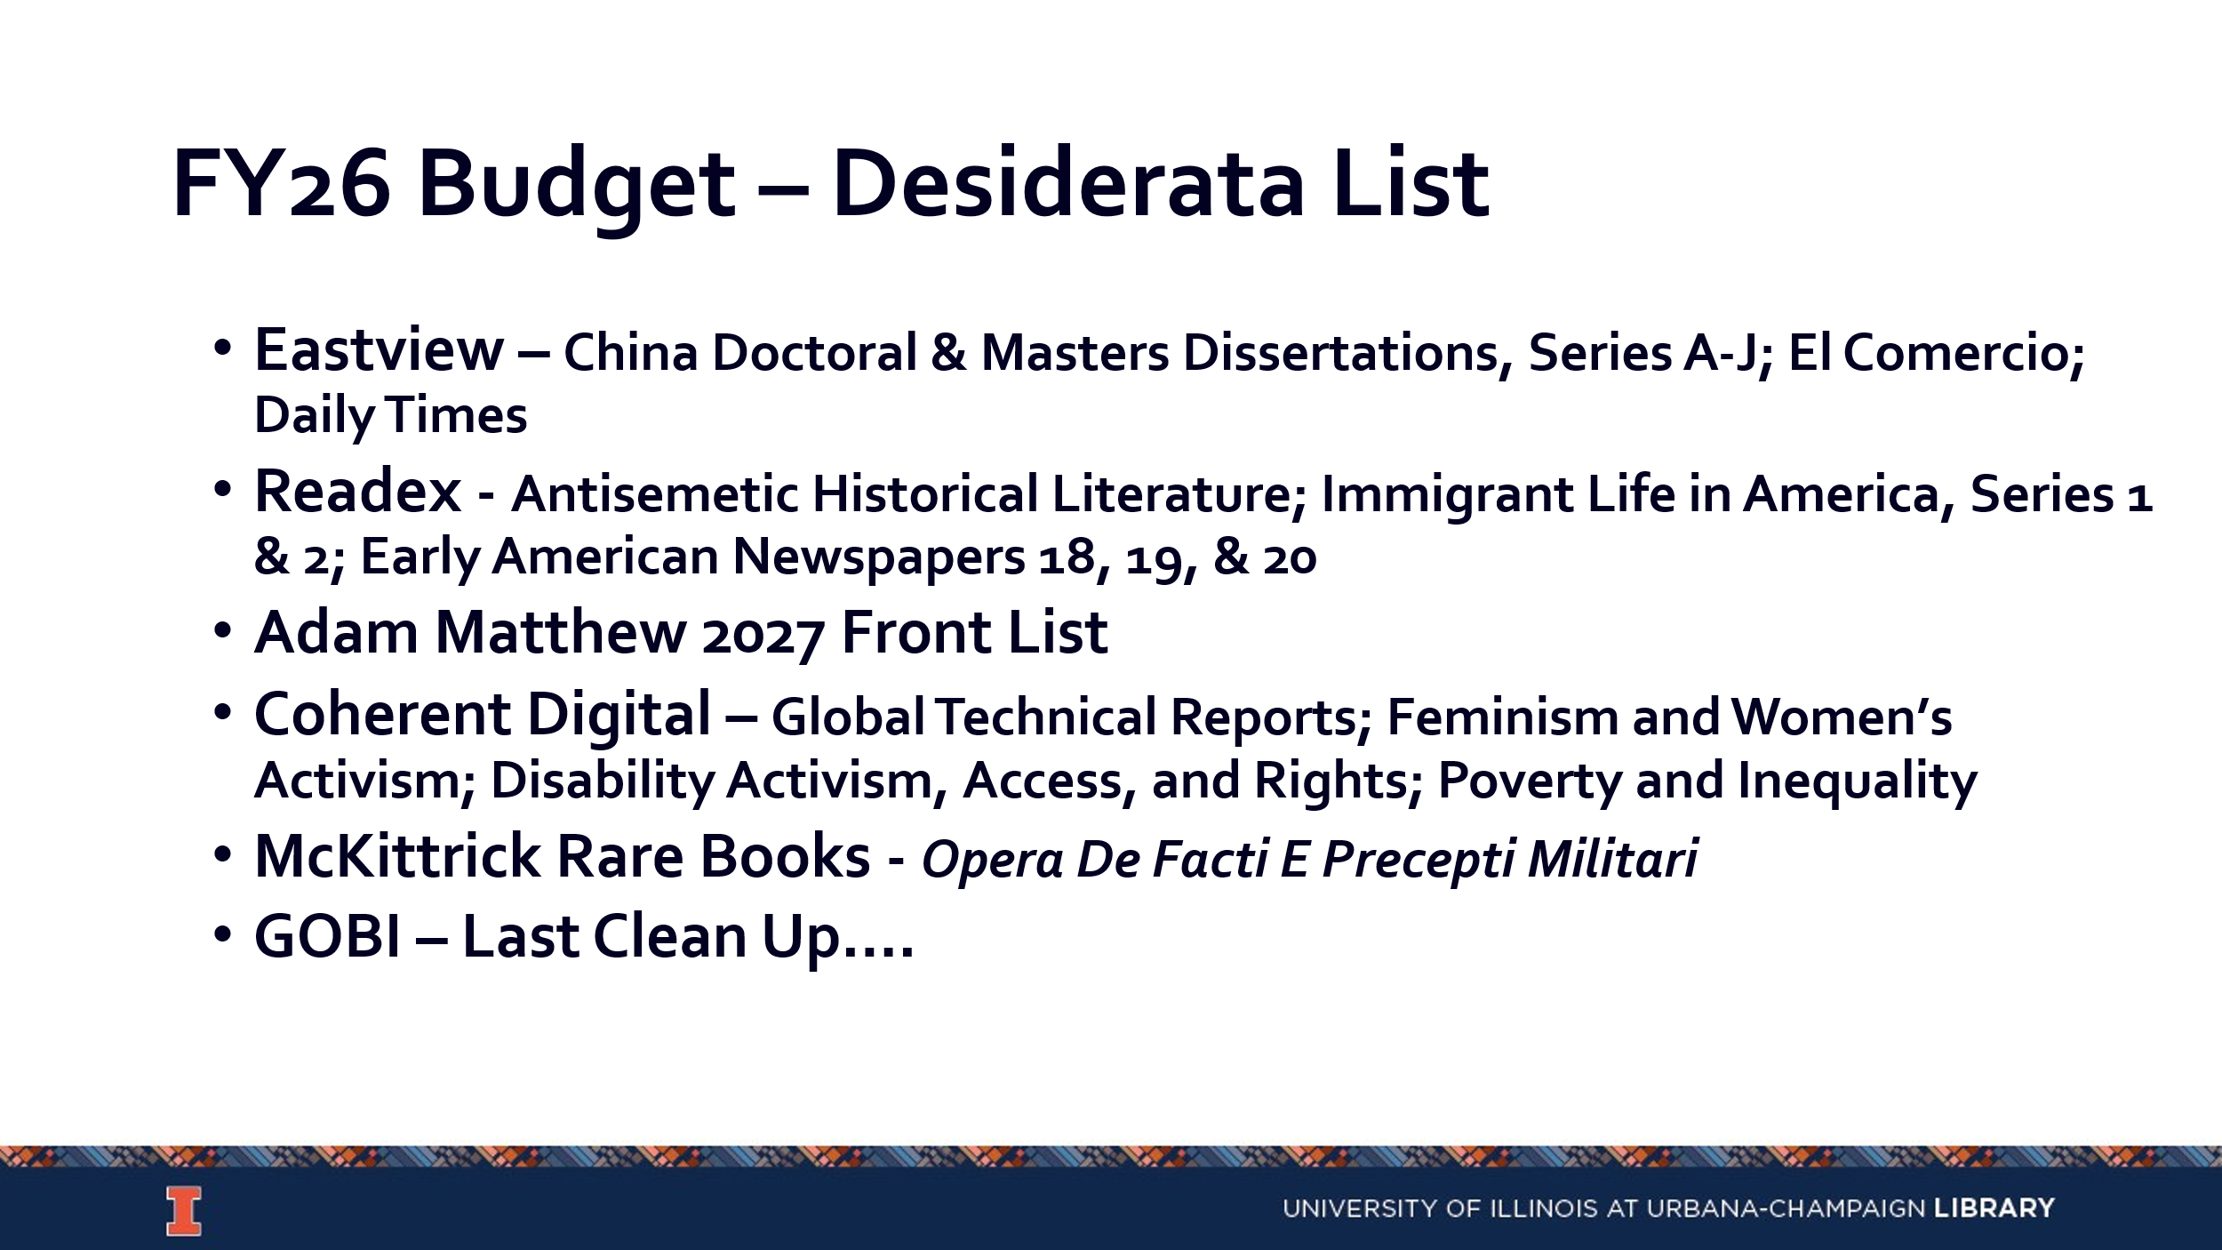
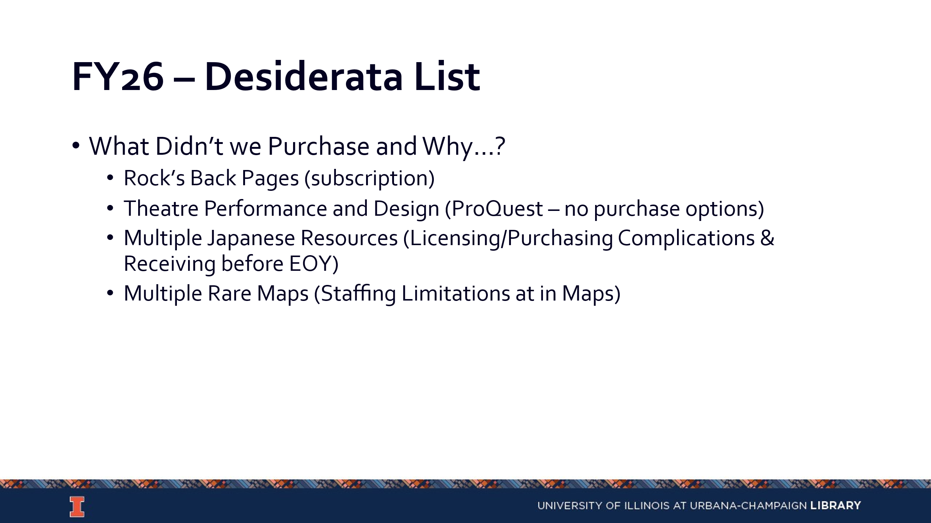
    - FY27 Budget
      - Liberal Arts & Science is no longer splitting the cost of the ICPSR membership with us.
      - Inside Higher Education is moving to a subscription model.
      - We are no longer prepaying the Big 10 and will be using that budgeted amount to pay for digitization through the Internet Archive. The hope is to have this work fully funded by next year.
      - FY27 marks the 3rd year of the 3-year campus commitment to budget increases, so we will need to begin preparations for FY28 with the potential impact of no increase for various funds.

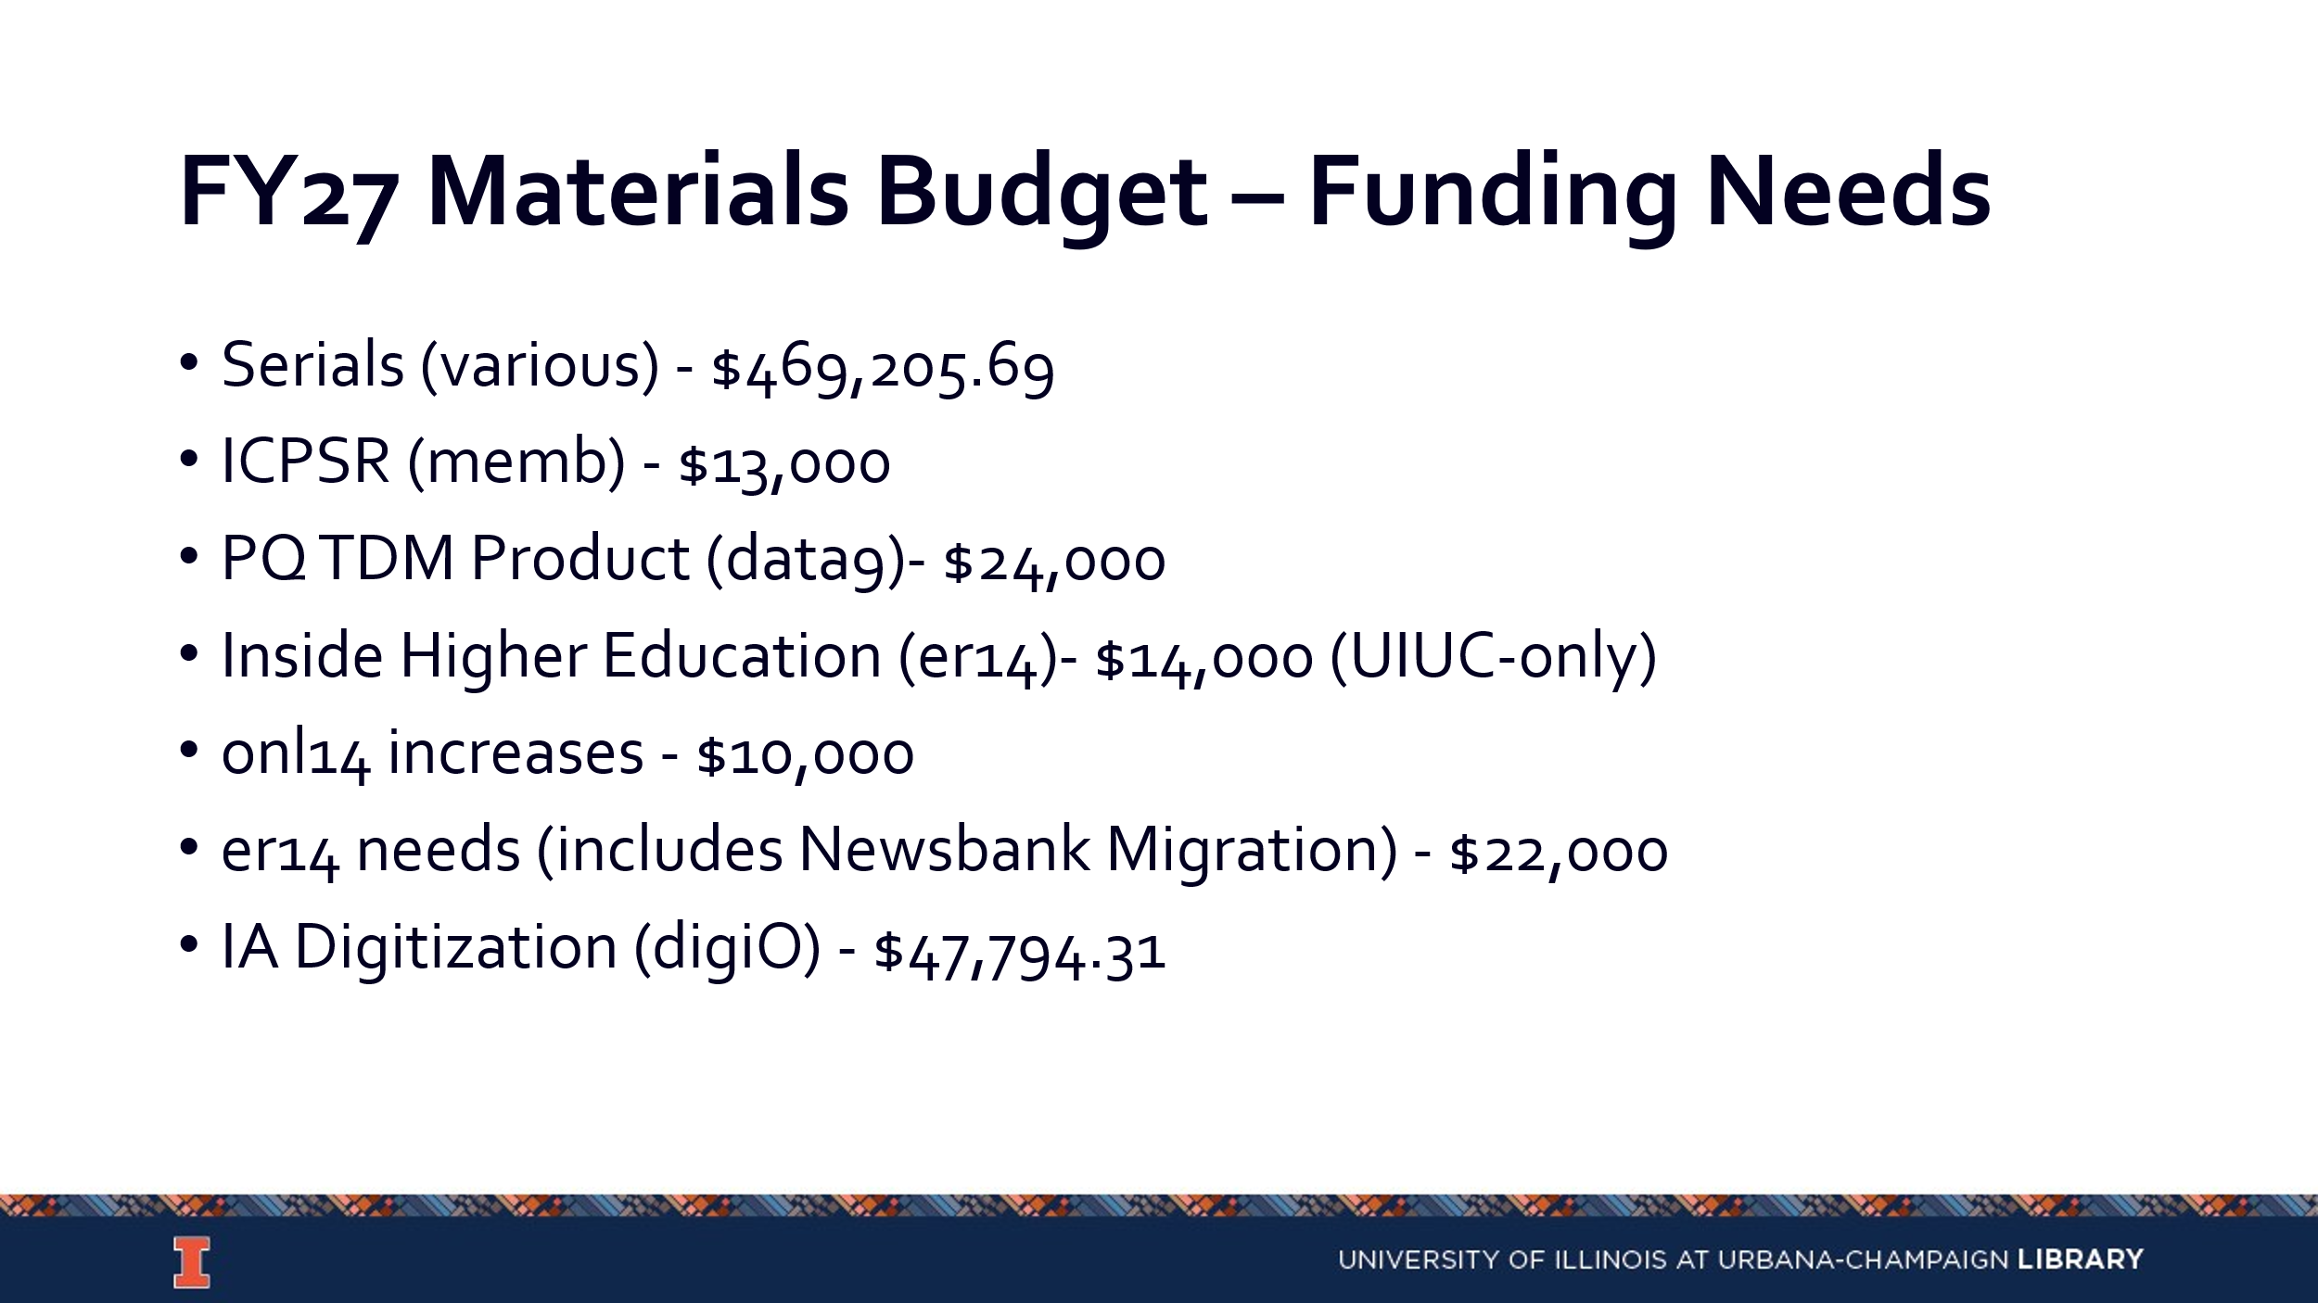

- Collection Development Topics
  - RACI Matrix for Collections Program
  - International Acquisitions Trips (please see accompanying reports)
  - Open Access Policy
    - We do not have any Library open access policy that details what we will and won’t support. We have supported some gold open access publishing through the Big 10 but have not provided direct funding ourselves.
    - Dean Stewart is supportive of CDC developing a more coherent open access policy. Feedback from divisions will be helpful in developing this.
    - It would be beneficial for CDC members to engage in a discussion about the various models to have a common understanding.

- Updates
  - Acquisitions No new updates
  - E-Resources No new updates
  - Preservation Services No new updates
  - BTAA Updates No new updates

--

Meeting adjourned at 3: 52 pm.

