Collection Development Committee
Minutes
June 25, 2024

Present: Tom Teper, Cindy Ingold, Kit Condill, Jenny Johnson, Paula Carns, Sanga Sung, Esra Coskun, Wendy Shelburne, Mary Schlembach

Notetaker: Hannah Williams

Agenda/Minutes

Agenda and last month’s meeting minutes approved.

FY24 Budget Progress
- Wrapping up the year….

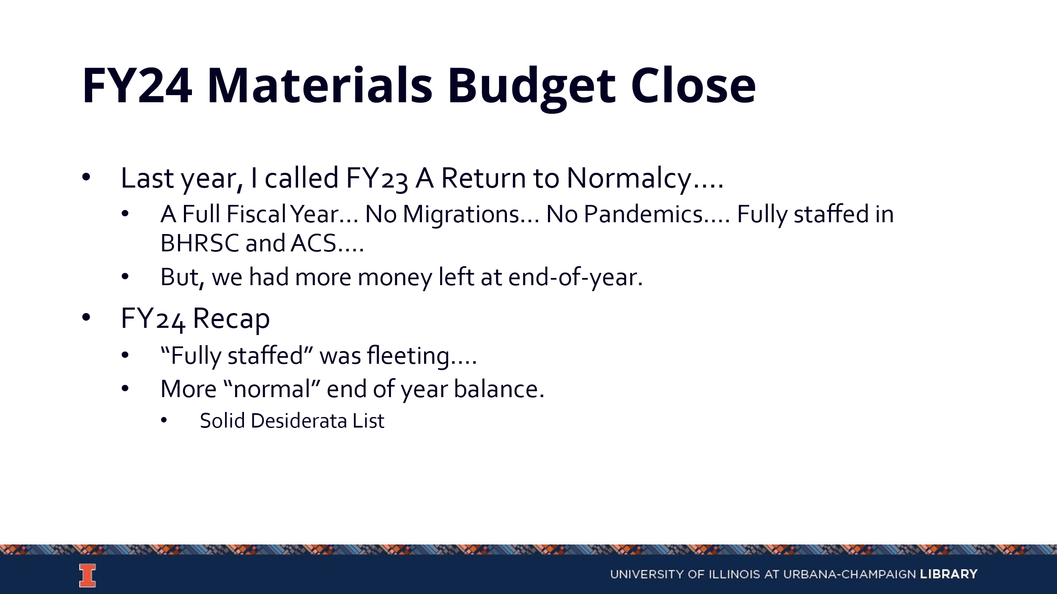

- Status of Invoices and Payments
- Desiderata List (https://uofi.box.com/s/44juoqudptvfbjyq90clne9smoy1i6h9).
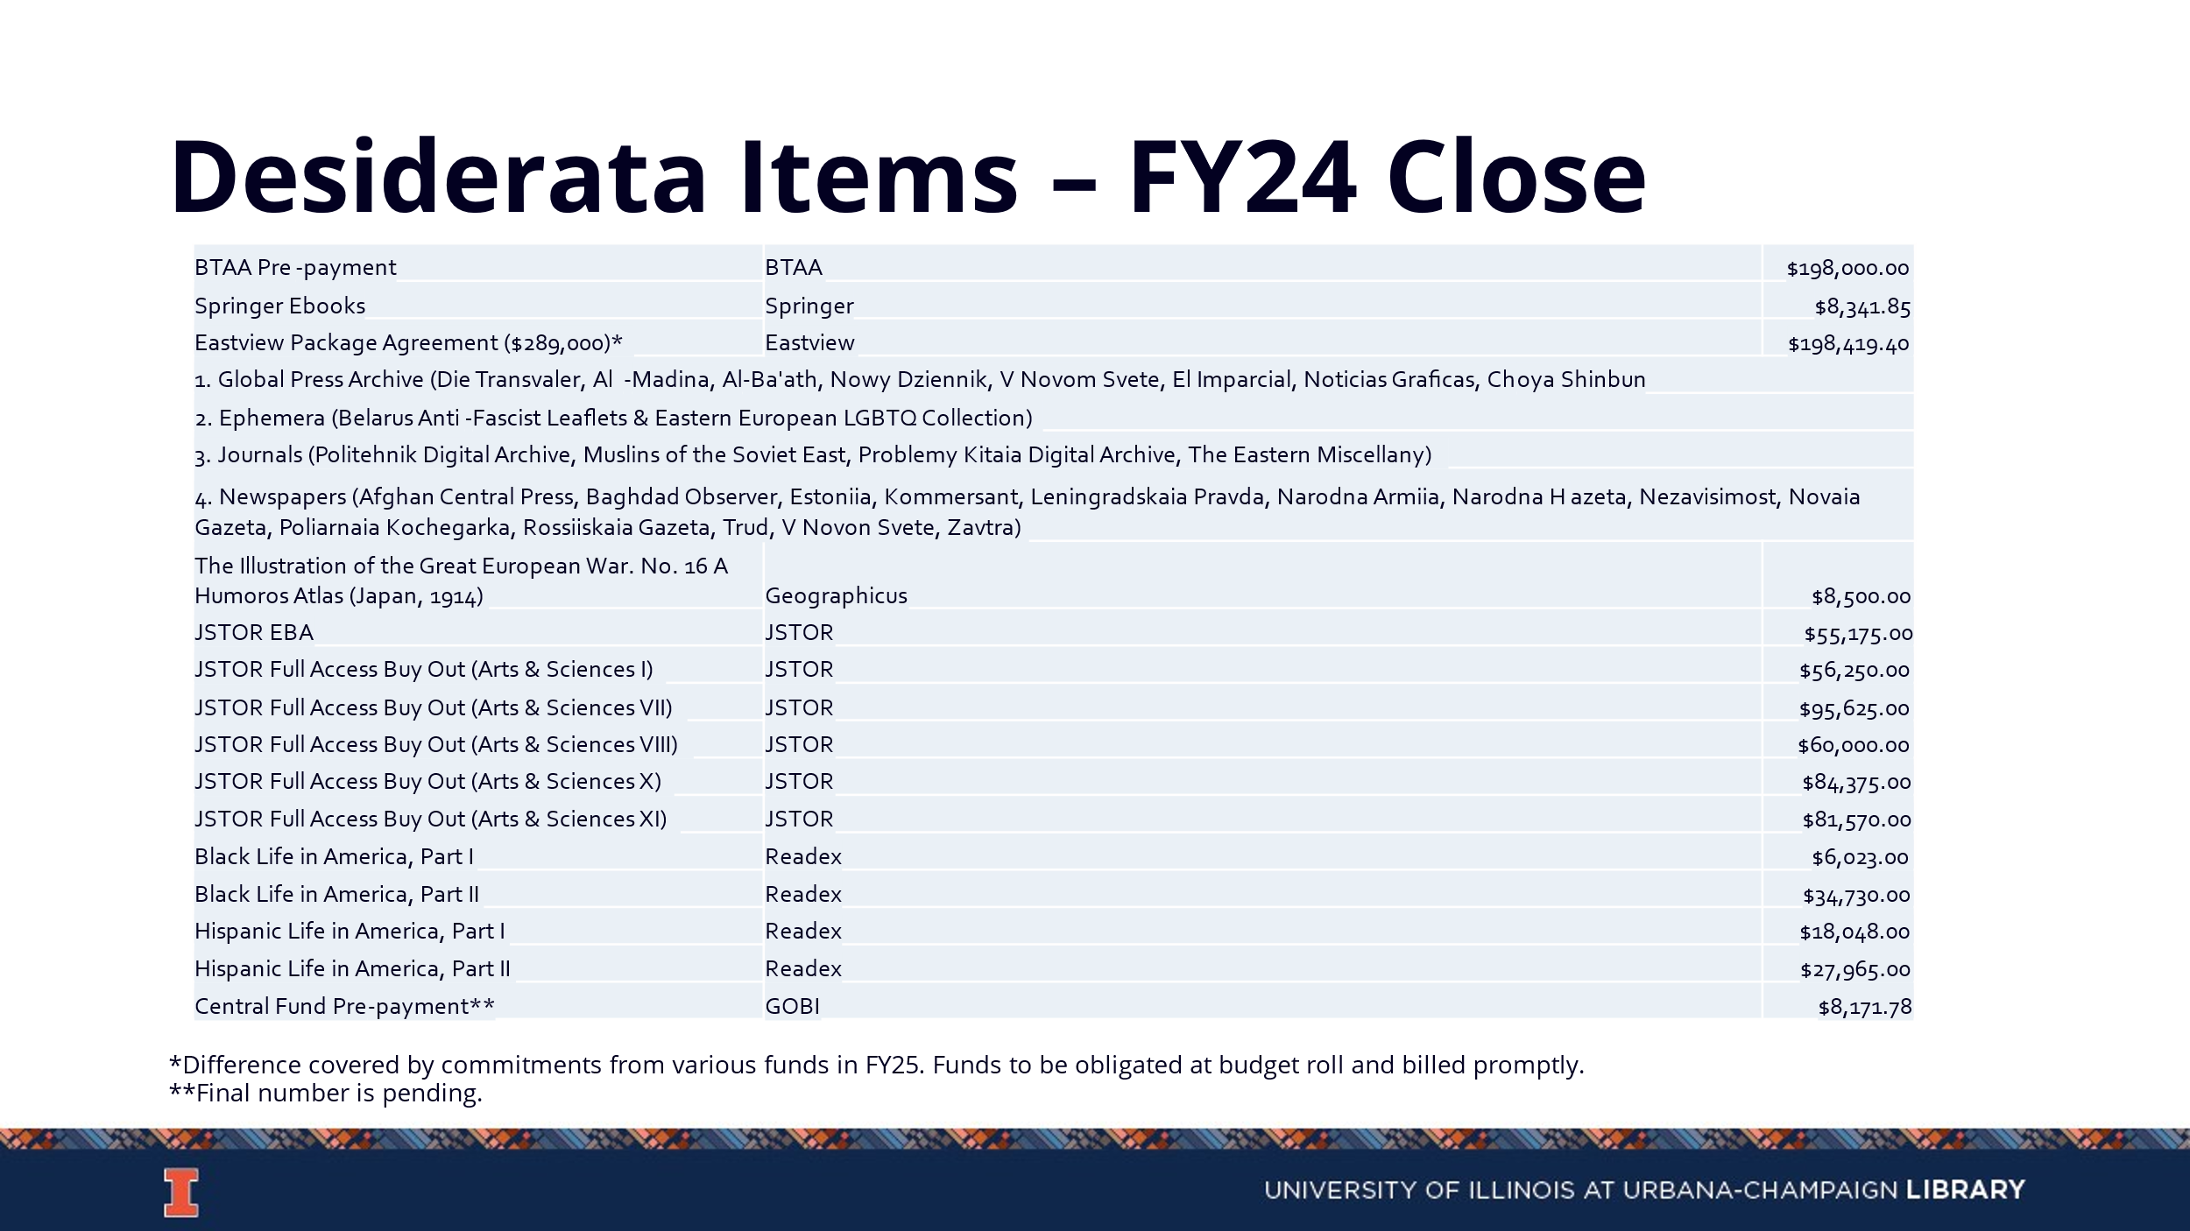
- Final Decisions to Close Budget

FY25 Budget Preparation
- News from Campus

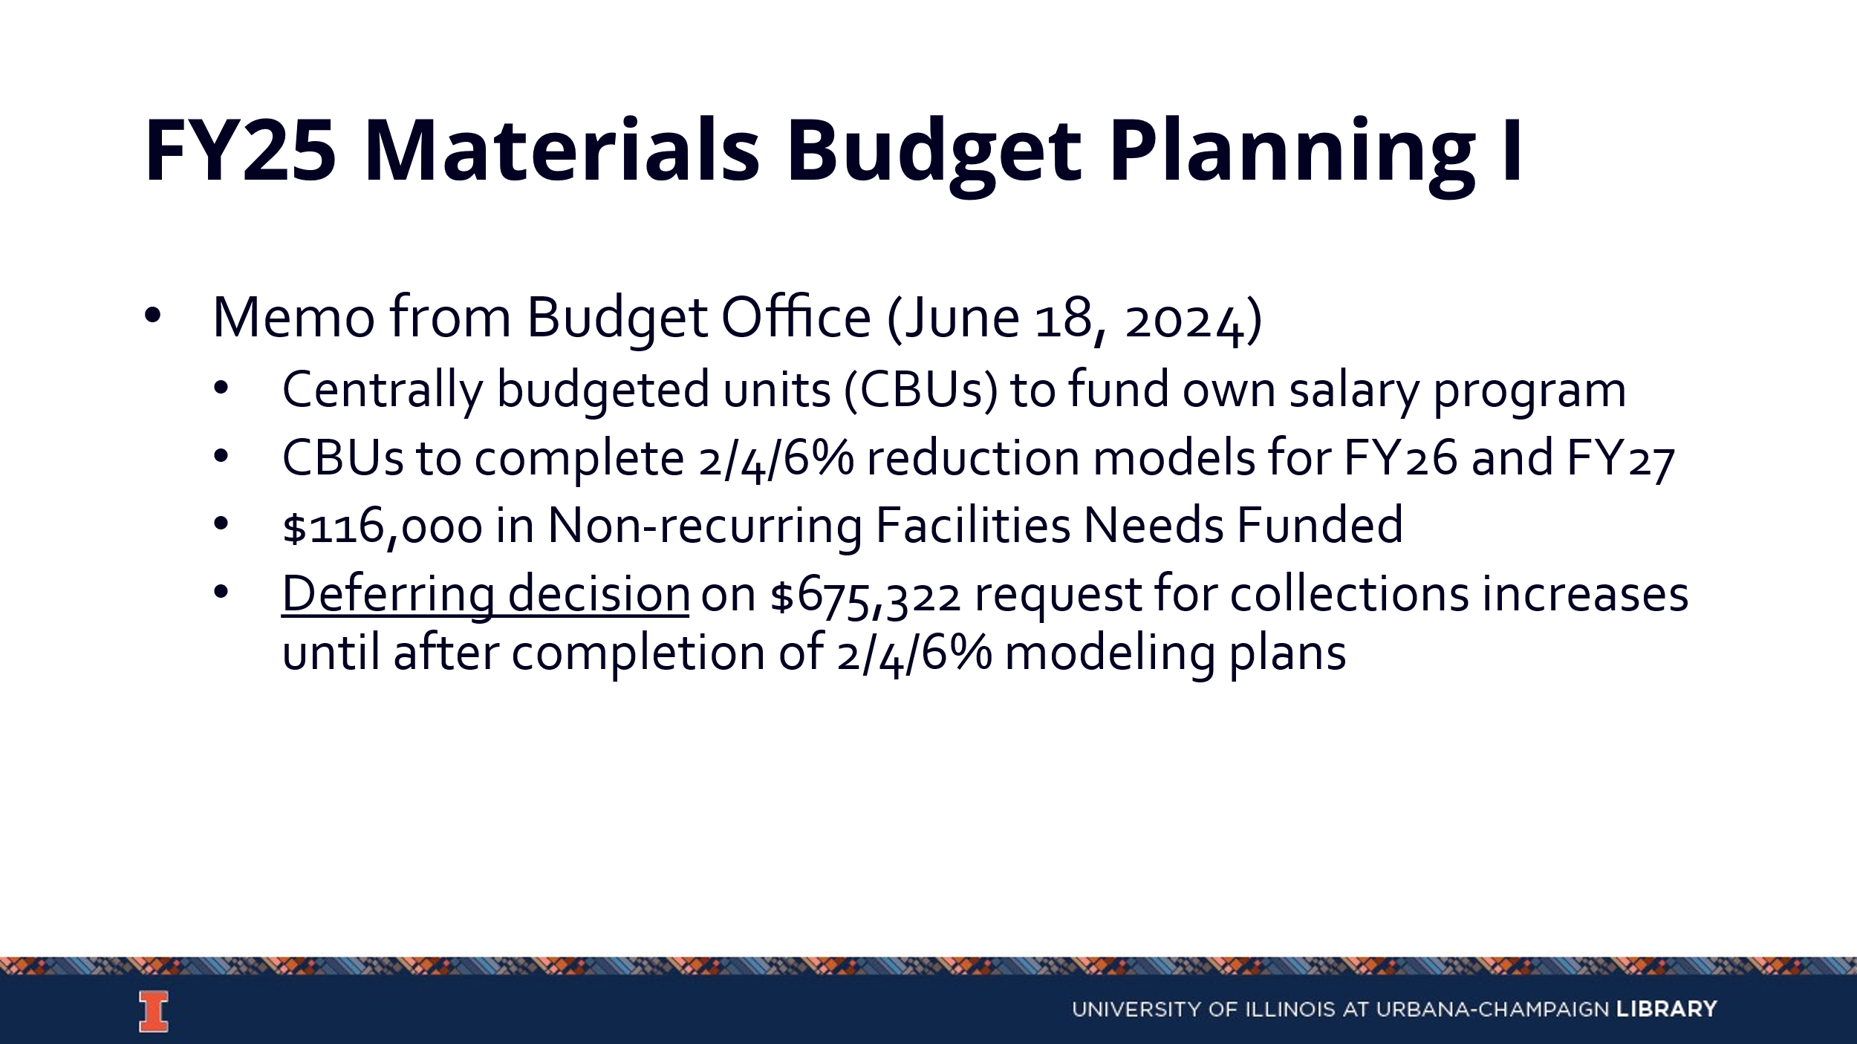

- Planning for FY25
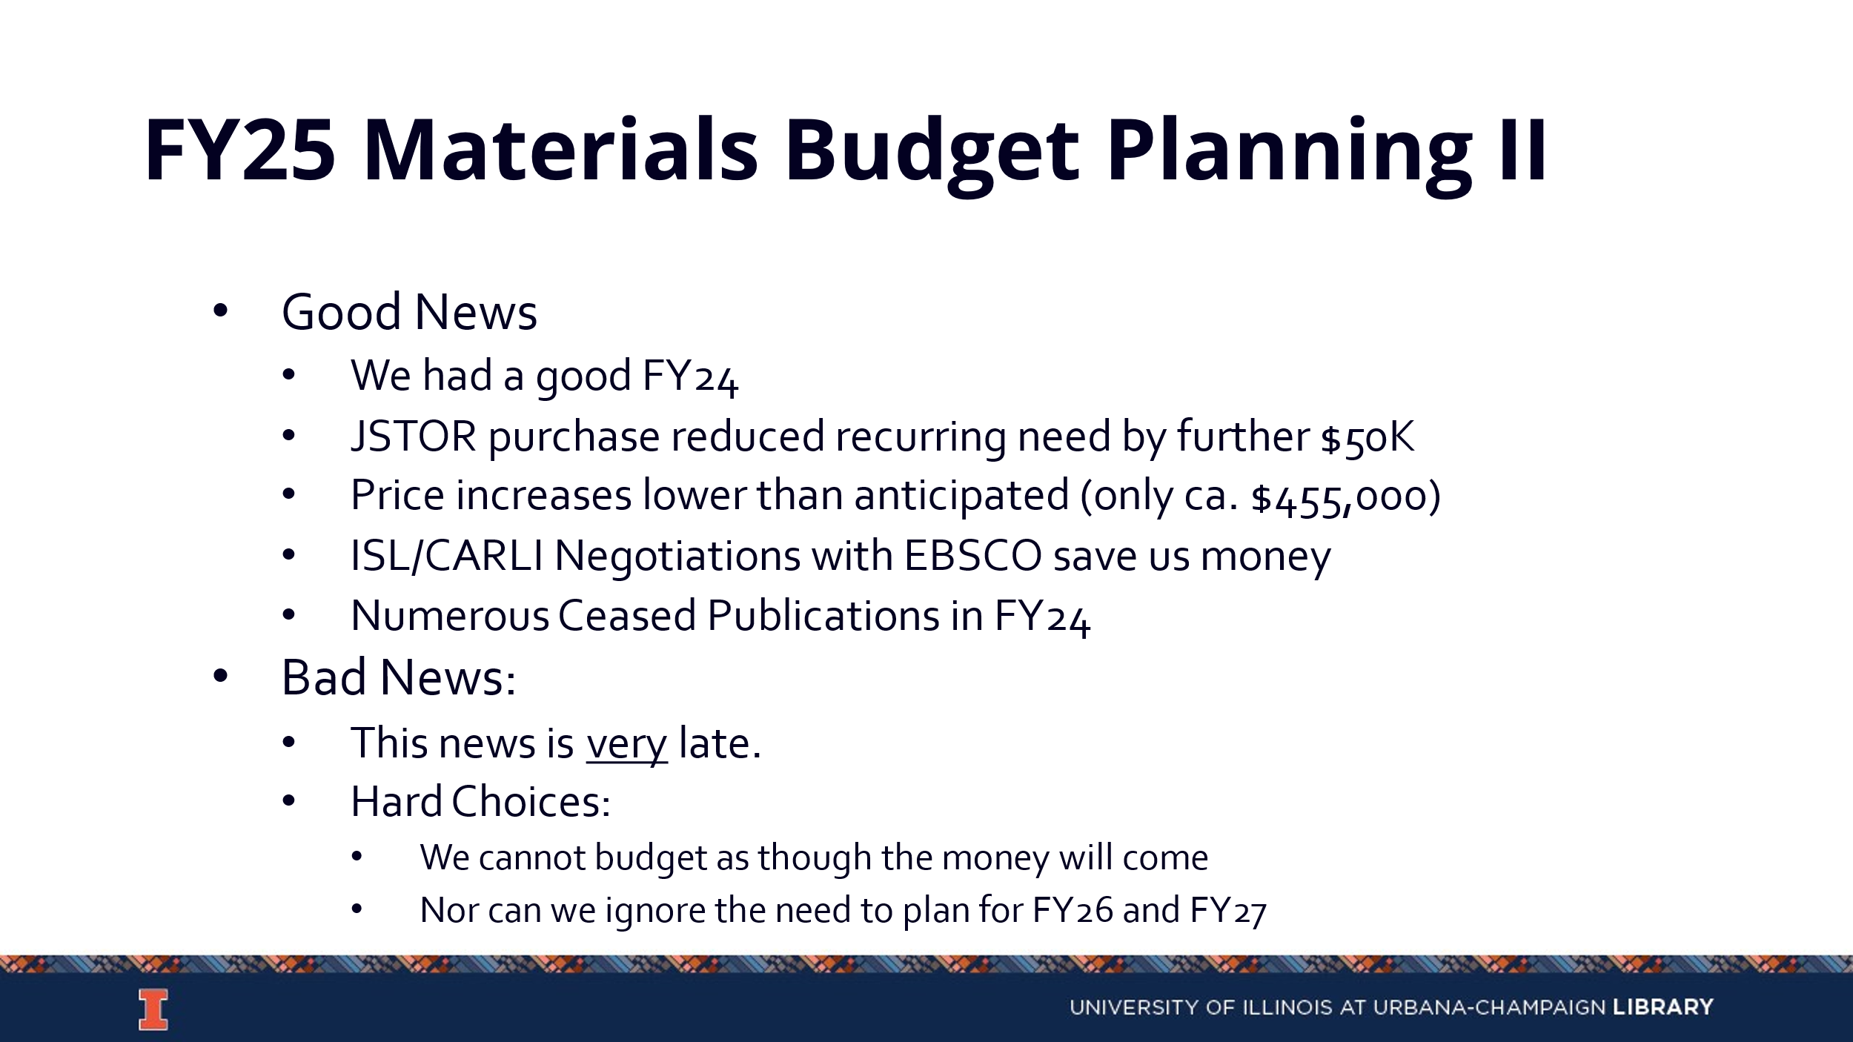

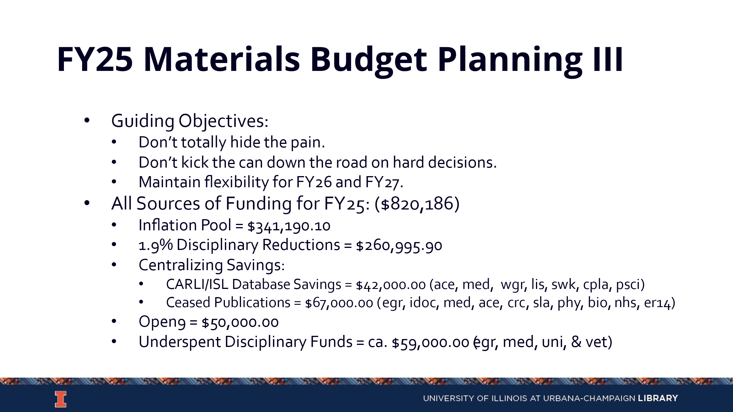

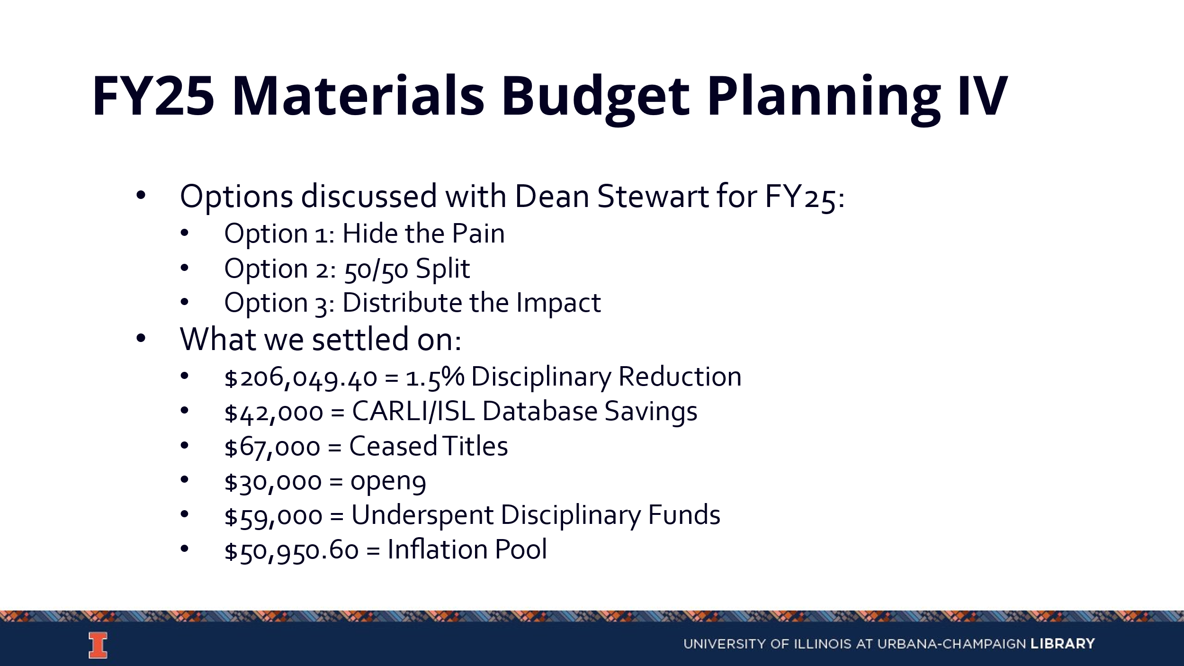

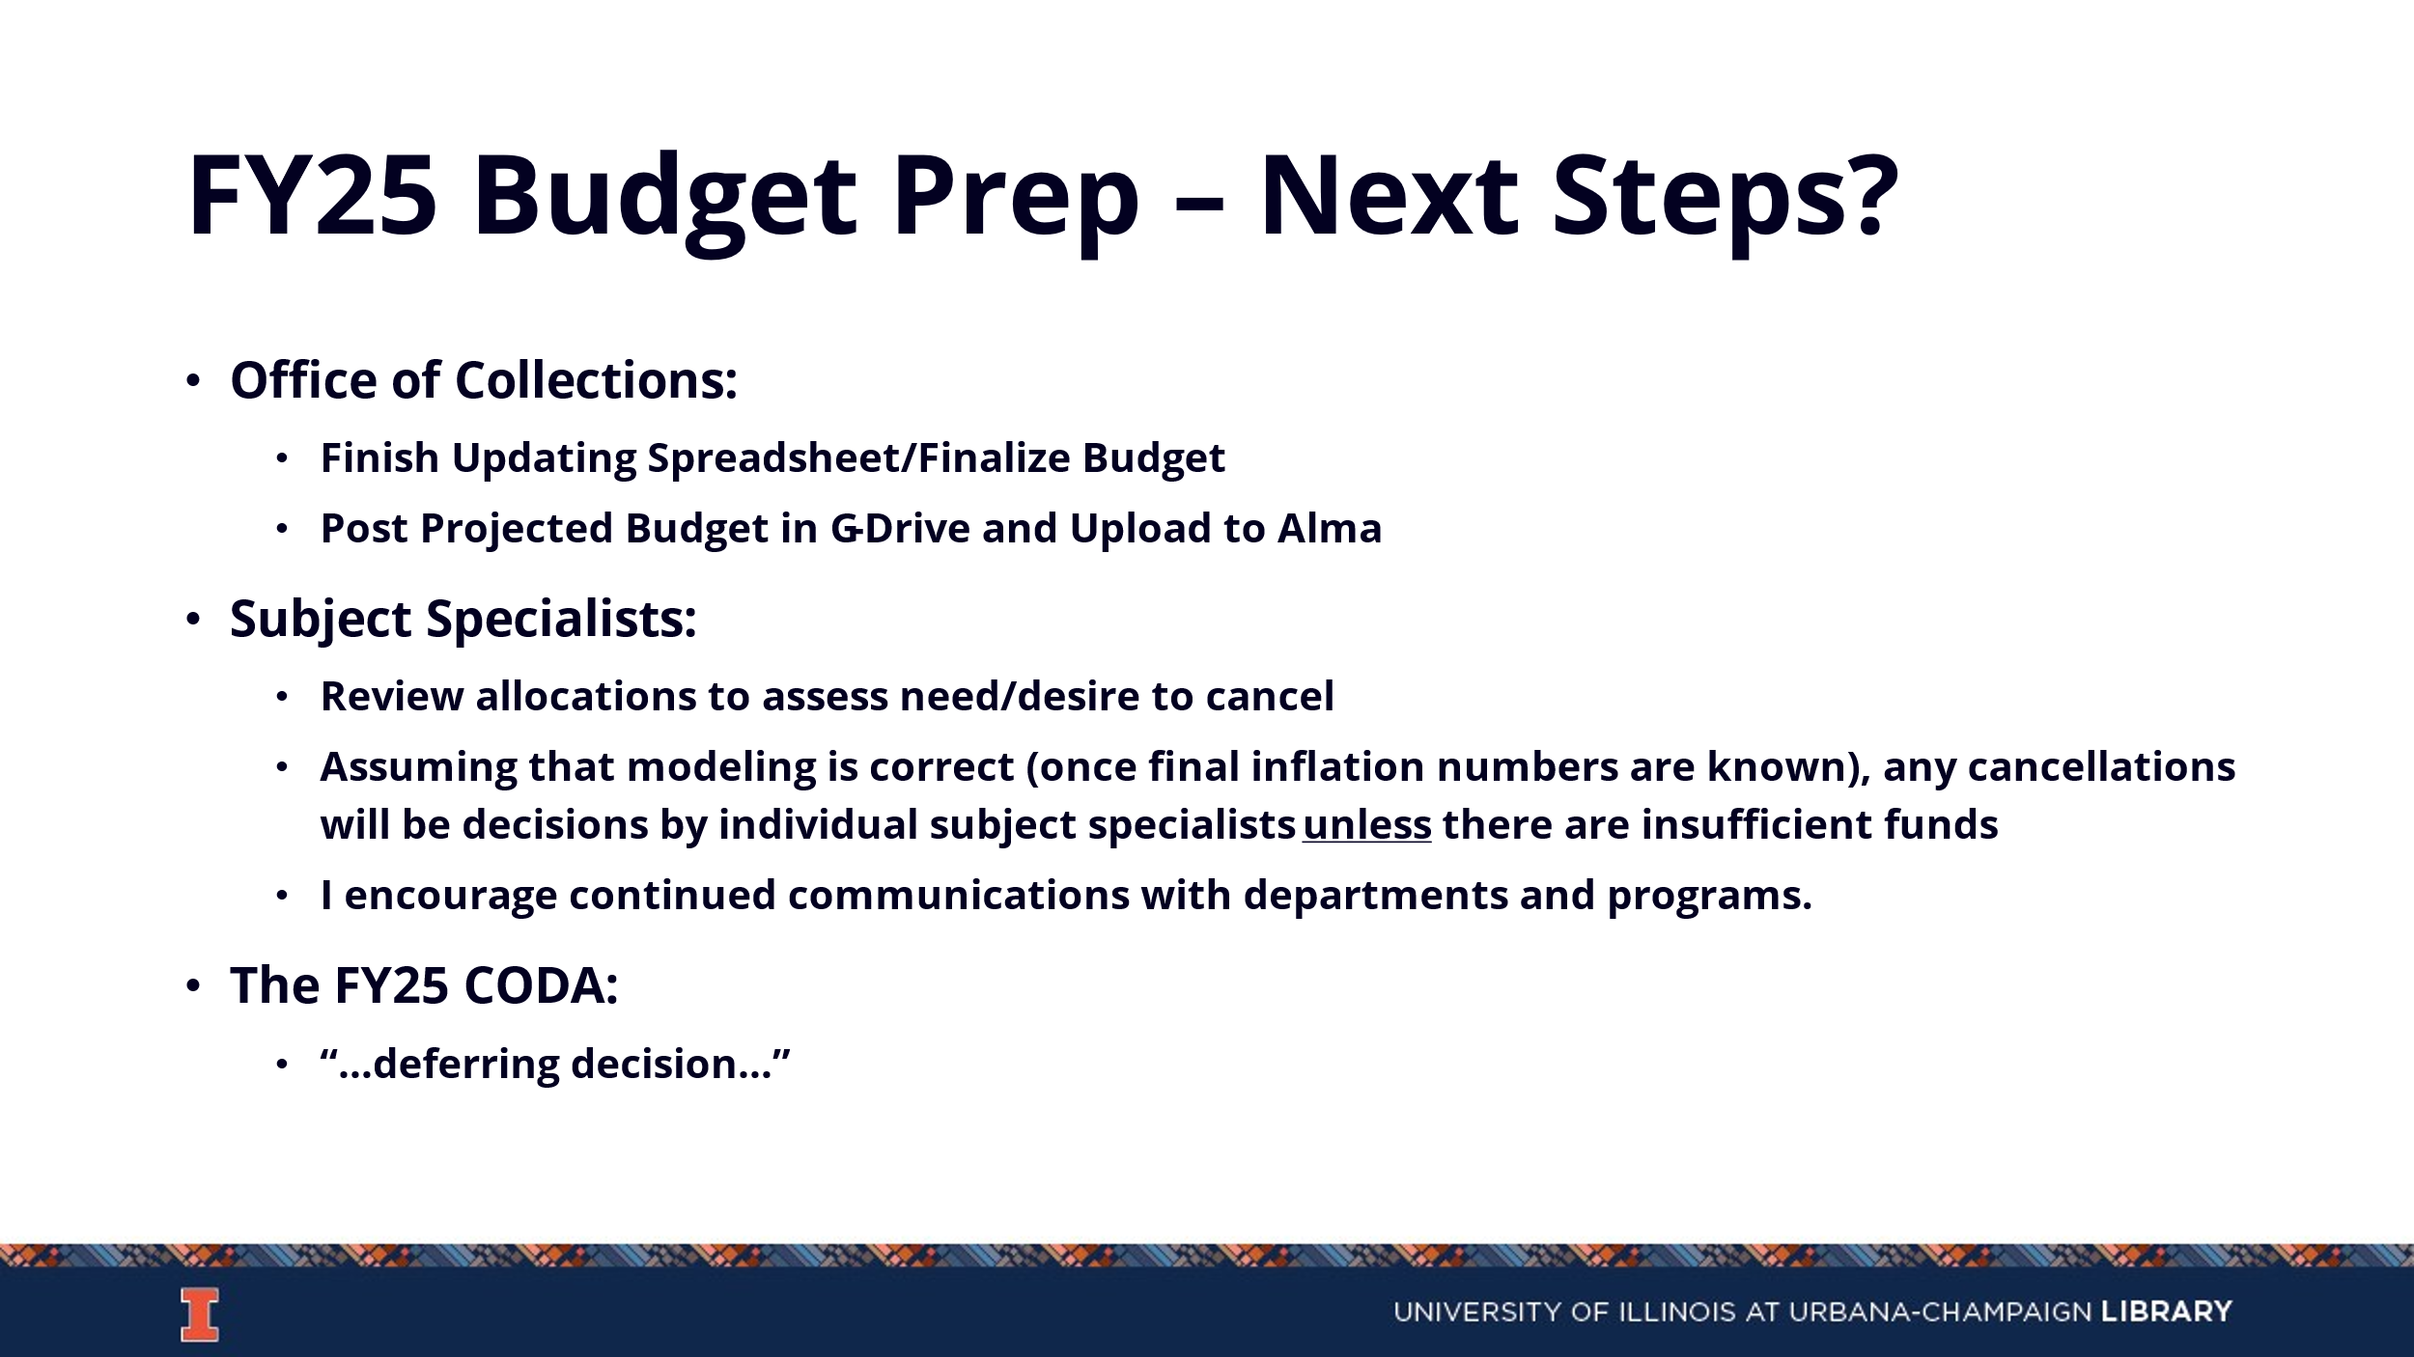
- Calendar

Updates
- Acquisitions
    - The ledger will be rolled on July 11th and the FY25 acquisitions calendar will be sent out once finalized.
- E-Resources
- Preservation Services
- BTAA Updates

--

