CAPT Minutes
July 30, 2026

Present: Tom Teper, John Laskowski, Jennifer Teper, Chloe Ottenhoff, Mary Laskowski, Michael Norman, Tracy Tolliver, Will Schlaack, Kyle Rimkus, Mary Ton, Eric Mosher, Hannah Williams (minutes)

- Approve agenda and minutes
  - Minutes and agenda were approved.

- Updates
  - Kyle Rimkus is replacing Eric Mosher as the chair of the Repositories, Preservation and Access WG. Ayla Kenfield will be the vice chair.
  - Diana Eynon is replacing Chloe Ottenhoff as the chair Cataloging and Metadata Working Group. Rachel Scott will be the new vice chair.

- Accessibility Update – John Laskowski
  - Evie Cordell and John Laskowski are attending LLG in August with a call to action to ensure Libguides are made accessible, if they are not already. There will be various trainings opportunities on how to make Libguides accessible.
  - The campus Web Content Implementation Team is working on best practices for archiving content under Title II regulations and a redesign of the digital accessibility website for campus.
  - John will be releasing the Year 2 Midyear Review of the Accessibility Roadmap in August.
  - Assistive tech ancillaries have been added to room 109, including alternative mice and keyboards.
  - A brand-new website for the Mortenson Center is being created which will greatly improve accessibility. This will launch on August 11th.
  - John will scale back accessibility office hours from weekly to monthly.
  - The campus steering committee has transitioned into an advisory committee.
  - Templates are being created for colleges to create to own roadmaps for accessibility.
  - The work of the Accessible Reader Support Task Force is proceeding as planned.

- Quarterly working group reports

- Search, Discovery, and Delivery- Michael Norman

Search, Discovery, and Delivery Working Group (SDDWG) Report – July 30, 2026
Library Search (Primo) Transition and Launch Activities
May-July 2026
The Search, Discovery, and Delivery Working Group (SDDWG) successfully completed the implementation and launch of the new Library Search (Primo) platform on July 28, 2026. The new system replaces existing Primo catalog instances and serves as the central discovery platform for the University Library, supporting the planned retirement of Easy Search beginning in Fall 2026.
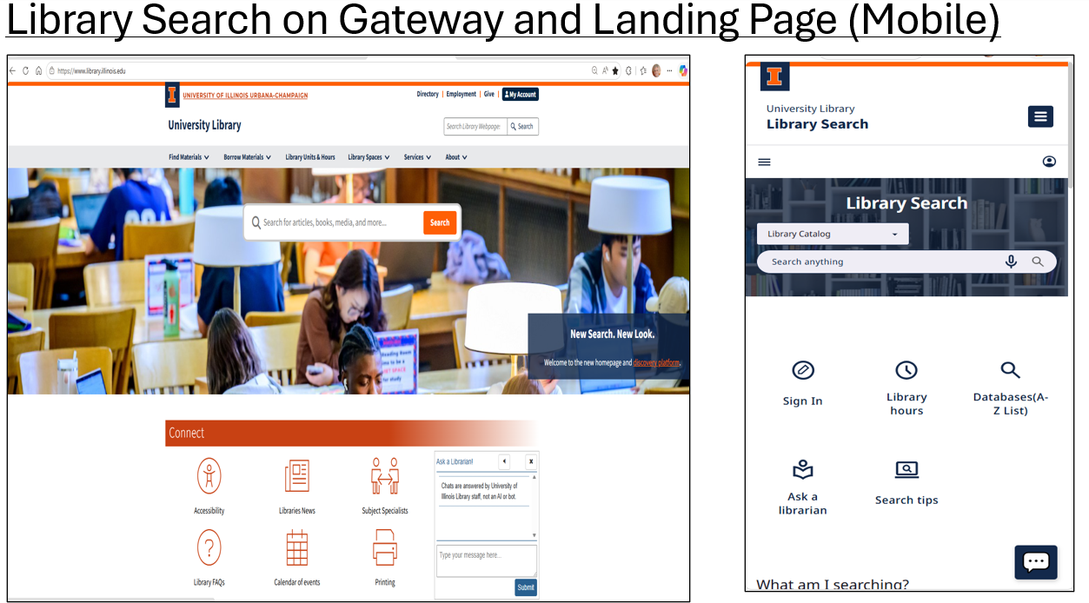
Communication and Outreach
Throughout the spring and summer, the Working Group conducted extensive outreach to prepare library faculty and staff for the transition. Activities included:
- Announcing the planned migration to Library Search (Primo) and the eventual retirement of Easy Search.
- Providing access to a preview version of the New Discovery Experience (NDE) to allow staff to test functionality and update instructional materials before the production launch.
- Developing and distributing talking points and supporting documentation for use in conversations with faculty, graduate students, and other library users.
- Hosting weekly Discovery Virtual Open Office Hours during summer 2026 to support testing, gather feedback, and answer questions regarding the new discovery interface.

Training and Support
To facilitate adoption of the new system, SDDWG organized virtual workshops for library personnel focused on navigating and using Library Search (Primo). These sessions were offered before and immediately following launch, with recordings made available for future reference.
The Working Group also responded to individual inquiries from library colleagues regarding permalinks, instructional materials, and migration-related questions. Feedback indicated that staff found the available documentation and workshops valuable in helping them prepare for the transition.
Launch and Initial Assessment
The new Library Search (Primo) platform officially launched on July 28, 2026, alongside the updated Library website. Following launch, staff were encouraged to explore the system and provide feedback through an embedded survey. The Working Group noted that, as one of the first consortium libraries to adopt the new Primo interface, continued refinement and enhancement of the discovery experience will be an ongoing process.
Initial feedback from colleagues has been mixed with some positive reflections but also some requests to bring back access to the old version of Library Search. Library units began updating websites, instructional materials, and orientation resources to incorporate the new search interface. Colleagues have reported that the implementation appeared to be functioning well so far as we move into the beginning of the Fall Semester.
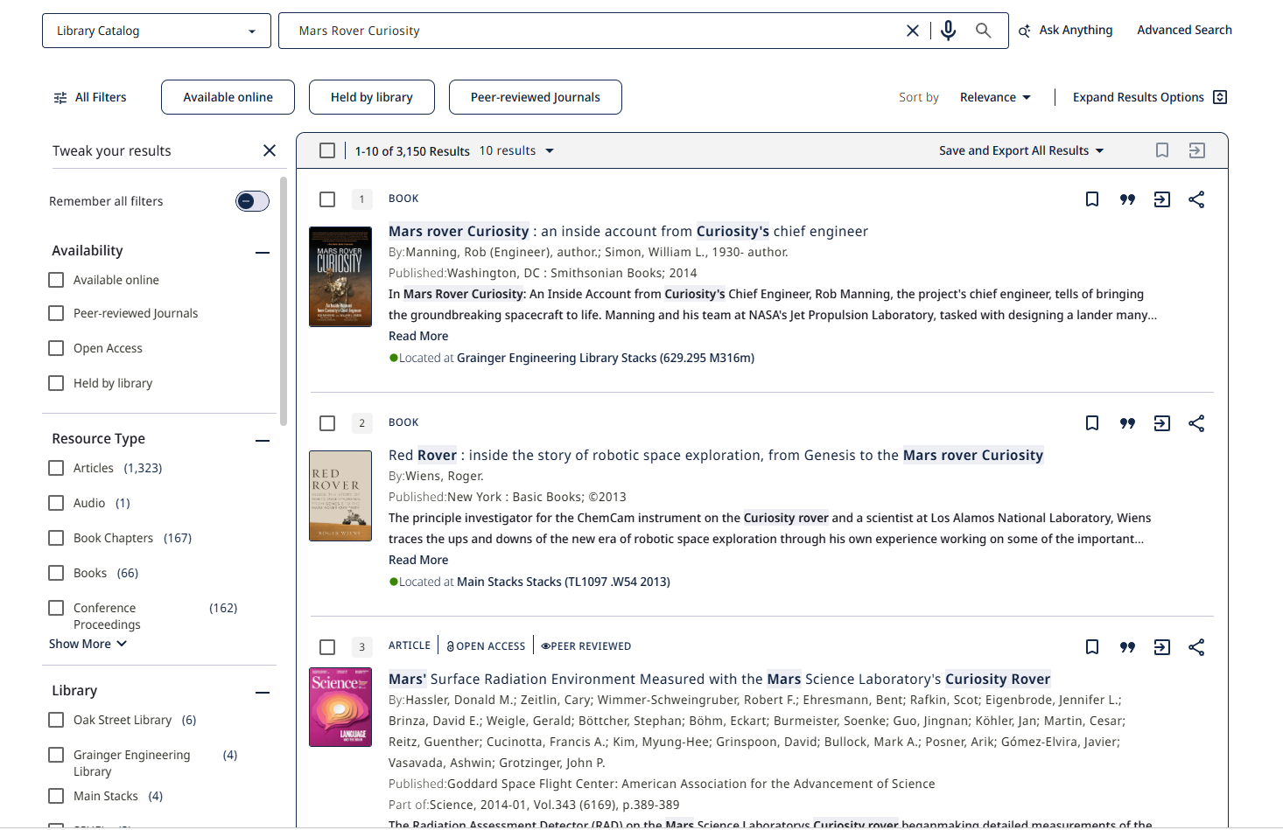
Collaboration and Acknowledgments
The successful deployment of Library Search (Primo) was the result of significant collaboration among library faculty and staff. Special accolades go out to Jay Heldreth for all the work to optimize the Library Search (Primo) for launch. The Working Group received assistance through testing, feedback, outreach efforts, and implementation support from colleagues across the Library.
The co-chairs expressed appreciation for the collaborative work undertaken throughout the project and noted the potential for future research and assessment activities related to discovery services and the use of Primo in advanced research workflows, including systematic review searching.
Mixpanel Analytics for Library Search (Primo)
With the launch the new Primo NDE Library Search, we also gained access to the Mixpanel Analytics suite. Mixpanel provides analytics for user activity within the Primo NDE interface and will complement the reporting capabilities we currently use in Alma Analytics. For background information, you may find the following Ex Libris documentation helpful:
https://knowledge.exlibrisgroup.com/Primo/Product_Documentation/020Primo_VE/Primo_VE_(English)/Primo_VE_Analytics_-_Mixpanel/010_Introduction_to_Mixpanel

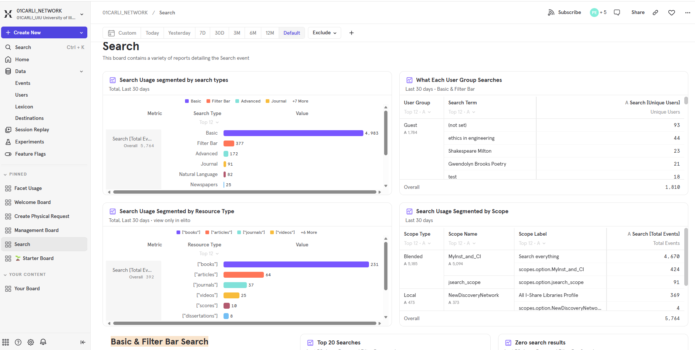

Top 10 (12) Tips for working in the new Library Search (Primo)
- Always Sign-In – The Primo Central Discovery Index is already very big but when Signed in, results from Scopus and Web of Science can be viewed as well; What am I searching in Library Search document
- Biggest change is the consolidated and streamlining of the search options from five down to three
- Different Search Profiles/Views: Library Catalog; Course Reserves; All I-Share Libraries
- Facets are your friends when searching against such a large mega-index; Show Resource type bar after search results appear
- Known-item searching – can copy an entire citation in and almost always find the resource; Expand Results function
- Can follow the Citation trails – Cited by and Cited In and links to full-text of these sources if available
- Export results into various bibliographic management tools; the importance of Permalinks and QR Code links
- Updated “My Account” functionality
- Ask Anything search – Nature Language and ChatBox-like search feature. Show the Systematic Review example
- Additional searches in the Primo Library Search Banner along the top including Course Reserves, All I-Share Libraries, QR, Newspapers Search, Citation Linker, Browsing, etc.
- Accessibility – BrowZine integration included by format (PDF or web-based), View Issue Contents, Retraction, Expression of concern, and Second order retraction, etc.
- Sarah Park’s Library Search Chrome Extension – Primo Library Search on the Go: https://bit.ly/UofILibrarySearch
- Comments and Questions - Discovery Team Dynamix: Email discovery@library.illinois.edu
Next Steps
The Working Group will continue to:
- Monitor system performance and user feedback.
- Support library personnel as they transition instructional and web content to the new platform.
- Gather assessment data on system usage and user experience.
- Explore opportunities for ongoing enhancement of discovery services and future research related to the Library Search platform.
As of the launch date, Library Search (Primo) had begun seeing substantial use by library patrons, providing an encouraging indication of early adoption of the new discovery platform.

- Web- John Laskowski
- The working group will be meeting next week to debrief the new search experience launch and examine the feedback that has been received.

- RACI Discussion of CAPT Role/Charge
  - A discussion is needed on how to consistently identify collaborations and to what extent they rise to being on the chart.
  - The working groups vary in their function and represent a variety of needs. Some are groups with advisory roles, while some are explicitly designed to gather feedback and coordinate with leadership.
  - Some of the working group charges do not align well with a RACI matrix.
  - The Ad Hoc Governance Tracking Working Group is examining all Library committees, task forces, and working groups to determine which ones have decision-making properties and which are advisory.
  - Many working groups have grown in size, making it harder to disseminate responsibility and direct work, which has led to some becoming more about information sharing.
  - Some groups do not have the top-down capacity to set priorities and policies.
  - Discussions around digital strategies will start with unit leadership and then broaden.

Meeting adjourned at 3pm.

