Collection Development Committee Minutes
July 22, 2025

Present: Tom Teper, Cindy Ingold, Esra Coskun, Paula Carns, Jennifer Teper, Mary Schlembach, Amy Fry, Hannah Williams (notes)

Agenda/Minutes

Agenda and last month’s meeting minutes approved.

- FY26 Budget Update
  - Provost’s office intends to allocate $600,000 for FY26-28. The message that came with our budget indicated it did leave open the possibility of a mid-year rescission.
    - This money will be used to:
      - cover increases on recurring materials
      - offset the cost for the IEEE agreement that the provost’s office has been covering, in light of the additional funding they are providing
      - cover the HathiTrust/geospatial portions of the BTAA bill. This will take roughly $50,000 off the operating side of the budget, as this has previously been paid with carryover or gift dollars
      - addition to ipi0 as an international programs fund due to Title VI grants being in limbo. This funding will be used for the development of an area studies collection and support if grant money is lost. If the grant program is renewed then the money will be taken back the next fiscal year.
      - Fund the Internet Archives digitization, which has been funded with carryover money from the collections budget. These materials are predominately newspapers from Indigenous communities.
  - We will not be in a position where any of our funds are forced to make cancellations this year

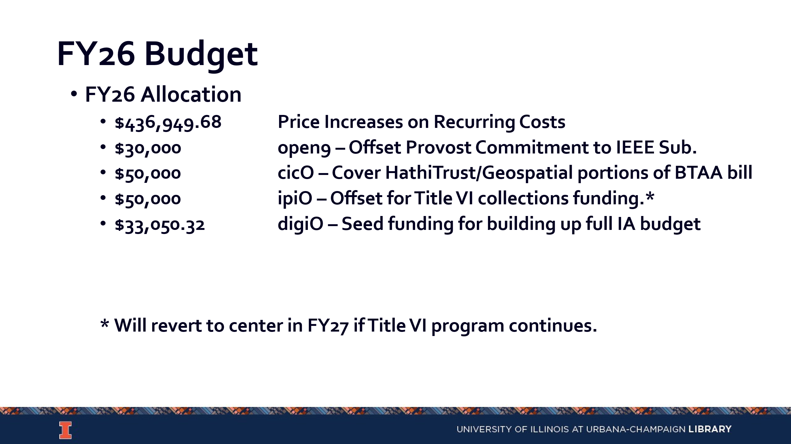

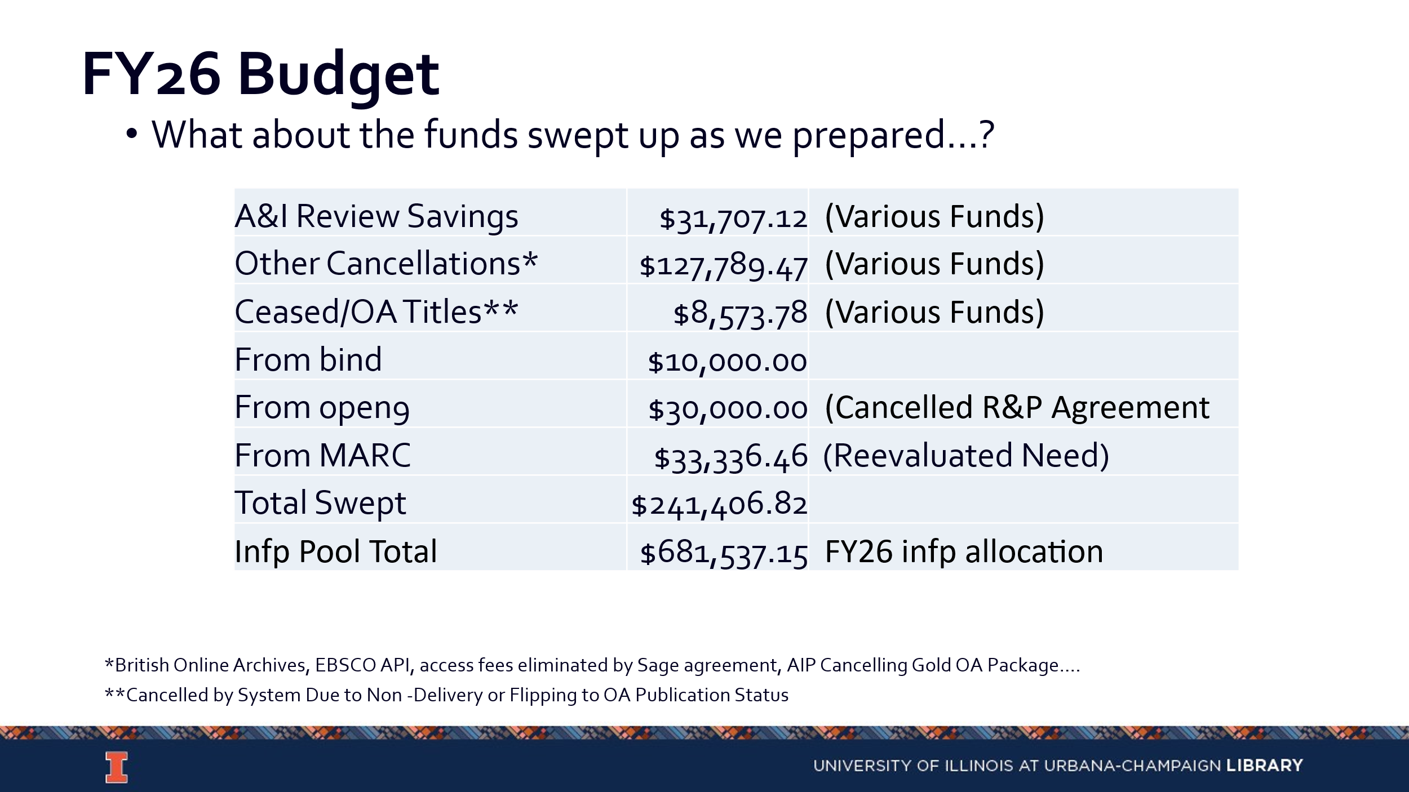

- Inflation pool money will likely be set aside for FY27 as a safety net in case anything changes with the stated intent from the provost’s office. This should cover inflation for a year, or two years if we don’t provide full coverage.

- Collection Development Topics
  - What should be on the agenda for FY26?
    - Potential for collections forum that everyone can participate in
    - Managing serial funds and opportunities for selectors to be present at discussions
    - Potential to move more selection to auto-ship approval
    - Formatting priorities for Internet Archives
  - Collection Development Philosophy Discussion (All): https://library.yale.edu/policy/collection-development-statements.
- Updates
  - Acquisitions- No new updates
  - E-Resources- No new updates
  - Preservation Services- No new updates
  - BTAA Updates- No new updates

--

Meeting adjourned at 3:40 pm.

