Collection Development Committee
July 25, 2023

Present: Tom Teper, Celestina Savonius-Wroth, Esra Coskun, Amy Fry, George Gottschalk, Mike Dickinson, Sarah Williams, Wendy Shelburne, Jennifer Teper, Jenny Johnson, Mary Schlembach

Notetaker: Hannah Williams

Agenda/Minutes
Tom opened the meeting asking for additions or changes to the agenda, and approval of last month’s meeting minutes. Agenda and minutes unanimously approved.

FY23 Budget
- Desiderata List – Discussion of Priorities
  - The central desiderata list process has been working well. This same process will be used for FY24.
  - Additional notes have been added to items on the FY23 list, and the annotated list will remain in box for viewing.
- FY23 Wrap Up

FY24 Budget
- The FY24 budget is available in the G drive and will be sent out once finalized. Tom and Esra can be contacted with any questions about the budget.

Local Discussion Topics
- Acquisitions Leadership (Tom)
  - George is departing in August. Tom has been meeting with MJ, Wendy, Amy, and Stephanie B. to outline a coverage plan which will be shared later.
- Elsevier Negotiations
  - Tom has been meeting with Elsevier about the new contract that would go into effect on January of 2024. Elsevier proposed four different contract models, of which only three were viable.
  - The first option was what is essentially our current model with a discount on our base cost but no discounts to publishing. The second option is a model similar to our current model with no initial discount in the base price for journals and other content but would carry a small discount on publishing costs. The third model was a read and publish agreement focused almost entirely on the core hybrid titles that Elsevier publishes.
  - Consultation with local deans had positive feedback on the offer and consensus on the counter offer. We will be proposing a five-year counter offer, with a 2.5% price cap.
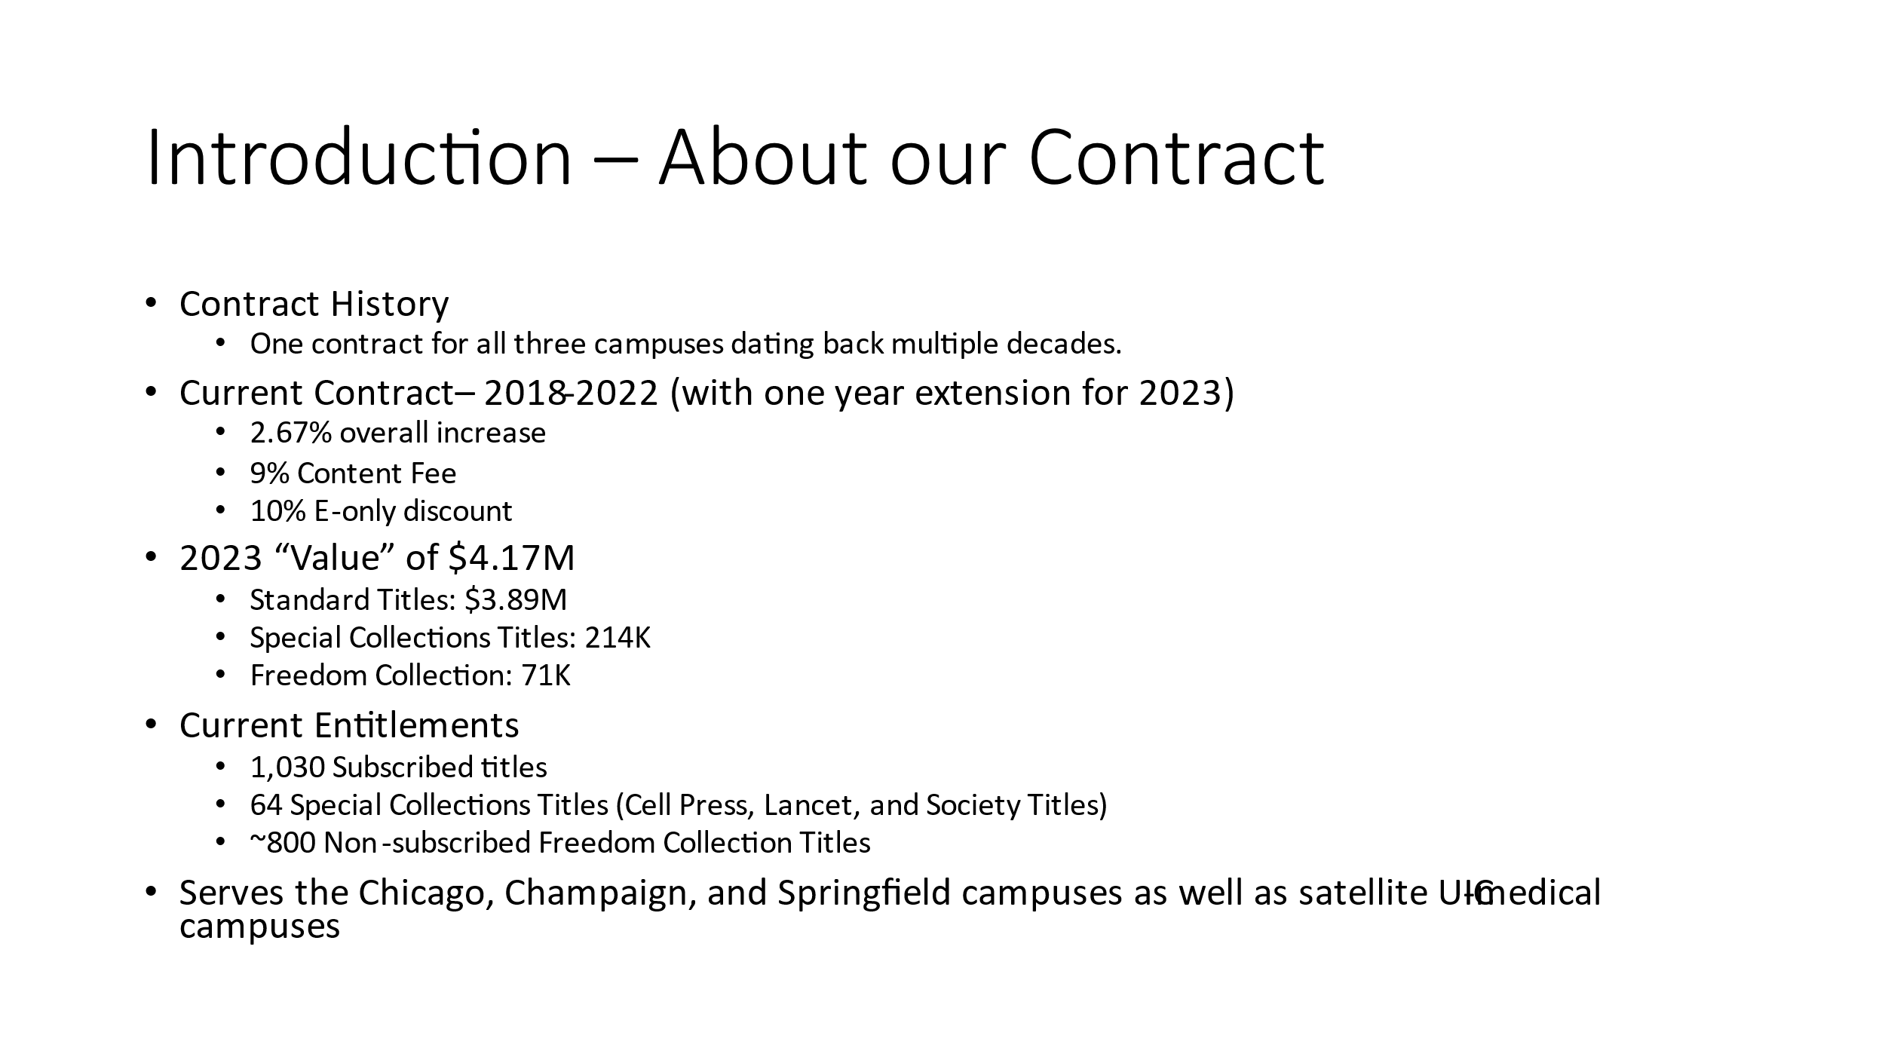

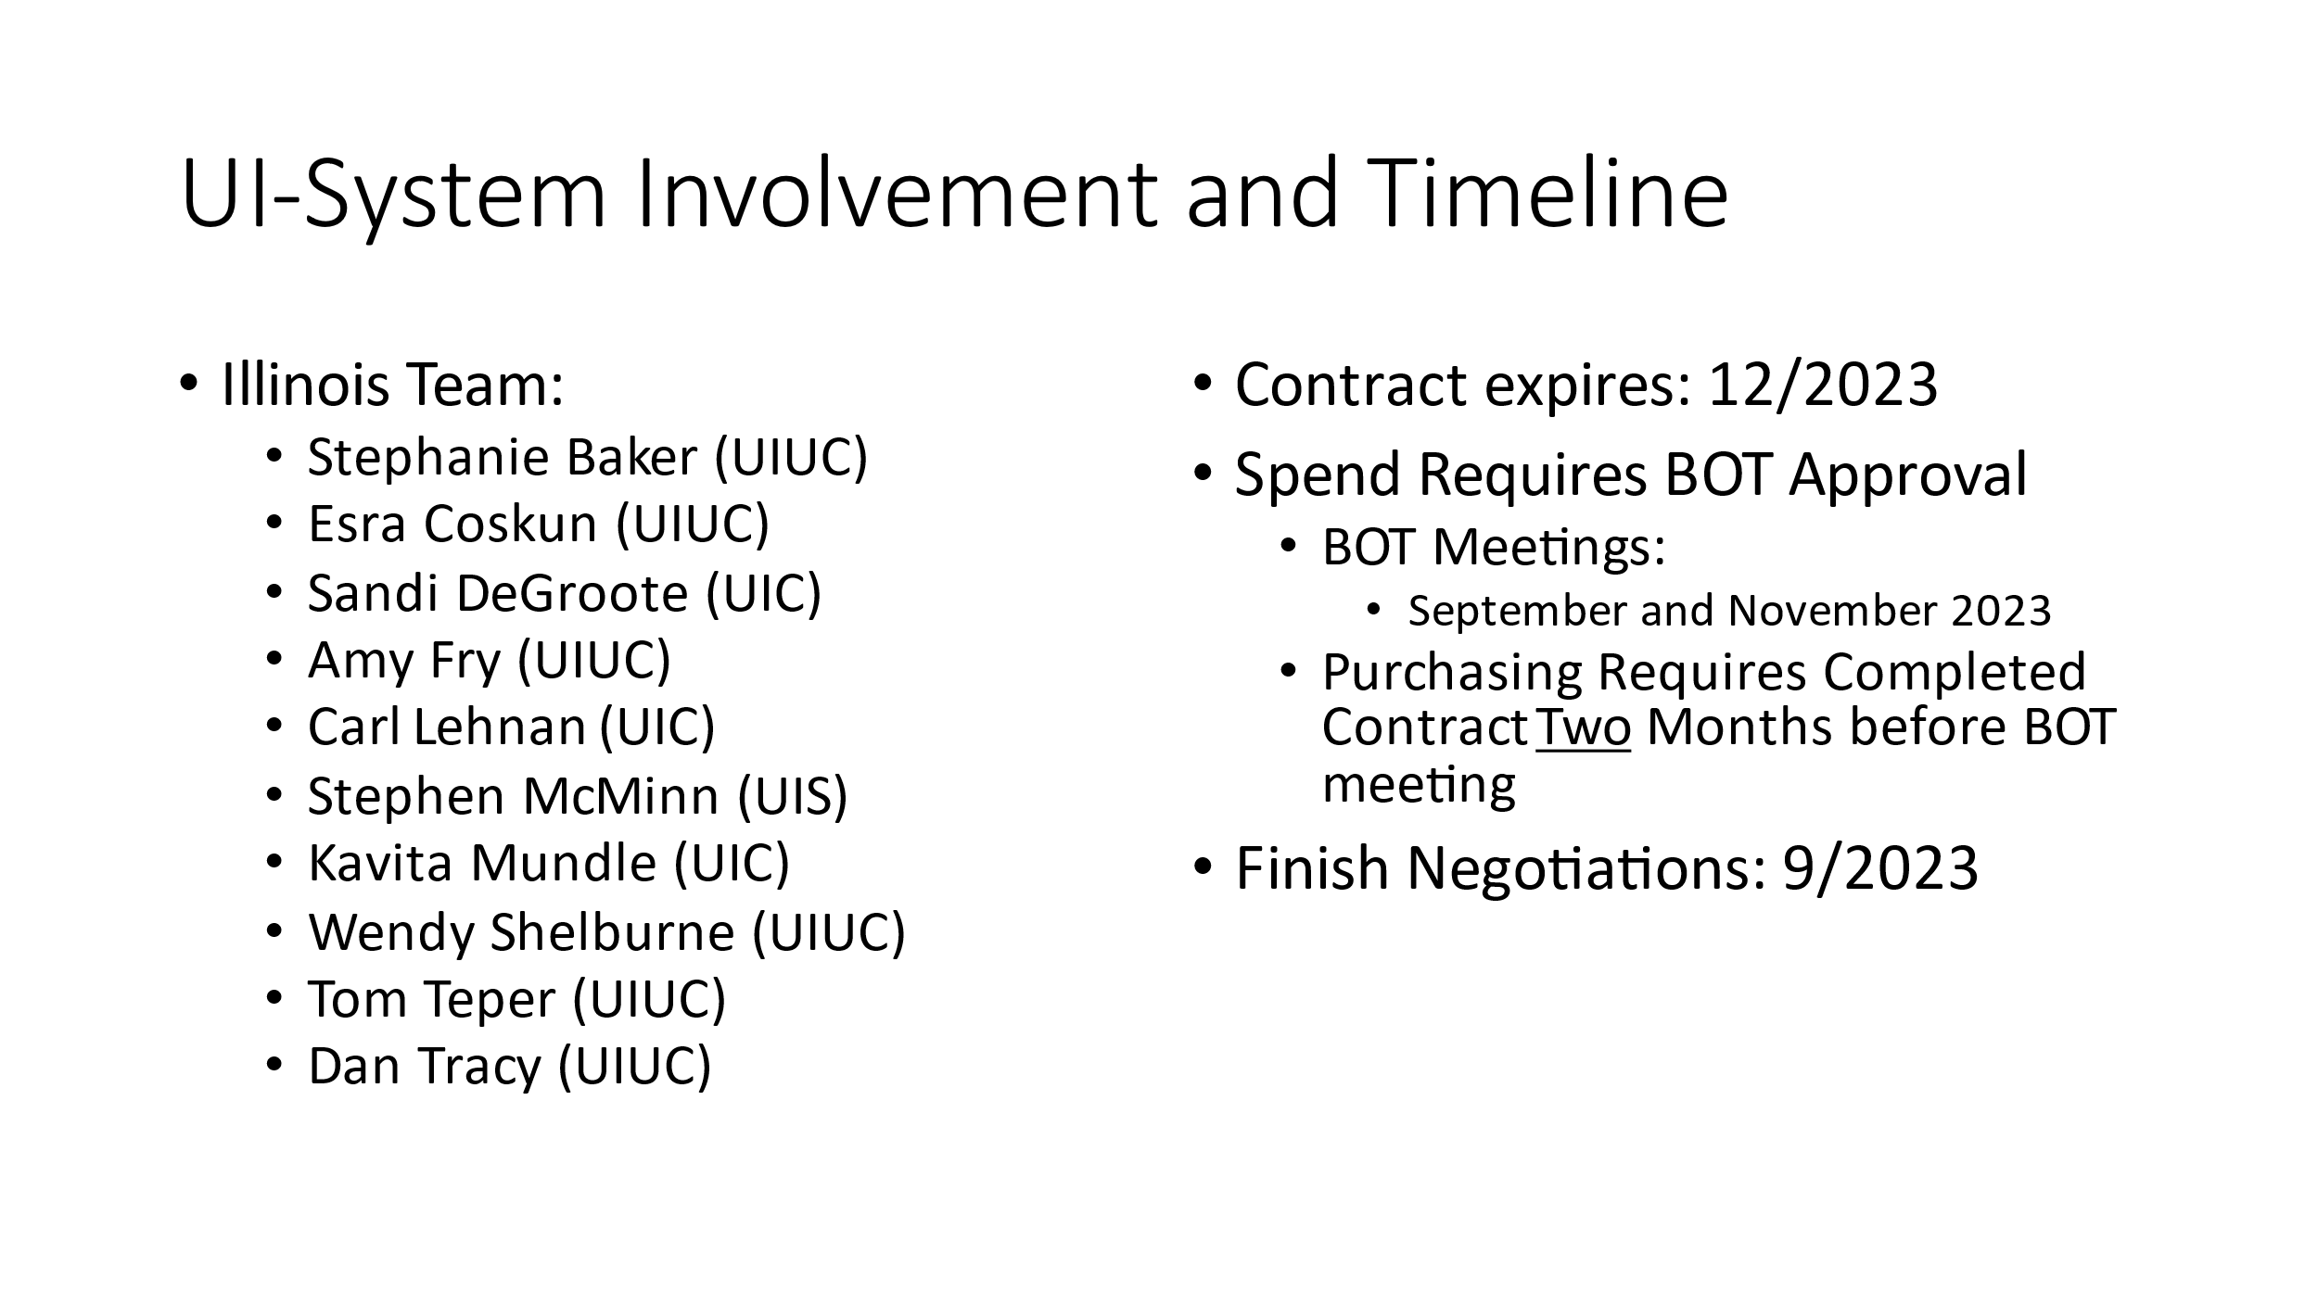

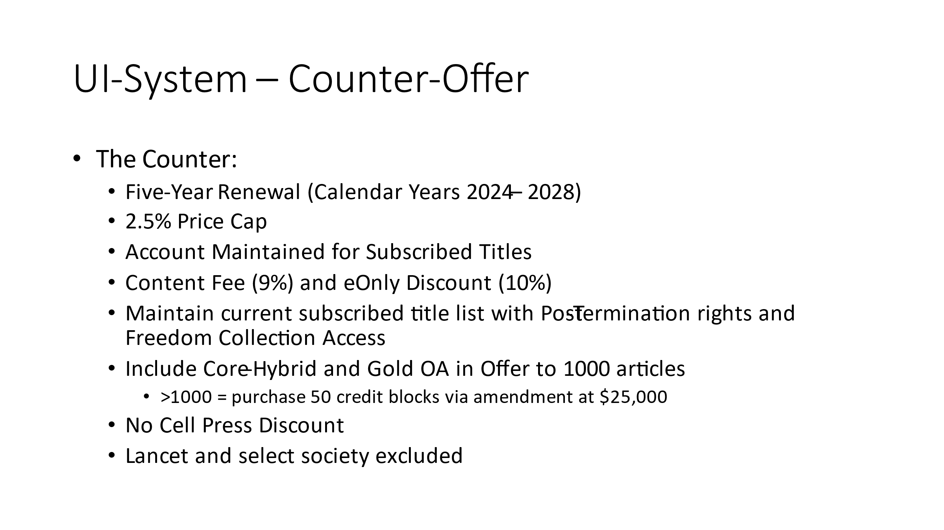

- Taylor & Francis EBA Pilot (Amy & Tom)
  - Stephanie Baker has been working with a data set of books purchased from Taylor & Francis from FY19-FY22.
  - A limited T&F DDA was piloted in spring 2023. This was done through the EBSCO platform, as T&F will not do a DDA on their platform. We are trying to improve our options, as the DDA does not work best.
  - Subject selectors wanted to see where usage of T&F has been going. Use of T&F eBooks has been strong, and eBooks have been purchased using many different funds. There has been an uptick of interdisciplinary use of these books.
  - An idea for a T&F frontlist EBA has been brought up. This would include Routledge and Routledge India prints but would not included CRC Press. This would also include a 15-year fixed backfile, with titles being added as long as we continue the EBA.
  - Tom and Amy will be speaking more with subject selectors about this idea.

- Firm Orders and Special Funds (George)
  - George has been working to clean up special funds. All print one time orders before FY23 are being looked at. These will be broken up by fund manager and sent out. Items that need to be revisited with the vendor can be, and all others will be closed and cleaned up.

- Course Information Management Update (Tom)
  - The course information management system, Course Lead, has been used for proposed revisions to courses. Dean Wilkin was receiving notifications about the proposed revisions to identify any needs that would pose a challenge for the Library to address.
  - The system is being revisited, and there is a meeting in August with administrators from each of the colleges. Tom will be presenting and encouraging these individuals to work with subject specialists about the potential impact on the Library while proposals are being put together.
  - Tom would like to receive any comments or suggestions for this meeting.

Updates
- Acquisitions
- No new update.
- E-Resources
  - A reminder will be sent about journal renewals.
- Preservation Services
  - Jennifer will be sending an update to libnews about the toxic materials project. A quarantine area has been set up in the stacks.
- BTAA Updates- Sage and Springer Renewals
  - They have agreed to renew for one year with the same price increases that had been previously approved.
  - Our inner library loan agreements need to be brought back into alignment with the Big 10. There have been cases where new acquisitions are marked as not lendable outside of Illinois or the university. There will be ongoing conversations around this.

Meeting adjourned at 4:23 pm.

