CAPT Minutes
January 29, 2026

Present: Tom Teper, John Laskowski, Kyle Rimkus, Tracy Tolliver, Will Schlaack, Wendy Shelburne, Mary Ton, Chloe Ottenhoff, Michael Norman, Jennifer Teper, Eric Mosher, Hannah Williams (notes)

- Agenda and previous minutes approved.

- Quarterly working group reports

- Search, Discovery, and Delivery Working Group Report – Michael Norman & Kate Lambaria – January 29, 2026
- Sarah Park will be interim Co-Chair of the Search, Discovery, and Delivery Working Group during Lambaria’s sabbatical
- Kate Lambaria has started a sabbatical in recent weeks and Kate will be out through the beginning of August 2026. Sarah Park has graciously volunteered to pinch-hit for Kate over this period. Sarah will be able to start attending these CAPT meetings next month.
- The Toggle options in the Single Search Box available (and being used):
- We are seeing more use of the Toggle and the Primo Library Search. It got off to a slow start last Fall, but our Primo Library Catalog different versions usage numbers are going up. The usage of Articles+ has increased by over 80% since this time last year.
- User Experience - Library Service Satisfaction Survey 2025
Discovery Experience Overview section:
Questions included:
1) What types of information do you search the Library website for?
2) When working on a research project or assignment for a course, what is your usual process
3) Thinking back on a recent experience searching the Library website, what information was most important when selecting
https://uofi.box.com/s/h049s2xv1agcrf4fssr2s1ktaig1l9oz
- Creation Team Dynamix for Primo Maintenance
  - The Search, Discovery, and Delivery Working Group did announce the creation of a new Primo Maintenance queue in TeamDynamix (TDX) starting this Spring Semester 2026. Library colleagues can now submit questions, issues, and suggestions related to the group’s work by creating a TDX ticket and selecting Primo Maintenance.
  - If you prefer, you can also reach us via email at discovery@library.illinois.edu

- Newspapers Search in Primo
  - We were able to push out additional options for searching against Newspaper titles and article content. In the screenshot below, this includes 1) a separate Newspapers Search in the banner across the top of Primo that searches an billion+ article index; 2) Filtering by Newspaper resource type either pre-filter or post-filter after search is initiated; 3) Recommendation boxes pointing to other sources to help guide the user in search for current newspaper content

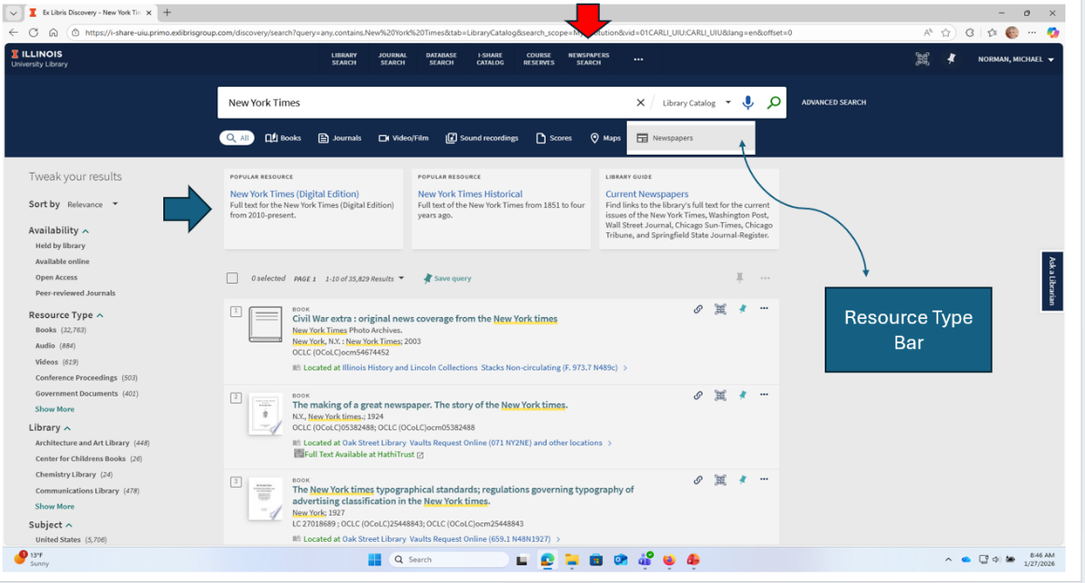

- Browzine Linking Service
  - Starting in January 2026, we have activated the BrowZine addon functionality into Primo. These added value links helps with accessibility in showing the different versions available to Library Users to read (PDF or HTML Web version), and LibKey authentication service in the results. We are hoping this will improve access to Unpaywall links as these have been problematic in linking to the full text content for some articles.

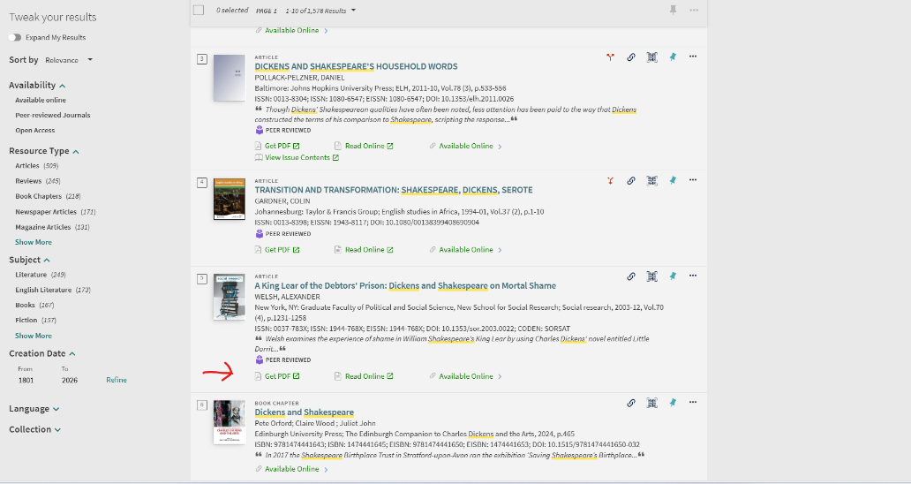

- Web Working Group- John Laskowski
  - The staff website is being reorganized. Marisa Modugno is doing some design work for this.
  - We are examining different ways to present a new library search experience as we move away from Easy Search.
  - The search box will be incorporated with the spotlight (the large image on the home page). The search box will remain constant but the images and links/buttons they contain will change as the session changes. This will be incorporated at the end of the spring semester, in line with the end of Easy Search.The cosmetic side will be controlled largely out of communications.
  - The Office of Strategic Marketing and Communication is standardizing the guidelines for branding and web structures. Our global menu is problematic and doesn’t match with what other colleges are doing. Our theme in WordPress predated the campus theme, which makes it harder for us to align with the new theme.
  - We are exploring the idea of taking the global menu out of the header and putting it into a Library specific footer.
  - There is a new hire on John’s team. Her title is UX and Content Specialist. She will be helping primarily with the content side of web strategy and web maintenance. She will also be doing training for GA’s and new staff for WordPress.

- Accessibility- John Laskowski
  - Our WordPress sites are about 89% accessible.
  - AxeMonitor will likely be replaced as the campus wide solution in the next few months. The Chicago campuses have already been moving away from it.
  - John is working on the draft for the year two accessibility roadmap. This will take several areas of focus from year one into new categories or platforms, such as LibGuides and the staff site.
  - Primo will also be a big focus in year two, and there will be a new interface.
  - An instructor and reader support task force will be created to focus on instruction for the teaching faculty and support for reference staff.
    - We will not be responsible for making things accessible for instructors but will be responsible for keeping them informed of the best practices for finding accessible materials.
  - PDF remediation is still up in the air at the campus level. We will continue to monitor the marker for solutions that might work well for the Library that wouldn’t scale to campus.
  - Library digital exhibits are also part of year two. Several categories of content will need to be looked at for archiving, but content created before 2024 will be tagged and can remain but won’t be able to be updated.
  - John has weekly office hours from 11-12 every Thursday on Zoom.

- Parking lot items-review

- Any other new business

Meeting adjourned at 2:20 pm.

