Student Focused Spaces Task Force:

Focus Group and Photovoice Summary Report
July 2023

Contents
- Background
- Executive Summary – Themes & Recommendations
- Focus Group Background
- Photovoice Background
- Appendices

Background
The Student Focused Spaces Task Force first convened in January of 2022. After reviewing and prioritizing the charge, the team spent Spring 2022 selecting areas to pursue in support of the outcomes “Design, develop, and conduct assessment and user experience studies to regularly and consistently solicit student feedback across library spaces” and “Be guided by the Library’s Diversity, Equity, Inclusion and Accessibility vision and consider the broadest range of diverse student needs.” The team settled on investigating what factors impact students’ feeling of belonging in Library spaces, and how these factors impact the design and delivery of spaces where students feel welcome. A priority was designing studies which would recruit broadly across student populations, comprise inclusive questions and prompts, and provide opportunities for a diversity of perspectives to emerge.

Based on an extensive literature review, the team selected Photovoice and Focus Groups as the research methods to employ. These qualitative methods were selected in part to elicit feedback in students’ own words, as well as provide a variety of ways to consider the theme of “belonging” in Library spaces.

Executive Summary – Themes and & Recommendations

Theme 1: Confidence versus feeling like you are in the wrong place – When participants felt like they belonged, they articulated that emotion in terms of “feeling confident,” rather than the language used in our initial questions of “feeling welcome” or “belonging.” Students who experienced a sense of belonging expressed feelings of being secure within themselves, within the space, as well as a freedom from the judgement of others (both Library staff and other students). A greater sense of confidence was identified as a motivator for continual success with one participant stating: “when I feel like I belong, it makes me feel like I have a purpose and when I have a purpose, I feel like I belong” and “[you are] more likely to take initiative or speak your mind if you belong.” A feeling of “calm” was similarly associated with spaces where a student felt accepted. A key takeaway for the Library to consider based on this feedback is that creating an environment of belonging does not just make the students feel good about their experience, it can increase their overall academic and emotional success on campus.

Students were quick to identify situations where their confidence was drained by spaces or experiences that increase a sense of not feeling welcome. Students identified feeling anxious, on display, exposed, and physically restricted in spaces conjuring a lack of belonging. One example students pointed to was the process of walking through a vast, quiet space – The Main Library Reading Room – trying to find an empty seat and the added emotional burden of the return trip if no seat is found. What could often be pointed to as a curated, majestic hall of knowledge to some is a lonely, spotlighted walk through a corridor of silent – potentially judgmental – observers to many. A participant noted this feeling occurring in library spaces when they were “Maybe doing something that is not right, or doing it(?) the wrong way.”

This theme ties into themes around signage and presentation of spaces – encountering a space which has an ambiguous presentation of intended usage can drain confidence and lead to feeling like a student might be in the wrong place. The Main Library in particular was noted as a building where there was not a clear delineation between patron spaces and staff spaces, particularly on floors above the first level. Similarly, some participants commented that they did not go to smaller unit libraries if they weren’t majoring in a related discipline, under the assumption that they would be unwelcome in those spaces.

Theme 2 - Signage
In the Photovoice study, participant photos often included signage. Signs were used to communicate a variety of information from hours to available resources. Students also focused on the design of the signs. Poorly designed signs might imply that employees did not care, were not supported, or that the information being shared was not important. For some, signage helped create a welcoming feeling, especially for specific identities (for example, signs for gender neutral bathrooms and their availability). Signage also needs to be appropriately sized to effectively communicate the message (e.g., not everything should be on 8.5”x11” paper).

The focus group participants echoed those of the Photovoice study. Signage is a problem of Goldilocks proportions, meaning we have both too much and not enough, and none of it is “just right.” The primary audience for signs should be users. Students have pinpointed the following problems.
- Too much jargon - “Stacks doesn’t mean anything to me. Just have a sign that says, ‘Books this way.’” Also, “there are too many assumptions about information.” These comments suggest we’re leaning into a “prestige bias” mindset where the Library is using signage as self-promotion instead of empowering users.
- Lack of perspective – for example, the number of signs and references we have to Room 66 over-emphasis the importance of that space in the overall structure of the Library.
- An overall lack of understanding about Library space particularly the Main Library. Statements shared by students about not understanding why there are so many locked and unidentified doors indicate a general lack of understanding about the Library as an organization. There is no expectation that staff require offices or that space within the Library should be restricted from users.
- The lack of intuitive signage generates a sense within students that achieving success in the Library requires asking staff for help which results in detailed tutoring on basic principles. This process seems to be demoralizing to many students, particularly for activities which feel like they should be obvious (e.g. identifying where the books are in the Main Library). Participants want comprehensive, understandable information in their hands (or phone) and to have the choice of speaking to Library employees as an option instead of a requirement.
- There were some concerns expressed that signs which designated expected behaviors (e.g. quiet zones) were not consistently enforced in some units.

Theme 3 - Variety of options – Students appreciate the choices various libraries present, with some visiting different spaces based on specific needs, and others zeroing in on a favorite space. While there were some commonalities across participants, differences were noted in choices of types and kind of seating/furniture, volume levels, privacy, access to food, and lighting. For example, some students preferred bright light to help motivate them, such as that in the Orange Room, while others liked the individual table lamps in the Main Library Reading Room and the Grainger second floor study spaces. The ability to modify spaces and have some control of personal environments was also desired, such as flexible seating, room to spread out, and the ability to work in groups. There was also recognition that the character of some spaces (e.g. the Orange Room) change throughout the day.

While the choice of a study space was strongly influenced by personal preferences, friends were another strong influence which might sway participants to choose a different location. A repeated example that came up was the use of the Grainger Engineering Library and Information Center (GELIC to librarians, Grainger to students) for late night and group study. Access to food through the coffee shop and group rooms and spaces influenced participants who did not identify Grainger as a favorite space to study there anyway.

Although it is slightly different than having options to choose from, several participants expressed a desire to have control over their surroundings, such as being able to adjust lighting or furniture arrangements. It’s not just that there are a wide variety of preferences to consider in our spaces; students expressed an interest in having more direct control over their environment, which makes them feel more welcome to settle into the space and feel like they belong there.

Furniture and other features were emphasized in the Photovoice study. Participants photographed and discussed tables at length. Large tables seemed to waste space, unless there was a way to communicate that it’s okay to share with someone. This difference was demonstrated through photos of the lower-level Illini Union tables (awkward) and the Reading Room where people often share tables and that is expected. Student participants appreciated individual study areas, like the Funk ACES carrels.

Seating options were featured heavily in the photographs, including chairs that were specifically mentioned either for their comfort or lack thereof, or for their ability to facilitate long-term study or only short visits. It is important to have options for different types of study and for all body types.

Participants also wanted a variety of sound levels in study spaces, and they acknowledged that this is often self-regulated by students (see Appendix 2). There is a difference between a buzz that facilitates studying and sound that is distracting, such as the piano in the Illini Union.

Other options discussed include:
- Many photographs also included technology, such as access to power, computer stations for individual work, and personal laptops and other devices.
- Food and coffee: coffee cups were featured in many of the photographs and students explicitly requested options for spaces where they could eat food.
- Location: students appreciate having study options across campus, including locations close to their dorms/housing, or in buildings they spend a lot of time in for classes, work, etc. (see Appendix 2).
- Outdoor spaces: students appreciate outdoor seating/study options when the weather is nice, but most of the furniture is not conducive to long periods of working as an accessible power source is required for laptops.

Theme 4 – Safety and security
When choosing a place where one belongs, basic needs must be met first. No matter the features or options available, if students do not feel safe in a space they will not go there. Funk ACES was described by some as feeling safe because it is an open space and everyone can see one another. However, others described how isolated the location feels at night, with no buses running nearby. Students described feeling different about several library locations at night, such as liking how busy Grainger was at night. Grainger was described as a nice dark, with good lighting even at night, whereas the architecture and lack of lighting makes the Main Library seem scarier at night, like walking in a haunted house. For some, walking outside at night is a nonstarter because of safety concerns.

Theme 5 – Privacy is valued
Students want to feel that they can have private space even in the middle of a busy library. For example, in the Reading Room there is a feeling that one is on display, especially when walking in and trying to identify a space to study. In other units, such as GELIC, students reported wanting private study space where people aren't coming up behind you. Proposed solutions participants identified include arranging rooms so students have some physical privacy when seated, and also providing clear communications which indicate that library staff value privacy and support it.

Theme 6 - Clear expectations for space use
Participants valued knowing how a space is intended to be used, especially when it is a new space to them. It can be hard to know the “social rules” of a space, so the library should consider ways to communicate this visually (see Appendix 2). The Spring 2023 participants discussed at length the unknown purpose of various spaces within the Illini Union, including the lower level that was previously a food court and is now used as a study space. People tended to leave the tables dirty when they did eat there, and students awkwardly spaced themselves out amongst the tables.

The value of understanding how a space is intended to be used was demonstrated by a conversation with Fall 2022 photovoice participants about the Main Library Reading Room. Irene [participant] commented “I like that this is a dedicated quiet space.” Later on, Victor [facilitator] summarized the discussion with: “Sense of belonging is related to the space being purpose built for what you want to do. But also tied to who is in the space.” Jami [participant] and Irene agreed with this summary, and Jami added: “It’s more about my work, want to be around people with the same energy.”

Additionally, while focus group participants would like more direct access to materials, having study spaces integrated into browsable collections feels invasive to many students. Grainger’s third floor space was offered as an example of this overlap of spaces. Whether they are the one studying or the one looking for materials, students expressed a sense of disruption as well as an invasion of space. Ideally something like the floor plan of the Law Library where study space and browsable collections are adjacent but self-contained would be preferred

Participants also identified temporary spaces where they do not spend a lot of time but might quickly take care of tasks or catch up with someone. This included the low, soft furniture in the Scholarly Commons and certain spaces in the Illini Union. Whether these spaces were intended for short-term use is unclear, but participants were on the same page about that kind of use when looking at photos together.

Recommendations for Action

The Follow-up groups listed below are recommended as the appropriate actors to investigate implementation of the study’s recommendations:
- Library Internal Marketing Group – For signage creation, language, UX, best practice, and distribution of signage. The group may also want to work with Library Administration to secure a budget for a signage revamp, and also to inventory the types of signage and space need request they receive to build a larger picture of library space allocation.
- Web Team – For recommendations about how spaces are presented on the website.
- Library Facilities - For recommendations which involve the placement of furniture, allocation of resources such as power, and related needs.
- Unit Heads (and others who manage patron spaces) - For recommendations which involve updating unit signage, designating study space types within a unit, and communicating expectations about spaces to patrons within a unit space.

Recommendation 1 - Clearly communicate space expectations visually
- University Library signage should be evaluated for consistency and user-focused priorities, with messaging aligned with the patron priorities for using the space, rather than lists of what not to do in a space. Signage is a way of appealing to people’s senses and helps create a welcoming environment. Some signage focuses on policing versus offering alternatives, and students reported feeling worried they are doing something wrong in Library spaces, particularly the Main Library. Students have different needs at different times, and they value spaces they can adapt. An example of improved messaging related to food includes: “Hungry? Eat here. Vending machines are located here.”
- If there will be high activity/events and a change in the level of sound in a space, this needs to be clearly communicated.
- Updated signage should use language appropriate for the audience, reducing library jargon, and focusing on empowerment rather than restriction. Marie Oestergaard, speaking on the topic of design thinking for libraries at the UXLibs conference in June stated, “the moment you put up ‘forbidden’ signs you lose! People who want to misbehave will not be deterred by a sign and others will be off-put or intimidated.” This also applies to training for staff to deliver feedback offer alternatives rather than just saying “don’t do that.”
- As too much signage creates visual clutter, patron-focused priorities should be reflected in the content of signage, with a goal of informing students about how to use Library spaces effectively, with clearly understood expectations.
Recommendation 2 - Improve wayfinding across library locations
- Even in their favorite study spaces, students sometimes don’t know how to get to certain areas and are reluctant to ask staff (upper levels in Funk ACES for example). Clear, student-focused signage, both online and across physical locations, should be developed, evaluated, and maintained with regular updates.
Recommendation 3 - Highlight variety
- Students want different types of spaces depending on their particular needs. They want long term study, short term study, individual and group study.
- No one place can accommodate all, but the library could better market what is available through the libraries and where those spaces can be found.
- Findings indicate that unit libraries should lean into their distinct characteristics, while at the same time adopting common and consistent language, branding, signage, and marketing to help students understand what to expect when they visit a new library. Smaller unit libraries, particularly those not regularly reaching maximum capacity, are also encouraged to participate in shared marketing efforts, and identify collaborative methods to communicate that their spaces are welcome to students outside of the primary disciplines served.
- The information on the Library’s study space webpage is a starting point for considering characteristics and language to use, but continued student input and use of student language will help clarify the intended uses of each Library space.
Recommendation 4 - Improve organization and presentation of collections in the Main Library
- Participants reported difficulties locating collections in the Main Library, identifying materials within those collections, as well as understanding the organization of materials across multiple physical spaces (e.g. collocation of like materials). Increasing the findability and browsability of materials in the Main Library would address the needs students expressed in the study. Participants called out the challenges of finding popular fiction or “fun” reading within the current arrangement of materials.

Recommendations for further study
Recommendation 1 – learn more about appropriate space adjacencies.
- Further investigation into how to situate student study spaces in relation to library spaces and services would help maximize student comfort levels. While some feedback was received about incongruous adjacencies (e.g. group study next to collection browsing areas), more information would help develop a plan to align different types of study spaces within individual units.
Recommendation 2 – identify how to integrate food-friendly spaces
- The ability to eat while studying, and as part of taking breaks from studying, was frequently mentioned. Some selections of study space were made based on both the ability to eat within the space, and the location of nearby sources of food. The Funk ACES Library, for example, is situated in a food desert, which influenced willingness to study there for some patrons. Further study about where and when to include food, and how to make food options available for students within or near Library units, is needed.

Focus Group Study
The focus group team designed a series of prompts organized around the theme of identifying what elements contributed to a space feeling welcoming to students. In order to connect the discussion to students’ lived experiences, the script began by asking students to describe spaces outside of the library where they had previously felt welcome or accepted, and what elements contributed to those feelings. The second part of the script then asked students to connect those experience back to their use of library spaces, and identify parallels and differences. Focus groups were held in Fall 2022 and Spring 2023, with a total of 5 session (3 in person, 2 on Zoom) and 33 total participants. Undergraduate and Graduate students participated, from a variety of majors and programs.

Some participants regularly used Library spaces, others used them infrequently. The themes discussed above illuminate some of the characteristics which contributed to making Library spaces either feel welcoming or off-putting, and influenced whether students chose to return. Participants were generally willing to give a space a second chance if they have an awkward first encounter, but repeated feelings of discomfort could cause them to write a location off entirely. Comments included: “A good first impression can offset a bad second” and “Maybe someone is having a bad day... I always come back and see the difference.”

Photovoice Study
Photovoice is a participatory research method where participants are seen as co-researchers involved in developing the research prompts and involved in subsequent analysis to some extent. Participants take photos during their day-to-day lives to capture their experiences as they relate to the research prompts, then come together as a group to discuss them. The Photovoice research team broke down the process into three steps for participants:
- An initial informational meeting where student participants were introduced to the research goals, photovoice method, and expectations for their participation.
- A photo taking period where participants took photographs, submitting them along with comments via Canvas.
- A final discussion meeting where the student participants and research team came together to discuss the photos and identify themes and similarities/differences amongst student experiences in various study spaces.
The Photovoice study occurred in two separate rounds. Five students originally signed up to participate in the Fall 2022 round, and three students fully participated in the study. A total of 26 pictures were submitted by the participants. Eight students signed up to participate in the Spring 2023 round, and five students fully participated in the study. A total of 53 pictures were submitted.

The Fall 2022 round utilized defined prompts to guide the students’ photography. The prompts were developed by the full group (research team and participants) but influenced by existing ideas and questions about spaces held by the research team. Participants were asked to take photos for some, but not all, of the prompts based on the spaces they were using during the photo-taking period. These prompts included:
- initial impressions of spaces, such as entrances
- belonging and welcoming spaces in the library, on campus, and elsewhere
- environmental factors, such as colors and other décor, sounds, physical comfort, resources available
- unwelcoming spaces in the library, on campus, and elsewhere (no photographs were taken to represent this prompt)
- location and availability
- recommendations or changes
While the three students that completed the Fall 2022 round did participate fully, this experience felt forced and heavily focused on existing library features, perhaps due to the limitations of the prompts. Based on the Fall 2022 round, in Spring 2023, the research team instead asked participants to take three different photos of a space where they were working, and to take photos of at least three different spaces in total. By not focusing on specific criteria or features, this allowed participants to document their individual experience and emphasize the features that stood out to them. During the initial informational meeting, the research team also showed participants in the Spring 2023 round a picture and demonstrated the discussion process that would occur later. The research team believe this approach resulted in higher participation and more robust discussion with participants.

Participants photographed the library and non-library following locations:
- Scholarly Commons, including various workstations and seating options
- Reading Room
- Main Library entrances, gallery, hallways, or “other” spaces
- Funk ACES Library
- Orange Room, including zine cart and emphasis on colors
- Grainger Library entrance
- Communications Library
- Siebel Center, inside and outside seating
- Residence hall areas
- Illini Union, including the lower-level tables and the Starbucks
- Women’s Resource Center (a place of employment)
- Natural History Building (primary disciplinary building)
- Education Building (while waiting for a friend)
- Mechanical Engineering Laboratory (discovered via friend)
- Campus Instructional Facility

Appendices

Appendix 1 – Focus Group Questions
- What does it mean to “belong”? When you think about a sense of belonging, what comes to mind?
- Where do you feel that sense of belonging? (Prompts: On-campus? In town? Back in your hometown?)
- What emotions / words do you associate with feeling a sense of belonging?
- What emotions /words do you associate with feeling a lack of belonging?
- How would you compare those experiences of belonging and not belonging? Is one more emotionally impactful than the other?
- When entering a new place, how quickly do you feel a sense of whether you belong there or not? (Prompts: classroom, restaurant, party, etc.)
- How does that emotional first impression influence your decision to remain in a space or return to it in the future?
- What physical or environmental aspects of a space influence your sense of belonging, and how? (Prompts: Temperature? Lighting? Furniture? Art? Volume? Other?)
- What are some campus locations that give you a sense of belonging? What about those spaces makes them welcoming?
We’re going to turn to some library-specific questions now, but before we do is there anything anyone wants to add?
- Have you been in any of the University Library spaces? Which ones? How often? (Prompts: Maybe a particular building or study room? Maybe one of our service desks? Its okay if you haven’t been in the Library before.)
- Were those welcoming experiences? Why or why not?
- If you have not personally visited the Library, have you heard anything about the Library from friends? What have you heard?
- Do you feel a sense of belonging in this space?
- What, if anything, would increase that sense?
- How do /can Library employees affect your sense of belonging? (Prompts: availability, attitude, approachability, etc.)
We’ve come to the end of our questions, but does anyone have anything else to add?

Appendix 2 – Sample Photographs from Photovoice Study

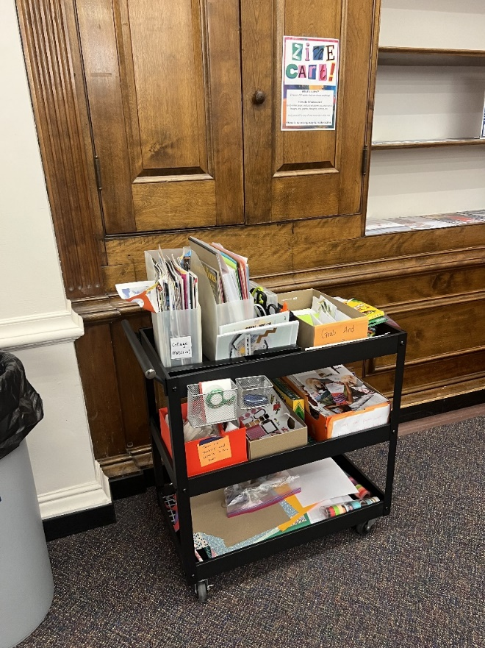
Photograph 1 This photograph was submitted during the Fall 2022 round in response to the prompt “Library spaces where you feel a sense of belonging.” The participant included the following comment with this photograph: “The main library has two study space in which I feel like I am welcomed and I belong. The first is the Orange Room, at first it didn't feel very welcoming because it was a dull room to me, but then they added the Zine station. The Zine station made it feel like I was welcomed to come and create something just for fun.”
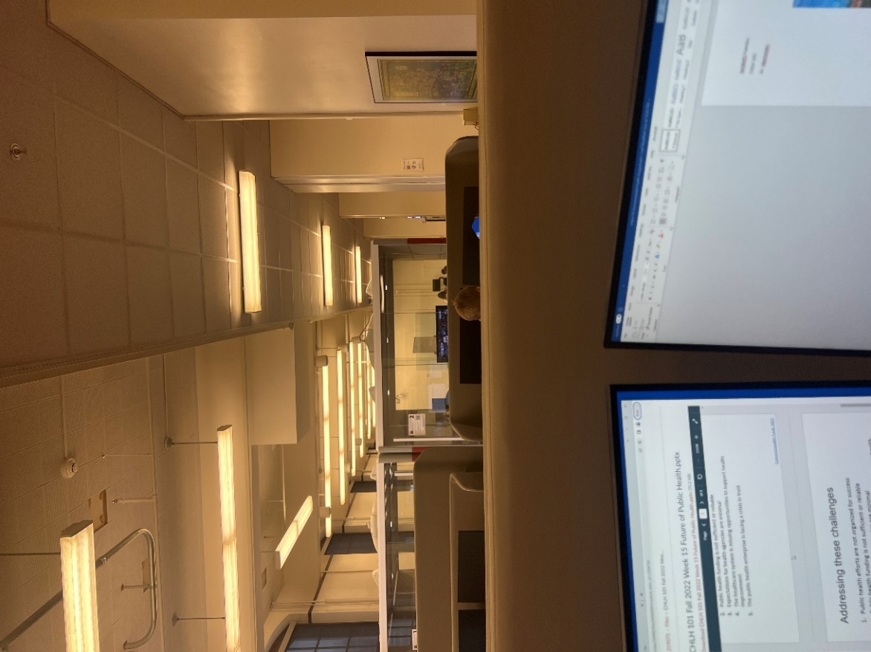
Photograph 2 This photograph was submitted during the Fall 2022 round in response to the prompt “Environmental factors – Sound.” The participant submitted the following comment with this photograph: “When I study, I cannot have complete silence or have too much noise. The scholarly commons is a place where people can talk and study so I like the balance there is. I also like the group work rooms because they help keep noise low, but some sound is still there, it is not loud. I do wish there was more because sometimes it is difficult to get them.”
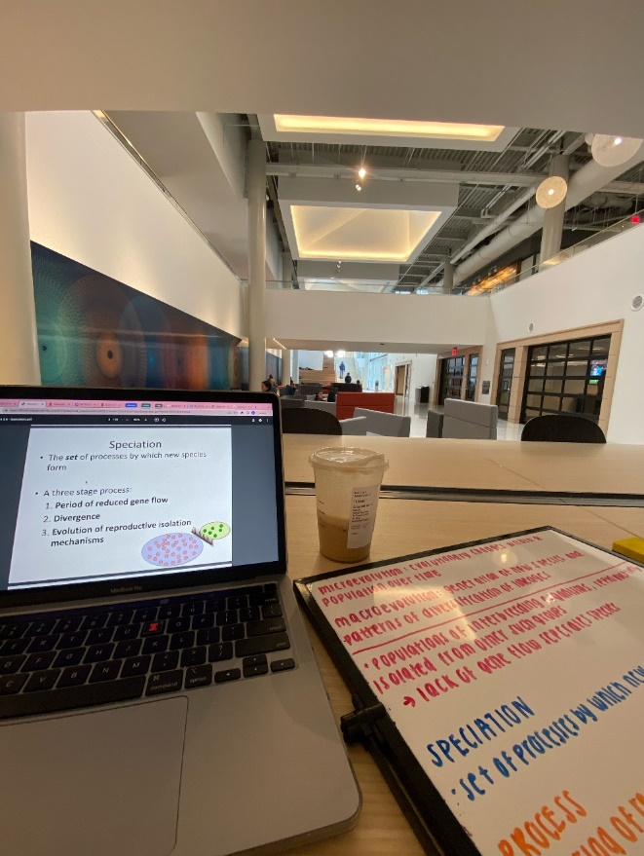
Photograph 3 This photograph was submitted during the Fall 2022 round in response to the prompt “location and availability.” The participant submitted the following comment with this photograph: “studying at my dorm is convenient since i don’t have to travel but it can be inconvenient as well since isr is well visited and sometimes there are hardly any spaces available.”
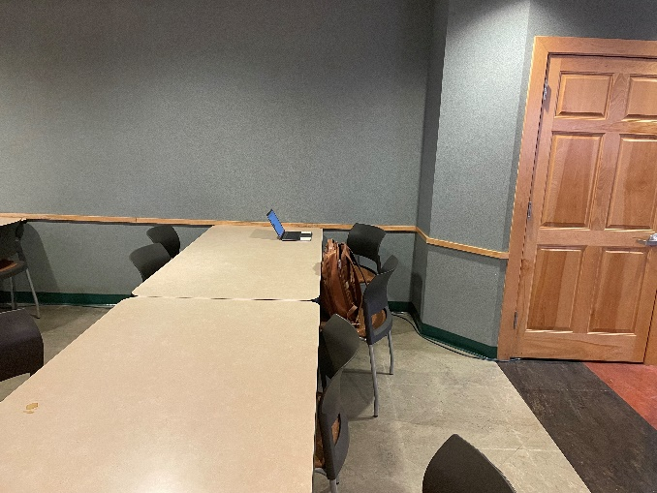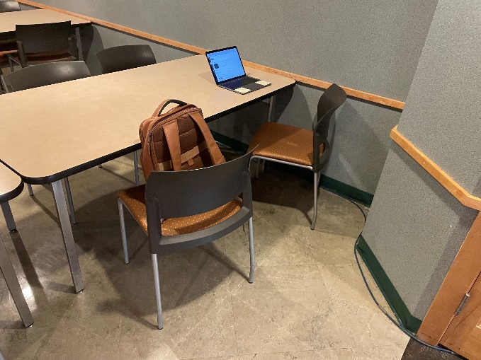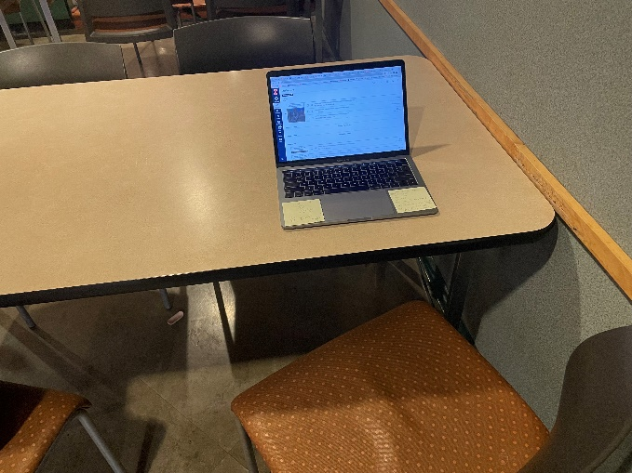
Collage 1 These photographs were submitted during the Spring 2023 round that did not include specific prompts. The participant submitted the following comment to support these photographs: “These three photos take place in my very short-term study location, the lower level of the Union. This location is primarily my short term location due to its unpredictable availability, its often disruptive noise level, but also due to its central location, which is never more than a few minutes away from my classes. These pictures were taken at 8:00 pm, to give a sense of the emptiness. The soft yellow lighting and outdated decor gives the space a sense of comfort, similar to a "Borders" bookstore from the mid 2000's. But the chairs and tables are simple and uncomfortable, another reason why accomplishing meaningful long term school work here is non-ideal. Another aspect that makes this space difficult are the scarce outlet supply. From my count, about 1 in 9 tables has outlet access, and often these tables are the first to be occupied.”
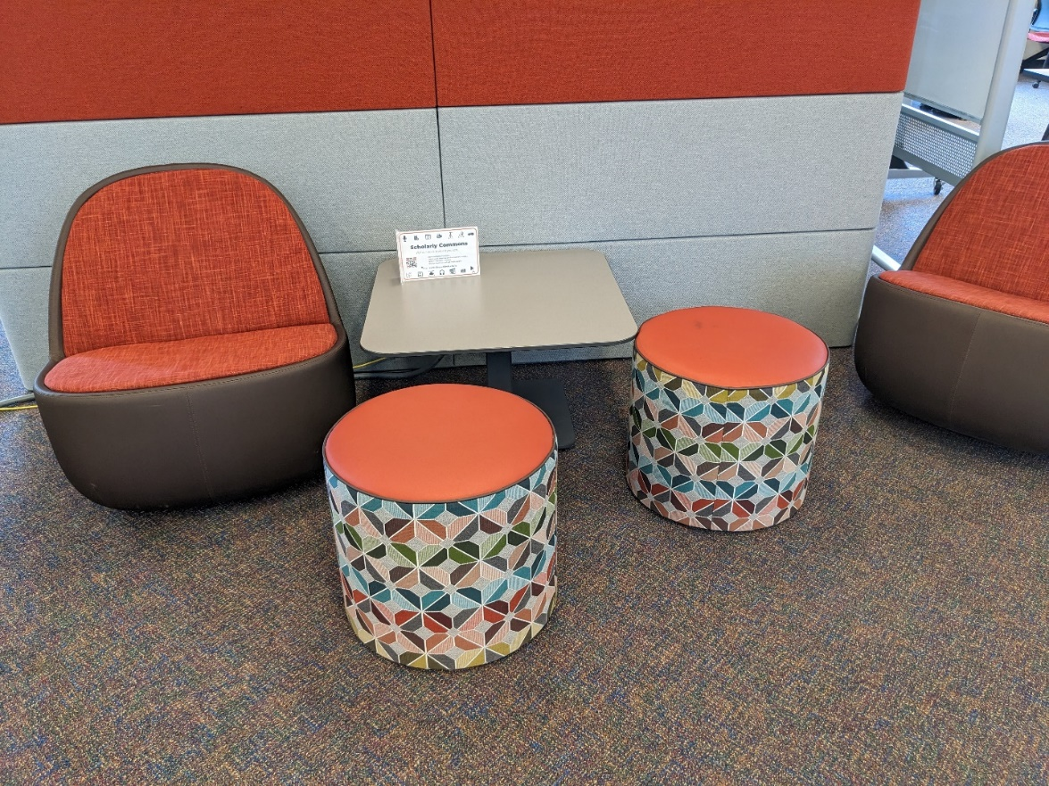
Photograph 4 This photograph was submitted during the Spring 2023 round that did not include specific prompts. The participant included the following comment with the photograph: “These are seats I found in the Scholarly Commons on the second floor. Compared to other options, these seats are usually available, maybe because they can be a bit uncomfortable to work on at times because they are so low. I find these chairs comfortable to do a light study session with a friend more so than if I were studying on my own or really needed to concentrate. Also, signs like the one on the table are really helpful to learn more about what a specific room in the library may offer. For example, I did not know that the library had self-use media studios before viewing this sign.”

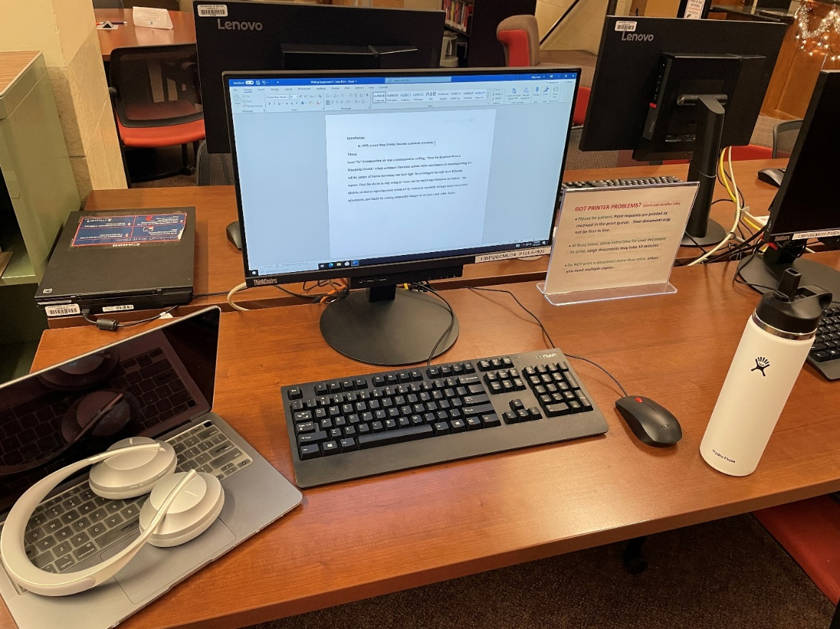
Photograph 5 This photograph was submitted during the Fall 2022 round in response to the prompt “Library spaces where you feel a sense of belonging.” The participant included the following comment: “I feel a sense of belonging because I feel comfortable working in this space. The computer desktop that is allowed students like me to work here makes me feel welcome to use the resources the library offers and makes me more motivated to work in this space.” During the discussion, they expanded further saying “It’s smaller, but the section in the middle is really comforting. I’m in my own little space even though there are other computers next to me. The atmosphere of the library itself makes me feel comfortable and welcoming. They are having coffee and cookies before finals and that makes me feel like I’m at home, in a little section of a house. Christmas decorations make me happy. Small things that make a space worthwhile.”

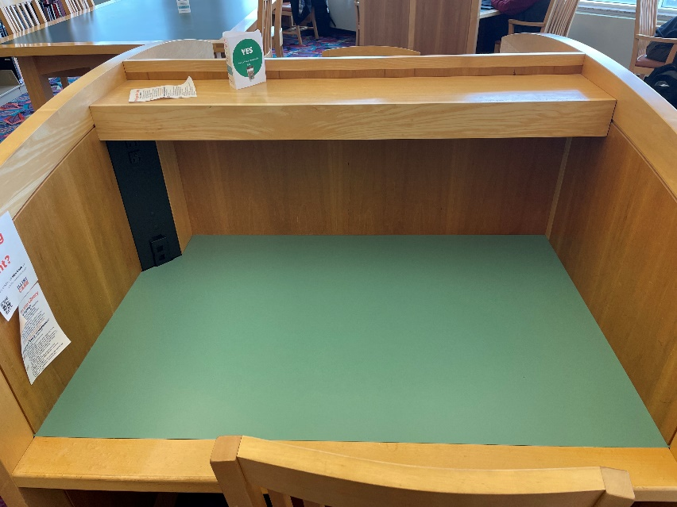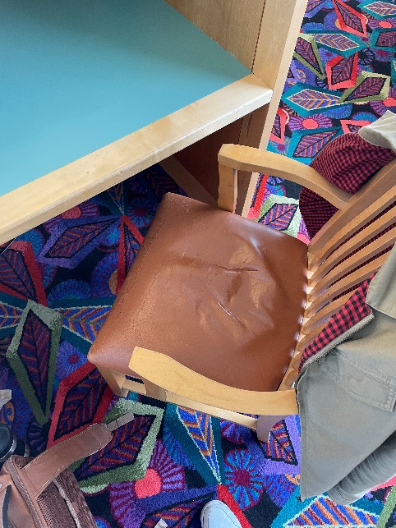
Collage 2 The participant that submitted the top two photos noted how Funk ACES was their new long-term study spot because of the individual carrels with chargers in each one. The participant wrote: “This was something that was sorely missing from every other place that I have studied at other than the quiet level of the UGL. The booths are spacious and have a top shelf for storage and organization. The final picture also shows the somewhat more comfortable seating that, while worn, clearly demonstrates an effort to make the space as inviting as possible for long term studying.” There was also discussion around how participants appreciated the carpet in this space since it absorbed sound while also being fun.
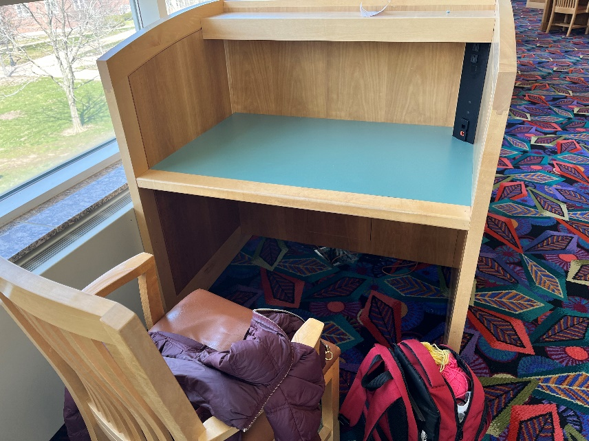
Photograph 6 This photo was taken by another participant who also photographed this space and feature, saying that “with the cubicles, you can be near someone without feeling close to them or having awkward interactions.”

