Collection Development Committee Minutes
February 25, 2025

Present: Tom Teper, Hannah Williams (minutes), Jenny Johnson, Amy Fry, Kelli Trei, Kit Condill, Stephanie Baker, Esra Coskun, Sanga Sung, Cindy Ingold, Paula Carns, Wendy Shelburne

Absent: Jennifer Teper, Mary Schlembach

Agenda/Minutes

Agenda and last month’s meeting minutes approved.

Announcements
- Clarivate changes
  - Clarivate is moving to a model that does not support the purchase and perpetual access to their content, including eBooks. They will also no longer support the purchase of print books and are getting rid of Rialto, their interlibrary loan software.
  - Institutions are given the option to purchase one of nine subject-based subscriptions to eBook content. We are an infrequent user of eBook Central so this will have limited impacts on us but access to historic content is uncertain. They will have one-time purchasing through the end of 2025 but will end after that.

FY25 Budget Updates

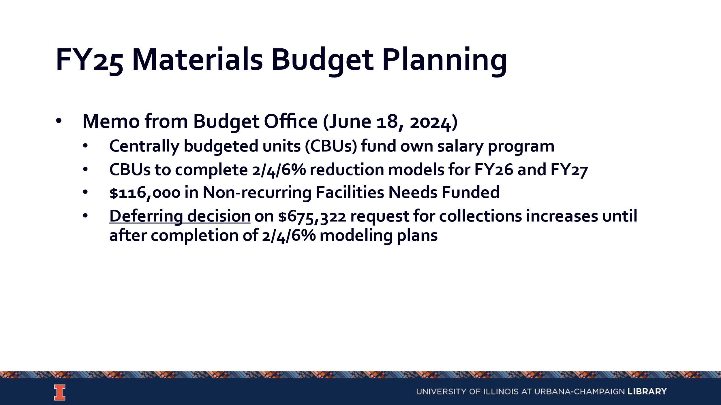
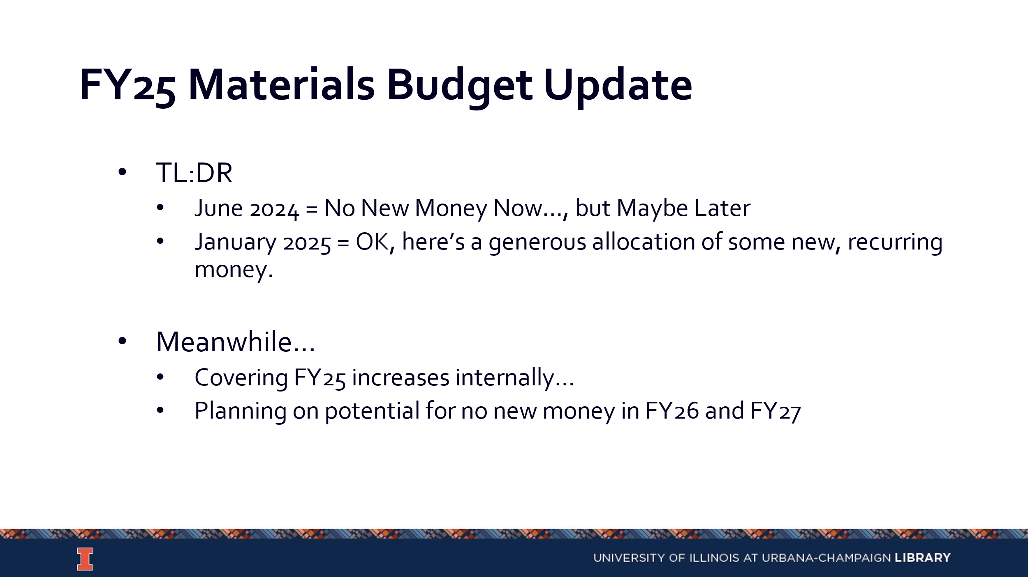

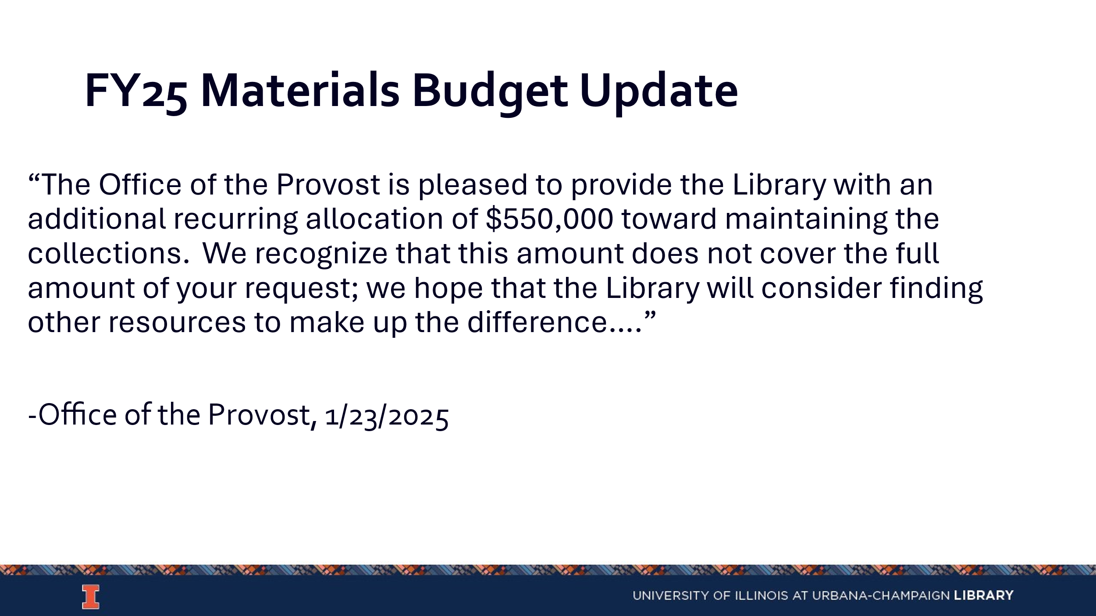

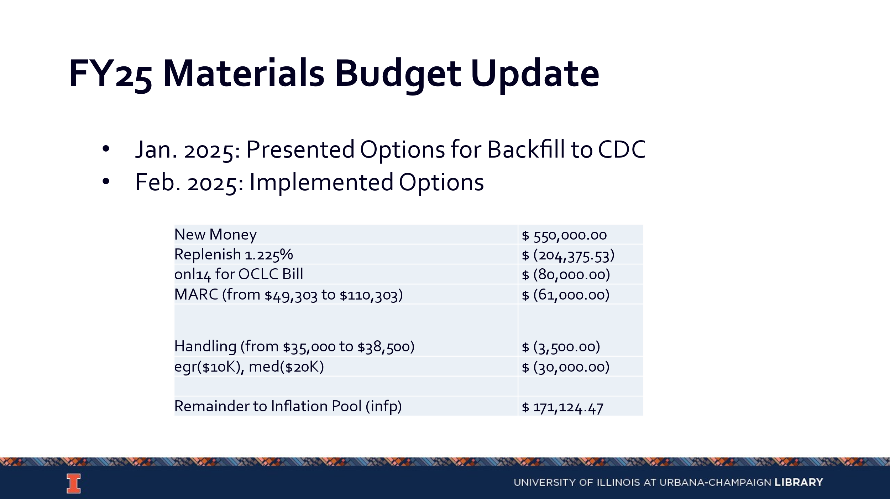

FY26/27 Budget Preparation

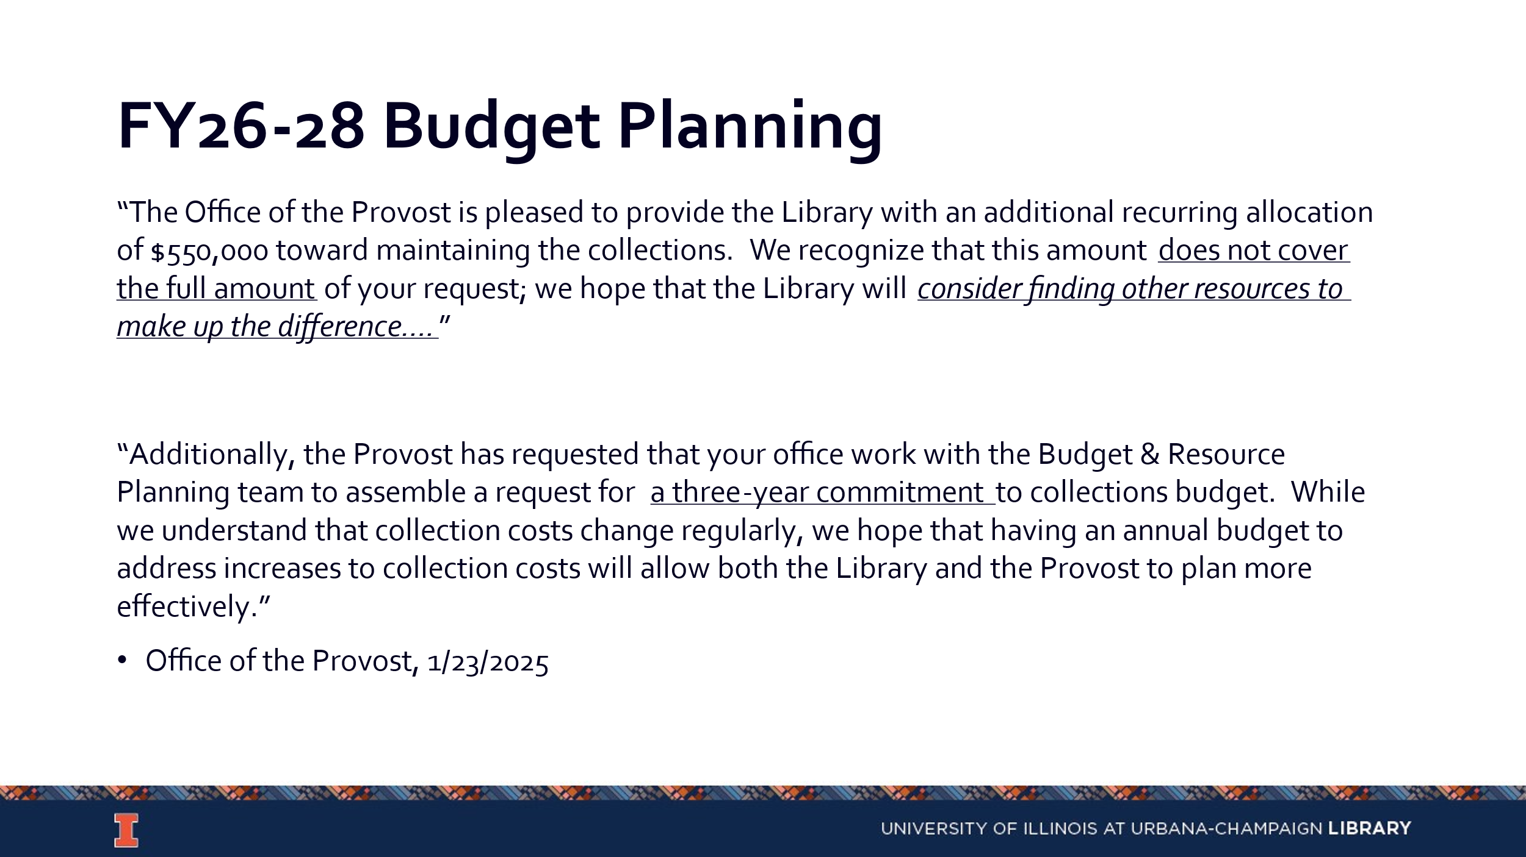

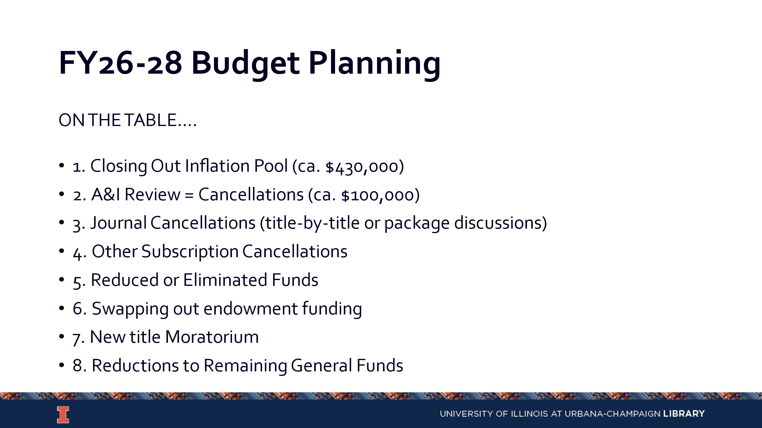
- Campus News…if any
- A&I Working Group (Kelli)
  - The midterm report was sent out to CDC. The group has created a spreadsheet of all services that are not recurring. There are 440 items on this list, but this includes items beyond A&I.
  - First discussions have been focused on items costing $20,000 or more, which is a total of 43 items. Committee members and divisions were encouraged to share A&I or other databases that should be discussed or considered for cancellation.
  - A list of recommendations will be included in the final report, which will be separated by time sensitivity for action.
  - A separate excel file of free resources will be made.
  - The goal is to have the final report by the end of March.
  - CDC supports keeping the final report accessible only to Library employees.
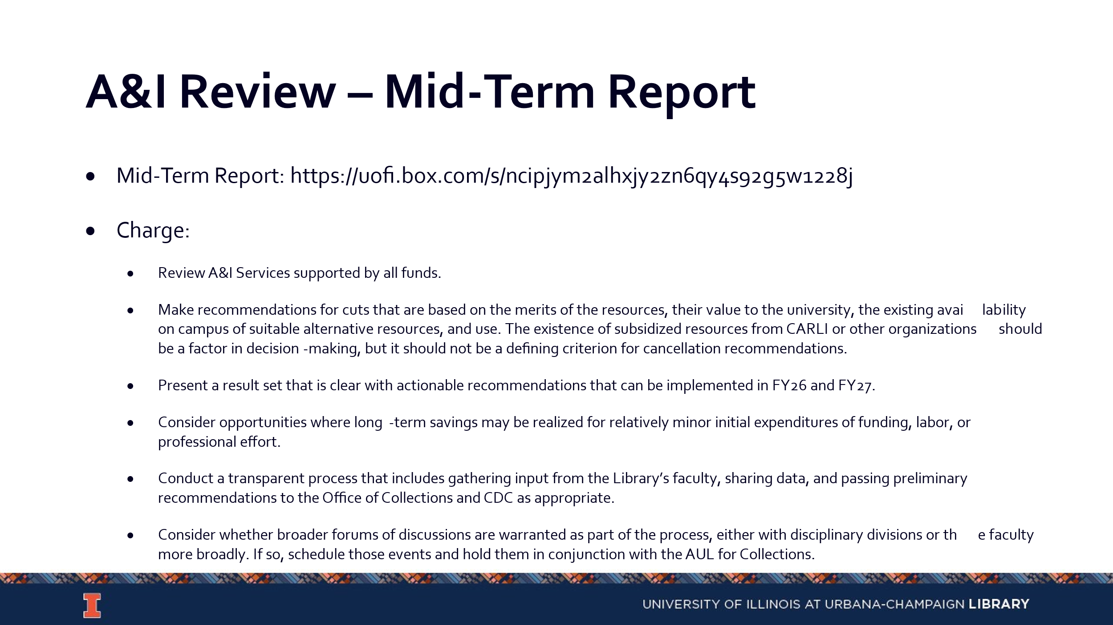

Taylor and Francis EBA

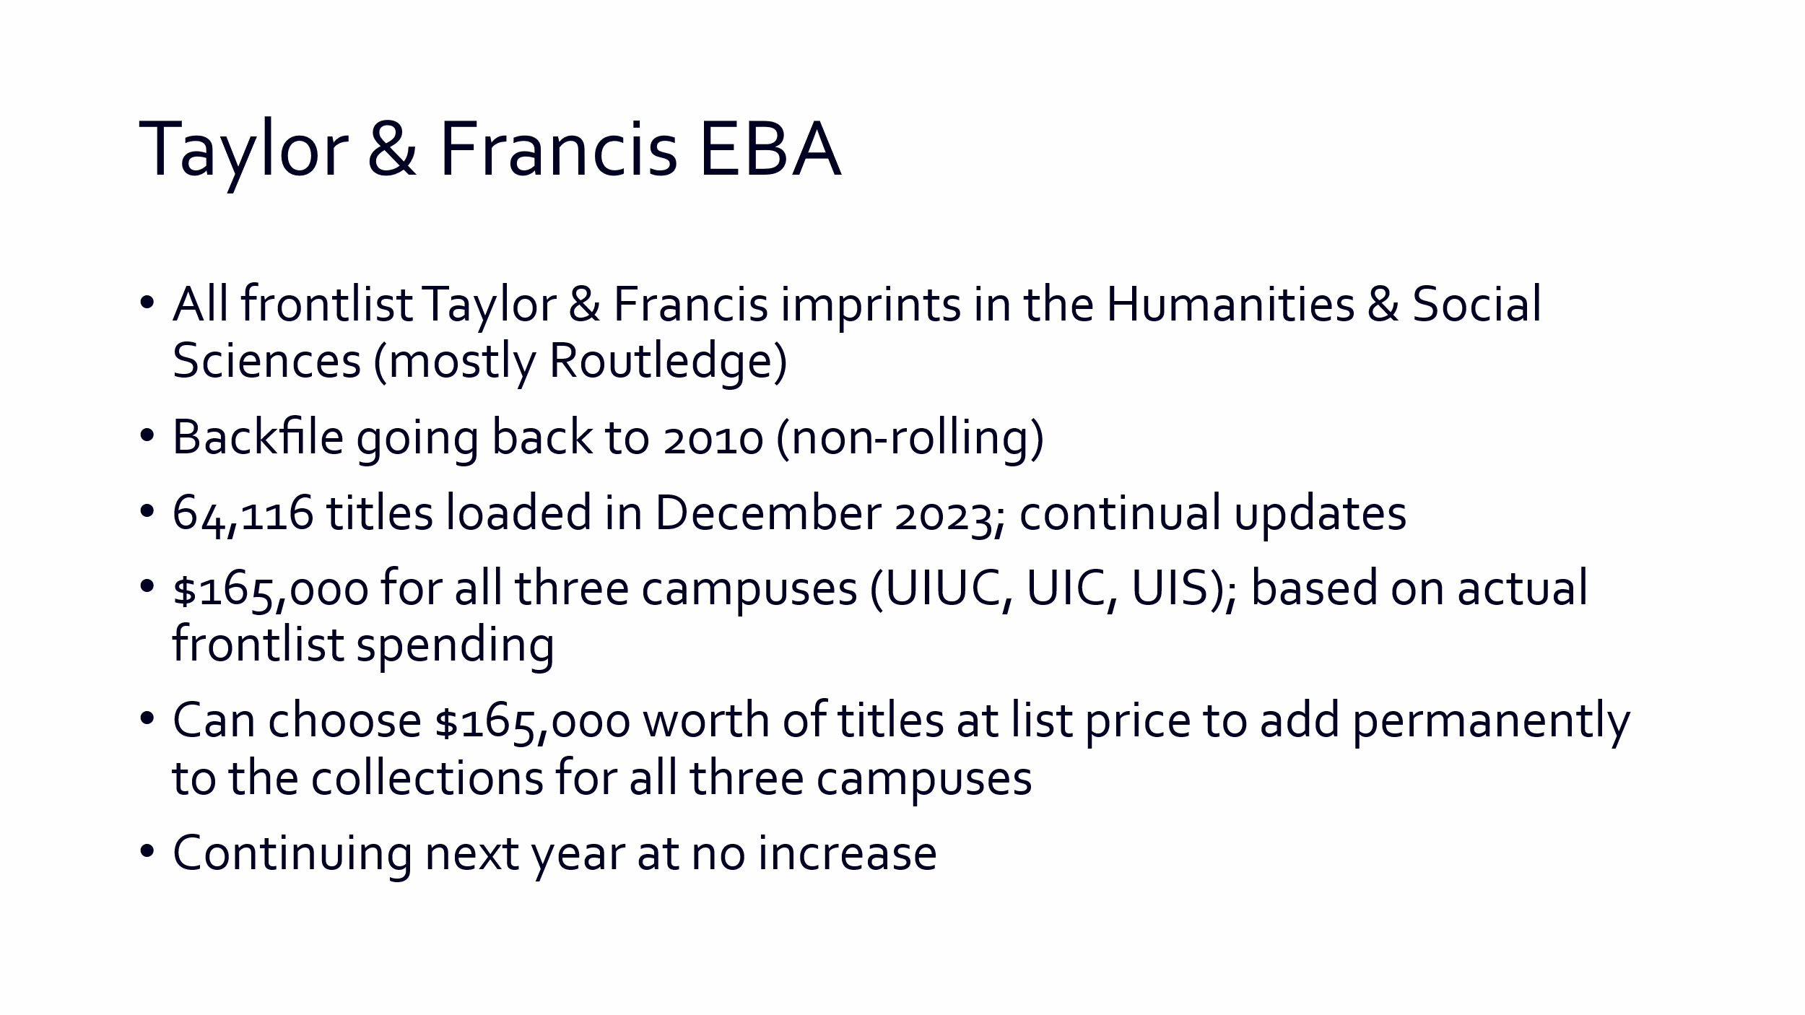

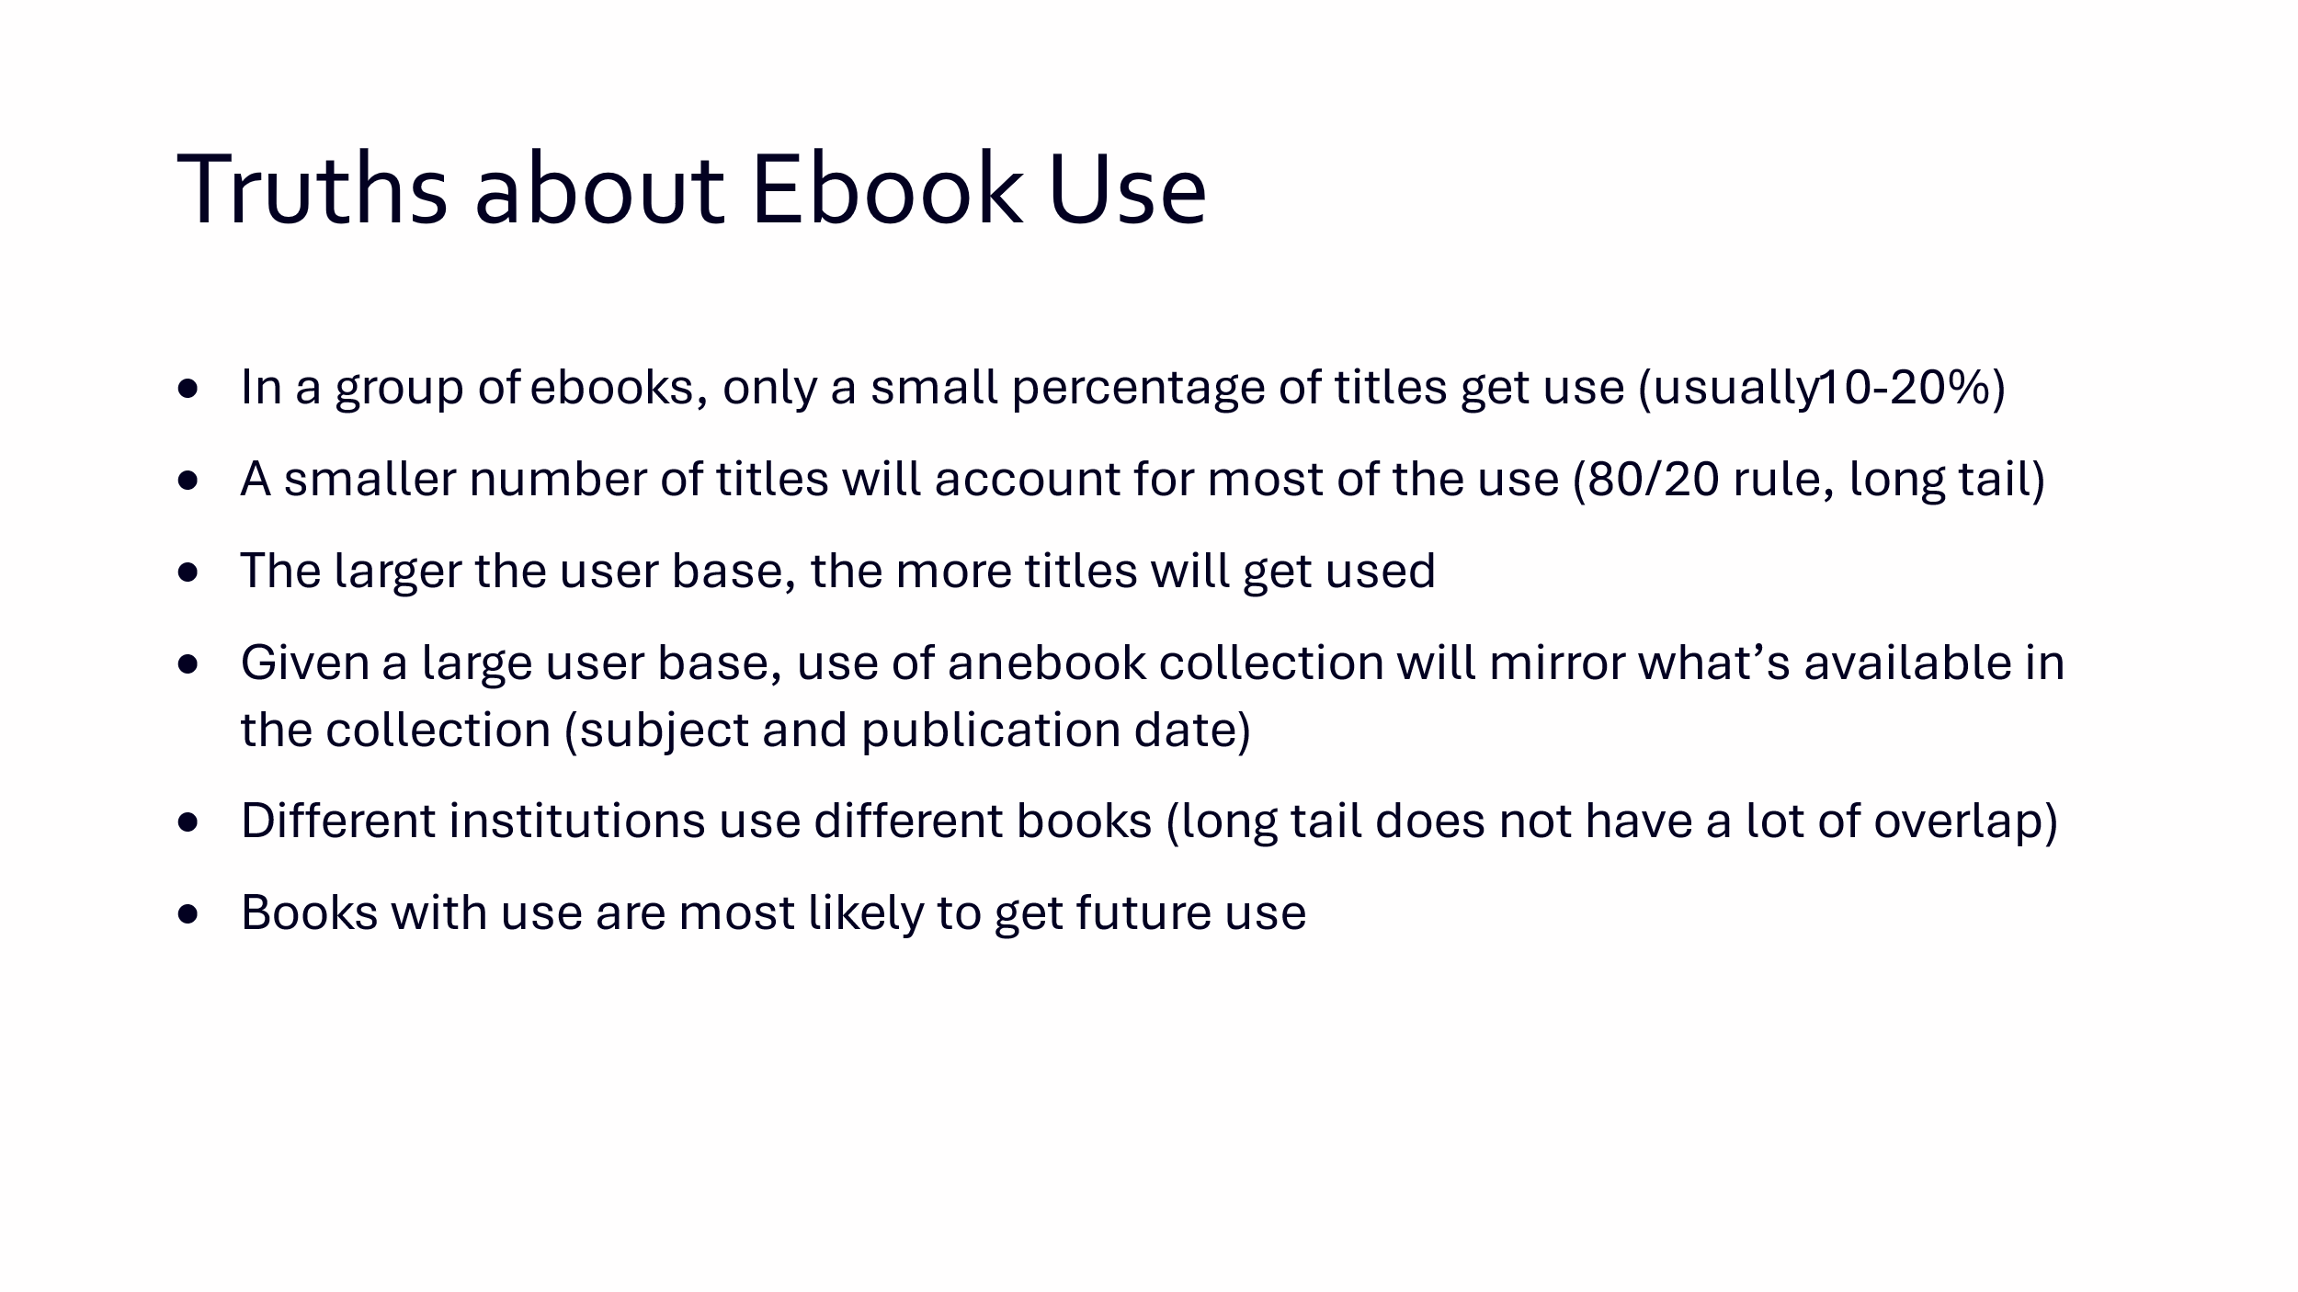

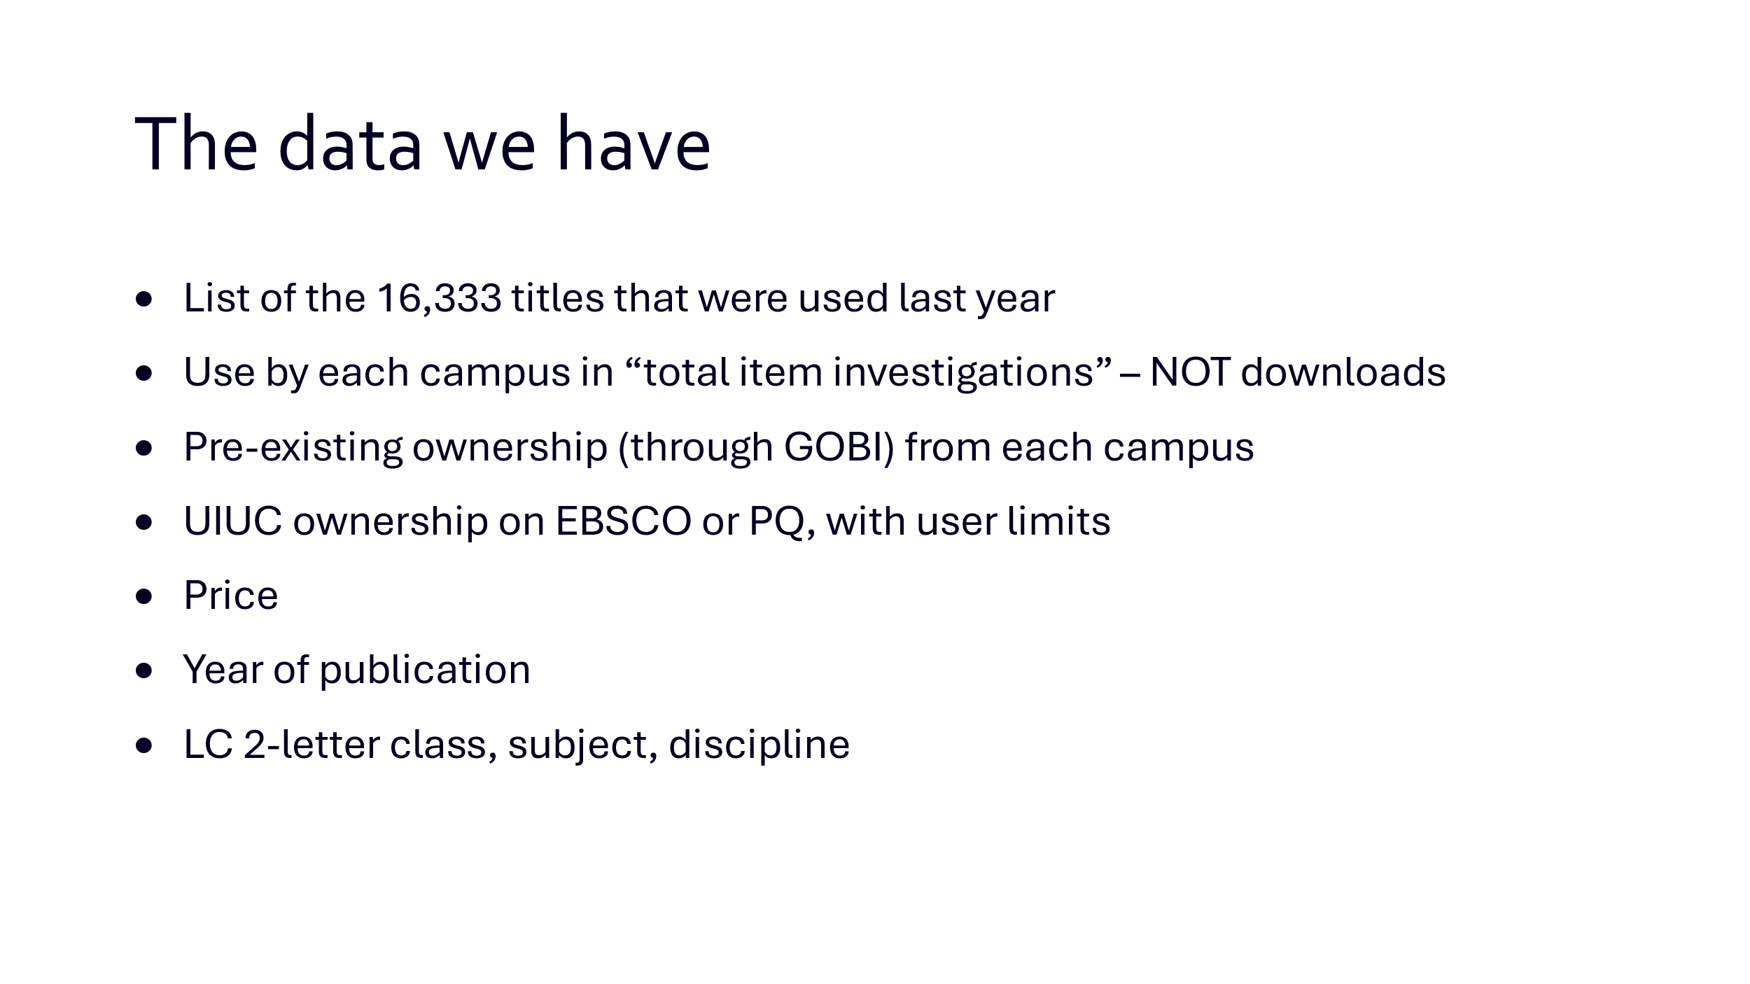

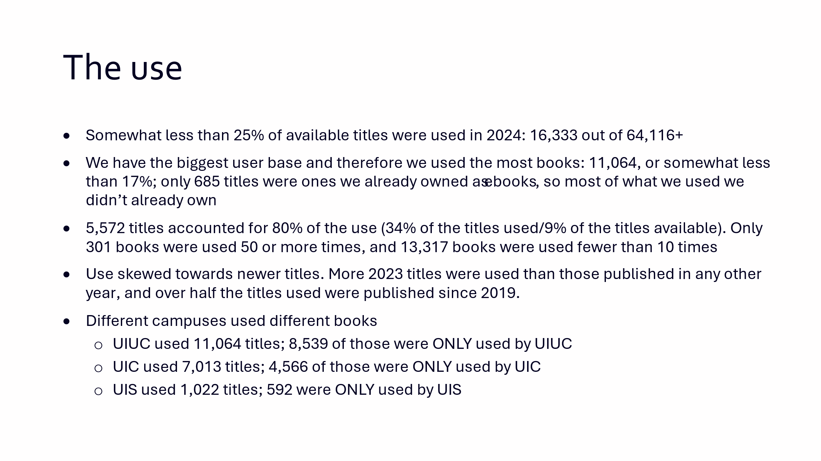

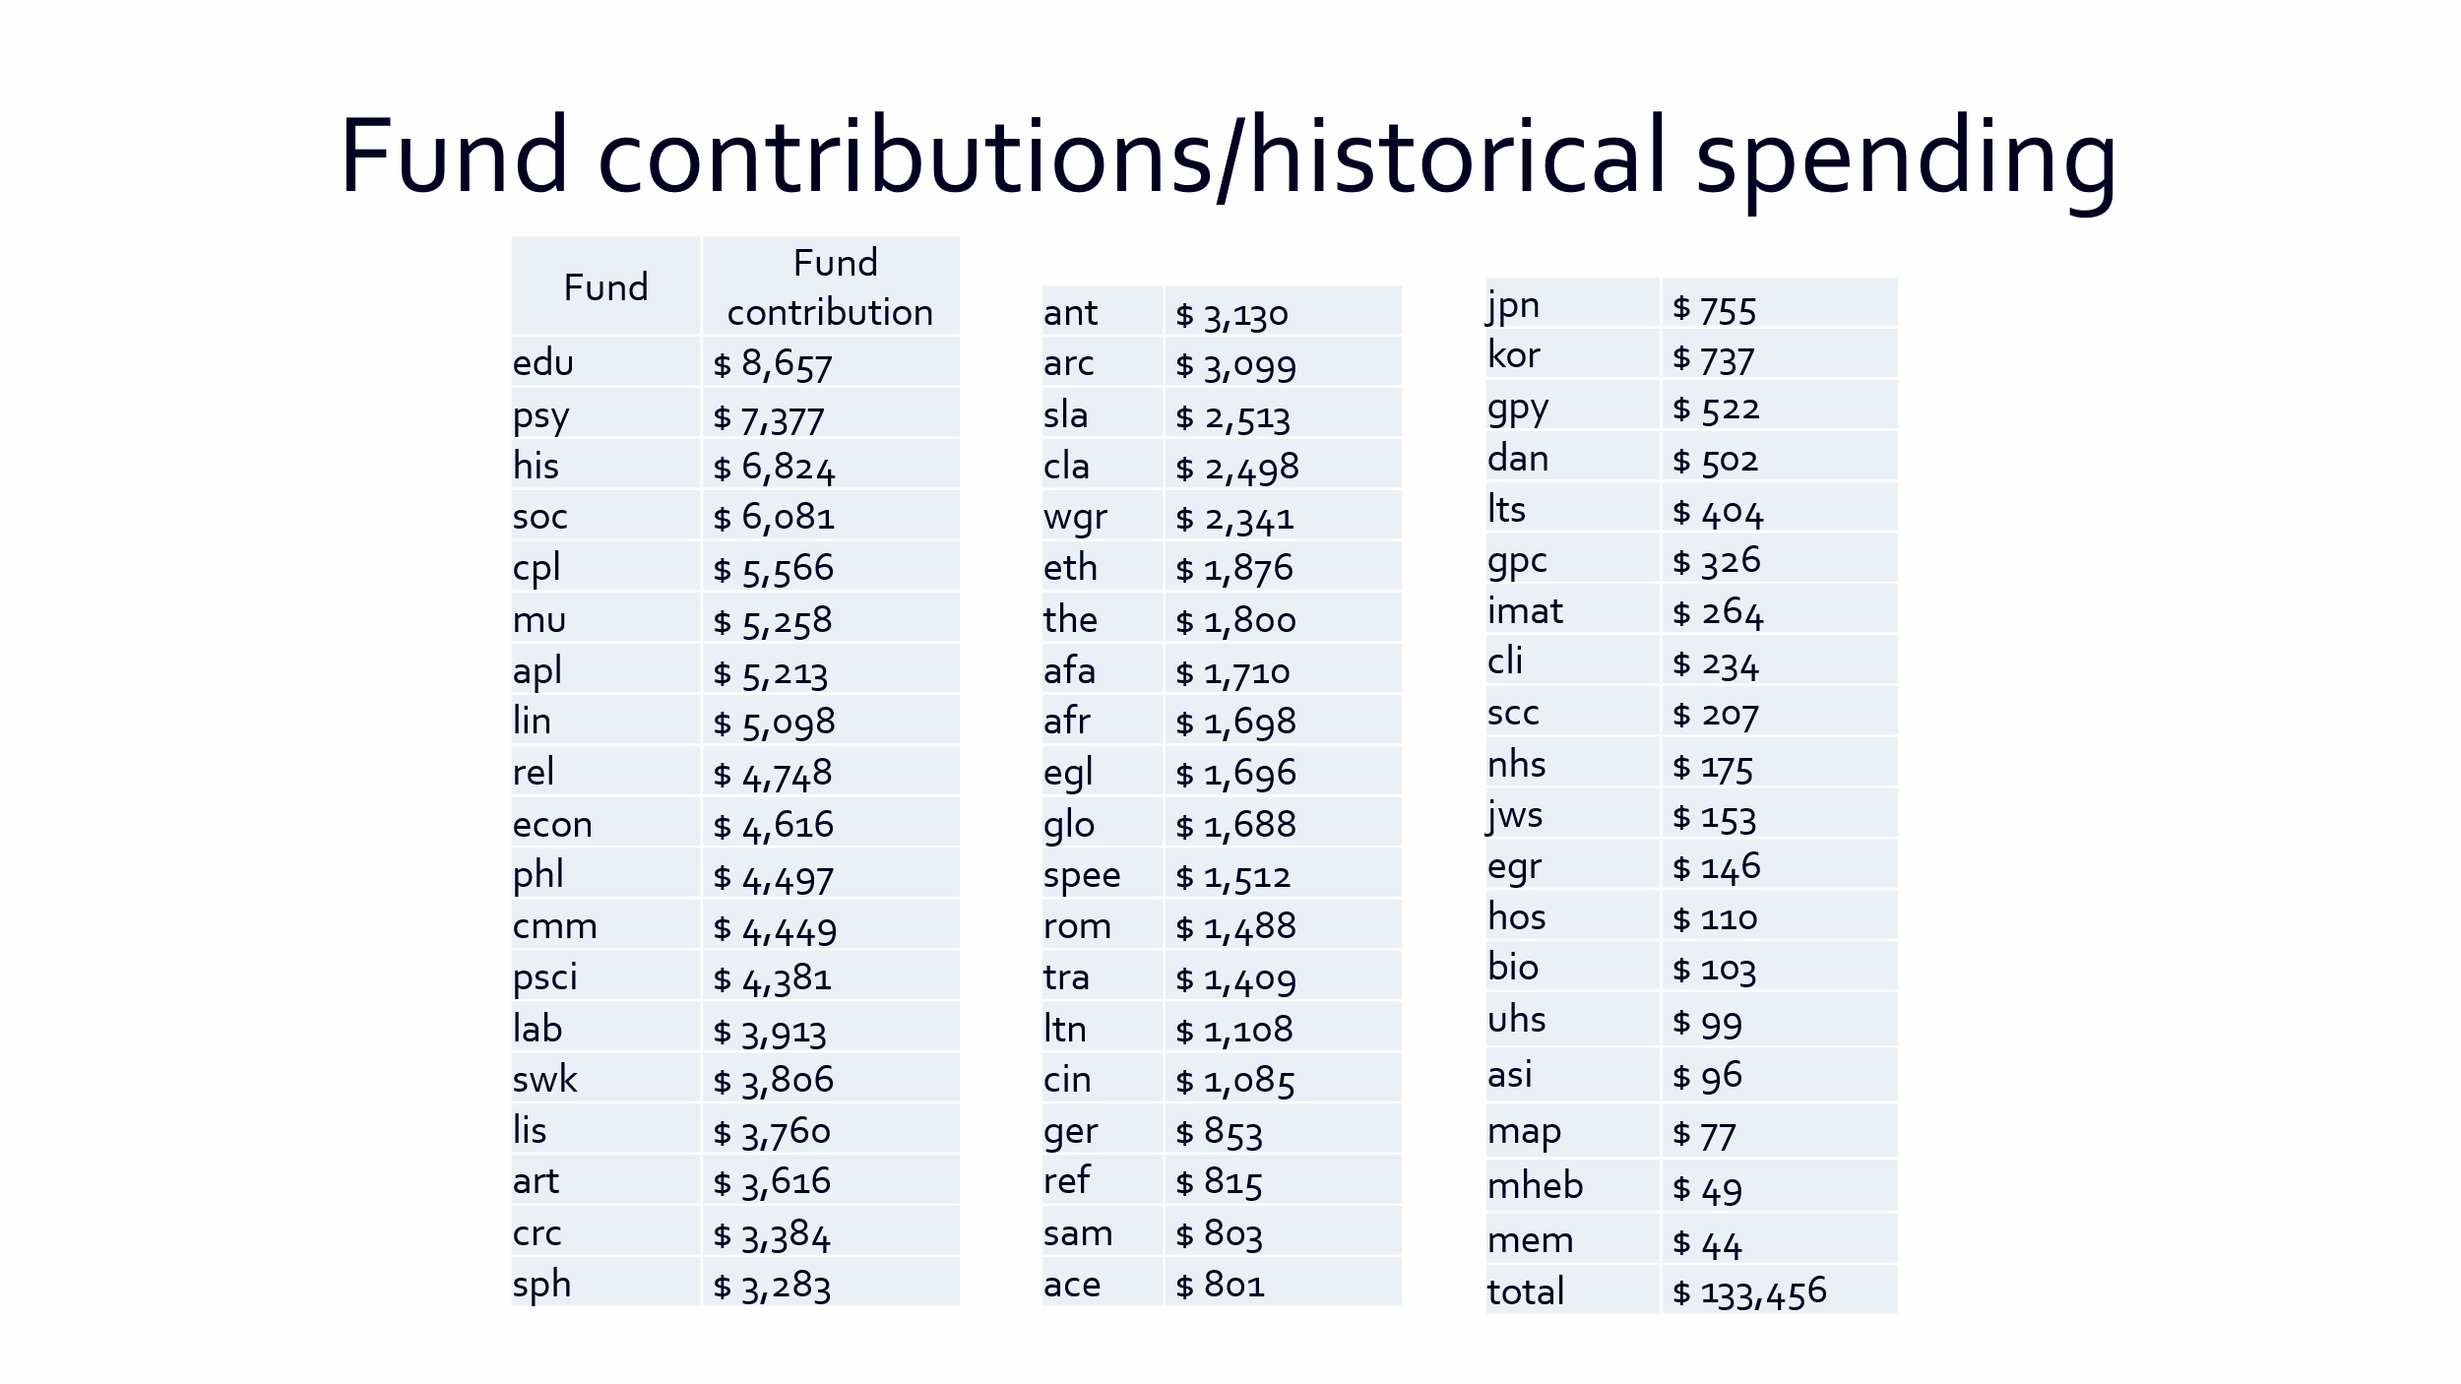

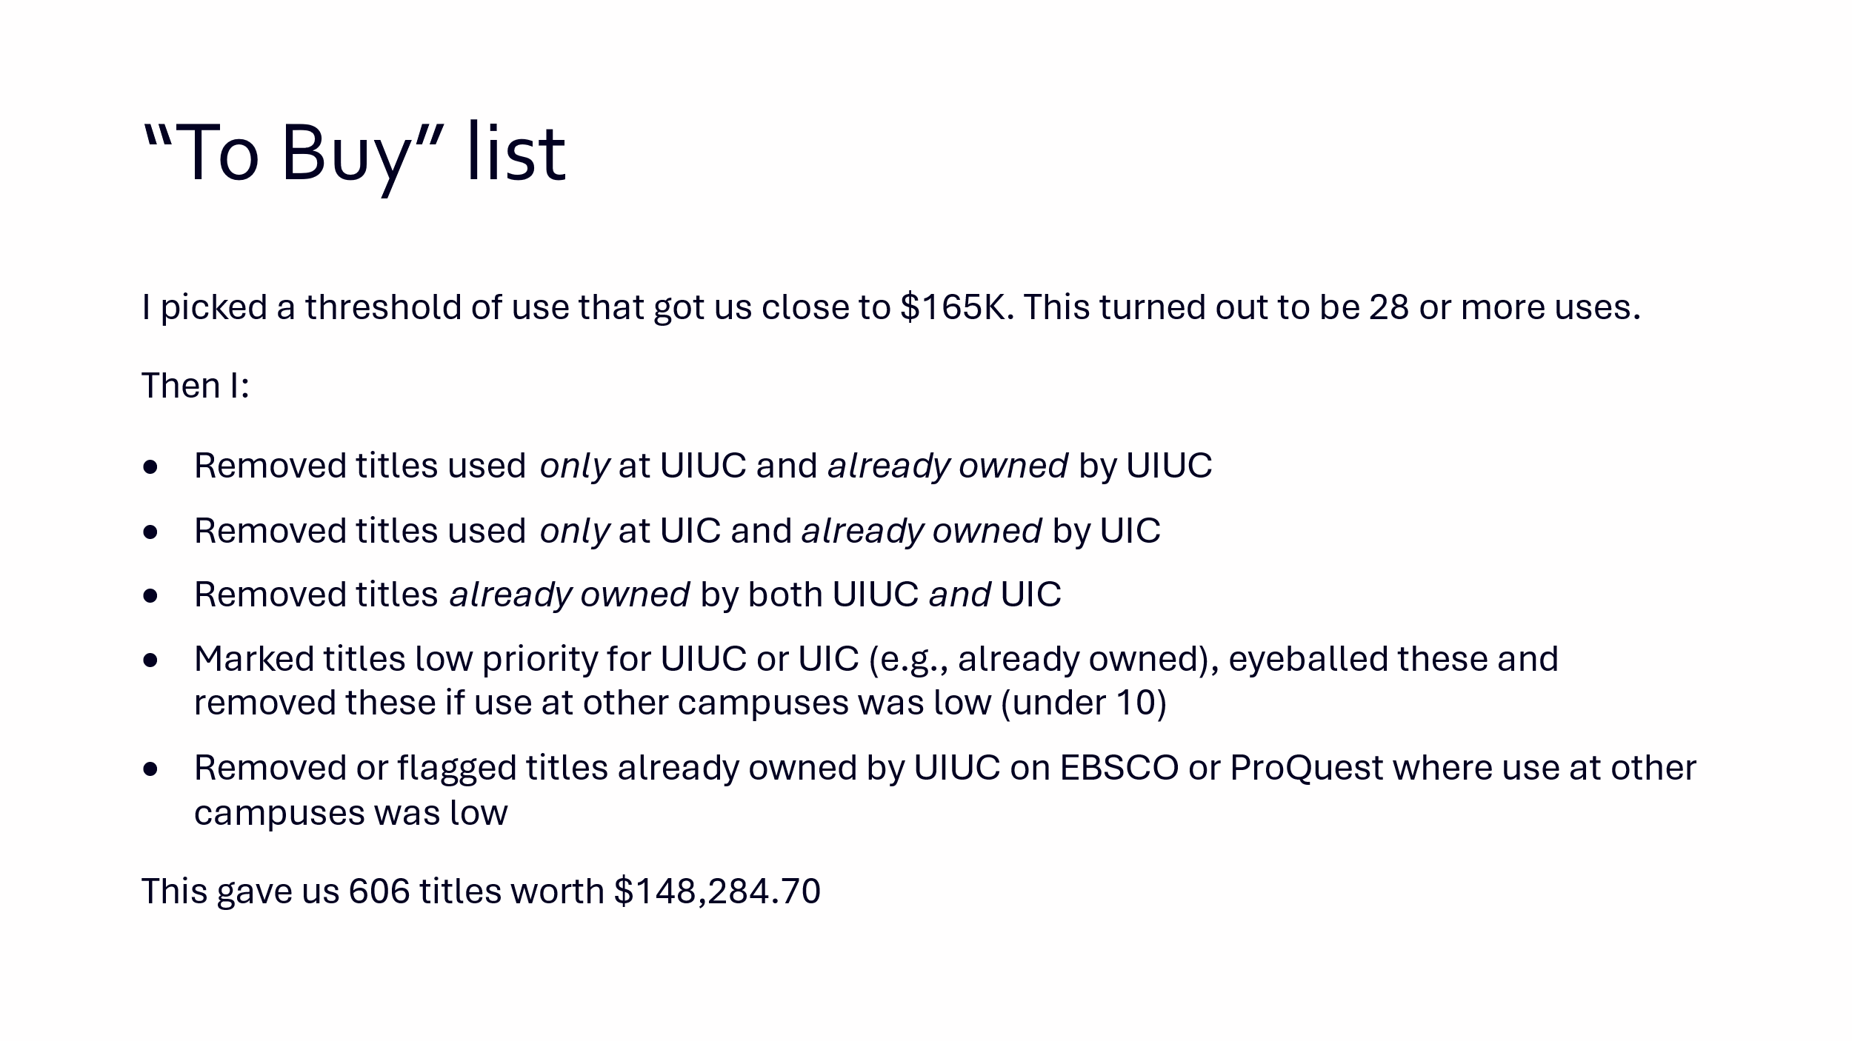

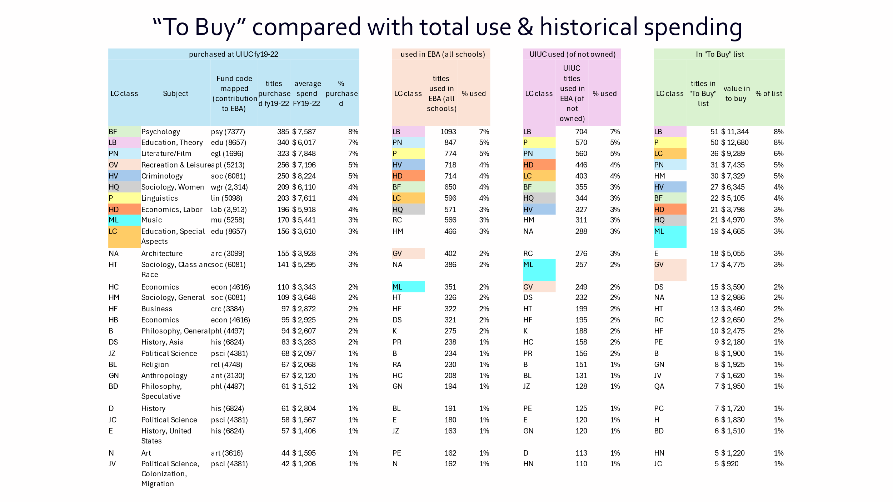
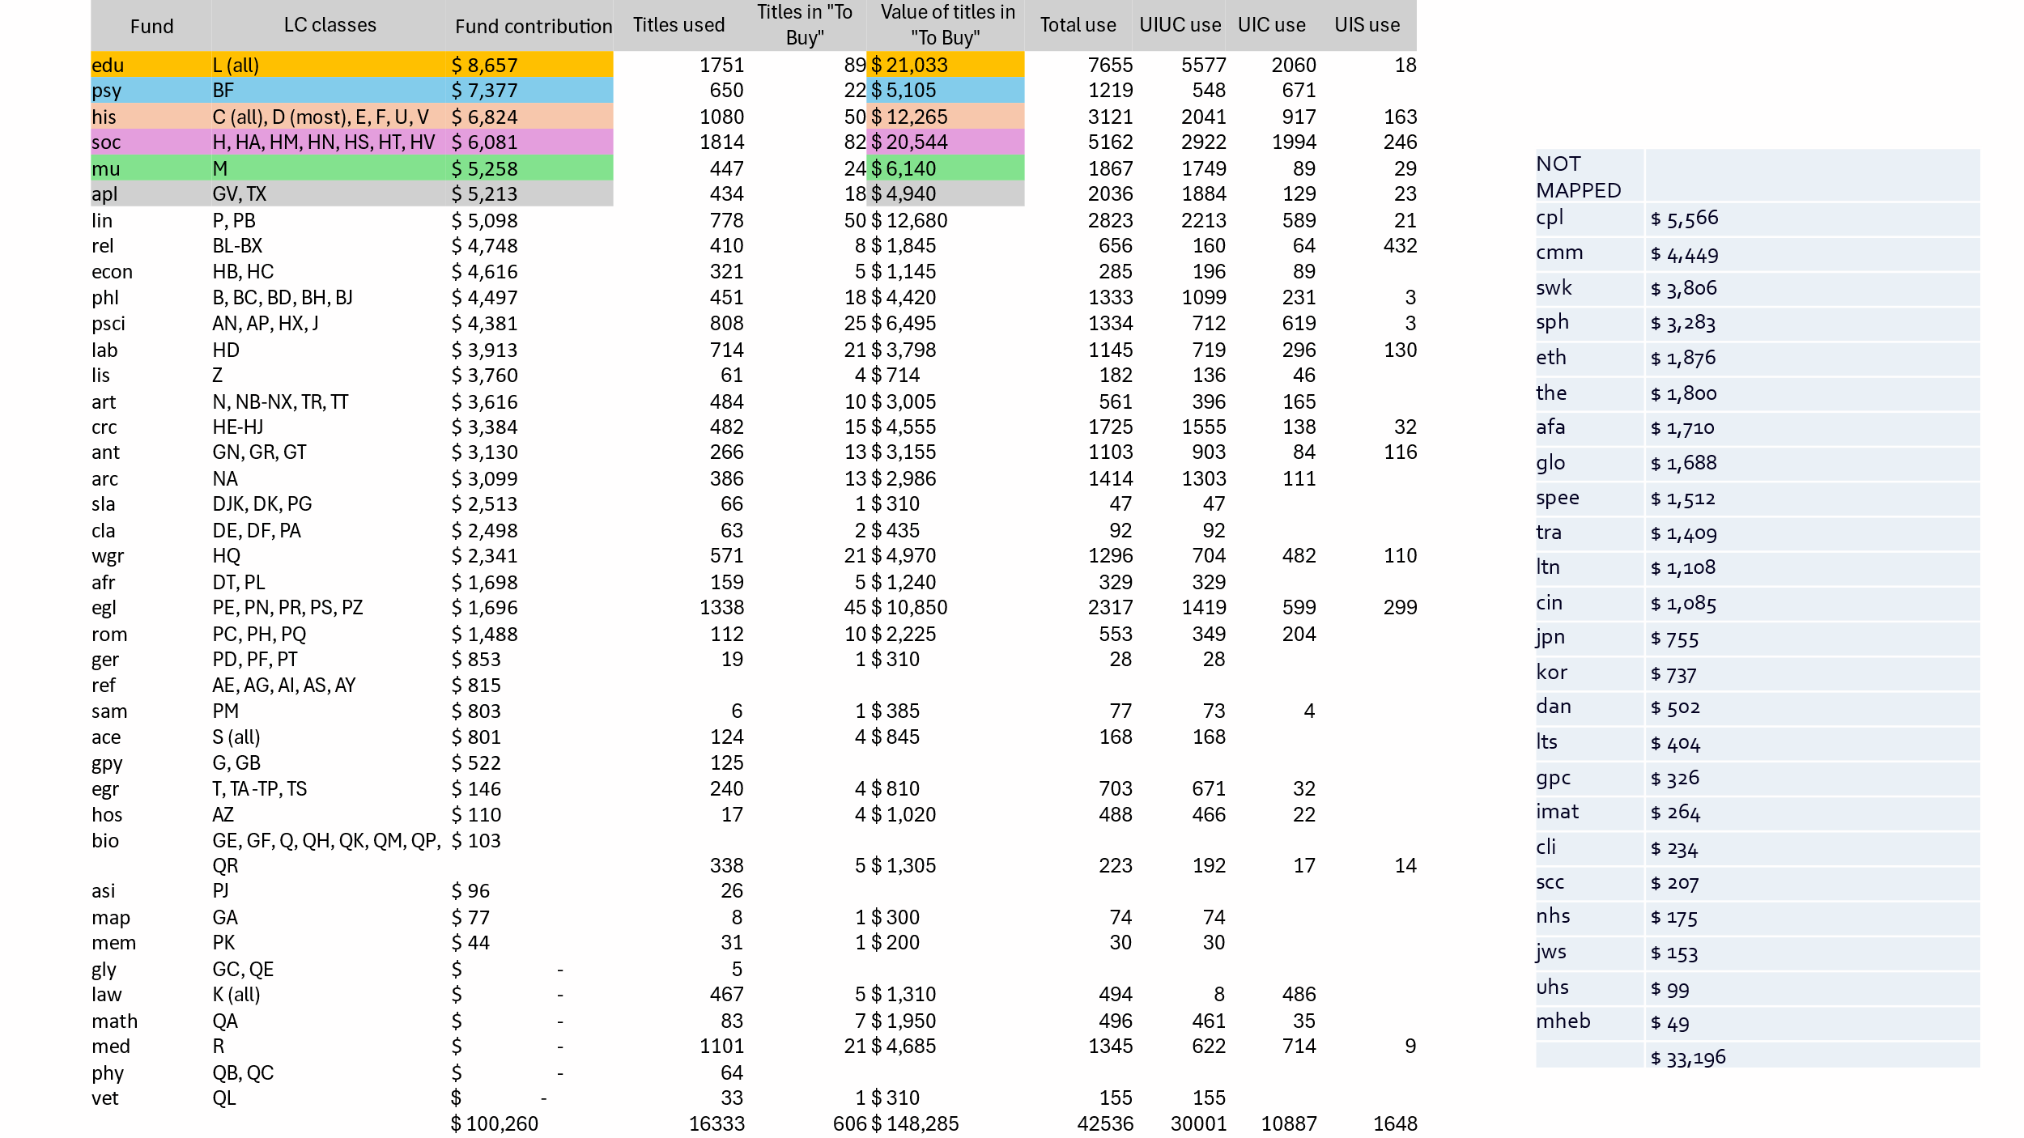

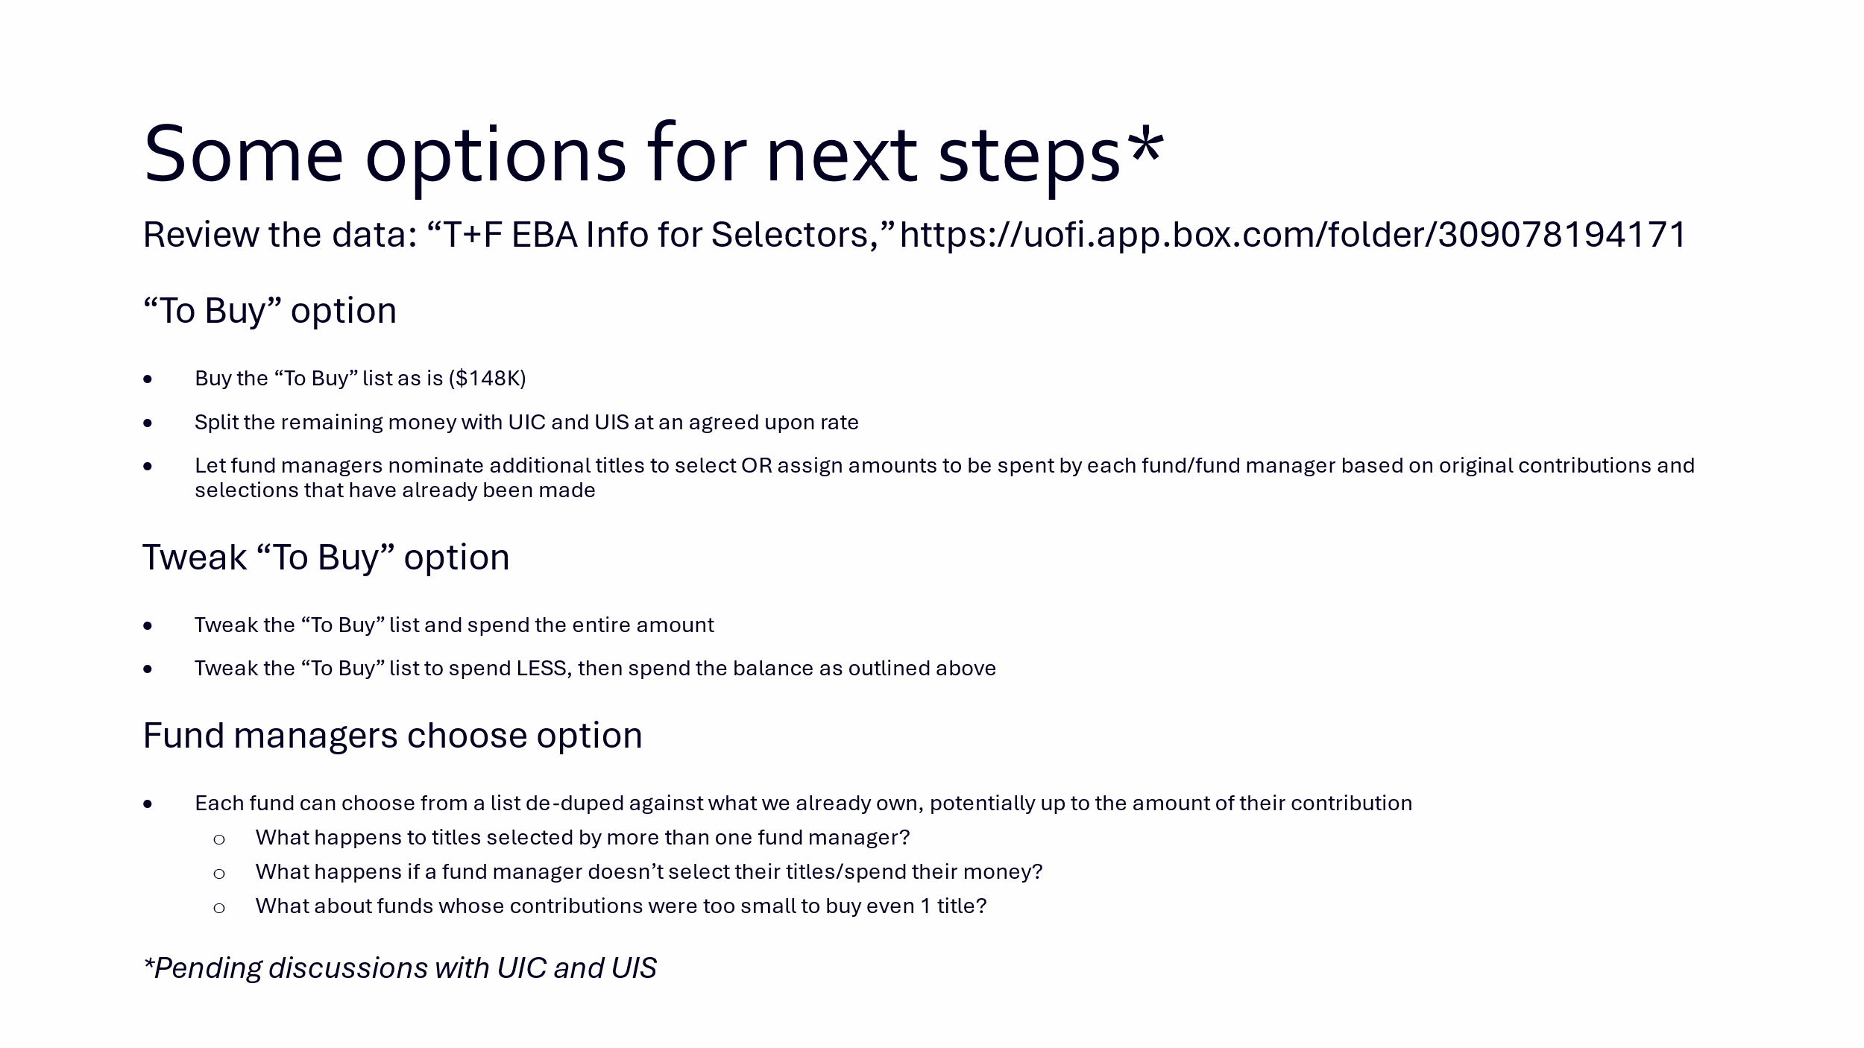

Collection Development Topics
- Collection Development Statements – Feedback from Divisions
  - Upcoming ADAII changes will require hundreds of pages to be manually edited to make them accessible. The Library has more webpages than any other unit on campus.
  - Some divisions do use these statements but do not feel a need for them to be available on the public webpage.
  - If the collection development statements are going to be made public, they should be updated into a pre-built, consistent format.

- Request for removal of materials policy/webpage (Kelli)
  - https://www.library.illinois.edu/staff/policies/request-for-removal-of-materials-from-the-collection-or-from-general-circulation-due-to-allegations-of-dubious-scholarship/
  - This page is very outdated and needs to be reviewed and updated. The title is confusing and does not reference the state law that ties grants to not removing books that are challenged.
  - CDC supports having this updated. Kelli will begin revisions and send them out to the group for continued work/feedback.

- 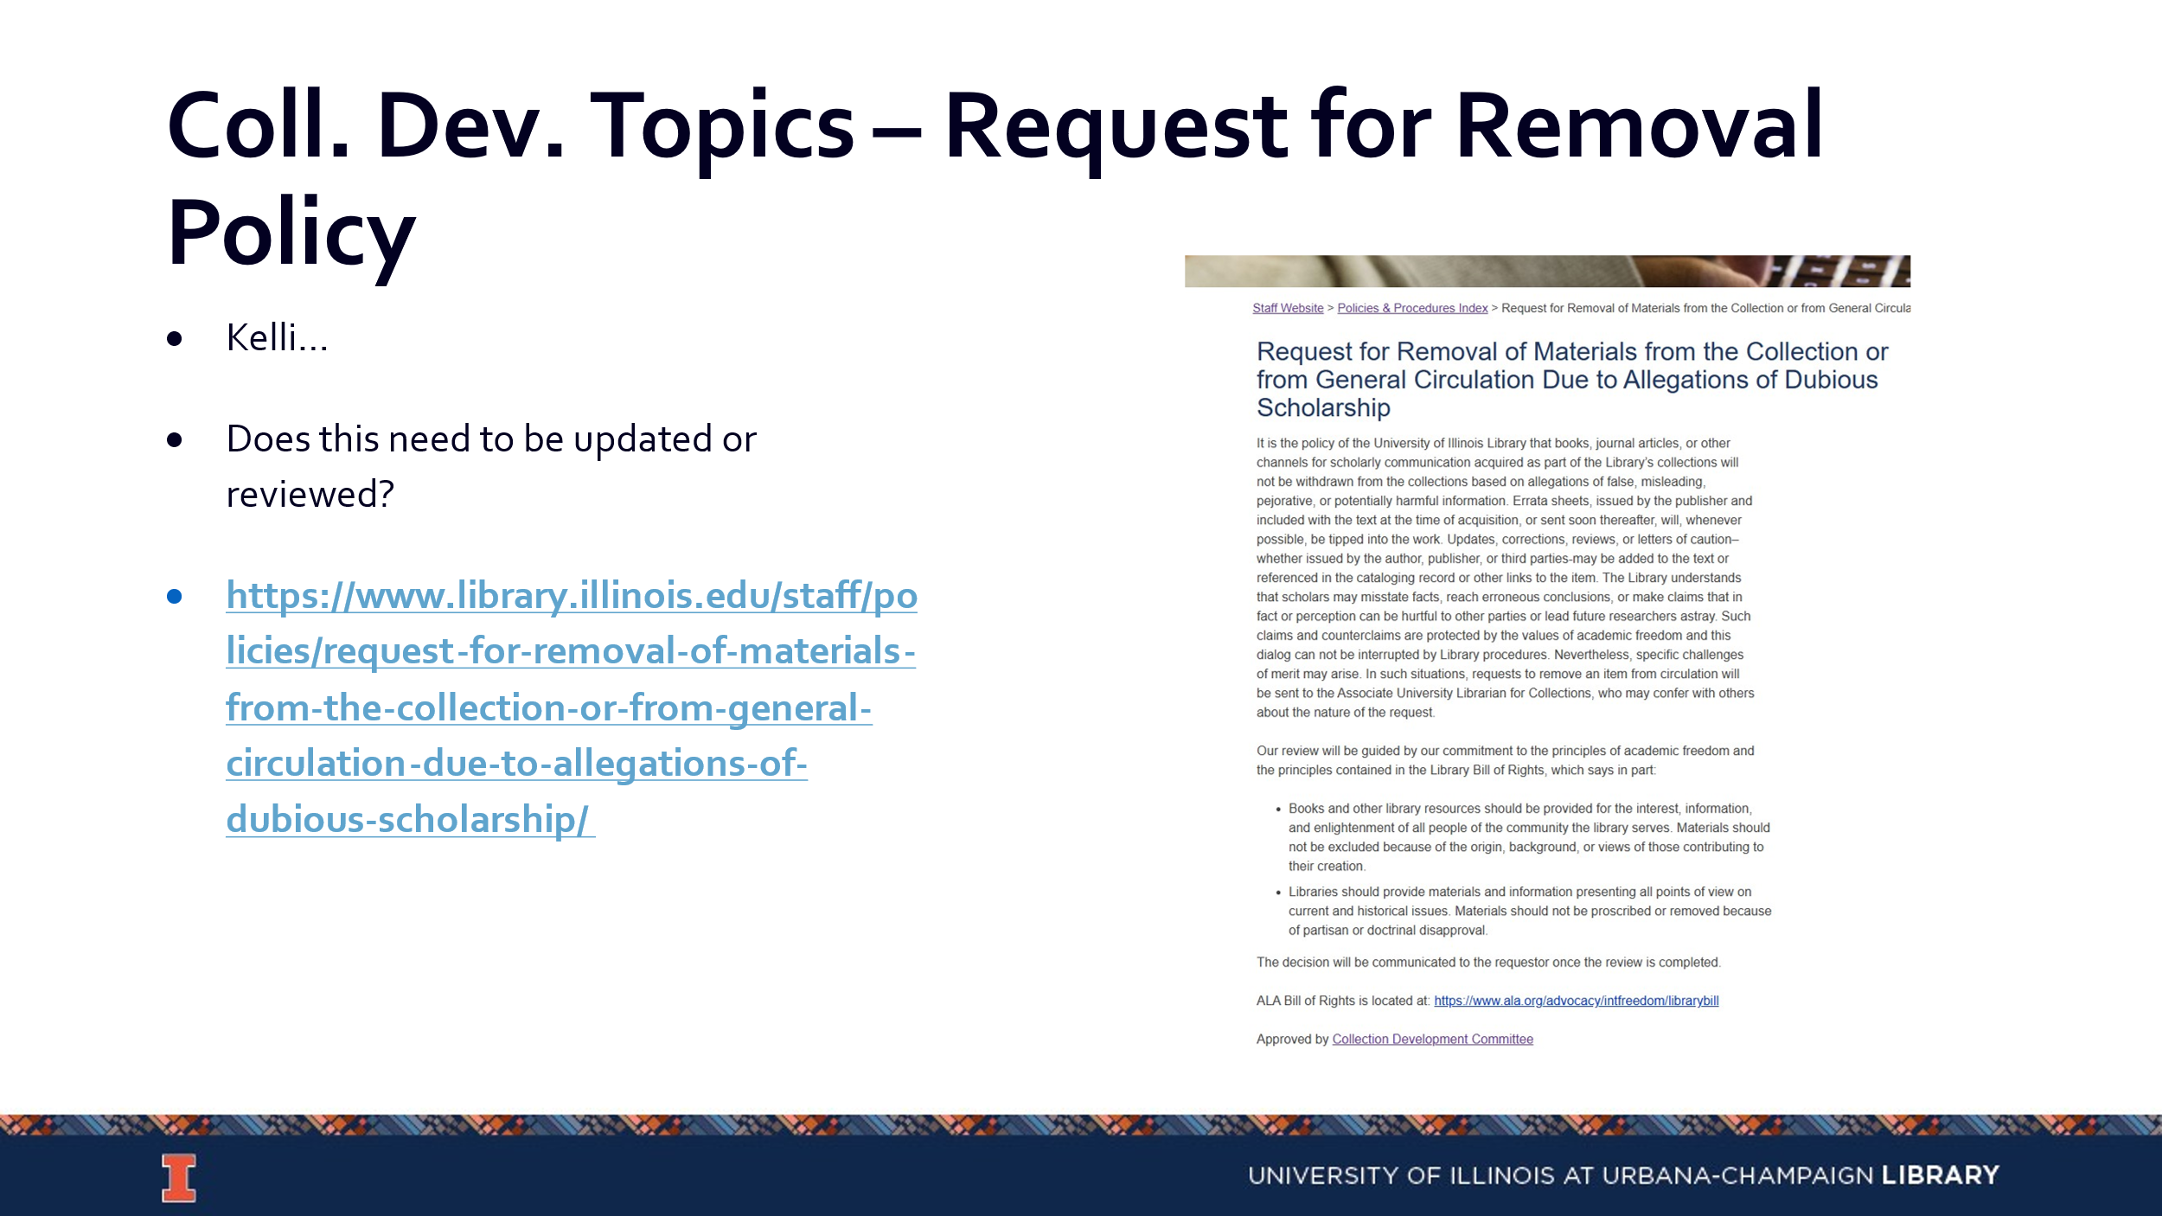

- Collegiate Readership Program Discussion (Sanga)
  - Those who oversee the Library instruction sessions for the general education courses are concerned with this program ending. They have asked CDC to gather feedback about the impacts of this on divisions, their instruction, and their students/users and additionally potentially look into a different subscription model or alternative.
  - Sanga will send out a follow up email that outlines these concerns, and reps can speak with their divisions.

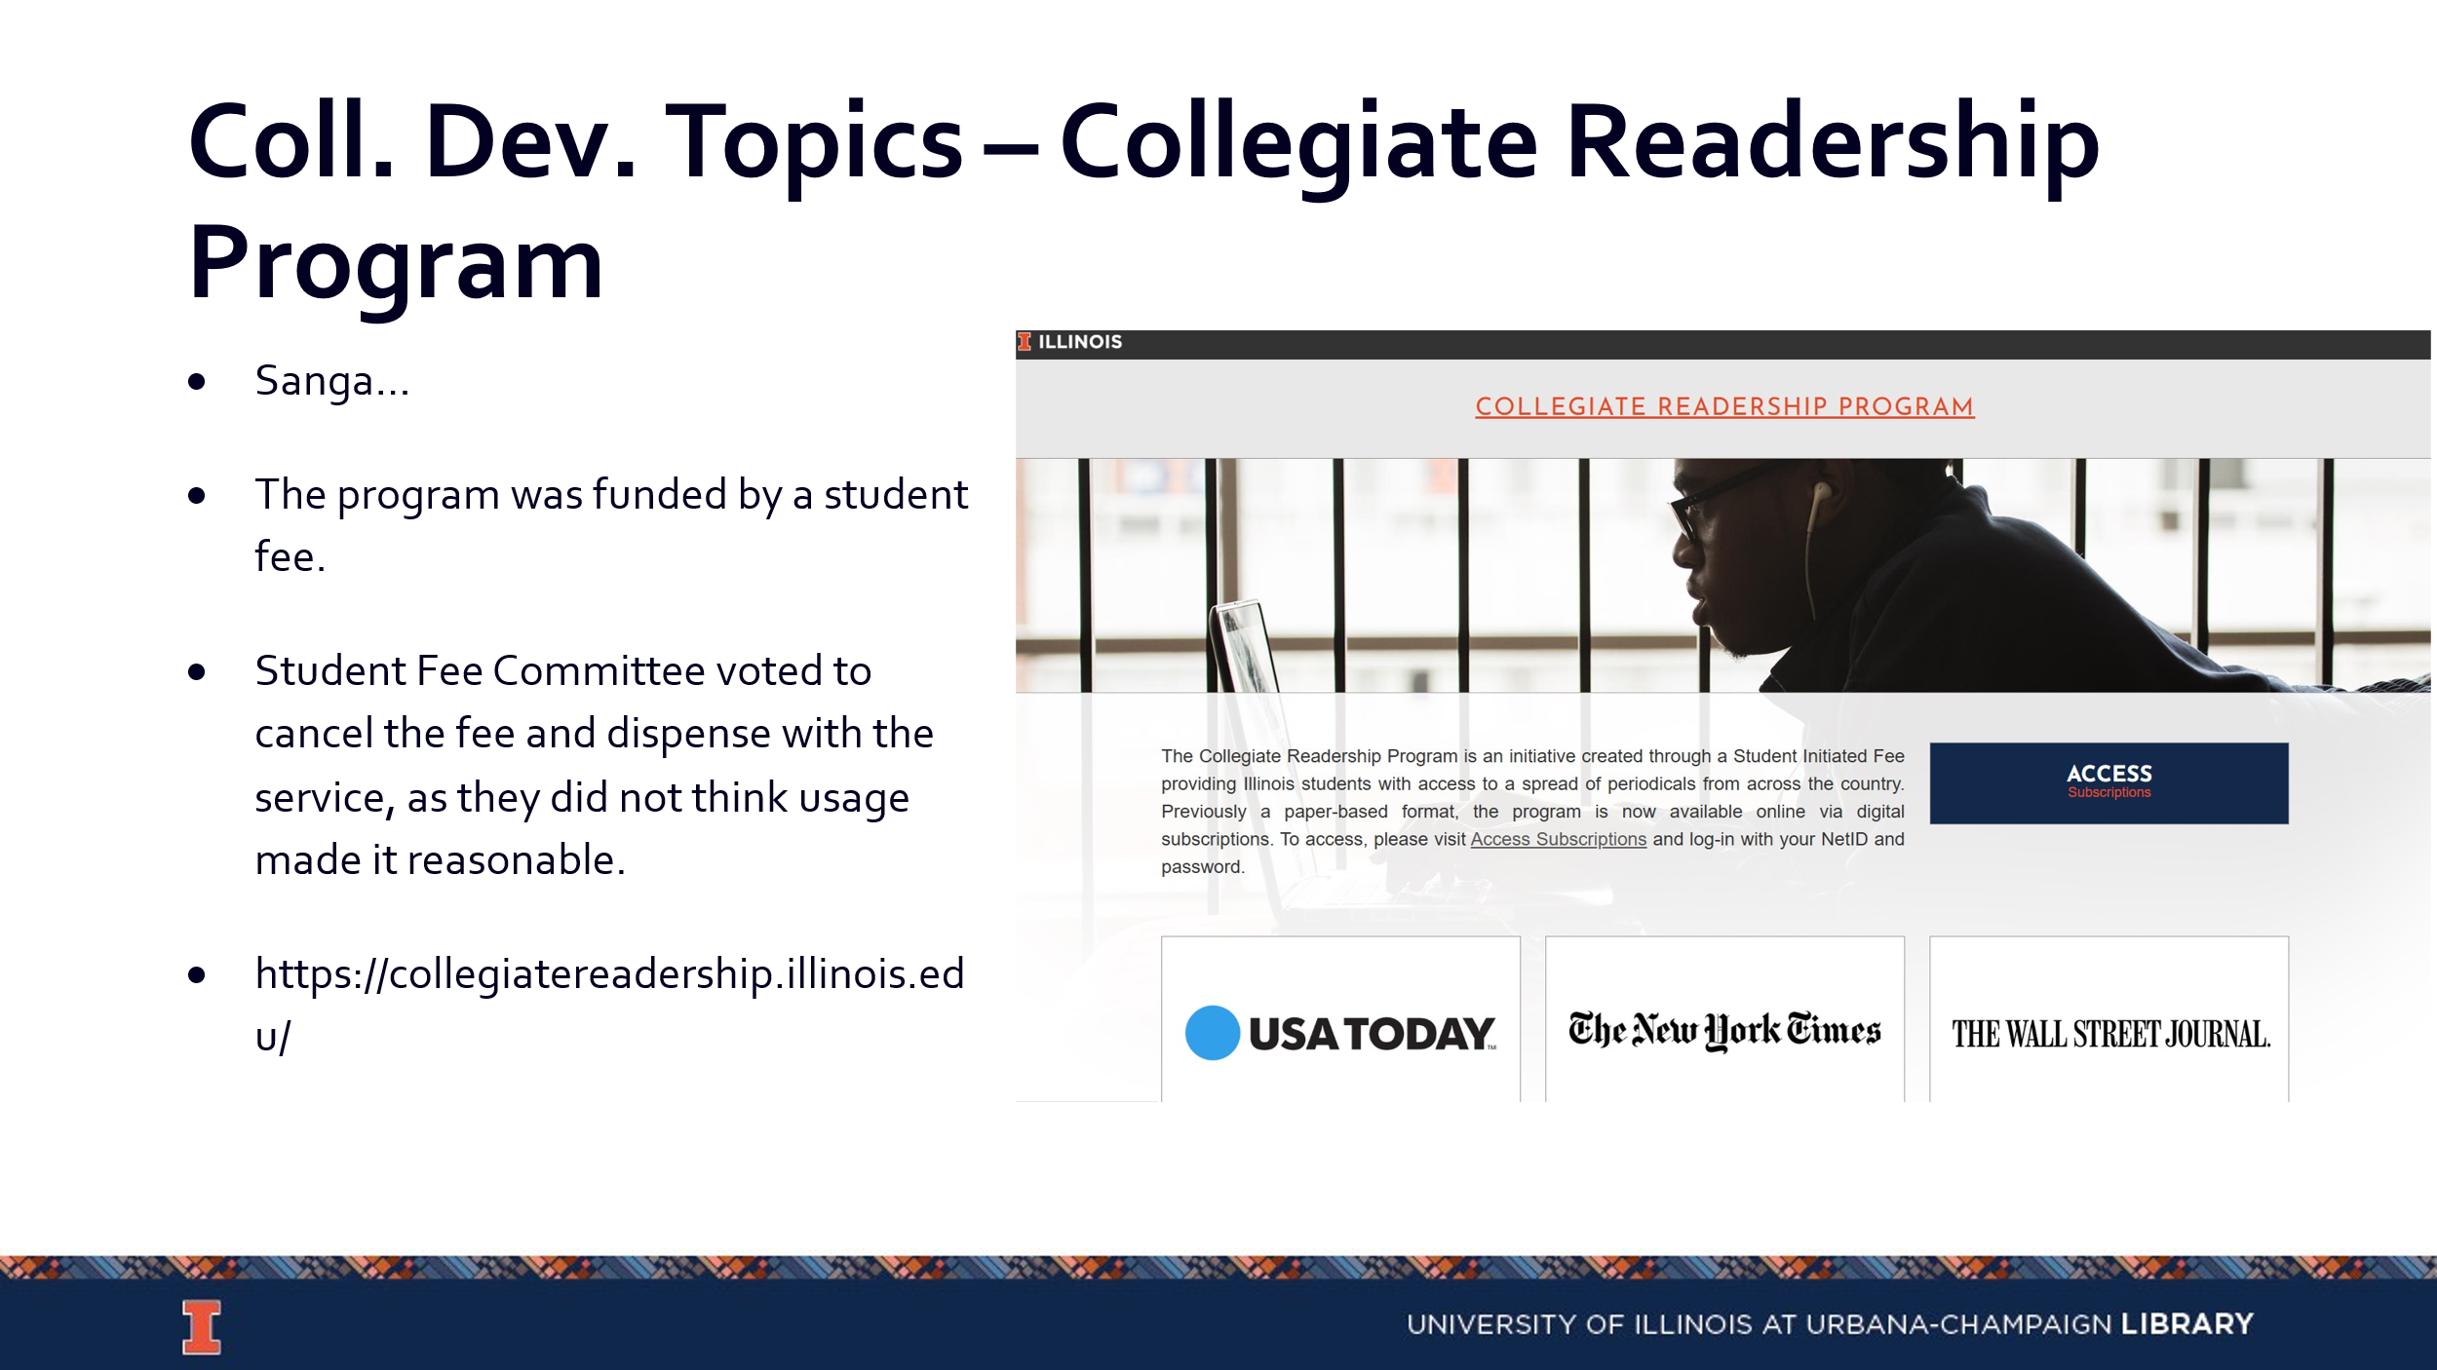

- Tracking of big ticket subscription titles (Cindy)
  - It would be helpful to have a system for tracking big ticket subscription titles. Should this be a tab added to the desiderata list or some other format?

Updates
- Acquisitions
- E-Resources
- Preservation Services
- BTAA Updates
  - Springer (BTAA)
  - Sage (BTAA)

--

Meeting adjourned at 4:32pm.

