CAPT Minutes
December 18, 2025

Present: Tom Teper, Michael Norman, Eric Mosher, Jennifer Teper, Kyle Rimkus, Chloe Ottenhoff, Will Schlaack, Kate Lambaria, Wendy Shelburne, Mary Ton, Tracy Tollliver, Hannah Williams (notes)

- Approve agenda and minutes

- Quarterly working group reports

- Cataloging and Metadata- Chloe Ottenhoff

CAPT - Cataloging and Metadata Working Group
December 18, 2025

Meetings: Met 2 times since last report, on October 16 and December 18
- BIBCO membership
  - U of Illinois Library has been approved to become a participant in the PCC’s BIBCO (Monographic Bibliographic Record Cooperative Program)
    - Anna Schlaack will be BIBCO liaison
      - Implications: Catalogers contributing to the program will be required to contribute records backed by complete authority work, descriptive and subject; will need to be RDA adherent
    - Next steps: training, logistics
- Alma/Primo Updates
- Michael gives the group regular updates on Alma and Primo to ensure we are all aware of changes that have happened or that are coming for staff behind the scenes or for users.
- New Version of Primo will possibly to go live Fall 2026
- Hopefully Sandbox testing can start in the spring
- Customizations currently in place regarding display should transfer to new version
- Official RDA
  - Libraries will need to implement Official RDA by April 30, 2027
  - Plans for training and workflows will begin in earnest in January
- BIBFRAME
- MJ has begun exploratory work with CARLI on BIBFRAME and gives regular updates from various meetings and presentations
  - Was part of an initial round of testing for early adopters
  - A lot depends on whether OCLC and ExLibris decide to support/develop editors
- Working Group future goals and priorities
  - Wait until new head arrives and revaluate membership, but also evaluate ideas for future priorities
    - Primo’s interaction with other services (DL, Archives space, etc.) and impact
    - Reparative cataloging discussion to be ongoing
    - BIBCO membership
    - Official RDA implementation
    - BIBFRAME implementation
    - Become more actively involved with CARLI working groups (Primo VE and Technical Services align most closely)

- Electronic Resources-Wendy Shelburne
- They are continuing to work on remote authentication processes to move from a deny list to an allow list.
- Changes were implemented last fall for Exproxy, and these changes will be applied to resources that use Shibboleth authentication starting on January 7th.
  - The biggest users of this will all be changed and the same time, including Elsevier, Springer, Nature, Wiley, EBSCO, Proquest, and Taylor & Francis.
  - This will close an inadvertent back door that some alumni have been using to access these databases, so there will likely be some alumni who are upset. They will still be able to use open access articles.
  - Discussions are beginning to bring VPN access under the same umbrella, with the end goal of having all remote authentication be essentially the same of all groups of authorized users.

- Medusa- Kyle Rimkus
  - A Future of Medusa group has been formed with Gen Schmitt, Seth Robbins, and Tracy Popp to explore if we can continue to support this or if it makes more sense to go with a vended solution.
  - They are currently quote-gathering from vendors, which will cost in the six figures. The suggestion is to request something in the budget for an enterprise account, which is request funding to support a piece of enterprise software or operation.
  - We need to ask for sufficient resources to begin banking both for the transition from Medusa and maintaining the operation as well as funds for down the road when it comes time to potentially replace Medusa.
  - Kyle is working on a document that summarizes the need to have something reliable for our digital materials and provides an overview of Medusa, its growth, and potential future.

- Search, Discovery, & Delivery Open House- Michael Norman
  - The open house was held on December 11th, and an update was sent last week with links to resources from the session.
    - The recording is available for viewing.
    - Search outline used during the live demonstrations
  - They would like the Library’s help with testing AI Insights.
  - An Easy Search and Primo maintenance queue was created in Team Dynamix and became available last week.

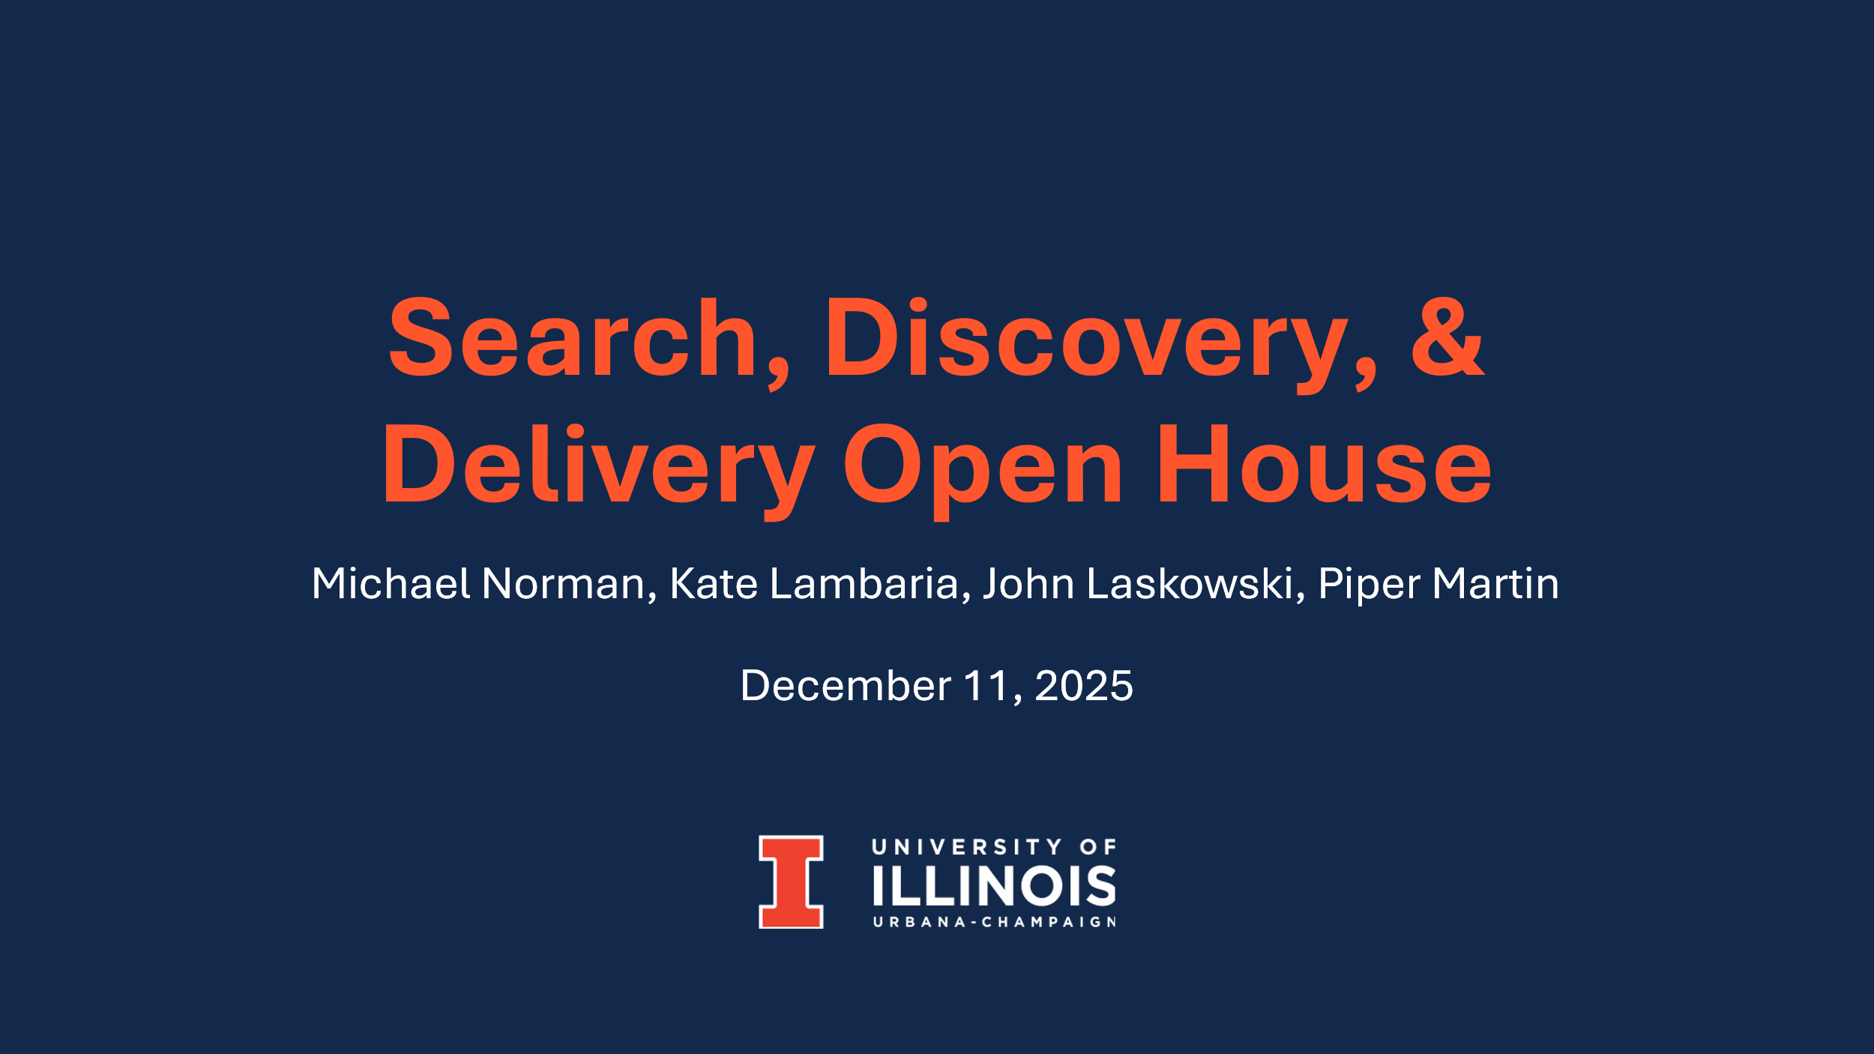
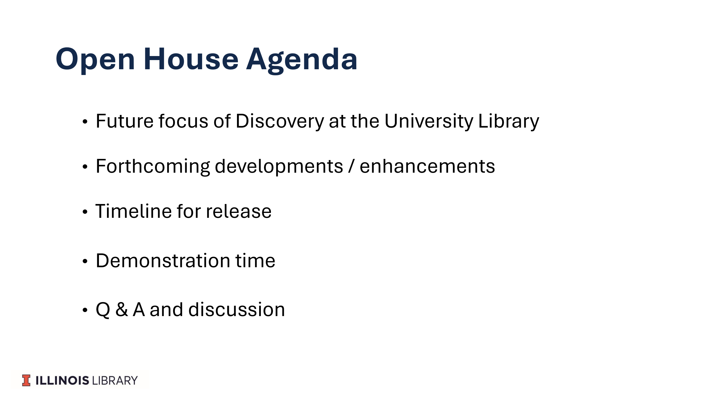
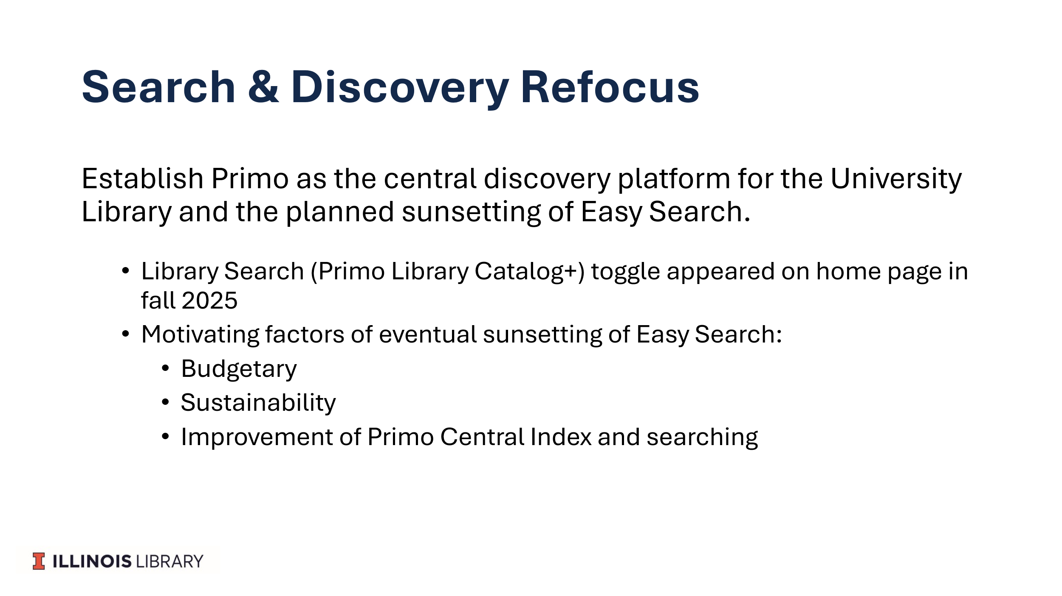

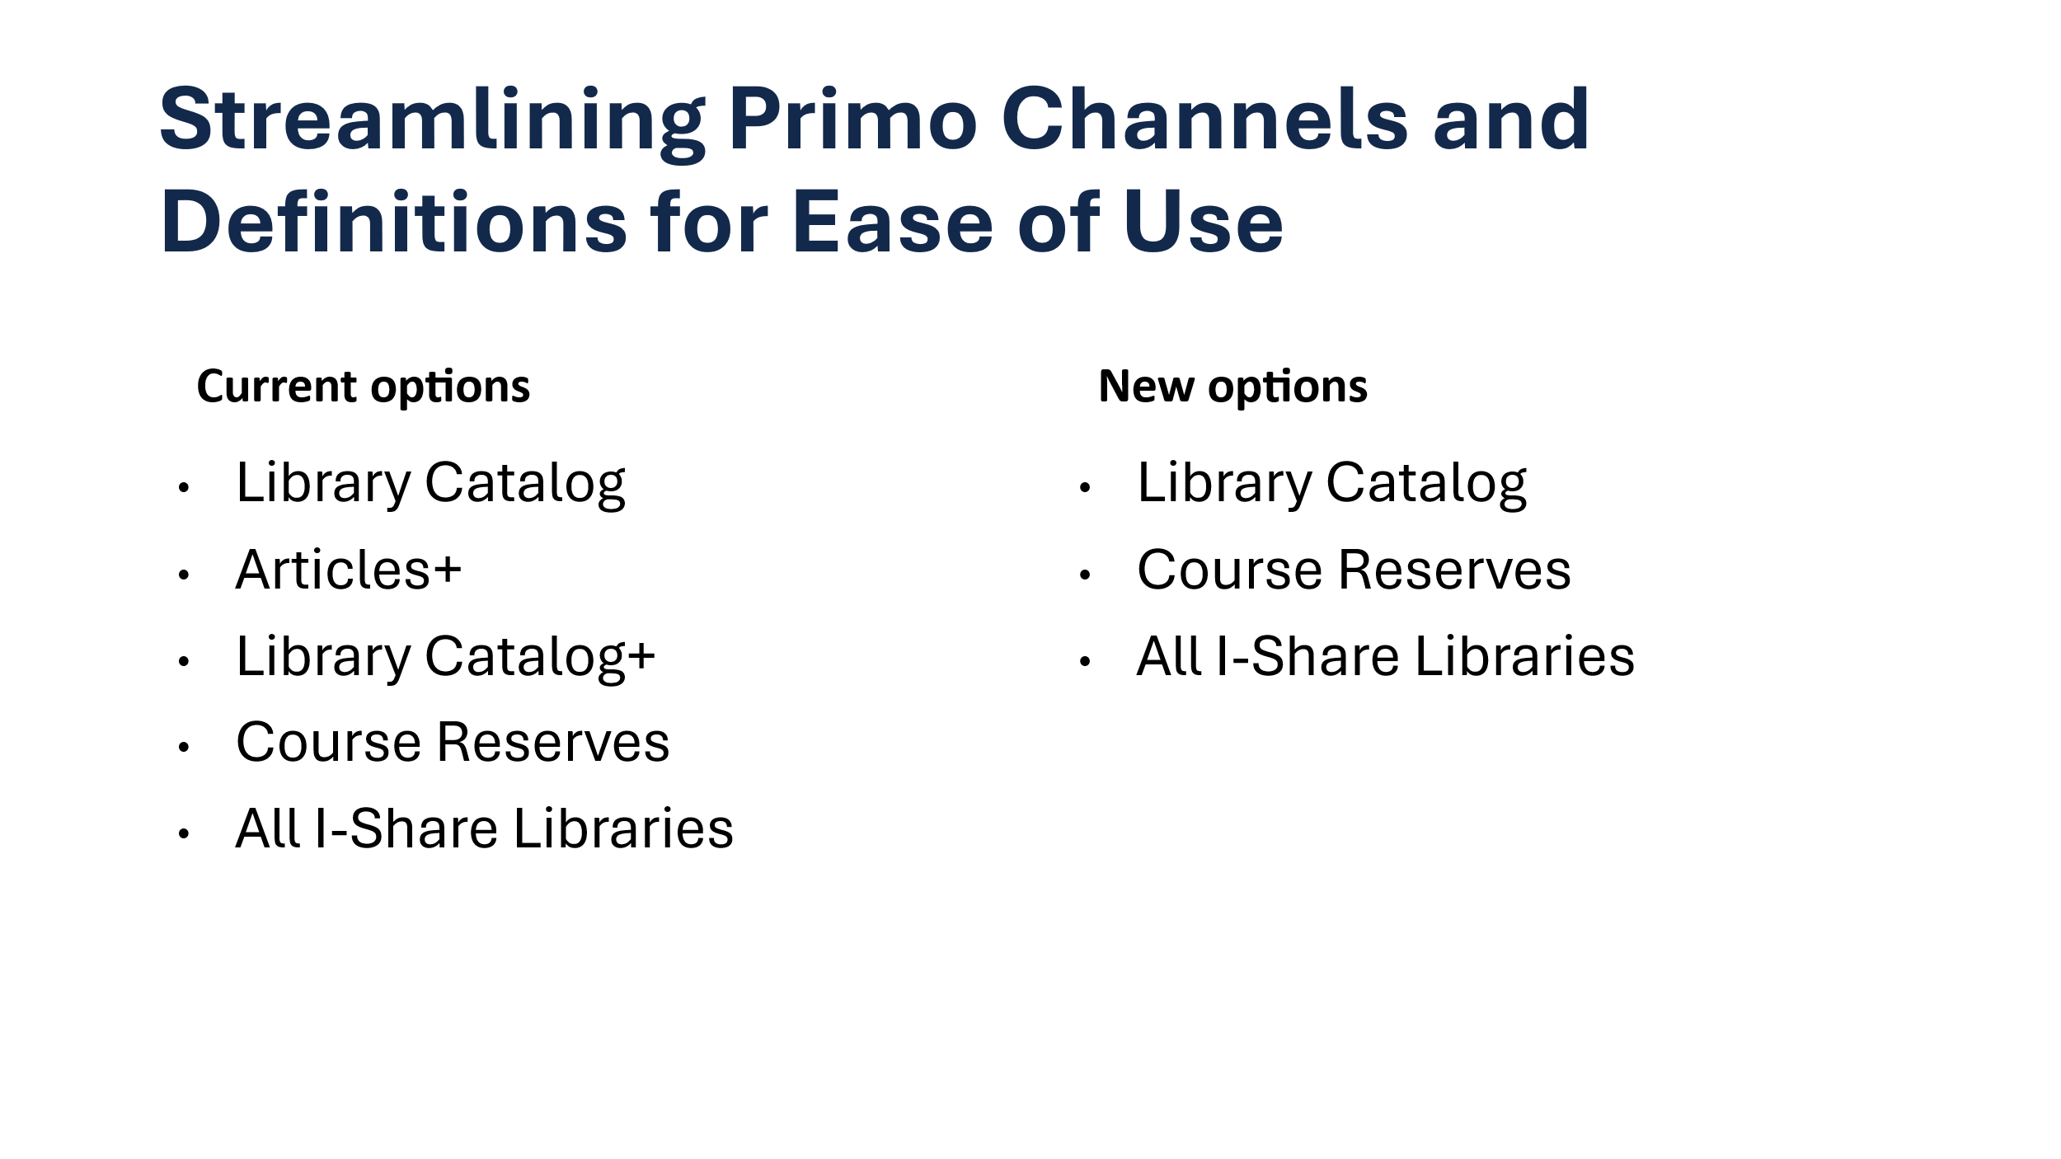
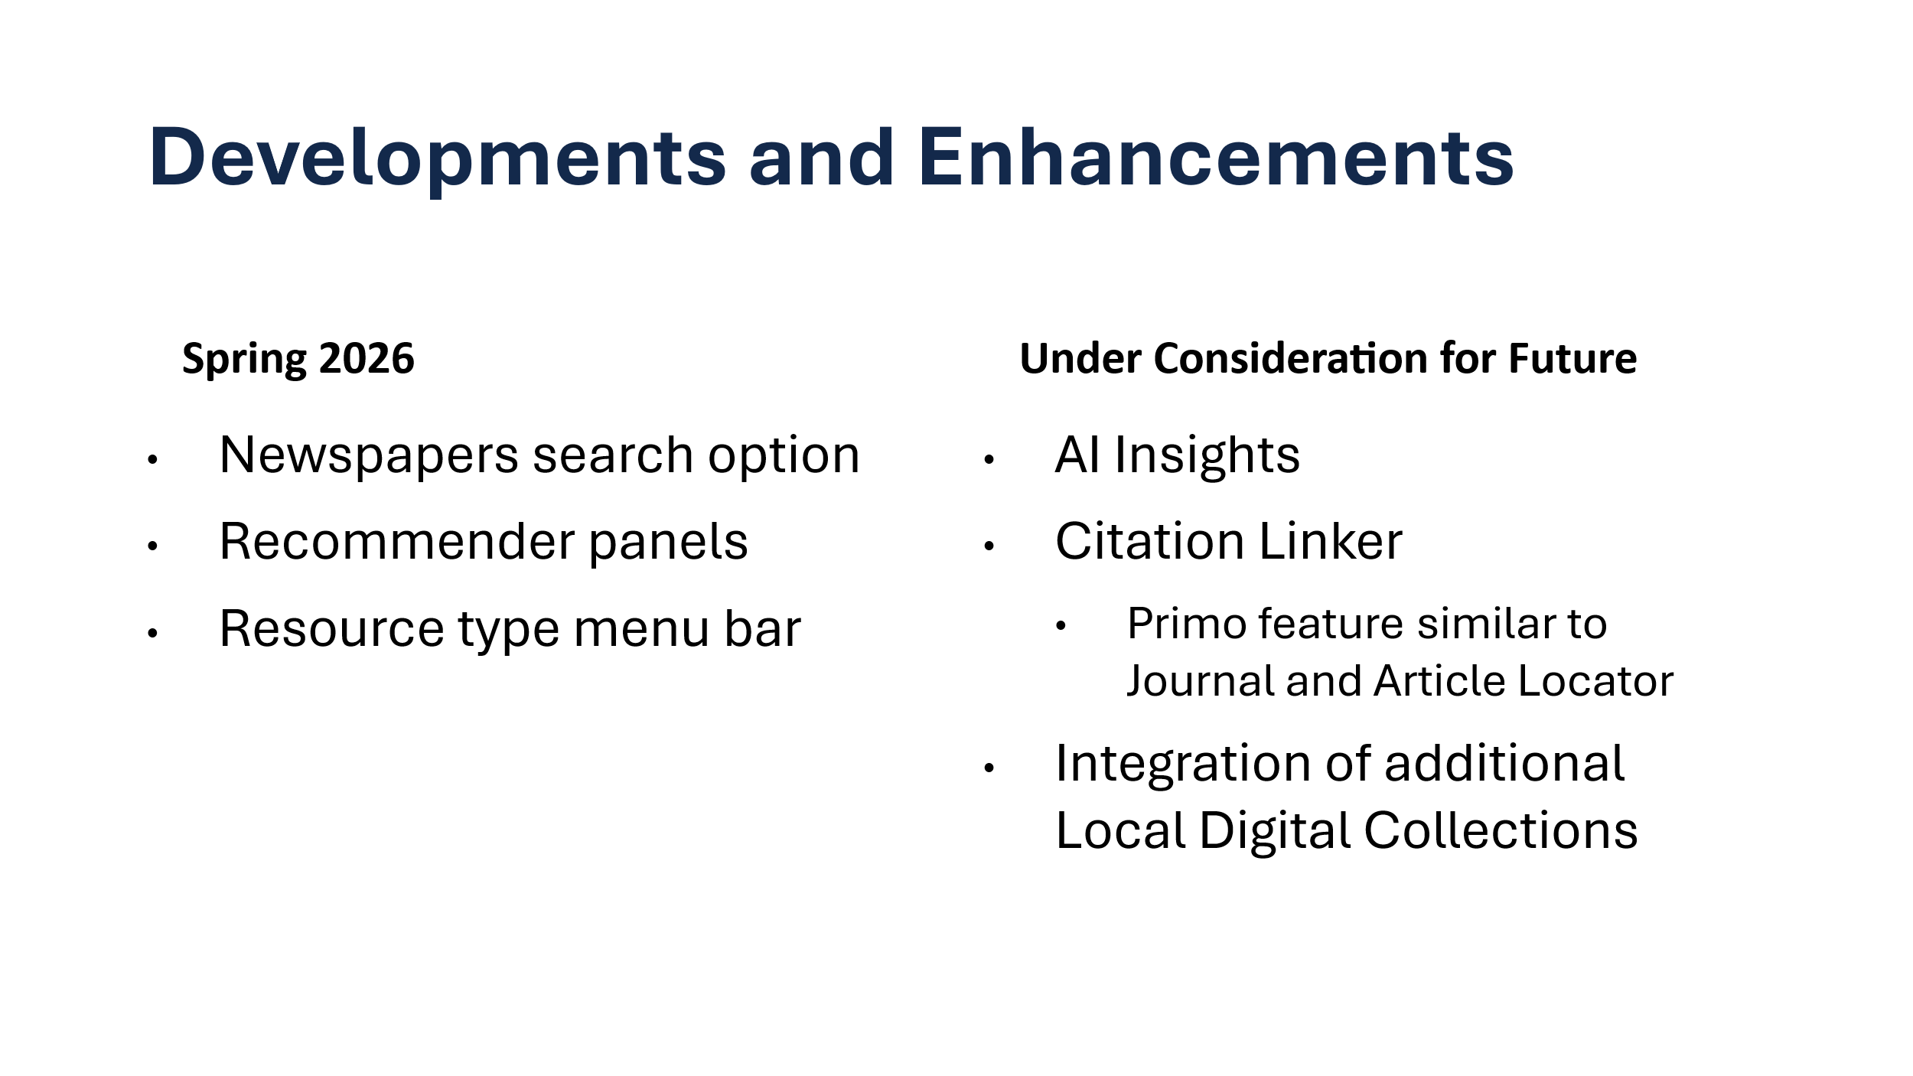
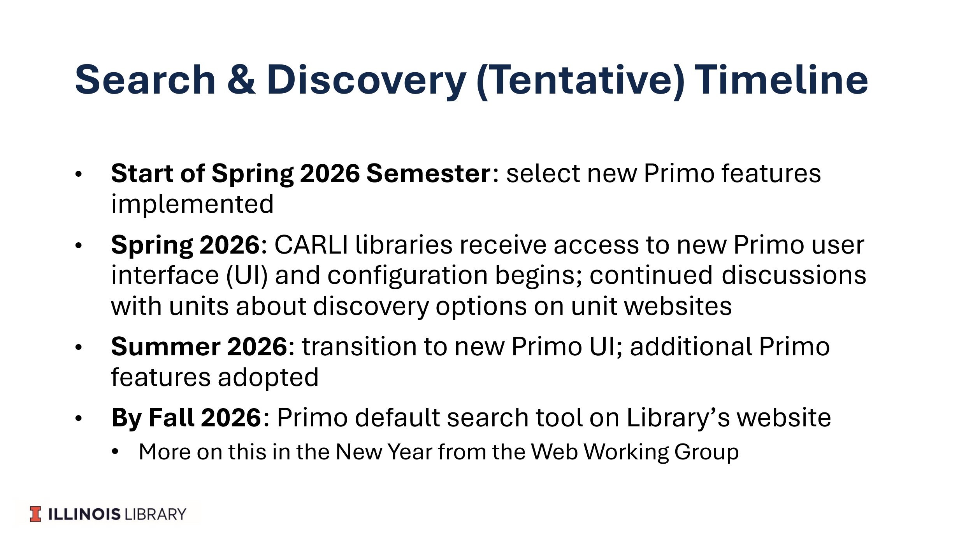

- Laptop Loaner Program- Tracy Tolliver
  - The machines were donated by Technology Services in 2022, and the warranties ran out in August. We don’t currently have the funds to replace them, but the program is very popular with almost all units rented out most of the time.
  - A proposal has been put together to either put in a budget request or evaluate the potential to pool with other colleges. The proposal would entail either a 60 laptop program leveled out over 3 years or a 100 laptop program over four years. This would also allow us to purchase the type of equipment we want in close or similar models.

- Parking lot items-review

- Any other new business

Meeting adjourned at 2:50 pm.

