CAPT Minutes
April 30, 2026

Present: Tom Teper, John Laskowski, Michael Norman, Sarah Park, Will Schlaack, Kyle Rimkus, Mary Ton, Tracy Tolliver, Chloe Ottenhoff, Hannah Williams (minutes)

- Agenda and minutes approved

- Accessibility Update – John Laskowski
  - The Accessibility Year 2 Roadmap has been launched. Some of the main areas of focus include accessibility of Libguides and the archiving process.
    - The archiving process as it related to Title II is different than our typical use and relates to a particular definition within the law of content you can archive as an exception to making it accessible.
    - This will need to be proceduralized and some standard language drafted to go into the archives.
  - Last year’s area of focus was Word Press and accessibility was increased by double digit percentages.
  - The Accessible Reader Support Task Force has launched. This will help instructors identify the accessibility of items in the catalog.
  - A group of student workers has been hired to manually remediate PDFs. Campus is also working on an automated document remediation process for PDFs, which should be able to remediate 80% of each document.
  - We are currently without a campus-wide web scanning tool. Axe Monitor is no longer a product we will work with. We are currently looking at Site Improve, which is used by the Springfield campus, however there are no tiers in the subscription model that allow for unlimited scanning.
  - New assistive technology is being added to room 109 to create an accessible study space. This includes different sizes of keyboards, an attachable number pad, and several mouse alternatives. There will also be two copies of each of these items in Loanable Tech, with one set for Main and one for Grainger.
  - John asked committee members to explain the benefit of universal design and accessibility to any colleagues expressing dissatisfaction with recent changes.

- Quarterly working group reports

- Web- John Laskowski
  - Eva Gellman has been added to the working group as an ex-officio member.
  - The group is prototyping the new search feature for the gateway, as well as a new navigation structure.
  - There is a feedback form located on the prototype page. People are encouraged to give feedback and encourage students to do the same.
  - The group is working closely with the Discovery Working Group on the new Primo interface and plans for the Easy Search end of life.

- Search, Discovery, and Delivery- Michael Norman

Search, Discovery, and Delivery Working Group Report – Michael Norman and Sarah Park, April 30, 2026

- New Search Box on the Library homepage that points to Primo/Library Search. Explore it and offer feedback. Great work by John, Eva, the Web Working Group, and the Web Team:
https://gateway-stage.library.illinois.edu/
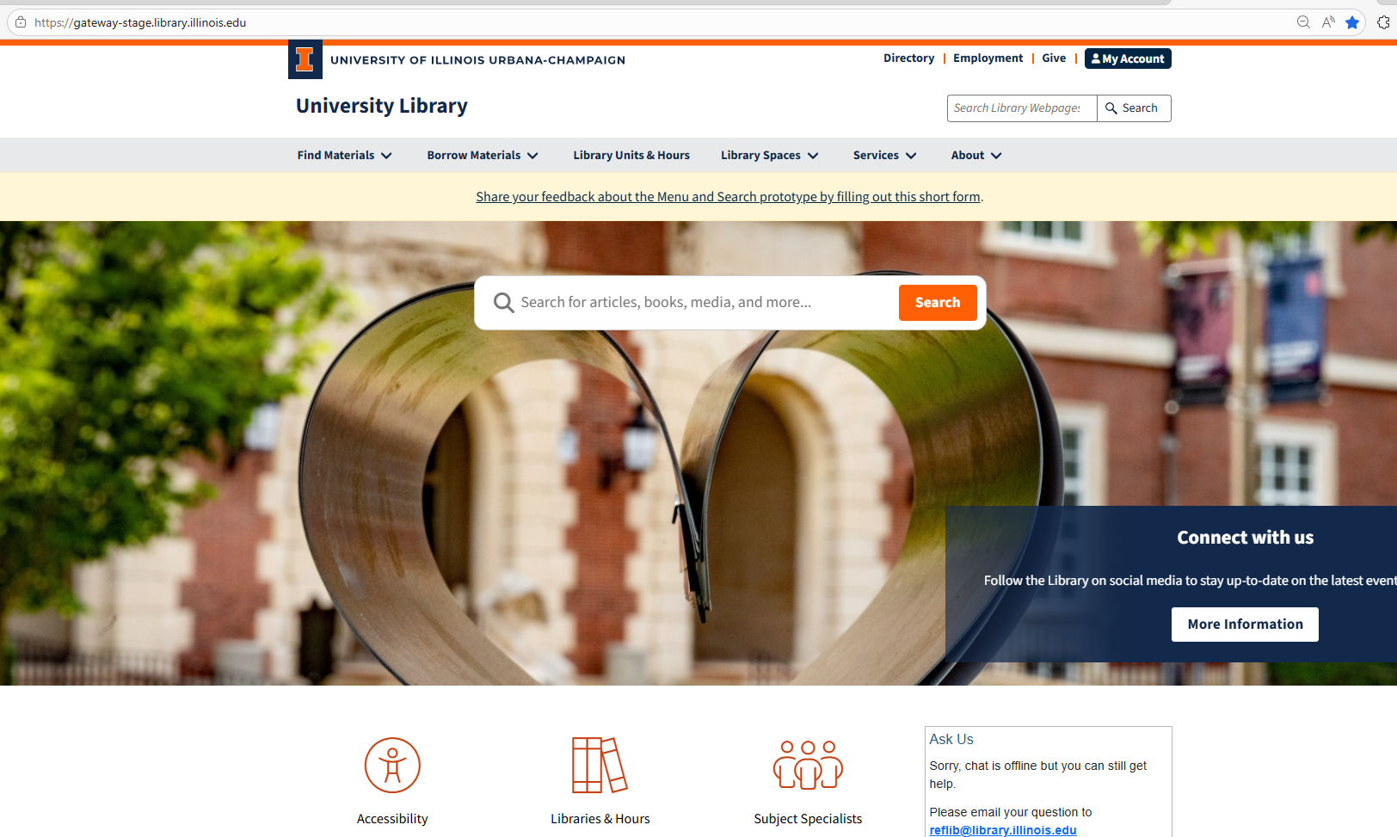
- New Primo/Library Search NDE version is available for Library testing and exploring. We will demo during the CAPT WG Report and the Discovery Virtual Open House on May 22, 2026.
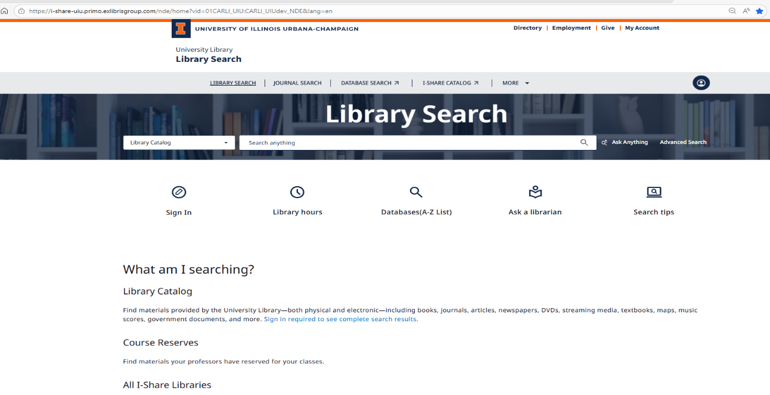

Primo/Library Search
- There will be much more representation of the Library’s Digital and Special Collections in the new Primo/Library Search.
- Primo/Library Search provides a scoped search across the University Library’s print and electronic holdings
- The goal is to provide one primary search box that enables discovery of most Library collections,
something users have long requested
- At the same time, it offers customized search options for specific collections, such as Maps, Musical Scores, or Archives, allowing users to refine and pinpoint results through the use of various facets.
- Important: We are going to have a contest in the Fall 2026 for the naming/branding of the Primo/Library Search. Please watch for that announcement later this Summer.

Expanded Content Coverage

- Searches most, but not all, electronic holdings. (Some specialized databases, e.g., select EBSCOhost databases still require direct access.
- Searches an extensive Central Discovery Index (CDI) with over 1 billion records, including: books and e-books, journal articles, book chapters, journals and newspapers, DVDs and streaming media, datasets, textbooks, maps, music scores, government documents, and more
- When signed into Library Search, affiliated users will also see results from licensed sources such as:
- Scopus
- Clarivate - Web of Science (Social Sciences Citation Index, Science Citation Index, Arts &
Humanities Citation Index, Emerging Sources Citation Index, Conference Proceedings
Citation Index)
- NewsBank
- GeoRef

Local and Consortial Content

- Will include most of the Library’s local digital collections, such as
- IDEALS
- University of Illinois Digital Library
- Illinois Data Bank
- Illinois Digital Newspaper Collection
- New collections search upcoming

Enhanced Discovery Tools

- Showcase Sarah Park’s University of Illinois Library Search Chrome Extension to search the University of Illinois' Library Catalog. Highlight text - article title, author names, DOI, or journal - on a page, right-click, and send search to the University of Illinois' Primo/Library Catalog
- Dedicated Newspapers Search that indexes more than 1 billion international newspaper articles.
- Citation Linker service will be active that allows one to search by citation or DOI. However, the Library Search box allows the copy and paste of a complete citation or DOI to find the article/book one seeks.
- BrowZine integration provides:
- Clear accessible and availability options
- LibKey full-text authentication
- Article-level browsing within journal issues

- Parking lot items-review

- Any other new business
  - Global Accessibility Awareness Day is coming up: https://gaad.umn.edu

Meeting adjourned at 2:52 pm.

