Collection Development Committee Minutes
April 29, 2025

Present: Tom Teper, Jenny Johnson, Cindy Ingold, Paula Carns, Esra Coskun, Stephanie Baker, Amy Fry, Kelli Trei, Sanga Sung, Kit Condill, Hannah Williams (notes)

Agenda/Minutes

Agenda and last month’s meeting minutes approved.

FY25 Budget Updates
- Important Dates: https://www.library.illinois.edu/staff/acs/fundmanagement/importantacqdates/
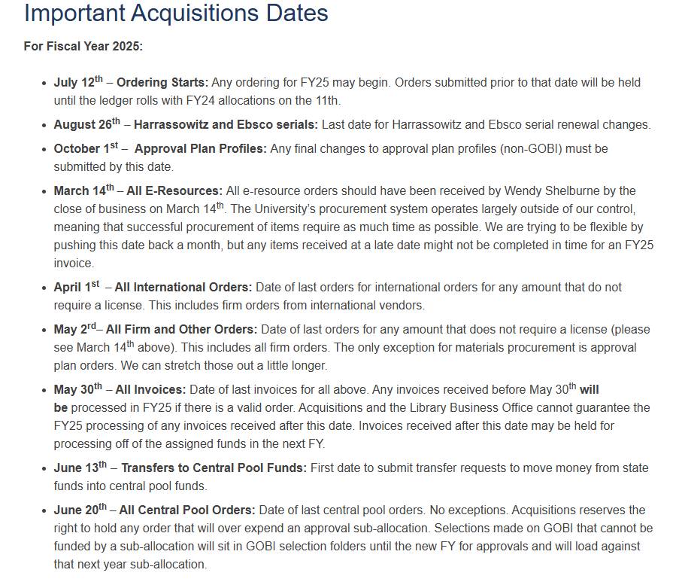
  - A reminder will go out about these dates. Divisions should be encouraged to place orders and spend down funds.
- Desiderata Discussion: https://uofi.box.com/s/44juoqudptvfbjyq90clne9smoy1i6h9.
  - See list for items and provided feedback.

FY26 Budget Preparation
- A&I Review – Final Recommendations (Kelli)
  - The final report was shared with CDC and is available in Box, along with information on databases, usage statistics, access fees, and free databases.

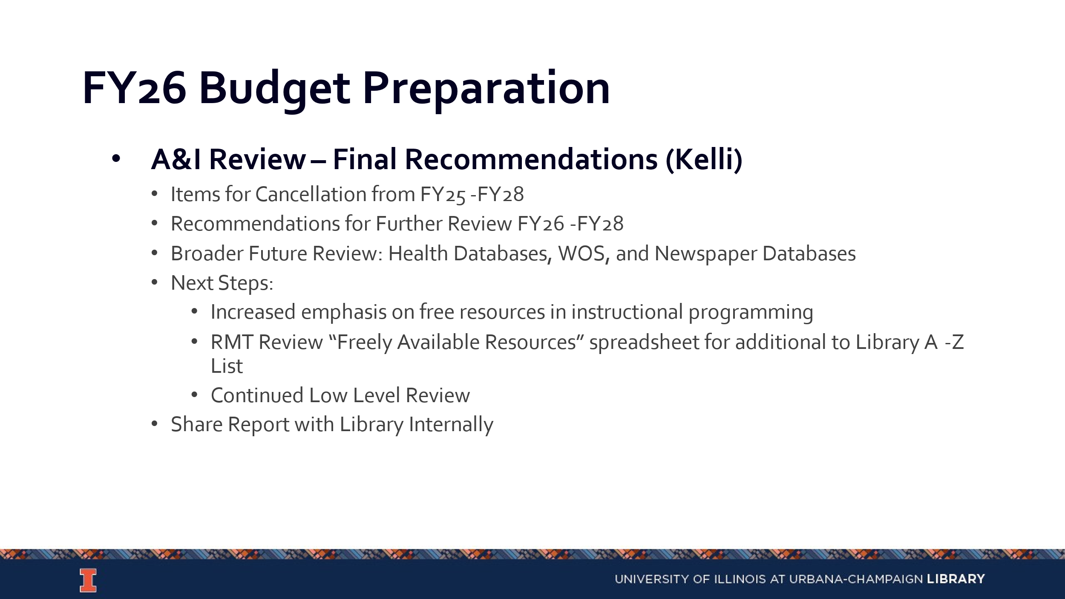
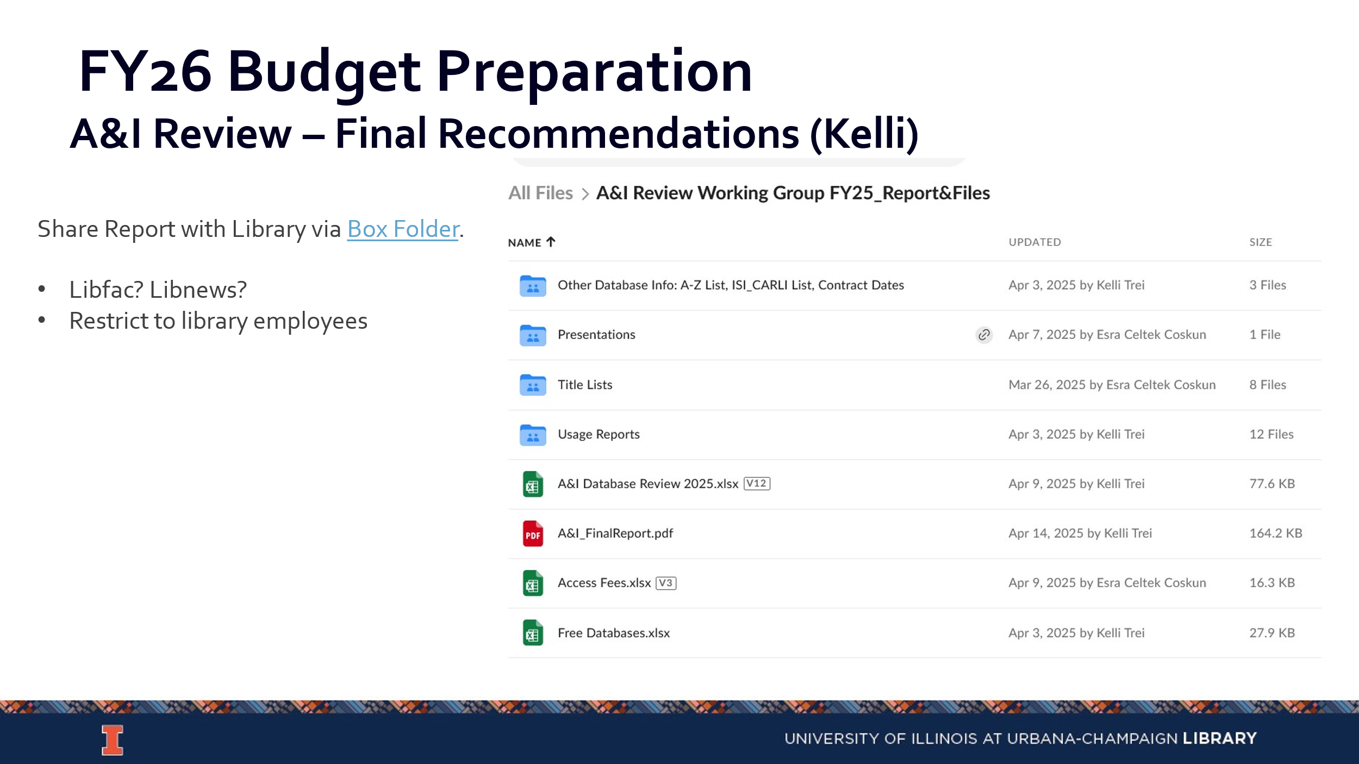
- Annual Budget Discussion Update
- Impact of Global Events – Tariffs, Shipping, etc…
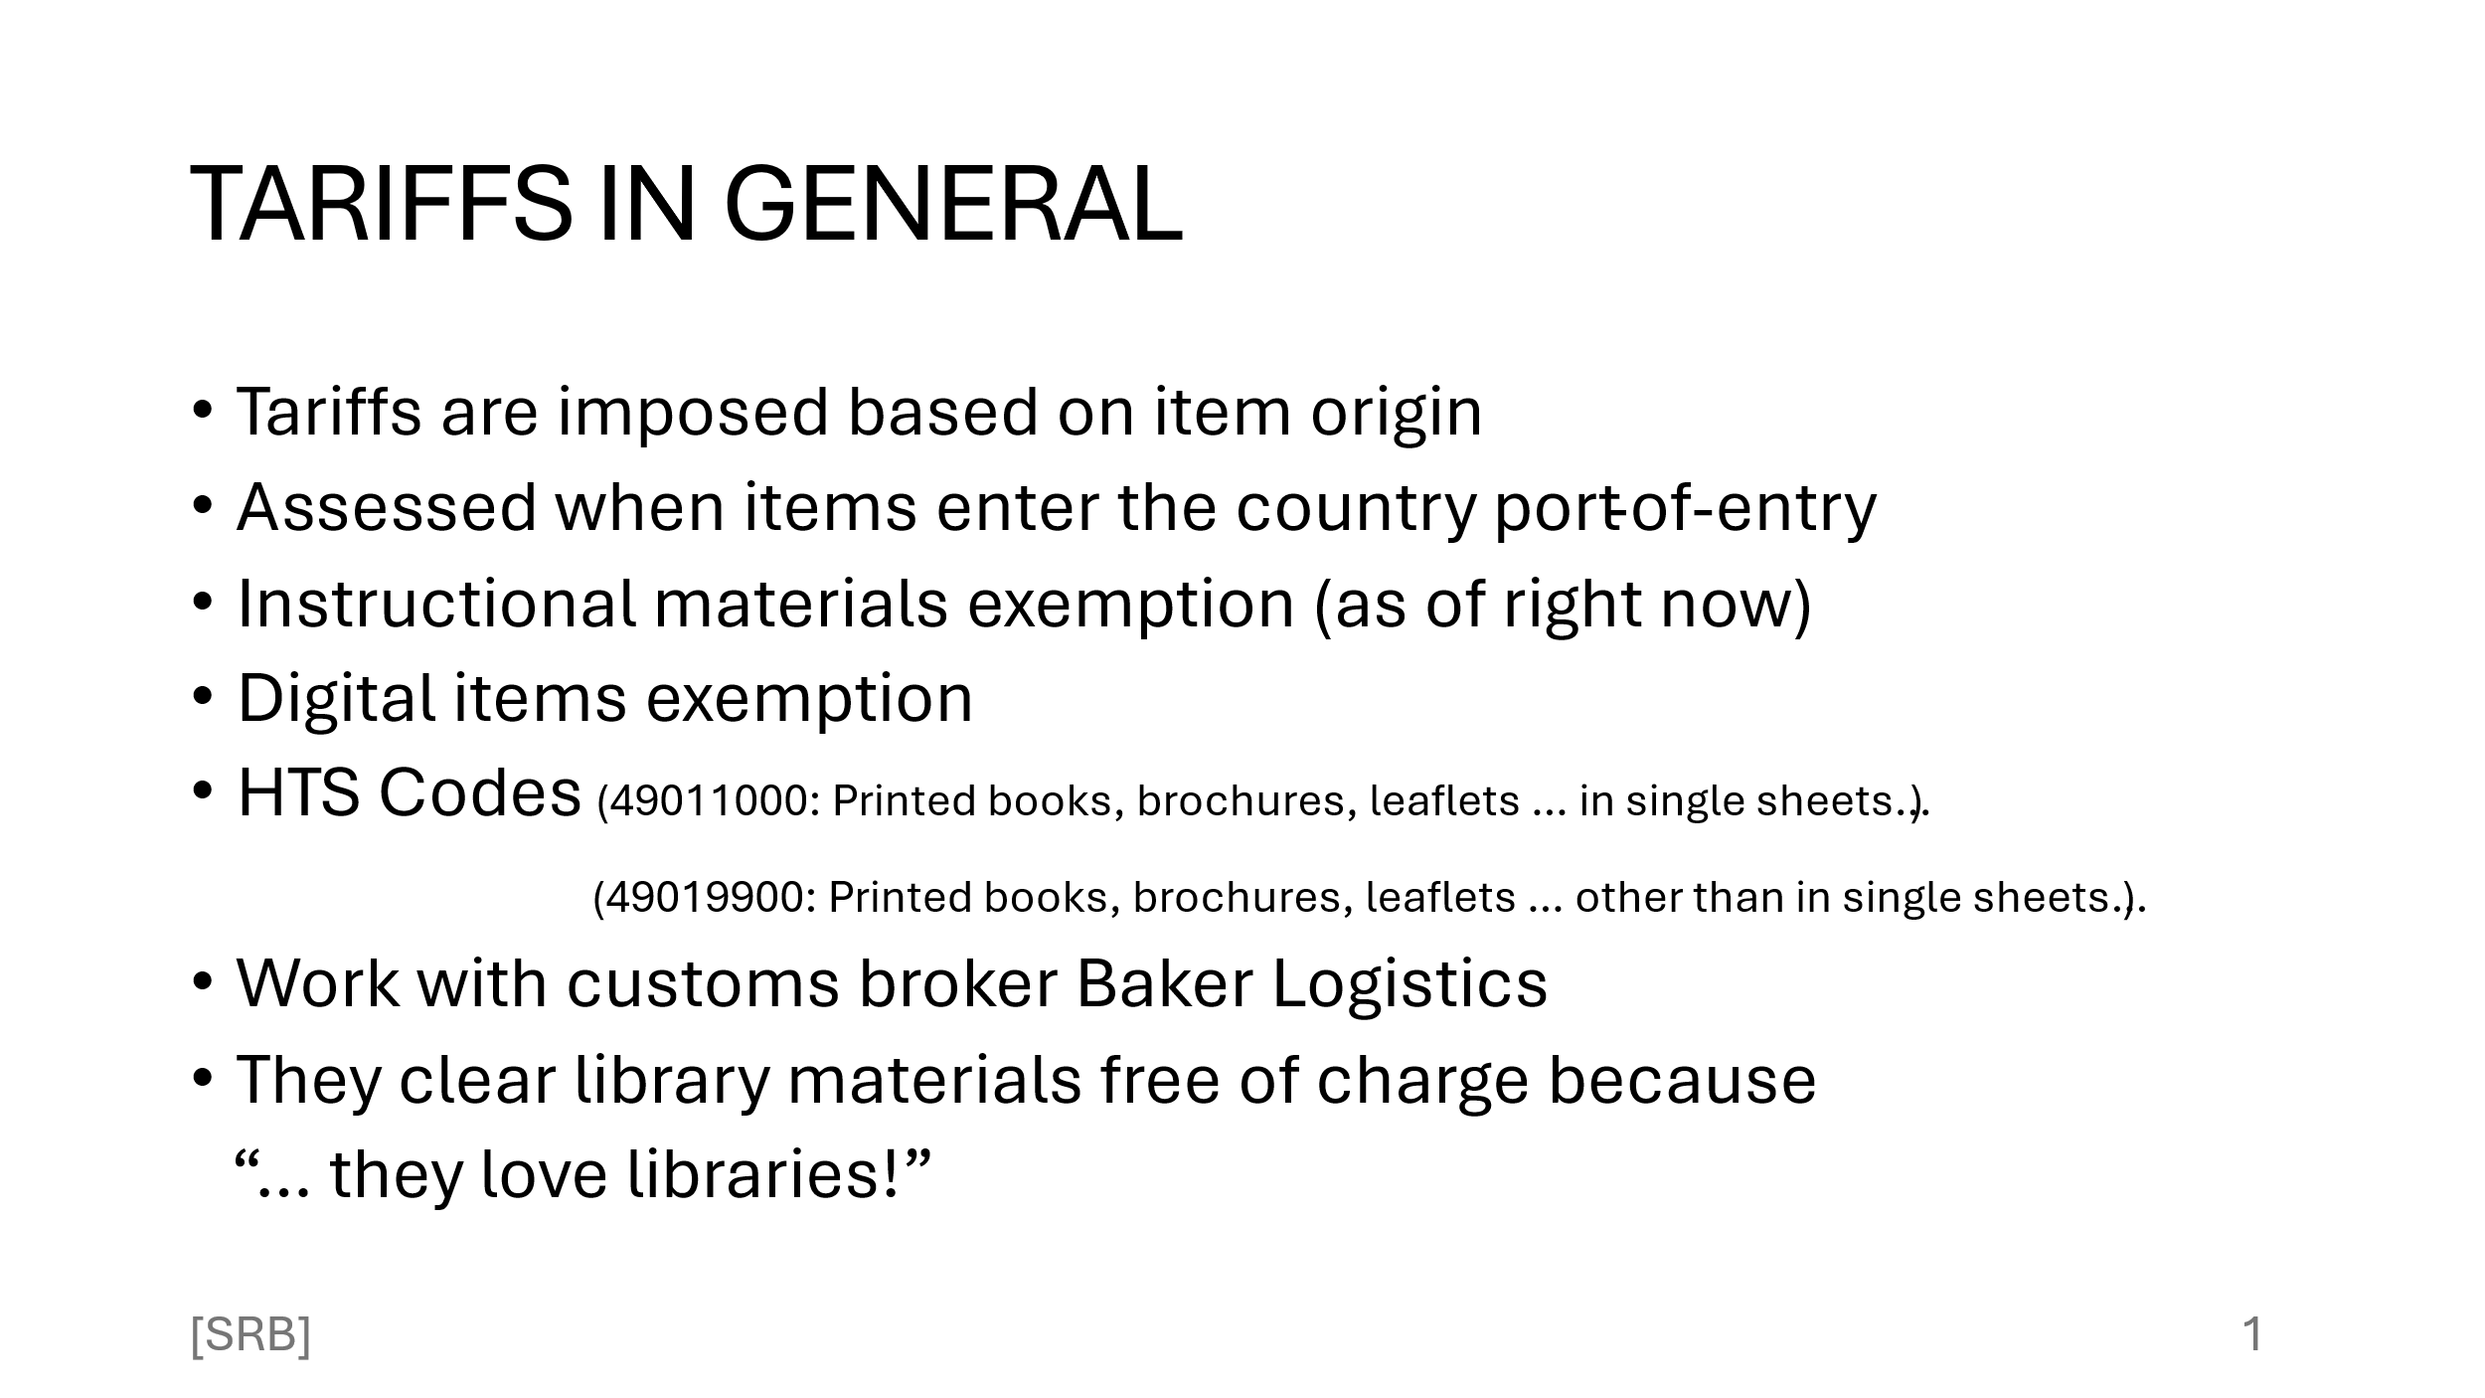
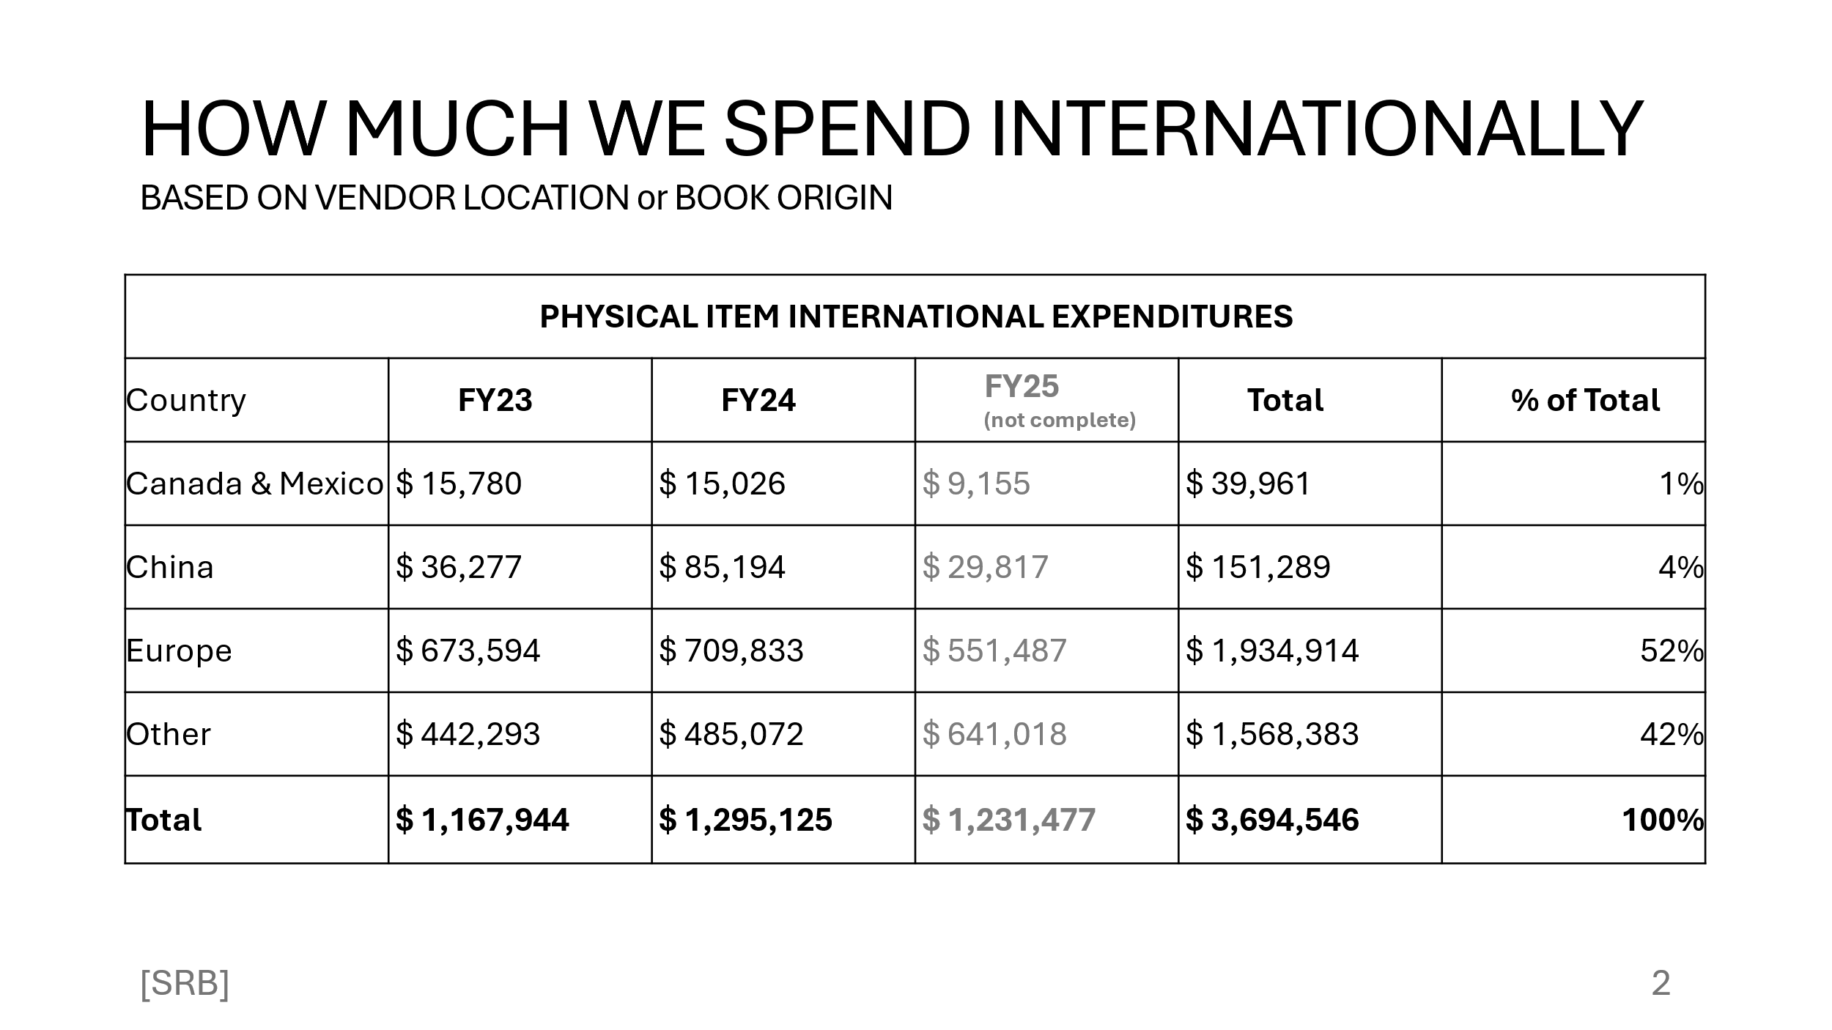
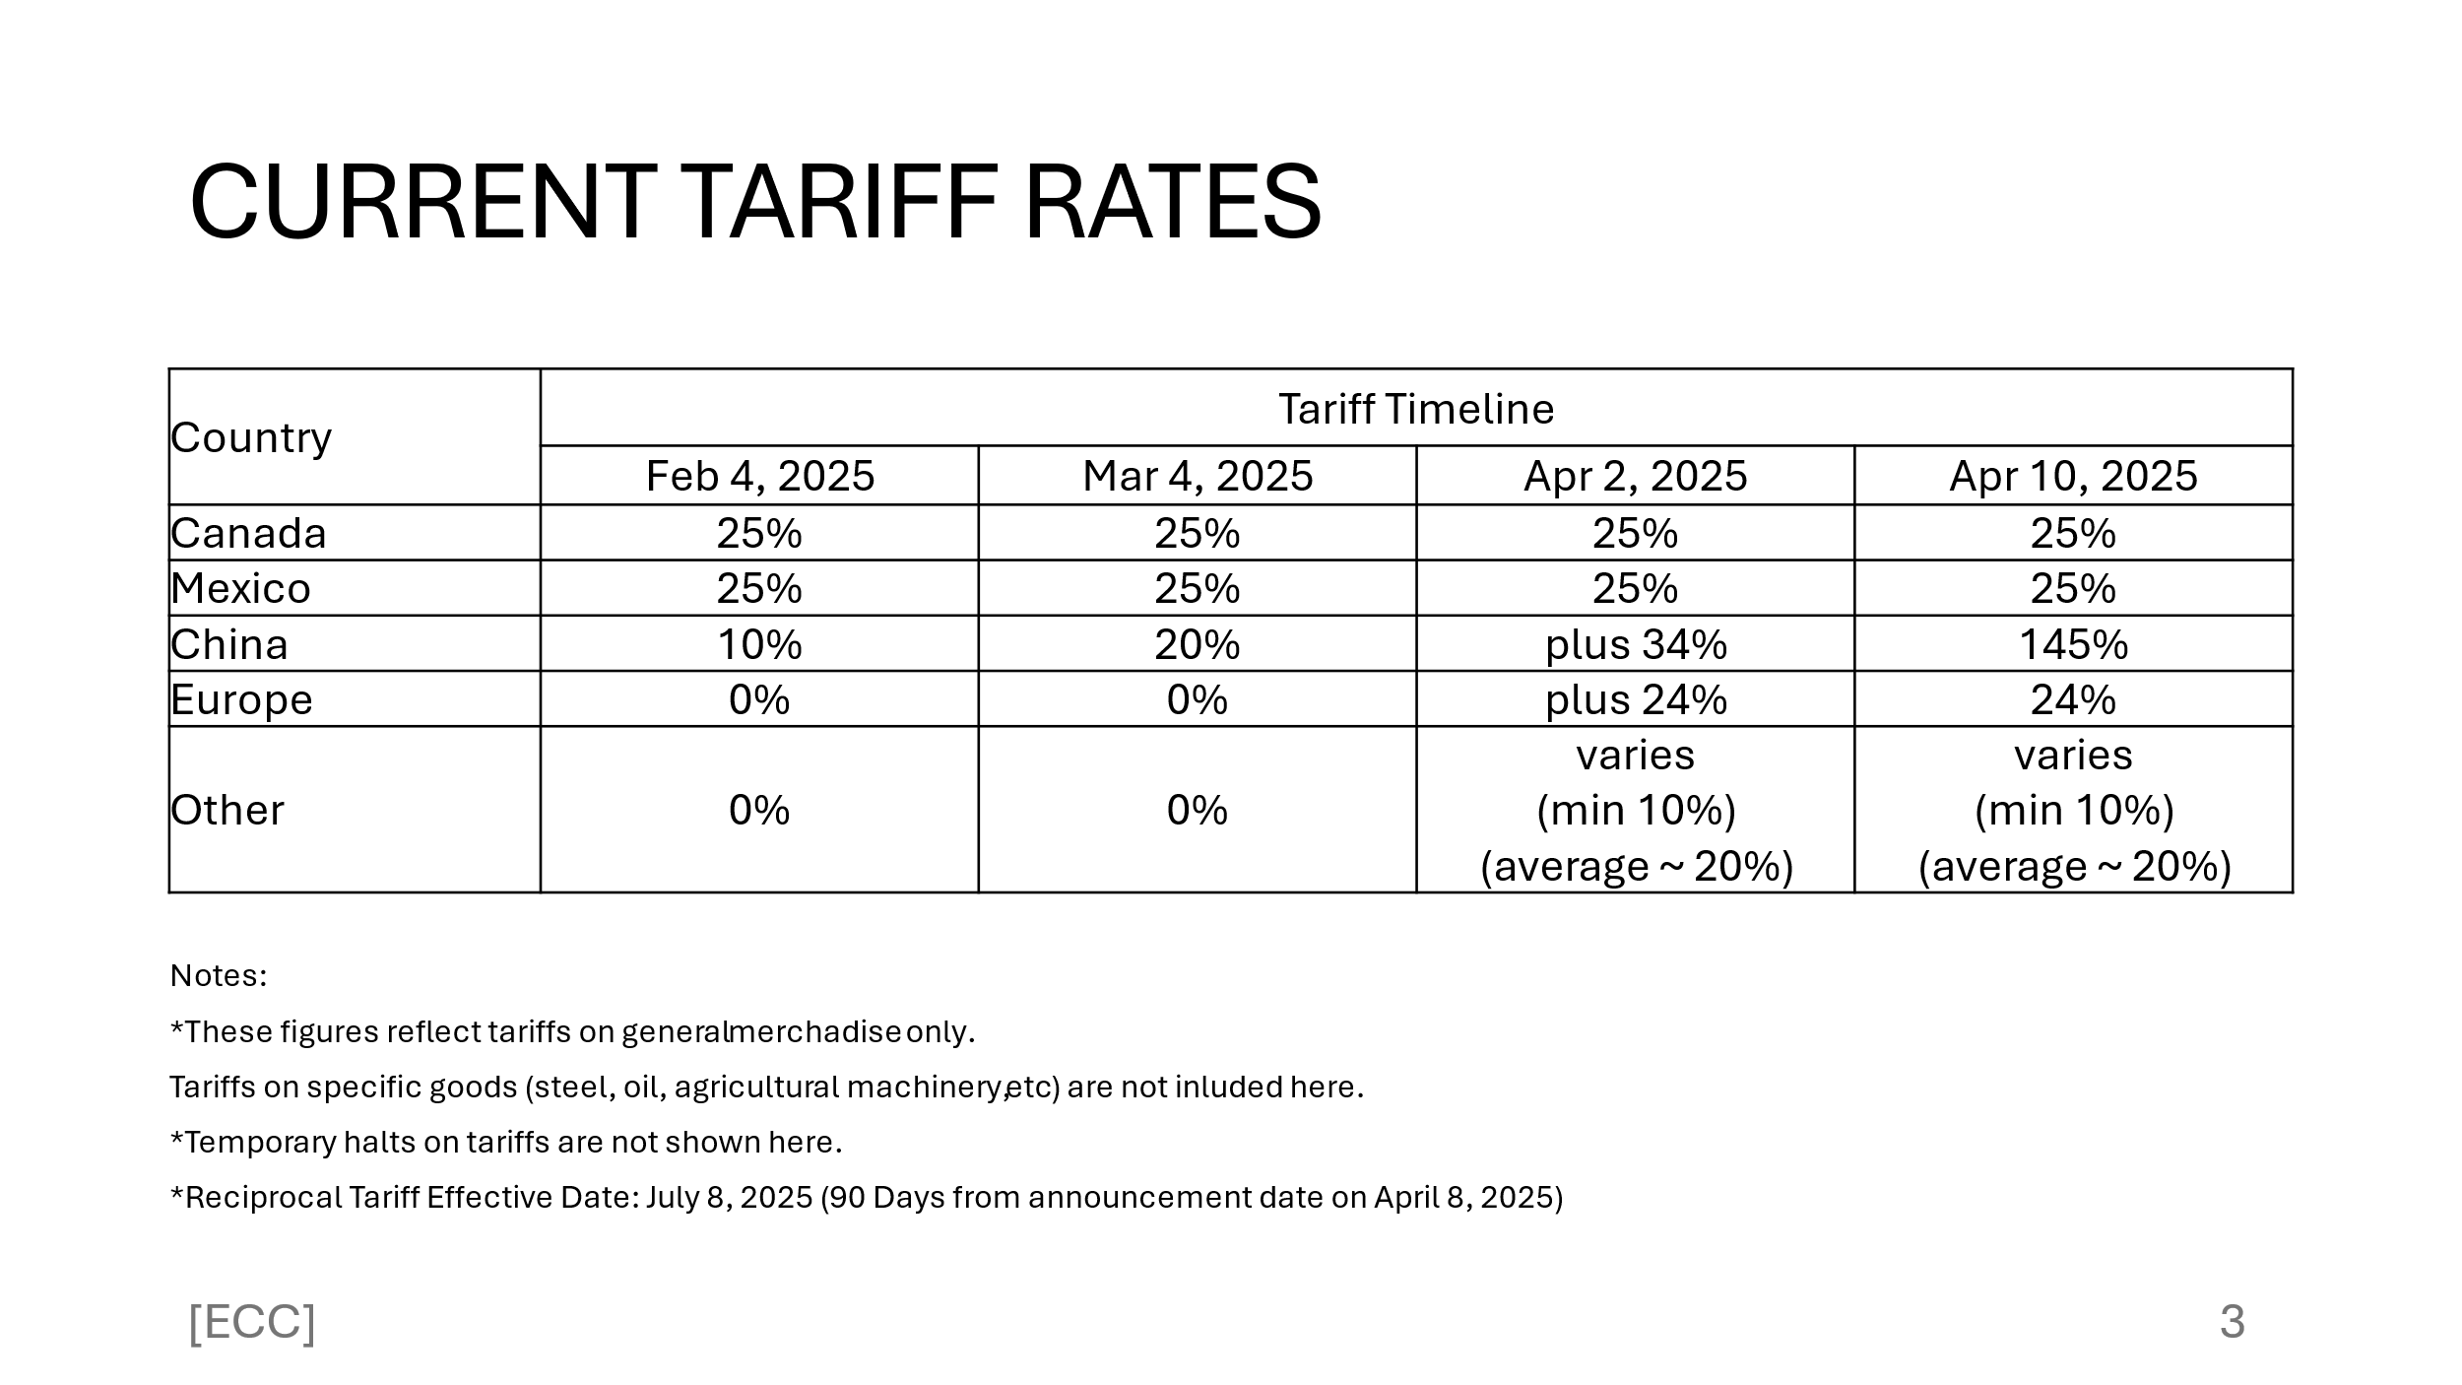
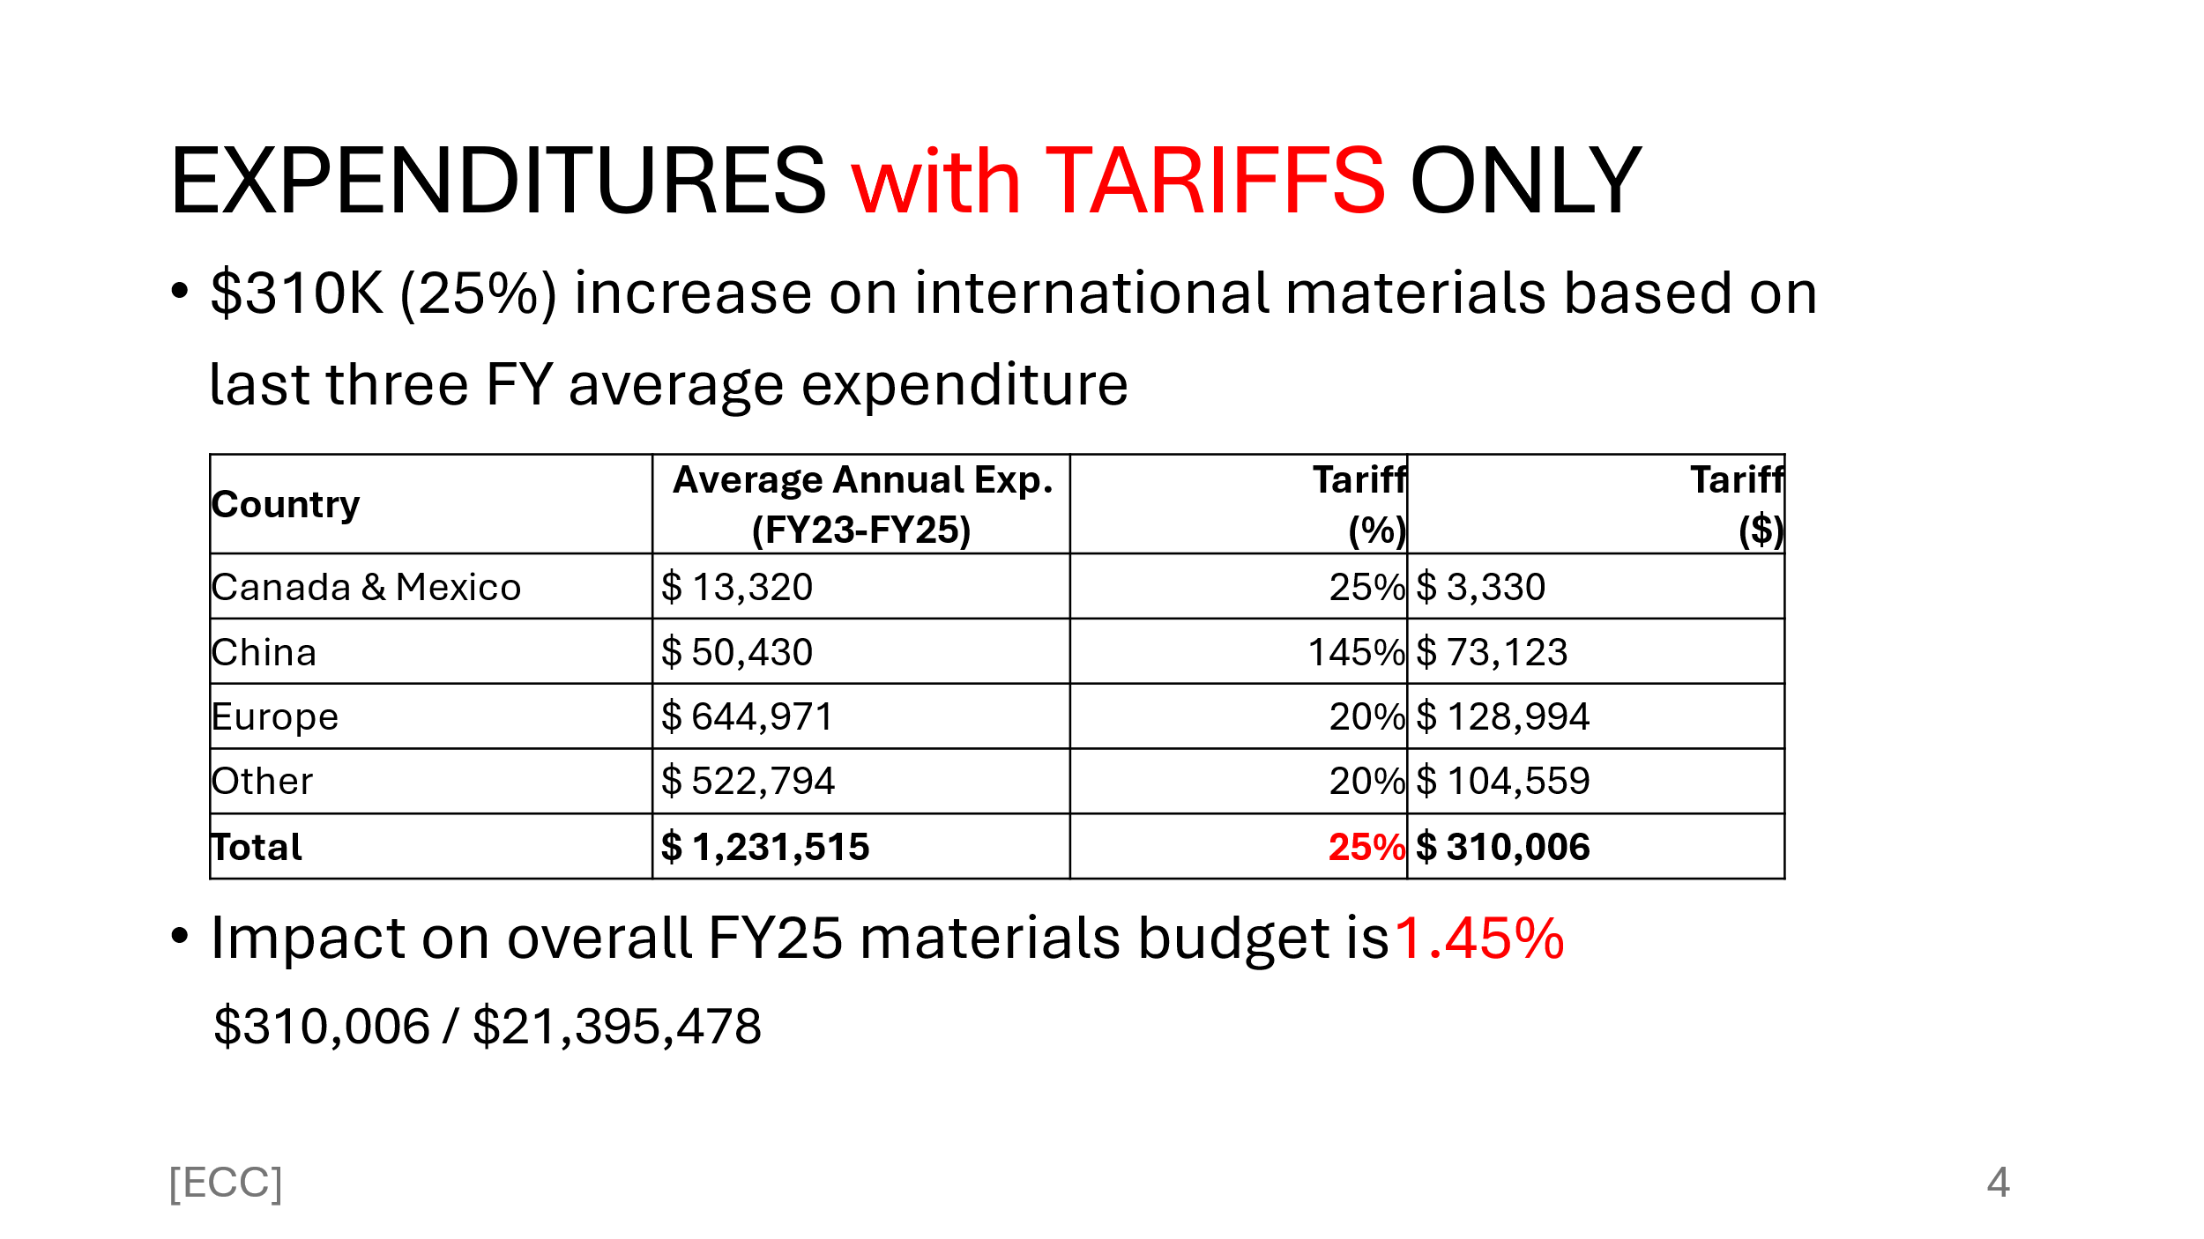
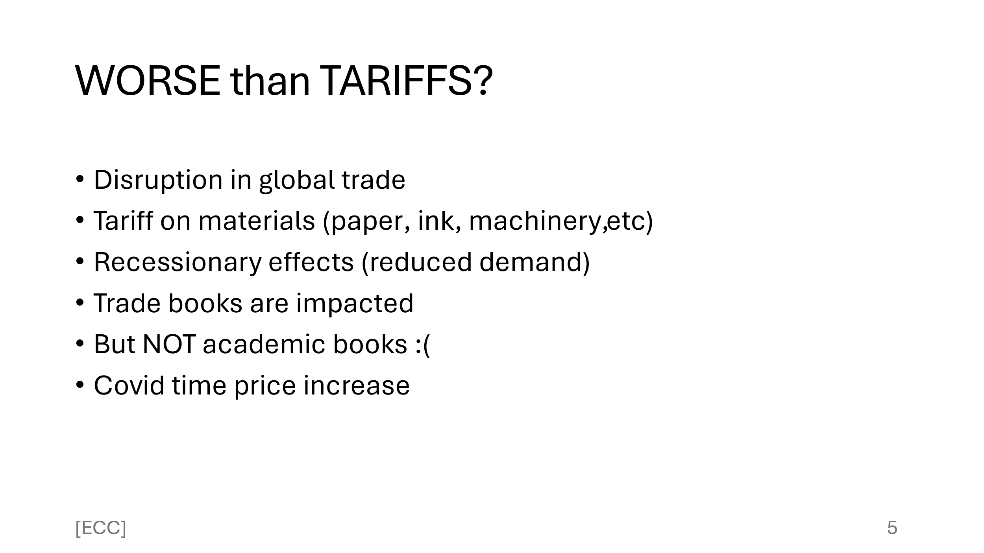
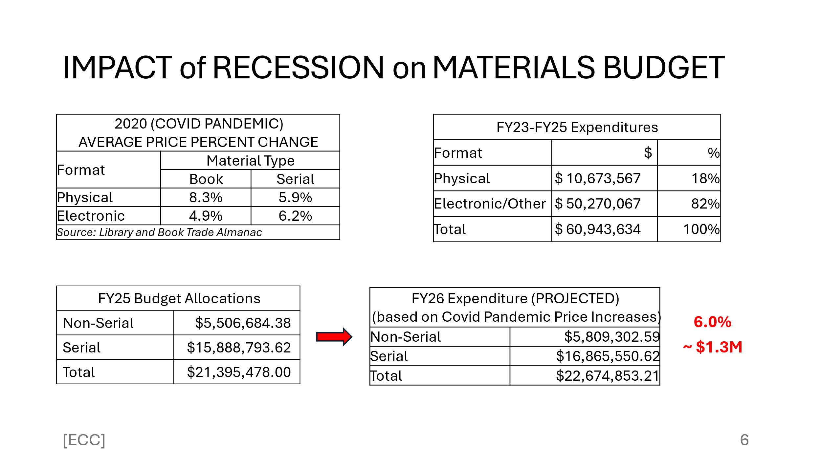
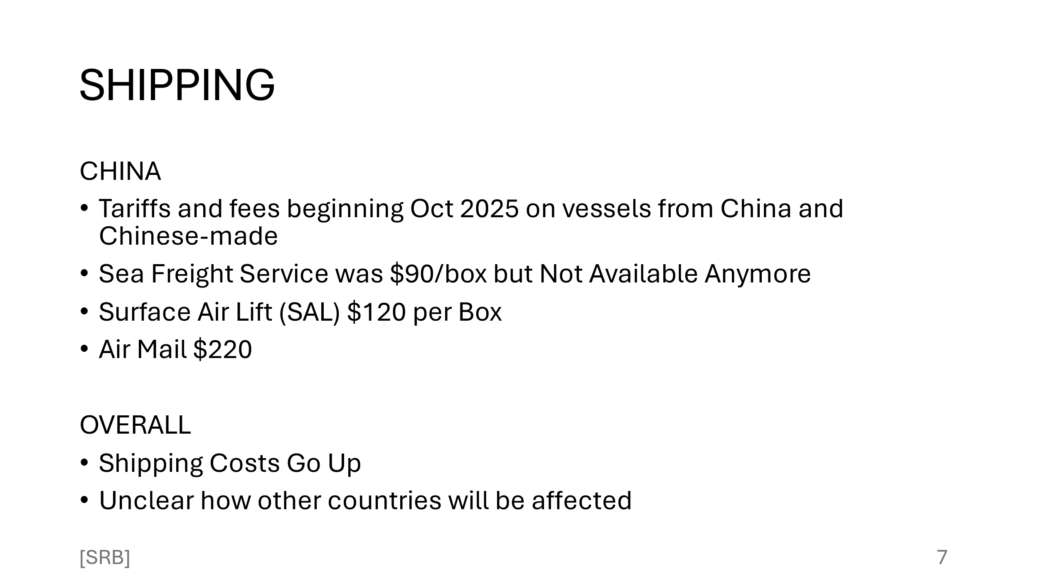
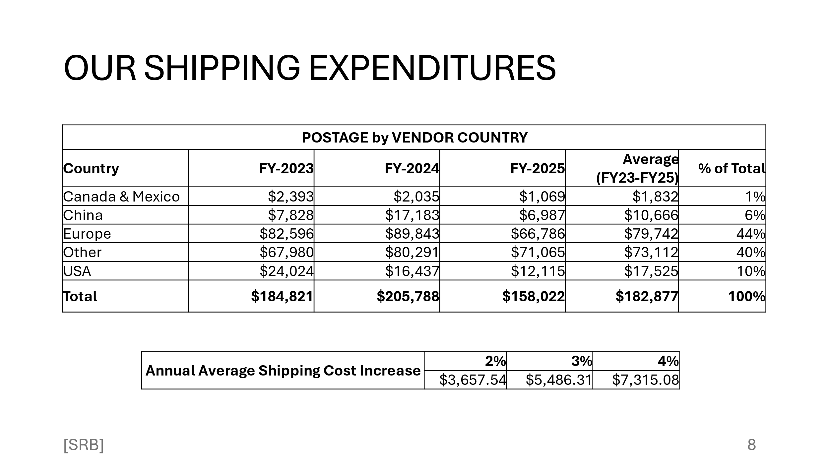
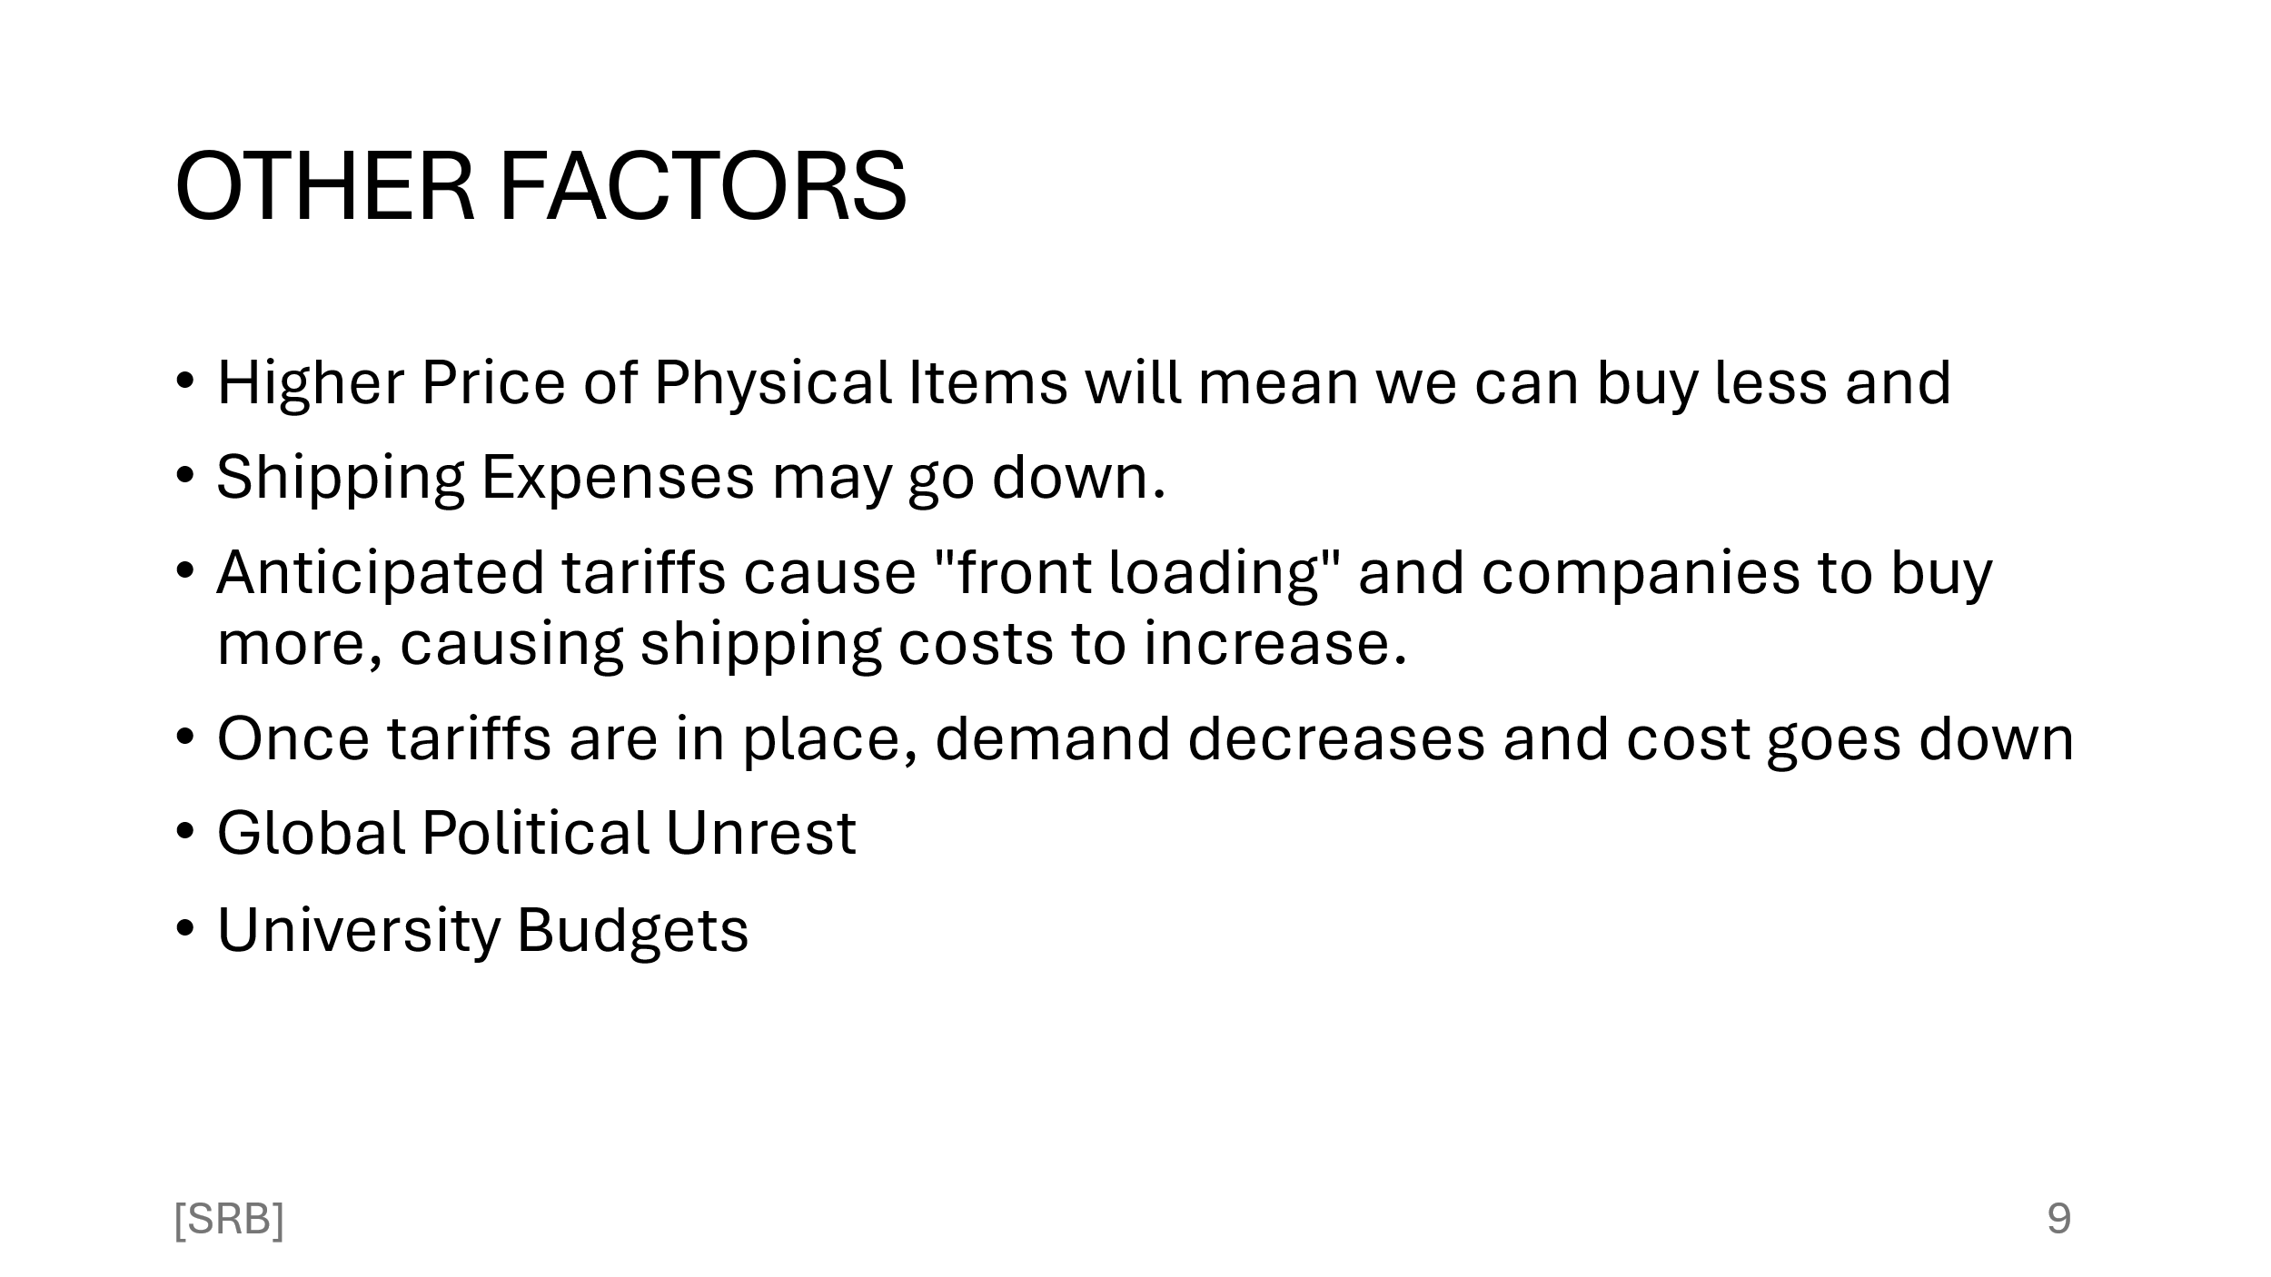

- FY26 Scenarios – What ifs…?

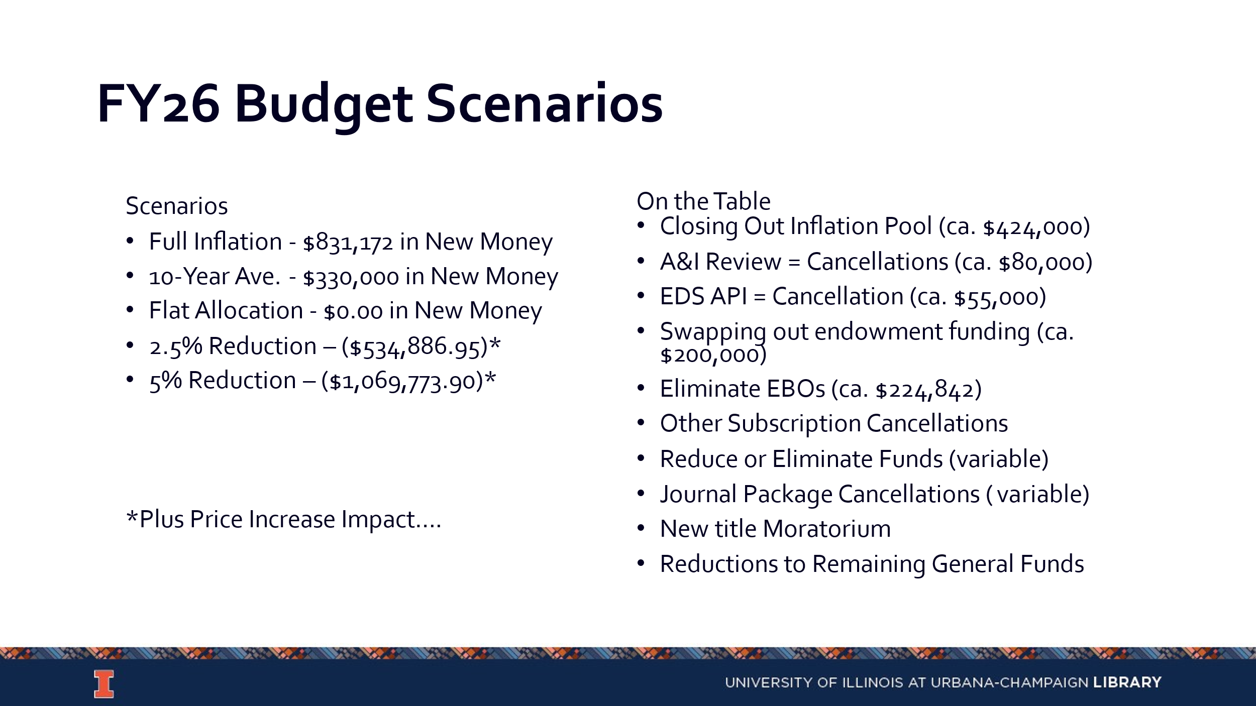
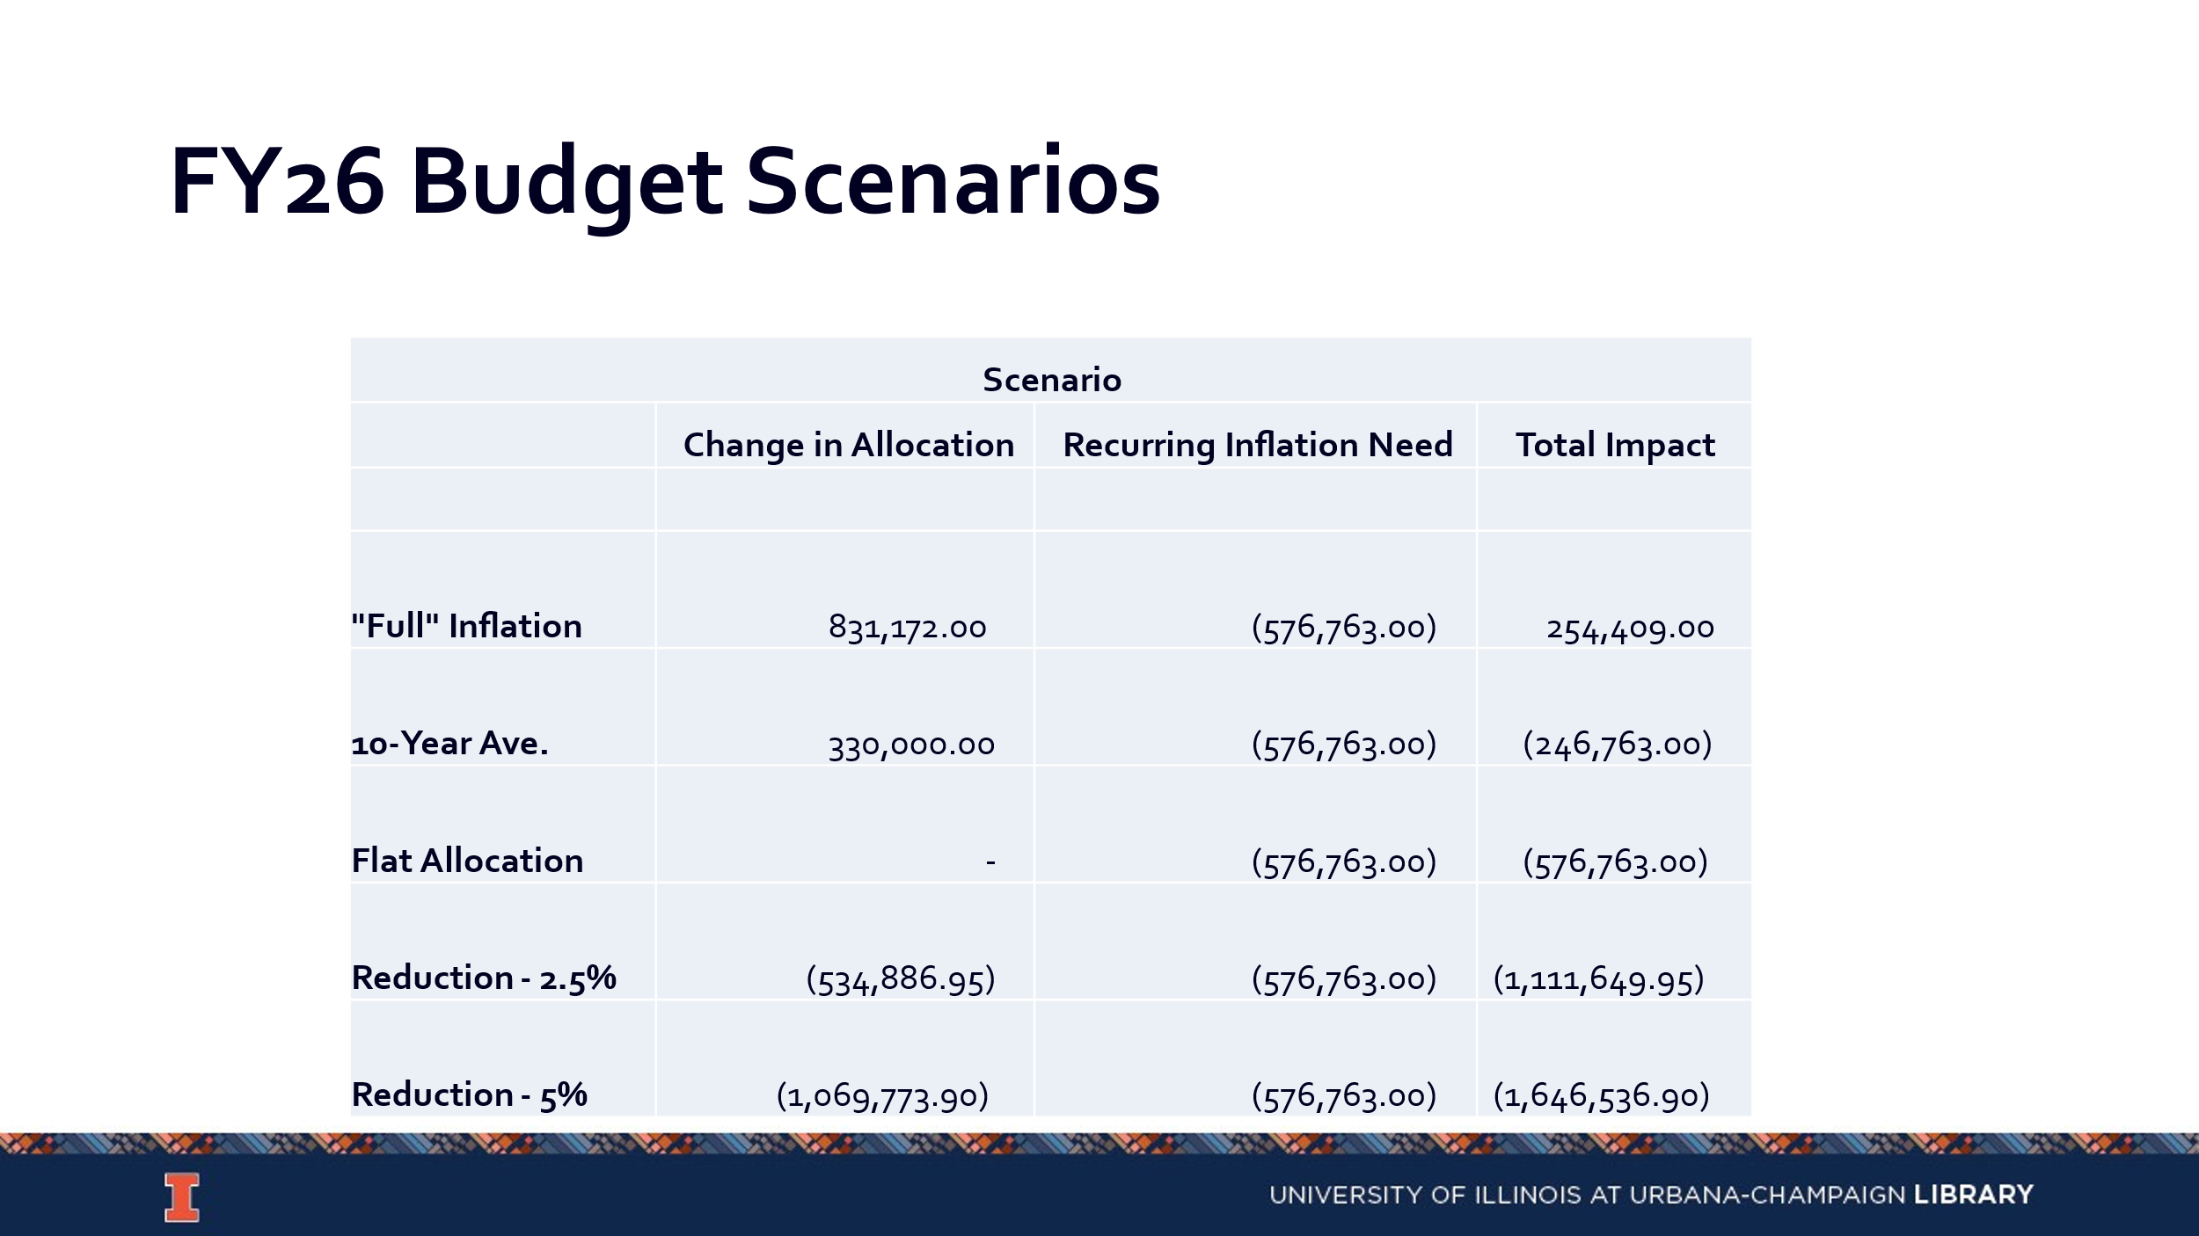
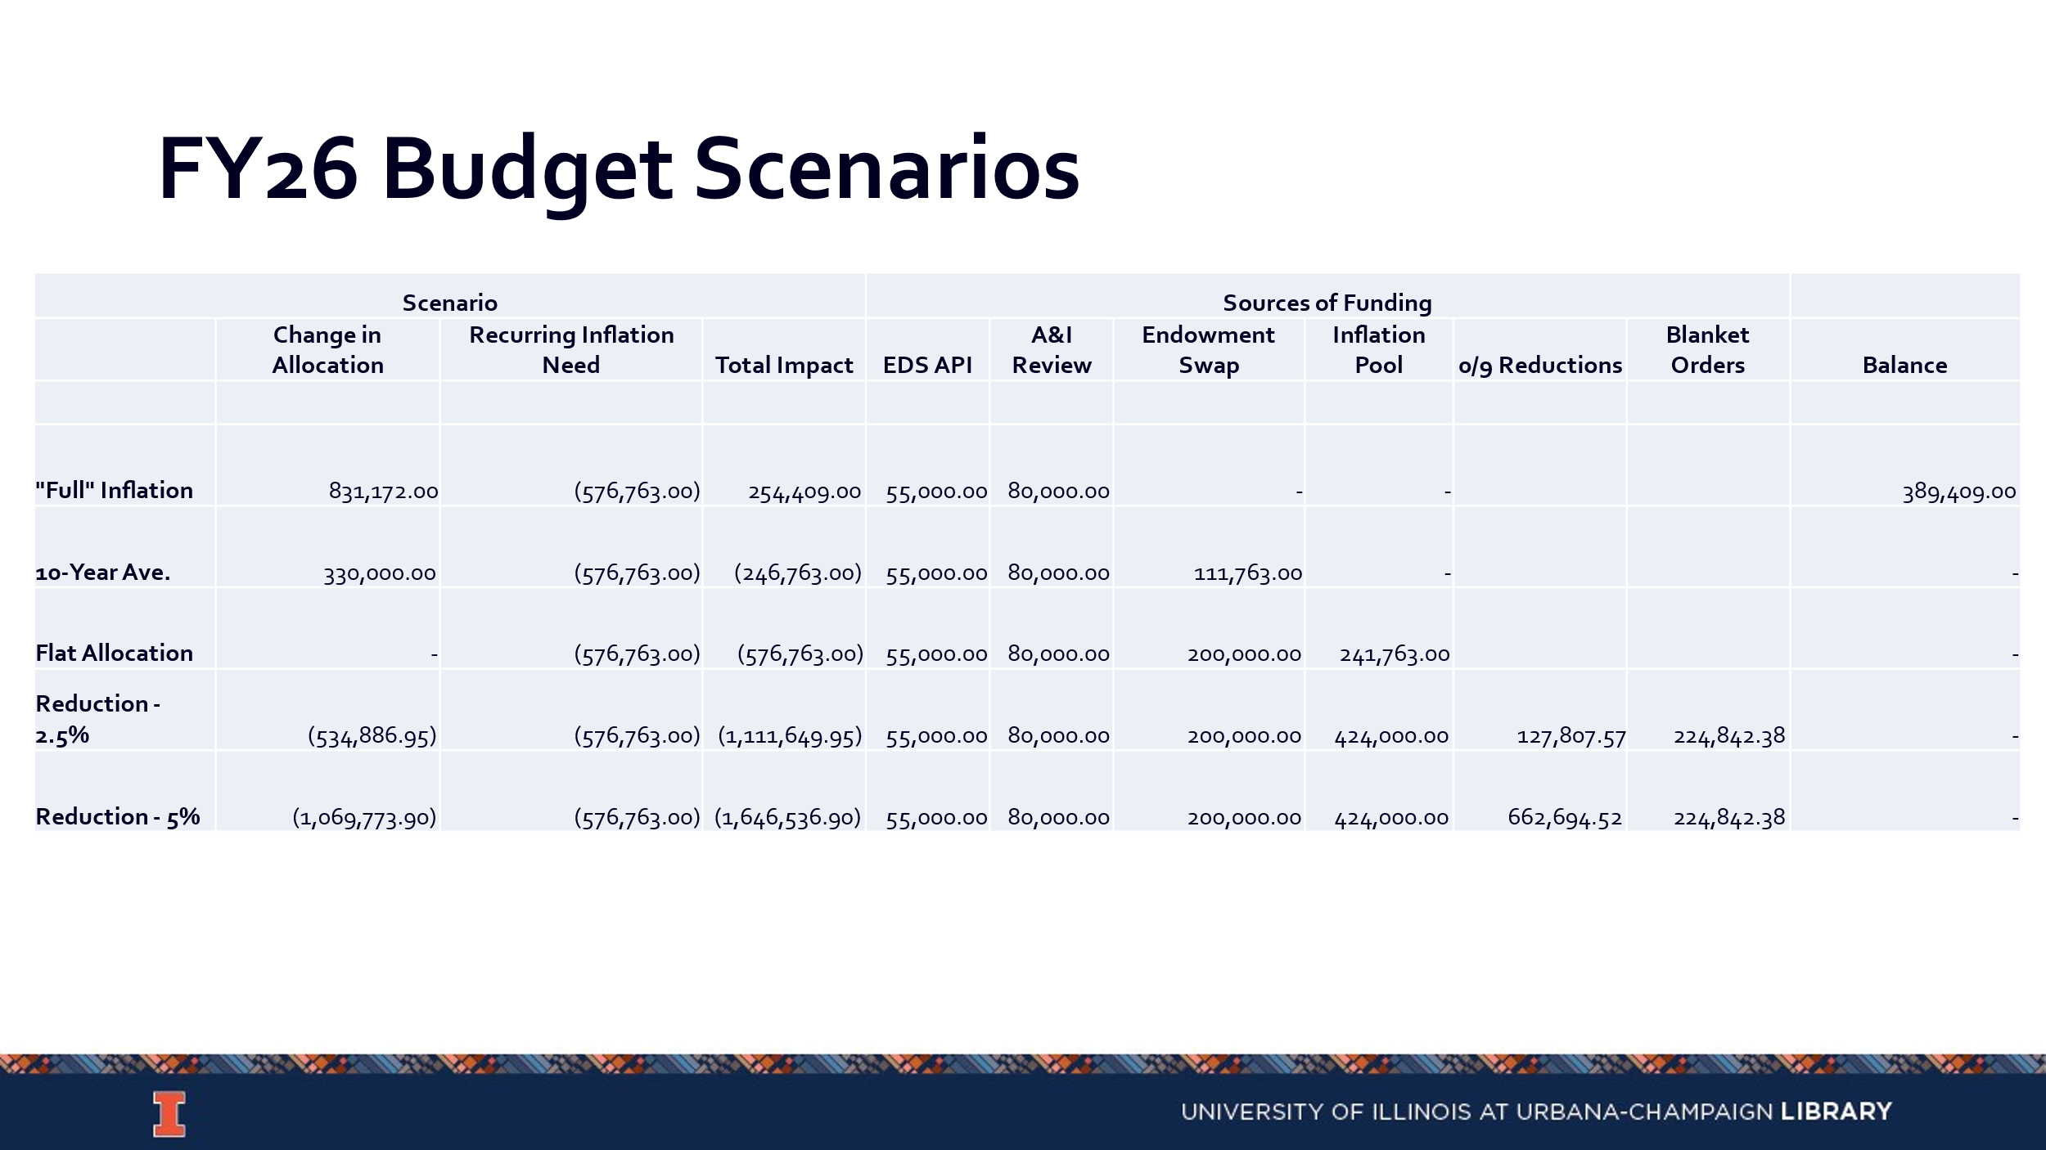

Collection Development Topics
- Request for removal of materials policy/webpage (Kelli)
  - https://www.library.illinois.edu/staff/policies/request-for-removal-of-materials-from-the-collection-or-from-general-circulation-due-to-allegations-of-dubious-scholarship/
    - The draft of the new policy will be sent to CDC for approval.
- Collection Development Philosophy
  - Please Read: https://library.yale.edu/policy/collection-development-statements.

Updates
- Acquisitions
  - Overlap Review, Orders, etc….
- E-Resources
- Preservation Services
- BTAA Updates

--

Meeting adjourned at 2:35 pm.

