Collection Development Committee Minutes
April 28, 2026

Present: Tom Teper, Cindy Ingold, Jen Yu, Mary Schlembach, Jenny Johnson, Steve Witt, Amy Fry, Wendy Shelburne, Hannah Williams (notes)

- Agenda and minutes
  - Agenda and minutes approved.

- FY26 and FY27 Budget Updates

  - FY26 – Almost Wrap Up Time

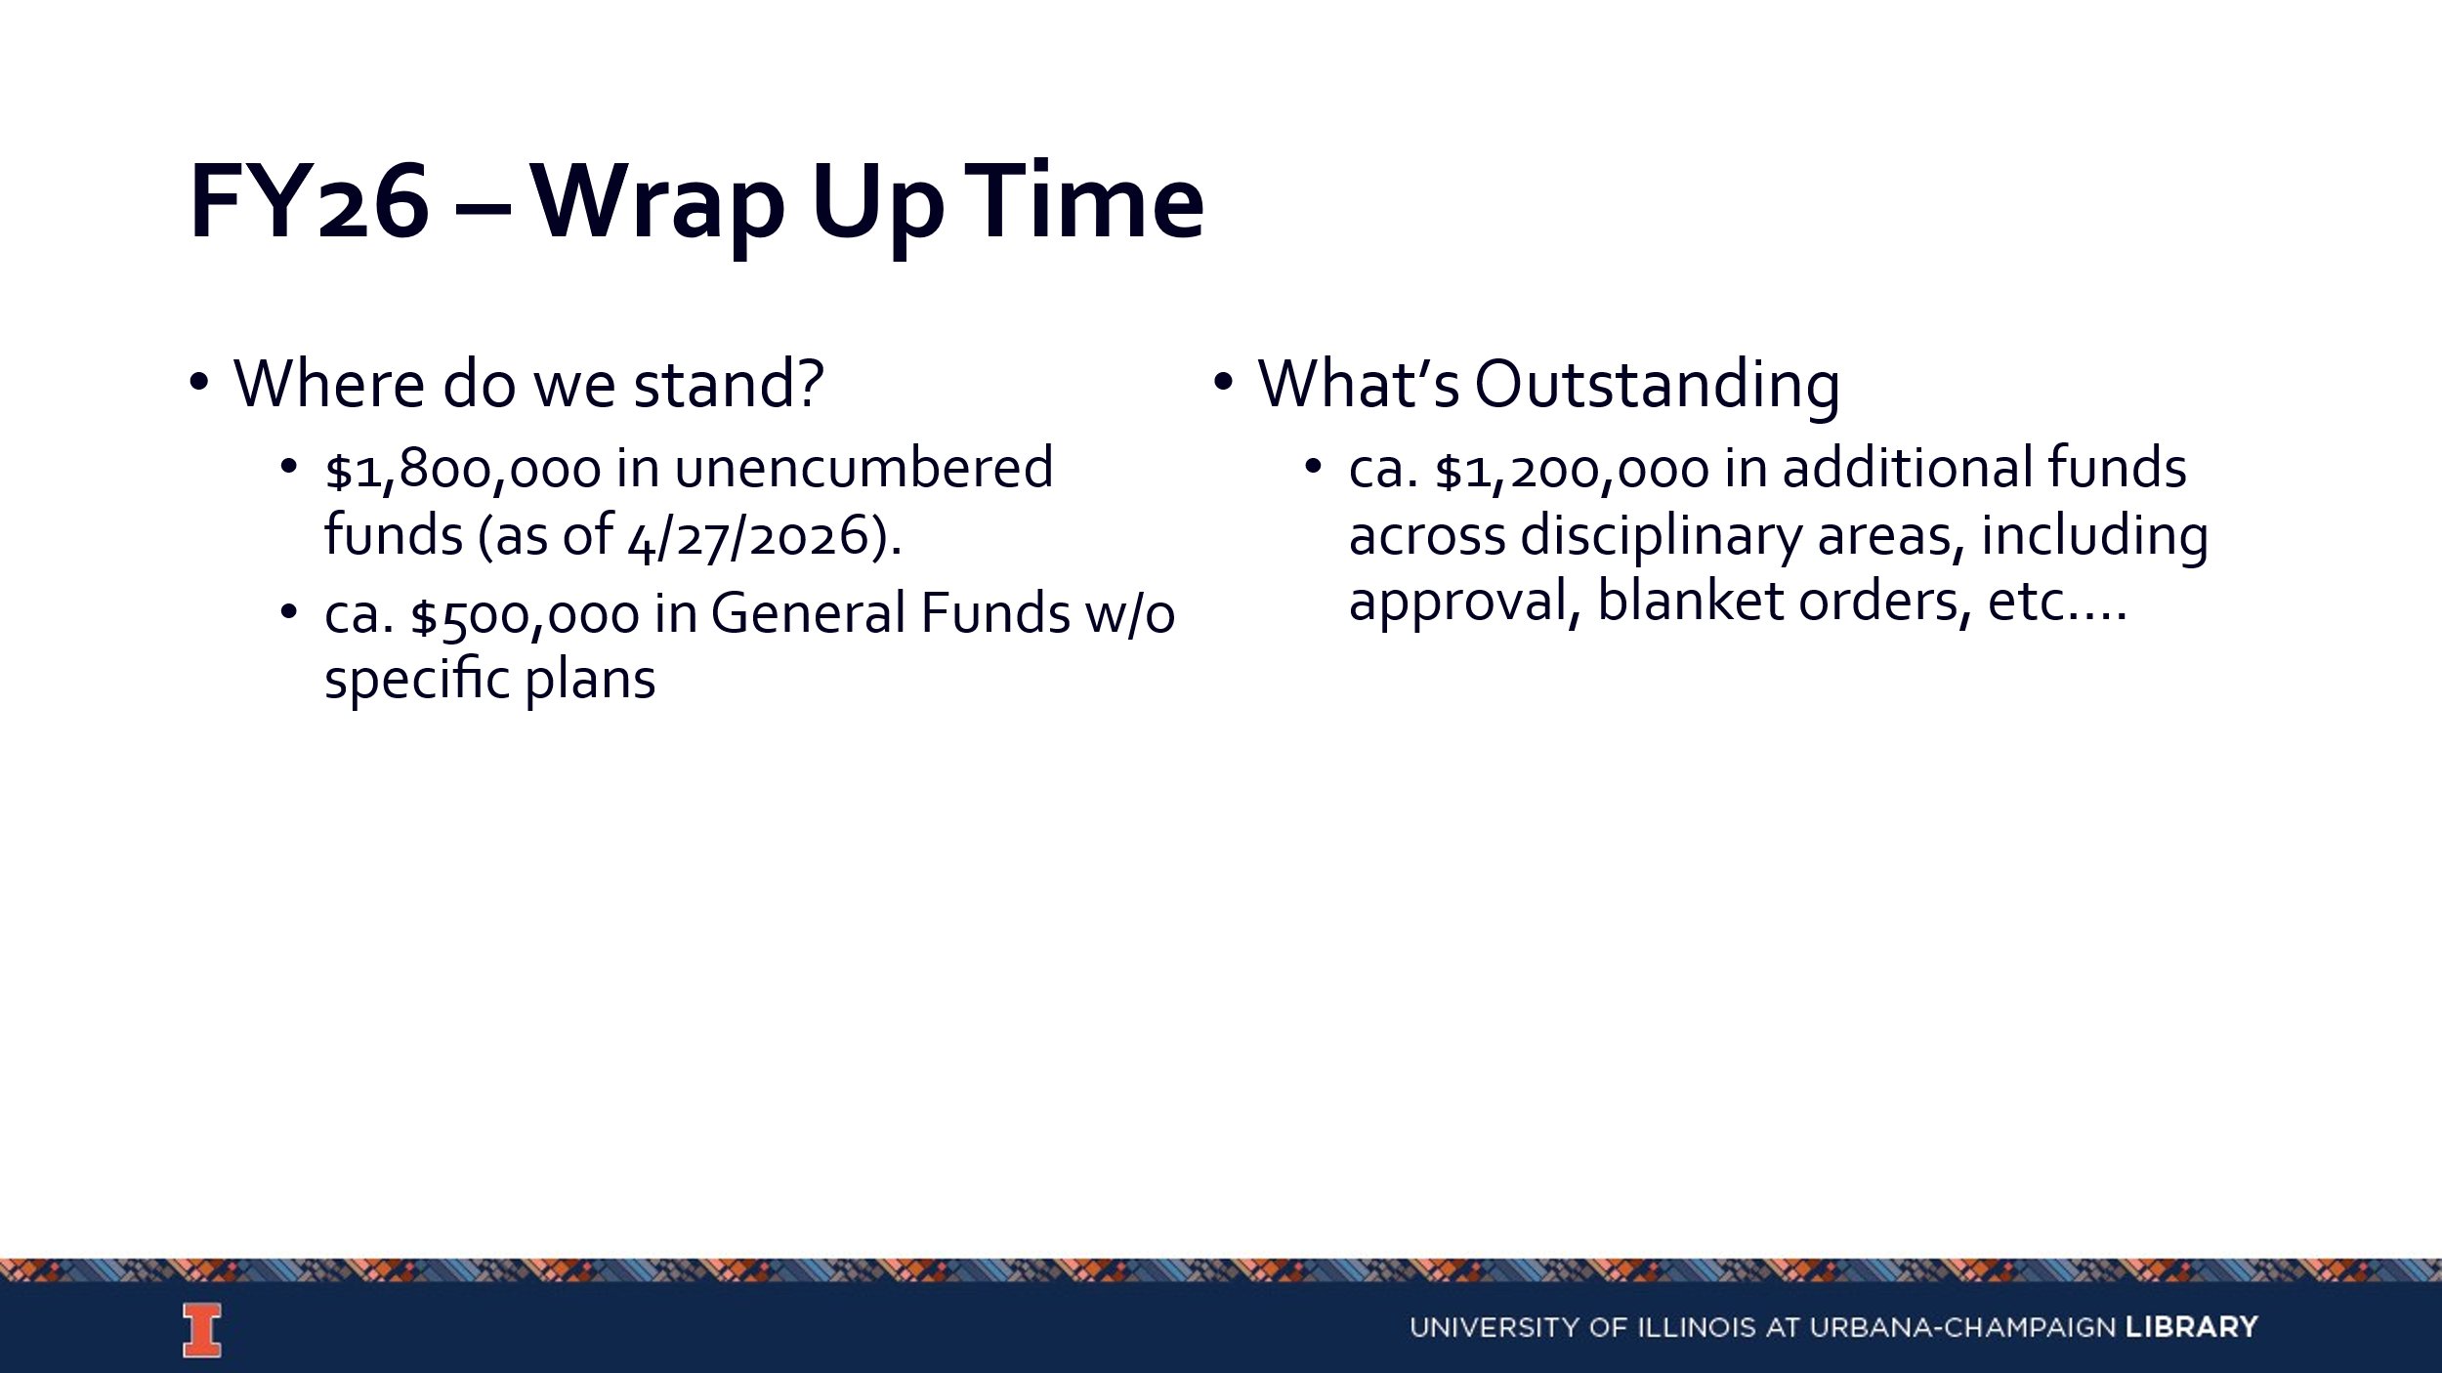

    - Divisions are encouraged to spend early and spend often.
    - Most major invoices have been processed.
    - Any suggestions on how to incentivize divisions to spend early can be provided to Tom.

  - FY26 – Desiderata List
    - https://uofi.box.com/s/44juoqudptvfbjyq90clne9smoy1i6h9
    - Clarivate has moved to a subscription only model, so any resources from ProQuest on the list are no longer an option.
    - Divisions should discuss priorities for the campus to identify items that might be strategically valuable based off the development of programs or other activities on campus.
    - Purchases need to take vendors into account to ensure items will be able to arrive quickly.

  - FY27 – Needs for Coming Year

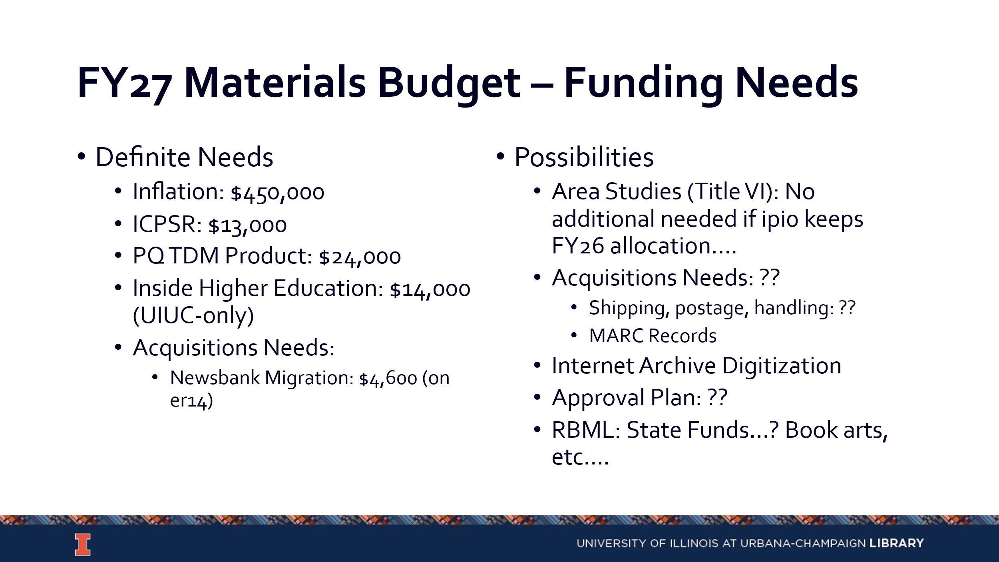

    - We will proceed under the assumption that we will receive $600,000 in campus
    - funding. This will be the second year of their three-year commitment.
    - The Internet Archive digitization effort is semi-unfunded. It has been funded by prepaying money to the Big 10 and using budgeted funds to pay for the Internet Archives. We need to get out of paying ahead in case we end up in a situation where we don’t have the money to pay ahead. This could create a problem in the next fiscal year.
    - Support for Rare Books is also somewhat unfunded. They have been relying on endowments and gifts largely.
    - Money could be set aside for a gap-filling program.
    - Divisions should discuss other potential needs and inform Tom.

- FY26 Collection Development Topics
  - Wiley Contract

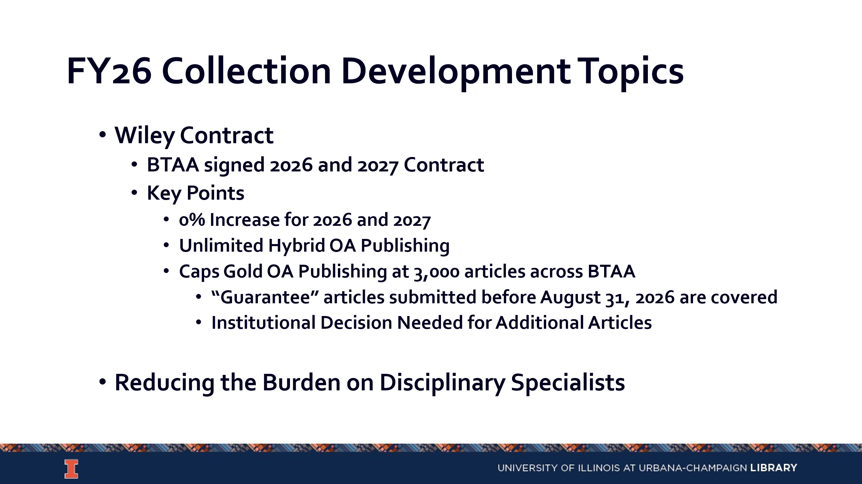
  - There are multiple options for the Wiley contract. The first is for the university to pay for the additional gold OA article charges. Another option is for the university to pay through the contract until they run out, at which time it becomes the faculty member’s responsibility if they wish to publish a gold open access article.
  - The potential cost for this is still being determined. This will be included on some level in the Library’s budget hearing meeting with the provost, taking next week.
  - We have a history with Wiley of having access to gold open access publishing because of the agreement that was spearheaded by the Big 10. As an institution the only gold open access publishing we support in a direct way is this Wiley agreement. Everything else we have is hybrid open access in a traditional journal or a completely separate publishing model. In those cases, the publishing half is being paid by departments and units external to the Library.
  - We will need to decide if we should be paying for the projected gold open access publishing costs through the Big 10 or if we need to regulate the amount of this type of publishing we are willing to support.

  - Reducing the Burden on Disciplinary Specialists
  - We get a lot of blanket orders and pre-approval lists versus firm orders in comparison to other institutions.
  - We need to give specialists more time to work with students and faculty.
  - It is critical that specialists have time to talk to faculty about their needs and new research areas. Autonomy with collections, including lack of an oversight committee, is a strength for our librarians.
  - Some people like to do title by title selection and others don’t. We have a lot of options for approval plans that can be grown or people can be added to. There are also options for plans through Gobi.
  - It would be helpful to create a suite of options for people to use in the way that suits them best. It is important to keep flexibility.

- Updates- No new updates
  - Acquisitions
  - E-Resources
  - Preservation Services
  - BTAA Updates

Meeting adjourned at 2:20 pm.

