CAPT Minutes
April 24, 2025

Present: Tom Teper, Hannah Williams (minutes), Michael Norman, John Laskowski, Angela Waarala, Jennifer Teper, Jenny Maddox Abbott, Kyle Rimkus, Tracy Tolliver, Seth Robbins, Wendy Shelburne, Mary Ton, Mary Laskowski

Agenda and minutes approved.

Accessibility Updates- John Laskowski
- Campus is building a digital accessibility website which will go live in a few weeks. This will be under the office of the Chief Information Officer and will contain information on accessibility training opportunities, resource tools and checklists, and ways to check for accessibility and remediate issues.
- The Library accessibility roadmap was presented to the Library leadership group. Unit heads are considering who will be their point person to represent their department, unit, and individual websites. John is compiling resources for these groups about best practices for alt text and accessibility for course reading materials.
- Working with the web development team to develop spreadsheets based on data exported from WordPress media libraries. Continuing to review our home grown platforms.

Quarterly working group reports

Search, Discovery, and Delivery Working Group Report – Michael Norman – April 24, 2025
- We want to honor Bill Mischo at today’s CAPT meeting. He was an awesome colleague and mentor to many of us over the years and helped the Library improve Search and Discovery (and Delivery) to create better ways for Users to find what they needed for their research. We will miss having Bill as a resource to consult as we continue to work to constantly improve Library Discovery, especially with working to include Generative AI features into our Discovery and Delivery of content, which he was continuing to research.
- On the recommendation of the Dean, the Search, Discovery, and Delivery Working Group have restructured to now have Co-Chairs lead this important team for Library Discovery. Kate Lambaria volunteered to take on this role of Co-Chair, and the Working Group uniformly agreed. This will guarantee equal representation of the technology and public services areas of all Discovery discussions. I will present this recommendation at the CAPT meeting in April for approval. In addition, during our conversation on this, we also realized that the Search, Discovery, and Delivery Working Group charge is woefully out of date and the Co-Chairs will work on revamping this over the summer to update and present back to CAPT for additional discussion. Thank you, Kate, for adding this to your already full plate of work.
- The Working Group has been very busy updating documentation for the changes to the Primo Library Catalog landing pages (see screenshot below for the Primo Library Catalog updated landing page). We also are working on the documentation for Easy Search and the How to Work with the Library Catalog and More Searching Tips for each discovery system. We will roll out the updated documentation after the end of the Spring Semester and into the Summer to be ready for the beginning of the Fall Semester.
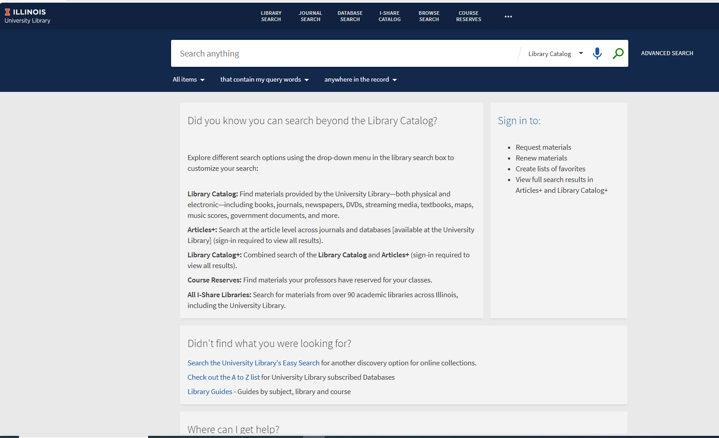
- Accessibility – This is the most important topic we have been discussing the last couple of meetings and how Accessibility compliance will impact the Library’s Discovery systems, especially Primo Library Catalog and Easy Search. We need to have solutions in place for the 2026 deadlines. The Library did receive a Technology Services Accessibility Evaluation of the Primo Library Catalog in February and there are many accessibility issues for the 1) Web version and the 2) Primo mobile version that we will need to address before we can ask campus for a new Accessibility evaluation, or an exception must be filed with the Technology Accessibility Review Committee. Also, after a preliminary review of Ex Libris’s Voluntary Product Template (VPAT) for the Primo Library Catalog, additional concerns were discovered where the vendor currently documents only partial compliance with Accessibility standards. To see the full review, navigate to this document in our Box Folder: https://uofi.box.com/s/64e6odzkr8x2c6tzivpycvllianamb56. We will continue these conversations in the Group and also reach out to the Web Working Group and CAPT to help figure out our best options to get our Library Discovery complaint with the governing standards.
- A new Primo Library Catalog Interface (UI) is coming to the Library and the I-Share consortium in 2026 or 2027. We will need to be ready for this and hopefully do lots of testing and exploration of the new Primo Interface before making it available to Library Users. From the initial announcement from Ex Libris (see the link below), this will be a big enhancement with many changes to the interface and layout of the Catalog. We will need to get into the Library’s plans to determine the best way to make the new Primo available to our Library Users. The initial announcement by Ex Libris does mention that there will be many new UX improvements with the upcoming release that looks more like Google and Bing interface and display of search results. See an initial reveal of the Primo Catalog interface in the screenshot below and more information about the new Primo UI here at this url: https://knowledge.exlibrisgroup.com/Primo/Product_Materials/001_Next_Discovery_Experience_(NDE)/Next_Discovery_Experience_User_Interface
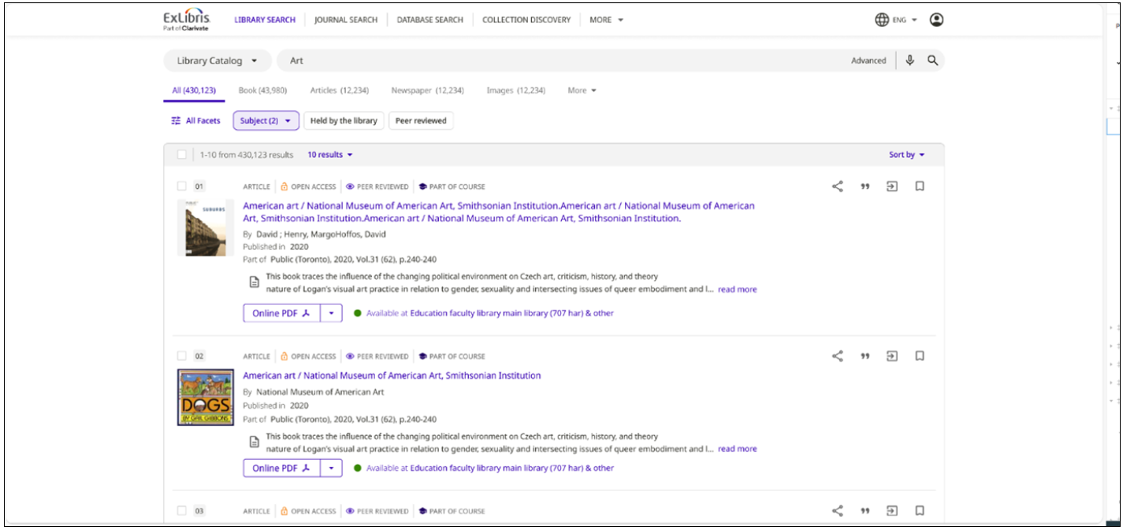
- Reminder: The Library’s is cancelling our license for the EBSCO EDS API service this Summer 2025. We won’t lose access to the EBSCO databases (EBSCOHost) but only the additional API and EBSCO Discovery Services. We have been working with TLAS and others to implement an alternative to swap out EDS with Primo Central Discovery Index (CDI) results for Undergraduate Easy Search, MPAL Easy Search, and Classic Easy Search versions. To see the devtest version of Easy Search without the EDS bento section, you can view at:
https://libeasysch19dev.library.illinois.edu/discovery/splitsearch.asp?searcharg=Shakespeare+Beethoven&typeofsearch=keyword&OPERATE=GO&selection=devtest

- Promotion and advertisement of the changes to the Primo Library Catalog and Easy Search. We are working with Heather Murphy and Marisa Modugno to determine the best ways to promote and advertise to campus and Library Users news about updates and current changes to Easy Search and the Primo Library Catalog and inform about future changes coming up next year in 2026. If anyone has some good ideas about ways to advertise these updates to Library Users, please let the Working Group know.
- We will continue to have many information sessions during the Summer 2025 to showcase the new search options in the Primo Catalog and demonstrate all the changes and configurations that have integrated the Primo Central Discovery Index (and the billion items index of most of the Library’s online resources) into one’s search strategies. Watch LIBNEWS for these announcements in the next few weeks.
- Plans for Discovery and Easy Search in 2026/2027: With Accessibility compliance coming next year and a new Primo interface on the near horizon, the Working Group has started discussions on future Discovery options going forward into the summer of 2026 and then subsequently into 2027. We will have more information and possible plans for Library Administration and CAPT about viable possibilities for the Library later this Summer 2025.
- Usage of Easy Search and the Primo Library Catalog since January 24, 2025: Here are usage stats from Easy Search and the Primo Library Catalog from January 24, 2025, when we went live with the integration of the Primo Central Discovery Index into both systems:
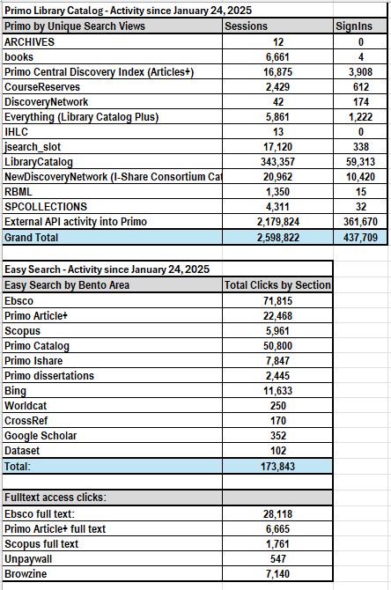

Web- John Laskowski

- Looking at new structure for full website. The menus haven’t been altered since 2019 and doesn’t reflect what all we do now. With the changes in federal funding we need to ensure that statements, missions, priorities, and priorities administration for the Library are easy to find.
- Proposed changes: expanding libraries and hours section to add units that don’t have public hours into the directory structure; tightening up services and spaces sections to match what we currently offer; adding new landing pages for administrative organization, missions and strategies, and policies and statements.
- The committee is discussing and will potentially do a prototype to collect internal feedback.

- Parking lot items-review

- Any other new business

Reports by Month
January-Search, Discovery, and Delivery, Web
February-Digital Production, Repositories, Preservation, and Access, LEITC
March-Cataloging and Metadata, Electronic Resources
April-Search, Discovery, and Delivery, Web
May- Digital Production, Repositories, Preservation, and Access, LEITC
June- Cataloging and Metadata, Electronic Resources
July- Search, Discovery, and Delivery, Web
August- Digital Production, Repositories, Preservation, and Access, LEITC
September- Cataloging and Metadata, Electronic Resources
October- Search, Discovery, and Delivery, Web
November- Digital Production, Repositories, Preservation, and Access, LEITC
December- Cataloging and Metadata, Electronic Resources

Meeting adjourned at 2:30pm.

