Collection Development Committee
October 25th, 2022

Present: Tom Teper, Cindy Ingold, Sarah Williams, Amy Fry, Carissa Phillips, Mary Schlembach, George Gottschalk, Wendy Shelburne, Mike Dickinson, Kit Condill, Jennifer Teper, Esra Coskun

Notetaker: Hannah Williams

Agenda/Minutes
Tom opened the meeting asking for additions or changes to the agenda, and approval of last month’s meeting minutes. Agenda and minutes unanimously approved.

Agenda approval for October- Minutes from September

FY24 Budget Discussion
- We are anticipating price increases of 580-600k for FY24.
- We have approx. 268k in inflation funding identified.
- At the Sept meeting it was agreed to model a 1.9% reduction at divisional level.
  - There is a spreadsheet located in the G drive along with use data from last year.
  - We will continue to look at central funding and other options.
- Evidence based and Patron driven acquisitions were zeroed out last year to cover price increases.
- We aim to have final decisions made by April and hope to have a budget allocation by then.
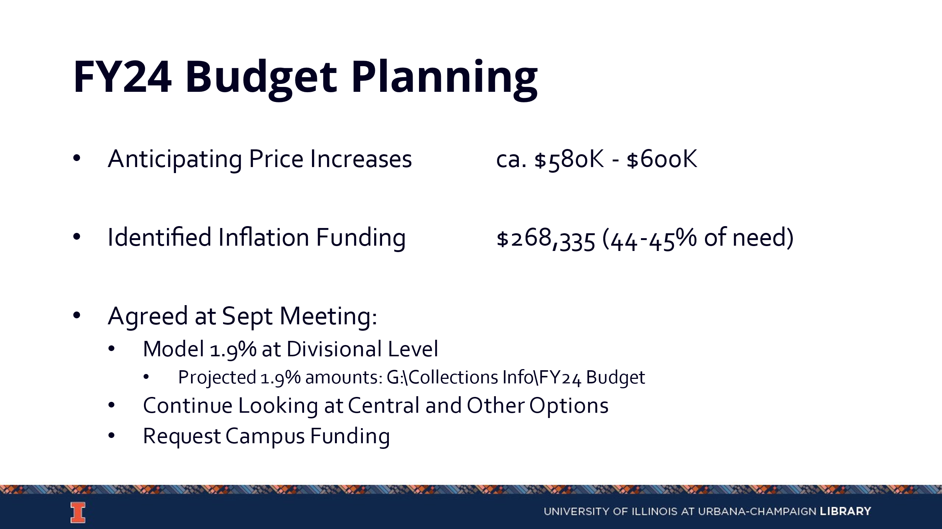

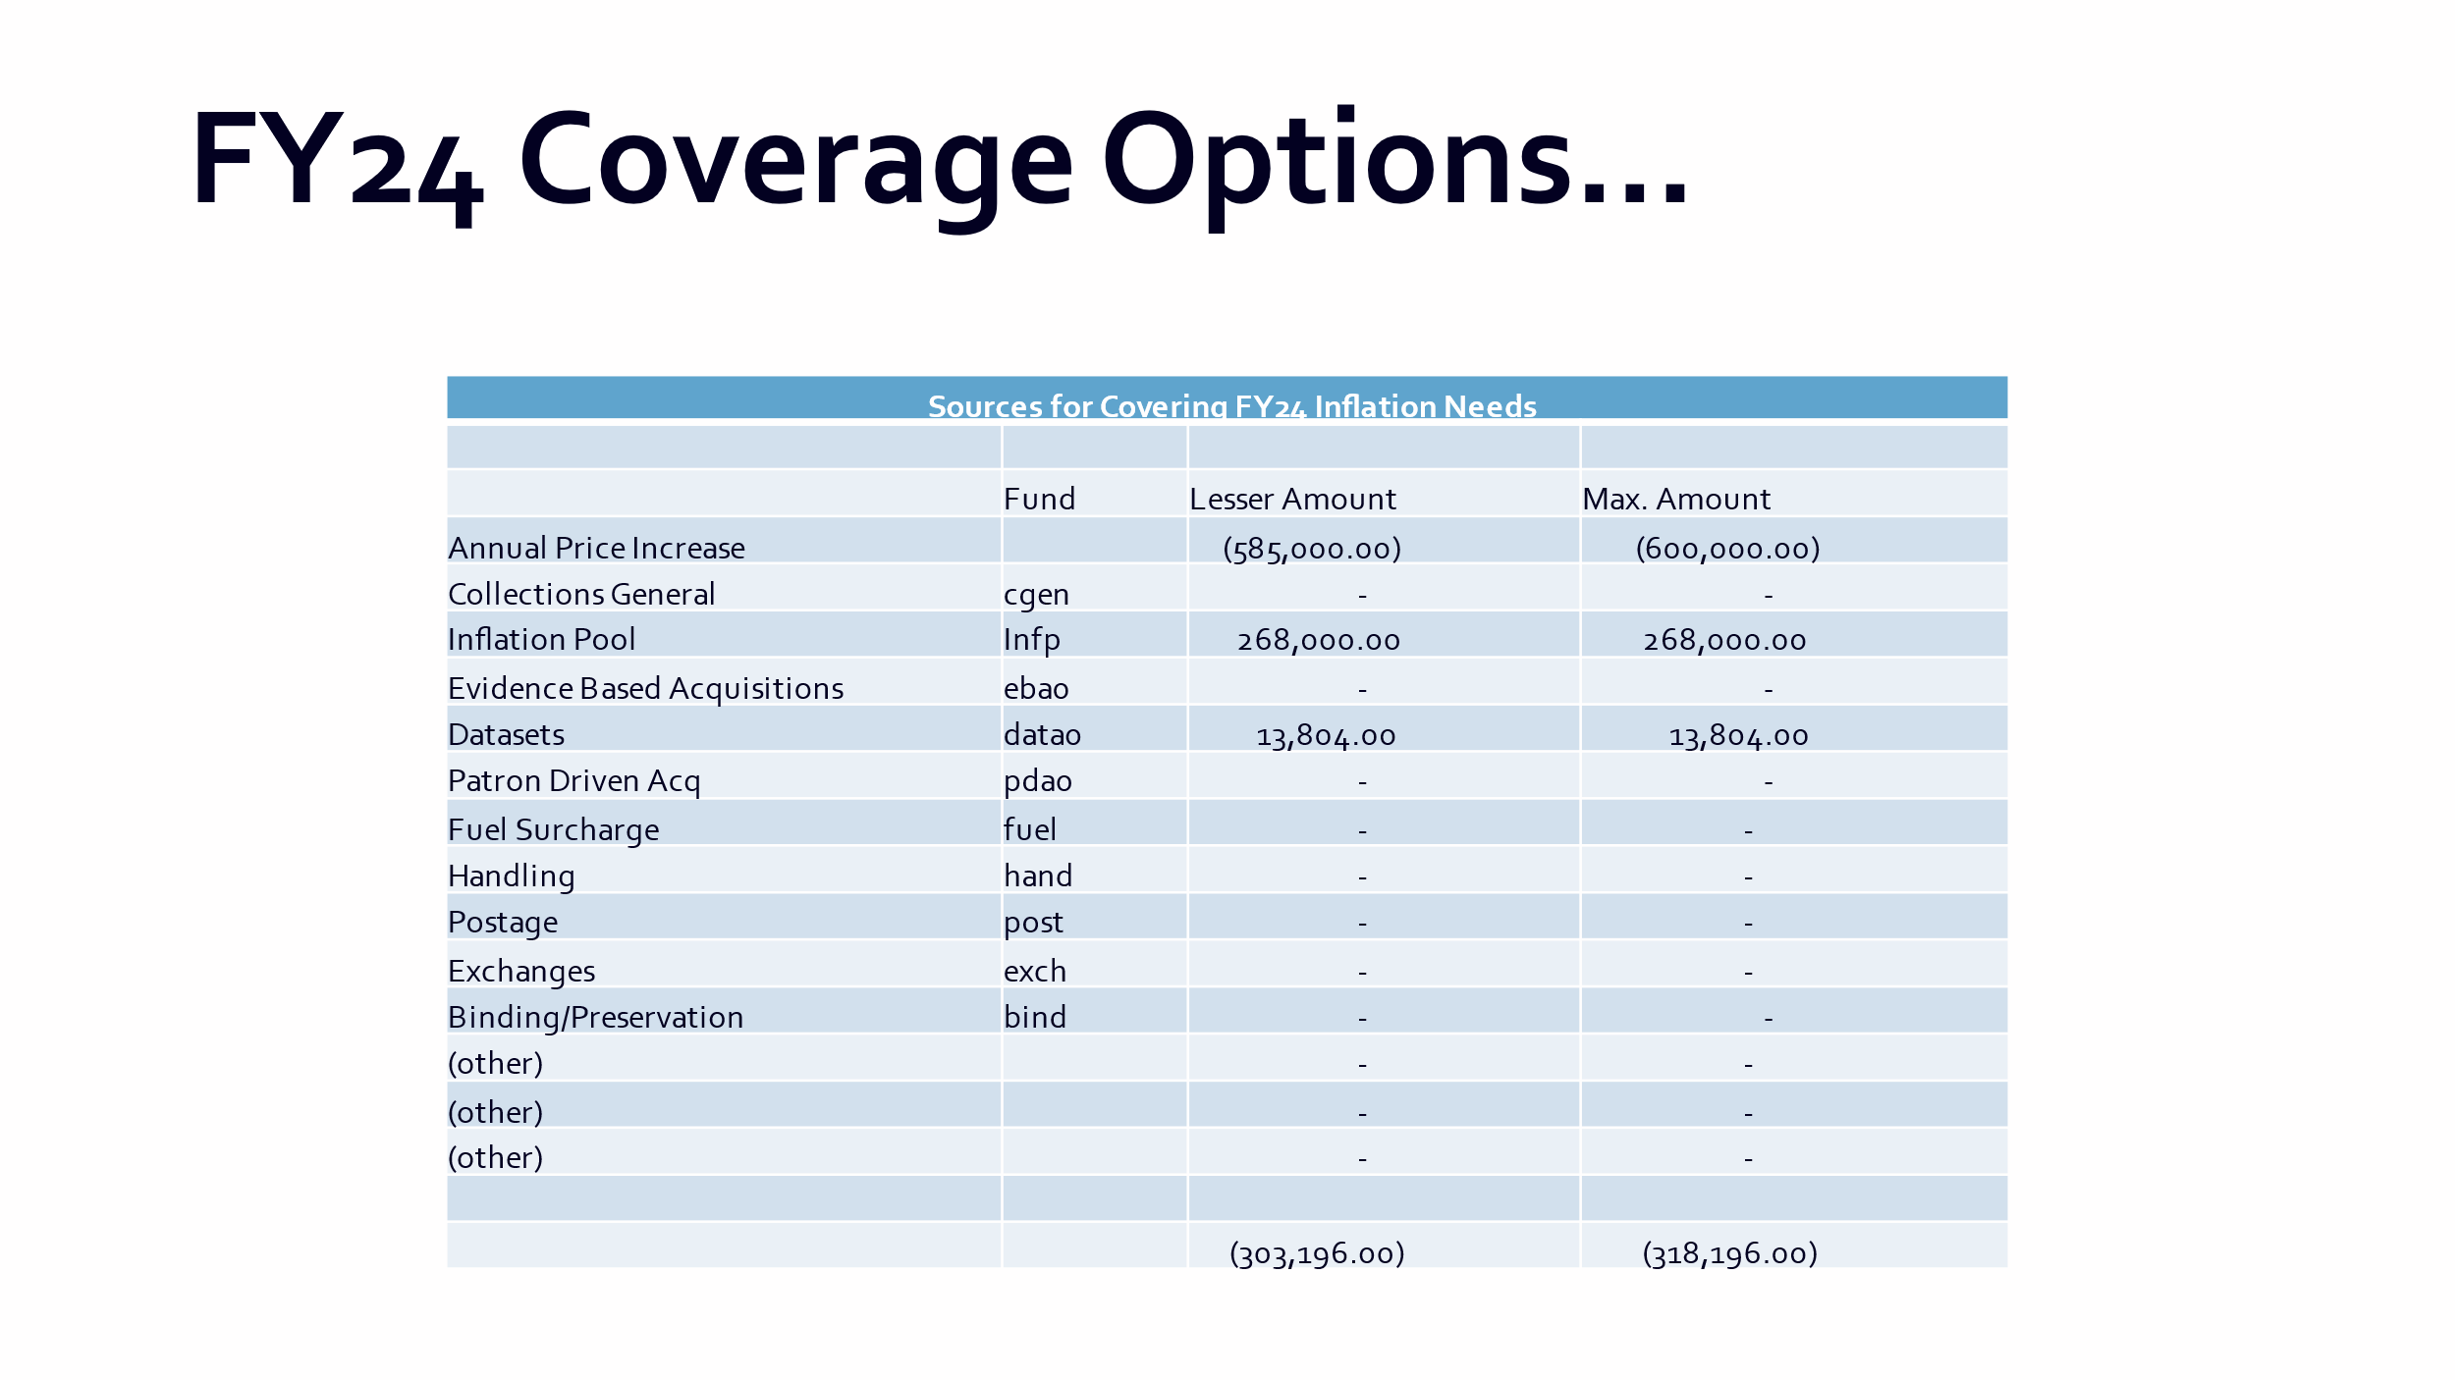

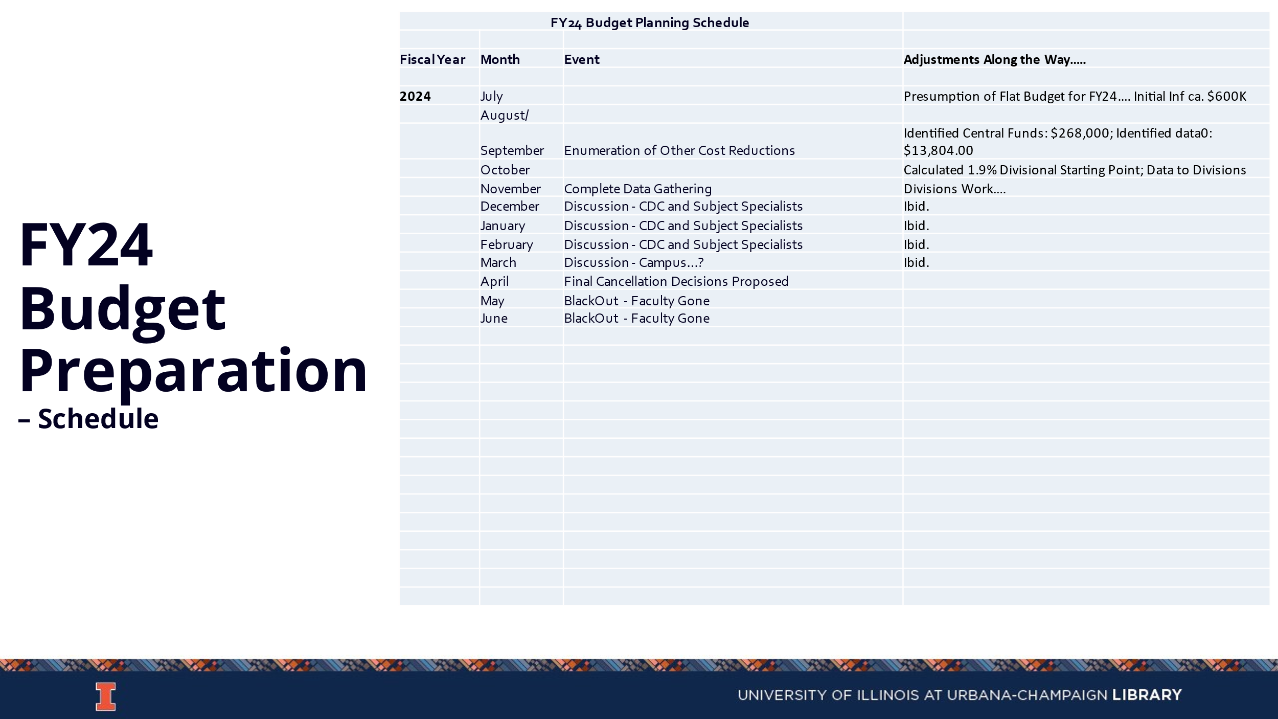

Discussion Topics

DEI Collecting Program Update (Tom)
  - Tom is seeking input on the end of year money and proposal program.
  - $150,000 of end of year money was spent on a program to collect books related to DEIA. The data that Amy Lana and George compiled was enhanced by Esra and Stephanie.
  - Utilizing various filters has the titles reduced to 2,215 with a cost of about $134,000.
  - Tom wants feedback on the categories as well, as well as certain subject areas or publishers that should be included or excluded.
  - The second component to this is a proposal program, where individuals can submit requests for funding. This would be a two-page application to submit for funding in amounts of $2,500 and $5,000
    - Individuals would identify the gap they are proposing to fill, how it was identified, any attempts made to address it, and if there are any special cataloging needs.
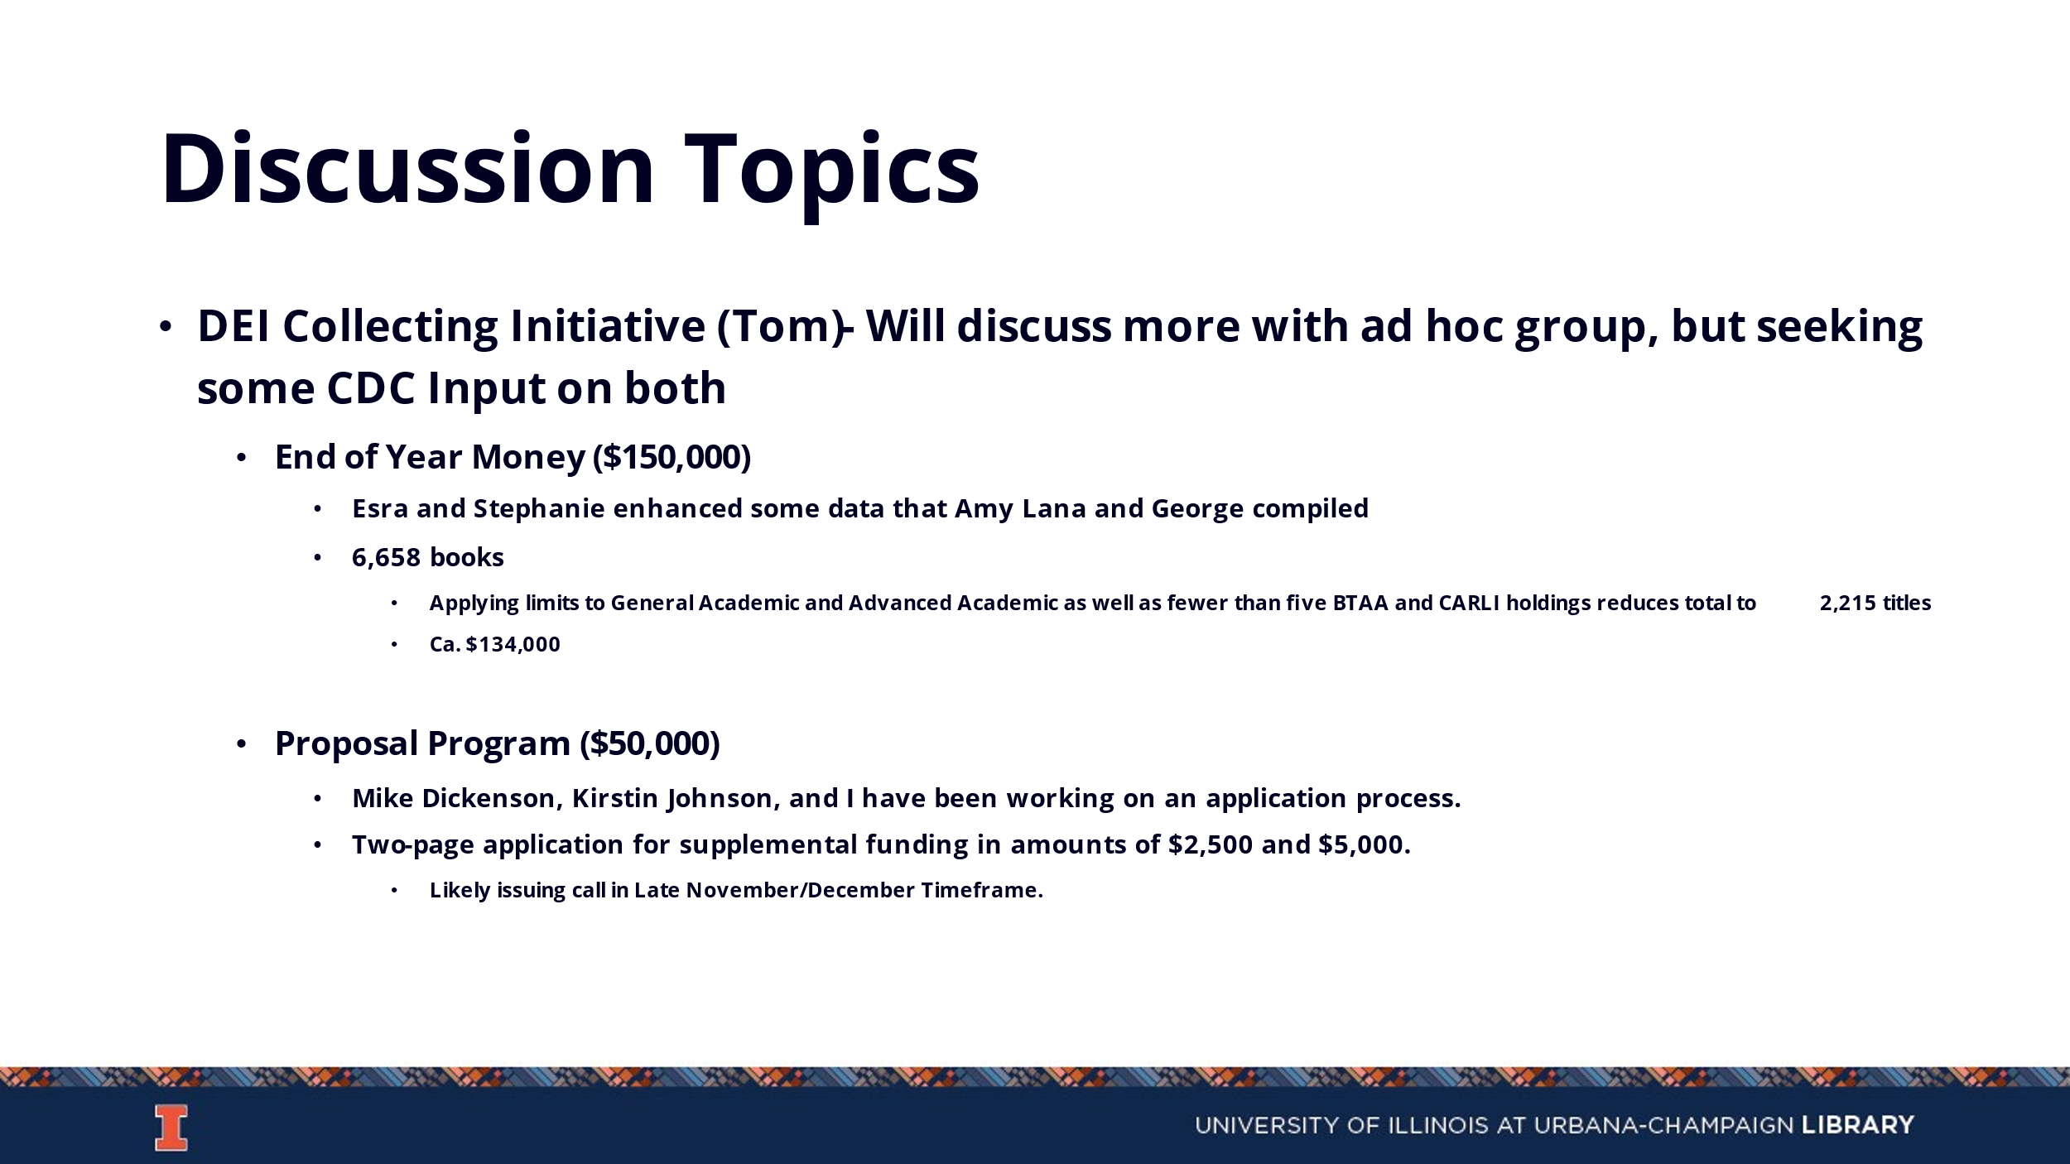

BTAA Offers
- Cambridge has submitted a proposal to the Big 10 for their front list titles, with some tiered pricing. The front list purchase would be for 2023-2025 at $83,000 a year. It excludes textbooks, multi-volume reference works, the Cambridge Histories online, Cambridge Companions online, and University Publishing online.
- There would be no central funding available to support this, so it would need to be supported from disciplinary funds.
- We are going to try to get some title lists from Cambridge for the last few years to get an idea of what would be included and which disciplinary areas.
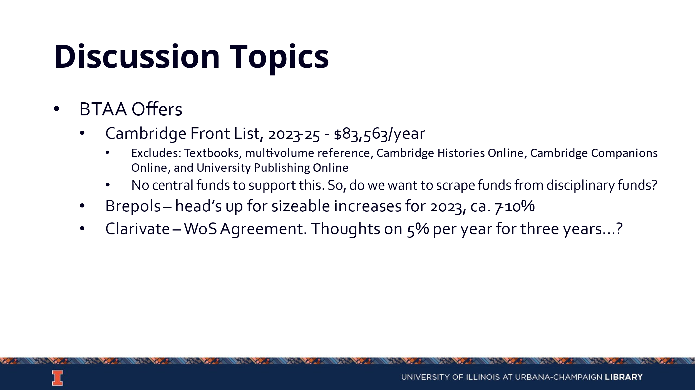

Updates
- Acquisitions
  - No new updates.
- E-Resources
  - No new updates.
- Preservation Services
  - The Indiana plant has lifted the limitations on the number of pieces we can send for binding per month. There was a mid-year price increase that is a 30% increase on monographs and 50% increase on custom serials. With the price increases, we might hit a financial ceiling before the fiscal year is up.
- Other Updates

