Collection Development Committee
September 27th, 2022

Present: Tom Teper, Kit Condill, Mike Dickinson, Cindy Ingold, George Gottschalk, Carissa Phillips, Esra Coskun, Wendy Shelburne, Bill Mischo, Amy Fry, Sarah Williams, Jenny Johnson,

Absent: Celestina Savonius-Wroth, Jennifer Teper, Becky Smith, Cherie Weible, Mary Schlembach

Notetaker: Hannah Williams

Agenda/Minutes
Tom opened the meeting asking for additions or changes to the agenda, and approval of last month’s meeting minutes. Agenda and minutes unanimously approved.

Membership
- There will be some upcoming changes to membership. Kyle is currently on sabbatical, and Cindy will be going on sabbatical in November. Lisa will be taking over for Cindy. Mary will be taking over for Bill. Mike will be continuing in the committee.

FY24 Budget Discussion
- Last year the allocation from campus was enough to cover half of the price increases with the remainder put aside into an inflation pool for FY24.
- Some of the money from campus for FY24 is intended to be used for purchases that enhance student success. This means for FY24 we can ask for additional funding to cover price increases, but there is no guarantee that we will receive it. We do need to prepare for the possibility to not receive any additional funding.
- We need to begin thinking ahead and preparing. Options include:
  - Flat reductions for remainder
  - Evidence based
  - End of year spending
  - Reductions of one-time spending
  - Combination of above
- It was noted there is a lot of data available from last year when divisions were preparing for possible cuts, which is a good starting point.
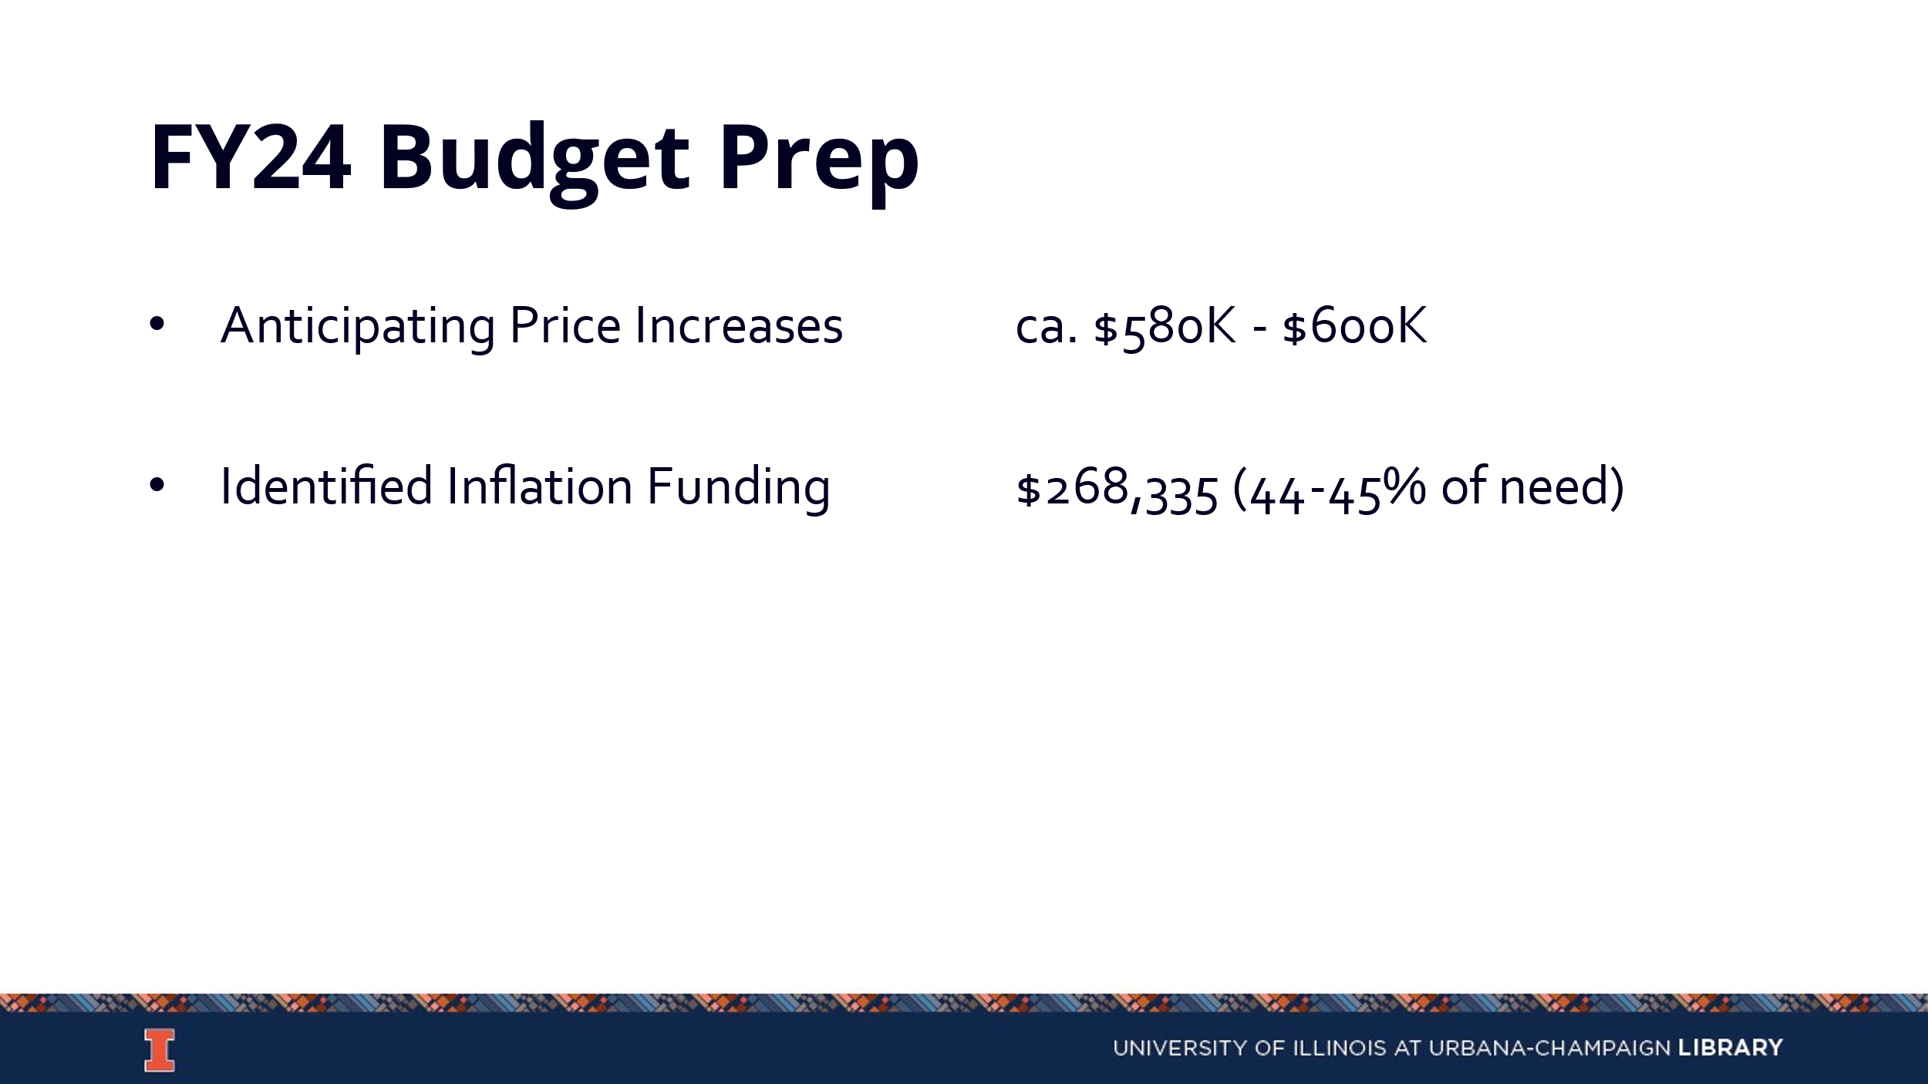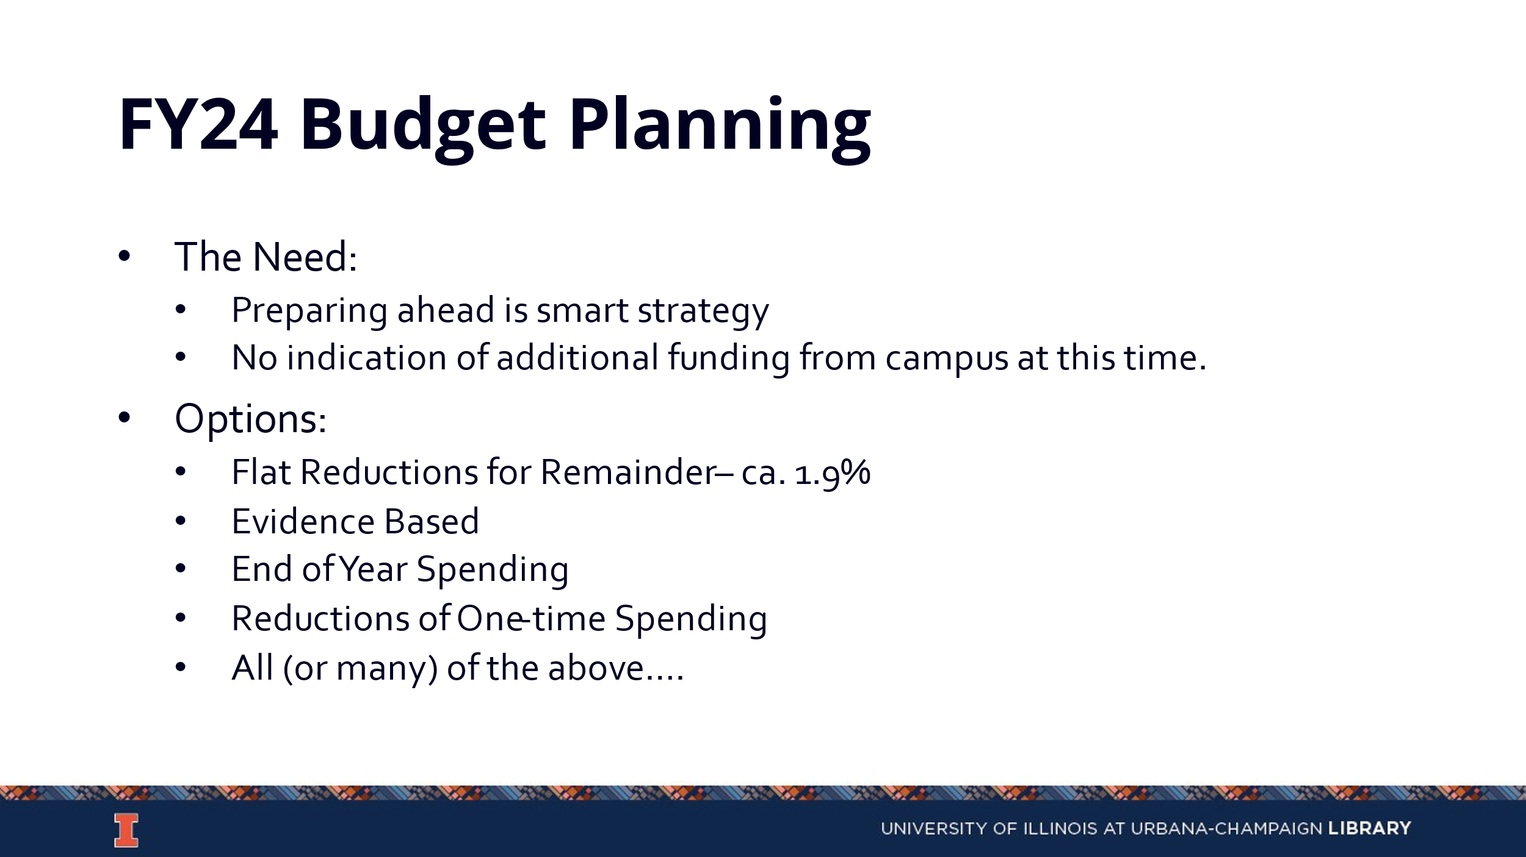
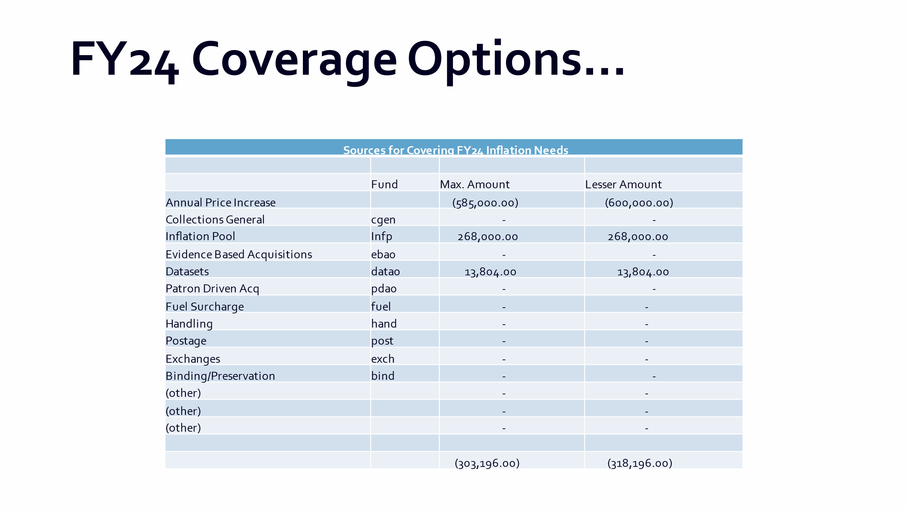

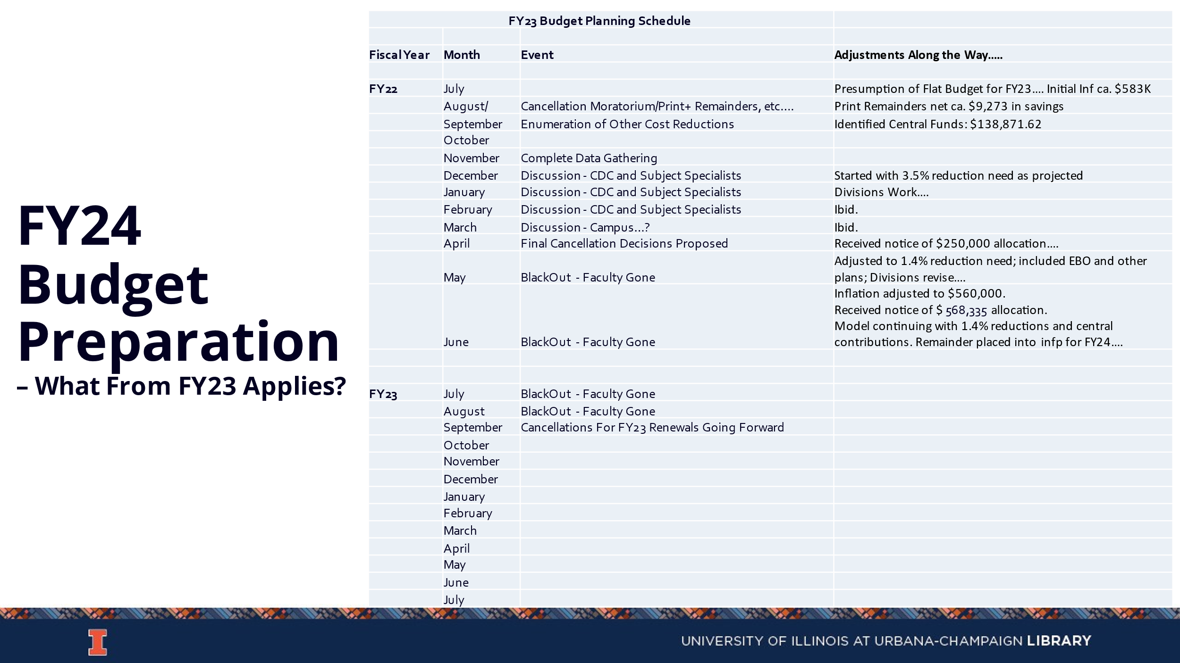

Discussion Topics

DEI Collecting Program Update (Tom)
- Some end of year money last year was put towards Gobi. George has been working with Amy Lana to get a report of DEIA related titles that are not held in any Big 10 or Carli institutions.
- Once a list of titles has been created, it will be brought to CDC for discussion.
- Subject specialists are also able to submit requests for money to fill gaps in the collection.

Approval Profiling – Adding Publishers from former PDA Subaccount (George)
  - Gobi approval subaccounts were consolidated by George’s predecessor. There is a list of 77 presses on the PDA subaccount. These publishers are on a profile that is intended to populate the catalog with records but the funds for that have been zeroed out as part of the cost savings recovery effort. This means these are not showing up in slips. Should these presses be handpicked, or should they be added back to the slips plan?
  - Those present did not seem to have strong opinions. They will default to putting them back into slips.
  - George will be posting the list in Box.

Data Purchase Program (Tom & Carissa)
  - Carissa and Michelle have been discussing how to manage the data purchase program going forward. It was suggested to manage these the same way as other collection purchase requests, through the suggest a purchase form. Tom would then send the data request to the relevant subject specialists.
  - It was suggested to have documents for selectors to consult as they are determining whether a purchase of a data set is feasible.
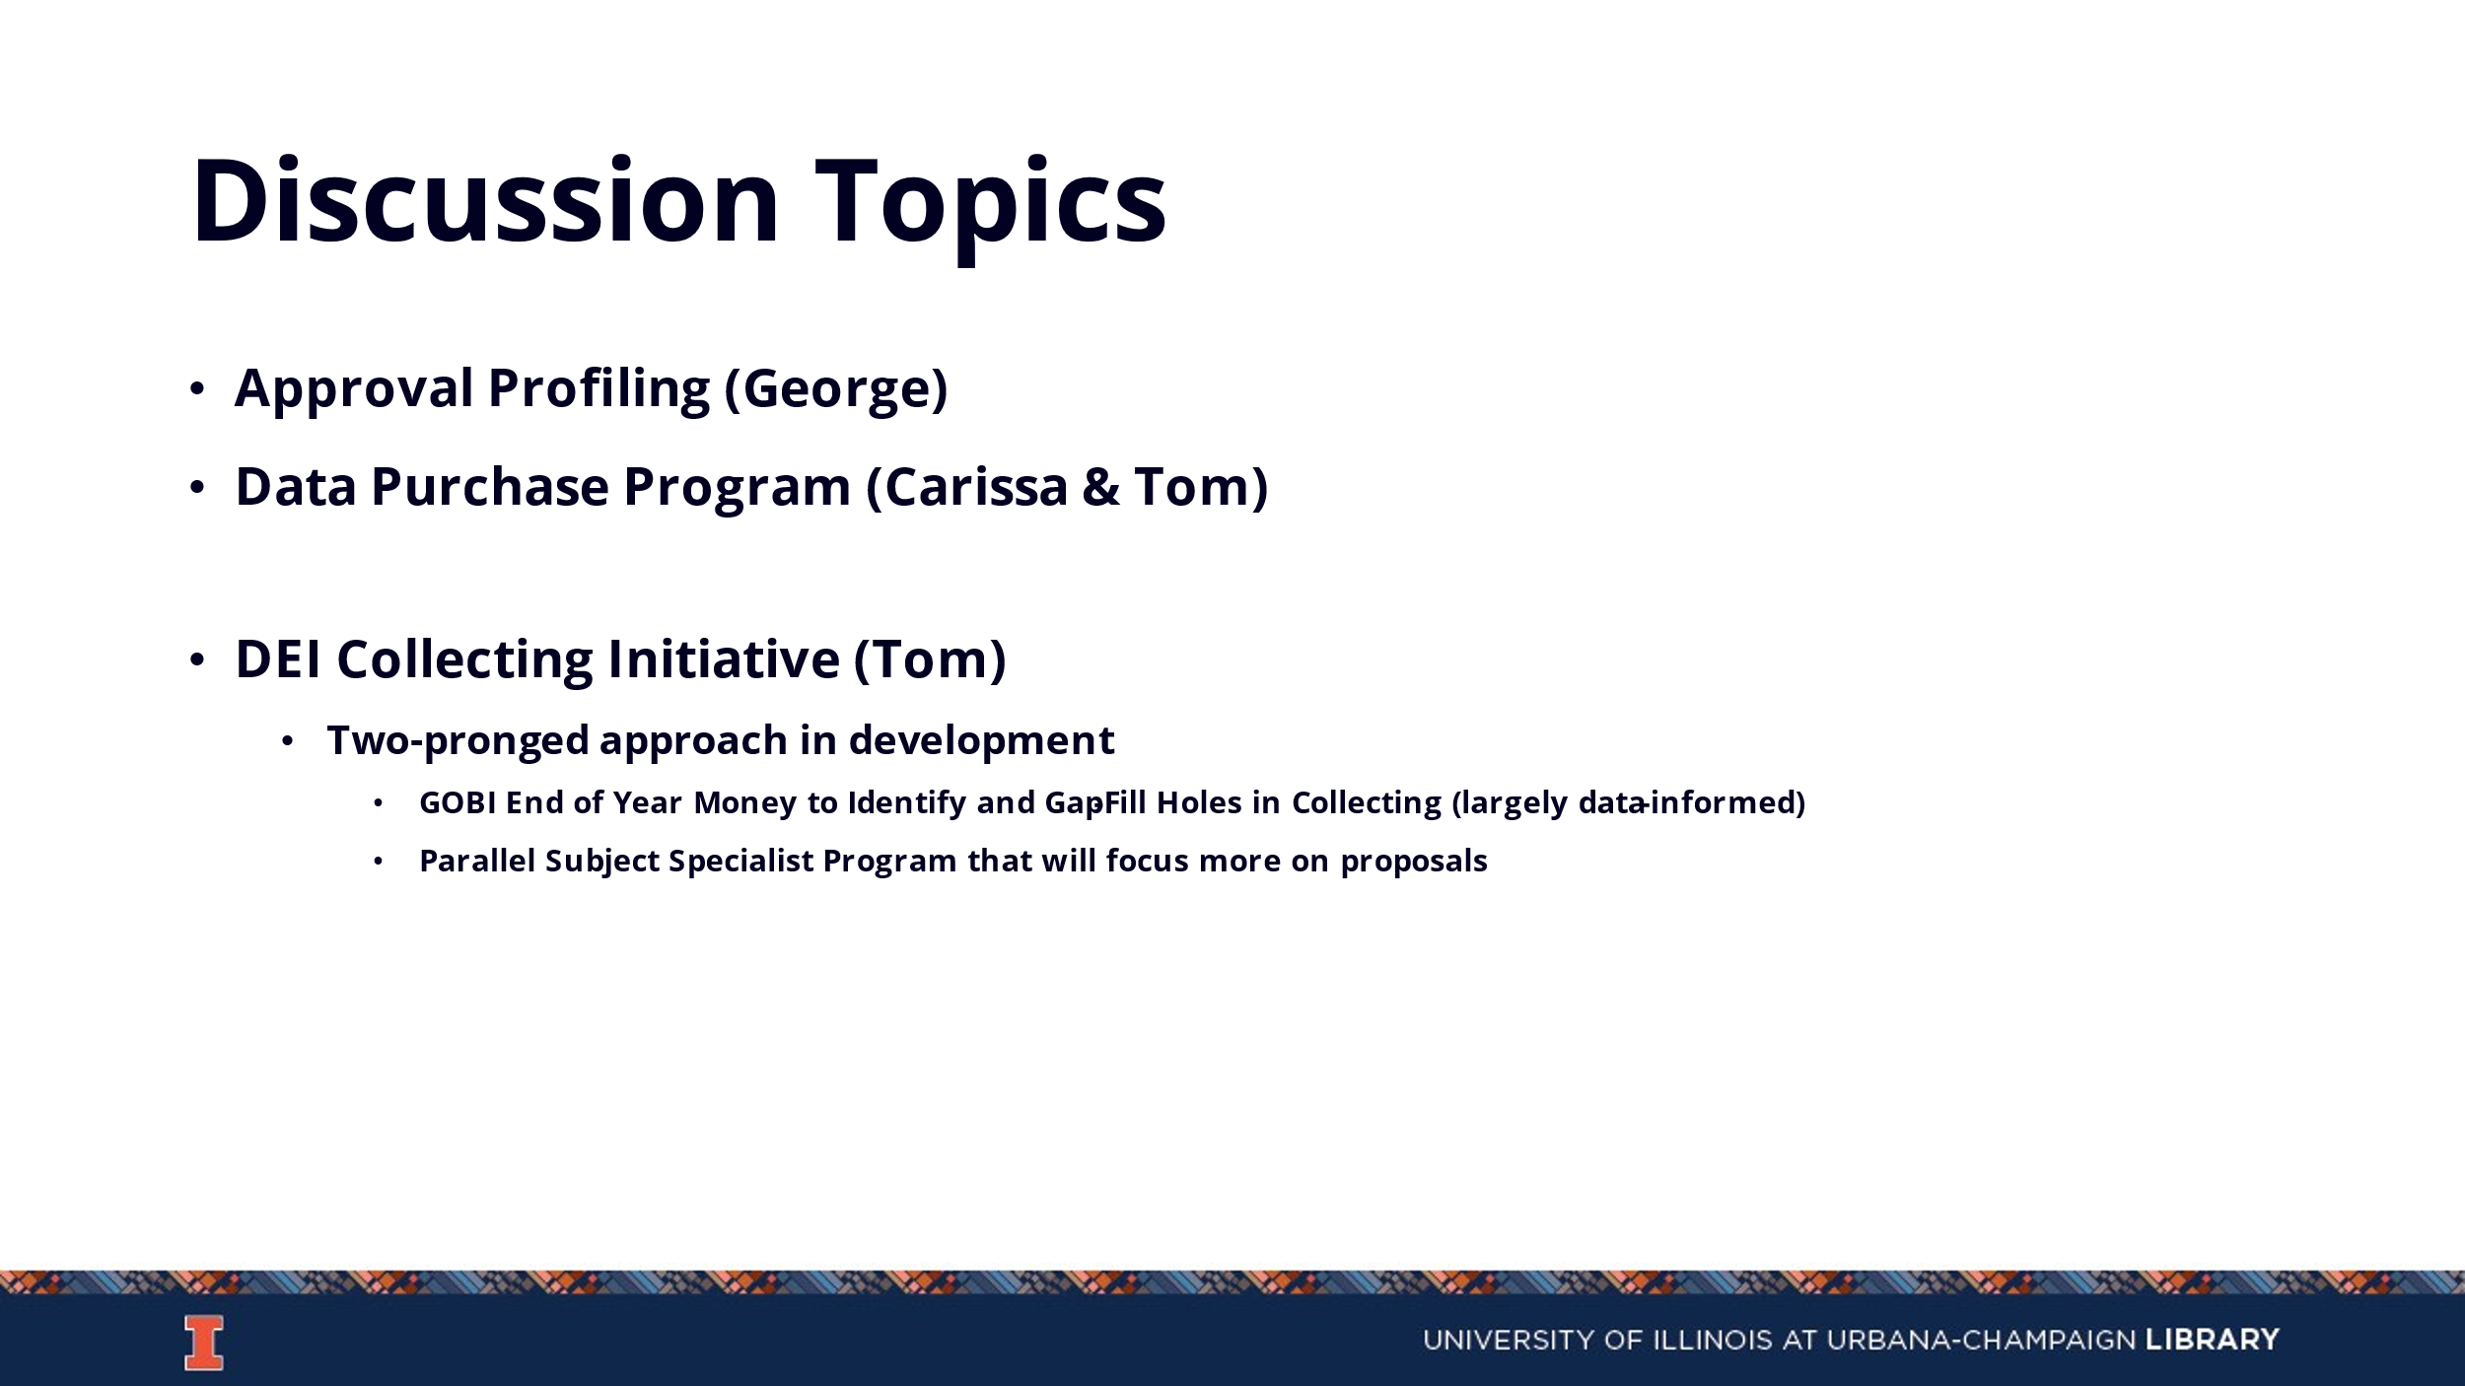

Updates
- E-Resources
  - No new updates.
- Preservation Services
  - No new updates.
- Other Updates

