Collection Development Committee
June 28, 2022

Present: Tom Teper, Carissa Phillips, George Gottschalk, Esra Coskun, Kyle Rimkus, Jenny Johnson, Celestina Savonius-Wroth, Mike Dickinson, Cindy Ingold, Sarah Williams, Wendy Shelburne, Jennifer Teper, Alex Cabada

Notetaker: Hannah Williams

Agenda/Minutes
Tom opened the meeting asking for additions or changes to the agenda, and approval of last month’s meeting minutes. Agenda and minutes unanimously approved.

FY22 Fiscal Year Close
- This year was started with a flat budget. Price increases were projected at $582,000 and were centrally funded.

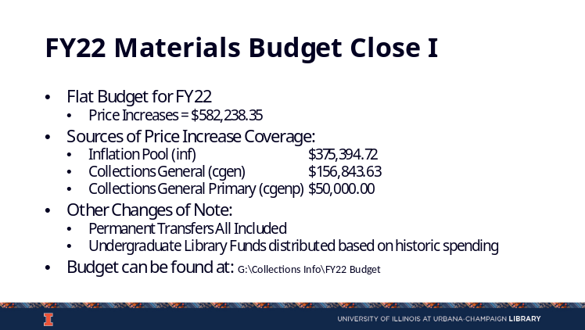

- As is our common practice, remaining funds for FY22 are being combined into a central, end of the year closing fund.
- A member present asked what the BTAA annual bill covers. Tom notes that, in part, it covers our involvement in the Cooperative Investment Program, where the money is leveraged to negotiate for purchases on behalf of member institutions. This also covers resources, scholarly communications related products, and open publishing initiatives. The $250,000 amount is a flat allocation for institutions at this point. He also noted that there was a summary of expenses for the last year sent out from the BTAA. He indicated that he would append that to the minutes (see Appendix A).
- At the time of the meeting, Tom included a list of prospective end-of-year purchases and noted which were on the desiderata list.

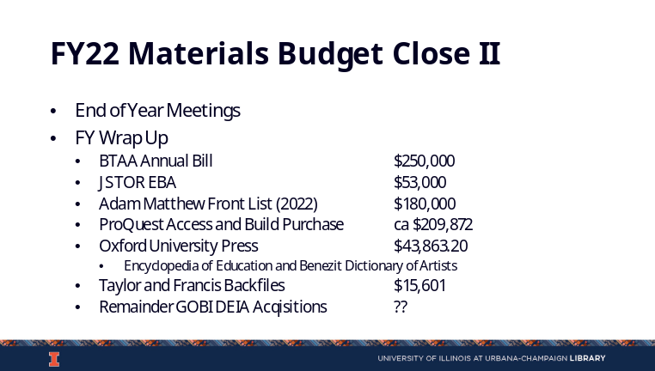

FY22 Desiderata List
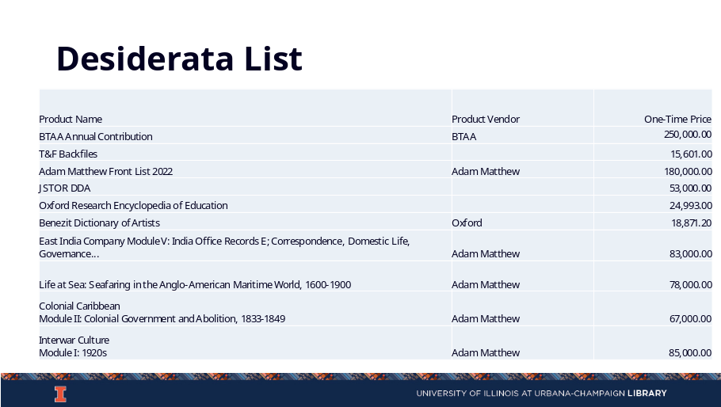

ProQuest Access and Build Wrap Up
- Tom and Heather are working on a communication for the Library explaining the end of the ProQuest trial. Tom encouraged everyone to communicate information to their divisions to give faculty time to acquire resources before the trial ends.
- In the discussion, Tom also provided a list of resources that were being acquired with the Access and Build credit as well as any supplemental funding from endowments or end-of-year funding.

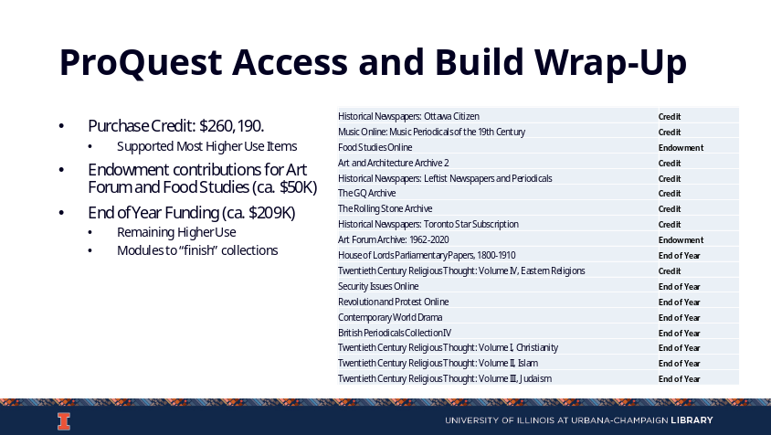

FY23 Budget Discussion
- Campus has allocated about $558,335,000 for the Library budget. After discussions with Dean Wilkin, we will move forward with the 1.4% reduction model. Any remaining funds from the campus allocation will be moved into an inflation pool in order to help us start discussions for FY24. This will be helpful as we move into the next year with a new Dean and new Provost.
- Cancellations are at the discretion of subject specialists. Tom encourages working with faculty and related programs to communicate any decision making. Amy and George will be sending out cancellation confirmations in July.
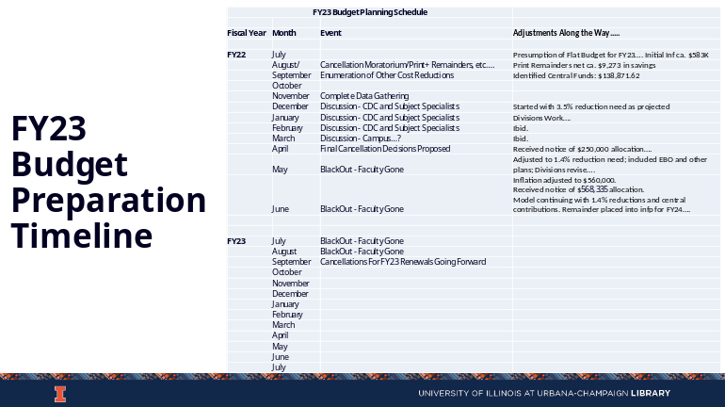

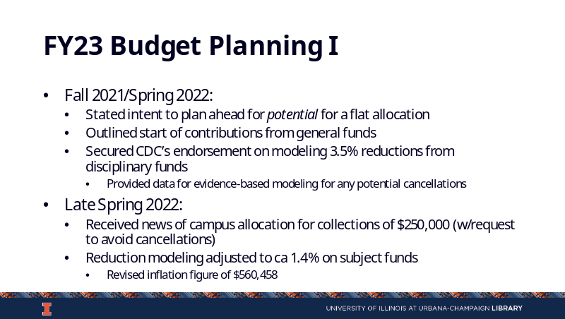

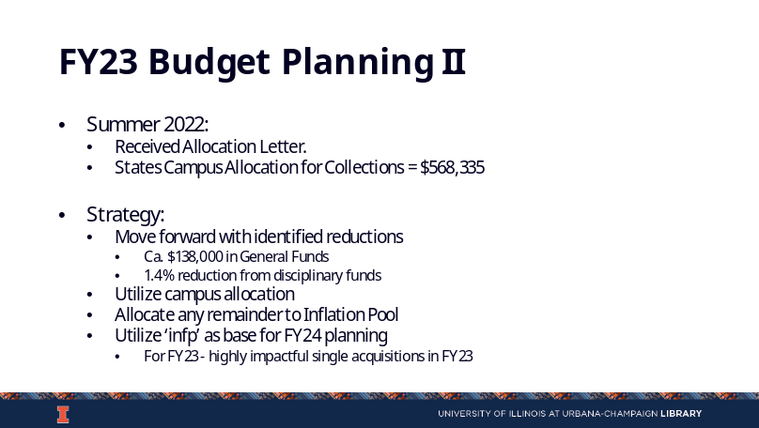

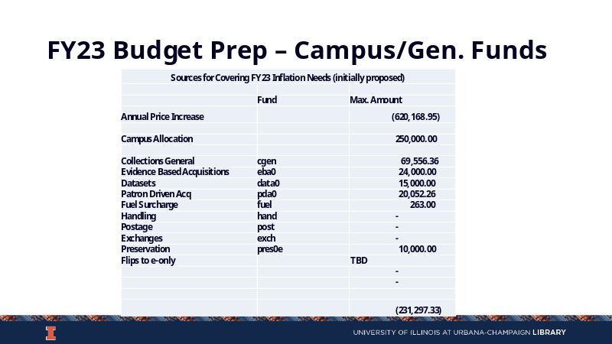

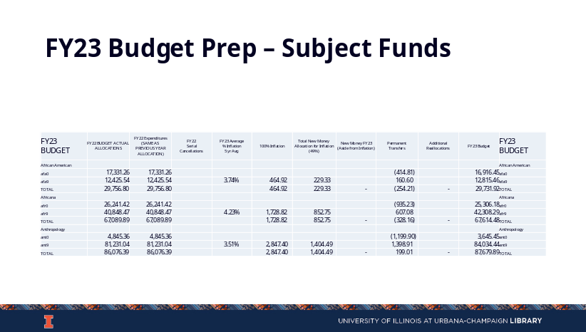

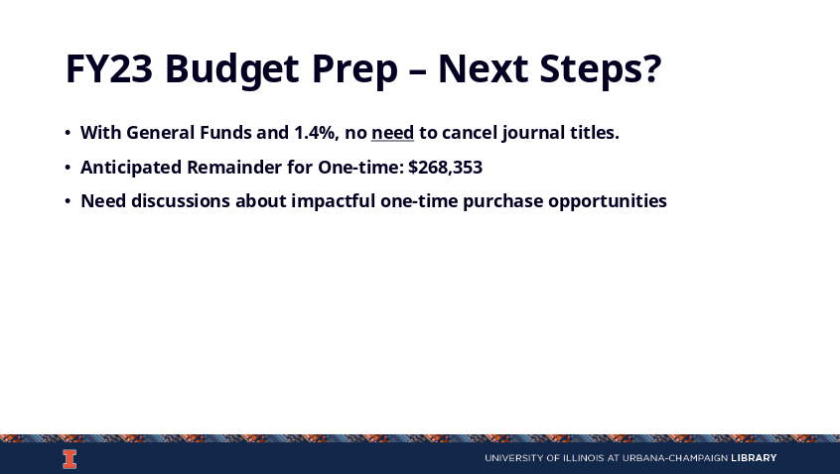

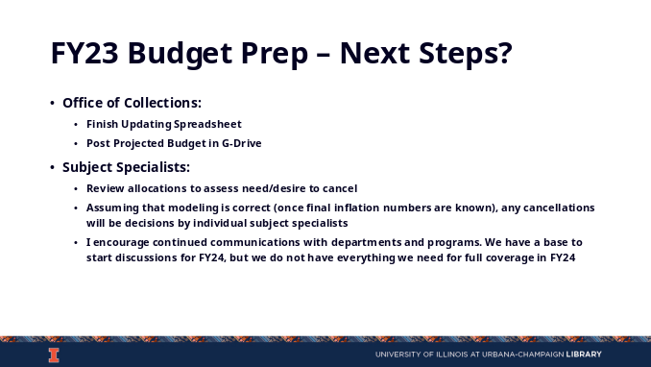

Discussion Topics
- Tom and Sarah will be starting on the Nature Publishing Group title additions and statement for August.
- The DEI Collecting Initiative has had several meetings and is moving toward a two-pronged approach. Some end of year money will be put towards Gobi to fill gaps in the collection utilizing a data-informed process. This will be focused on acquiring items that would deepen the collection and are not held by our easy borrowing partners. We will also use a more modest proposal-based collections approach using endowment money.
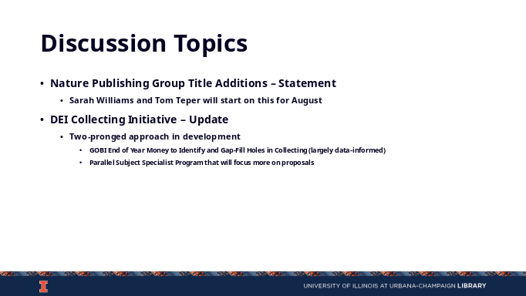

Updates
Acquisitions
- George will be touching base with some of the newer selectors. He hopes to put together a checklist or recorded webinar about fund reports. He encourages everyone to look at their fund reports in the next few weeks. George will be working on the central pool allocations soon.
E-Resources
- Wendy has entered and approved the last invoice.
Preservation Services
- No new updates.
Other Updates
- Esra modeled how inflation is calculated. Cindy suggested having a zoom session in regards to this once everyone is back to campus.

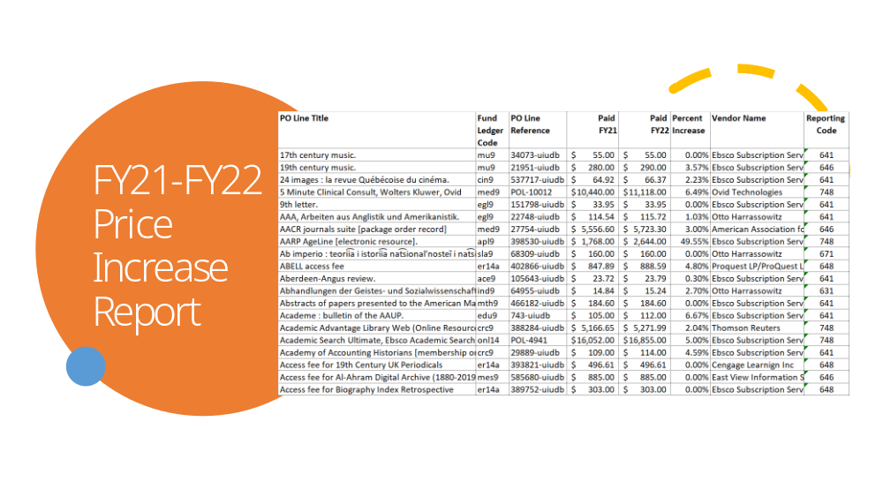

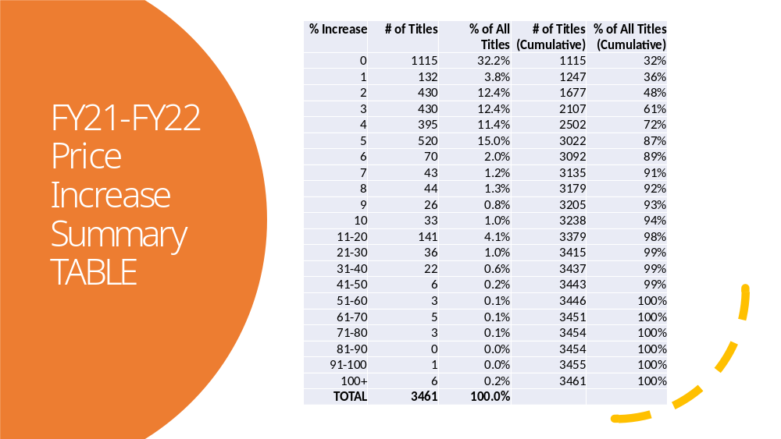

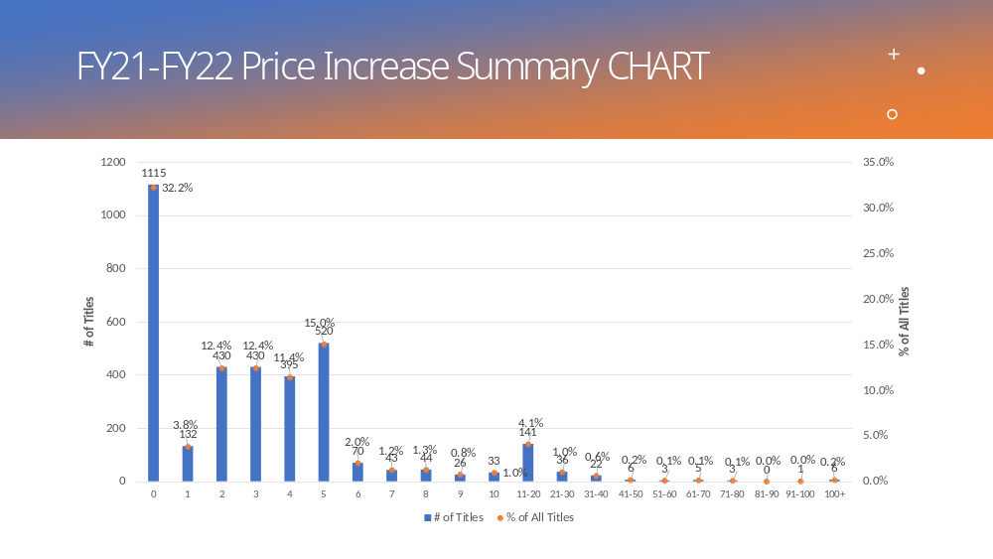
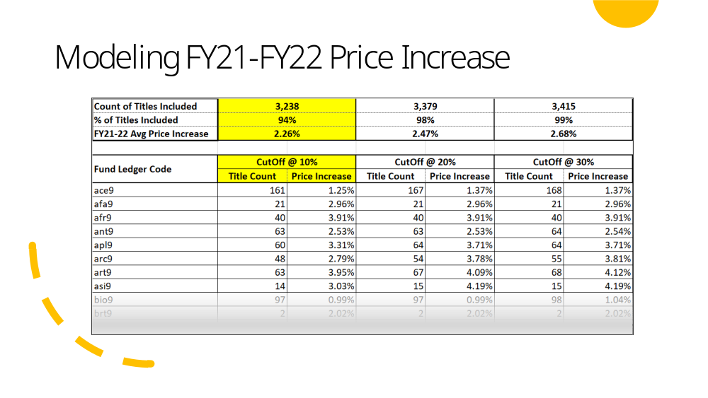
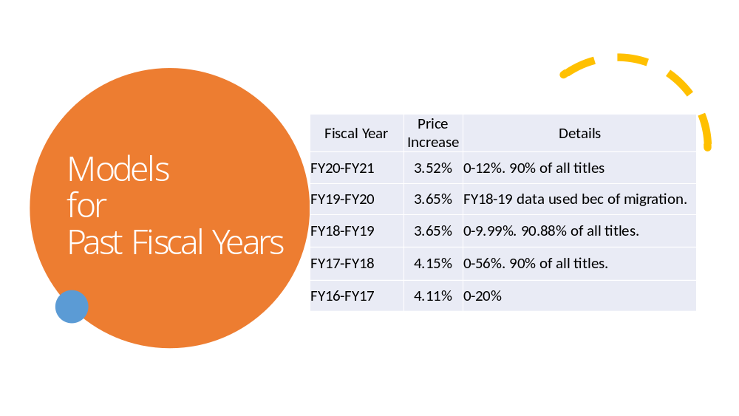
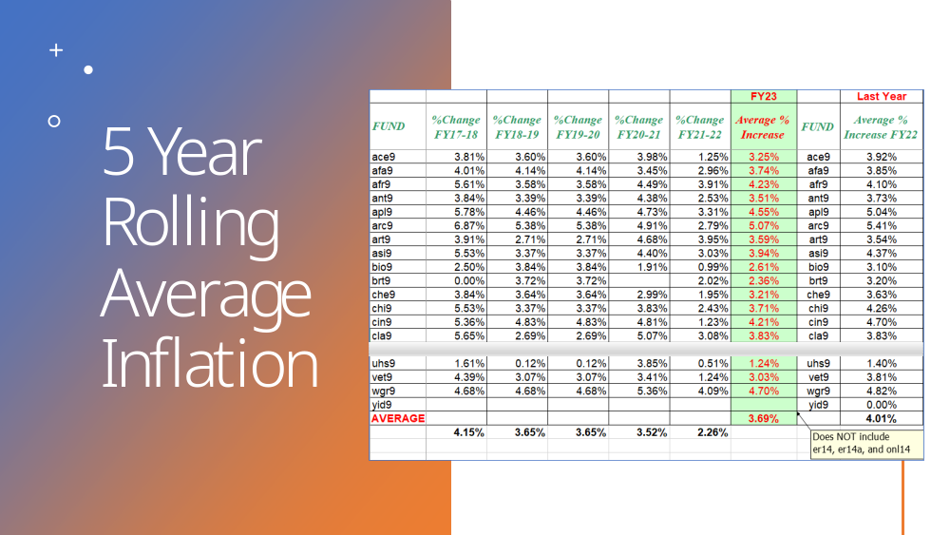

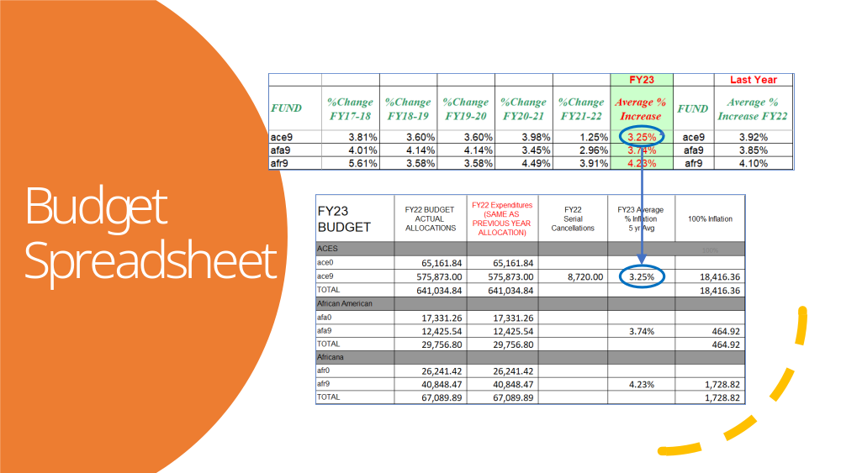
Parking Lot/Forthcoming Items

Appendix A: BTAA Cooperative Investment Program Expenses for FY22

Hi folks,

I’ve been asked by a few of you to provide costs for recent LSA/CIP purchases to help with an ARL survey. I imagine others may be ready to ask as well so I’m pre-emptively sending this message. The information below is from a document titled, “Big Ten Large Scale Acquisitions Program Summary 2008-2022” and can be found on the BTAA CDO-ERO Teams website (Large Scale Acquisitions group subfolder). Link for those with permission.
As you know the LSA program was a bit different the past two years as the library directors approved that the funds to be put into one pool of money to be used for various BIG Collection content, services, tools, etc. We now obtain pricing for the entire consortium rather than determining specific costs for each institution. This means that tier level pricing, discounting, and reductions for fewer than 15 participants (because of prior purchases) are imbedded in the BTAA group cost. Technically you could just divide the costs for each resource by 15, but that doesn’t always tell the whole story.
FY22 Individual Contributions: $200K plus $50K opt-in
- PLOS Collective Action for PLOS Biology and PLOS Medicine. BTAA authors can publish OA in these titles for no additional charges- $134,551 (year 2 of 3)
- Open Library of the Humanities support for 2021-2023- $98,007
- MIT Press D2O e-books 2021-2023- $265,000
- UM Press Fund to Mission e-books 2021-2023- $208.891
- arXiv- 3 years of support at the Champions level- $124,470
- Wiley OA fees associated with the one-year extension- $394,278
- Clarivate Data (institutions allowed to select any 3 resources)- $723,214
- Reveal Digital –Behind the Scenes of the Civil Rights Movement Collection- $540,000
- Open Access Community Investment Program (OACIP). Investment in 3 OA journals with 5 years of support- $45,000

FY21 Individual Contribution: $200K plus $50K opt-in
- Adam Matthew Collections (Institutional choices)- $791,200
- Big Collection Initiative – Support of the initiative including pilots, consultants, outreach, etc.-$560,000
- CDL Data Analyst Position to help with analyzing Wiley /BTAA publication data- $72,720 & $144,000 for FY22
- DOAJ Collective Support – Basic Support level for DOAJ for 3 years- $30,818
- DOAB-OAPEN Support for 3 years - $160,714
- Oxford Prospective Print support for OSO eBook collections & one print copy- $302,176
- PLOS Collective Action – OA Publishing in PLOS Medicine and PLOS Biology- $134,551 (year 1 of 3)
- Web of Science 2020 XML Update - $200,000
- Web of Science Expanded API & data sharing to assist with the Wiley OA e-Journal analysis - $26,914

Let me know if you have any additional questions.

Rob
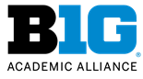 |  |  | Robert Van Rennes
Associate Director
Library Initiatives
217-300-4744
robert.vanrennes@btaa.org
www.BTAA.org
The nation's premier higher education consortium of top-tier research institutions.

