CAPT Minutes
April 28, 2022

Present: Chris Prom, Tom Teper, Michael Norman, Tracy Tolliver, William Kries, Wendy Shelburne, John Laskowski, Eric Kurt, Bill Mischo

Absent: Kyle Rimkus, Angela Waarala, MJ Han, Mary Laskowski

Notetaker: Hannah Williams

Agenda and Minutes
Tom Teper opened the meeting asking for approval of the April agenda, and March minutes. Agenda and minutes unanimously approved.

Updates
- Chris met with Dan Tracy and they are attempting to develop a copyright statement for our library digital exhibits website, as there was a creative commons license at the bottom that had been done by Spencer. The consultation process was unclear, so a new policy will be developed. This can be expected within the next month or so.

Primo Catalog Update- Michael Norman
- There will be a change initiated this summer in the Primo catalog that will help to alleviate some of the issues with ebooks links not being visible or difficulties in navigating the full display of the record. Michael modeled how this new deduping feature will combine multiple records for one title into a single display record. This new feature has the option to preference print or electronic records and the ability to turn off deduping for selected titles or records.

Quarterly Working Group Reports

- Web- John Laskowski

Web Working Group Report
April 28, 2022
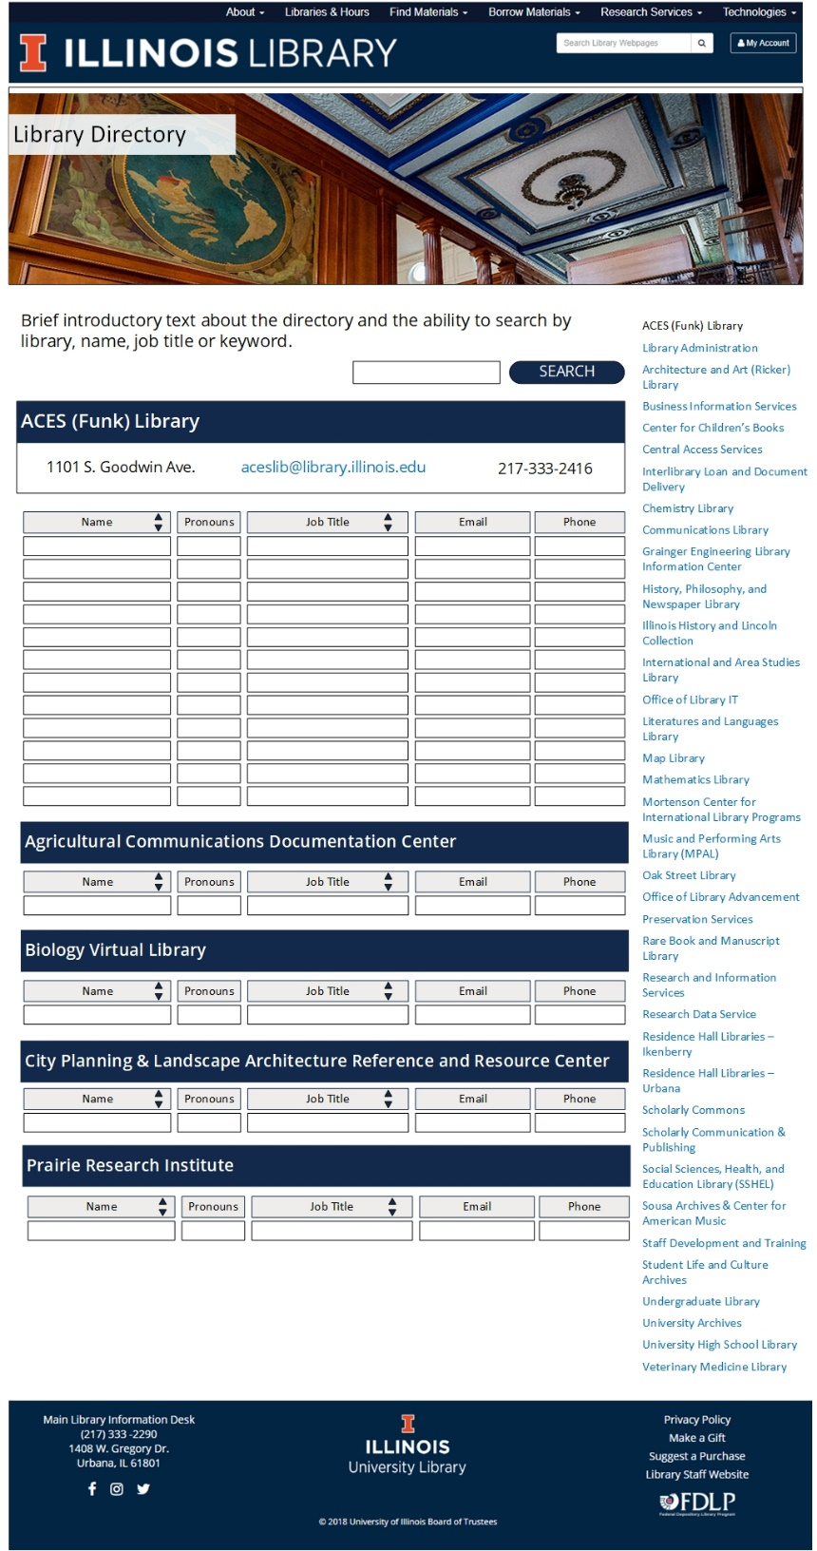
The Web Working Group has met twice since I last reported on our activity in January. Three items may be of particular interest to CAPT: New directory design, redrafting of the Web Policy document, and the introduction of Google Analytics 4 into our monthly meetings.
Library Directory. The current directory does not provide a satisfying experience. We’ve been looking at this as a separate phase of the update employee site and after many rounds of wireframes and discussion we’ve come up with a new design. Most of the improvements are in the search and sort functionality. The search will include a keyword field much like the Libraries and Hours search does. Therefore if you searched a term like “kinesiology,” the directory will return JJ in the search results because that is one of his subject specialties. We’re also implementing the ability to sort names and job titles within a unit for greater browsability when you know some information about who you need to contact but need additional help determining you exactly to contact. We also adding a pronouns field which is something we’ve talked about being a value-added field for some time. Finally, we’re adding a full library menu along the sidebar for ease of internal navigation.

Web Policy. During a recent conversation about what elements of a web experience need to be centrally branded with “the Library” as opposed to the particular service or space, we came across this active but completely antiquated policy on the staff site (https://www.library.illinois.edu/staff/librarywebcontentpolicy/). The group agreed that a new Web Policy needed to be written and agreed that it should be drafted by WWG members Helen Zhou, Heather Murphy, John Laskowski and Library IT representatives Tracy Tolliver and Dan Dalpiaz. Once the policy has been written and approved by WWG, it will be submitted to CAPT for review/revision before going to AC for review/approval.

Google Analytics 4. During the summer of 2021, Helen Zhou took the lead on a deep dive into the capabilities of Google Analytics 4. Myself and the four members of the web team participated in learning the best practices of the new system as well as identifying the types of metrics most often sought after in the Library. Google Analytics 4 was implemented across all Library site and we started recording data on September 1, 2021. During our February meeting I presented the following charts and comments covering the data for the Gateway and top-level pages for the first six months of operation. We determined we’ll begin reviewing these on a monthly basis and incorporate them more-fully into our planning process for continual iteration of the ability of those pages to meet the needs of our users.
Gateway Tab Clicks. Between September 1, 2021 and March 1, 2022 there were just over 1 million “sessions” on the Library Gateway. Within those 1 million sessions there were over 5 million “events” that took place without using the orange tabs (Easy Search, Chat, My Account, etc.). During that same time there were 50 thousand events engaging the tabs (remember, “Find Materials” is the default tab so these numbers aren’t a complete indicator of how often then resources are connected to from the Gateway.

I think what stands out to me about this information is not the use of the tabs, but rather the huge number of events taking place away from the tab structure. 90% of all events were done without tab navigation.
Spotlight clicks. We track how many clicks each of the different banners in the Spotlight receive. The point of this chart is not to compare numbers because there are too many time variables involved to make an accurate or meaningful comparison. Rather this is anecdotal information about what topics have been addressed in this space and the number of people who have engaged with the different banners.

Social Media traffic. We are currently tracking redirects we receive from Facebook and Instagram posts as well as tweets. These are all coming from official Library accounts and do not take into account traffic generated from shares or unofficial posts. To be clear, each of these engagements represents someone clicking a link from a specific post/tweet from the Library and landing on the associated page on our site.
I think it’s interesting to see not only the success of the various posts/tweets, but also whether certain topics do better on certain platforms.

Top Clicks. This report counts the links that get the most clicks across our entire WordPress installation. That doesn’t mean each individual use of a link, but rather the number of times any link to a URL is clicked. For instance, the 18,000 clicks for reserving rooms in Grainger doesn’t mean one specific link was clicked that many times. It means all the links that go to Grainger’s room reservation page were collectively clicked 18,000 whether they were on the Gateway, under Using Library Spaces, or on the Grainger site itself.

Keep in mind that while the Library facilities were open during the months under review Grainger, UGL, and ACES were the first libraries to open study space after quarantine which may have caused a continued bump in patron loyalty for their spaces, (but it might also just be a confirmation of what we already know about the popularity of those spaces).

Most Visited Pages. Again, this report looks at all our pages in our WordPress installation. I find this report to be very interesting for a number of reasons.

The first thing that jumps out at me is how many times some of these pages are being seen compared to the numbers above on the use of the Gateway tabs. The second is what Google calls an “engaged session:” this is a session during which the user stays on the page for 10 seconds or had 2 or more page views during the same session. That seems like a very low bar for “engagement.” But what I find most interesting is the average time of engagement. This is the third column reported for each of the pages, and you won’t see anything because the average time of engagement for each of this pages is between 16 and 42 seconds. The first page on this list that has an average time over 1 minute is the Communications Library homepage which is the 32nd most visited page during this time and the average time spent is 63 seconds.

- Search, Discovery, and Delivery – Bill Mischo
Clickthroughs
Ebsco Brief Record Link 288260 24.007
Primo Brief Record Link 250990 20.903
Ebsco Get Full-Text DOI Link 132839 11.063
Ebsco Get PDF Full-Text Link 66622 5.548
Bing 58688 4.888
Browzine Full-Text PDF 52289 4.355
Ebsco All Matches Link 49980 4.162
Ebsco Look for Full-Text OpenURL Link 37436 3.118
Primo See All 31181 2.597
Scopus Brief record Link 26745 2.227
Scopus Get Full-Text Link 21824 1.818
Suggestion Did You Mean Spelling Change 16812 1.400
EBSCO JSTOR Full-Text Link 13898 1.157
Suggestion Direct Link 13173 1.097
Suggestion Repeat Search in Easy Search 9129 0.760
Scopus All Matches Link 7935 0.661
EBSCO Publisher Full-Text Link 6328 0.527
Primo Direct Full-Text Link 6252 0.521
Hathi Temporary Full-Text Link 6246 0.520
Suggestion Direct DOI Link 5588 0.465
Proquest Link 5547 0.462
Suggestion AtoZ List link 5127 0.427
EBSCO Get HTML Full-Text Link 4538 0.378
CARLI Catalog link 4430 0.369
EBSCO Other Full-text Link 4016 0.334
Open Access Unpaywall 3719 0.310
Scopus Look for Full-Text OpenURL Link 3579 0.298
Scholix Dataset Link 3534 0.294
WorldCat Discovery Added Link 2361 0.197
Google Scholar Added Link 1866 0.155
EBSCO ScienceDirect Full-text Link 1696 0.141
EBSCO WOS Publisher Link 1625 0.135
I-Share Added Link 1510 0.126
CrossRef Title Word Matches Added Link 1480 0.123
EBSCO IEEE Full-text Link 1220 0.102
EBSCO Scopus Cited-by Link 1218 0.101
Suggestion Ask a Librarian Link 1206 0.100
Suggestion Libguide Link 1007 0.084
Re-do Search in Easy Search Added Link 1002 0.083

- Parking Lot Items-Review
- New Title List
- Illinois Databank
- Expertise Portal
- Persistent Identifiers

- Any Other New Business

Meeting adjourned at 2:30.

Reports by Month
January-Search, Discovery, and Delivery, Web
February-Digital Production, Repositories, Preservation, and Access, LEITC
March-Cataloging and Metadata, Electronic Resources
April-Search, Discovery, and Delivery, Web
May- Digital Production, Repositories, Preservation, and Access, LEITC
June- Cataloging and Metadata, Electronic Resources
July- Search, Discovery, and Delivery, Web
August- Digital Production, Repositories, Preservation, and Access, LEITC
September- Cataloging and Metadata, Electronic Resources
October- Search, Discovery, and Delivery, Web
November- Digital Production, Repositories, Preservation, and Access, LEITC
December- Cataloging and Metadata, Electronic Resources

