CDC Meeting Minutes
September 28, 2021
Via Zoom

Present: Tom Teper, Alex Cabada, Kit Condill, Esra Coskun, Mike Dickinson, Amy Fry, George Gottschalk, Cindy Ingold, Jenny Johnson, Carissa Phillips, Kyle Rimkus, Celestina Savonius-Wroth, Wendy Shelburne,

Absent: Jennifer Teper

Note Taker: Wendy Wolter

Agenda/Minutes
Tom opened the meeting asking for additions or changes to the agenda, and approval of last month’s meeting minutes. Agenda and minutes unanimously approved.

FY23 Budget Discussion – Planning for a Flat Allocation
- Recap
- Follow-up questions, etc.
- Next Steps

Tom presented the following Power Point:

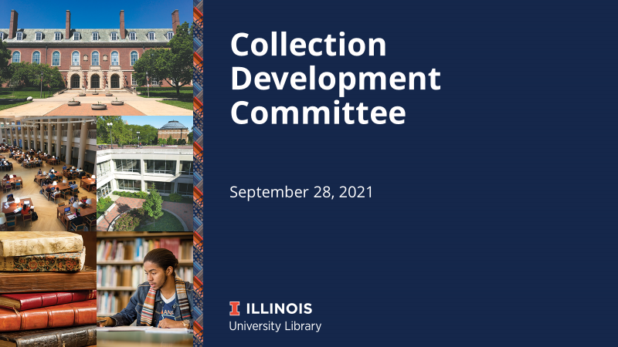

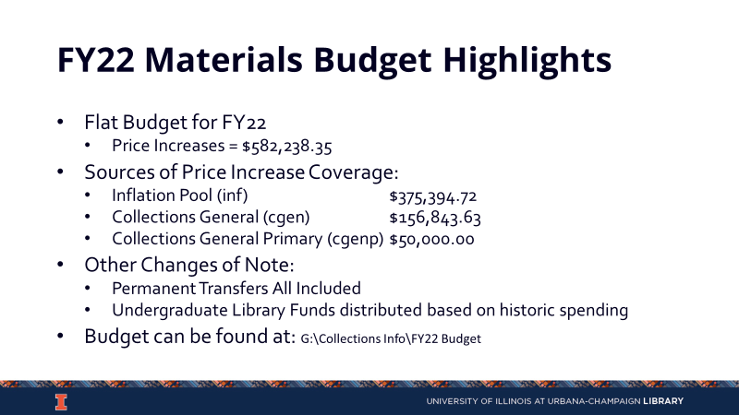

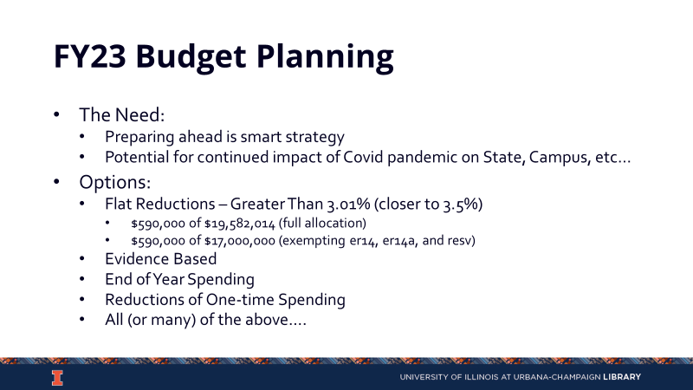

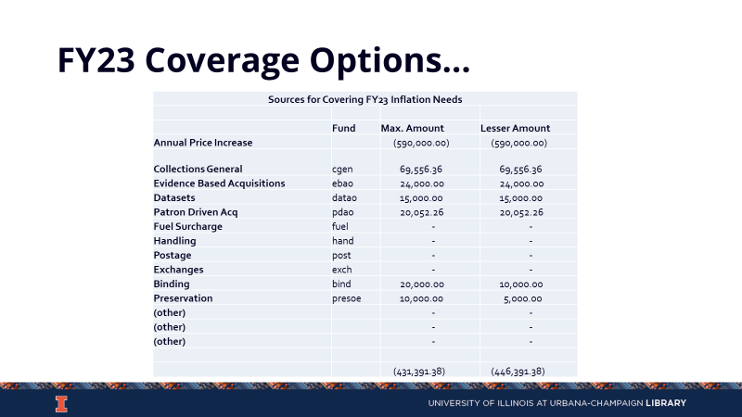

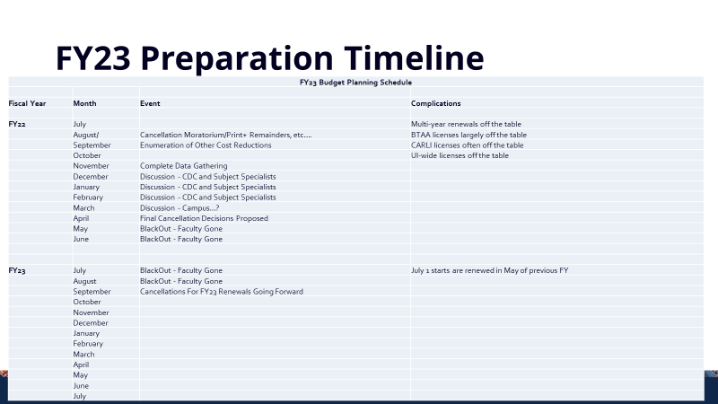
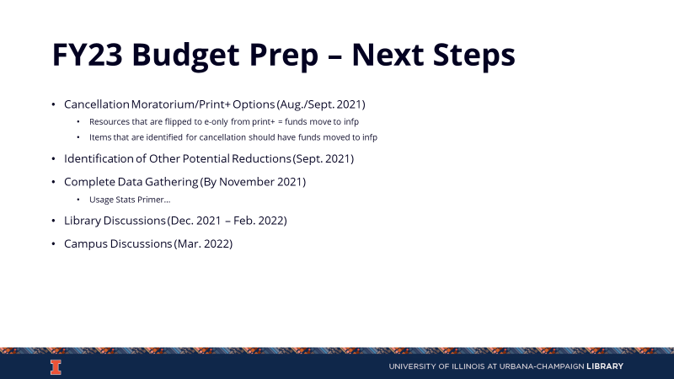

Wiley Data on OA Publishing – Esra
Esra presented the following Power Point
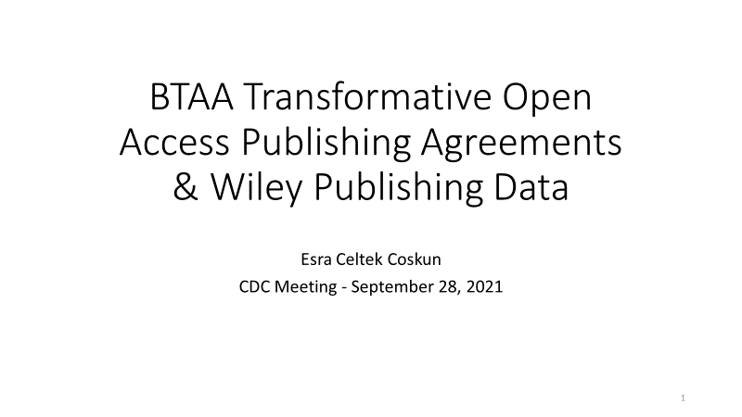

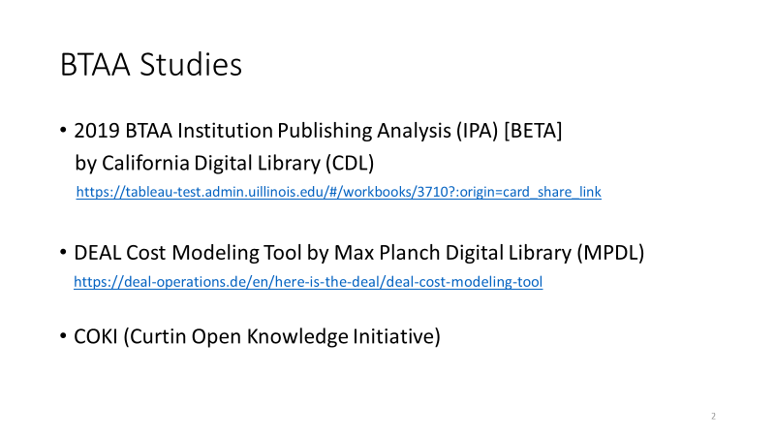
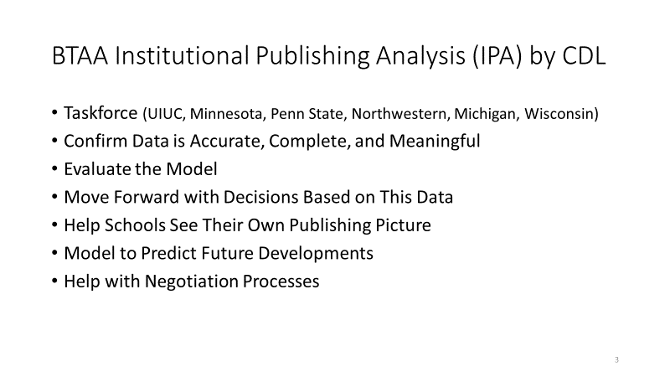
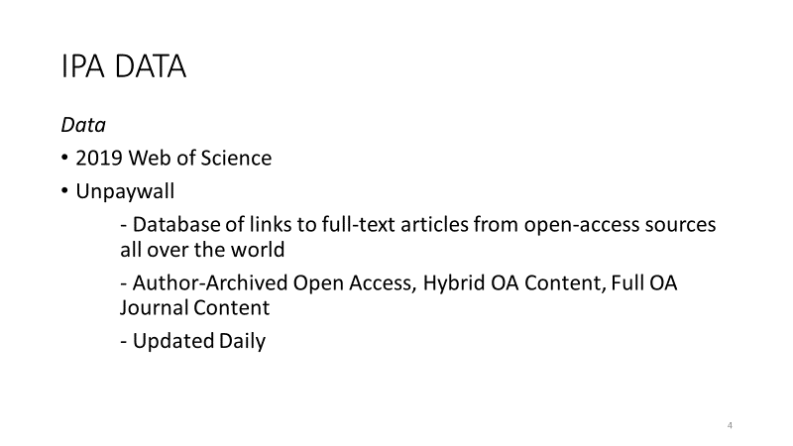
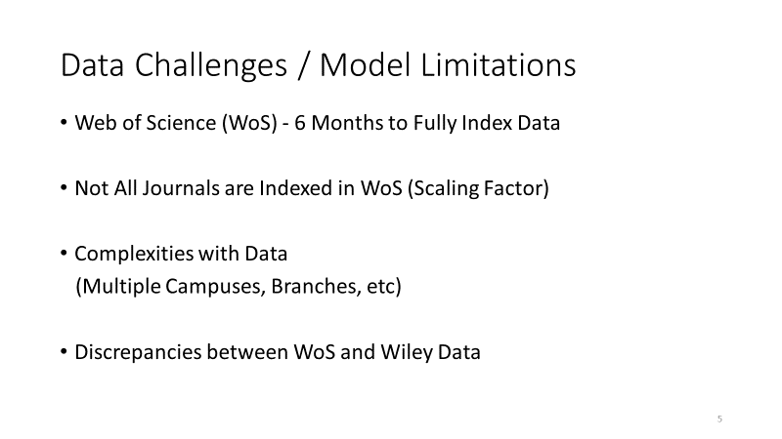
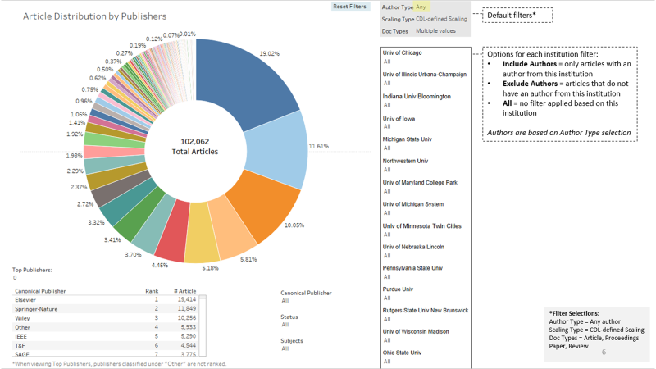
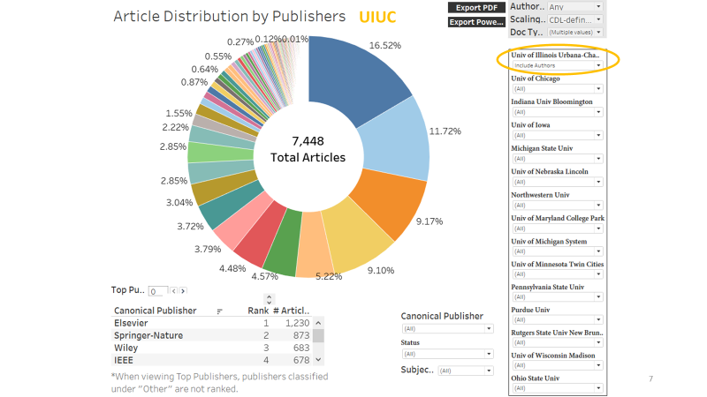
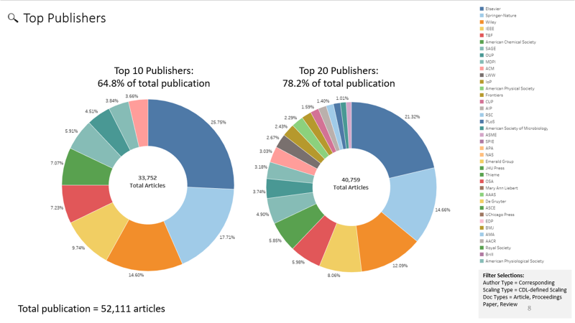

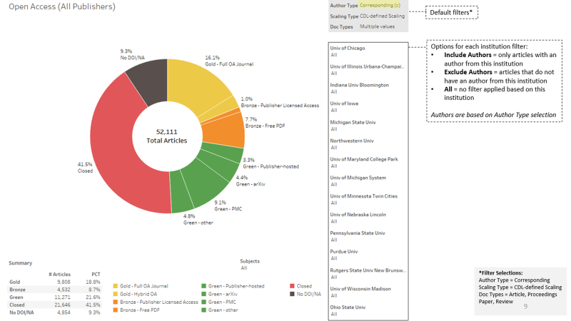

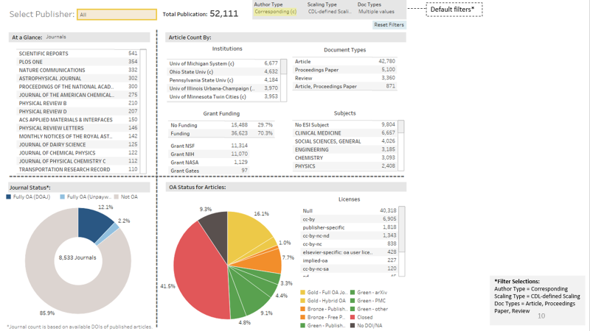

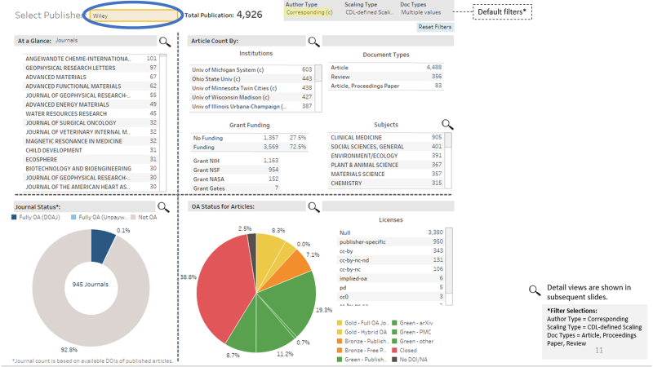
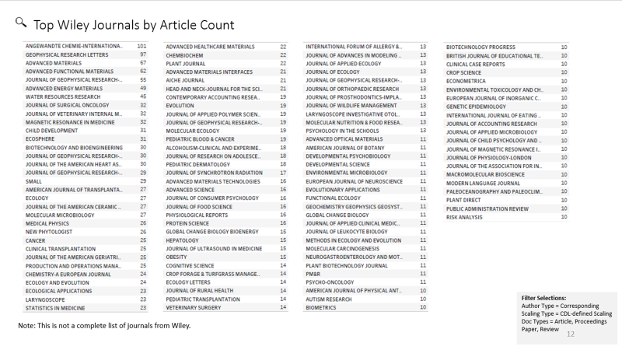

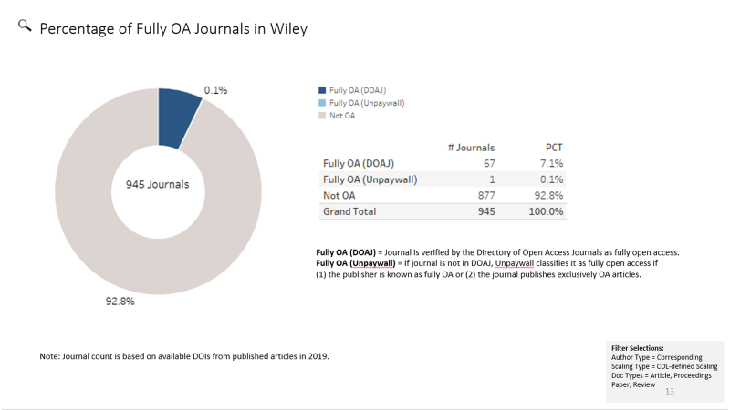

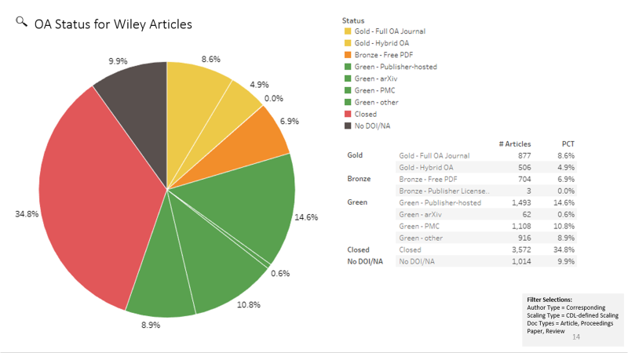

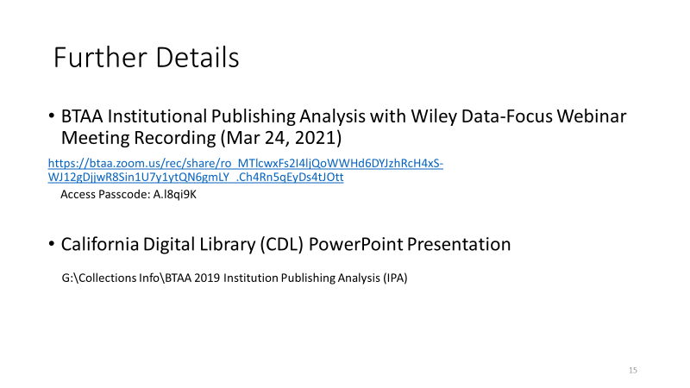

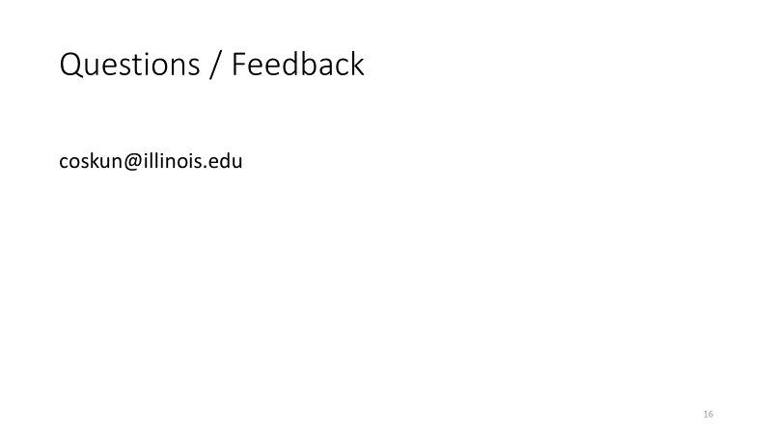
Updates
- Acquisitions – No updates.
- E-Resources- No updates.
- Preservation Services – Yung Jin will be starting next Wednesday as a visiting Conservator.
- Other Updates – Tom asked that if anyone is rotating off the committee, to please have their division rep contact him as soon as possible.

Meeting adjourned at 4:10 p.m.

