CDC Meeting Minutes
January 26, 2021
Via Skype

Present: Tom Teper, Alex Cabada, Kit Condill, Esra Coskun, Mike Dickinson, George Gottschalk, Cindy Ingold, Jenny Johnson, Emilee Mathews, Kyle Rimkus, Matt Roberts, Wendy Shelburne, Becky Smith, Sarah Williams

Absent: Jennifer Teper

Note Taker: Wendy Wolter

Agenda/Minutes
Tom opened the meeting asking for additions or changes to the agenda and approval of the November minutes. Agenda and minutes unanimously approved.

ILS Information Update – George
- Last minute frantic updates are now getting fewer and farther between on the non e-resource side.
- Ex Libris reached out to Stephanie Baker regarding the fund reports that she developed. They asked if they could share her format with other institutions. Way to go Stephanie!
- Fund report information is now always available. Fund managers do not have to wait on Acquisitions to receive fund reports.
- George will send out periodic fund report reminders, as he has in the past, via libnews.
- The Library is still very behind in invoice processing. Working to catch up but will take time.

Budget Prep for FY22/23 – Tom
- The Library can cover inflation increases for FY22, but in doing so, will eliminate the “rainy day” funds that have been built up over time. Once spent, it is highly unlikely that this money will be replaced by an additional infusion of resources. There is approximately $640K in the fund, and inflation should be approximately $600K.
- Tom has been asking the divisions for suggestions of how to cover inflation for FY23. The Life Sciences Division suggested to target central pool funds with sizeable zero funds and eliminate using the central fund for one year. This is possible; however, these funds are unlikely to be replaced. Once spent, they are gone. That would, effectively, mean that there would be no additional funding added to the central fund (e.g. ‘approvals’).
- Suggestion to use gift or endowment funds to fill in the gaps by reducing allocations to disciplinary areas with endowment funding. Possible, but need to check for purchasing restrictions.
- Library has ongoing contracts that cannot be changed. This needs to be taken into consideration when budget planning and constrains what we can do with many journal and database subscriptions.
- Esra and Vera pulling data on high cost, low use items, specifically with Ebsco. Decisions may need to be made by subject specialists (as in the past) with data provided as a starting point.
- Currently, there is no intention to give divisions flat reduction percentages. This would be very hard to justify in some subject areas.

Proquest Access & Build, and Avon – Tom
- The Access & Build program from Proquest ends as of August 2021. This program is very costly at approximately $300K per year. It is not likely that the Library will renew this program due to cost and the current state of the budget. All items received during this program have been labeled as part of the trial. We will keep those that we can, but, of course, others will go away.
- Another program the Library quickly purchased last spring is AVON (Academic Video Online). This was licensed for one year to assist with the emergent need for online learning. There is a lot of overlap with other Proquest products. Vera and Esra are looking at usage data. This also likely will not be renewed. The cost to renew would be $30K.
- Subsequent Note: PQ informed us that, based on the past expenditure, we are eligible to permanently acquire about sixty-eight of the titles. If we look at the titles by usage in the last year and eliminate any with overlap to other ProQuest packages, we can acquire every title that had twelve or more uses during the last year. With the cancellation likely, this seems to be the best course of action.

License Renewals- Wendy
Web of Science Renewal
Last UIUC invoice (January 2020): $264,808 Paid via er14, bio9, ace9, med9
And includes the following: 1900 - 2020 Science Citation Index Expanded
1900 - 2020 Social Sciences Citation Index
1975 - 2020 Arts & Humanities Citation Index
Journal Highly Cited Data,Web of Science citation connect package, 1910-2020 Cab Abstracts, Cab Global Health, and FSTA 1969-2020
Last renewal included some individual backfile purchases as well as purchase of WOS XML data that held down annual increases. XML data was purchased using BTAA Large Scale Acquisitions (LSA) funds. The new proposal includes much of the same with varying rates of annual increase dependent upon one-time purchases of WOS XML data refresh, LJUR (library journal utilization report –which we have purchased somewhat regularly over the years) and Emerging Social Ci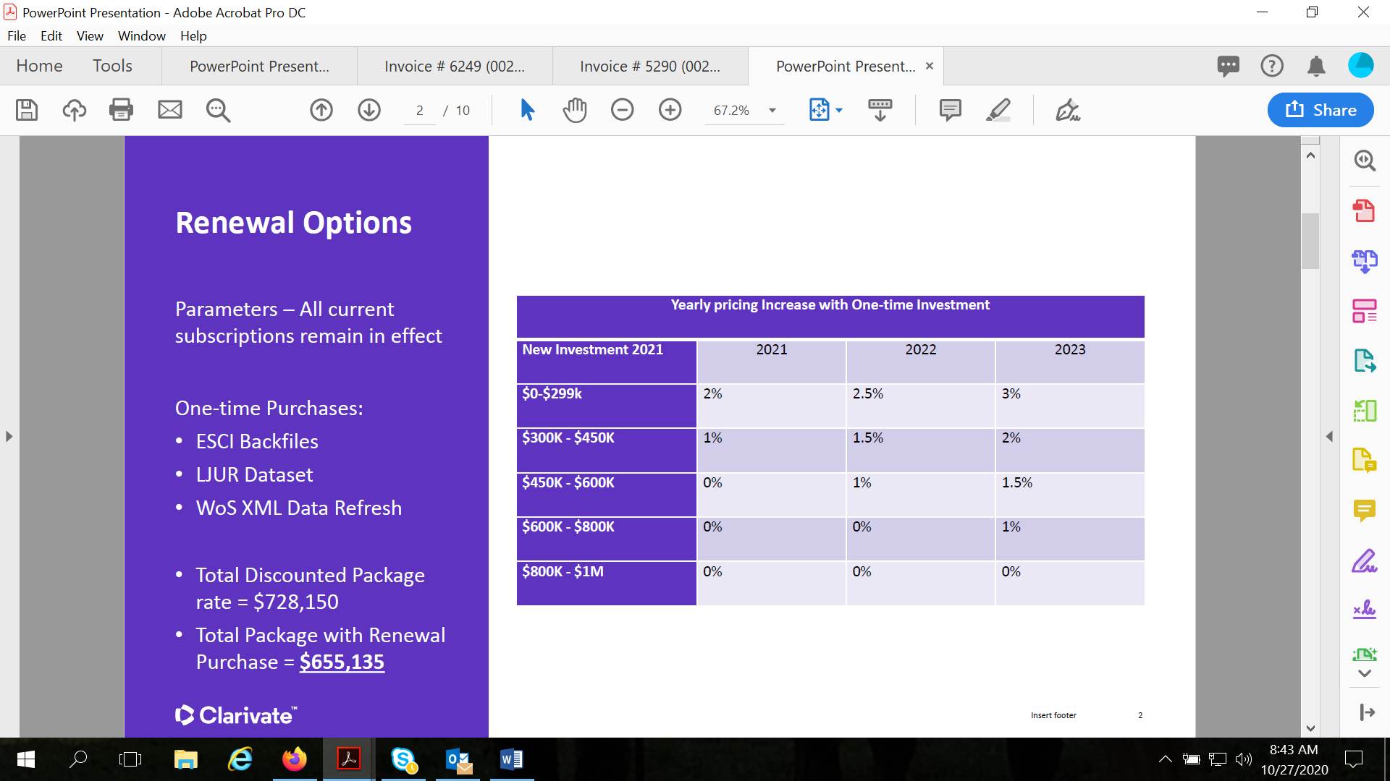tation Index (ESCI) data. Currently BTAA is looking at using LSA for additional purchases…
Updated proposal now looks like this. 2-year approved agreement for the reduction (-2%) in year 1 for 2021, and the flat (0%) in year 2 for 2022 with the purchase of 1 year of XML data refresh updates ($250k for the entire BTAA) purchased before the end of 2020. This provides ongoing cost relief in terms of the subscription products as the XML data would be a one-time purchase paid out of the Large Scale Acquisitions budget.
The XML data is still under lively debate/discussion among the libraries. More information forthcoming….
Cabi products are not included in this table as they are third party.

 | MEMBER INSTITUTION | AUTHORIZED ACCESS | ## | 2020 | 2021 | 2022
4 | University of Illinois  1408 West Gregory Street  Urbana, Illinois 61801 | 1900 - 2020 Science Citation Index Expanded  1900 - 2020 Social Sciences Citation Index  1975 - 2020 Arts & Humanities Citation Index 2015-2020 Emerging Sources Citation Index | ## | $ 147,763 | $144,807.74 | $144,807.74
4 |  | Journal Highly Cited Data | ## | $ 9,797 | $9,601.06 | $9,601.06
4 |  | Web of Science Citation Connection Package | ## | $ 71,519 | $70,088.73 | $70,088.73
4 |  | 1910-2020 Cab Abstracts | ## | $ 18,256
4 |  | CAB Global Health | ## | $ 7,702
4 |  | FSTA 1969-2020 | ## | $ 12,419 | $12,170.58 | $12,170.58

All database subs are renewed. FY21 invoice was approximately 6K less than fy20. XML data to be covered by BTAA LSA (Large Scale Acquisitions)
Sage Premier Renewal
Current BTAA conversation is a three-year agreement with price caps at 0%, 2%, 2% for the 3 year agreement.
FY20 spend was $315,736.85 over many subject funds and er14. This deal also includes any takeovers coming in during years 2 and 3 that are invoiced at full price until they deal restarts. After years of discussion I’ve managed to exclude law titles from this type of invoicing, e.g. they stay out of individual invoicing if they are takeovers.
The whole BTAA is pretty quiet about Sage so this one is going ahead best I can tell.
Sage has been completed and was invoiced by BTAA December 11th.
Springer Nature
Springer Nature overview: all products and increases and reflects a reduction from where we started
BTAA 2021-2023: 1%, 2% , 3%
Products | 2020 | 2021% | 2021 $ | 2022% | 2022 $ | 2023 $ | 2023 $
Scientific American | $ 22,974 | 0.5% | $ 23,089 | 2.0% | $ 23,551 | 3.0% | $ 24,257
Nature Legacy | $ 1,689,409 | 1.5% | $ 1,714,750 | 2.0% | $ 1,749,045 | 3.0% | $ 1,801,516
Nature All | $ 836,711 | 1.3% | $ 847,588 | 1.8% | $ 862,845 | 2.8% | $ 887,004
Palgrave Legacy | $ 46,273 | 0.5% | $ 46,504 | 1.5% | $ 47,202 | 2.5% | $ 48,382
Palgrave All | $ 98,761 | 1.0% | $ 99,749 | 1.3% | $ 101,045 | 2.3% | $ 103,369
Academic | $ 862,018 | 0.5% | $ 866,328 | 2.0% | $ 883,655 | 3.0% | $ 910,164
Springer Legacy | $ 7,552,530 | 0.5% | $ 7,590,292 | 1.5% | $ 7,704,147 | 2.5% | $ 7,896,750
Springer TONS | $ 208,251 | 0.5% | $ 209,292 | 1.5% | $ 212,431 | 2.5% | $ 217,742
Springer All | $ 2,945,926 | 1.0% | $ 2,975,385 | 2.0% | $ 3,034,893 | 3.0% | $ 3,125,940
Adis Journals | $ 128,309 | 0.5% | $ 128,951 | 1.5% | $ 130,885 | 2.5% | $ 134,157
eBooks | $ 2,421,830 | 2.8% | $ 2,488,430 | 3.5% | $ 2,575,525 | 4.5% | $ 2,691,424
Protocols | $ 122,370 | 1.0% | $ 123,594 | 2.0% | $ 126,066 | 3.0% | $ 129,848
Materials | $ 71,194 | 1.0% | $ 71,906 | 2.0% | $ 73,344 | 3.0% | $ 75,544
TOTALS | $ 17,006,555 | 1.1% | $ 17,185,858 | 2.0% | $ 17,524,633 | 3.0% | $ 18,046,099

UIUC specific information:
Total springer journals: $951,064.86
Springer protocols: $24,780.28
Springer Materials: $21,692.99
2021 Springer ebooks: $196,237.54
2021 total: $ 1,193,775.67

Nature (including Palgrave)
Palgrave journals: $7,065.30
Nature academic journals: $42,333.84
Nature branded and clinical journals: $171,143.41
Scientific American: $ 1,854.85
2021 Total: $222,397.40

For those of you asking about new nature titles, I’ll send any updates to that pricing as I receive them.

Springer has indicated that this is their final and best offer for 3 years. However, BTAA has been asked to go back and see if we can get a two-year agreement for 1% and 2%, and then this would be renegotiated for year 3 closer to year 3 (year 3 is currently at 3%). There is also a lot of conversation around the new nature titles as they continue to roll out new titles annually. Currently there’s 8 new titles we don’t have (121K recently discounted to 88K) and they have indicated there we be 6 more over the course of the next two years. All BTAA libraries (UIUC included) are discussing holding the line again and refusing to add new titles.

The offer did not change and Springer Nature was completed and invoiced by BTAA on December 11th.

Elsevier Book Series
Elsevier books series have renewed as follows: 0%, 2.5%, and 5% for a 3 year deal. The original offer would have been 2.5%, 5%, and 5% . this affects a small number of funds here at a spend of 25K or so with a UIC split and this is a deal we have been in for several years now.
Completed and invoiced by BTAA November 14th.

Elsevier journals (UIUC, UIC, and UIS – not BTAA)
We are currently working with Elsevier on an amendment that would extend our current 5 year agreement for one more year and allow for 0% increase on journals for FY22. This would mean our current agreement would end in 23 as opposed to 22. This requires BOT approval so there will be some time yet before it is completed. This is only for journals, e.g. not databases, ebooks, Pure, etc.

0% amendment is still in process. This would be in effect for fy22. Not fy21.

Oxford University press shared print (one print book, and e-for all participating schools)
This is currently under discussion for a renewal that would expand to include all front list OSO (Oxford Scholarship Online collections) 7 schools have indicated that they would like to participate (we are one) but there are some issues for some schools surrounding the desire to use LSA funding as opposed to their regular collections allocation. More information coming on this one.
the oxford print program is now expanded and was invoiced January 20th.

Cambridge University Press Read and Publish Agreement
Cambridge has sent a relatively cost neutral read and publish agreement for their journals. Basically this agreement like others works starts with our base spend, e.g. our current Cambridge subs est ($146,788) for 211 titles. There’s a top up charge of approximately $2100 and we will gain access to 192 titles, along with the read and publish aspect. This will lock this spend so there will be no cancels during the 3 year agreement

Here’s some text from Cambridge:
New Journals Access; Reduced Costs
This agreement will expand journals access for 10 institutions not already subscribing to the Cambridge Full Package, at a substantially discounted upgrade cost unique to this proposal. All institutions, including those already subscribing to the CUP Full Package, will benefit from reduced annual cost increases in subscription years 2022 and 2023 of 2% and 2.5%. Perpetual rights are provided to all volumes published during the agreement term; shallow back-file access is also guaranteed in line with the specific terms of each journal.
New OA Publishing Opportunities
For 12 BTAA members covered by this agreement, there will be no charge for corresponding authors who publish research open access in CUP’s gold and hybrid journals. The institutions included in this proposal account for approximately 10% of CUP’s North American research output. As well as securing the OA advantage for a significant pool of BTAA authors, this proposed partnership will accelerate CUP’s transition of its own journals list to open.

Completed and invoiced via Ebsco. Announcements and publicity about the deal forthcoming.

Cambridge University Press e-books (shared print)
There’s a new offer from Cambridge similar to Oxford for front list ebooks and a shared print copy for the group. We received this one on 11/19 so there’s still a great deal of email discussion about it and it doesn’t seem to have really landed anywhere yet. Several institutions, however, have indicated immediately that they can’t participate. For the remainder everyone is kicking around email questions mostly around cost and attempting to secure whole book ILL rights. As an aside, whole book ILL is still not secured with Oxford for that deal but they are discussing it with BTAA. More information will be forthcoming.
the Cambridge shared print ebook program was not approved at this time.

Karger (not BTAA just us)
We have been approached by Karger for a zero increase cost neutral read and publish pilot. We would renew our journals at a flat rate (104K) and like Cambridge no cancels. We already purchase all of Karger’s journals.

From Karger:
Starting January 2021, an unlimited publishing credit deposit in your name will be made available to researchers from your institute submitting manuscripts on the Karger homepage.
Your publishing credit deposit can be used for both Karger Gold Open Access journals and Karger subscription journals under the hybrid model.
The agreement covers all corresponding authors associated with and employed by your institution.

I am behind on agreements and may not be able to get this completed for this year.

Updates
- Acquisitions – People have asked about Gobi e-preferred slips. Currently default to print. Can change to default to e-book if available and possibly by fund. George will check with Amy about choices. If strong feelings about platform prioritization, then this will be pursued further.
- E-Resources- No updates.
- Preservation Services – No updates.
- Other Updates

