CAPT Meeting Minutes
May 27, 2021
Via Zoom

Present: Jim Dohle, MJ Han, Ayla Kenfield, John Laskowski, Mary Laskowski, Kyle Rimkus, Tom Teper, Tracy Tolliver, Wendy Shelburne

Absent: Bill Mischo, Michael Norman, Chris Prom

Notetaker: Wendy Wolter

Agenda and Minutes
Tom Teper opened the meeting asking for approval of the May agenda, and April minutes. Agenda and minutes unanimously approved.

ILS System Migration Update – Michael Norman
Upcoming Alma/Primo Downtime – May 29-30, 2021
We wanted to remind that Alma/Primo systems will be unavailable this coming weekend. Ex Libris will be moving their data center on May 29-30, 2021 and all services running out of that facility will be offline for approximately 24 hours. Services should be available again after 8 PM on May 30th.
Holdings in the Primo Catalog reverting to pre-HathiTrust ETAS original locations
To prepare for the culmination of the Library’s participation in the HathiTrust ETAS service on June 13th, Library Locations in the Primo Library Catalog will return to showing the original permanent location and holdings information for all items. Starting the week of June 7th, we will start to delete the Temporary Locations for over 5 million items. HathiTrust ETAS url links for in-copyright materials will also cease on June 13th. However, HathiTrust links will continue to show in the Catalog for public domain titles and items.
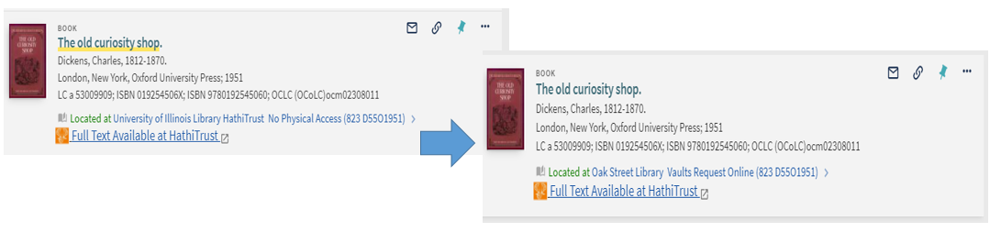

Alma Staff Training Page
The new consolidated Alma Staff Training webpage is available at https://www.library.illinois.edu/staff/alma/. We reorganized into new sections including the University of Illinois Training materials, CARLI & Ex Libris guides and recorded information sessions, Fulfillment videos and documentation, Cataloging, and contact information to report problems and provide feedback about either Alma and/or the Primo Catalog. Give the new Training site a view and let us know what you think at https://www.library.illinois.edu/staff/committee/alma-squad/.

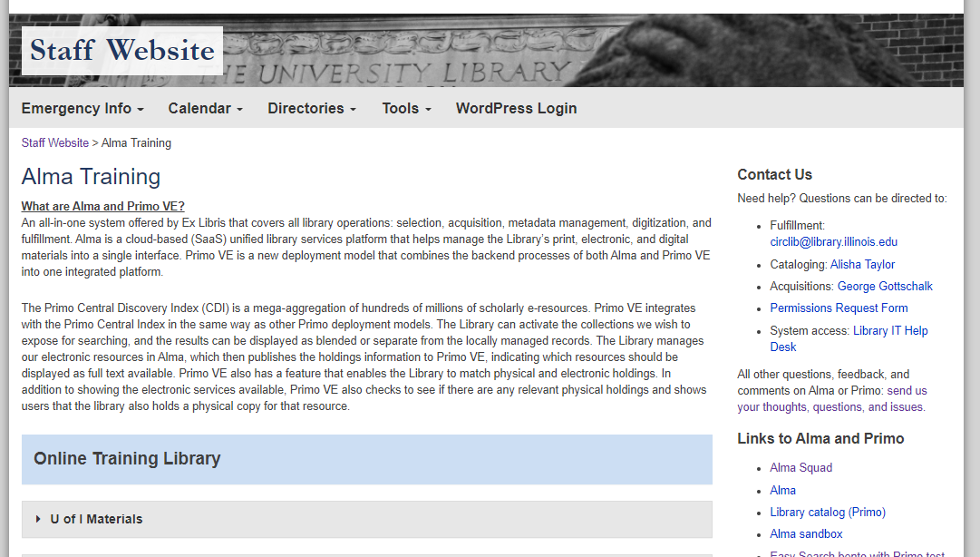
Training sessions on Searching and Navigating in Alma/Primo
On June 17, 22, and 30, we will have new introductory sessions on searching and navigating in Alma/Primo. There will be recordings of these sessions posted to the Alma Staff Training page.
Topic: Introductory session on Searching and Navigating in Alma and the Primo Catalog
----------------------------------------------------------------------------------------------------------------------------------
1) June 17, 2021 @ 1-2 pm Zoom Session
Join Zoom Meeting
https://illinois.zoom.us/j/86598938314?pwd=ZVVESmh2dTc4UjdLQmdTTXRHalV6Zz09
Meeting ID: 865 9893 8314 Password: 241478
----------------------------------------------------------------------------------------------------------------------------------
2) June 22, 2021 @ 10-11 am Zoom Session:
Join Zoom Meeting
https://illinois.zoom.us/j/86527891650?pwd=Y09tS3g0S1oyT2QxbUxTZzBwV0FCQT09
Meeting ID: 865 2789 1650 Password: 789315
-----------------------------------------------------------------------------------------------------------------------------------
3) June 30, 2021 @ 11-12 pm Zoom Session:
Join Zoom Meeting
https://illinois.zoom.us/j/83713926393?pwd=S1hCZi9QOFlZMEtaVmpKcm1KS05TUT09
Meeting ID: 837 1392 6393 Password: 013275

- The group suggested that Michael promote these training sessions via Libnews. Tom e-mailed Michael and asked that he begin sending out Libnews announcing these dates.

Quarterly Working Group Reports
Search, Discovery, and Delivery – Bill Mischo
Bill was not available for this meeting. This will be moved to next month’s agenda.

Digital Production – Kyle Rimkus
Emergency Access Digitization transition. With the library moving away from its “digital first” fulfilment policy, we are revising our approach and referring to it as “patron-driven digitization” rather than “emergency access digitization.” It has some similarities to controlled digital lending, but since we haven’t committed fully to everything this implies, we won’t brand it as such for now. At the moment, a new Primo feature for explicitly requesting digital access is now live. The HathiTrust ETAS will be turned off mid-June. Patrons will still be able to request in-copyright books to be digitized and accessed for a 21-day period after Shibboleth login. In the background, we are shifting certain pieces around. We will track more of this in Alma than we had previously, and Preservation Services will take on some of the preparatory work that had been spread out among other units. Looking forward, we would like to know if patrons enjoy having the option of digitization and expect a number of them will, and whether this will become a permanent service. In related news, we will be publishing on our COVID digitization workflow process in the next issue of the code4lib journal, which should appear in mid-June.

Staff transitions. To aid in supporting the digitization work above, Johna von Behrens has been transferred permanently to Preservation Services. In addition, Tricia Lampron, who plays a key role in supporting Metadata workflows and project planning for our Digital Collections, is leaving us for a position at UC Irvine. We will have an adjustment period as we figure out how to adapt to this.

EMMA grant phase II. The Mellon-funded Educational Materials Made Accessible (EMMA) grant led by John Unsworth at UVA is entering its second phase. We are one of the founding pilot partners, and have been working with DRES on remediation and deposit of items they digitize for patrons with print disabilities into the EMMA repository. EMMA unifies search for text-remediated content from multiple institutions across Bookshare, HathiTrust, and Internet Archive. In this phase, we will have stronger engagement from the iSchool in developing educational materials and have brought JJ Pionke on for his expertise in providing disability services.

Repositories, Preservation, and Access – Ayla Kenfield
Meetings
Held meetings in April and May. March meeting was cancelled.

Activities of Note
- IDEALS policies
  - reviewed:
    - Withdrawal Policy - Retiring IDEALS specific one and replacing with the Library’s Digital Collections Takedown Request policy
    - IDEALS Service Level Definition
      - Technically an IDEALS policy but it mostly gives information that’s repeated in other policies. Asked Jason Strutz to look it over to see if this matched Library IT’s service definition. Decided not to recommend.
    - Policies Governing Dissertations and Theses - Reviewed by Thesis Office who recommended no changes be made.
  - Still need to incorporate suggested changes into most of reviewed policies before sharing them with Big CAPT.
  - Next up: Metadata Policy*
- Metadata Policy will not be reviewed in full by the RPA working group because it’s mainly a statement of all the elements available in IDEALS, specifies required and optional elements, and controlled vocabularies and standards in use. The metadata framework for new IDEALS has been developed in close conjunction with Metadata Services.
  - This lead to a question that Kyle and I decided we’d like this group, but more specifically, the Cataloging and Metadata working group to discuss:
    - IDEALS Metadata Policy states: “Specific metadata fields such as abstracts may be subject to copyright. IDEALS does not provide its metadata under an open license at this point.”
    - We think it would make sense to have a Library-wide policy for licensing our metadata?
      - Does IDHH have a policy on this?
LEITC – Jim Dohle

Monthly meetings
- Last met: 05/20/21 (Working group); 10/15/20 (Advisory group)
- Next meeting: 06/17/21 (Working group); [TBD] (Advisory group)

Membership
- No recent changes to membership; revisited group membership at May ’21 meeting

Recent activity

COVID-19 updates
  - In person activities gradually increasing as campus progresses with phased re-opening plans
  - Studios ramping up reservation capacity, aligning with campus safety protocol
  - Virtual support and online consultations continue
  - Development of 3D and VR related projects continues

Collaborations
  - UIUC campus VR and Emerging Technologies groups
    - Ongoing Library participation in campus efforts to discuss a variety of emerging technology and extended reality topics including Virtual Reality, Augmented Reality, 3D and 360 video, etc.
    - Updates from Emerging Tech steering committee meeting 05/20/21
      - Virtual Community Locations for Music/performing arts – Jake Metz working with local venues including Rose Bowl
      - Noise cancelling headset options
        - Guide of choices: https://www.rtings.com/headphones/reviews/best/by-feature/wireless-bluetooth
      - HP Reverb/HP Omnicept ($1300) – level up data collection capacity compared to consumer VR headsets
        - Heart rate/Pupillometry/Eye tracking/etc.
        - https://www8.hp.com/us/en/vr/reverb-g2-vr-headset-omnicept-edition.html
      - Short-Form educational content – VR, Emerging Technology, Advanced Audio Editing, Esports
        - Branding: Digital Badges, Certificates, “Stacked Credentials”
        - Jim Wentworth: CITL Certificates are informal
        - https://citl.illinois.edu/citl-101/teaching-learning/teaching-certificates

Web presence
  - LEITC website (no update 05/21)

Technologies
  - 3D and VR applications, tools and content management
    - 3Deposit
      - Rob Wallace [RW] with IDEA Lab continues work with 3Deposit, a service coordinating system(s) for centralized storage, access and discovery of 3D assets and virtual reality generated content.
      - 3deposit rewrite is finished; dev deployment up at https://3deposit.library.illinois.edu
      - Putting together a full workflow guide for capturing, post-processing in Artec Studio, depositing, and distributing.
- Komodo (VR learning tool)
      - Komodo completed alpha user testing this semester with two courses: MSE404 (Computational Materials Science – Microscale) and ARTS221 (Fashion Illustration)
      - https://vr.web.illinois.edu/2020/11/09/fashion-critique-in-komodo/
      - Continue to work with these instructors Spring ‘21 semester; applied for grant funding
    - Ginger
      - Building 'street-view' tours for College of Engineering and DRES committee; Command line tool and desktop application; development continuing remotely
      - Update: work continuing on Ginger project Spring and Summer ‘21
        - 360 photo tour generator and editor
        - Supports DRES & College of Engineering Facilities project on ‘Invisible Disabilities’
    - 3D Scanning Service
      - Artec Leo 3D Scanner information
      - Status update: Scanner received 02/21; training for users to held 02 & 03/21; first preliminary scans of human brains completed 05/21
      - Space for hardware storage and post processing located in IDEA Lab
      - First library-related scans will be items identified from RBML collection
  - UIUC Anyware
    - Eric Mosher continues to work with a cross-functional team from the UIUC campus formed to manage the Virtual Computer Lab.
    - UIUC Anyware information
      - Overview: https://go.illinois.edu/UIUCAnyWare .
      - Knowledgebase: UIUC AnyWare: Documentation and Additional Information.
      - To use the service, simply log in to UIUC AnyWare using a browser and you will be prompted to install Citrix Workspace.
    - Currently, the Library has 16 high-end Dell workstations (purchased as part of the Main Library room 220 refresh) available in the “Library Scholarly Commons” resource pool in the UIUC Anyware virtual computer lab.
    - These workstations include Scholarly Commons advanced software available to users who cannot physically access the machines on campus.
    - Update: Eric and the UIUC virtual workstation team are evaluating Citrix use this past AY and are considering options for Fall 2021 given campus plans for phased reopening of buildings and services.
  - Pro Gear Rental (High-end loanable technology) @ UGL
    - Pro Gear (advanced technology equipment/kits) kits available to rent for UIUC campus faculty staff and students. Dovetails with recent collaboration between the College of Media and UGL/Media Commons to support loanable technology for the Media and Cinema Studies (MACS) minor in Media Production.
    - Update: Live as of February 2020 and subsequently on hold March 2020 due to campus COVID-19 response; scheduled to re-launch for Fall 2021 semester.

Outreach/engagement
  - LEITC working group members are discussing opportunities to collaborate with Library innovation grant recipients, including AI Machine Learning and Data Science, 3D Scanning, etc.

Spaces

Grainger Engineering Library & IDEA Lab
- Grainger Commons rooms 233/235: project to replace existing Audio/Visual control system (99% completion Fall 2020)
- IDEA Lab reconfiguration): recent remodeling complete – see Appendix A for information about new IDEA lab layout and functionality
- E-sports on UIUC campus
  - IDEA lab participation
    - Re-use of new immersive learning lab in IDEA lab – allow E-sports teams to use the facility during nights, weekends, and other low-use periods

UGL & Media Commons
- UGL move planning
  - Media Commons, Scholarly Commons, IDEA Lab and IT are coordinating with the Undergraduate Library/Main Library Integration Working Group sub-groups on the technology and related services to be transitioned from UGL in 2021/22
- Self-Use Audio and Video Booths
  - Online for Spring 2021 semester
  - Remote telepresence troubleshooting methods implemented
- Audio Production Studio
  - Online and available for use pending Media Commons hourly staff availability
- Immersive Production Studio
  - High-resolution 360 video and spatial audio capture workflows have been refined.
  - Immersive Media studio move from UGL to Grainger Library basement planning underway.
  - Jake Metz is interested in testing/pushing content to the IDEA lab vis wall over the network
    - Eric Mosher and Rob Wallace will help with testing
  - High data bandwidth applications for immersive media studio
    - JM wants to start looking at use cases network/storage options
    - High network bandwidth possible 50-60 TB?
- VR Spaces
  - Currently offline until other MC and UGL services are proven to be offered in a safe capacity
- UGL289: Flexible, Technology-Enhanced Teaching and Learning Classroom
  - Hardware Install completed
  - Used for Remote Instructional Services Fall 2020 and Spring 2021 semesters

Main Library & Scholarly Commons
- Main Library room 220 (Summer-Fall 2020): ongoing project to add Audio/Visual control system, and add advanced workstations as part of wider space refresh
- Main Library room 106 (timeline TBD): ongoing project to add live streaming capacity to existing Audio/Visual system
  - Project on hold as room 106 is temporarily repurposed as part of Library re-opening Fall 2020/Spring 2021. Re-assessment planned for June 2021

Future plans

Near term: 1-6 months
  - Review options for technology and related service changes with UGL move planning groups and assess opportunities, challenges, feasibility, and cost.
  - Work with John Laskowski on ways to prototype and test physical spaces with online users.
  - Continue participation in campus and Library re-opening and operational response given the unique circumstances of the COVID-19 pandemic
  - Meet with members of the Library AI/ML group, discussing topics such as recommender systems, chat bot/assistants, AI bias detection tools, etc.
  - Discuss research and early findings working with campus licensed cloud platforms (AWS, Azure, GCP) and machine learning tools

Mid-term: 6-12 months
  - Coordinate with UGL move planning groups to operationalize the strategic plans for moving UGL technology and associated services to other Library locations
  - Rokwire project and the Library
    - begin preliminary work to organize future Library involvement, including collecting user stories, identifying relevant services/technologies and associated API’s, creating user experience brief, and beginning to wireframe Library @ Rokwire app UI
  - Work with Communications group (Murphy) on marketing plans for Library emerging and advanced technologies resources (expertise, hardware, software, etc.) as the campus begins transitioning back to more on-premise instruction and interaction
  - Review Extended reality (XR) @ Educause report & explore XR resources page and community group.
  - Projects awaiting prioritization:
    - Explore using LibDirectory database and associated web applications to connect users to Library advanced technology-related faculty, staff and expertise.
    - Organize documentation and discovery of emerging and advanced technology resources:
      - Develop inventory of Library advanced technology spaces, equipment, and associated funding sources.
      - Review campus Research IT portal version 2.0, discuss strategy for Library-related resource imports, exports and edits

Longer term: 12-24 months
  - Engage with incoming faculty and staff with position responsibilities related to emerging and advanced technologies.
  - Investigate future opportunities to work with DPI (Discovery Partners Institute) efforts on the UIUC campus and in Chicago.

Appendix A: IDEA Lab Remodel 2020/21

IDEA Lab 2.0
Updates for Fall 2021
5/20/2021
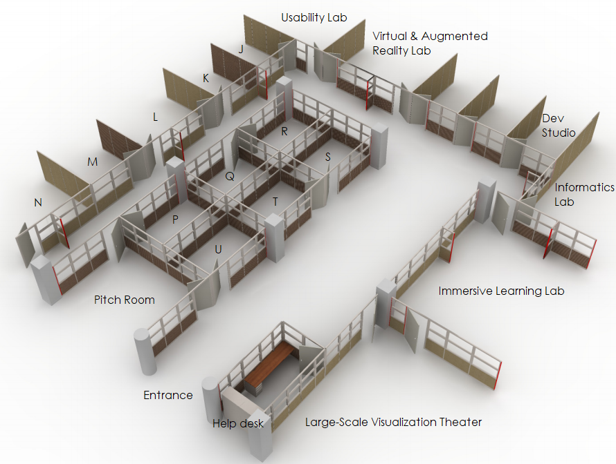

Background
Planning for a reconfiguration of the IDEA Lab started in late 2019, with a planning meeting and document drafted in January 2020. IDEA Lab staff consulted with Library Facilities, Library IT, Engineering IT, and Grainger staff to evaluate the proposed changes and receive feedback. Generally, the plan was to subdivide the open layout of the Lab to better support new and existing use cases and needs. Purchasing and installation for the new partitions and furniture took place over the Summer and Fall of 2020, and into Spring of 2021.

Layout and Spaces
The above image shows the new layout:
- 8 small group (4-6 people) conference rooms, each equipped with collaboration tables and displays.
- The “Pitch Room” for small group (4-8 people) presentations. Equipped with a 84” wall-mounted display, A/V support equipment, and lounge seating.
- The “Large-Scale Visualization Theater” for large group (12-15 people) viewing of audio/video content on the 8’x15’ 8K display wall, equipped with teleconferencing devices, and lounge seating with attached desks.
- The “Immersive Learning Lab” for large group (12-15 people) workshops, course labs, RSOs, campus eSports, equipped with high-end workstations for development, VR-content, and an instructor station that casts to two 84” wall-mounted displays.
- The “Informatics Lab” for medium groups (6-10 people), equipped with 4-panel 8K “mini visualization wall”, multiple rolling display carts, teleconferencing devices, and a large wall-mounted whiteboard.
- The “Dev Studio” for IDEA Lab graduate students and hourly developers to build and test IDEA Lab custom software projects as well as storage and post-processing support for the Artec Leo 3d Scanner and 3DS3 scanning project.
- The “Virtual & Augmented Reality Lab” for small group (4-6 people) experimentation and development support for VR/AR, including workstations, headsets, and support equipment.
- The “Usability Lab” for small group (4-6 people) usability sessions, including a moderator workstation, multiple high-res webcams, and support software and equipment for conducting experiments and recording outcomes.
- The “Help Desk” located at the entrance to the Lab for questions, space reservation check-ins, and loanable tech. All Lab rooms will be locked when not in use, valid reservations will be required for every space.
- Two public high-end workstations will also be available in the remaining “open space” areas of the Lab, along with limited lounge seating, and an area for posting community and campus announcements.
- Previously, the IDEA Lab was equipped with 3d printers and support equipment for rapid prototyping. This space and equipment has been moved to a new location within Grainger, with plans for a more comprehensive “Maker Space”.

Access Policy
Previously, the IDEA Lab had a closed access policy. Patrons were required to apply on semester-to-semester basis to be granted access to the Lab. Once granted, patrons would use their iCards to swipe into the space any time Grainger was open (ie. 24 hours a day during the regular semester).
IDEA Lab 2.0 is adopting a new “open” access policy:
- IDEA Lab will have operating hours, tentatively 10AM-10PM Monday-Friday, with some limited hours on the weekends (not including virtual resources which will be unaffected).
- IDEA Lab will be open to the public during operating hours. No access applications required.
- All spaces described above will be reservable by any campus member, using the “Spaces” tool administered by Springshare, for both recurring and on-off uses.
- All Loanable Technology will be reservable by any campus member, using the “Equipment” tool administered by Springshare.
- IDEA Lab will be staffed by a trained lab tech during all operating hours. Techs will be available for on-site technology trouble shooting, space & equipment reservations, tours & questions, as well as support for regular and one-off events utilizing the Lab spaces and technology.
New Business
MJ requested approval of the review procedure for removing suggested harmful language. The group made the following suggestions:
- The title should be more specific.
- Search terms and subject identifiers should be more specific.
- A clear explanation of what is covered.

MJ’s group will work on the above items and bring back to this group.

- Parking Lot Items-Review
- New Title List
- Illinois Databank
- Expertise Portal
- Persistent Identifiers

Meeting adjourned at 2:50 p.m.

