CAPT Meeting Minutes
June 24, 2021
Via Zoom

Present: MJ Han, Ayla Kenfield, Bill Mischo, Michael Norman, Chris Prom
Kyle Rimkus, Tom Teper, Tracy Tolliver

Absent: Jim Dohle, John Laskowski, Mary Laskowski, Wendy Shelburne

Notetaker: Wendy Wolter

Agenda and Minutes
Tom Teper opened the meeting asking for approval of the June agenda, and May minutes. Agenda and minutes unanimously approved.

ILS System Migration Update – Michael Norman
Everything is set up with Alma and Primo. Now that we are no longer using HT ETAS, we removed all of the temporary locations from the catalog (ca. 5.1-million items) over about three days. Kudos to Jay Heldreth’s work on the Primo side and EasySearch component. Everything should be set up the way that it was pre-ETAS. There is a little clean-up work being done on this since adding the HT ETAS temporary locations deleted any pre-existing temporary locations. It looks like it impacted ca. 2,100 items that we are in the process of correcting. The good news is that we can run reports against Alma Analytics to regain that previous Temporary Location information. Alma records every activity (event) that occurs in the catalog including when an item is moved to a different location or, in this case, if temporary location is assigned to an item. Alma defines this as keeping a provenance of activity for all items in the catalog. This provenance location information is available in Alma Analytics and reports can be run against that activity.

Quarterly Working Group Reports
Search, Discovery, and Delivery – Bill Mischo
Easy Search: increase in searches this summer, up 15% and click throughs up 19%.

Fixed a problem identified by Susan Braxton where Primo records displayed by clicking in from Easy Search did not allow extraction and saving of permalinks and the QR code. Very slight problem with the query string we were sending to Primo.

Continuing tweaking of the Open URL that we are sending from Easy Search to the Alma link resolver.
Will be changing the language on the DOI links and Publisher links in Easy Search to indicate that “this link will work if we are subscribing to the journal through the publisher. Otherwise try the Other Fulltext Links.” Study shows 96% of the DOI and Publisher links resolve properly but small percentage that don’t. Users seem to understand that we are putting up optimistic links. Publisher links also fail for other reasons; ongoing dialog with EBSCO.

OhioLink/Schonfeld study and Task Force:
Now is the time for a revolution in discovery.
- Catherine Coleman, Stanford Library, 2018
The systems we buy…will require a fundamental re-orientation to the needs of the academic user, and similarly a fundamental re-architecture and re-configuration ….
OhioLINK It’s Not What Libraries Hold; It’s Who Libraries Serve, 2020
- https://doi.org/10.18665/sr.312608
- Presentation at CNI 2020

Semantic search with EBSCO; also Yewno problems.

Adding to the EBSCO and Scopus API results asynchronously (via the API-supplied DOIs):
- Altmetric Badges giving attention scores
- Scholix derived dataset links
- UnPaywall open access links showing OA articles
- Browzine PDF links and issue TOC links
- Alma-Primo Link Resolver links for non-DOI fulltext

Ongoing transaction log and user studies. Usability Lab in the IDEA Lab.
Logs Instrumented to record user actions, system suggestions, search reformulations, and clickthroughs
- Identify search sessions
- Collected 11 years of logs: 16.5 million searches and 15.8 million clickthroughs
- Latest study: May 2017 – April 2018: 2.75 million actions, 1.51 million searches, incl 1.1 million in bento system
- Sample of 5,400 searches analyzed for type of search (known-item vs. Exploratory), success rate, user behaviors

- Average words per query = 6.2 - up from 5.6, 5.1, 4.1, 3.8 in previous analyses)
  - 9.1% are one word, 44.9% are 3 or less, 28.7% are 7 or more, 20.5% are 9 words or more
  - Copy and paste searching
  - 2.07 searches per session. 60% of sessions are one search
- In 21.8% of searches, a search suggestion was offered; the suggestion was clicked 28.1% of the time. Most popular: “did you mean” spelling suggestions and the Direct Suggestion links
- 1% were DOI searches (76 searches per day)
- In the sample of 5,400 searches, 1.5% of the searches were citation searches. 45 per day, 16,000 for the year
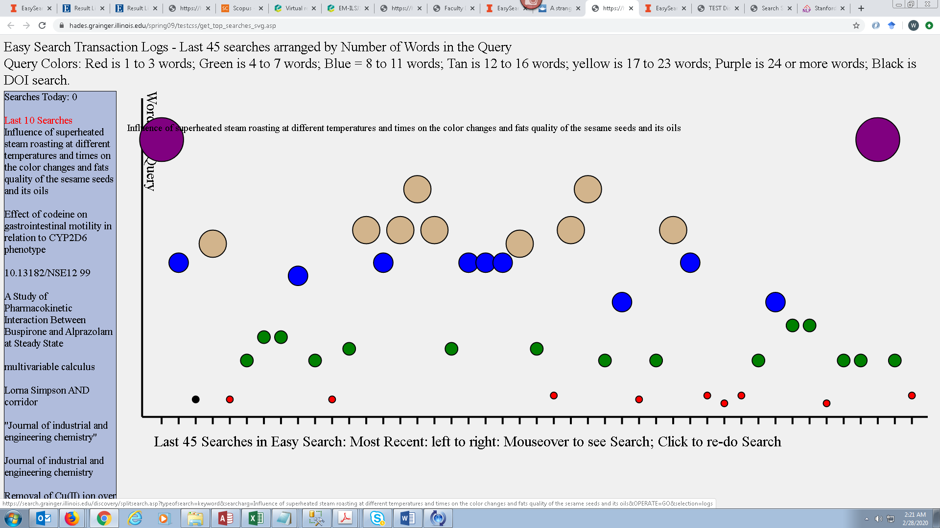

- Average of 2,707 clickthroughs per day. 116 different click actions with 44 of the links being clicked an average of once a day or greater
- 58.3% of 1.1 million searches had a clickthrough action
- 78.6% of the 530K sessions had a clickthrough action

April 2020: 141,784 searches, 3770 clicks per day
- Full Text clicks: 1600 per day, 41.7% of all clicks
- Browzine - PDF: 224 per day, TOC: 5 per day
- Bing - 102 clicks per day
- “Did You Mean” spelling suggestion - 54.7 per day
- Unpaywall - 20 per day – increasing since remote teaching
- Direct Link Suggestions – 20 per day
- AtoZ Journal list - 19.3 per day
- Dataset (Scholix) - 6.2 per day
- Ask a Librarian - 4.3 per day
- Email a Subject Librarian – 1.9 per day
- Clicking an Ad - 1.8 per day

Monitoring 42 academic libraries with bento instances
10 libraries have dropped bento, 7 are Primo installations
All have Books and Articles areas
WSDS for articles: 21 Summon, 10 Primo, 10 EBSCO EDS
Website search = 34
Library/research guides = 24
Journal titles = 20
Databases = 23
Digital collections = 12
Manuscripts/Archives = 9
Dissertations/Theses = 3
Institutional Repository = 3
Course Reserves = 3
FAQ = 6
Contacts = 18

Cataloging and Metadata – MJ Han
EDI work in cataloging
- Presented at the Library Hangout for what we have been doing
- Works underway –
  - Working with CARLI and Discovery Group (Michael!) to make the alternative terms display and searchable
  - Refining review procedures
Data Cleanup projects
- Ongoing
  - Serials summary note (MFHD 866 field)
  - Duplicated records with the same OCLC number
  - Holdings cleanup
    - misuse of the holdings 866 field
    - misuse of the holdings public notes 852 $$x
- Host Bibliographic records:
  - Workflow completed
    - Series – unlink a series record from the real title
    - Serials title changes – relink holdings records to an appropriate title record
  - Under discussion:
    - Bound volumes with unique titles – complicated and several variants
For Special collections
- Local extensions set up
- BibNotification considerations

Alma training for serials - ongoing

E Resources – Wendy Shelburne
- Wendy was unable to attend this meeting. The E Resources report will be moved to next month’s agenda.

- Parking Lot Items-Review
- New Title List
- Illinois Databank
- Expertise Portal
- Persistent Identifiers

Meeting adjourned at 2:40 p.m.

