CAPT Meeting Minutes
July 29, 2021
Via Zoom

Present: Bill Mischo, Michael Norman, Chris Prom, Kyle Rimkus, Tom Teper, Tracy Tolliver

Absent: MJ Han, Ayla Kenfield, John Laskowski, Mary Laskowski, Wendy Shelburne

Notetaker: Wendy Wolter

Agenda and Minutes
Tom Teper opened the meeting asking for approval of the July agenda, and June minutes. Agenda and minutes unanimously approved.

ILS System Migration Update – Michael Norman
The new I-Share Union Catalog View
On July 22nd, CARLI made available a separate I-Share Union Catalog View which allows users to search all resources across the 89 institutions participating in I-Share, including physical inventory, electronic inventory, and external data sources imported into local Primo VEs. It also includes external data sources items like CARLI Digital Collections, institutional repositories, digital asset management systems, and LibGuides, which usually are only viewable in the institutional Primo VE interface to which they were added. The link to the new I-Share Union catalog is: https://i-share-network.primo.exlibrisgroup.com/discovery/search?vid=01CARLI_NETWORK:IShare_UNION
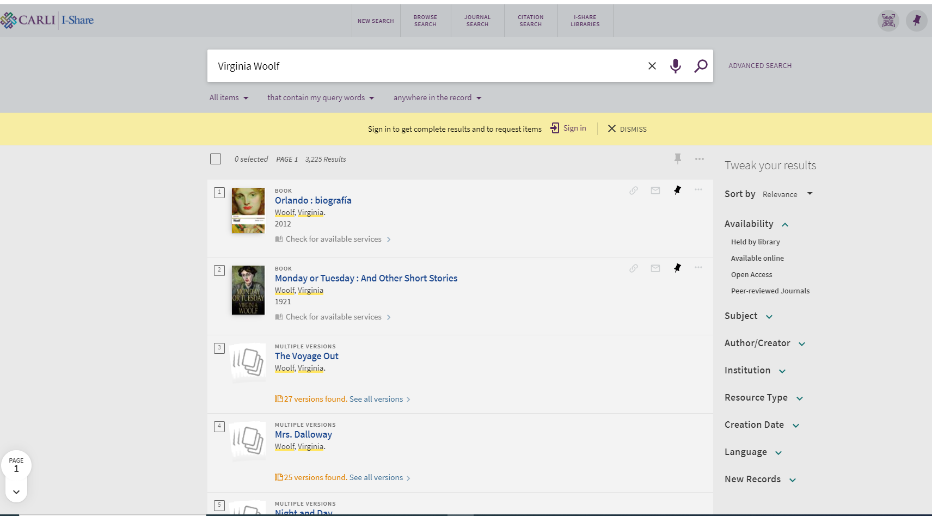
This version of the I-Share Union Catalog (see screenshot above) is configured differently from the I-Share Catalog that the Library provides access to on our Primo landing pages and drop-down menus. There are major differences between to 2 versions. The new separate one combines and groups together various versions of the title into one display record (i.e. 25 versions found for the book Mrs. Dalloway above). The UIUC version of the I-Share Union Catalog is similarly configured to our Primo settings (see screenshot below) where each title has single display in the brief record results:
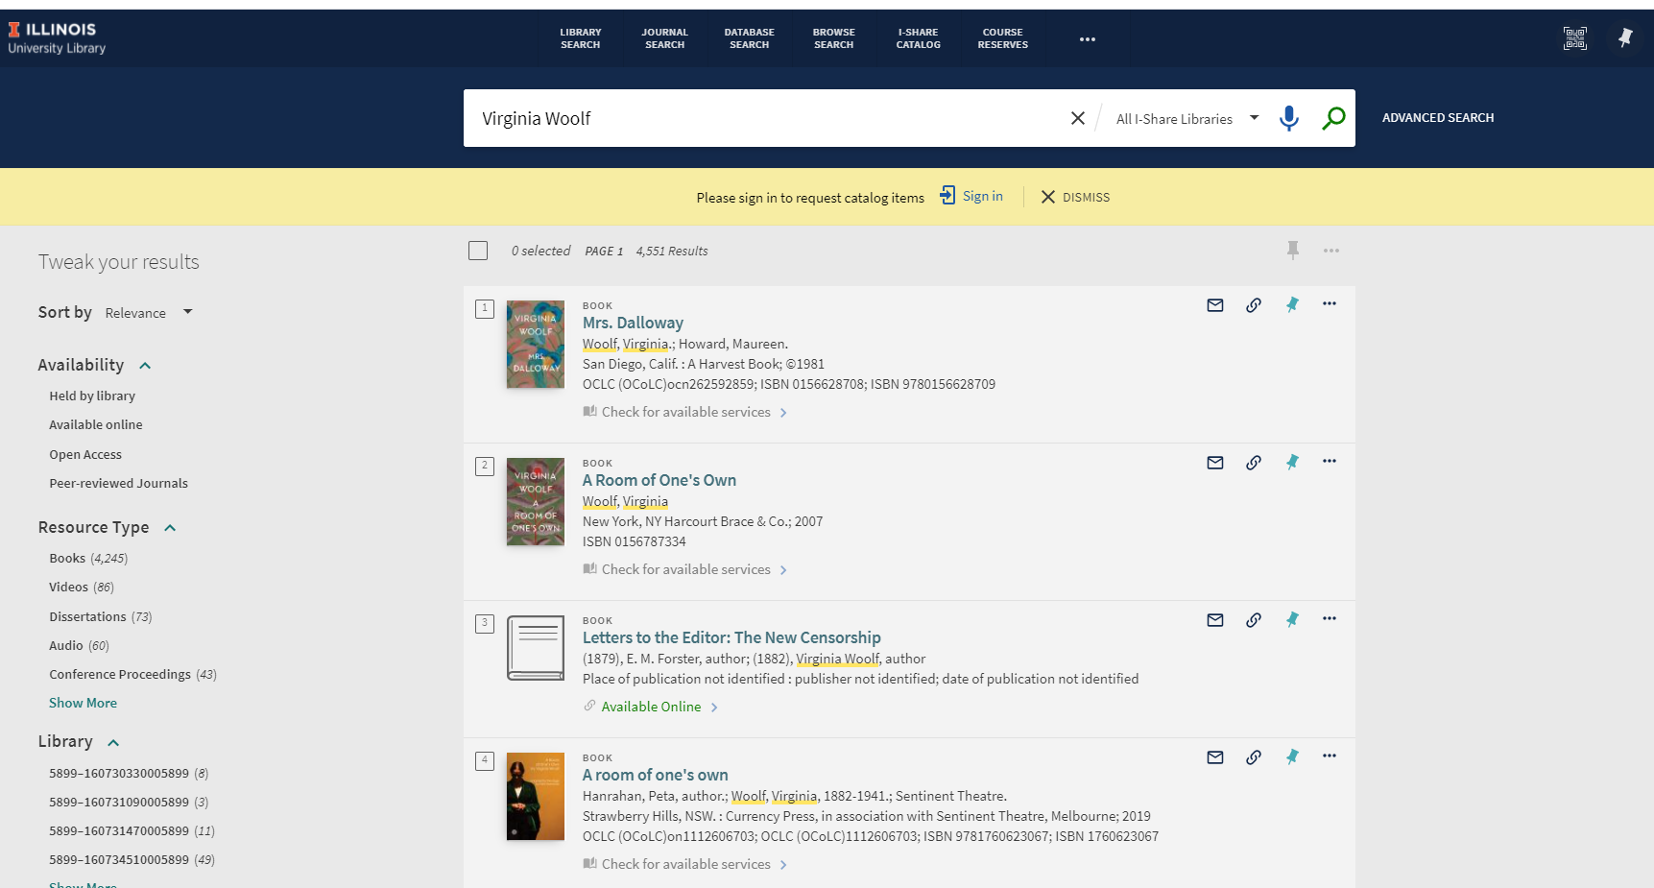
The Library will need to determine how best to advertise this new I-Share Union Catalog view to users. It could be confusing to have two different versions of the I-Share Catalog available to UIUC Library users and the different logistics of logging in and requesting materials in the two different systems. We will have more information out soon about how best to utilize the two different versions. Here is a URL link for more information on the new I-Share Union Catalog: https://www.carli.illinois.edu/products-services/i-share/discovery-interface/i-share_union_view
I-Share Title Overage
CARLI alerted us recently that the consortia is currently storing a greater number of bibliographic title records in the Alma cloud than was contracted for. The title count is one of the Alma pricing metrics, so this overage could lead to cost increases in the Alma annual license fee that CARLI pays Ex Libris. They believe that a substantial portion of the overage is due to duplicate titles in Alma, some of which is an after-effect of the data migration for all I-Share libraries. To get back below the overage of records, Ex Libris is allowing over the next year to bring the numbers into contractual compliance. CARLI is asking individual libraries to make this data cleanup a high priority to complete by June 30, 2022.
Ex Libris and CARLI believe that there are multiple factors that have led to I-Share so quickly having exceeded the contractual title count. One of these factors is the number of duplicative e-resource titles that were migrated into Alma from our multiple Voyager databases, SFX, and other e-resource management systems. Over the years, the consortia libraries had created many duplicates in Voyager by loading the same e-resource collection bibliographic data into each Voyager database to make up for Voyager’s lack of true e-resource management functionality.
CARLI will be providing reports to help identify and address redundant or obsolete data in the Alma cloud.
UIUC Primo Library Catalog Activity from June 24, 2020 to June 30, 2021
We thought a preliminary snapshot of the Primo Library Catalog usage activity from June 24, 2020 to June 30, 2021 might be of interest. We are still delving into how best to utilize the Alma and Primo usage stats and will be presenting on this at an upcoming information session of the Primo Library Catalog:
Action Group | Action Sub Group | Action | Sessions | Actions | Signed In
Primo Catalog | Actions | Primo Catalog - Overall Activity | 5,062,404 | 6,478,563 | 798,024
Primo Catalog | General | Display full record | 3,264,850 | 3,884,253 | 169,248
Primo Catalog | Search | AZ list | 125,833 | 154,046 | 15,354
Primo Catalog | Search | Advanced search | 69,281 | 117,393 | 9,845
Primo Catalog | Search | Basic search | 599,179 | 815,391 | 104,007
Primo Catalog | Actions - Send To Section | BibTeX | 3,155 | 3,704 | 1,110
Primo Catalog | Actions - Send To Section | Citation | 14,879 | 27,381 | 3,976
Primo Catalog | Actions - Send To Section | Click on the QR action from full record display | 1,178 | 1,359 | 517
Primo Catalog | Actions - Send To Section | EasyBIB | 2,774 | 3,132 | 733
Primo Catalog | Actions - Send To Section | EndNote Web | 1,144 | 1,326 | 320
Primo Catalog | Actions - Send To Section | Print | 5,116 | 5,675 | 1,506
Primo Catalog | Actions - Send To Section | RIS Export | 3,950 | 5,358 | 1,360
Primo Catalog | Actions - Send To Section | Remove from eShelf | 1,972 | 2,953 | 1,588
Primo Catalog | Actions - Send To Section | eMail | 6,276 | 7,729 | 2,463
Primo Catalog | Actions - Send To Section | Permalink | 24,261 | 45,373 | 5,441
Primo Catalog | Citation Style | Citation Style 1 - MLA (7th Edition) | 9,097 | 11,616 | 1,660
Primo Catalog | Citation Style | Citation Style 2 - APA (6th Edition) | 5,240 | 7,339 | 1,023
Primo Catalog | Citation Style | Citation Style 3 - Chicago/Turabian (16th Edition) | 3,302 | 5,172 | 873
Primo Catalog | Citation Style | Citation Style 4 - MLA (8th Edition) | 1,746 | 2,641 | 361
Primo Catalog | Citation Style | Citation Style 5 - Harvard | 462 | 626 | 59
Primo Catalog | Lateral Linking | Lateral Linking – Author | 5,312 | 12,281 | 2,358
Primo Catalog | Lateral Linking | Lateral Linking – Ispartof | 31 | 55 | 5
Primo Catalog | Lateral Linking | Lateral Linking – Relation | 105 | 220 | 100
Primo Catalog | Lateral Linking | Lateral Linking – Subject | 6,206 | 15,768 | 3,099
Primo Catalog | Tags and Reviews | Add tag | 3 | 6 | 6
Primo Catalog | eShelf | Save to eShelf | 3,924 | 11,332 | 9,173
Primo Catalog | Virtual Browse | Click Next in Virtual Browse | 33,413 | 36,989 | 11,449
Primo Catalog | Virtual Browse | Click Previous in Virtual Browse | 24,220 | 26,601 | 8,293
Primo Catalog | Virtual Browse | Click on Record from Virtual Browse | 10,784 | 13,789 | 4,838
Primo Catalog | Virtual Browse | Navigate to Virtual Browse | 8,308 | 9,927 | 4,393
Primo Catalog | General | Go to Search History | 799 | 858 | 702
Primo Catalog | General | Go to eShelf | 3,716 | 4,475 | 3,670
Primo Catalog | General | Main Menu Links | 66,423 | 77,251 | 44,712
Primo Catalog | My Account | Sign-in to My Account | 91,948 | 95,339 | 0
Primo Catalog | My Account | Sign-out from My Account | 9,366 | 9,426 | 5,514
Primo Catalog | My Account | Add Label in eShelf | 137 | 1,399 | 1,399
Primo Catalog | My Account | Blocks and Messages | 5,251 | 6,118 | 6,116
Primo Catalog | My Account | Cancel Request | 772 | 987 | 986
Primo Catalog | My Account | Fine and Fees | 7,410 | 9,004 | 9,004
Primo Catalog | My Account | Loans | 27,409 | 37,850 | 37,843
Primo Catalog | My Account | Overview | 71,791 | 83,363 | 83,353
Primo Catalog | My Account | Personal Settings | 5,417 | 6,268 | 6,268
Primo Catalog | My Account | Remove Label in eShelf | 23 | 79 | 79
Primo Catalog | My Account | Renew Loans | 5,367 | 11,708 | 11,708
Primo Catalog | My Account | Requests | 17,071 | 22,734 | 22,728
Primo Catalog | My Account | Set alert | 3 | 3 | 3
Primo Catalog | My Account | Sort eShelf by author | 10 | 13 | 13
Primo Catalog | My Account | Sort eShelf by date | 4 | 4 | 4
Primo Catalog | My Account | Sort eShelf by title | 16 | 18 | 18
Primo Catalog | General | Click on Remember All Filters | 244 | 299 | 56
Primo Catalog | General | Facet filtering | 30,243 | 55,213 | 12,803
Primo Catalog | General | Facet set as persistent – Exclude | 1 | 1 | 0
Primo Catalog | General | Facet set as persistent – Include | 43 | 46 | 9
Primo Catalog | General | Next page | 30,873 | 90,281 | 19,160
Primo Catalog | General | Previous page | 46 | 61 | 12
Primo Catalog | General | RSS subscription | 2 | 3 | 3
Primo Catalog | General | Remove facet filtering | 3,592 | 5,382 | 1,347
Primo Catalog | Records Bulk | Add bulk of records to favorites | 6 | 6 | 4
Primo Catalog | Records Bulk | Export bulk of records to Bibtex | 11 | 12 | 5
Primo Catalog | Records Bulk | Export bulk of records to RIS | 8 | 12 | 2
Primo Catalog | Records Bulk | Select a single record | 373 | 987 | 389
Primo Catalog | Records Bulk | Select displayed records | 112 | 131 | 42
Primo Catalog | Records Bulk | Select top records | 15 | 17 | 6
Primo Catalog | Records Bulk | Send bulk of records to Easybib | 11 | 15 | 8
Primo Catalog | Records Bulk | Send bulk of records to Email | 15 | 18 | 5
Primo Catalog | Records Bulk | Send bulk of records to Endnote | 4 | 4 | 1
Primo Catalog | Records Bulk | Send bulk of records to Print | 14 | 22 | 6
Primo Catalog | Records Bulk | Unselect a single record | 118 | 190 | 92
Primo Catalog | Records Bulk | Unselect all records | 46 | 50 | 14
Primo Catalog | Sort | Sort by author | 144 | 159 | 40
Primo Catalog | Sort | Sort by date | 1,143 | 1,650 | 229
Primo Catalog | Sort | Sort by local sort field | 2,241 | 2,957 | 435
Primo Catalog | Sort | Sort by rank | 228 | 253 | 46
Primo Catalog | Sort | Sort by title | 437 | 485 | 84
Primo Catalog | Browse | Browse Dewey call numbers | 1,475 | 2,812 | 29
Primo Catalog | Browse | Browse Library of Congress call numbers | 6,833 | 14,662 | 149
Primo Catalog | Browse | Browse NLM call numbers | 5 | 5 | 1
Primo Catalog | Browse | Browse authors | 4,074 | 5,308 | 2,055
Primo Catalog | Browse | Browse generic call numbers | 565 | 4,797 | 96
Primo Catalog | Browse | Browse page | 6,283 | 7,171 | 3,555
Primo Catalog | Browse | Browse related records | 4,421 | 5,902 | 1,267
Primo Catalog | Browse | Browse titles | 4,494 | 5,902 | 1,666
Primo Catalog | Search history | Saved query | 27 | 66 | 64
Primo Catalog | Search history | Session query | 58 | 111 | 52
Primo Catalog | Voice Search | Voice Search | 63 | 111 | 24
Primo Catalog | Voice Search | Voice Search – didn’t get it | 53 | 73 | 13
Primo Catalog | Voice Search | Voice Search – exit | 138 | 146 | 51
Primo Catalog | Voice Search | Voice Search- Didn’t get it, please check your mic | 22 | 22 | 3

Alma/Primo Open Office Hours occurring each week through September 29th
We continue to have an Alma/Primo Open Office Hour starting on Wednesday at 11 AM each week. Michael Norman will dedicate this hour to working in Alma or Primo Library Catalog to highlight many of the different activities in the two systems. In a collaborative manner, we will discuss Alma and the Primo Library Catalog and demonstrate the various functions of both systems. There will be time for questions and comments during the hour. The Zoom session for the weekly open office hour is:
Topic: Alma/Primo Weekly Open Office Hour

Every week at 11:00 AM on Wednesday, until Sep 29, 2021:
Aug 4, 11, 18, 25
Sep 1, 8, 15, 22, 29

Quarterly Working Group Reports
Web – John Laskowski
The Web Working Group has finalized the design of the new Employee Site rebuild. The homepage wireframe is shown here. The Web Team will work on developing the new structure and design while the WWG commits two smaller teams to working on “stage 2” developments. These smaller teams are focused on exploratory possibilities for improving our current calendar and directory features. The trick with each of these features is to eliminate existing redundancies where possible without losing any of the functionality that underlie the initial decision to create those redundancies.
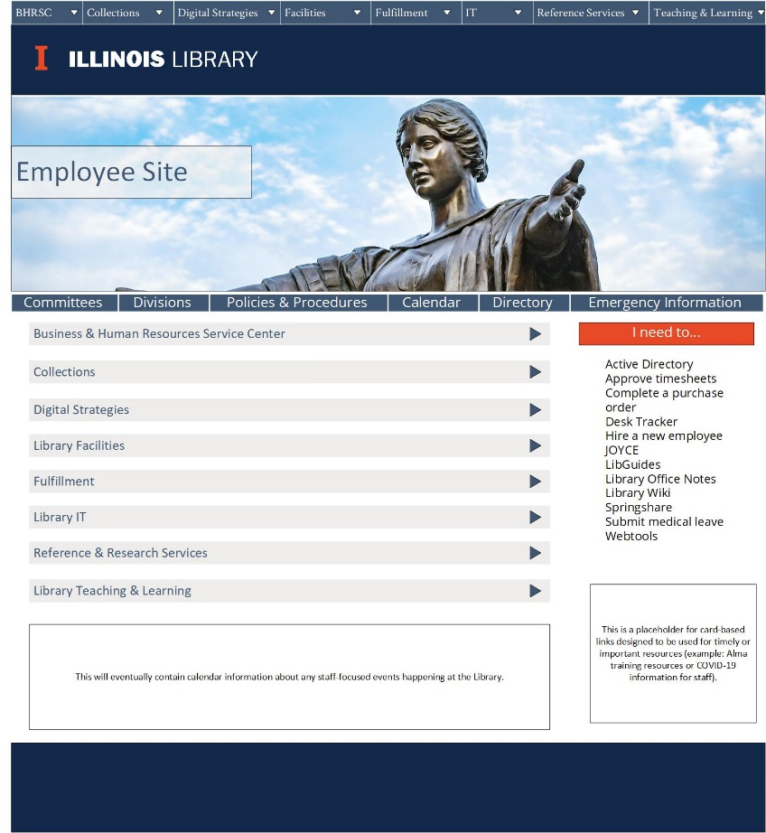
Heather Murphy and Kate Lambaria are working with me on the calendar issue (while also looking at redesigning the News & Events tab on the Gateway). Laila Hussein Moustafa, Michael Norman, and Megean Osuchowski working with me on the directory issue.

Two of our members’ terms expire in August. Helen Zhou and Megean Osuchowski occupy two of the five appointed positions on the working group. Because of this, we do not need to solicit volunteers to replace them should either choose to step down. Luckily, I’m happy to announce both Helen and Megean have agreed to serve another two-year term on the WWG.

- IT Staff Changes, Gaps, and Needs – Chris and Tracy
- LEITC new chair approval
- Tracy reported that Jim Dohle suggested Eric Kurt, co-chair of the LEITC committee become chair of LEITC since Jim’s departure from the Library. It is also suggested that Eric become part of CAPT in place of Jim.

- Parking Lot Items-Review
- New Title List
- Illinois Databank
- Expertise Portal
- Persistent Identifiers

Meeting adjourned at 2:05 p.m.

