CAPT Meeting Minutes
February 25, 2021
Via Skype

Present: Jim Dohle, MJ Han, Ayla Kenfield, John Laskowski, Bill Mischo, Michael Norman, Chris Prom, Kyle Rimkus, Tom Teper, Wendy Shelburne

Absent: Mary Laskowski, Tracy Tolliver

Notetaker: Wendy Wolter

Agenda and Minutes
Tom Teper opened the meeting asking for approval of the February agenda, and December minutes. Agenda and minutes unanimously approved.

ILS System Migration Update – Michael Norman
New Alma Interface –The new Alma UI will become the exclusive user interface on March 7th. When Ex Libris released the new Alma Interface back in November 2020, one could revert to the old UI Interface. Starting on March 7th, after logging into Alma, we will only be able to work in this new Alma interface. For a short demo of the new Alma Interface (with some comparisons to the older version), see: https://www.youtube.com/watch?v=hXrWOVB1BNo

New Alma Metadata Editor – The new Alma Metadata (MD) Editor becomes the default version on March 7, 2021 as well. Users can still switch back to the Old Metadata Editor if one wants through June 6th, 2021, when the new MD Editor becomes the exclusive version. To switch back to the original MD Editor, select Old Editor on the right-hand side of the top toolbar of the new Metadata Editor. To see a demo of the new Metadata Editor: https://www.youtube.com/watch?v=LUL_N8FzFIs&feature=youtu.be

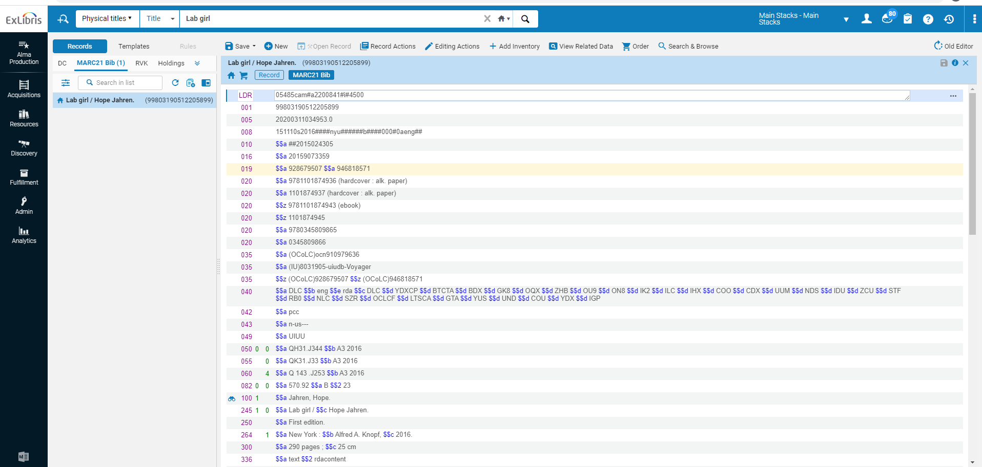

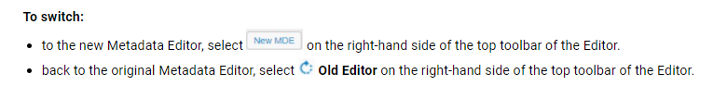

Working with Alma/Primo in Microsoft Internet Explorer – After March 7th, 2021, Alma and the Primo Library Catalog will no longer support the Microsoft Internet Explorer browser (including no longer fixing display or performance issues of Microsoft IE). Ex Libris certifies the following browsers: Microsoft Edge, Google Chrome, Mozilla Firefox, and Apple Safari.

AngularJS – The AngularJS community has announced that Angular JS will no longer be further development and all AngularJS applications that are working now will continue to work currently but no new development work will continue into the future. Ex Libris is reviewing options how this could affect Primo VE in the future. The Library does utilize AngularJS in several web programs in the Primo Catalog and we are examining options to switch to new coding libraries in the future.

Refresh of the Premium Sandboxes – The Alma and Primo Sandboxes were refreshed on February 14th. Previously, The Sandboxes had data from August 2020. With this new refresh, these new versions of the Premium Sandboxes have new data and changes to configuration that have occurred the past six months.

Access to HathiTrust ETAS in the Primo Catalog – Earlier in February, we were able to update all items in the catalog that have access to full-text version through the HathiTrust ETAS program. Over 5 million items of the Library’s collections are now available. Access to new titles are added on a continuous basis as new items are added to HathiTrust Digital Library on a daily basis. Currently, about 51 percent of the Library’s print collection is available through the HathiTrust ETAS.

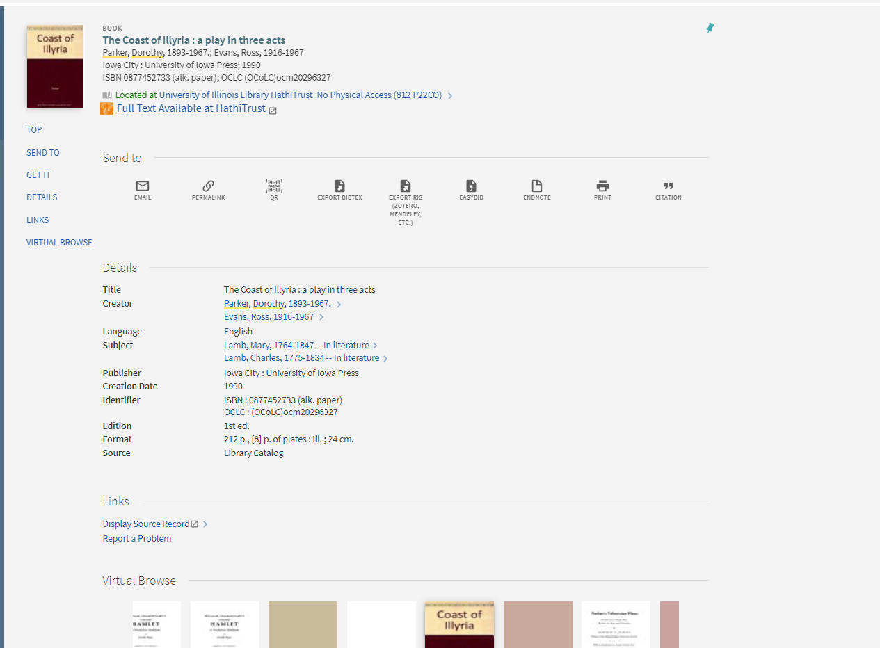

Quarterly Working Group Reports
Search, Discovery, and Delivery – Bill Mischo
- The system for generating the Research Impact Visualization One Medical Research Group has been updated to include a PDF link. Also added is a related articles link. This is a huge value to our users. There has been an uptick in searches in click throughs since these have been added.
- Working on the Alma Link Resolver for better full text access.

Web – John Laskowski
The big project for the Group currently is the redesign and rebranding of the “Staff Site” into the “Employee Site.” All employees are currently able to engage with an interactive, web-based prototype of the proposed design and complete a survey bout the proposed changes. This UX study will close Sunday and we’ll begin to analyze the responses. As of this morning, 26 people have completed the survey and taken an average time of just under 29 minutes to complete it. This is slightly misleading because the participants are encouraged to have the survey and the prototype open at the same time and it is unlikely many people can spend 30 uninterrupted minutes on anything in the current environment.

As with any potential designs there is room for improvement and several good recommendations have been proposed by survey respondents, but the exercise overall has been successful. The purchase of the prototyping software last year has been a huge boon for both web design and UX participation. Staff outside of UX and IT feel a greater sense of ownership over what is rightfully their sites and the Web Team’s time is schedule more effectively.

Two additions to the Gateway since the last report:
- We’ve created an Alert post type in WordPress that allows me and others to post notices at the top of the Gateway and all other pages. We have had a similar tool in the past that only the Web Team could control so this one allows us to be much more responsive to situations as they arise.
- Sticky tabs. Something UX participants have pointed out is that the site doesn’t “remember” which orange tab you were using when you linked away from the Gateway. Now when you linked away from the Gateway and then come back within the same session the last tab you had open remains open.

Finally, not directly related to the work of the Web Working Group, but in keeping with our general philosophy of considering our wide variety of users and increasing “marketing” of Library expertise, Monday we launch nine new sites for Preservation Services. They are aimed “outward” at our users and can be found under the “About” menu in the universal navigation menu.

Digital Production – Kyle Rimkus
As recently reported to LIBNEWS, I have gathered updated numbers on our Emergency Access Digitization service which I can provide, covering July 20, 2020 - February 20, 2021. During this time period,
- We received 2,440 patron-requested items in Preservation Services; of these, based most importantly on whether the patron expressed a preference for print or digital:
  - We sent 1,750 items to lockers for in-person pickup in the Marshall Gallery (72% of all requests).
  - We digitized 544 items for online access (22% of all requests).
    - 26 items were in the public domain; these we digitized in our in-house Internet Archive scanning center and made freely available in the Internet Archive.
    - 518 items were still protected by copyright; these we digitized in-house in Preservation’s Digitization Services group and made available to requesting patrons in our own local Digital Collections platform, with eventual limited access in HathiTrust Emergency Temporary Access System (ETAS). These items total 136,2228 pages digitized here on site.
  - We withdrew 133 items from the digitization queue due to their prior availability in electronic format or removed them due to other miscellaneous errors (6% of all requests).

It is interesting to note that in our first three months we found ourselves digitizing about 13% of all requested items. As we transitioned to the second half of the 2020 Fall semester, we expected to see a rising demand for digital access in response to campus instruction going fully remote, and for this reason we added new digitization staff and equipment to the project. Indeed, in the past four months, we have had to digitize 31% of all items to keep up with patron demand for remote access in digital format. For those keeping track, over the entire seven-month period so far, the numbers average out to 22% of all requests evincing a preference for digital access, 72% specifying a preference for physical access in lockers, and 6% of items being located as ebooks already available elsewhere. There’s a bit of ambiguity in these numbers, as not all patrons make it known which format they prefer, and in these cases, we may digitize or send to lockers based on our scanning capacity, but since our process focuses on making sure to digitize at least everything people request in digital format, to the best of our knowledge these numbers seem to reflect patron demand.

One thing I didn’t mention in the LIBNEWS was that we have also been providing emergency access digitization services for media content. To date, Media Preservation has digitized (both in-house and outsourced) 97 media assets as part of the Library’s COVID-19 response.

With CAPT and others, we are interested in exploring what we should be thinking about looking ahead to the end of the pandemic. We could consider keeping some of what we’ve built for emergency access (digitization equipment, staffing, software) to support some form of controlled digital lending, that is, ongoing on-demand patron-driven digitization for limited online access.

Repositories, Preservation, and Access – Ayla Kenfield
Current membership:
- Chair: Ayla Stein Kenfield, SC&P
- Vice-Chair: Kyle Rimkus, Preservation Services
- Seth Robbins, SCARS
- Hoa Luong, RDS
- Dan Tracy, SC&P
- Jason Strutz, Library IT
- Mark Zulauf, SC&P
- Sarah Harris, Archives

Meetings
Held meetings in December, January, and February

Activities of Note
- IDEALS policies
  - reviewed:
    - Access and Use Policy
    - Access Restriction Policy
    - Community Policy
  - Still need to incorporate suggested changes into new versions.
  - Next up: Individual Depositor Policy
- Another discussion on the second handle server and whether or not IT should devote resources to developing a GUI for minting new handles.
  - This led to a question we’d like this group to discuss:
    - It would help a great deal if we had a service owner to guide what's helpful and what's overkill. IT generally thinks this service belongs in cataloging if there's someone with expertise on how to organize handles, so they make sense for the various users of them.

LEITC – Jim Dohle

Monthly meetings
- Last met: 02/18/21 (Working group); 10/15/20 (Advisory group)
- Next meeting: 03/25/21 (Working group); 03/21 (Advisory group)

Membership
- No changes to membership as of 02/21; will revisit Advisory group membership at March ’21 meeting.

Recent activity

COVID-19 updates
  - Most in-person activities continue to be postponed or canceled due to coronavirus
  - Most studios are available to be reserved in limited capacity.
  - Virtual support and online consultations continue.
  - Development of 3D and VR related projects continues.

Collaborations
  - UIUC campus VR and Emerging Technologies groups
    - Ongoing Library participation in campus efforts to discuss a variety of emerging technology and extended reality topics including Virtual Reality, Augmented Reality, 3D and 360 video, etc.
    - Recent Updates
      - Emerging Tech steering committee meeting 02/18/21.
        - Guest presentation and discussion with Dr. Judith Pintar (iSchool)
        - Planning for forthcoming undergraduate and graduate minor program in Gaming Studies

Web presence
  - LEITC website (no update 02/21)

Technologies
  - 3D and VR applications, tools, and content management
    - 3Deposit
      - Rob Wallace [RW] with IDEA Lab continues development on 3Deposit, a service coordinating system(s) for centralized storage, access and discovery of 3D assets and virtual reality generated content.
      - RW: 3deposit rewrite is finished; dev deployment up at https://3deposit.library.illinois.edu
      - Putting together a full workflow guide for capturing, post-processing in Artec Studio, depositing, and distributing.
- Komodo (VR learning tool)
      - [RW]: Komodo completed alpha user testing this semester with two courses: MSE404 (Computational Materials Science – Microscale) and ARTS221 (Fashion Illustration)
      - https://vr.web.illinois.edu/2020/11/09/fashion-critique-in-komodo/
      - Continue to work with these instructors Spring ‘21 semester.
      - Applied for grant funding.
    - Ginger
      - [RW]: Building 'street-view' tours for College of Engineering and DRES committee; Command line tool and desktop application; development continuing remotely.
      - Update: work resuming on Ginger project Spring ‘21
        - 360 photo tour generator and editor
        - Supports DRES & College of Engineering Facilities project on ‘Invisible Disabilities’.
    - 3D Scanning Service
      - Artec Leo 3D Scanner information
      - Status update: Scanner received 02/21; training for users to be held 02 & 03/21
      - Space for hardware storage and post processing located in IDEA Lab.
      - First scans will be items identified from RBML collection.
  - UIUC Anyware
    - Eric Mosher continues to work with a cross-functional team from the UIUC campus formed to expand and enhance the Virtual Computer Lab.
    - UIUC Anyware information
      - Overview: https://go.illinois.edu/UIUCAnyWare .
      - Knowledgebase: UIUC AnyWare: Documentation and Additional Information.
      - To use the service, simply log in to UIUC AnyWare using a browser and you will be prompted to install Citrix Workspace.
    - Currently, the Library has 16 high-end Dell workstations (purchased as part of the Main Library room 220 refresh) available in the “Library Scholarly Commons” resource pool in the UIUC Anyware virtual computer lab.
    - These workstations include Scholarly Commons advanced software available to users who cannot physically access the machines on campus.
  - Pro Gear Rental (High-end loanable technology) @ UGL
    - Pro Gear (advanced technology equipment/kits) kits available to rent for UIUC campus faculty staff and students.
    - Dovetails with recent collaboration between the College of Media and UGL/Media Commons to support loanable technology for the Media and Cinema Studies (MACS) minor in Media Production.
    - UPDATE: Live as of February 2020; program on hold March 2020 due to campus COVID-19 response

Outreach/engagement
  - LEITC working group discussing opportunities to collaborate with Library innovation grant recipients, including AI Machine Learning and Data Science, 3D Scanning, etc.

Spaces

Grainger Engineering Library & IDEA Lab
- Grainger Commons rooms 233/235: project to replace existing Audio/Visual control system (99% completion Fall 2020)
- IDEA Lab reconfiguration): new services & resources, including VR Instruction Lab, 3D Digital Scanning Service, Usability Lab, Pitch Room, and new Collaboration Rooms (99% completion February 2021)

UGL & Media Commons
- UGL move planning.
  - Media Commons, Scholarly Commons, IDEA Lab and IT are coordinating with the Undergraduate Library/Main Library Integration Working Group sub-groups on the technology and related services to be transitioned from UGL in 2021/22
- Self-Use Audio and Video Booths
  - Online for Spring 2021 semester
  - Remote telepresence troubleshooting methods implemented.
- Audio Production Studio
  - Online and available for use pending Media Commons hourly staff availability.
- Immersive Production Studio
  - High-resolution 360 video and spatial audio capture workflows have been refined.
  - An investigation of Immersive Media and Low-Latency network streaming methods is ongoing.
- VR Spaces
  - Currently offline until other MC and UGL services are proven to be offered in a safe capacity.
- UGL289: Flexible, Technology-Enhanced Teaching and Learning Classroom
  - Hardware Install completed
  - Used for Remote Instructional Services Fall 2020 and Spring 2021 semesters

Main Library & Scholarly Commons
- Main Library room 220 (Summer-Fall 2020): ongoing project to add Audio/Visual control system and add advanced workstations as part of wider space refresh.
- Main Library room 106 (timeline TBD): ongoing project to add live streaming capacity to existing Audio/Visual system
  - Project on hold as room 106 is temporarily repurposed as part of Library re-opening Fall 2020/Spring 2021.

Future plans

Near term: 1-6 months
  - Review options for technology and related service changes with UGL move planning groups and assess opportunities, challenges, feasibility, and cost.
  - Work with John Laskowski on ways to prototype and test physical spaces with online users.
  - Continue participation in campus and Library re-opening and operational response given the unique circumstances of the COVID-19 pandemic.
  - Meet with members of the Library AI/ML group, discussing topics such as recommender systems, chat bot/assistants, AI bias detection tools, etc.
  - Discuss research and early findings working with campus licensed cloud platforms (AWS, Azure, GCP) and machine learning tools.

Mid-term: 6-12 months
  - Coordinate with UGL move planning groups to operationalize the strategic plans for moving UGL technology and associated services to other Library locations.
  - Rokwire project and the Library
    - begin preliminary work to organize future Library involvement, including collecting user stories, identifying relevant services/technologies and associated API’s, creating user experience brief, and beginning to wireframe Library @ Rokwire app UI.
  - Work with Communications group (Murphy) on marketing plans for Library emerging and advanced technologies resources (expertise, hardware, software, etc.) as the campus begins transitioning back to more on-premise instruction and interaction.
  - Review Extended reality (XR) @ Educause report & explore XR resources page and community group.
  - Projects awaiting prioritization:
    - Explore using LibDirectory database and associated web applications to connect users to Library advanced technology-related faculty, staff, and expertise.
    - Organize documentation and discovery of emerging and advanced technology resources:
      - Develop inventory of Library advanced technology spaces, equipment, and associated funding sources.
      - Review campus Research IT portal version 2.0, discuss strategy for Library-related resource imports, exports, and edits.

Longer term: 12-24 months
  - Engage with incoming faculty and staff with position responsibilities related to emerging and advanced technologies.
  - Investigate future opportunities to work with DPI (Discovery Partners Institute) efforts on the UIUC campus and in Chicago.
New Business – Cataloging and Metadata Working Group
Alternatives to the LCSH
“Aliens” and “Illegal Aliens” Subject Terminology

Prepared for the CAPT CMWG in January 2021 by:
- Erika Johnsrud
- Patricia Lampron
- MJ Han

Background
There have been a lot of discussions and actual conversion works for the Library of Congress Subject Heading (LCSH) Aliens and Illegal Aliens since 2016 as those terms impede efforts towards equity, diversity, and inclusion (EDI). The Library of Congress (LC) tried to revise the subject heading “Illegal aliens” in 2016 to “Noncitizens” and “Undocumented immigrants” as alternative subjects to “Aliens” and “Illegal aliens” as recommended by the
ALA/ALCTS Subject Analysis Committee (SAC) Working Group. Unfortunately, the House of Representatives objected to the change and ordered LC to continue using the terms.

However, many libraries decided to change or find ways not to use those terms in catalog records or display those terms in their public display. According to our research many libraries have already completed the conversion of those terms to more appropriate terms.

This report includes the motivation of the work and recommendations of the conversion work.

Motivations
The University of Illinois has many students, staff, and faculty from many different countries and provides research support for those visiting scholars from foreign countries. The University’s strategic plan includes that “We will be leaders in advancing diversity and equity that will contribute to creating an institution committed to excellence in discovery, teaching, and research, and a climate where all can achieve their highest aspirations in a safe and welcoming environment.” The Library’s strategic plan also stresses that we have to provide and support the EDI efforts in collection buildings and access services. This LCSH terms conversion project will be the first step of those efforts to support campus users and Library’s commitment toward the EDI work.

Recommendations

LCSH terms affected
The following are identified as the first conversion target with the recommended terms as LC tried to change in 2016.

LCSH | Alternative Term(s) | Number of records in UIUC/Carli that contain LCSH on 1/14/2021
Aliens | Noncitizens | 3474/6007
Illegal aliens | Undocumented immigrants | 1554/2990
Alien criminals | Noncitizen criminals | 132/238
Alien detention centers | Immigrant detention centers | 115/167
Alien labor | Foreign workers | 904/1087
Alien property* | Foreign property | 98/138
Children of illegal aliens | Children of undocumented immigrants | 50/90
Children of alien laborers | Children of foreign workers | 35/44
Deportation of aliens | Deportation of immigrants | 1/1
Illegal alien children | Undocumented immigrant children | 100/160
Women illegal aliens | Women undocumented immigrants | 25/53
Church work with aliens | Church work with noncitizens | 1/29

Work plan

- Conversion
There are two ways we can work on the conversion, change the actual catalog record, and change the display in PRIMO interface. While changing those terms in the catalog records sounds more permanent, it has its own challenges as below:
- We are a part of CARLI and catalog records in Alma are not just our Library’s own but shared with all CARLI libraries. So, all network zone records can be easily changed by either other member libraries.
- All catalog records in Alma can be refreshed by the OCLC Bib Notification work whenever the OCLC record has changes in main and additional access points, which will erase our change.
- The new terms are not in the LCSH yet.

Because of these challenges, UC Berkeley and U. of Colorado added new terms to the catalog records instead of changing them, and several institutions work with their discovery layers rather than changing their catalog records, including Villanova, California State, and SUNY. The SUNY has an extensive document on how to work with PRIMO to display those terms (also available in the research document).

We recommend that the Library change the display of those LCSH terms to those more appropriate EDI compliant terms in PRIMO. Based on the preliminary discussion with the CAPT Discovery Group, the work can be done by setting up a new rule.

- Catalogers
Catalogers will keep using the LCSH terms but be aware of the changes in display. The alternative terms will be available and in the LibGuide and updated whenever it is needed.

- Digital Library (newly ingested collections + current collections)
Current terms in the Digital Library System (DLS) will be evaluated for context and revised as necessary for EDI efforts. Future subject and keyword terms describing content in the DLS will utilize the same evaluation and application of recommended terms. The Metadata Specialist will regularly audit subject and keyword terms to comply with the recommendations.

- On-going maintenance
- The CAPT CMWG will closely monitor any updates/developments of the LCSH.
- ACS will monitor LCSH terms that need to be changed.
- ACS is going to review all bibliographic records with the LCSH term “Aliens” to identify whether the term is for the undocumented immigrants or extraterrestrial being and make appropriate changes accordingly.

Approved by the CAPT CMWG on February 8, 2021

- CAPT approved and welcomed this change.
- Bill will take to AC for approval and share the results with the group.
- If approved by AC, John will place this on the website in an area where this can be found easily.

- Parking Lot Items-Review
- New Title List
- Illinois Databank
- Expertise Portal
- Persistent Identifiers

Meeting adjourned at 2:25 p.m.

This was the first time a chamber of Congress had intervened over an LC decision regarding subject headings.
https://docs.google.com/spreadsheets/d/1oknCl6NNj5IsN6O7kjNc3B9ACUUArgMlrYIpyIPEX1w/edit?usp=sharing
https://strategicplan.illinois.edu/
https://www.library.illinois.edu/staff/wp-content/uploads/sites/24/2019/03/LibraryStrategicFramework-draft_2019may2.pdf
The LC updated its heading to “Foreign workers,” however the catalog still contains the former LCSH. We already updated those records.
The LC updated its heading to “Children of foreign workers.” ACS has updated those records with the new term.

