DEIA Task Force Meeting 2/16/2021

Present:
- Jessica Ballard
- Francisco Juarez
- Chris Prom
- Zoe Revell
- Erik Chapman
- Lauren Phegley
- Elisabeth Paulus
- DoMonique Arnold
- JJ Pionke
- Jen-chien Yu
- Heather Murphy
- George Gottschalk
- Norris Purdy
- Jake MacGregor
- Joe Lenkart

Missing:
- None

Agenda

- Starting off
  - Joe thanked the task force members for the helpful feedback from last meeting about the initial teams. Some members reached out by email to provide further ideas and suggestions, which was welcome
  - Jessica affirmed Joe’s comments and briefly described the agenda

- Shared Agreements
  - Jake designated to write down the shared agreements, selected old fashioned flip charts after brief discussion
  - Group brainstormed and discussed shared agreements
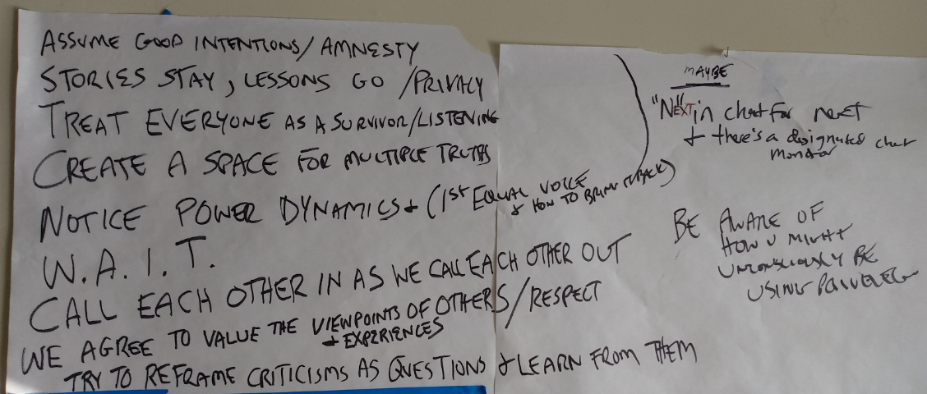
  - Jake transferred Shared Agreements to Google Doc so everyone can further refine and improve. Please review and edit the Shared Agreements here: https://docs.google.com/document/d/1ypSw75LoO0LOBFYF5-jZ7_4dQc4AFQx7yEAyrNsUmEk/edit?usp=sharing

- Forming teams
  - Joe: saw several themes from comments and suggestions members offered on the Box document about forming teams, which were
    - Communication
    - Assessment
    - Consultancy
    - DEIA definition and mission
    - Change management
  - Jen: asked in regards to assessment, are we assessing the task force (TF) itself? Jen prefers either to not do assessment or to assess the entire DEIA piece
  - JJ: we may need assessment in order to be transparent about the work that the TF is doing
  - Francisco: sought clarity on how we’re defining assessment, i.e., what does ‘assessment’ MEAN?
  - Jessica: agreed and said it might be more about how we define it for ourselves
  - JJ: shared example about a class project management where change happened concurrently with the project, i.e., there was a ripple effect and so without having planned in advance how to measure change, it was hard to demonstrate the effect the project had. Assessment is important for transparency and accountability
  - Jen: understands the point but sometimes ripple effect or impact can’t be measured until several years after something has happened
  - JJ: further shared example of Dean’s hangout as having ripple effects
  - Erik In chat: Are we developing an assessment plan for our specific work, or putting in place (or attempting to identify) a rubric to try to measure the impact of DEIA efforts which survives the task force?
  - George in chat: Agree with Erik's question as a great way to get at this. Perhaps a question for the Dean when we communicate back on our work? Or one of the reasons for communicating with the Dean. "We read it this way, but are suggesting something different because..."
  - Joe: the teams we create could help create scope around these areas. They could craft the scope and definitions of their area and bring it back to the whole group
  - Chris: the word assessment can be loaded b/c it depends on what we’re trying to measure and it could lead us to developing all kinds of metrics, and it may be difficult to measure impact throughout the entire library. So perhaps we focus on the core points about creating as much transparency as possible and assessing as we go about what did and didn’t work. On tech projects, we use something called a sprint retrospective to collect periodically what did or didn’t work, and record that, as a simple way to measure our progress, be transparent, and hold ourselves accountable. We could create a structure that doesn’t need to be too formal.
  - JJ: I would follow up and just say that the assessment doesn't have to be long. a 5 question survey in December--hit the easy button!
  - Jessica: noted the time and indicated we need to decide how to move forward
  - Jake: just want to make a quick point that I can sense some hesitancy about the consultant piece-- that it may be too soon.
  - Jessica: my hesitancy is that the Director for DEIA (search currently underway) may have consulting experience and we may not want to complicate things [or step on toes]
  - Jake: rather than having the consultant be the focus, I saw a couple areas on the Box document where it was more about the underlying need, and so maybe that’s a better place to start
  - JJ in chat: Kaamilyah in OAE has been working with DEI groups across campus. It might be useful to invite her to speak to us
  - Joe: seeing 3 areas now: communication, assessment, and needs analysis
  - Chris: can you speak about difference between assessment and needs analysis, why they would be different
  - Joe: explained rationale about separation [I did not capture this, I was reaching the Chat Messages—Joe can you please add here. Seemed like we leaned toward keeping them separate though. – JDM]
  - At this point we were close to 5PM, Jessica asked if people were able to stay a few minutes longer. Heather had to leave for a meeting
  - JJ: suggest 2 hour meetings and clarifying how we are communicating (teams, email, etc.)
  - Chris in chat: I agree with JJ. It would be helpful to have more or longer meetings, at least initially.
  - Francisco: pointed out there are 4 method in use now: Box, Zoom, Teams, email. Box important for sensitive info or preparing documents for dean, Teams has learning curve. Email is awful, if we do use it, please make a group for the email so we can more easily tell if one of us is emailing about the task force or other projects & work. And perhaps only Joe and Jessica use email list to announce things, and then the discussion happens
  - Elisabeth: mentioned difficulty with longer meetings with unit/supervisor expectations and would need to step off if it gets too big
  - Francisco in chat: i wouldn't like that to happen, Elisabeth. For you to step down. that sucks
  - Lauren in chat: It is the same with GA's as well
  - Erik in chat: Identify.
  - DoMonique: asked about having an MS Teams tour
  - Heather: also interested
  - Someone: Noted that Zoe had shared info about MS Teams training
  - Jake: offered to coordinate (potentially getting some info/assistance from Francisco and/or Megean Osuchowski) a short MS Teams tour if the group is interested; can help support the task force
  - Chris in chat: I like the idea of having Megean or Francisco give us a tour. I can’t make the Friday session, unfortunately. Tour could be a one-off lunch or something just for those interested and not take up time in a meeting
  - JJ: expressed concern that we are behind and can we go to the Dean to make it OK for task force members to set aside more chunks of time for the task force
  - Jessica: will discuss with dean about roadblock of juggling expectations and creating enough time for Task Force
  - Several members noted we don’t want to lose the voices of those who don’t have as much flexibility over their schedules and/or significant operational duties/demands
  - Zoe: please be sensitive to our employees and avoid naming names if bringing up with the dean
  - George in chat: Yes, you can clarify with the Dean without specifics

