CDC Meeting Minutes
November 24, 2020
Via Skype

Present: Tom Teper, Alex Cabada, Kit Condill, Esra Coskun, Mike Dickinson, George Gottschalk, Cindy Ingold, Jenny Johnson, Wendy Shelburne, Becky Smith, Jennifer Teper, Sarah Williams

Absent: Emilee Mathews, Kyle Rimkus, Matt Roberts

Note Taker: Wendy Wolter

Agenda/Minutes
Tom opened the meeting asking for additions or changes to the agenda. Agenda and last month’s minutes unanimously approved.

ILS Information Update – George
- George –We are planning to schedule fund report training. Do folks have a preference of December or January for this training?
- Tom – Before spring semester begins on January 25th.
- Cindy and Sarah suggested that January would be better as everyone is currently wrapping up fall semester.
- George – We will plan to schedule training sometime mid-January.
- Tom – This is great George. I am glad this is being scheduled.
- Wendy – The ILL request form is now working. Michael fixed it today. There are still issues with how purchases and incumbrances are recording in Alma.
- Tom – Will there be any impact to the budget if things aren’t rolling along correctly?
- Wendy – Stephanie and I have been discussing this. We are hopeful that this problem will not cause big problems down the road, but honestly, we are not sure.
- George – One of the problems we are seeing is that when an invoice is paid, it is not showing as paid.
- The group discussed the many software glitchs that the team is having with Alma. Wendy and George were very candid with the group about the ongoing issues and stated that this year is a mess.
- Tom – Thank you George and Wendy for sharing all of this with us. It is very important that we be transparent with our Subject Selectors and let them know what is going on. If you need feedback, please query this group. Any other questions? No other questions were asked.
Budget Prep for FY22/23 – Tom
- Tom – We are half-way through FY21. FY22 is coming very quickly. As you know from discussions last month, we are planning as though there will be no new money for FY22 and the potential exists for FY23. We have to look at what that means. As you know, two years ago, we did a cancellation exercise. We looked at low use or no use items. The money from these cancellations went into the inflation pool. This fund has covered one-time purchases and will cover about two thirds of price increases. Combined with some other funds that we use to cover one-time acquisitions, we have sufficient resources to cover price increases for FY22 if there are no additional campus resources. Then, we really need to discuss FY23. We do not know that we will receive no additional dollars, but prudent planning means that we should anticipate how we would cover approximately 600K for price increases for FY23’s recurring resources. How do we identify our coverage for that?
- Becky – There is also the issue with publishers merging. Some publishers are using the fiscal situation we are all in to take advantage and get something out of this for themselves.
- Tom – Some of the vendors have been great with these challenges we are facing, and some, not so much. Any thoughts how we model this for the coming year?
- Kit – I believe a couple of years ago we looked into what could be cut from E-Resources. Should we look into usage based on percentage of users per department, multiple purchase discount benefits?
- Tom – The matrix model that was employed almost twenty years ago used data about numbers within departments, degrees conferred, etc…, but it proved to be very cumbersome and not very functional. So, we abandoned the centrally coordinated utilization of this data to make budgetary adjustments many years ago.
- Cindy – I have mentioned this before, but isn’t this something to bring to our divisions to get feedback from them?
- Tom – Yes, it would be great to receive feedback from the divisions.
- Sarah – I plan to have these discussions with my division.
- Tom – We are also dealing with emergent needs. Academic Video Online, for example, was picked up on an emergency basis for this spring. If we continue, it will cost money over and above price increases for existing content. So, I would appreciate input from the divisions as much as possible on these topics. As Subject Selectors, it will be beneficial for you to have priorities that have been discussed with the programs that you serve. This type of stewardship is good, prudent planning. Let’s keep this on the agenda for January. Perhaps you will have feedback by then.

License Renewals- Wendy
- Wendy – I e-mailed everyone my report of where contracts are with publishers. It is in everyone’s best interest to have contracts finalized by the end of the year.
- Tom – Please forward Wendy’s update to the folks in your division.
- Web of Science Renewal
- Last UIUC invoice (January 2020): $264,808 Paid via er14, bio9, ace9, med9
- And includes the following: 1900 - 2020 Science Citation Index Expanded
1900 - 2020 Social Sciences Citation Index
1975 - 2020 Arts & Humanities Citation Index
- Journal Highly Cited Data,Web of Science citation connect package, 1910-2020 Cab Abstracts, Cab Global Health, and FSTA 1969-2020
- Last renewal included some individual backfile purchases as well as purchase of WOS XML data that held down annual increases. XML data was purchased using BTAA Large Scale Acquisitions (LSA) funds. The new proposal includes much of the same with varying rates of annual increase dependent upon one-time purchases of WOS XML data refresh, LJUR (library journal utilization report –which we have purchased somewhat regularly over the years) and Emerging Social 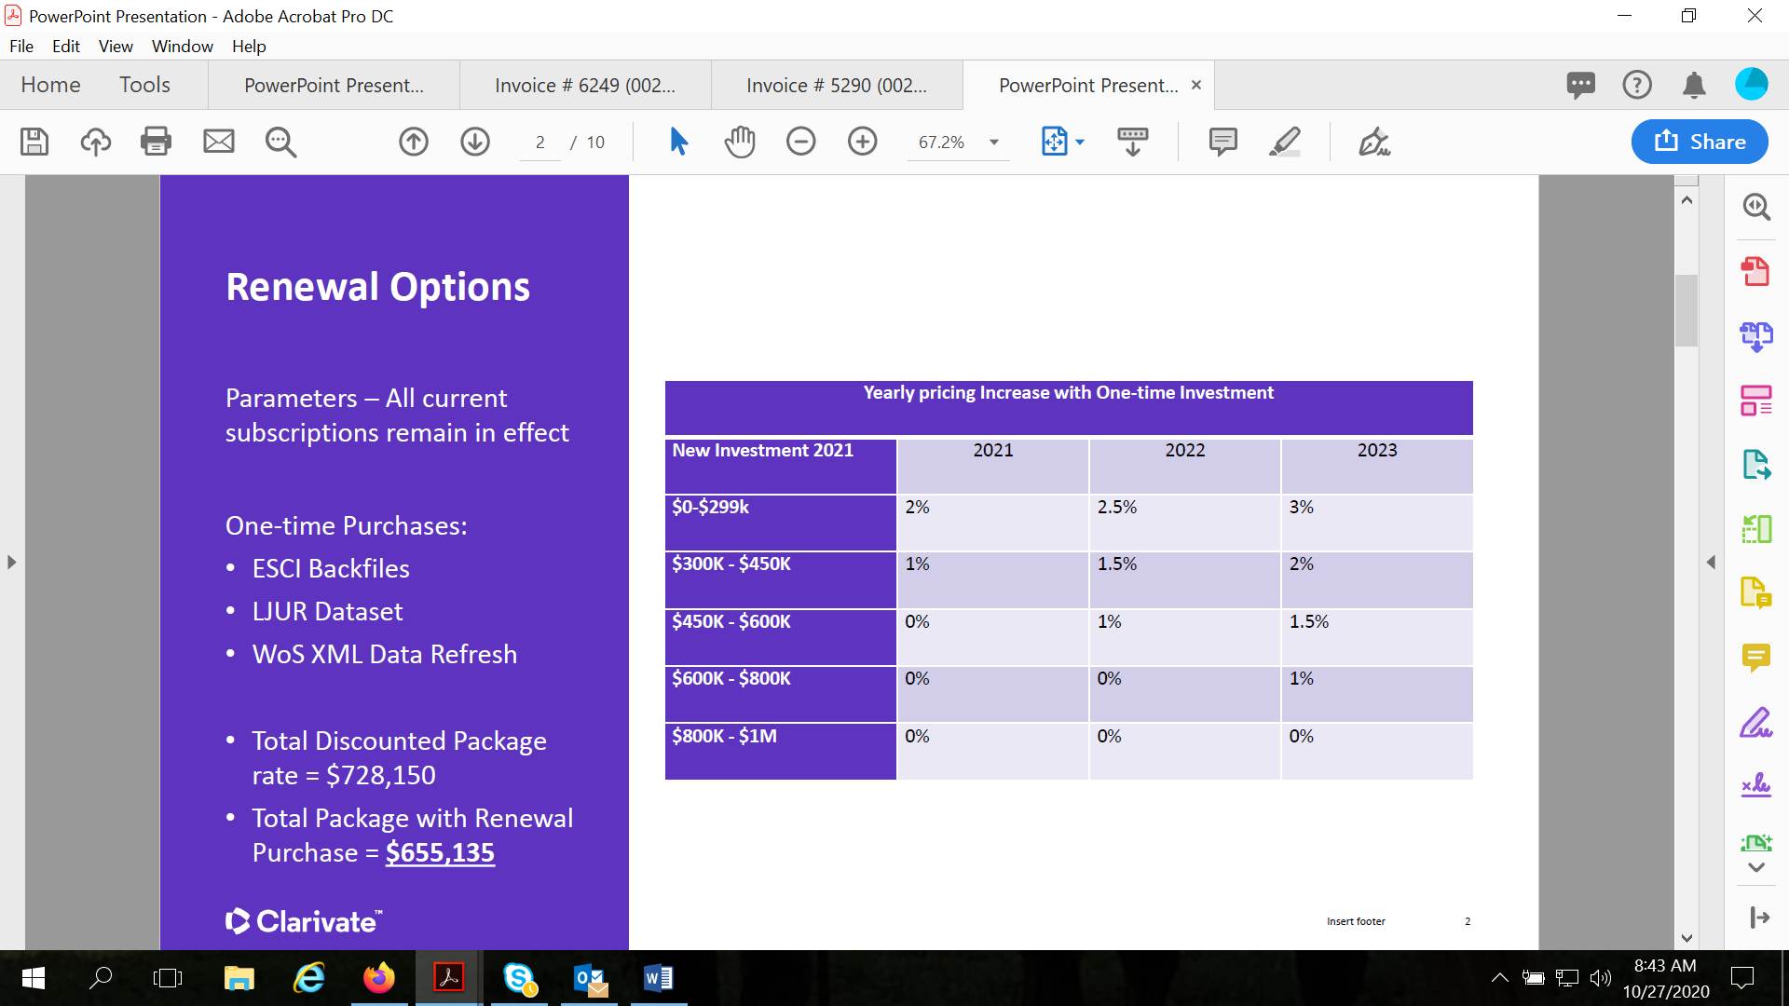Citation Index (ESCI) data. Currently BTAA is looking at using LSA for additional purchases…
- Updated proposal now looks like this. 2-year approved agreement for the reduction (-2%) in year 1 for 2021, and the flat (0%) in year 2 for 2022 with the purchase of 1 year of XML data refresh updates ($250k for the entire BTAA) purchased before the end of 2020. This provides ongoing cost relief in terms of the subscription products as the XML data would be a one-time purchase paid out of the Large Scale Acquisitions budget.
- The XML data is still under lively debate/discussion among the libraries. More information forthcoming….
- Cabi products are not included in this table as they are third party.
 | MEMBER INSTITUTION | AUTHORIZED ACCESS | ## | 2020 | 2021 | 2022
4 | University of Illinois  1408 West Gregory Street  Urbana, Illinois 61801 | 1900 - 2020 Science Citation Index Expanded  1900 - 2020 Social Sciences Citation Index  1975 - 2020 Arts & Humanities Citation Index 2015-2020 Emerging Sources Citation Index | ## | $ 147,763 | $144,807.74 | $144,807.74
4 |  | Journal Highly Cited Data | ## | $ 9,797 | $9,601.06 | $9,601.06
4 |  | Web of Science Citation Connection Package | ## | $ 71,519 | $70,088.73 | $70,088.73
4 |  | 1910-2020 Cab Abstracts | ## | $ 18,256
4 |  | CAB Global Health | ## | $ 7,702
4 |  | FSTA 1969-2020 | ## | $ 12,419 | $12,170.58 | $12,170.58

- Sage Premier Renewal
- Current BTAA conversation is a three-year agreement with price caps at 0%, 2%, 2% for the 3 year agreement.
- FY20 spend was $315,736.85 over many subject funds and er14. This deal also includes any takeovers coming in during years 2 and 3 that are invoiced at full price until they deal restarts. After years of discussion I’ve managed to exclude law titles from this type of invoicing, e.g. they stay out of individual invoicing if they are takeovers.
- The whole BTAA is pretty quiet about Sage so this one is going ahead best I can tell.
- Springer Nature
- Springer Nature overview: all products and increases and reflects a reduction from where we started
BTAA 2021-2023: 1%, 2% , 3%
Products | 2020 | 2021% | 2021 $ | 2022% | 2022 $ | 2023 $ | 2023 $
Scientific American | $ 22,974 | 0.5% | $ 23,089 | 2.0% | $ 23,551 | 3.0% | $ 24,257
Nature Legacy | $ 1,689,409 | 1.5% | $ 1,714,750 | 2.0% | $ 1,749,045 | 3.0% | $ 1,801,516
Nature All | $ 836,711 | 1.3% | $ 847,588 | 1.8% | $ 862,845 | 2.8% | $ 887,004
Palgrave Legacy | $ 46,273 | 0.5% | $ 46,504 | 1.5% | $ 47,202 | 2.5% | $ 48,382
Palgrave All | $ 98,761 | 1.0% | $ 99,749 | 1.3% | $ 101,045 | 2.3% | $ 103,369
Academic | $ 862,018 | 0.5% | $ 866,328 | 2.0% | $ 883,655 | 3.0% | $ 910,164
Springer Legacy | $ 7,552,530 | 0.5% | $ 7,590,292 | 1.5% | $ 7,704,147 | 2.5% | $ 7,896,750
Springer TONS | $ 208,251 | 0.5% | $ 209,292 | 1.5% | $ 212,431 | 2.5% | $ 217,742
Springer All | $ 2,945,926 | 1.0% | $ 2,975,385 | 2.0% | $ 3,034,893 | 3.0% | $ 3,125,940
Adis Journals | $ 128,309 | 0.5% | $ 128,951 | 1.5% | $ 130,885 | 2.5% | $ 134,157
eBooks | $ 2,421,830 | 2.8% | $ 2,488,430 | 3.5% | $ 2,575,525 | 4.5% | $ 2,691,424
Protocols | $ 122,370 | 1.0% | $ 123,594 | 2.0% | $ 126,066 | 3.0% | $ 129,848
Materials | $ 71,194 | 1.0% | $ 71,906 | 2.0% | $ 73,344 | 3.0% | $ 75,544
TOTALS | $ 17,006,555 | 1.1% | $ 17,185,858 | 2.0% | $ 17,524,633 | 3.0% | $ 18,046,099

- UIUC specific information:
- Total springer journals: $951,064.86
- Springer protocols: $24,780.28
- Springer Materials: $21,692.99
- 2021 Springer ebooks: $196,237.54
- 2021 total: $ 1,193,775.67
- Nature (including Palgrave)
- Palgrave journals: $7,065.30
- Nature academic journals: $42,333.84
- Nature branded and clinical journals: $171,143.41
- Scientific American: $ 1,854.85
- 2021 Total: $222,397.40
- For those of you asking about new nature titles, I’ll send any updates to that pricing as I receive them.
- Springer has indicated that this is their final and best offer for 3 years. However, BTAA has been asked to go back and see if we can get a two year agreement for 1% and 2%, and then this would be renegotiated for year 3 closer to year 3 (year 3 is currently at 3%). There is also a lot of conversation around the new nature titles as they continue to roll out new titles annually. Currently there’s 8 new titles we don’t have (121K recently discounted to 88K) and they have indicated there we be 6 more over the course of the next two years. All BTAA libraries (UIUC included) are discussing holding the line again and refusing to add new titles.
- Elsevier Book Series
- Elsevier books series have renewed as follows: 0%, 2.5%, and 5% for a 3 year deal. The original offer would have been 2.5%, 5%, and 5% . this affects a small number of funds here at a spend of 25K or so with a UIC split and this is a deal we have been in for several years now.
- Elsevier journals (UIUC, UIC, and UIS – not BTAA)
- We are currently working with Elsevier on an amendment that would extend our current 5 year agreement for one more year and allow for 0% increase on journals for FY22. This would mean our current agreement would end in 23 as opposed to 22. This requires BOT approval so there will be some time yet before it is completed. This is only for journals, e.g. not databases, ebooks, Pure, etc.
- Oxford University press shared print (one print book, and e-for all participating schools)
- This is currently under discussion for a renewal that would expand to include all front list OSO (Oxford Scholarship Online collections) 7 schools have indicated that they would like to participate (we are one) but there are some issues for some schools surrounding the desire to use LSA funding as opposed to their regular collection’s allocation. More information coming on this one.
- Cambridge University Press Read and Publish Agreement
- Cambridge has sent a relatively cost neutral read and publish agreement for their journals. Basically, this agreement like others works starts with our base spend, e.g. our current Cambridge subs est ($146,788) for 211 titles. There’s a top up charge of approximately $2100 and we will gain access to 192 titles, along with the read and publish aspect. This will lock this spend so there will be no cancels during the 3 year agreement.
- Here’s some text from oxford:
- New Journals Access; Reduced Costs
- This agreement will expand journals access for 10 institutions not already subscribing to the Cambridge Full Package, at a substantially discounted upgrade cost unique to this proposal. All institutions, including those already subscribing to the CUP Full Package, will benefit from reduced annual cost increases in subscription years 2022 and 2023 of 2% and 2.5%. Perpetual rights are provided to all volumes published during the agreement term; shallow back-file access is also guaranteed in line with the specific terms of each journal.
- New OA Publishing Opportunities
- For 12 BTAA members covered by this agreement, there will be no charge for corresponding authors who publish research open access in CUP’s gold and hybrid journals. The institutions included in this proposal account for approximately 10% of CUP’s North American research output. As well as securing the OA advantage for a significant pool of BTAA authors, this proposed partnership will accelerate CUP’s transition of its own journals list to open.
- Cambridge University Press e-books (shared print)
- There’s a new offer from Cambridge similar to Oxford for front list ebooks and a shared print copy for the group. We received this one on 11/19 so there’s still a great deal of email discussion about it and it doesn’t seem to have really landed anywhere yet. Several institutions, however, have indicated immediately that they can’t participate. For the remainder everyone is kicking around email questions mostly around cost and attempting to secure whole book ILL rights. As an aside, whole book ILL is still not secured with Oxford for that deal but they are discussing it with BTAA. More information will be forthcoming.
- Karger (not BTAA just us)
- We have been approached by Karger for a zero increase cost neutral read and publish pilot. We would renew our journals at a flat rate (104K) and like Cambridge no cancels. We already purchase all of Karger’s journals.
- From Karger:
- Starting January 2021, an unlimited publishing credit deposit in your name will be made available to researchers from your institute submitting manuscripts on the Karger homepage.
- Your publishing credit deposit can be used for both Karger Gold Open Access journals and Karger subscription journals under the hybrid model.
- The agreement covers all corresponding authors associated with and employed by your institution.

Resva – FY20 Carryover – Tom
- Tom – Because of the early FY20 close, some funds rolled over. George and Wendy have gone through and identified every encumbrance for ebook acquisitions that were made during the move to remote learning. With all of those paid, we have a little less than 50K left. Those encumbrances that George and Wendy identified equaled approximately 52K for e-resources that have not gone against subject funds. These largely correspond to the ebooks that were ordered to meet requests for items in Oak Street and the Stack as part of the e-first response My thought is to use the remaining funds to cover expenses this coming spring semester, rather than asking for departmental funds to cover those. I would like recommendation on proceeding with this direction. Would you all consider this as a general consensus? All agreed.

Updates
- Acquisitions – ACS folks are considering sharing more in-depth information on how and why they use the practices they use. This will be for better understanding and support of one another.
- E-Resources- We will be having a discussion on Ebsco e-books. We will be receiving a 12% discount. I will send out an announcement when this comes through. I have negotiated with Wiley a 50% fee discount.
- Preservation Services – No updates
- Other Updates

