CDC Meeting Minutes
October 27, 2020
Via Skype

Present: Tom Teper, Alex Cabada, Kit Condill, Esra Coskun, Mike Dickinson, George Gottschalk, Cindy Ingold, Jenny Johnson, Emilee Mathews, Kyle Rimkus, Matt Roberts, Wendy Shelburne, Becky Smith, Sarah Williams

Absent: Jennifer Teper

Note Taker: Wendy Wolter

Agenda/Minutes
Tom opened the meeting asking for additions or changes to the agenda. Agenda and last month’s minutes unanimously approved.

ILS Information Update – George
- George –We are still having issues with fund reports. Fund reports can be found under Analytics in Alma. Stephanie is very busy making changes and fixing problems. I will share my screen briefly to show you the differences between Voyager and Alma.
- Jenny – On my title list, some things show up twice. It also looks like items are paid twice.
- George – Yes, this is something that Stephanie is working on fixing. We will let everyone know when this has been fixed.
- Tom – This is a work in progress. We are moving in the right direction. ACS is doing a great job getting this information out to everyone.
- Wendy – I hope everyone saw Michael’s e-mail that came out last week. Everything old will be gone as of this Friday. We have spent a lot of time the last two weeks working on the SFX button. Many thanks to Esra and Vera. There will still be a discover button, but now it will link to Primo. Google Scholar had to be changed. There is a link in Michael’s e-mail to instructions. If you find something wrong, please let us know.
- Tom – We are trying to hit the highest volume use down vs. going alphabetical.
- Wendy – Yes, we are hitting the biggest and most usage first.

Budget Prep for FY22/23 – Tom
- Tom – We are looking at a number of options and scenarios, and as we’ve discussed, we are anticipating a flat budget for FY22. Inflation costs are covered for this fiscal year (FY21). As for FY22, we have done a fair amount of preparation in the organization. Right now, I am feeling reasonably confident that we will be able to weather FY22 without significant reductions, even though it will be tight. Between the inflation pool funds that we have banked and funds that I have been utilizing for larger, central acquisitions like ProQuest’s Access & Build program, we should be able to cover inflationary increases for FY22. We also know that economic cycles can last multiple years. Consequently, we should take this time to prepare for the potential that we would need to cancel titles in FY23. Esra and Vera have been pulling data on usage. I would like to have a discussion of how we go about doing this.
- Kit – Just to re-cap, we have enough funds for FY22, but should count on cancellations for FY23?
- Tom – In a nutshell, yes on FY22. We will have roughly 560K inflation increases for FY23 and no guarantee of additional funding to cover that. I think we should begin planning now, rather than waiting until the last minute in case we need to make cancellations.
- Matt – Are we going to have discussions before cancellations occur? I am very concerned about the Arts & Humanities as purely data-driven models tend to not reflect well on those disciplines.
- Cindy – Would it be helpful to discuss this with our divisions? Should we begin choosing items to cancel?
- Tom – I think the data needs to be gathered and come into play to a certain extent. In the past, we have identified resources that had no usage or one use for $2-3,000 subjects. It is fair to say that those are less valuable to Campus. This is not the only criteria, but part of the evaluation. In some cases, we’ve moved items to gifts and endowments, if that is an available option. This can be more nuanced than straight figures, but they provide a starting point.
- Matt – I understand that this is a starting point. The data will show less usage with the Arts & Humanities. I would appreciate a more nuanced approach.
- Tom – I completely understand. Cindy has been through this several times, and maybe she has some thoughts about how we have done this in the past.
- Cindy – Yes, I have been through this three times. However we do this, we never say that something has to be cancelled. We talk to the Subject Selectors, and work together. It might be better for the divisions to look at the numbers and come back to CDC.
- (unknown) – What about looking at program strengths, etc…?
- Tom – It may be a good place to start to have these discussions, but I would be reluctant to rely upon that too heavily either. If we were at an institution that was less comprehensive – Purdue or Indiana University, for instance – one would expect an overwhelming level of support for the sciences or the humanities. But, we are not. We are at a comprehensive research university and need to support scholarship broadly. A few years ago, we gathered data of expenditures by department. This is old data, so I would hesitate to use it at this point. Moreover, I am not sure that it would be all that helpful. We could go across the board and use percentages, but I’m not sure this is a good solution either.
- Emilee – What is the Collections budget, 22 million?
- Tom – The budget is 19.6 million. 500K is not a huge percentage, but it’s not tiny either. I’m a little reluctant to focus on straight percentages. It’s really not a fair model. Cindy, as you said, this will be good to discuss with your divisions once we have some data.
- Cindy – Years ago a formula-based model was used. No formula is preferred. Looking at data and having discussions with our divisions is a good place to start.
- Tom – I agree. The model that emerged out of the Matrix model from years ago was just a mess to manage and unsatisfactory to everyone. I’m happy to have the cushion that we have and 18 months lead time in order to have discussions.
- Wendy – I think I remember years ago that we asked the divisions to decide on cancellations.
- Sarah – I think in 2017 we cancelled some items when I took over for Pat. Tom handed this decision over to me when I first started.
- Tom – JJ walked into a similar situation. His predecessor overspent, and he had to figure it out.
- Sarah – I think this plan will work well for us.
- Tom – The message is, we are fine for FY22, and good for this fiscal year. Discussions going forward will need to focus on FY23 on the off chance that we receive no additional funding then. As in past years, I think that before Subject Selectors add recurring commitments, they should figure out what will be on their list of cancellations. I am happy to continue asking Esra and Vera to gather data and have discussions with divisions. We have multi-year contracts and agreements with the Big 10. We have limited choices with multi-year agreements. That said, I would like to avoid what some of us walked into 15 years ago. There was lots of disciplinary finger pointing, which was not very understanding of the broader Campus mission and not a very collegial model for discussing these challenges. We are very comprehensive, which makes us need to work harder and look at the broader view. It is a challenge.
- Cindy – Would it be helpful to come up with guidelines or principals?
- Tom – I think that’s fair Cindy. We can begin brainstorming and kicking things around collectively.

Alma Analytics and Fund Reports – George
- Tom – George, you have already touched on fund reports and analytics. I think we can now skip this on the agenda unless anyone objects?
- No objections.

Big 10 License Renewals – Wendy
- Wendy – I e-mailed a Word document to everyone. There are three significant renewals with the Big 10. They are all multi-year commitments and expensive.

Web of Science Renewal
Last UIUC invoice (January 2020): $264,808 Paid via er14, bio9, ace9, med9
And includes the following: 1900 - 2020 Science Citation Index Expanded
1900 - 2020 Social Sciences Citation Index
1975 - 2020 Arts & Humanities Citation Index
Journal Highly Cited Data
Web of Science citation connect package
1910-2020 Cab Abstracts, Cab Global Health, and FSTA 1969-2020

Last renewal included some individual backfile purchases as well as purchase of WOS XML data that held down annual increases. XML data was purchased using BTAA Large Scale Acquisitions (LSA) funds. The new proposal includes much of the same with varying rates of annual increase dependent upon one-time purchases of WOS XML data refresh, LJUR (library journal utilization report –which we have purchased somewhat regularly over the years) and Emerging Social Citation Index (ESCI) data. Currently BTAA is looking at using LSA for additional purchases…
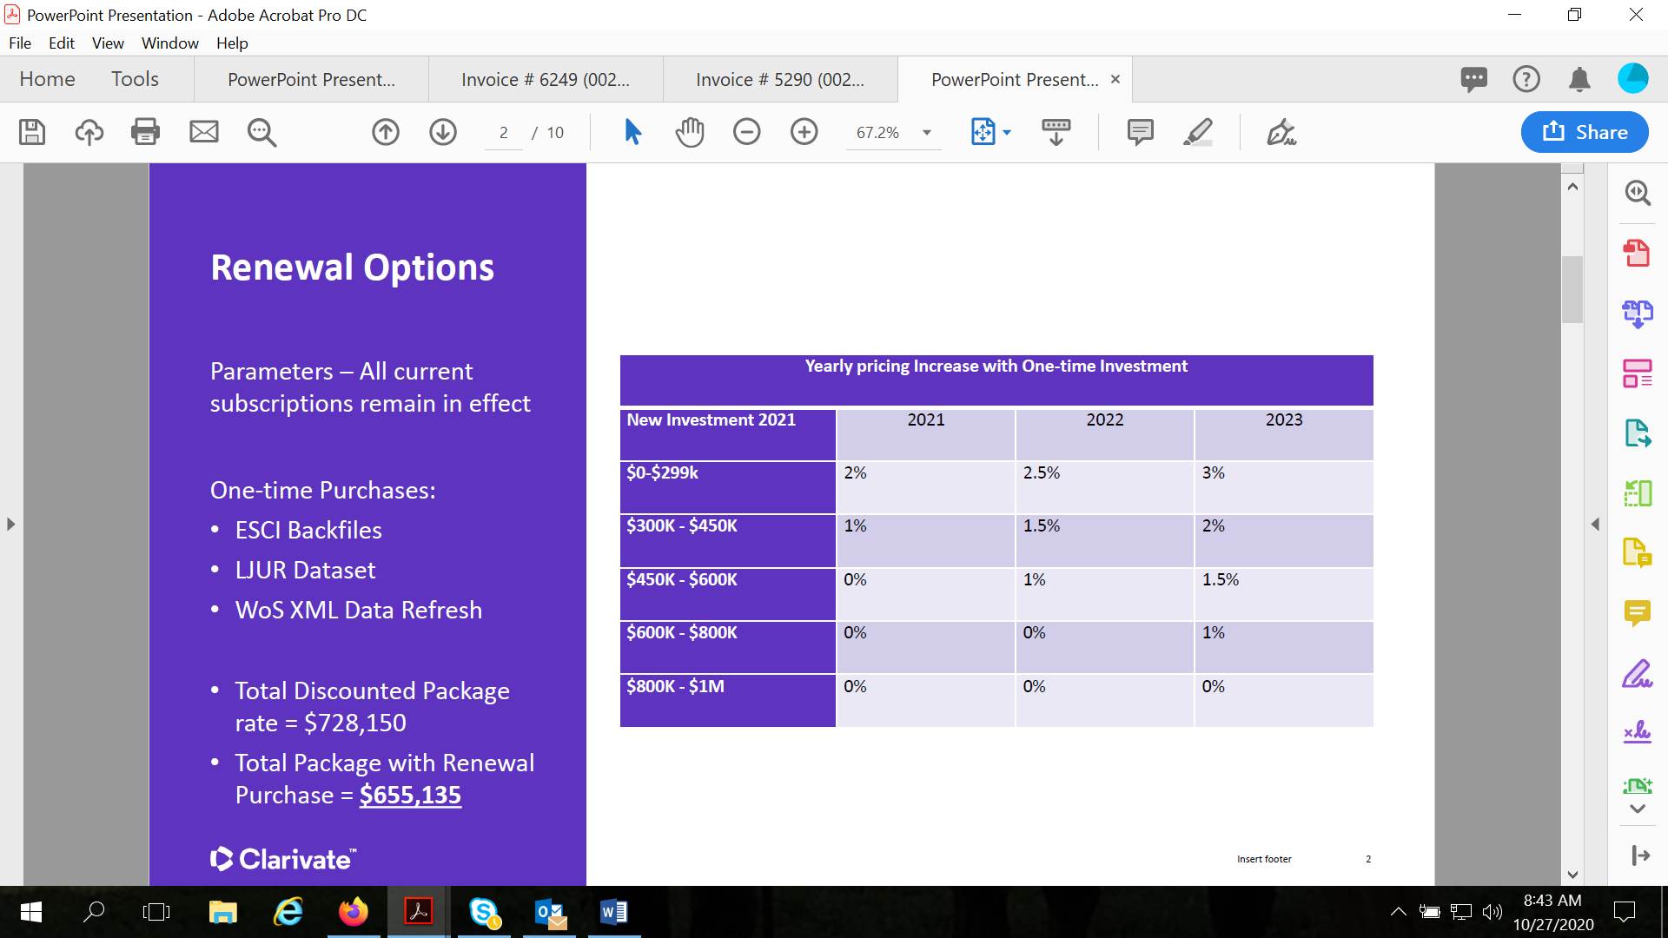
Sage Premier Renewal
Current BTAA conversation is a three-year agreement with price caps at 0%, 2%, 2% for the 3 year agreement.
FY20 spend was $315,736.85 over many subject funds and er14. This deal also includes any takeovers coming in during years 2 and 3 that are invoiced at full price until they deal restarts. After years of discussion I’ve managed to exclude law titles from this type of invoicing, e.g. they stay out of individual invoicing if they are takeovers.

Springer Nature overview: all products and increases and reflects a reduction from where we started
BTAA 2021-2023: 1%, 2% , 3%
Products | 2020 | 2021% | 2021 $ | 2022% | 2022 $ | 2023 $ | 2023 $
Scientific American | $ 22,974 | 0.5% | $ 23,089 | 2.0% | $ 23,551 | 3.0% | $ 24,257
Nature Legacy | $ 1,689,409 | 1.5% | $ 1,714,750 | 2.0% | $ 1,749,045 | 3.0% | $ 1,801,516
Nature All | $ 836,711 | 1.3% | $ 847,588 | 1.8% | $ 862,845 | 2.8% | $ 887,004
Palgrave Legacy | $ 46,273 | 0.5% | $ 46,504 | 1.5% | $ 47,202 | 2.5% | $ 48,382
Palgrave All | $ 98,761 | 1.0% | $ 99,749 | 1.3% | $ 101,045 | 2.3% | $ 103,369
Academic | $ 862,018 | 0.5% | $ 866,328 | 2.0% | $ 883,655 | 3.0% | $ 910,164
Springer Legacy | $ 7,552,530 | 0.5% | $ 7,590,292 | 1.5% | $ 7,704,147 | 2.5% | $ 7,896,750
Springer TONS | $ 208,251 | 0.5% | $ 209,292 | 1.5% | $ 212,431 | 2.5% | $ 217,742
Springer All | $ 2,945,926 | 1.0% | $ 2,975,385 | 2.0% | $ 3,034,893 | 3.0% | $ 3,125,940
Adis Journals | $ 128,309 | 0.5% | $ 128,951 | 1.5% | $ 130,885 | 2.5% | $ 134,157
eBooks | $ 2,421,830 | 2.8% | $ 2,488,430 | 3.5% | $ 2,575,525 | 4.5% | $ 2,691,424
Protocols | $ 122,370 | 1.0% | $ 123,594 | 2.0% | $ 126,066 | 3.0% | $ 129,848
Materials | $ 71,194 | 1.0% | $ 71,906 | 2.0% | $ 73,344 | 3.0% | $ 75,544
TOTALS | $ 17,006,555 | 1.1% | $ 17,185,858 | 2.0% | $ 17,524,633 | 3.0% | $ 18,046,099

UIUC specific information:
Total springer journals: $951,064.86
Springer protocols: $24,780.28
Springer Materials: $21,692.99
2021 Springer ebooks: $196,237.54
2021 total: $ 1,193,775.67

Nature (including Palgrave)
Palgrave journals: $7,065.30
Nature academic journals: $42,333.84
Nature branded and clinical journals: $171,143.41
Scientific American: $1,854.85
2021 Total: $222,397.40

For those of you asking about new nature titles, I’ll send any updates to that pricing as I receive them.
Publisher’s Weekly
Just an update that our previously purchased via BTAA publisher’s weekly archive which has been homeless owing to the demise of NA publishing will be moving to Eastview.

- Sarah – I haven’t been involved with a large collection before, so if the Big 10 comes to an agreement, everyone chips in, is that correct?
- Wendy – We all contribute. They have a bucket of money. They try to keep inflation costs down when having discussions. Sage Premier affects a lot of you. For FY20, we spent 315K plus. When you look at the Springer report, this is not all ours. This includes all the Big 10. These are the current discussion items. If anyone wants to see Springer e-book pricing for items we don’t have, please let me know.
Updates
Acquisitions – No updates.
E-Resources – No updates.
Preservation Services – No updates.

Meeting adjourned at 4:30 p.m.

