CAPT Meeting Minutes
June 25, 2020
Via Skype

Present: MJ Han, Ayla Kenfield, John Laskowski, Bill Mischo, Michael Norman, Chris Prom, Kyle Rimkus, Tom Teper, Tracy Tolliver Cherie’ Weible

Absent: Jim Dohle, Heidi Imker, Wendy Shelburne

Notetaker: Wendy Wolter

Agenda and Minutes
Tom Teper opened the meeting requesting approval of the agenda. Agenda unanimously approved, noting that Wendy Shelburne will be absent from this meeting, and the E-Resource report will move to next month’s agenda.

ILS System Migration Monthly Update- Michael Norman
As of June 24, we are live on Alma and the Primo Library Catalog. The implementation of both systems went as expected and we will continue to work over the summer to optimize the setup of Alma and the Primo Catalog to be ready for the beginning of the Fall Semester. The Library’s Home Page is actively pointing to the new Primo Library Catalog. All internal and external work should now occur in the Alma and Primo VE systems. To see the production version of the Primo Library Catalog, navigate to this url to view the production interface: https://i-share-uiu.primo.exlibrisgroup.com/discovery/search?vid=01CARLI_UIU:CARLI_UIU&lang=en

Continuing Issues with Alma and Primo Library Catalog
As expected, we are encountering some issues with being live on Alma/Primo. We are still encountering some overall slowness in both systems for internal and external searching. Often the real-time calls in the Primo Library Catalog to pull in local holdings information takes over 30 seconds to display. Some collections, such as IDEALS records, where not imported into Primo as expected. We will need to produce that export ourselves in the next couple days. We are having issues with the deduping process in Primo Catalog as well, particularly for e-serials. Many times, the full representation of e-access to journals is not displaying as expected. The Primo Search API calls are still returning slower than desired but we have seen some improvements with the new search parameters from the June release of enhancements to Primo VE. We will continue work over the next several weeks to improve Alma and Primo in these important areas.
- Michael - To correct the dedupe issue, we can simply turn this function off.
- Tom – If we turn this function off, and it doesn’t work, can we reverse it?
- Michael – Yes, within minutes.
- MJ – We are in the process of updating 57 libguide pages. This should be done by Monday.

Access to Voyager and VuFind Catalogs Going Forward
We do still have access to static copies of Voyager and VuFind catalogs. From June 24, 2020 until October 30, 2020, CARLI plans to provide a static copy of Voyager for staff clients, MS Access reporting, and Voyager Web Reports. CARLI will also continue to provide read-only versions of the UIUC Library's local library catalogs and the I-Share union catalog that are derived from Voyager data (including New VuFind, VuFind 0.6, and Classic Voyager (WebVoyage). All three catalogs will be retired on October 30.

Bulk Renewal of Loans
CARLI did a bulk renewal of everything that was due from January 1st to September 30th, 2020. The new due date will be October 1st, 2020, so that users will not get fined for materials they could not return while libraries were closed.

Requesting of Resources in Alma/Primo
Local requesting of U of I Library materials has been enabled in Alma/Primo. Patrons can see the Request button for local materials show after they log into the new Primo Library Catalog. However, Resource Sharing (called Automated Fulfillment Network (AFN) in Alma and the Primo Catalog) is currently not active in Alma/Primo; the earliest it will be available is the week of July 6th. Watch for more news on the reactivation of Resource Sharing of I-Share materials.

Training information for Alma and Primo Library Catalog
The ILS Coordination Team has created a site to centralize our training documentation and recordings of the various training sessions that have occurred over the past several months. Check out the site at https://www.library.illinois.edu/staff/alma/ to see full training calendar occurring over in May and June and the informative sources collected for working in Alma and Primo VE.
Also, recordings of the many Alma and Primo training sessions that have occurred in May 2020 (and earlier ones as well) at: https://www.library.illinois.edu/geninfo/discoveryservices/ils-coordination-team/

Questions about Alma or Primo Library Catalog
If you have questions or need to report problems about Alma and/or the Primo Library Catalog, there is a new section on the Alma Staff Training page in the Contact Us section at https://www.library.illinois.edu/staff/alma/.
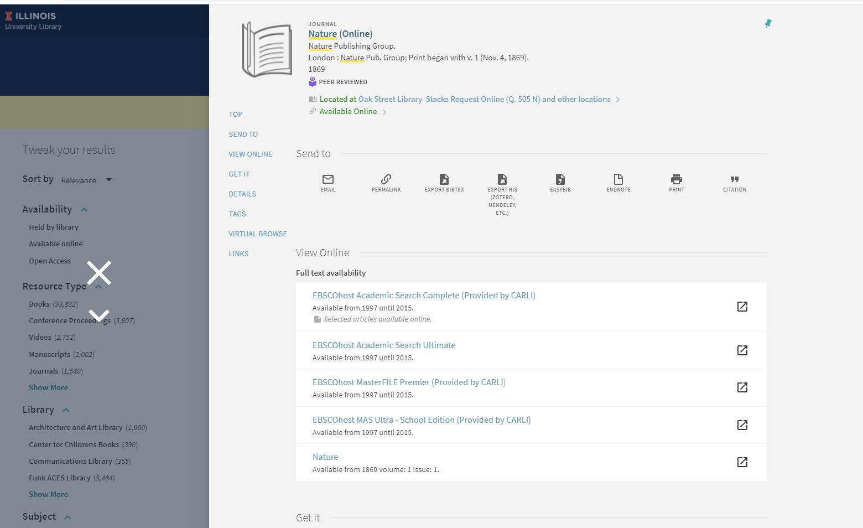

Sample search in new Primo Library Catalog (Nature)
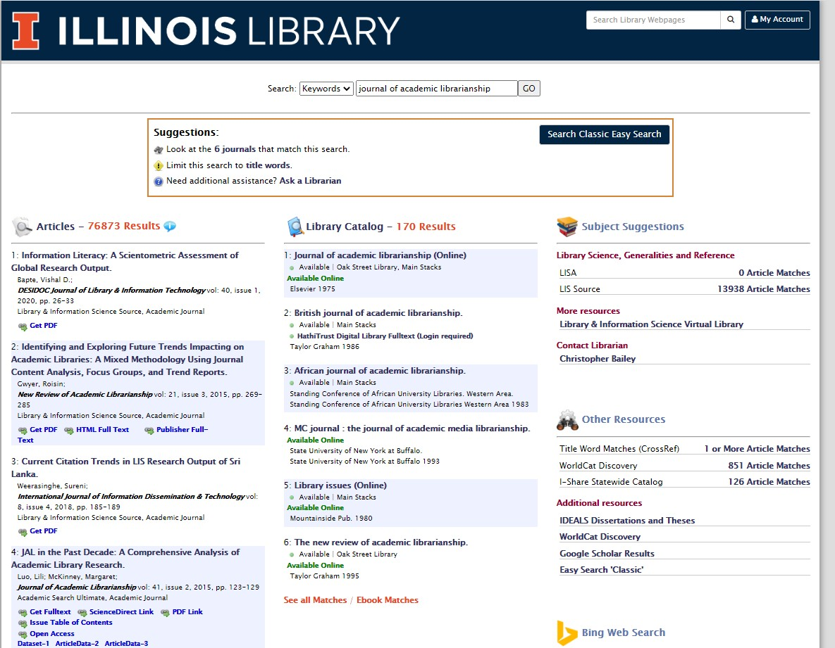
Sample search in Easy Search with results from Primo Catalog

Quarterly Working Group Reports
Cataloging and Metadata – MJ Han
Data cleanup projects
- Records with Location discrepancies: corrected more than 53K records
- Bibliographic records with duplicate OCLC numbers: combined more than 64K records
- Finding better records for all Marcette records: searched about 38K records
Alma cataloging hangout sessions
- Six sessions covering item, MFHD, and bib records in Alma
Cataloging training
- Five cataloging training sessions covering different types of resources were provided for staff who do cataloging including,
  - microfilm,
  - map,
  - rare books,
  - music, and
  - media.
*All training materials are available in LibGuide.
Alma data review
- Acquisitions, cataloging, and e-resources data have been reviewed.

Cataloging policy updates
- Copy number: Copy numbers are unique to the bib not the classification scheme.
- Use of the 852 field subfield m for the call number suffix – Alma supports suffix search. This will allow users can search suffix terms in Alma.
Plans for after Alma migration
- Preparing data cleanup projects
  - Bound volumes
  - Location cleanup
  - Move local note to appropriate local fields including:
    - Collection title
    - Acquisition history
    - URL for finding aids
    - Item specific notes
- Alma cataloging profiles - Finalizing a new set of profiles (from 91 to 29)
- More Alma training: Acquisitions and cataloging
- LibGuide updates – 57 pages (most of pages will be ready by June 26.)
- Cataloging by remote staff – a hybrid workflow is ready for staff who work remotely
- And more…

- Parking Lot Items-Review
- Lockss – This needs to be reviewed. We were invoiced $11,690 in January 2020. This does not align with the Cloud Program. The group voted to cancel this. Chris will speak with Tom.
- New Title List
- Illinois Databank
- Expertise Portal
- Persistent Identifiers

