CAPT Meeting Minutes
December 17, 2020
Via Skype

Present: Jim Dohle, MJ Han, Ayla Kenfield, John Laskowski, Michael Norman, Tom Teper, Wendy Shelburne, Tracy Tolliver

Absent: Mary Laskowski, Chris Prom, Kyle Rimkus, Bill Mischo

Notetaker: Wendy Wolter

Agenda and Minutes
Tom Teper opened the meeting asking for approval of the December agenda, and November minutes. Agenda and minutes unanimously approved.

ILS System Migration Update – Michael Norman
Ex Libris pushes out upgrades to both systems the first weekend of each month. We do get access to the upgrades and changes in the UIUC Sandbox versions two weeks before the eventual roll out to our Production versions. To see the new changes, Ex Libris posts release notes in their Knowledge Center documenting the changes and fixes coming in the next release. You can see Alma Release Notes here: https://knowledge.exlibrisgroup.com/Alma/Release_Notes/2020 and for Primo VE: https://knowledge.exlibrisgroup.com/Primo/Release_Notes/002Primo_VE/2020

Utilization of Mobile Access QR Code as Link in Primo Catalog
The December release of upgrades for Primo introduced the QR code in the catalog. The QR code appear in the upper right of any search results page. This allows users to copy QR as a link to a single record. Also, a QR code can be produced for a canned search to promote and expose a set of records, search results, or collections. See image below for example with the QR button circled in the upper right of the display.
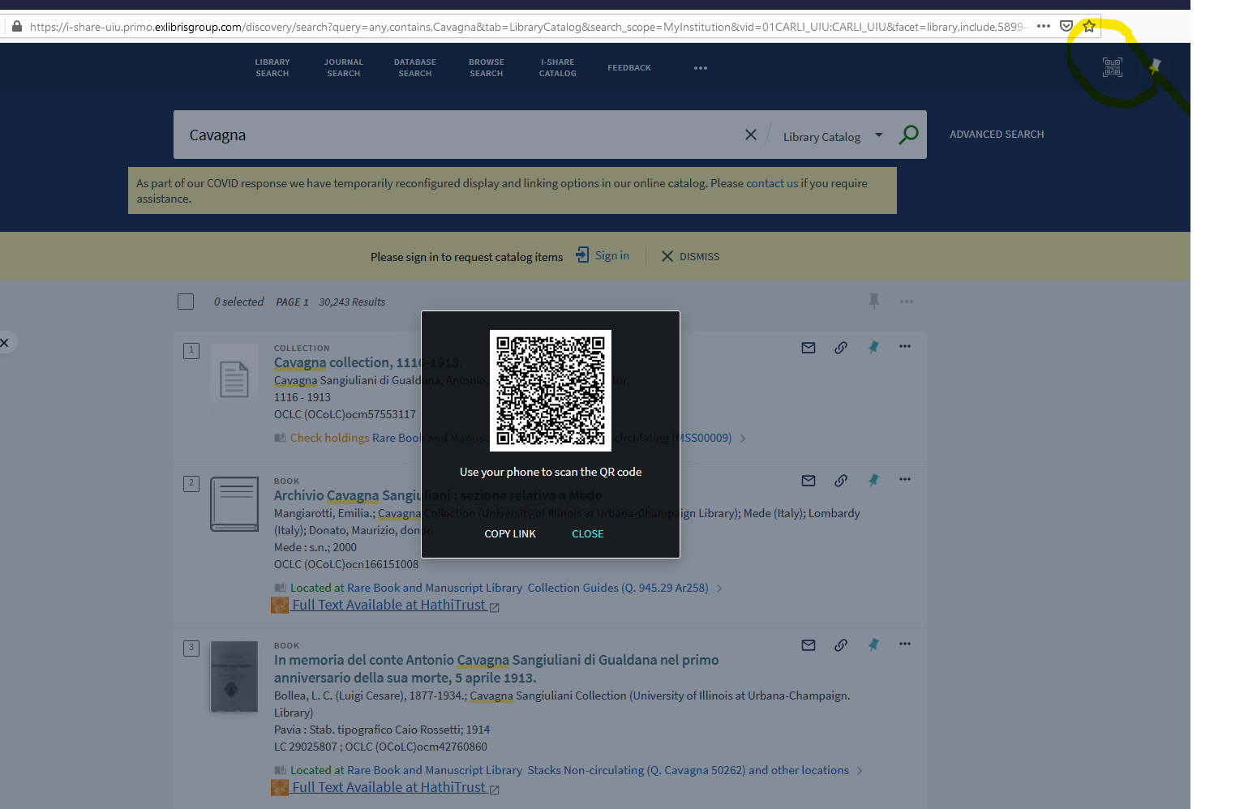

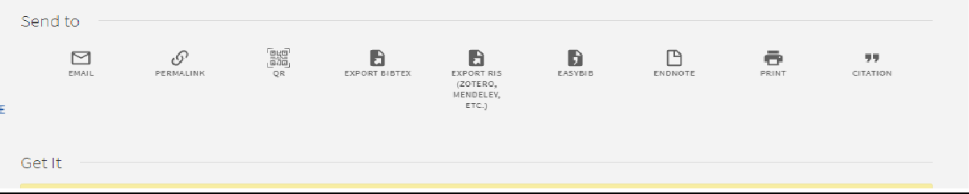

Integration of InterLibrary Loan (ILL) into Primo Catalog and Alma Linkresolver Service
We continue to integrate the InterLibrary Loan service into the Primo. In Alma/Primo, the Linkresolver service is integrated and managed in Alma. Unline SFX, when clicking on the Discover UIUC Online in the indexing and abstracting services (EBSCO, ProQuest, Scopus, Google Scholar, Microsoft Academic, PubMed, etc.), the Alma Linkresolver determines if the Library has full-text access or not. If the service does not determine the Library has access (inventory), it generates an InterLibrary Loan request link. Sometimes, the appearance of this Linkresolver page is taking 10-12 seconds to appear. Ex Libris announced there should be improvements in this lag time with the January 2021 upgrade.
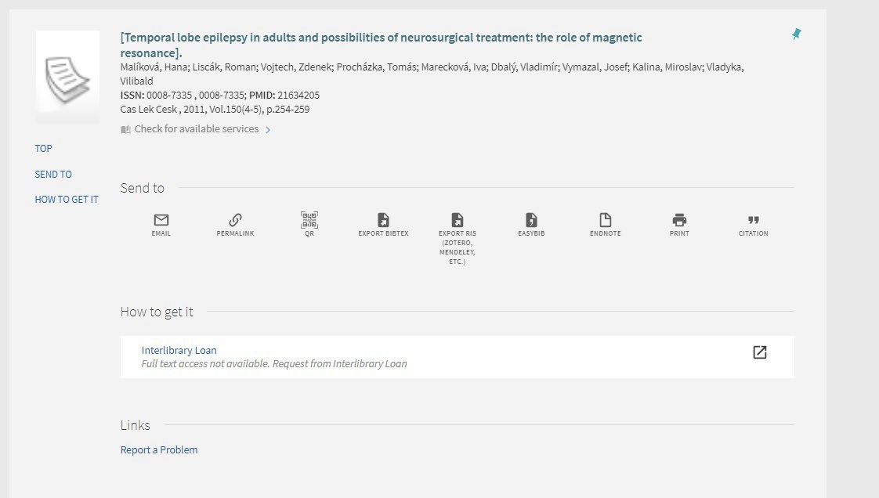

Web Browser compatibility Issues with Primo Catalog
Intermittently, there are times we are having compatibility issues with the Primo Catalog and the latest versions of web browsers when logging into one’s My Account. Primo should be compatible with these browsers, e.g. Safari, Chrome, Firefox, and Microsoft Edge (they do note issues with Microsoft Internet Explorer 11 version). If you encounter this issue,
1) check to see if the latest version of these browsers are being used and/or 2) institute a refresh of page if results in My Account are not showing properly (Control button and F5 to refresh).

Alma and Primo Analytics permissions training
Starting in January 2021, we will also be offering introductory sessions in working in Alma Analytics and Primo Analytics. Oracle Business (OBIEE) is the underlying system for both analytics instances. Similar to what we do with WordPress, at the beginning of each semester we will offer training sessions in using the Analytics suite of tools. If one has access to the Analytics tools, he or she will need to attend one of these sessions on learning the basics of running analyses and reports in the two systems. Those dates will be:
Topic: Alma Analytics Training Session Time: Jan 12, 2021 10:00 AM
Jan 19, 2021 10:00 AM
Jan 26, 2021 10:00 AM
Join Zoom Meeting https://illinois.zoom.us/j/87078324559?pwd=NjRkMVdSUVRsTUl2MkdVeGNNbFlWUT09

Meeting ID: 870 7832 4559
Password: 185217

Alma and Primo Analytics work sessions
We will have weekly information sessions on working in Alma Analytics each week starting on December 2nd. The weekly schedule will be each Wednesday at 1 pm:
Topic: Alma Analytics Work Sessions Join Zoom Meeting
https://illinois.zoom.us/j/89899828282?pwd=eStmMDZUa3VqTE5uZ0l5L3hkbDBjQT09
Meeting ID: 898 9982 8282
Password: 531383

Quarterly Working Group Reports
Cataloging and Metadata – MJ Han
Data Cleanup projects
- Serials summary note (MFHD 866 field) – workflow document is done and several staff are working on the project. *each holdings record has its own issue.
- Duplicated records with the same OCLC number – workflow document is ready and need to identify a right group of staff.
- Bound volumes (under review now)
- Holdings cleanup
  - misuse of the holdings 866 field
  - misuse of the holdings public notes 852 $$x
- Item records cleanup
  - item type migration
  - library location
Plans for additional Alma training
- Physical inventory work (all library staff)
- Special needs for cataloging work (special collections)
- Upcoming deployment of a new metadata editor (staff with the cataloger role)

Repositories, Preservation, & Access – Ayla Stein
Current membership:
- Chair: Ayla Stein Kenfield, SC&P
- Vice-Chair: Kyle Rimkus, Preservation Services
- Seth Robbins, SCARS
- Hoa Luong, RDS
- Dan Tracy, SC&P
- Jason Strutz, Library IT
- Mark Zulauf, SC&P
- Sarah Harris, Archives

Meetings
Had meetings in October and November, cancelled September 2020 meeting

Activities of Note
- Change of membership - Cara Bertram rolled off and Sarah Harris took her place
- IDEALS policies
  - Reviewed Digital Preservation support policy
    - For some reason this is separate from the other Digital Preservation policy. Since they were both written at a time before Medusa, much of what is specified in the support policy is Decided to strike most of the text in the support policy and merge it into the main Digital Preservation policy, so moving forward, we’re proposing there is a single policy for IDEALS digital preservation
  - Next - Access and Use Policy
- Boutique projects
  - Helped Jason Strutz come to a decision on how to move forward with boutque projects
    - DECISION: Jason will prioritize the existing projects that are urgent to deal with, and submit request for help identifying stakeholders and potential actions
    - DECISION: put together a libguide (or equivalent) to help people decide what platforms are available/point people to work that’s been done by Spencer Keralis in this area
- LOCKSS - DECISION: KILLED IT. Officially

Electronic Resources – Wendy Shelburne
ERWG has meet twice since the last report in October.
At our November meeting we continued discussions regarding the link resolver change (SFX to ALMA) and Stephanie also discussed the redeploy of display logic work in ALMA that we had set up in SFX. This will be ongoing. Essentially display logic is a configuration that works to present to the user the “best” option for a full text result when resolving an open url. Here’s some examples below:
To hide all Elsevier other than the Elsevier autoload collection:
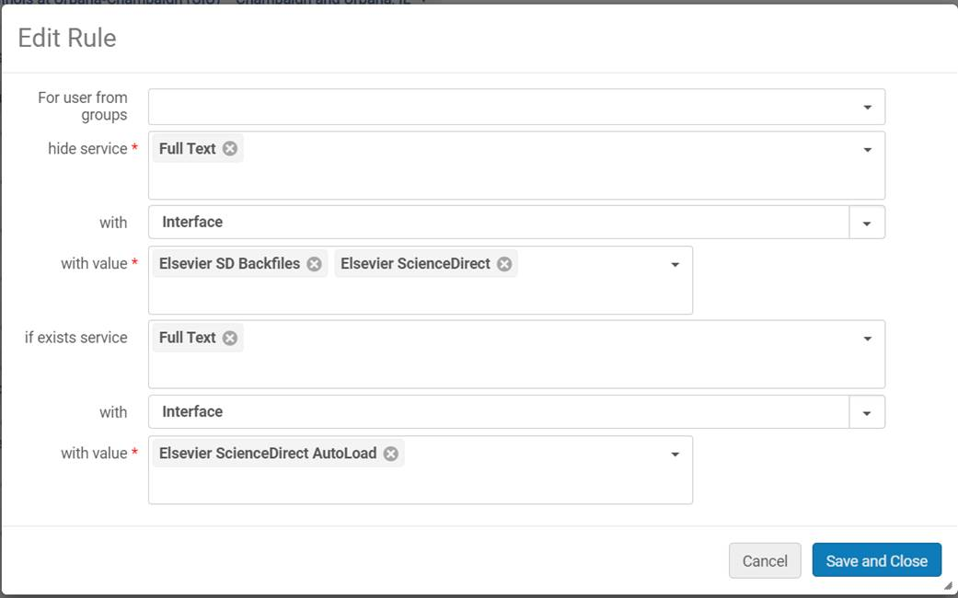
To hide other EbscoHost collections if EbscoHost Academic Search Ultimate is available:
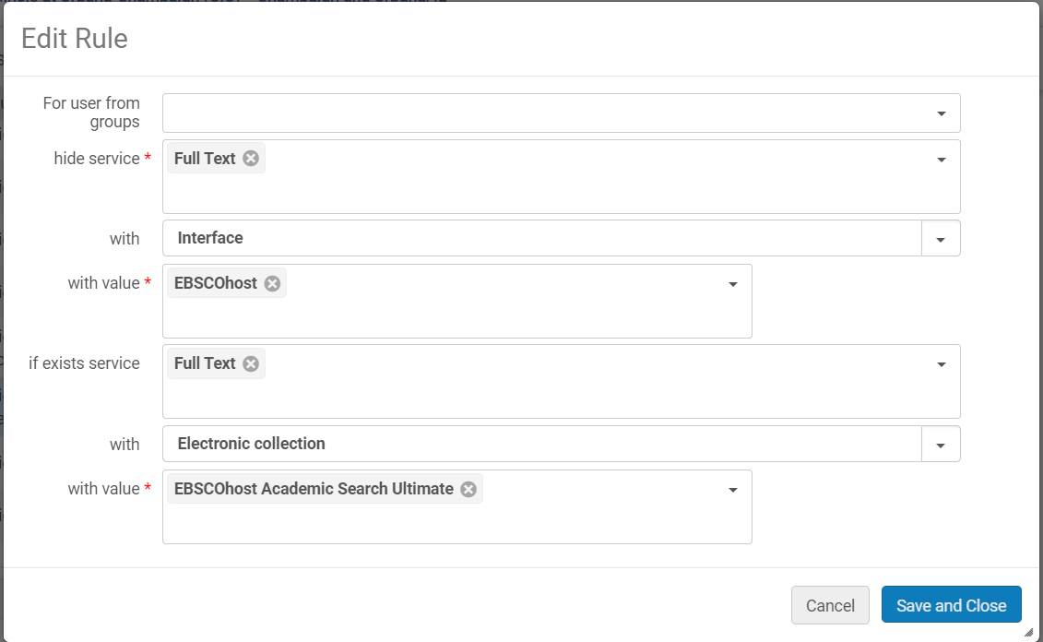

Online Services Order – To push aggregator collections to bottom of list:
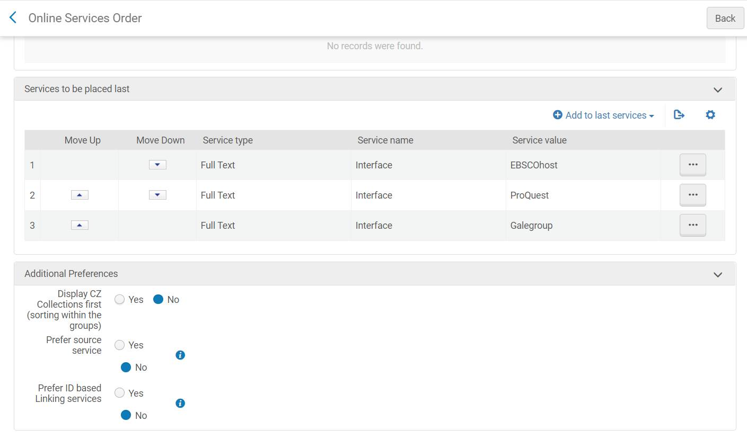

Open Url changeover work has slowed and now it is catch as problems show up, and as of last week we believe Scopus is now working properly. There were issues that had to be solved between product managers in Amsterdam and Singapore so this took some time and coordination.

At our December meeting we spent time looking at some open url problem tickets for troubleshooting purposes to attempt to sort out the root cause of some very curious resolution errors. We also found out that much of what we were seeing were known issues that have been reported to ExLibris for product enhancements years ago. And our best example is resolution to book titles when there is no ISBN in the record. When this happens ALMA essentially makes up a result that is nonsense. In our example one word of the title matched, a new author was added, and 3 locations came back to the user and not one was the title from the users original request. For those of us who have been working with openurl for years it isn’t necessarily surprising or shocking, but it is an example of a difference between SFX and ALMA and an example of some of the more esoteric challenges we will face as we learn the new system.

- Parking Lot Items-Review
- New Title List
- Illinois Databank
- Expertise Portal
- Persistent Identifiers

Meeting adjourned at 2:25 p.m.

